Luke Grice

ECE 497 IOT

Final Project Description

**Introduction**

A typical thermostat is set either to cool or to heat. The device works by simply turning on or off the furnace or the A/C to increase or decrease the inside temperature. In order to save electricity, one has to manually open and close windows at certain times to cool or heat the house without the use of the furnace or the AC unit.

This project proposes using an outdoor thermometer and an indoor thermometer to determine whether opening the windows will bring the internal temperature to the desired level. If it determines that opening the windows is beneficial, then it opens the window via a linear actuator. Else, the last resort is to turn on either the furnace or the AC.

**Block Diagram**

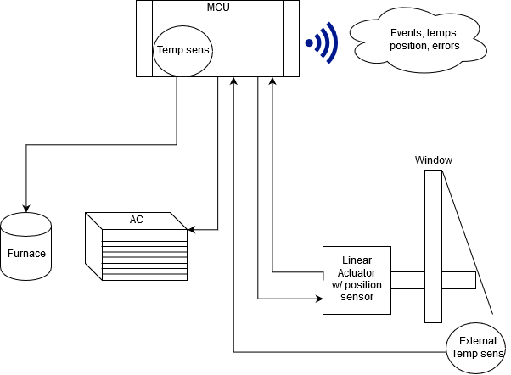

*Figure 1: Temperature Control Block Diagram*

From Figure 1 see that the MCU will control the heating and cooling elements along with the linear actuator which will open and close the window. The actuator will return its position and this is how the MCU will know the state of the window. If the window is in the incorrect state the MCU will report an error state. Under normal operation the MCU will compare the internal temperature and the external temperature and determine which method of heating or cooling to use. Table 1 shows the possible states. The connecting lines for inputs and outputs to and from the MCU do not necessarily represent wired connections. It may be possible to wirelessly send the external temperature, and similarly, wirelessly control the various appliances. This will depend on the cost, and ease of access to the controls that would be needed.

*Table 1: MCU states*

|  |  |  |  |  |  |
| --- | --- | --- | --- | --- | --- |
| **Desired Temp** | **Internal Temp** | **External Temp** | **Window** | **Furnace** | **A/C** |
| 20oC | 20oC | NA | Closed | Off | Off |
| 20oC | >20oC | > internal | Closed | Off | On |
| 20oC | >20oC | < internal | Open | Off | Off |
| 20oC | <20oC | > internal | Open | Off | Off |
| 20oC | <20oC | < internal | Closed | On | Off |

To show the logic the MCU must perform Figure 2 contains a flow chart of how the logic results in each of the possible states. Instead of continuously polling the temperature a good trigger will need to be found to go from the idle state to check temperature state. After this, various if statements will be evaluated in sequence to traverse the decision tree down to the correct state. After the desired state is selected an additional check will be performed to ensure that everything responded as expected. If any appliance does not return the commanded state, or no return is seen then the device will report an error. These errors will be represented by error numbers and this will be sent to one of the fields on Thingspeak. The tentative error numbers are as follows:

1. No Error
2. Window Open when should be Closed
3. Window Closed when should be Open
4. Window state unknown
5. Furnace On when should be Off
6. Furnace Off when should be On
7. Furnace state unknown
8. AC On when should be Off
9. AC Off when should be On
10. AC state unknown

After each time the decision tree is traversed the board will upload to the Thingspeak fields:

1. State:

0: All Off, 1: Window Open-cooling, 2: Window Open-heating, 3: AC On, 4: Furnace On

1. Internal Temp
2. External Temp
3. Error Number

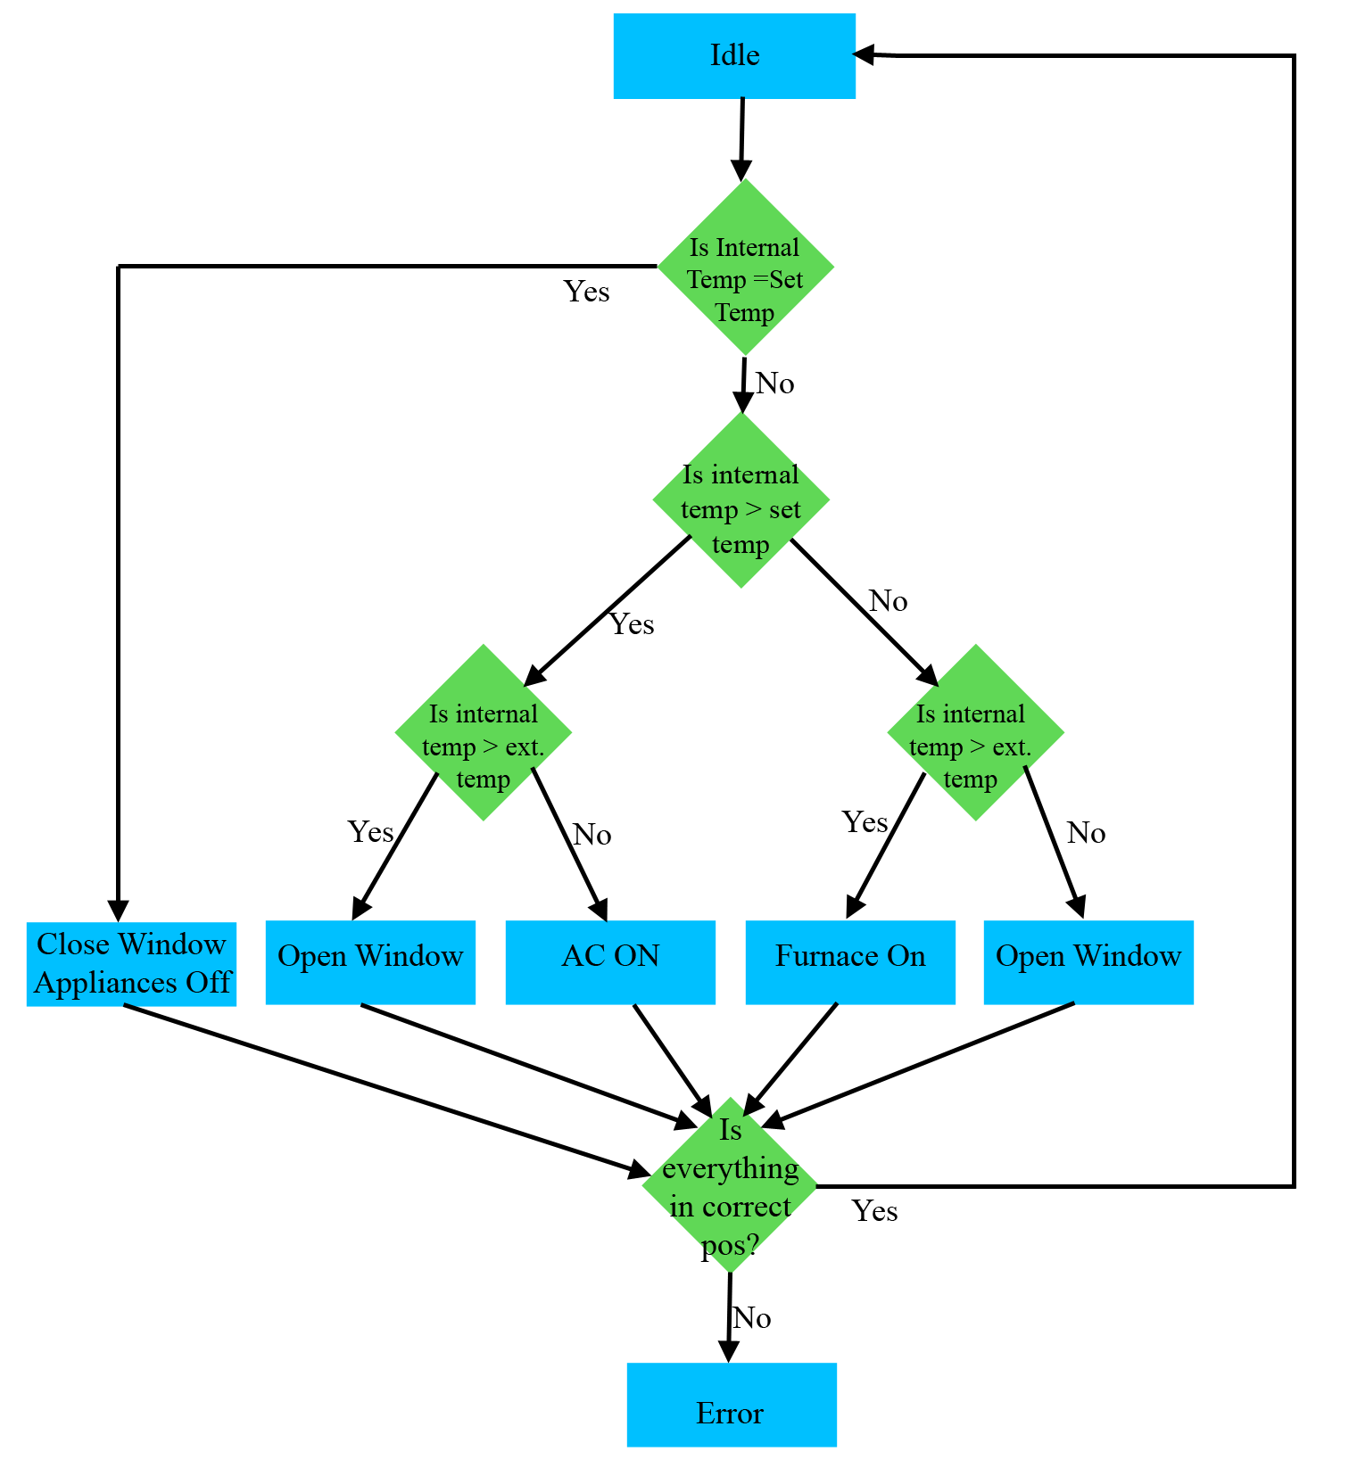

*Figure 2: MCU Logic*

**Parts**

Table 2 lists the external parts and pieces required for this project along with their price and expected arrival date.

*Table 2: Parts List*

|  |  |  |  |  |
| --- | --- | --- | --- | --- |
| **Part** | **Price** | **Qty** | **Arrival Date** | **Total** |
| Linear actuator | $70 | 1 | Mar 20 | $79 |
| 2 Chan Relay | $6.85 | 1 | Mar 20 | $17.42 |
| Temp Sensor | $9.52 | 1 | Mar 20 | $17.51 |
| Mock AC | $0 | 1 | - | 0 |
| Mock Furnace | $0 | 1 | - | 0 |
| Wood | $0 | As Req | - | 0 |
| Hinges | $2 | 2 | - | $4 |
| **Total** |  |  |  | **$117.93** |

This is subject to change as more shopping is done to attempt to consolidate shipping.

**Outcome**

The end result will be a carry able mockup of a home heating and cooling system. The microcontroller will use the logic described above to open and close a small homemade window. If opening a window is not sufficient for adjusting the temperature it will instead turn on one of the relays which will be connected to a mock AC unit and heater. This will demonstrate the ability to interface to high voltage applications, control an electric servo, connect to external sensors in addition to the already configured on board ones, perform error detection and logging, and upload this information via WIFI.

Parts Links

<https://www.robotshop.com/en/l16-actuator-100mm-1501-6v-rc-control.html>

<https://www.progressiveautomations.com/lc-200#ig_lightbox2[gal]/1/>

<https://www.mouser.com/ProductDetail/Olimex-Ltd/MOD-TC/?qs=rR6Ke2evSQWtVSD7KPZtzQ%3D%3D&gclid=EAIaIQobChMI8dmKkPbp2QIVhB9pCh0QBwKqEAQYAiABEgKAXvD_BwE>

<https://www.robotshop.com/media/files/pdf/L16_Datasheet-2.pdf>