Exercise 1:

UIC is building a system for all the persons on campus. Each person has a mobile phone number. Persons can be students or teachers or security guards. Each student has a student ID, a dormitory number, a major, and a home address. Each teacher has an office number, a staff ID number, and an office phone number. Each security guard has a staff ID number. Some teachers can be mentors. For a mentor, we need to know the email address.

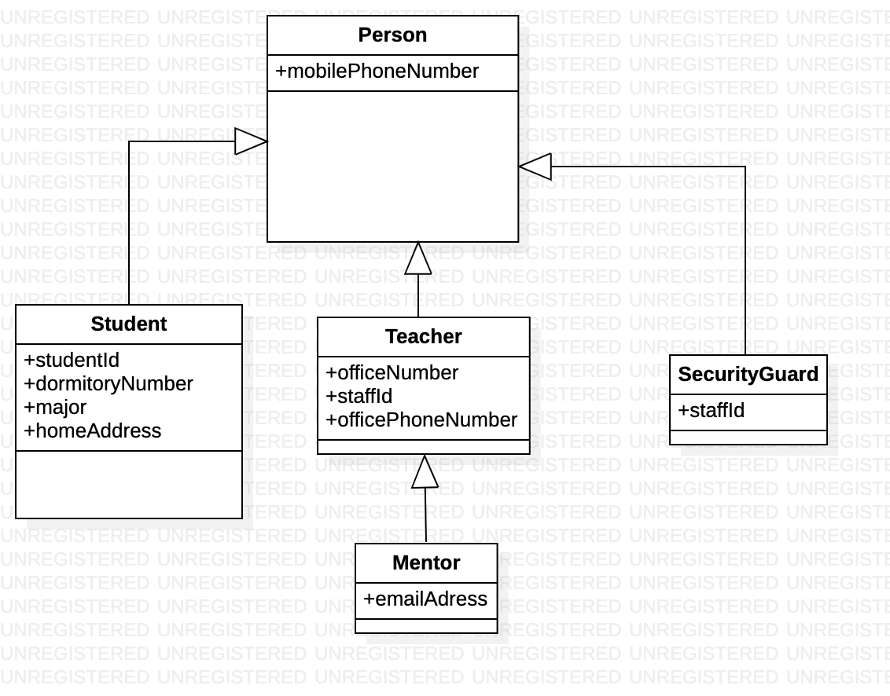

Exercise 2:

1. A college has two types of students: undergraduate students and graduate students.
2. A graduate student can be a TA.
3. The college also has two types of teachers: lecturers and professors.

One TA can help one lecturer or one professor. One lecturer can have at most 2 TAs, one professor can have 4 TAs. A college can have many students and many professors, but each student has only one college and each professor has only one college.

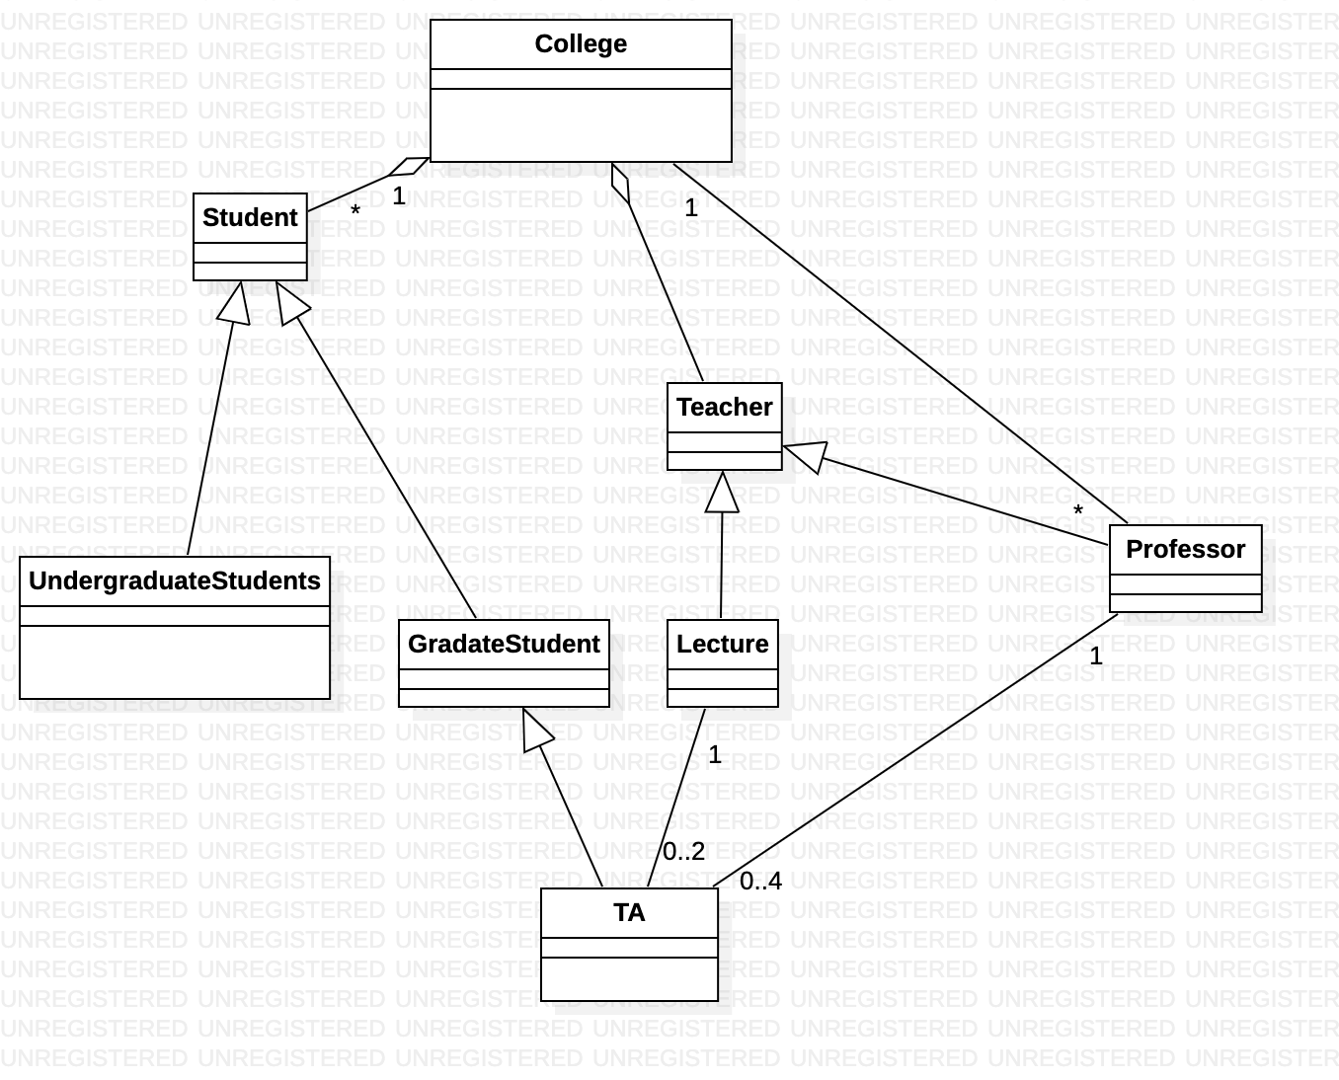

Exercise 3:

The UIC library has many books. The library has many users (represented as an interface) which are of two kinds: students or teachers. There are two types of students: undergraduate students and graduate students. Students have a student ID number and teachers have a staff ID number. Books have an ISBN number and a status indicating whether the book is in the library or has been borrowed. The library has the following rules:

1. All users can search for books
2. All users can borrow books.
3. All users can return books.
4. Undergraduate students can borrow at most 10 books.
5. Graduate students can borrow at most 20 books.
6. Teachers who worked in UIC for more than 5 years can borrow at most 30 books.

In addition, if you are an undergraduate student or a graduate student or a teacher then you know which books you have, but from a book it is not possible to find out which undergraduate student or graduate student or teacher has borrowed it.

