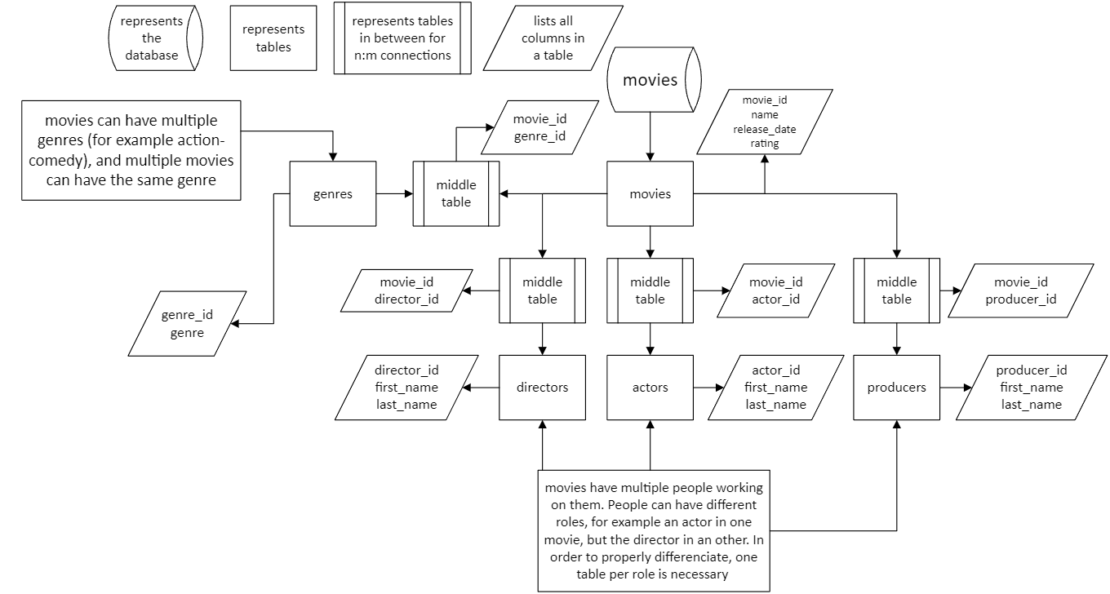Filmdatabase

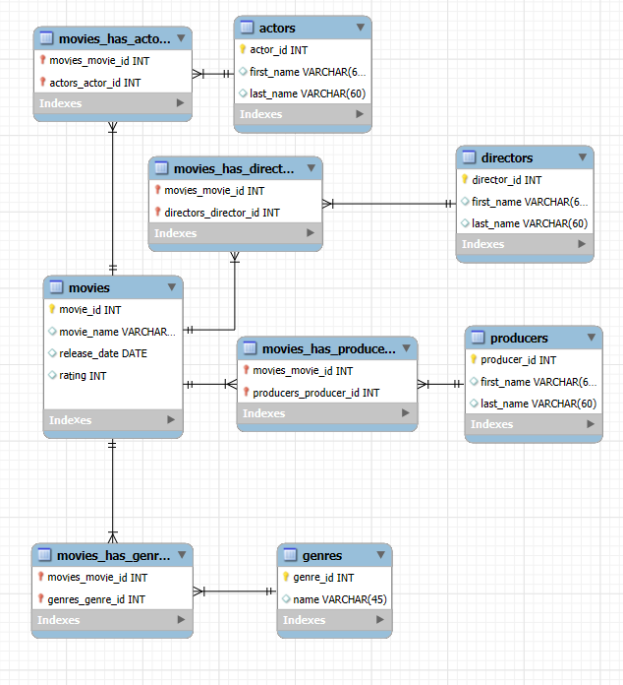

SQL Script

-- MySQL Workbench Forward Engineering

SET @OLD_UNIQUE_CHECKS=@@UNIQUE_CHECKS, UNIQUE_CHECKS=0;

SET @OLD_FOREIGN_KEY_CHECKS=@@FOREIGN_KEY_CHECKS, FOREIGN_KEY_CHECKS=0;

SET @OLD_SQL_MODE=@@SQL_MODE, SQL_MODE='ONLY_FULL_GROUP_BY,STRICT_TRANS_TABLES,NO_ZERO_IN_DATE,NO_ZERO_DATE,ERROR_FOR_DIVISION_BY_ZERO,NO_ENGINE_SUBSTITUTION';

-- -----------------------------------------------------

-- Schema movies

-- -----------------------------------------------------

-- -----------------------------------------------------

-- Schema movies

-- -----------------------------------------------------

CREATE SCHEMA IF NOT EXISTS `movies` DEFAULT CHARACTER SET utf8 ;

USE `movies` ;

-- -----------------------------------------------------

-- Table `movies`.`movies`

-- -----------------------------------------------------

CREATE TABLE IF NOT EXISTS `movies`.`movies` (

`movie_id` INT NOT NULL AUTO_INCREMENT,

`movie_name` VARCHAR(100) NULL,

`release_date` DATE NULL,

`rating` INT NULL,

PRIMARY KEY (`movie_id`))

ENGINE = InnoDB;

-- -----------------------------------------------------

-- Table `movies`.`genres`

-- -----------------------------------------------------

CREATE TABLE IF NOT EXISTS `movies`.`genres` (

`genre_id` INT NOT NULL AUTO_INCREMENT,

`name` VARCHAR(45) NULL,

PRIMARY KEY (`genre_id`))

ENGINE = InnoDB;

-- -----------------------------------------------------

-- Table `movies`.`movies_has_genres`

-- -----------------------------------------------------

CREATE TABLE IF NOT EXISTS `movies`.`movies_has_genres` (

`movies_movie_id` INT NOT NULL,

`genres_genre_id` INT NOT NULL,

PRIMARY KEY (`movies_movie_id`, `genres_genre_id`),

INDEX `fk_movies_has_genres_genres1_idx` (`genres_genre_id` ASC) VISIBLE,

INDEX `fk_movies_has_genres_movies1_idx` (`movies_movie_id` ASC) VISIBLE,

CONSTRAINT `fk_movies_has_genres_movies1`

FOREIGN KEY (`movies_movie_id`)

REFERENCES `movies`.`movies` (`movie_id`)

ON DELETE NO ACTION

ON UPDATE NO ACTION,

CONSTRAINT `fk_movies_has_genres_genres1`

FOREIGN KEY (`genres_genre_id`)

REFERENCES `movies`.`genres` (`genre_id`)

ON DELETE NO ACTION

ON UPDATE NO ACTION)

ENGINE = InnoDB;

-- -----------------------------------------------------

-- Table `movies`.`actors`

-- -----------------------------------------------------

CREATE TABLE IF NOT EXISTS `movies`.`actors` (

`actor_id` INT NOT NULL AUTO_INCREMENT,

`first_name` VARCHAR(60) NULL,

`last_name` VARCHAR(60) NULL,

PRIMARY KEY (`actor_id`))

ENGINE = InnoDB;

-- -----------------------------------------------------

-- Table `movies`.`movies_has_actors`

-- -----------------------------------------------------

CREATE TABLE IF NOT EXISTS `movies`.`movies_has_actors` (

`movies_movie_id` INT NOT NULL,

`actors_actor_id` INT NOT NULL,

PRIMARY KEY (`movies_movie_id`, `actors_actor_id`),

INDEX `fk_movies_has_actors_actors1_idx` (`actors_actor_id` ASC) VISIBLE,

INDEX `fk_movies_has_actors_movies1_idx` (`movies_movie_id` ASC) VISIBLE,

CONSTRAINT `fk_movies_has_actors_movies1`

FOREIGN KEY (`movies_movie_id`)

REFERENCES `movies`.`movies` (`movie_id`)

ON DELETE NO ACTION

ON UPDATE NO ACTION,

CONSTRAINT `fk_movies_has_actors_actors1`

FOREIGN KEY (`actors_actor_id`)

REFERENCES `movies`.`actors` (`actor_id`)

ON DELETE NO ACTION

ON UPDATE NO ACTION)

ENGINE = InnoDB;

-- -----------------------------------------------------

-- Table `movies`.`directors`

-- -----------------------------------------------------

CREATE TABLE IF NOT EXISTS `movies`.`directors` (

`director_id` INT NOT NULL AUTO_INCREMENT,

`first_name` VARCHAR(60) NULL,

`last_name` VARCHAR(60) NULL,

PRIMARY KEY (`director_id`))

ENGINE = InnoDB;

-- -----------------------------------------------------

-- Table `movies`.`movies_has_directors`

-- -----------------------------------------------------

CREATE TABLE IF NOT EXISTS `movies`.`movies_has_directors` (

`movies_movie_id` INT NOT NULL,

`directors_director_id` INT NOT NULL,

PRIMARY KEY (`movies_movie_id`, `directors_director_id`),

INDEX `fk_movies_has_regisseurs_regisseurs1_idx` (`directors_director_id` ASC) VISIBLE,

INDEX `fk_movies_has_regisseurs_movies1_idx` (`movies_movie_id` ASC) VISIBLE,

CONSTRAINT `fk_movies_has_regisseurs_movies1`

FOREIGN KEY (`movies_movie_id`)

REFERENCES `movies`.`movies` (`movie_id`)

ON DELETE NO ACTION

ON UPDATE NO ACTION,

CONSTRAINT `fk_movies_has_regisseurs_regisseurs1`

FOREIGN KEY (`directors_director_id`)

REFERENCES `movies`.`directors` (`director_id`)

ON DELETE NO ACTION

ON UPDATE NO ACTION)

ENGINE = InnoDB;

-- -----------------------------------------------------

-- Table `movies`.`producers`

-- -----------------------------------------------------

CREATE TABLE IF NOT EXISTS `movies`.`producers` (

`producer_id` INT NOT NULL AUTO_INCREMENT,

`first_name` VARCHAR(60) NULL,

`last_name` VARCHAR(60) NULL,

PRIMARY KEY (`producer_id`))

ENGINE = InnoDB;

-- -----------------------------------------------------

-- Table `movies`.`movies_has_producers`

-- -----------------------------------------------------

CREATE TABLE IF NOT EXISTS `movies`.`movies_has_producers` (

`movies_movie_id` INT NOT NULL,

`producers_producer_id` INT NOT NULL,

PRIMARY KEY (`movies_movie_id`, `producers_producer_id`),

INDEX `fk_movies_has_producers_producers1_idx` (`producers_producer_id` ASC) VISIBLE,

INDEX `fk_movies_has_producers_movies1_idx` (`movies_movie_id` ASC) VISIBLE,

CONSTRAINT `fk_movies_has_producers_movies1`

FOREIGN KEY (`movies_movie_id`)

REFERENCES `movies`.`movies` (`movie_id`)

ON DELETE NO ACTION

ON UPDATE NO ACTION,

CONSTRAINT `fk_movies_has_producers_producers1`

FOREIGN KEY (`producers_producer_id`)

REFERENCES `movies`.`producers` (`producer_id`)

ON DELETE NO ACTION

ON UPDATE NO ACTION)

ENGINE = InnoDB;

SET SQL_MODE=@OLD_SQL_MODE;

SET FOREIGN_KEY_CHECKS=@OLD_FOREIGN_KEY_CHECKS;

SET UNIQUE_CHECKS=@OLD_UNIQUE_CHECKS;

Added another table for storing soundtracks from the different movies, because why not.

Added two more columns to the *actors*, *directors* and *producers* tables. The *age* column was renamed to died_age to show when they died. Still_alive column removed

Adding data to tables

Here I’m adding data by writing it straight into the table. The program then auto-generates and executes the SQL query. In this situation, it’s a join table, so the code must be executed after adding data to *movies* and *genres* tables:

INSERT INTO `movies`.`movies_has_genres` (`movies_movie_id`, `genres_genre_id`) VALUES ('1', '1');

INSERT INTO `movies`.`movies_has_genres` (`movies_movie_id`, `genres_genre_id`) VALUES ('1', '2');

I normally add data with SQL queries like this:

Data in the databases

A view that combines every piece of data in the database using 11 joins. There is a massive amount of data here, so I won’t show it all. It is shown in the other screenshots in a more orderly fashion.

Everything in the “actors” table

Everything in the “directors” table. One director directs multiple movies.

All the possible genres I have included.

Everything in “movie” table. I found very little information about the 6th movie.

The movies_has_actors middle table. Movies usually have multiple actors, and actors can be in many movies (n:m connection)

The movies_has_directors middle table. (n:m)

The movies_has_genres middle table. (you know the drill)

The movies_has_producers middle table.

The soundtrack_people table. There should be a middle table with the IDs, but I made the table after the EER diagram and forgot about it.

The “producers” table

“Roles” table

“Soundtracks” table

Views for readability

The “genre” view contains movies with their genres

Actor view with actors

Directors

Producers

And finally; soundtracks.

The final EER diagram with all tables*

*The soundtrack people has roles table is a part of the soundtrack people table in the database, even though it shouldn’t be