Scherr, Nathan

COMP 235

Final Project

# Section 1

What is MVC?

MVC stands for model-view-controller. It is a pattern for developing applications that are well architected, testable and easy to maintain. The objectives of the MVC design pattern are:

1. To use Models that represent the data of the application and that use the validation logic to enforce business rules for that data.
2. To use Views of template files that your application uses to dynamically generate HTML responses.
3. Controllers of classes that handle incoming browser requests, retrieve model data, and then specify view templates that return a response to the browser.

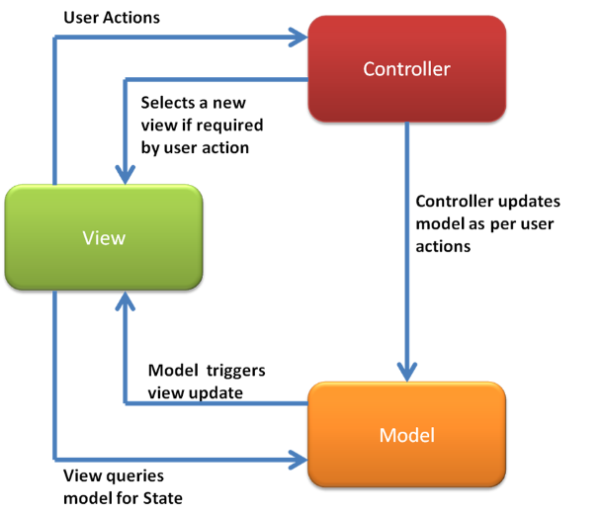

What is meant by a code first approach to MVC? What is Razor?

Using a code first approach means that you can create the design and classes for a domain first instead of needing to have a database design in place already. Razor is a view engine. The view engine creates view based templates for an elegant way to create HTML output using C#.

How to use a code-first approach to create an MVC application that would populate a dropdown list box with a list of movie categories.

* In the ActionResult Index add a parameter for genre.
* Then add code to for an object to hold a distinct list of genre from the movies db.
* The object is then stored in a ViewBag as a SelectList object.

# Section 2

How the mapping application works:

* Using HTML web page the client enters a Latitude, Longitude, and their direction of facing into the panel.
* On the client side when the add button is clicked the web page takes the information and creates an instance of a WeatherReport.
* Next an instance of WeatherUtilities is created calling the addWeatherReport method and passing it the WeatherReport.
* A connection is established with the server and the information is saved into the reports table.
* When the page reloads ASP.Net makes a call to run a select query server side returning the results into a list of all coordinate points
* The ASP.Net repeater then goes through each item in the list creating an invisible table.
* JQuery reads through this table and using the Google Maps api plots each Latitude and Longitude location on the map.

What is .Net AJAX? How and why would you implement AJAX into this mapping solution?

Ajax is a set of web development techniques, web applications can send data to and retrieve from a server asynchronously without interfering with the display and behavior of the existing page. This decouples the interchange layer from the presentation layer. By doing so Ajax allows web pages and web applications to change content dynamically without the need to reload pages.

In order to implement this into the mapping solution I would start by adding a ScriptManager to the page. Next would be to include the ASP Repeater in an update panel. Once in the panel when any data is sent through the Add link button the update panel is the only item that is updated instead of the whole page. Lastly will be to move the javascript from the header and put it into the bottom of the body on the page.

# Section 3

What is Windows WCF?

WCF is Windows Communication Foundation, it is a tool used for service oriented architecture. Instead of having classes and methods in the production website they are store in the WCF. The website can then make a call the WCF and the WCF calls the server. The server relays the information back to the WCF and then the WCF send to the client. In this way you can have multiple clients on the same website all making calls through the WCF that can handle them each separately.

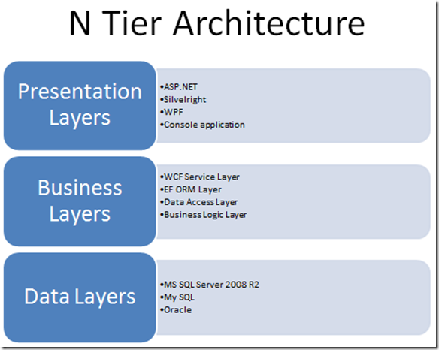

What are the roles of Operation Contracts, and Data Contracts?

The role of a Data Contract is to create an object class that can then be constructed and use methods to return information to the presentation layer. The role of the Operation Contracts are to set out what methods that will need to be created in the .svc file. These are the methods that make the calls to the data layers and then will return the requested information to the presentation layer.

How does an ASP application consume a WCF service (provide a set of steps)?

1. Client makes a request on the presentation layer.
2. The presentation layer then sends request to the WCF.
3. The WCF performs the requested method.
4. The method connects to the data layer and pulls the requested information then closes the connection.
5. The WCF then returns the requested information to the presentation layer where it is displayed.

What does WCF mean for the presentation layer of the application?

It means that the connection to the data layer is now hidden and not accessible from the presentation layer. This provides an additional level of security and structure.