1. Introduction (Task 1)
- Finite State Machines (FSM) are useful for testing because... (寫那段理論)。
2. Feature Selection (Task 2)
- I chose the Shopping Cart component.
- This feature is suitable for FSM because the cart transitions through distinct states (Empty, Active, Obsolete) based on user actions.
For this project, I have selected the Shopping Cart component of the Shopizer system. This feature lends itself well to being described by a Finite State Machine (FSM) because the shopping cart has a distinct lifecycle that transitions through specific states based on user interactions.
Specifically, the cart is not just a static data container; it transitions between EMPTY, ACTIVE, and OBSOLETE states. The model is considered non-trivial because the validity of user actions depends on the current state. For example:
- A user cannot update the quantity of an item in an EMPTY cart.
- Removing the last item from an ACTIVE cart must trigger a transition back to the EMPTY state.
- Deleting the cart moves it to an OBSOLETE state where no further actions are permitted.
Using an FSM allows us to strictly define these logical boundaries and ensure the system handles edge cases correctly.
3. Functional Model (Task 3)
- State Diagram:
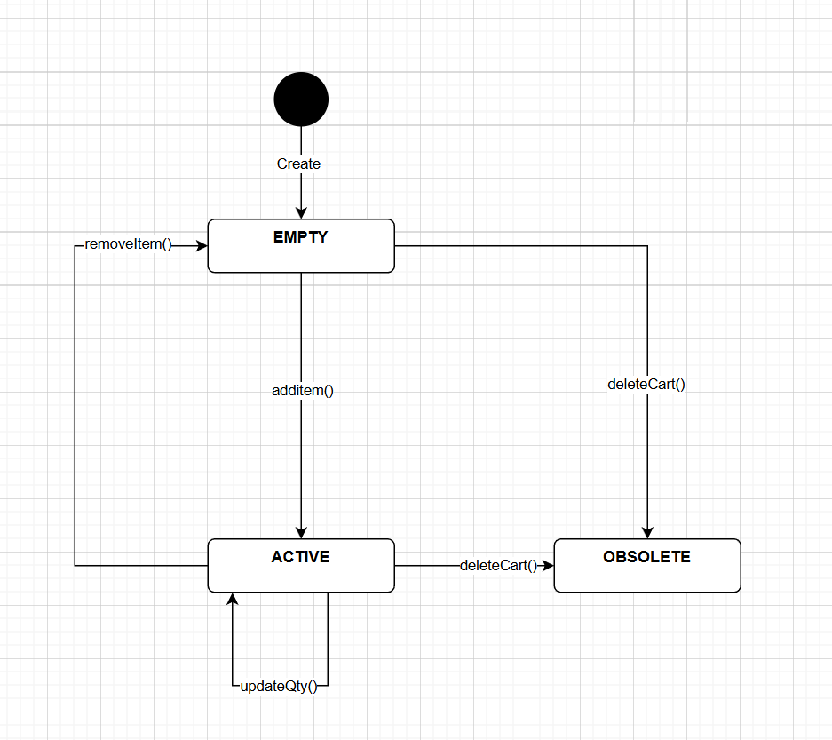
- Transitions:
  - Add Item: Triggers a transition from EMPTY to ACTIVE.
  - Update Quantity: Maintains the ACTIVE state (Self-loop).
  - Remove Item: Triggers a transition to EMPTY only when the last item is removed.
  - Delete Cart: A global action that moves the cart to OBSOLETE from any state
4. Test Implementation (Task 4)
- I implemented the test using JUnit in MyCartStateTest.java.
- Test Strategy: To ensure 100% transition coverage of the Finite State Machine model, I designed two distinct test scenarios in MyCartStateTest.java. This approach ensures that every possible state transition arrow defined in the model is executed and verified.
  - Scenario: Standard Lifecycle (testShoppingCartFSM):
    - Purpose: Verifies the standard workflow of a shopping cart, including creating, adding items, updating quantities, emptying, and finally disposing of the cart.
    - Transition Path: EMPTY ACTIVE (addItem) ACTIVE (updateQty) EMPTY (removeItem) OBSOLETE (deleteCart).
  - Scenario: Force Deletion:
    - Purpose: Verifies the specific edge case where an ACTIVE cart (containing items) is directly deleted without being emptied first.
    - Transition Path: ACTIVEOBSOLETE (deleteCart).
- Test Code: (貼上程式碼)
- Execution Result: 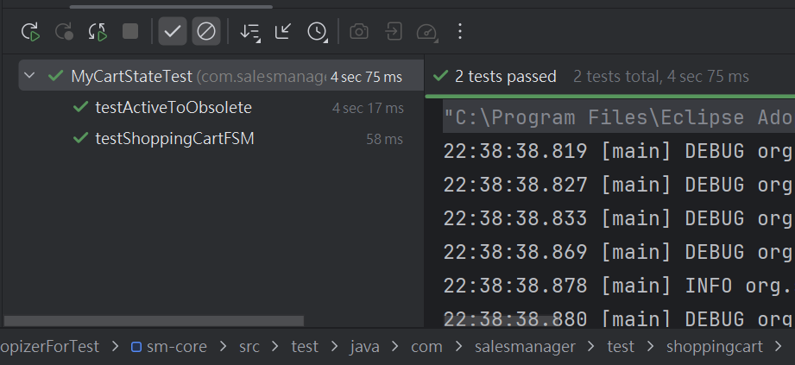
- Note: The code has been pushed to my Github fork.

