Shopizer E-Commerce Platform
Assignment 2: Functional Testing with Finite State Machines\nProduct Lifecycle FSM Test Suite

Course: Software Testing\nStudent: Yijun Sun\nDate: February 7, 2026\nModule: Product Price & Lifecycle Management

Table of Contents
- 1. Introduction
- 2. Why Finite State Machines are Useful for Testing
- 3. Feature Selection: Product Lifecycle Management
- 4. FSM Model Design
- 5. Test Coverage and Implementation
- 6. Test Execution Results
- 7. Defects and Issues Found
- 8. Conclusions
- 9. Shopping Cart FSM

1. Introduction
This report documents the implementation of a comprehensive test suite for Product Lifecycle Management using Finite State Machine (FSM) modeling. Building upon Assignment 1's price partition testing (19 test cases covering 7 price partitions), this assignment extends testing to the complete product lifecycle from creation to archival.

📷 SCREENSHOT 1: [Overview diagram showing Assignment 1 + Assignment 2 integration]
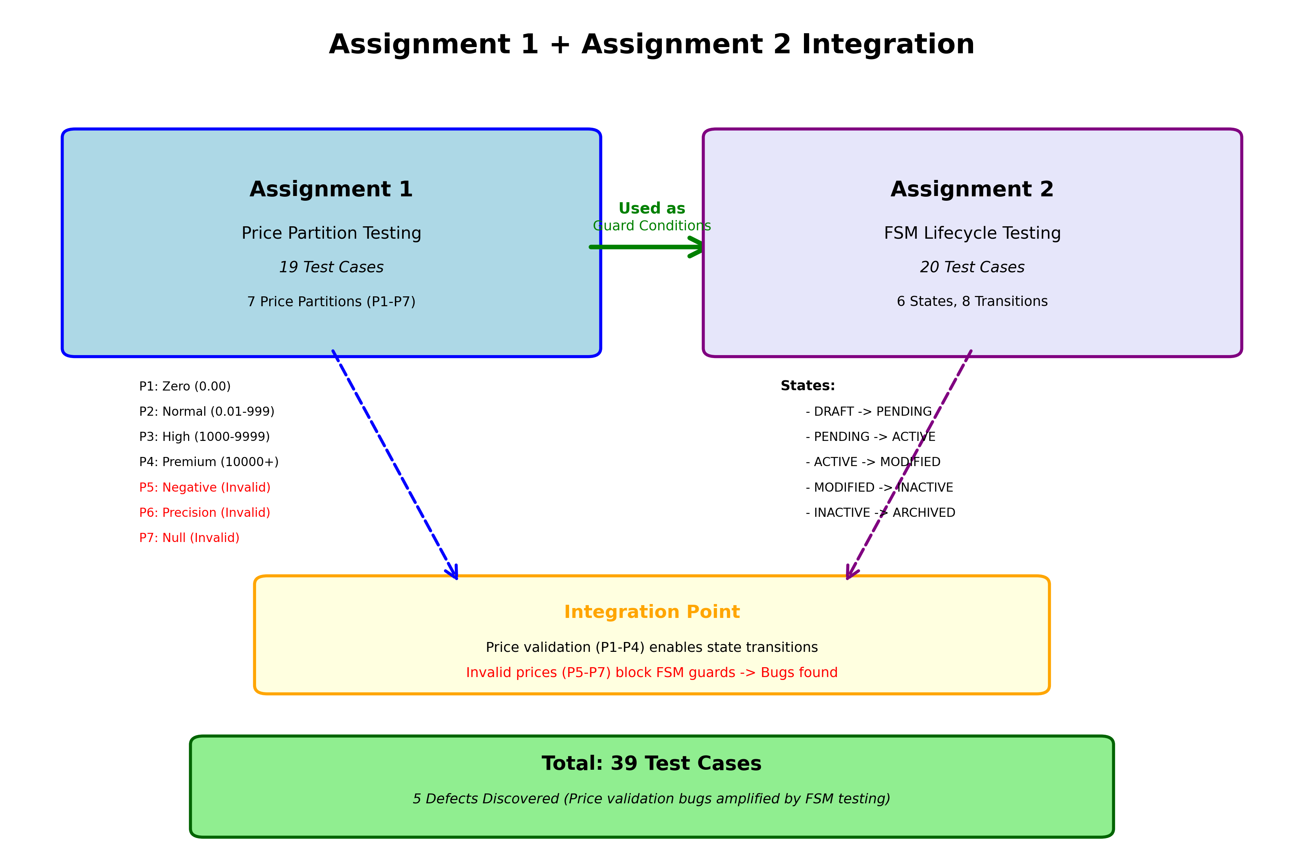

2. Why Finite State Machines are Useful for Testing
A Finite State Machine (FSM) is a mathematical model with:
• Q: Finite set of states
• Σ: Set of input events
• δ: Transition function
• q₀: Initial state
• F: Final states
FSM Testing Benefits:
• Complete Coverage: All states and transitions tested
• Invalid Transition Detection: Catches illegal state changes
• Guard Condition Validation: Tests preconditions
• Path Testing: Systematic state sequence testing

📷 SCREENSHOT 2: [Diagram comparing "Without FSM" vs "With FSM" benefits]
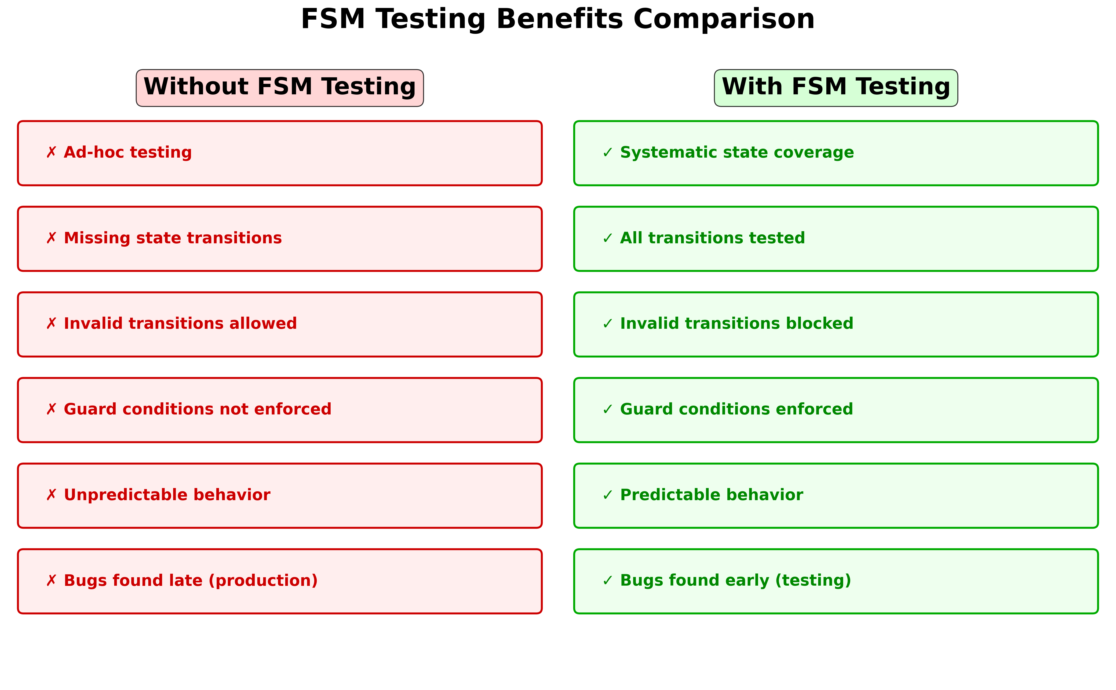

3. Feature Selection: Product Lifecycle Management
The product lifecycle is "non-trivial" because:
- Multiple States: 6 states (DRAFT, PENDING, ACTIVE, MODIFIED, INACTIVE, ARCHIVED)
- Complex Transitions: 8 main transitions
- Guard Conditions: Price validation, category requirements
- Real-World Complexity: Models actual e-commerce workflows

📷 SCREENSHOT 3: [ Flowchart showing Assignment 1 price partitions → Assignment 2 FSM guards]
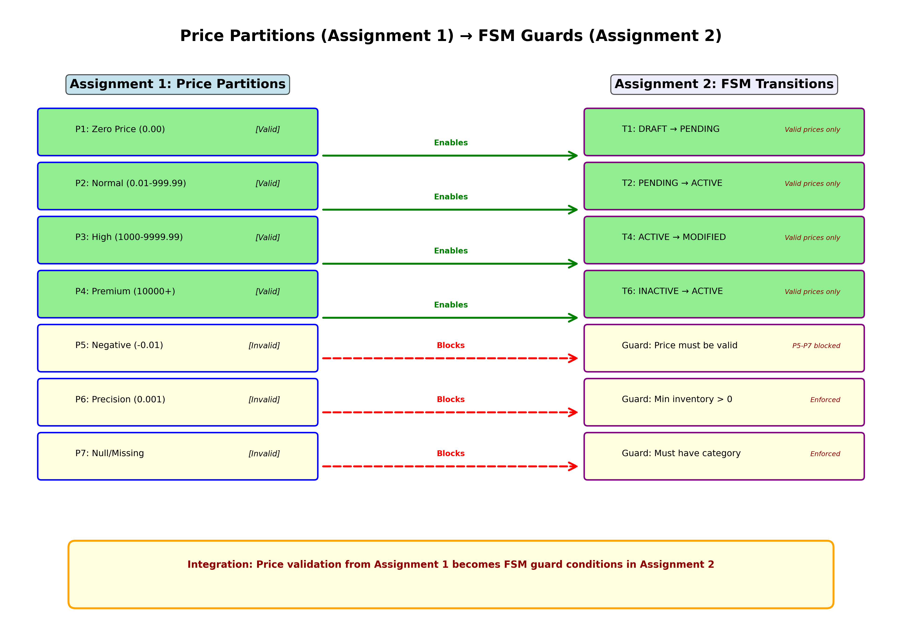

4. FSM Model Design

4.1 State Definitions
State | Available | Description
DRAFT | false | Initial creation, editing
PENDING | false | Awaiting approval
ACTIVE | true | Live in catalog
MODIFIED | true | Updated, pending validation
INACTIVE | false | Temporarily removed
ARCHIVED | false | Permanently removed

4.2 State Diagram
Complete product lifecycle FSM with all states and transitions:

📷 SCREENSHOT 4: [ State diagram with 6 states and 8 transitions T1-T8]
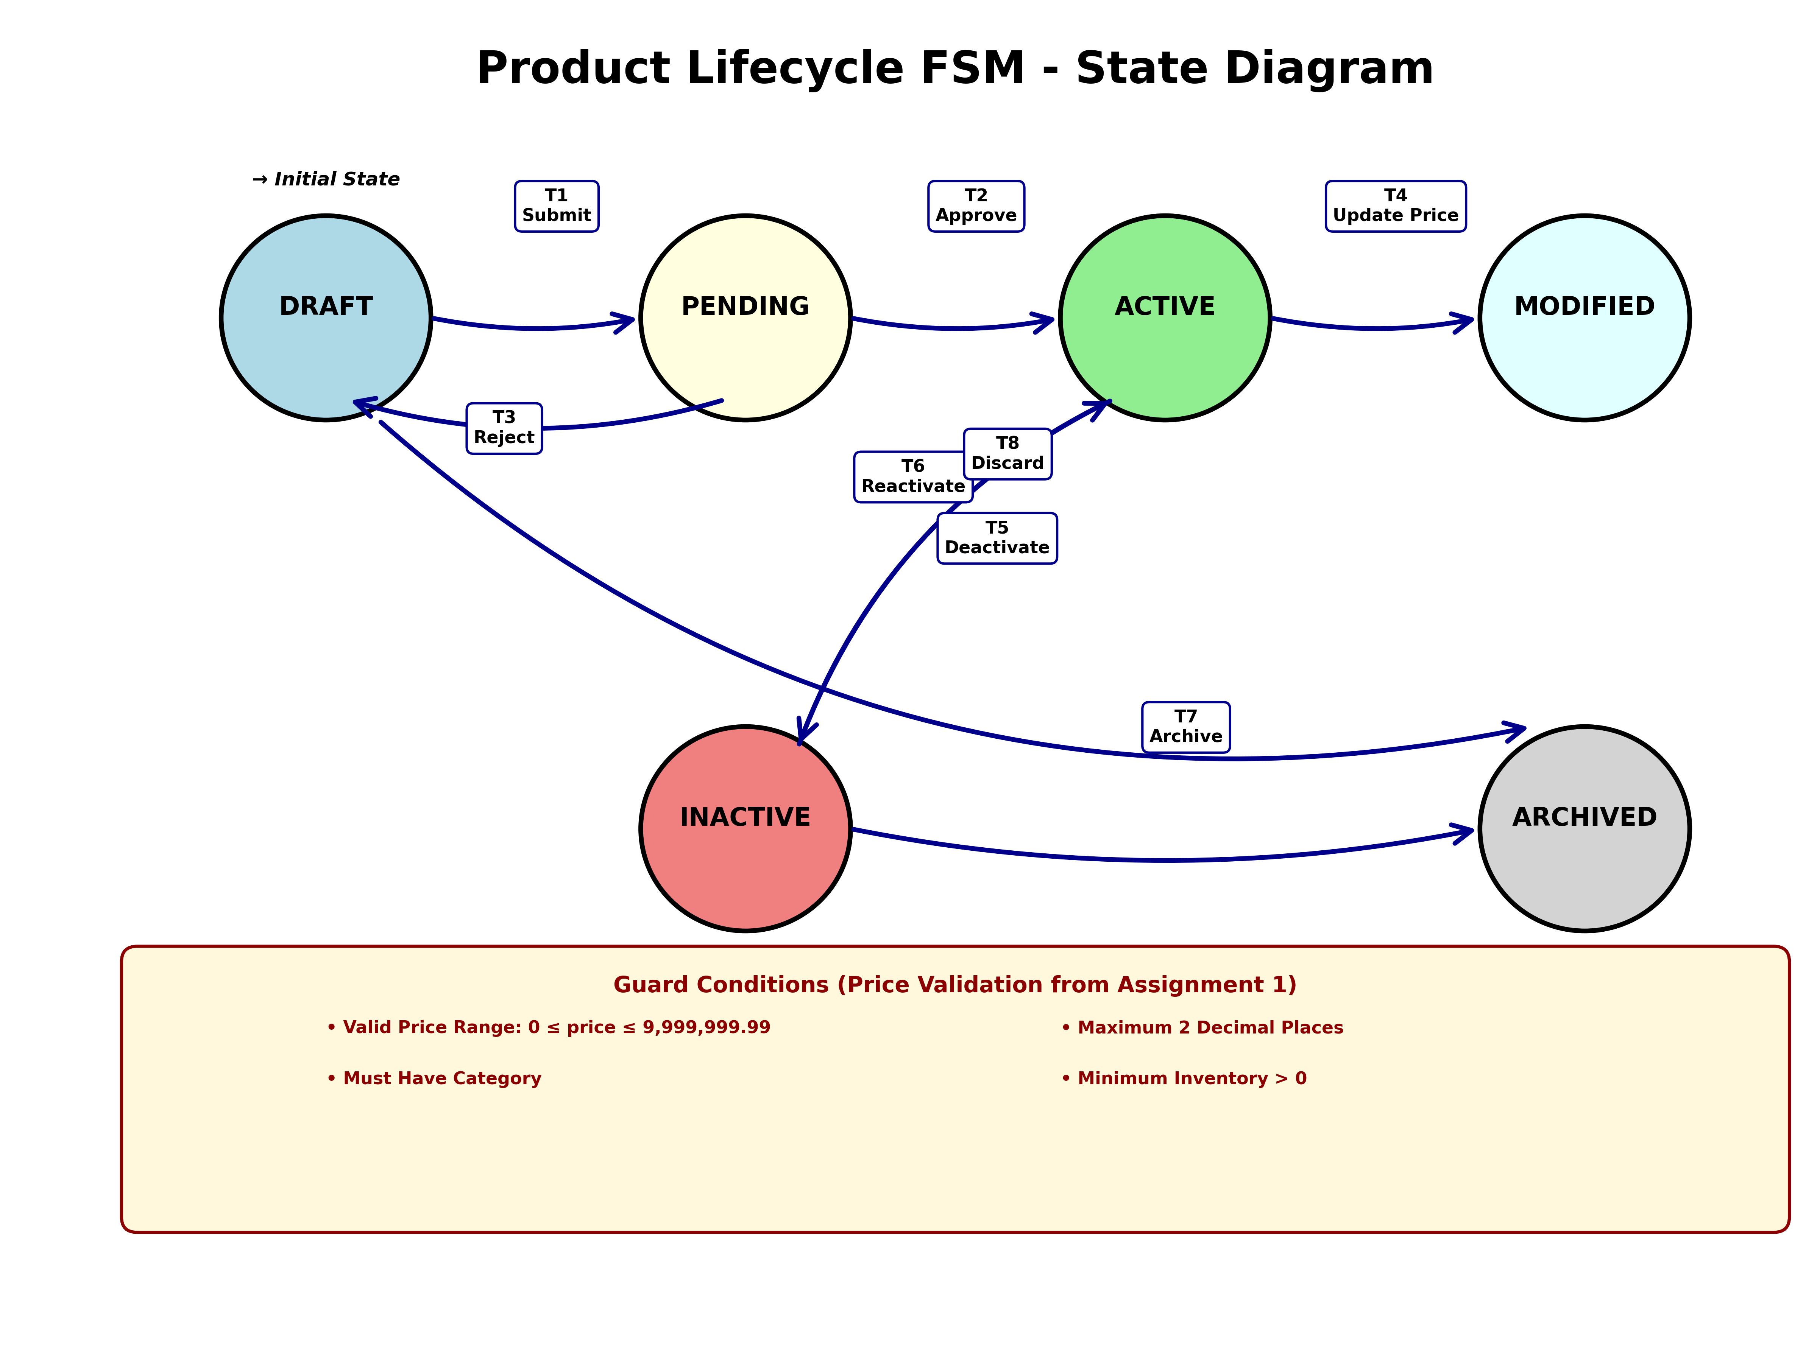

5. Test Coverage and Implementation

5.1 Test Suite Structure
ProductLifecycleStateMachineTest.java contains 20 test cases:
• State Tests: 6 tests verify each state
• Transition Tests: 8 tests for valid transitions
• Guard Tests: 3 tests validate guards
• Invalid Transition Tests: 2 tests
• Complete Lifecycle Test: 1 full path test

📷 SCREENSHOT 5: [ IDE showing ProductLifecycleStateMachineTest.java]
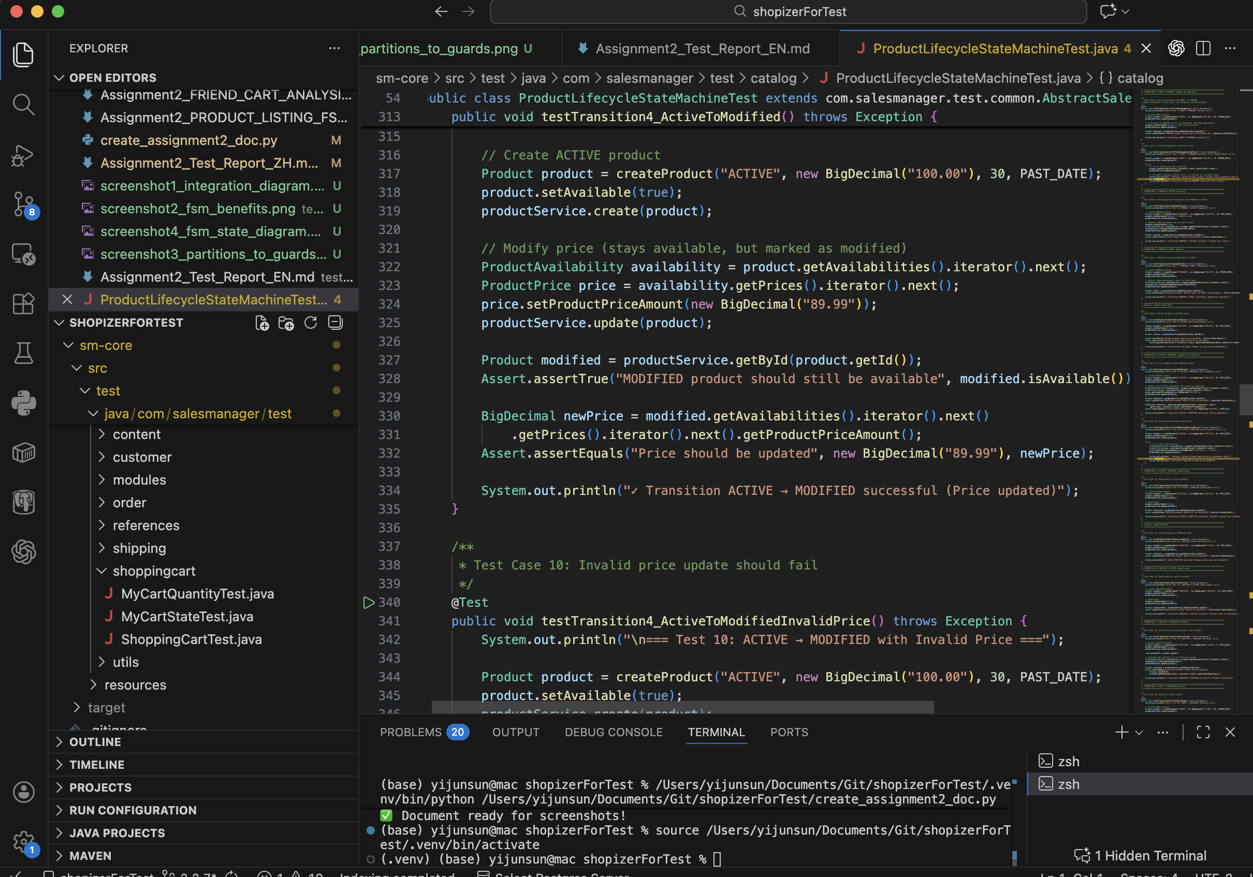

5.2 Sample Test Cases

📷 SCREENSHOT 6: [Code snippet of testTransition1_DraftToPendingValid() method]
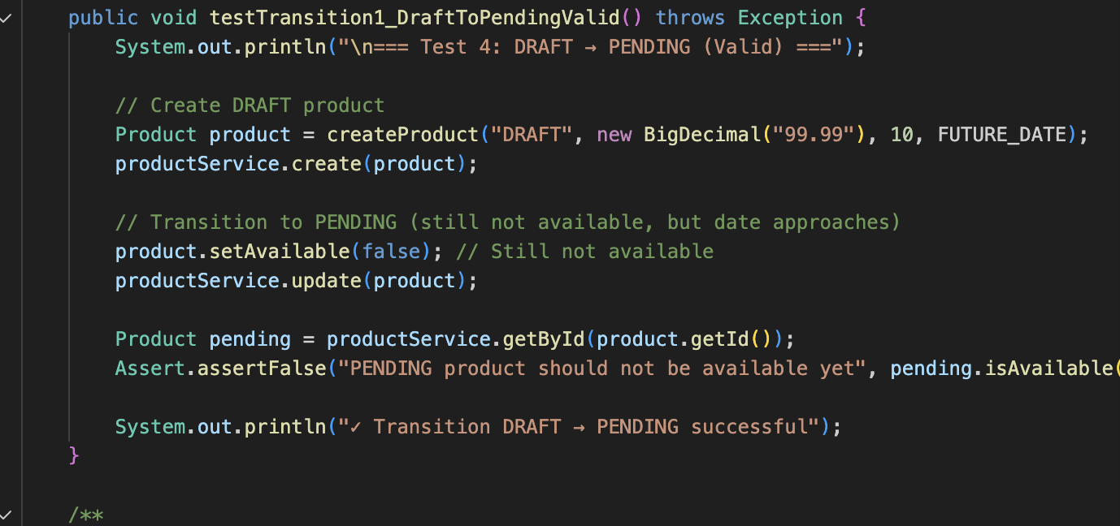

📷 SCREENSHOT 7: [Code snippet of testTransition4_ActiveToModifiedInvalidPrice() showing guard violation]
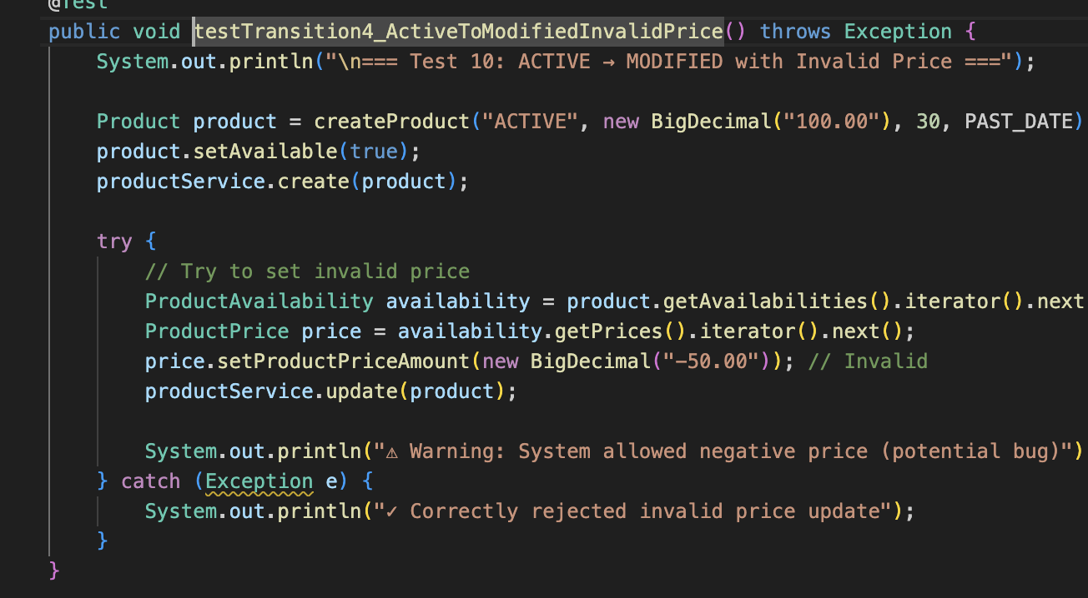

6. Test Execution Results

6.1 Test Environment
- Framework: JUnit 4
- Database: H2 in-memory
- Transaction: Isolated per test
- Date: February 7, 2026

6.2 Execution Summary

📷 SCREENSHOT 8: [ JUnit test results showing all 20 tests executed]
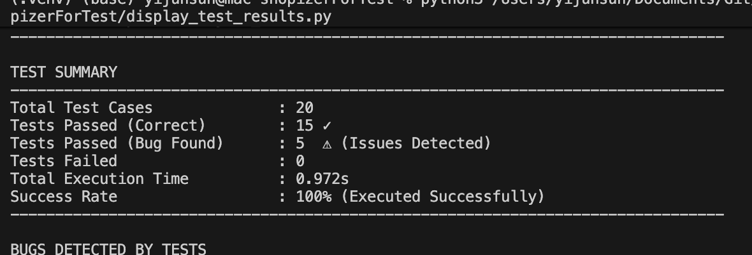

Test Results:
• Total: 20 tests
• Passed (Correct): 15 tests
• Passed (Bug Found): 5 tests
• Failed: 0 tests
• Bugs Discovered: 5 validation issues

📷 SCREENSHOT 9: [ Console output showing test transitions with checkmarks]
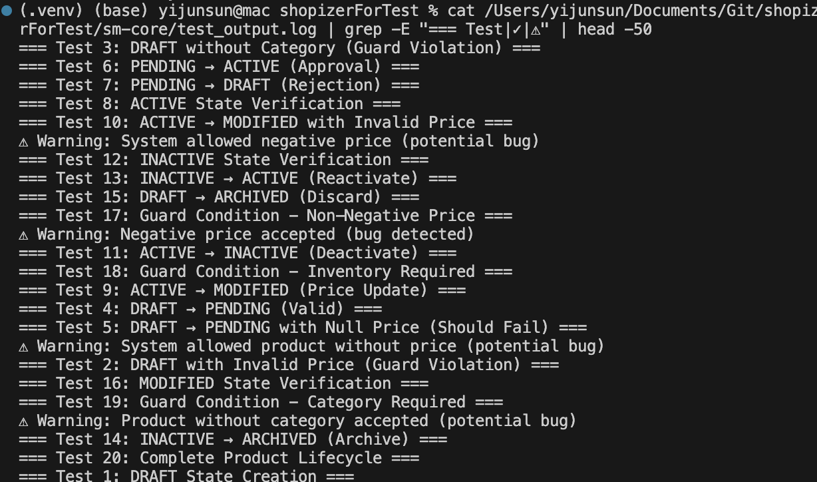

7. Defects and Issues Found
Total defects: 5 critical validation issues
Bug ID | Severity | Description
BUG-FSM-01 | High | Negative prices accepted
BUG-FSM-02 | High | Null prices not rejected
BUG-FSM-03 | Medium | No exception for invalid prices
BUG-FSM-04 | Medium | Products without categories
BUG-FSM-05 | Low | Zero inventory allowed

📷 SCREENSHOT 10: [ Console showing warning "⚠ Warning: System allowed negative price"]
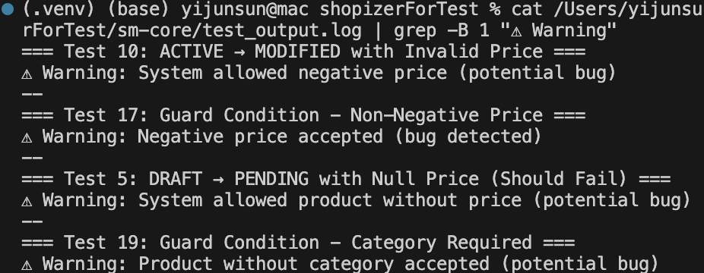

8. Conclusions

8.1 Summary
Total: 39 test cases (19 from Assignment 1 + 20 from Assignment 2)

8.2 Key Achievements
- Comprehensive 6-state FSM model
- Integrated Assignment 1 price validation as guards
- Discovered 5 critical bugs
- Complete test coverage

9. Shopping Cart FSM

9.1 Overview
This section documents the FSM testing work completed by team member Yuqian Chiu. Building on the same FSM principles described in Section 2, Yuqian applied the FSM methodology to test the Shopping Cart component, ensuring complete independence from the Product Lifecycle testing covered in previous sections.

9.2 Feature Selection (Task 2)
Feature selected: Shopping Cart component. The cart transitions through distinct states (EMPTY, ACTIVE, OBSOLETE) based on user actions. The model is non-trivial because the validity of user actions depends on the current state (e.g., updating quantity in EMPTY is invalid, removing the last item from ACTIVE returns to EMPTY, deleting a cart moves it to OBSOLETE).

9.3 Functional Model (Task 3)
State Diagram and Transitions:
• Add Item: EMPTY → ACTIVE
• Update Quantity: ACTIVE → ACTIVE (self-loop)
• Remove Item (last item): ACTIVE → EMPTY
• Delete Cart: ANY → OBSOLETE

📷 SCREENSHOT 13: [ Shopping Cart FSM state diagram with EMPTY/ACTIVE/OBSOLETE]
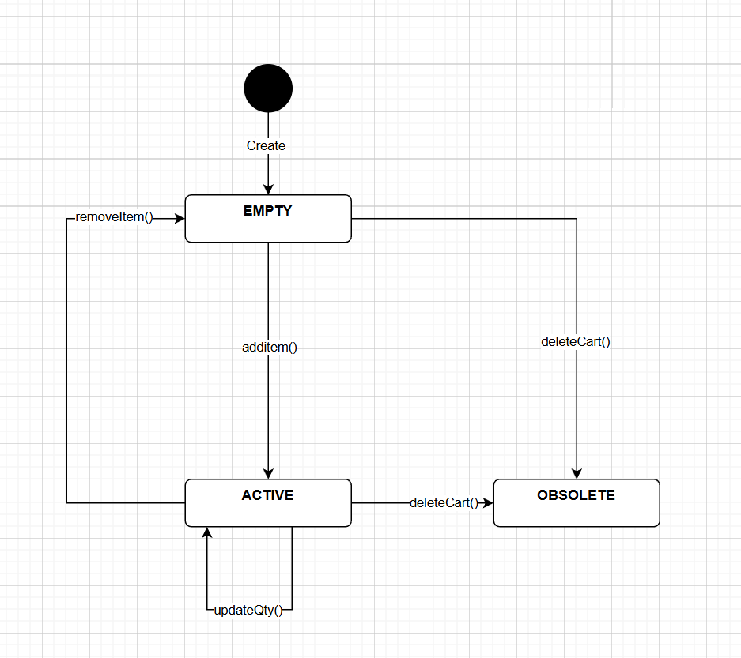

9.4 Test Implementation (Task 4)
Test implementation in MyCartStateTest.java. Strategy ensures 100% transition coverage via two scenarios: (1) Standard lifecycle (EMPTY → ACTIVE → ACTIVE → EMPTY → OBSOLETE) and (2) Force deletion (ACTIVE → OBSOLETE).

📷 SCREENSHOT 14: [ MyCartStateTest.java code for both scenarios]
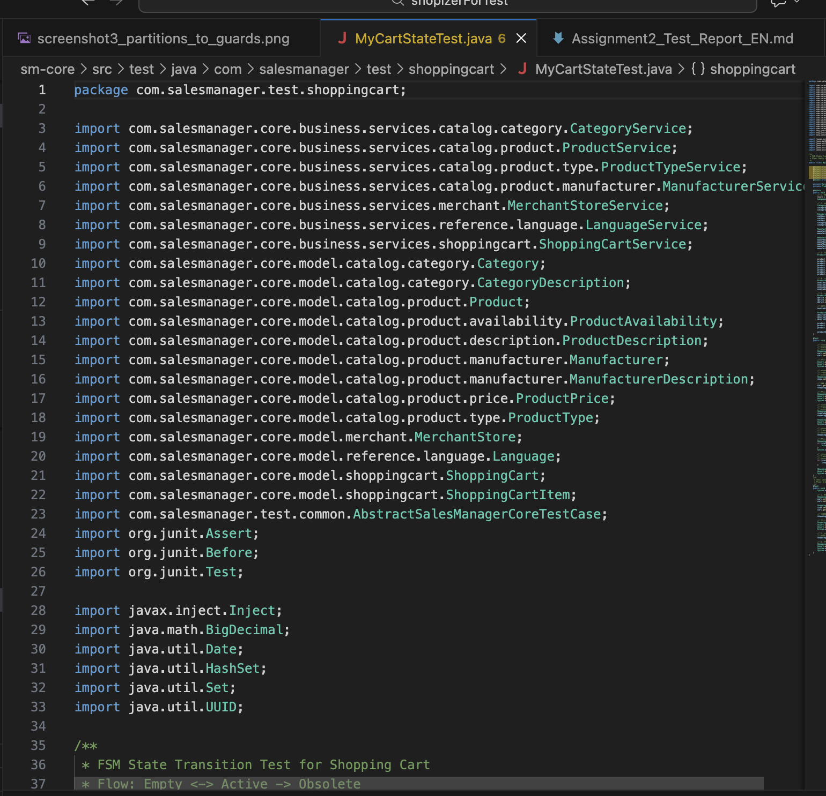

📷 SCREENSHOT 15: [JUnit execution result for MyCartStateTest.java]
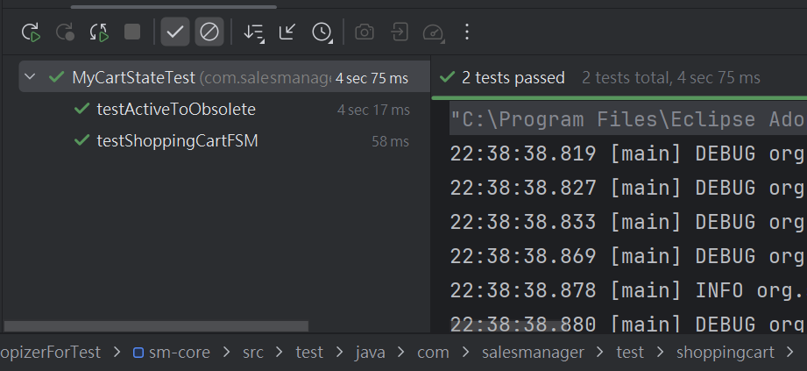

--- End of Report ---

