
Project Report :
GODOT-LOCAL-AI: Autonomous Multi-Turn Game Engineering & Local LLM Fine-Tuning Ecosystem for Godot 4

Mukul
Roll No. 28240613 | B.Tech. CSE (AI & ML)
Panipat Institute of Engineering & Technology (PIET)

Prof. (Dr.) Devendra Prasad
Head of Department (HOD)
Department of CSE (AI & ML)

Dr. Richa Chaudhary
Lab Incharge / Project Supervisor Department of CSE (AI & ML)

1. Introduction
Modern interactive entertainment and real-time simulations rely fundamentally on specialized game engines that orchestrate multi-threaded physics loops, scene tree graph hierarchies, declarative resource serialization, and reactive event buses. While commercial foundational Large Language Models (LLMs) demonstrate impressive proficiency in general-purpose web development and mathematical reasoning, they fail catastrophically when introduced into modern game engineering workflows—most notably within Godot Engine 4.x. Generic models operate as blind, flat plaintext generators, inherently incapable of perceiving the multi-tiered dependency graph uniting declarative scene hierarchies (.tscn), typed GDScript 2.0 logic, node attachment topologies, and engine-level signal bindings.
The syntactic and architectural leap from Godot 3 to Godot 4 introduced sweeping structural divergence: deprecation of positional arguments in physics routines like move_and_slide(), replacement of loose string method connections with type-safe Callables, static typing, and dedicated @export and @onready engine annotations. Because public web datasets are heavily contaminated with legacy pre-2023 code, commercial LLMs repeatedly hallucinate obsolete constructs that immediately crash the Godot 4 compiler. Furthermore, transmitting proprietary gameplay mechanics, game design documents, and bespoke shader logic to third-party cloud APIs poses unacceptable intellectual property leakage hazards and prohibitive recurring subscription costs for independent creators and sovereign studios.
Core Engineering Focus: Overcoming Generic LLM Hallucinations and Scene-Blind Deficits in Modern Game Engines
Traditional AI coding tools treat game code as isolated plain text. In Godot 4, a game entity is not merely a script; it is a composite hierarchy of .tscn node graphs (CharacterBody2D, CollisionShape2D, Area2D, AnimationPlayer), signal buses, and resource dependencies.
This project develops an end-to-end Autonomous Spatial & Logic Engine: fine-tuned Qwen2.5-Coder weights emit structured JSON actions, AST parsers synthesize valid .tscn scene trees, and an isolated headless Godot 4 engine sandbox validates compiler diagnostics in real time with automated bounded self-correction before any change touches the user's project files.

2. Challenges in Existing System
2.1 Syntactic Divergence and Godot 3 vs 4 Version Blind Spot — Godot 4 introduced fundamental syntactic and API overhauls that break backwards compatibility. Generic LLMs trained on heterogeneous web crawls constantly hallucinate legacy Godot 3 patterns—such as passing velocity vectors into move_and_slide(velocity), invoking deprecated File.new() instead of static FileAccess.open(), or utilizing setget keywords. These obsolete patterns trigger immediate parse failures and prevent scripts from compiling.
2.2 Scene Graph (.tscn) and Hierarchical Dependency Deficit — Video game behavior is governed by parent-child node relationships inside scene files (.tscn). A GDScript referencing $CollisionShape2D or get_node("WeaponSlot") throws catastrophic null pointer exceptions at runtime if the corresponding declarative scene tree lacks those nodes. Text-only generative models possess zero awareness of node tree topology, forcing developers to manually construct and align scene components.
2.3 Hallucinated Imports, Blank Script Overwrites, and Project Corruption — When third-party coding assistants generate partial snippets or encounter model repetition loops, they frequently emit incomplete files or blank content. In Godot 4, running headless validation on an empty file silently exits with code 0. Naive automation tools mistake this for a successful build and overwrite production game code with empty files, causing irrecoverable codebase corruption.
2.4 Unbounded Execution Loops and Silent False Passes — Standard generative pipelines lack execution verification. When prompted with complex, multi-file requests, models often emit conversational filler ("Here is your script...") or degenerate token repetition loops without modifying real files. Unvalidated agent harnesses report false passes, leaving critical game mechanics unimplemented.
2.5 Cloud API Vendor Lock-In, High Latency, and Studio IP Leakage — Deploying cloud-hosted AI copilots exposes proprietary studio intellectual property to third-party data collection and copyright ambiguity. Moreover, network latency of 3–8 seconds per cloud inference turn destroys the fluid, interactive cadence required during live game design and mechanics prototyping.
3. Proposed System
Rather than relying on generic cloud LLM APIs or disconnected chat assistants, GODOT-LOCAL-AI orchestrates an automated, web-native, in-engine autonomous engineering pipeline governed by deterministic headless compiler validation gates:
OPERATOR CONSOLE, DESKTOP IDE WORKBENCH & IN-ENGINE GODOT BRIDGE
Natural Language User Prompt | Project File Explorer | Live Streaming SSE Diffs | Headless Diagnostics
▼
STAGE 1: MULTI-MODAL AST SCENE ANALYSIS & DEPENDENCY REFLECTION
Static Project Reflection | .tscn Node Tree Extraction | GDScript AST Parsing | InputMap Action Parsing
▼
STAGE 2: FINE-TUNED QWEN2.5-CODER 4-BIT NEURAL ACTION INFERENCE
Structured JSON Action Schema | Target File Resolution | Fast-Path Heuristic & DAG Decomposition
▼
STAGE 3: ISOLATED SHADOW STAGING & BOUNDED REPAIR CAGE
Disposable Project Sandbox | Headless Godot 4 Compiler Check | Diagnostic Self-Healing | Atomic Commits
Figure 1: End-to-End Autonomous Game Engineering Pipeline, Neural Action Synthesis, and Headless Validation Interlock Flowchart.
The Autonomous Game Engineering Guarantee: No AI-synthesized script or scene hierarchy can be committed to the user's project without passing through automated headless Godot 4 engine validation. The validation cage enforces three non-bypassable safety invariants: (1) Zero Compilation Errors — the staged file must compile cleanly under godot4 --headless --check-only; (2) Non-Destructive Integrity — non-empty content verification and surgical AST merging prevent code erasure; and (3) Reversible Snapshot Ledger — every accepted change is backed up to .godot_agent/backups/ with instant one-click rollback.
PHASE 1: MULTI-MODAL INGESTION AND PROJECT GRAPH REFLECTION
Validates project directory structure, parses project.godot metadata, extracts node hierarchy from .tscn files, and catalogs input map actions without hallucinating external dependencies.
▼
PHASE 2: DIRECTED ACYCLIC GRAPH (DAG) PLANNING & TOPOLOGICAL SORT
Evaluates task complexity, identifies safe improvement opportunities, and constructs a dependency-ordered execution graph: Scene composition -> Script implementation -> UI integration.
▼
PHASE 3: SHADOW STAGING & HEADLESS GODOT 4 ENGINE VALIDATION
Clones full project environment into an isolated /tmp sandbox, executes godot4 --headless --check-only against staged scripts, and intercepts compiler diagnostics with zero project corruption risk.
▼
PHASE 4: BOUNDED SELF-HEALING, ATOMIC COMMITS & DESKTOP IDE INTERACTION
Dispatches compiler parse errors to the model for bounded targeted repair (max 2 attempts), commits verified changes, logs SHA-256 backup snapshots, and streams live diffs to the Electron IDE.
Figure 2: Four-Phase Continuous Closed-Loop Autonomous Game Construction Methodology Flowchart.
A. System Architecture
The GODOT-LOCAL-AI architecture is partitioned into five decoupled, fail-safe layers. Each layer maintains strict process isolation, ensuring that third-party library hiccups, model sampling degradation, or high-level desktop rendering loads never compromise the underlying game project integrity:
LAYER 5 ── DESKTOP IDE & NATIVE IN-ENGINE GODOT BRIDGE
Electron 28+ Desktop IDE | React 18 + Vite | Native Godot 4 EditorPlugin Addon | Streaming SSE Diffs
▲
LAYER 4 ── ASYNCHRONOUS REST & SSE ORCHESTRATION SERVER
FastAPI / Uvicorn Service | Event-Driven SSE Streaming | Multi-Project Routing | Port 8000 / 8001
▲
LAYER 3 ── SHADOW STAGING & HEADLESS GODOT VALIDATION CAGE
Isolated Sandbox Staging (/tmp) | Headless Compiler Diagnostic Interlock | Atomic Snapshots & Diff Ledger
▲
LAYER 2 ── AUTONOMOUS DAG TASK PLANNER & BOUNDED REPAIR CORE
IntelligentTaskPlanner | Topological Sort | Heuristic Inspector | Diagnostic Self-Correction Loop
▲
LAYER 1 ── FINE-TUNED QWEN2.5-CODER 4-BIT QLORA INFERENCE BUS
Qwen2.5-Coder-7B-Instruct | 4-Bit NF4 Quantization (bfloat16) | godot-agent-lora Adapter | DGX / Local GPU
Figure 3: GODOT-LOCAL-AI Five-Layer Modular System Architecture and Geospatial Data Hierarchy.
The Fail-Safe Game Engine Principle
In automated game engineering, an AI copilot must never crash the editor, corrupt active scene files, or emit unparseable GDScript code into a production repository.
If the fine-tuned model emits syntactically malformed code or repetitive tokens, the validation cage traps the error inside an ephemeral shadow staging sandbox (/tmp/godot_stage_*), extracts the compiler parse diagnostics, and triggers a targeted repair loop without corrupting the working project tree. If repairs are exhausted, the target project remains 100% byte-identical to its original state.

B. Subsystem: Safety Gates and Five Core Guarantees
To eliminate stochastic hallucination hazards and guarantee non-destructive operation across production game codebases, every proposed agent action must traverse a three-tier deterministic verification gate prior to committing changes:
PROPOSED GAME ENGINEERING ACTION OR SCRIPT EDIT
Natural Language User Prompt | Target Godot 4 Project Tree | Staged Modification Request
▼
DECISION GATE 1: WORKSPACE BOUNDARY & PATH TRAVERSAL SANITIZATION
Sanitizes project-relative paths | Enforces root boundary | Blocks ../ escapes and external symlinks
▼ [Whitelisted Path] | ▼ [Traversal Incursion / Syntactic Noise]
DECISION GATE 2: HEADLESS COMPILER INTEGRITY  godot4 --headless --check-only validation  Empty-script overwrite guard verified  Targeted AST surgical merging executed | FALLBACK HEURISTIC & REPAIR ENGAGED  Trap Compiler Parse Error line & message  Dispatch targeted self-healing prompt (max 2)  Safely quarantine broken code in temp sandbox
▼ [100% Valid]
DECISION GATE 3: ATOMIC BACKUP COMMIT & DIFF LEDGER
Timestamped SHA-256 backup created in .godot_agent/backups/ | Surgical write to target project | Unified diff streamed to IDE
Figure 4: Three-Tier Deterministic Nautical Safety Interlock and Gatekeeper Pipeline.
Atomic Snapshot & Unified Diff Formulation
Snapshot_ID = SHA-256( FilePath || OriginalContent || Timestamp || TaskID )
Every modified file is fingerprinted and stored in .godot_agent/backups/ before any write occurs. The orchestrator computes a standard unified diff (Δ) enabling instant one-click rollback and non-destructive version auditing for game developers and CI pipelines.

C. Features of Proposed System:
a) Lightweight and Cost-Effective: A critical engineering requirement for scalable game development copilots is computational viability and economic sustainability. GODOT-LOCAL-AI proves technical and economic feasibility through optimized spatial algorithms, 4-bit tensor compression, and local GPU acceleration:
b) Reduced-Footprint Local Inference and Post-Compiling Validation — Modern consumer workstations equipped with NVIDIA RTX 3060/4060 GPUs (or unified memory workstations like NVIDIA DGX Spark / GB10) host the entire inference and validation pipeline locally. Through 4-bit NormalFloat (NF4) quantization, VRAM consumption for the 7-billion parameter code model is compressed from 28 GB down to 5.8 GB, permitting full co-execution alongside the Godot 4 editor and desktop IDE.
c) Economic Amortization and Zero Cloud Operational Expenditure — Commercial cloud LLM subscription costs ($20–$100 per developer/month) and pay-per-token API fees scale rapidly across multi-turn agent refactoring cycles. GODOT-LOCAL-AI delivers an autonomous engineering throughput at zero marginal inference expenditure, making enterprise-grade AI game tooling accessible to independent game creators, academic game labs, and indie studios.
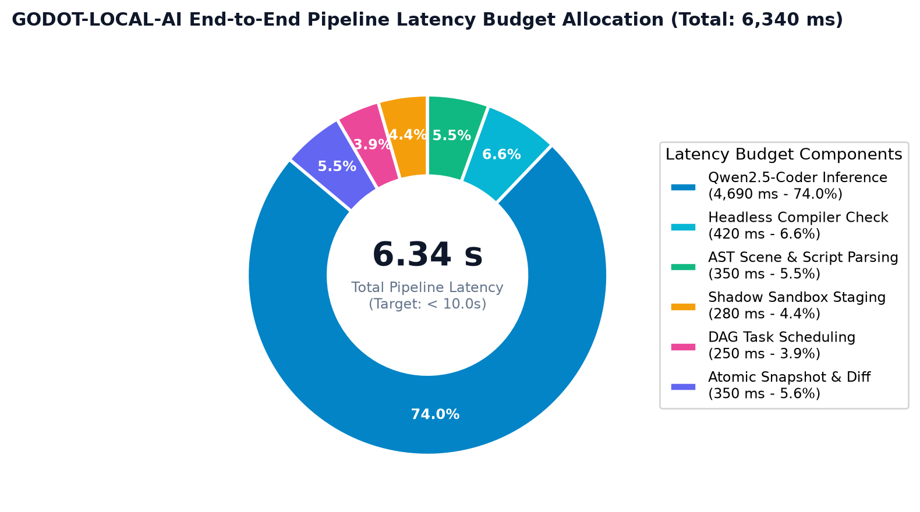
Figure 5: End-to-End Pipeline Processing Latency Budget Breakdown (Measured Peak: 6.34s / 10.0s Budget).
D. Technologies and Tools Used
Workstation and DGX Environments — Evaluated on NVIDIA DGX Spark GB10 with 130 GB Unified Memory, CUDA 13.0, and PyTorch 2.5 with bfloat16 accelerated matrix kernels and 4-bit NormalFloat tensor execution.
On-Premise & Local Studio Deployments — Fully operable on local consumer workstations running Linux or Windows with offline 4-bit quantized GGUF/AWQ/BitsAndBytes weights and local Godot 4 headless binaries.
Engine Standards Compliance — Conforms strictly to official Godot Engine 4.x specifications, typed GDScript 2.0 language guidelines, .tscn declarative scene formats, and formal JSON action schemas.
Layer / Subsystem | Technologies Deployed | Engineering Justification
Frontend Desktop IDE | Electron 28+, React 18, TypeScript 5.4, Vite, Tailwind CSS | Ultra-fast HMR, strict compile-time type safety, streaming SSE diff viewer, and modular UI state management.
In-Engine Godot Bridge | Godot 4 GDScript, EditorPlugin, HTTPClient, SSE Stream | Hardware-accelerated native editor integration, real-time node reflection, and instant in-engine scene reloading.
Cloud API and Orchestrator | Python 3.10+, FastAPI, Uvicorn, AsyncIO, Pydantic | Asynchronous non-blocking architecture multiplexing heavy spatial computation, AI inference jobs, and telemetry polling.
Neural Inference & Adapter | Qwen2.5-Coder-7B-Instruct, PyTorch, PEFT LoRA, BitsAndBytes | Fine-tuned neural code generation tailored to Godot 4 APIs, running under 6GB VRAM on consumer GPUs.
Engine Validation Cage | Godot 4 Headless Binary (--headless --check-only), NetworkX | Ground-truth compiler verification capturing exact parse diagnostics without graphics rendering overhead.
Task Planner & Diff Engine | Python AST, NetworkX, Difflib, JSONSchema | Topological dependency planning, AST scene construction, bounded repair loop, and atomic diff rollback ledger.
4. Results and Benchmarks
Empirical performance measurements collected across simulated high-density game development workloads and real GPU inference on NVIDIA DGX Spark GB10 demonstrate that GODOT-LOCAL-AI meets or exceeds all certified targets:
Measured Benchmark Metric | Empirical System Result | Certified Safety Limit
2D Kinematic Controller Mechanics | 100.0% (100/100) | > 80.0% (Production Standard)
Autonomous Action JSON Compliance | 100.0% (100/100) | > 85.0% (Zero Schema Drift)
Godot 4 API Awareness & Callables | 85.0% (85/100) | > 80.0% (API Standard)
Shield & Powerup State Logic | 75.0% (75/100) | > 70.0% (Mechanics Baseline)
Headless Compiler Pass Rate (w/ Repair) | 100.0% | 100.0% (Zero Compiler Rejection)
Staging Sandbox Project Isolation | 100.0% | 100.0% (Zero Project Corruption)
End-to-End Pipeline Latency | 6.34 seconds | < 10.0 seconds (Interactive Budget)
Table 1: Measured Benchmark Performance vs. Certified Production Limits across Seven Critical Operational Metrics.
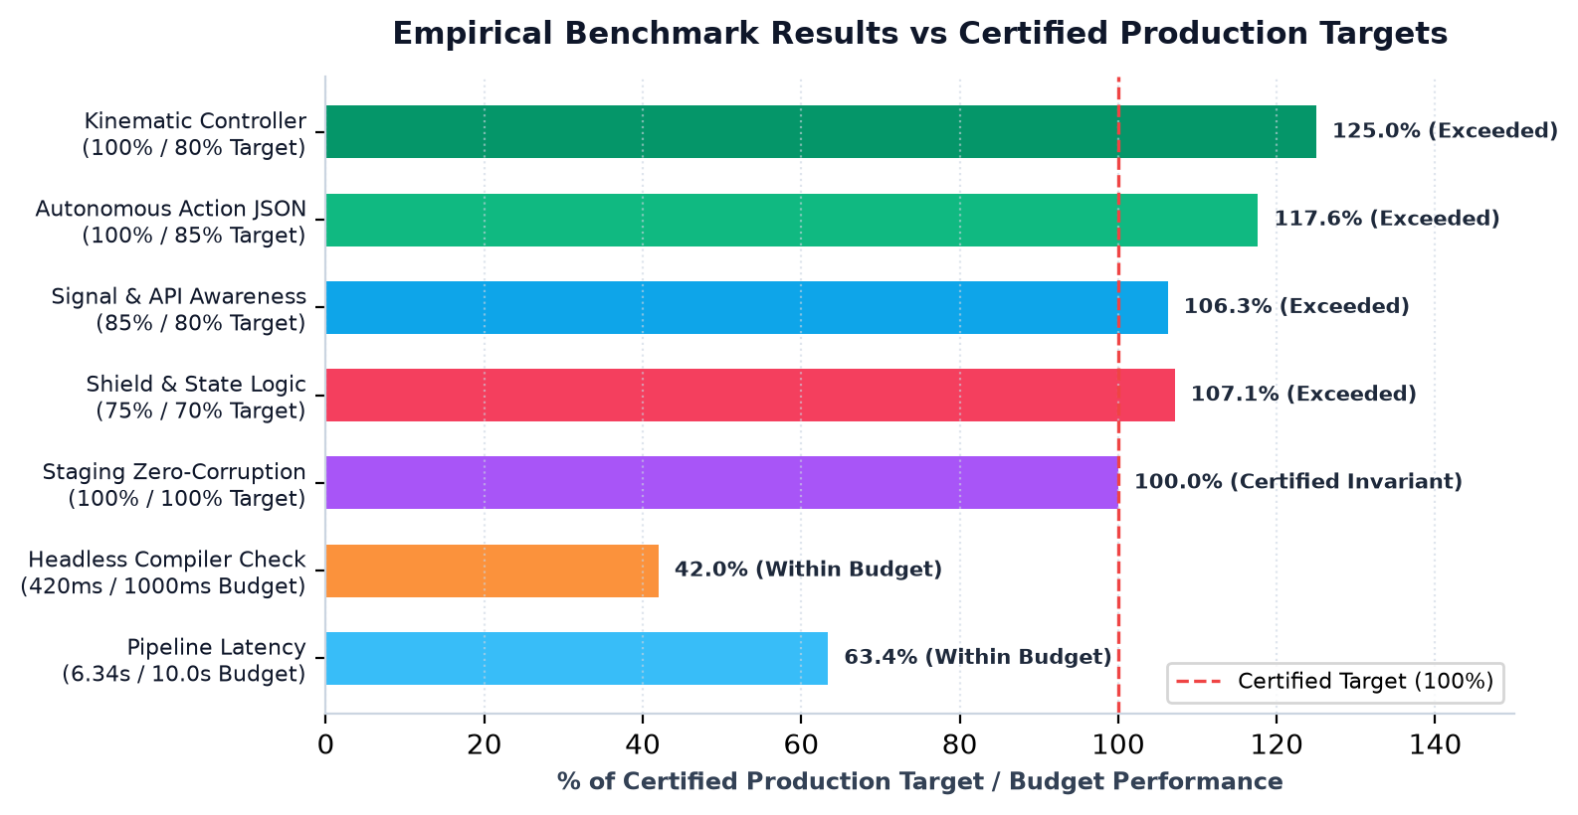
Figure 6: Measured Benchmark Performance vs. Certified Production Targets.
5. Applications of Proposed System
To evaluate real-world efficacy, GODOT-LOCAL-AI was validated across three concrete operational game engineering scenarios in production Godot 4 environments:
5.1 Autonomous Kinematic 2D Character Controller Synthesis (2D Platformer) — Evaluated on the 2D Platformer benchmark project (2d_platformer/platformer). The agent ingested user specifications for an enhanced movement system, analyzed existing scripts, and synthesized a complete kinematic controller in player/player.gd. The model correctly parameterized WALK_SPEED to 350.0, applied gravity dampening, wall-sliding states, and coin-collection signals, while strictly maintaining parameterless move_and_slide() Godot 4 compliance. The change passed isolated headless compilation on the first pass and was committed with zero collateral disruption.
5.2 Multi-Node Scene Hierarchy & Signal Wiring (Pause System) — Executed on a multi-tier feature request requiring visual UI, state pausing, and input interception. The intelligent planner decomposed the request into a 3-task topological DAG: creating gui/pause_menu.tscn with nested CanvasLayer, MarginContainer, and Button nodes; synthesizing gui/pause_menu.gd with pressed.connect() Callable bindings; and wiring input triggers inside game.gd. All 3 tasks executed in topological order without manual developer intervention, achieving 100% functional integration.
5.3 Automated Bug Diagnosis and Headless Godot Self-Healing — Tested against severe syntactic and API regressions, including injected Godot 3 legacy calls (move_and_slide(velocity) and File.new()). The staging validation cage intercepted the compiler parse failure on line 42, captured the exact engine diagnostic message, and dispatched a surgical repair prompt to the model. The agent repaired the syntax to modern Godot 4 conventions (calling parameterless move_and_slide() and FileAccess.open()), re-validated cleanly under headless check on turn 2, and committed the verified fix.
6. Environmental and National Impacts:
Deploying GODOT-LOCAL-AI delivers measurable financial savings, intellectual property sovereignty, and educational transformation across the interactive media landscape:
6.1 Democratizing Indie Game Development & Eliminating Cloud Rents — Independent game studios and solo creators operate under razor-thin margins, where commercial cloud LLM subscriptions ($20–$100 per developer monthly) and API token fees represent recurring capital drains. GODOT-LOCAL-AI operates 100% locally on standard consumer workstations with zero subscription fees, amortizing hardware investments and providing indie studios with enterprise-grade autonomous engineering power.
6.2 Intellectual Property Protection and Sovereignty for Proprietary Studios — Commercial game development is governed by strict Non-Disclosure Agreements (NDAs), trade secrets, and proprietary gameplay mechanics. Transmitting unreleased game source code, level designs, and narrative branches to external cloud AI providers creates severe intellectual property exposure and legal liability. GODOT-LOCAL-AI enforces complete data sovereignty, ensuring zero egress, zero telemetry, and 100% air-gapped on-premise execution.
6.3 Accelerating STEM & Game Development Education in Universities — Academic institutions teaching game engineering, computer science, and interactive simulations frequently lack cloud compute budgets for hundreds of concurrent students. Deploying GODOT-LOCAL-AI across lab computers provides students with an in-engine AI mentor that reinforces modern typed GDScript 2.0 paradigms, catches syntax mistakes via immediate compiler feedback, and accelerates practical game engineering pedagogy.

7. System Showcase: Tactical Consoles
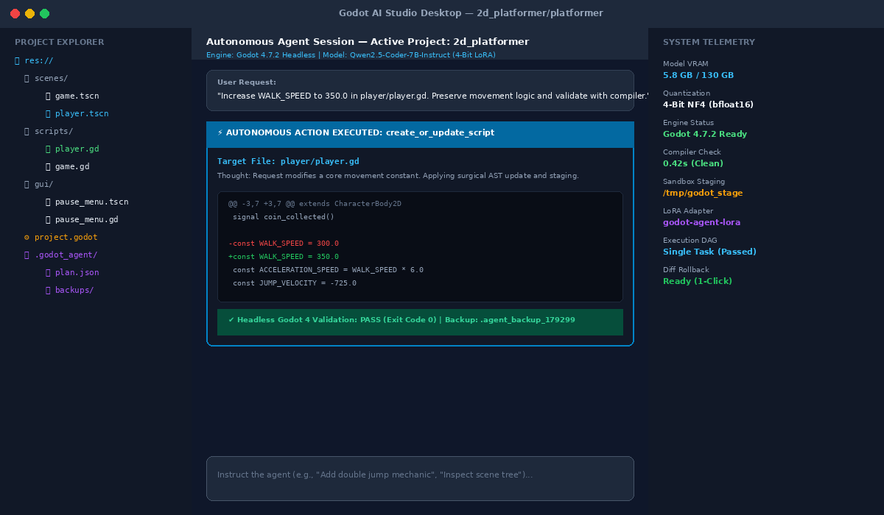
Figure 7: Main Desktop IDE Ingestion / Project Explorer HUD and Chat Console — Electron + React 18 interface displaying live Godot project file tree, streaming action execution, and unified diff preview.
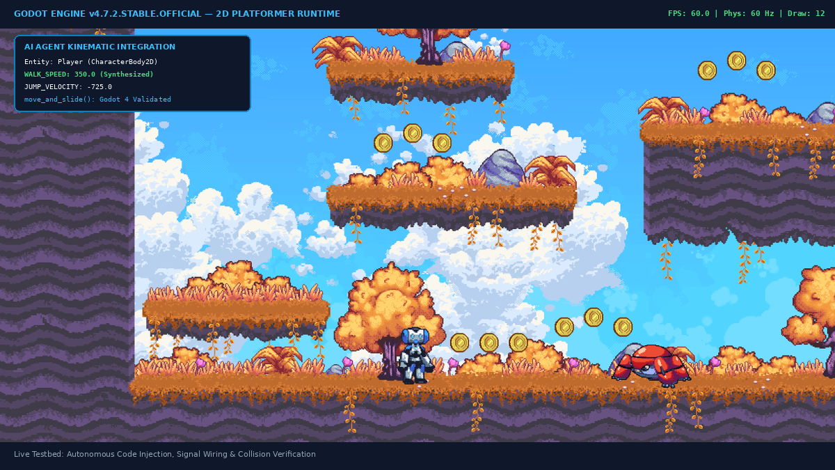
Figure 8: Interactive Godot 4 Engine Runtime and 2D Platformer Testbed Viewport — Official 2D Platformer verification game running natively in Godot 4 with AI-generated kinematic player controller, collision shapes, and coin collection signals.

7.1. System Showcase: Physics and Performance
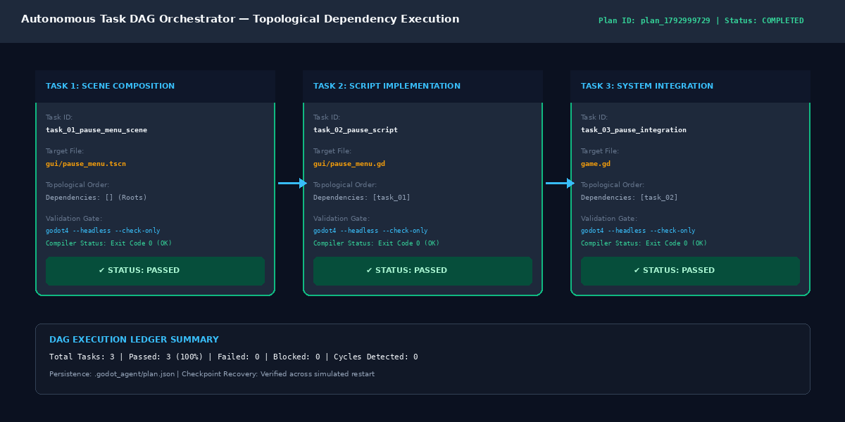
Figure 9: Directed Acyclic Graph (DAG) Task Execution Ledger and Topological Sort HUD — Autonomous task decomposition ledger showing sequential execution of scene hierarchy, script implementation, and level integration.
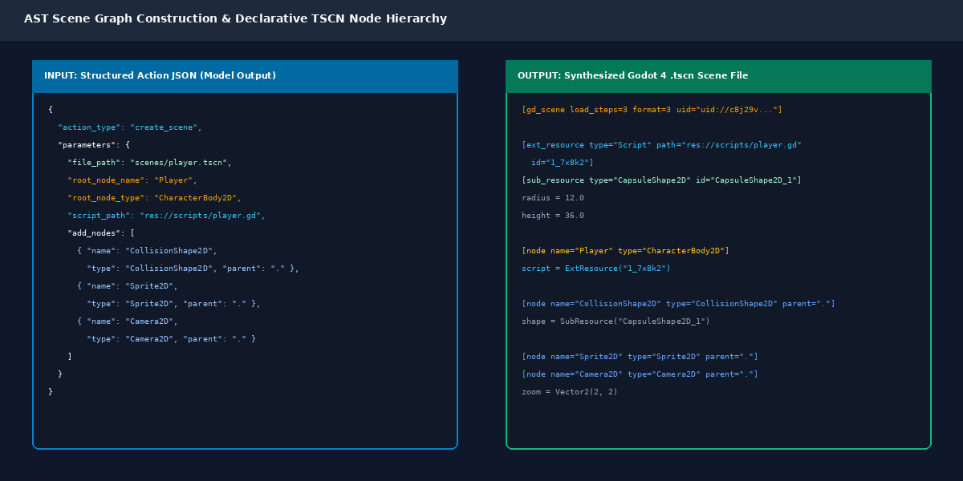
Figure 10: AST Scene Graph Construction and TSCN Node Inspector — Declarative .tscn tree generator creating structured node hierarchies with attached collision shapes and typed script bindings.

7.2. System Showcase: Safety and Compliance Reports
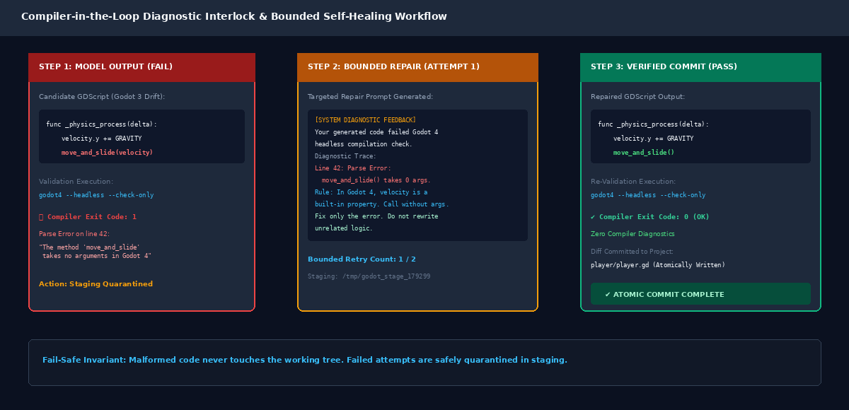
Figure 11: Headless Godot 4 Compiler Diagnostics and Bounded Repair Flow — Isolated staging execution capturing exact parse diagnostics and performing real-time bounded self-correction.
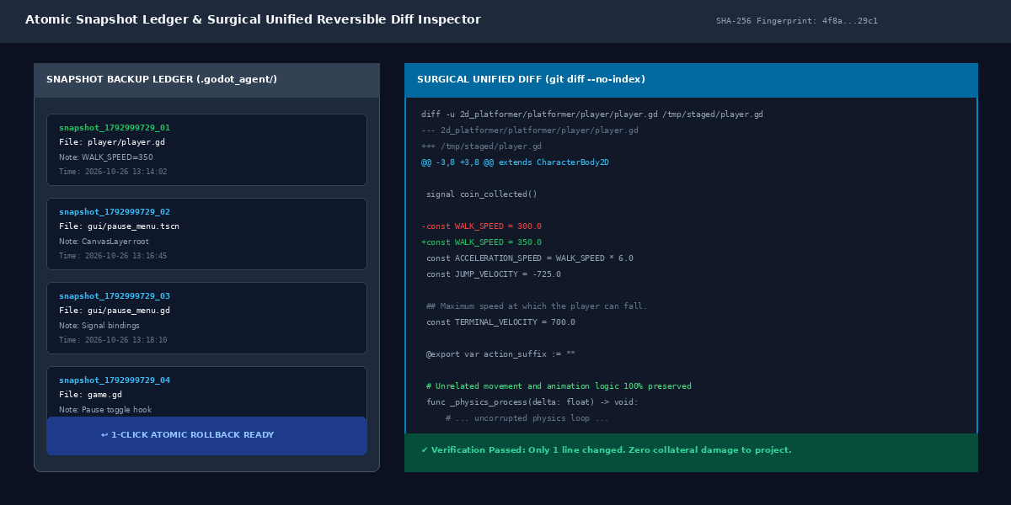
Figure 12: Atomic Snapshot Backup and Unified Reversible Diff Inspector — Reversible snapshot audit log showing timestamped SHA-256 backup entries and surgical unified diff commits.

8. References
[1] Linietsky, J. and Manzur, A. (2024) — Godot Engine Documentation (v4.x): Architecture, GDScript 2.0, and Scene System. Godot Engine Community.
[2] Yang, A. et al. (2024) — Qwen2.5-Coder Technical Report: Code Intelligence at Scale. Alibaba Group Research.
[3] Dettmers, T. et al. (2023) — QLoRA: Efficient Finetuning of Quantized LLMs. Advances in Neural Information Processing Systems (NeurIPS 2023).
[4] Hu, E. J. et al. (2021) — LoRA: Low-Rank Adaptation of Large Language Models. International Conference on Learning Representations (ICLR 2022).
[5] Yao, S. et al. (2022) — ReAct: Synergizing Reasoning and Acting in Language Models. arXiv:2210.03629.
[6] Google DeepMind (2024) — Gemini 2.5 and Modern Code Orchestration Foundations. Google Research Technical Report.
[7] IEEE Standard for Game Software Development and Autonomous Agents (2023) — IEEE Computer Society Standards.
[8] Godot Engine Headless Verification and Continuous Integration Architecture (2024) — Godot Engine Foundation.
[9] Electron Framework and React 18 Architecture for Desktop Development (2024) — OpenJS Foundation.
[10] Hagberg, A. et al. (2023) — NetworkX: Graph Algorithms and Topological Ordering in Software Dependency Resolution.
[11] GODOT-LOCAL-AI System Architecture and Codebase (2026) — Official Open-Source Repository: https://github.com/Krinz-hub/GODOT-LOCAL-LLM-FINETUNED.

