ASG AIRLINES
End-to-End Data Engineering Case Study

Submitted by

Name - KRIPA DHANDHANIA
GitHub repository link - https://github.com/Kripa-Dhandhania/Airlines_DataEngineering.git

1. Executive Summary
This project implements an end-to-end data engineering pipeline for airline data. The pipeline ingests raw flight, booking, passenger and payment data, performs data-quality validation and transformation, protects sensitive information, and creates analytics-ready datasets.
The final Gold layer is connected to Power BI to provide insights into flight duration, routes, airlines, bookings, payments and data quality.

2. Objectives
- Build an end-to-end airline data pipeline.
- Identify and handle data-quality issues.
- Clean and transform raw datasets.
- Protect passenger PII.
- Create analytics-ready data models.
- Generate business KPIs.
- Develop an interactive Power BI dashboard.
- Maintain quarantined records for auditability.

3. Dataset Description
Dataset | Raw Records | Purpose
Flights | 1,020 | Flight and route information
Bookings | 1,000 | Booking transactions
Passengers | 1,039 | Passenger information
Payments | 1,000 | Payment transactions
The datasets contain operational, transactional and passenger-related information.

4. Technology Stack
Python, Pandas, Jupyter Notebook, CSV, Git/GitHub and Power BI
Python was used for ingestion, validation, transformation and aggregation, while Power BI was used for visualization and analysis.

5. System Architecture

Bronze - Stores the ingested raw data.

Silver - Contains validated, cleaned and transformed data.

Gold - Contains dimensional models and KPI aggregations optimized for analytics.

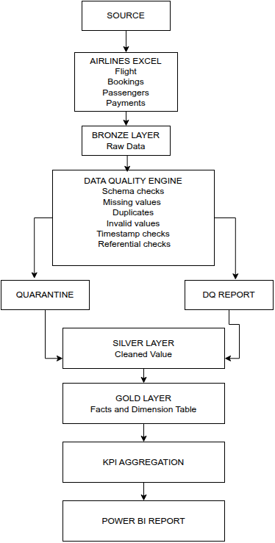

6. Data Ingestion
The source Excel workbook contains four datasets: flights, bookings, passengers and payments.
The ingestion process loads each dataset into the Bronze layer while preserving the original structure. Data-quality checks are then applied before records move to the Silver layer.

7. Data Quality Framework
A reusable validation framework was implemented with 23 data-quality rules.
The checks cover:
- Duplicate records
- Missing values
- Invalid identifiers
- Invalid statuses
- Invalid payment values
- Invalid Aadhaar formats
- Timestamp inconsistencies
- Referential integrity

Results
- 23 rules evaluated
- 14 rules had violations
- 1,651 violation events detected
- 79 records quarantined
Invalid records were isolated instead of being silently deleted.

8. Data Cleaning & Transformation
The Silver layer performs:
- Duplicate removal
- Missing-value handling
- Data-type standardization
- Timestamp conversion
- Duration calculation
- Overnight-flight detection
- Status standardization

9. Quarantine & Error Handling
Records failing critical validation checks are moved to the quarantine layer for investigation.
A key anomaly was identified in flight SJ192, where the arrival timestamp occurred before the departure timestamp.
Instead of correcting the record automatically, it was quarantined to preserve data integrity and auditability.

10. PII Protection
Passenger data contains sensitive information such as Aadhaar numbers, phone numbers and email addresses.

11. Referential Integrity
One booking, B1636, references quarantined flight SJ192.
The booking was retained for transactional completeness but flagged as referencing a quarantined parent record. It is excluded from affected validated operational flight metrics.

12. Data Flow Diagram
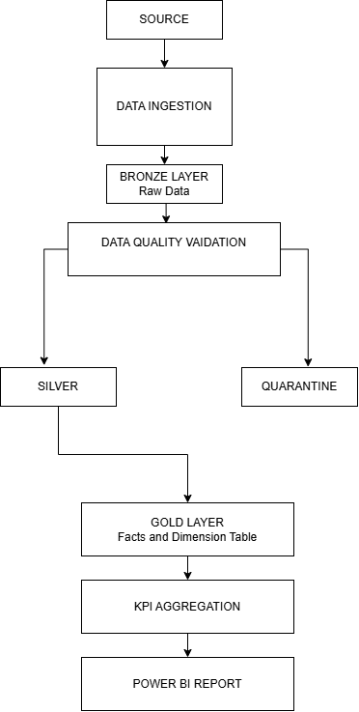

13. Data Model
A dimensional model was created consisting of:

Dimensions
- Dim Airline
- Dim Route
- Dim Passenger
- Dim Payment Method
- Dim Date

Fact Tables
- Fact Flight
- Fact Booking
- Fact Payment

14. KPI & Aggregation Layer
The Gold layer contains pre-aggregated KPI datasets for efficient reporting.
Key metrics include:
- Total Flights: 1,004
- Average Flight Duration: 164.49 minutes
- Overnight Flights: 122
- Total Bookings: 1,000
- Total Revenue
- Airline Flight Share
- Route Traffic
- Booking Status Distribution
- Data Quality Metrics

15. Power BI Dashboard
The Power BI report contains five analytical pages:

1. Executive Operations
Provides an overall view of flights, bookings, revenue and operational activity.
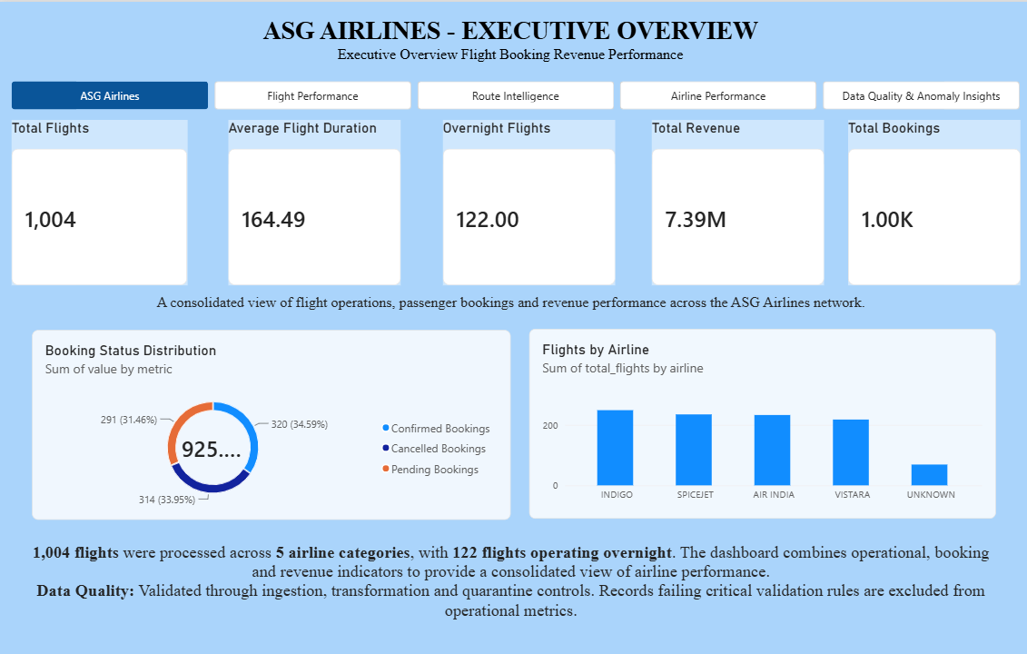

2. Flight Performance
Analyzes flight duration and overnight operations across airlines.
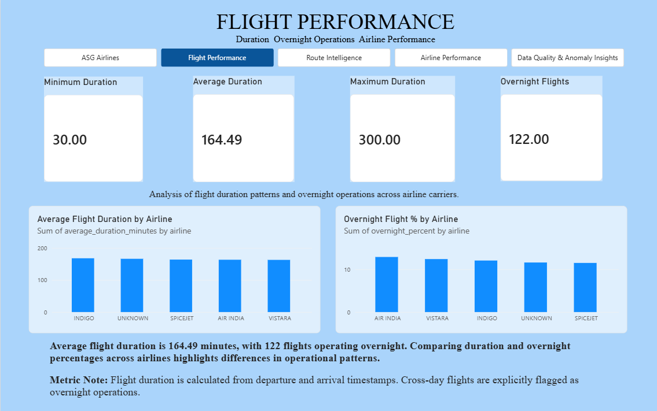

3. Route Intelligence
Analyzes route traffic, duration and overnight activity.
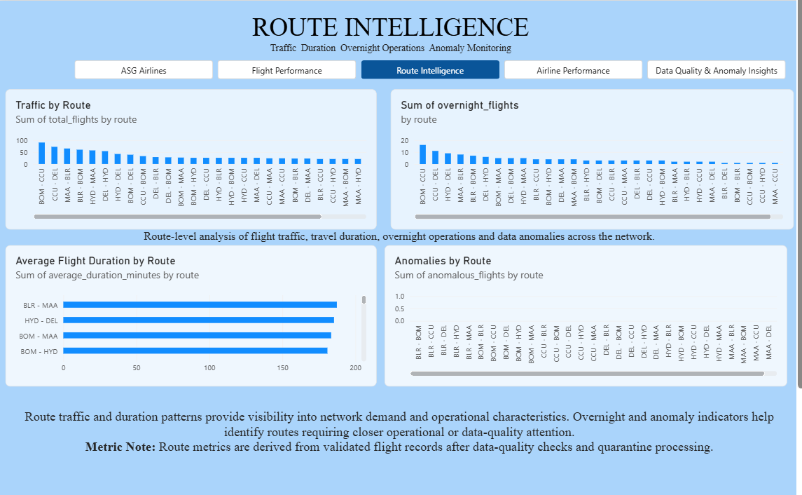

4. Airline Performance
Compares airlines based on flight volume, market share, duration and overnight operations.
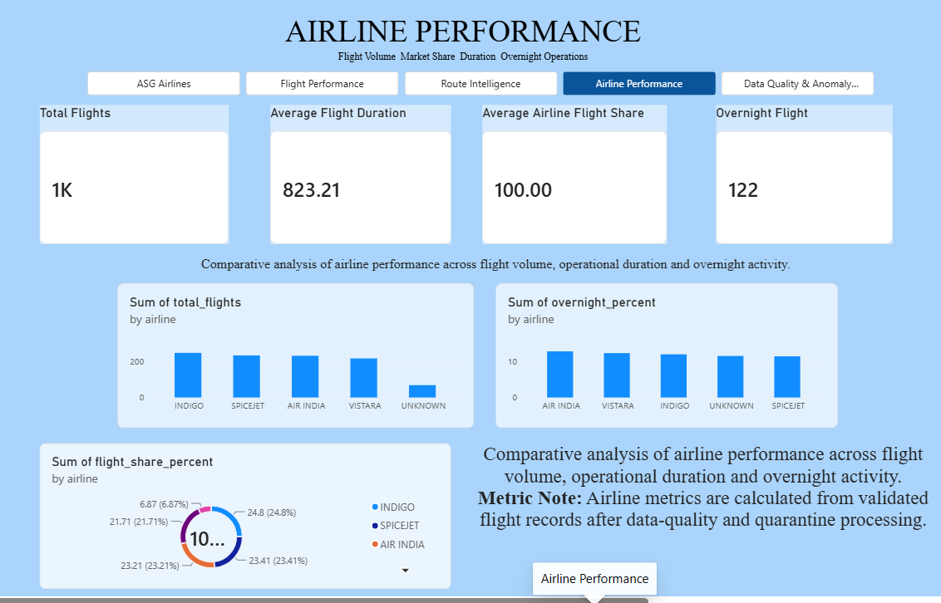

5. Data Quality & Anomaly Command Center
Displays validation failures, quarantined records and data-quality indicators.
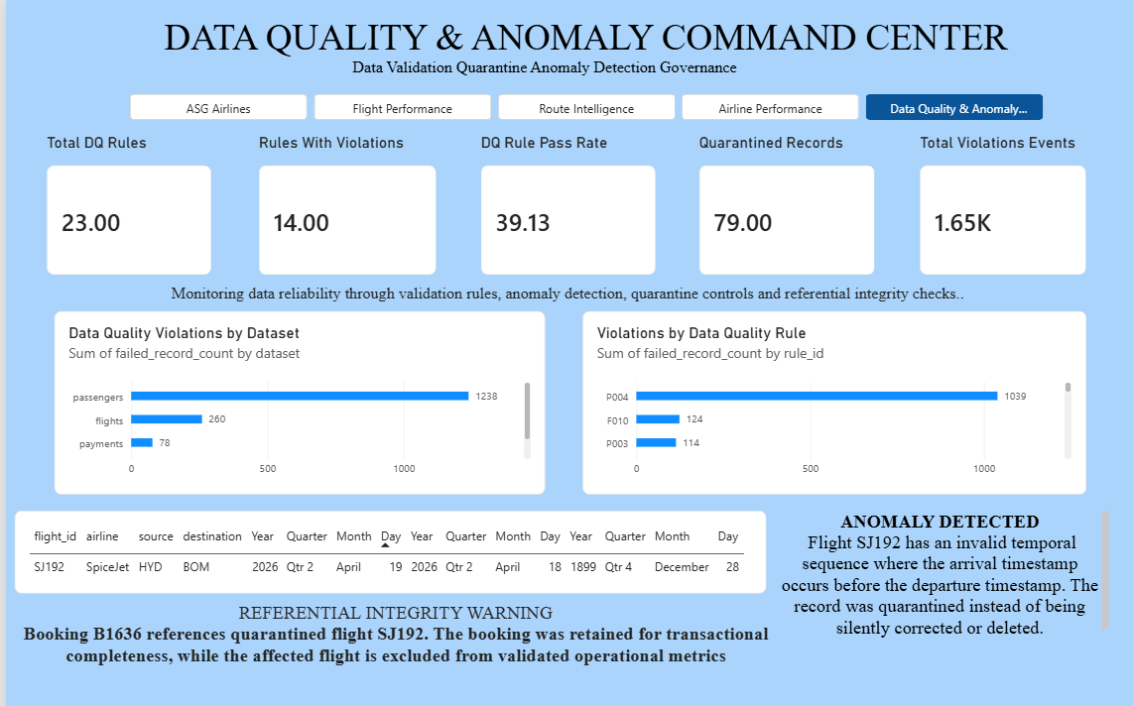

16. Conclusion
The project demonstrates a complete data engineering workflow from raw ingestion to business intelligence.
The combination of data-quality validation, quarantine handling, PII protection, dimensional modelling, KPI aggregation and Power BI visualization provides a reliable foundation for airline analytics.

