# WEB PROJECT

Submitted by: Kripsan Thakuri

Program: BCA 3rd Semester

Submitted to: Dipendra Silwal

College: Oxford College of Engineering and Management

**Project: Corporate Culture Explorer**

* **Site Map**

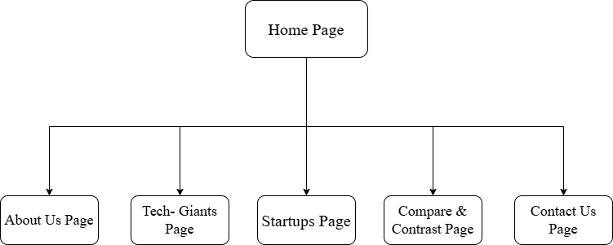

* **References**

1. Chomsky, R. (2024, January 5). *33 sustainable start-ups to follow in 2024*. Sustainable Review. Retrieved December 9, 2024, from <https://sustainablereview.com/33-sustainable-start-ups-to-follow-in-2024/>.
2. TechCrunch. (n.d.). TechCrunch: Startup and technology news. Retrieved December 9, 2024, from <https://www.techcrunch.com>.
3. OpenAI. (2024). *ChatGPT (December 2024 version)*. Retrieved December 9, 2024, from <https://chat.openai.com>.