Week 1: EDA & Preprocessing in NLP
Dataset: 500 reviews. Findings: {'positive': 193, 'negative': 190, 'neutral': 117}. Top words: [('not', 234), ('product', 217), ('okay', 117), ('great', 117), ('bad', 117), ('terrible', 100), ('service', 100), ('late', 100), ('delivery', 100), ('i', 100), ('love', 100), ('this', 100)]
Graph 1: Sentiment Distribution - Positive sabse zyada
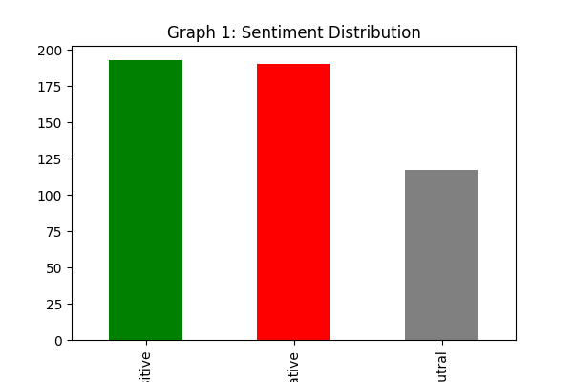
Graph 2: Text Length - length 30-35 ke beech
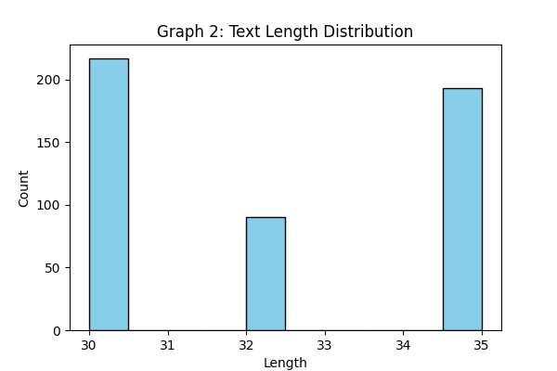
Graph 3: Most common words - product, not, excellent
