Analysis

Description of the problem

Dr Robotnik’s Mean Bean Machine is a 1994 Westernised port of Puyo Puyo for the Sega Genesis/Mega Drive. It is a game that I have enjoyed throughout my childhood on many different forms – cheap emulation consoles, the Sega Mega Drive Collection for Xbox 360, using Fusion emulator on PC among other forms. However, all of these present glaring issues that directly affect the enjoyment of the player – emulation consoles usually are slow with clunky controllers and are not good for much else and thus are not practical to use permanently; the Sega Mega Drive collection on Xbox 360 suffers with a noticeable input lag problem, with inputs sometimes taking hundreds of milliseconds to be processed, directly affecting how fast you can play; PC emulation either results in a small or blurry image and makes it difficult to play with others or share your scores and achievements.

The goal of this project is to solve these problems by creating a superior, native PC remake of the game. Everything in the original game shall work exactly as in the original, including re-constructing the algorithms used for the playstyles of the various AI opponents. I also intend to include many quality of life improvements to solve the problems listed about: multiple customisable input method and handling will be supported, many algorithmic optimisations shall be made to improve performance, graphics shall be upscaled in a way that remains a crisp pixel look instead of introducing blur, an SQL web server will allow score and time leaderboards to exist and a replay file system shall be introduced to allow players to easily share gameplay. This project exists to create a superior version of DRMBM for a new generation to enjoy, as well as offering a way for modern Puyo Puyo players to enjoy the OPP rule set on modern devices.

If the goals above are reached, further extension goals include the introduction of my own custom AI opponents with algorithms designed for optimal, “perfect” gameplay and the use of websockets to facilitate real-time online matches between two remote players.

Alternatives

The Puyo Puyo community has created many alternatives that we shall explore, and compare the advantages and disadvantages of each.

**Emulation**

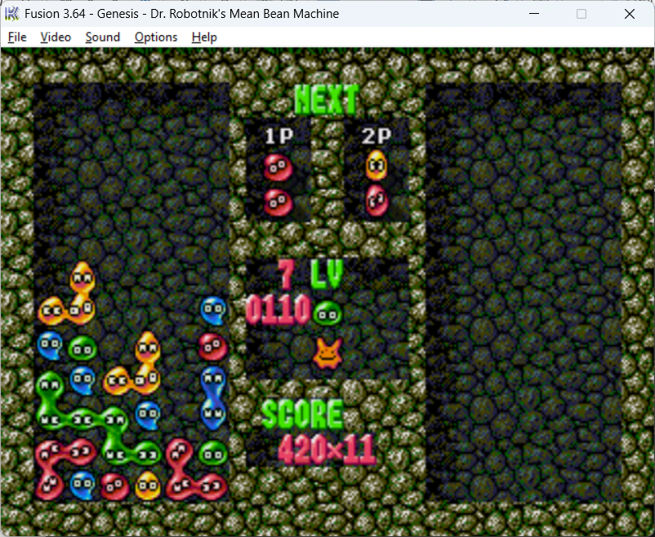 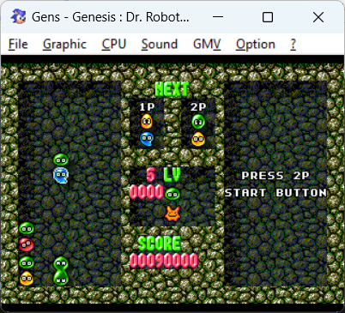

Link: cannot be provided due to specialised hardware being required to dump the ROM. Yet another disadvantage.

Many different emulators exist for the Sega Mega Drive, such as Fusion or Gens shown above, or the official Sega emulator that can be found on Steam. These are programs that accept a binary ROM dump of the original cartridge and attempt to emulate the code.

|  |  |
| --- | --- |
| Advantages | Disadvantages |
| * Convenient for mass production and distribution. Sega can create one Mega Drive emulator and release an entire of library of games that use the same program * True to the original experience. Since you are playing a copy of the original game, you can be sure you are getting an authentic experience * While clunky, save states allow you to save high scores and progress through the story, as well as letting you manipulate sequences of beans | * Resolution is locked at the console’s original and upscaling is blurry and unappealing * Very static and not customisable. It is incredibly difficult to edit a ROM if you wanted to play with, for example, different handling or textures * Saving progress is difficult * Emulators are difficult to run and can easily lag on lighter hardware, running the game at higher levels can struggle on older processors * It is impossible to play with friends remotely (or if it is possible, then it’s too difficult for the average user to achieve) |

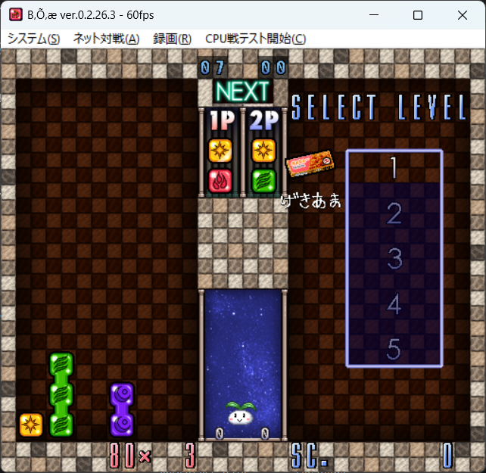**B puyo**

Link: <http://bx1.digick.jp/puyo/dl.php>

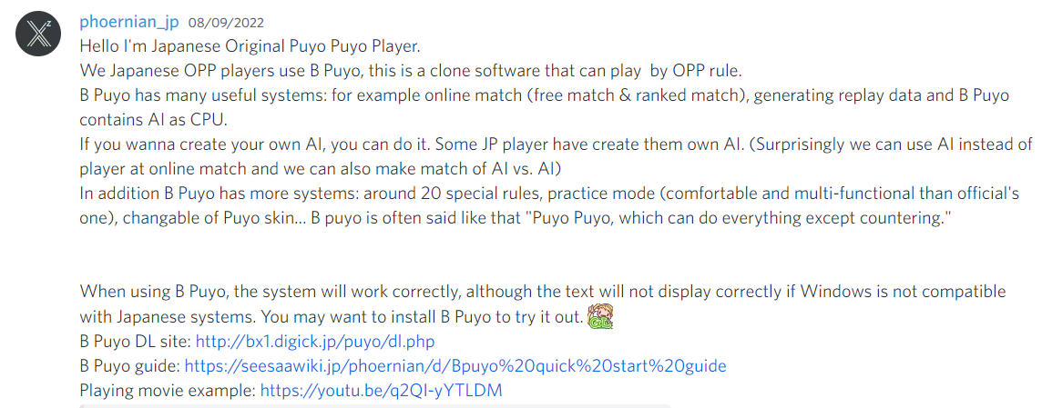B puyo is a popular online Puyo-clone recommended to me by the Japanese community.

|  |  |
| --- | --- |
| Advantages | Disadvantages |
| * Custom textures, custom AI, custom rules, custom anything really * Easy to use online multiplayer * Great performance as a native PC program | * Will only run on Windows, excluding Mac and Linux users * The entire thing is in Japanese, with no translation options. Furthermore, servers are in Japan, creating ping issues for non-Japanese players. This is great for the Japanese community, but unfortunately disadvantages me as a Western player * The resolution is locked to being a small window, making it uncomfortable to use on high-resolution displays |

**Project GelaVolt**

Link: <https://gelavolt.io/>

To quote the game’s creator, “Project GelaVolt is a modern, techno-themed pixel art fangame of SEGA's Puyo Puyo series, one of Japan's most successful puzzle fighter franchises. Currently, GelaVolt is focused on the competitive aspects of the game and it's intended purpose is to help introduce people and help people get better at Puyo Puyo. However, if all goes well, GelaVolt will become a free alternative that plans to solve some of the communities problems: lack of players, lack of crossplay and lack of general quality netcode.” It is a Puyo-clone written in Haxe that runs in browsers. 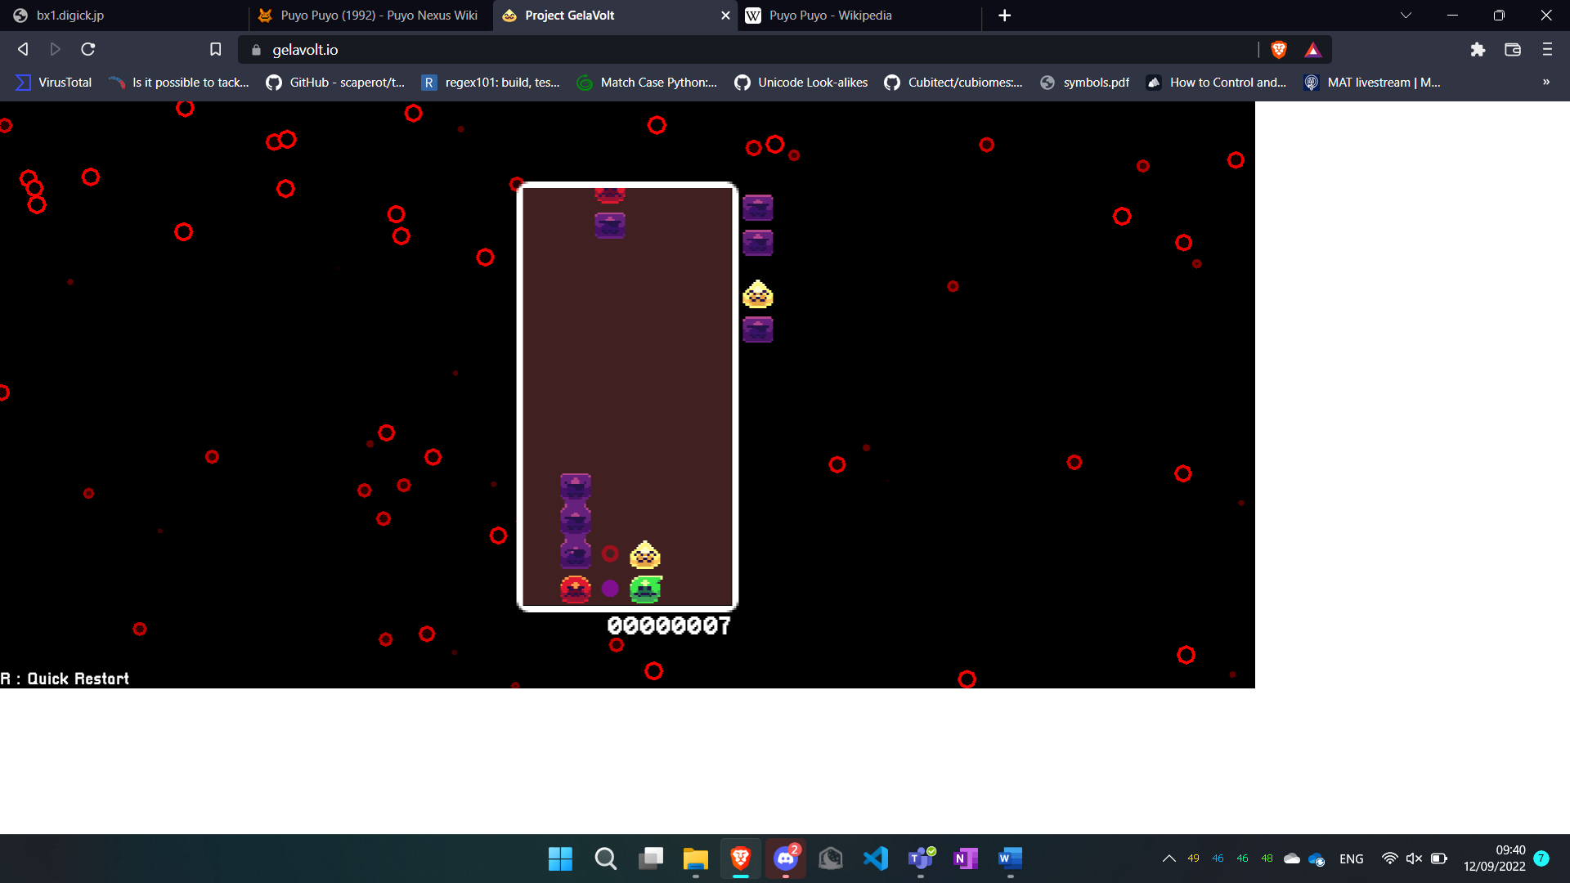

|  |  |
| --- | --- |
| Advantages | Disadvantages |
| * Appealing design * Is lightweight and capable of running well in browsers * Supports many different control schemes out of the box (controller, keyboard, etc.) * Only version I’ve played that has hard drop | * Multiplayer is in the works but is currently not supported at the time of writing * Things such as textures are not customisable * Is unstable and crashes regularly |

**Puyo Puyo Tetris 2**

Link: <https://store.steampowered.com/app/1259790/Puyo_Puyo_Tetris_2/>

Puyo Puyo Tetris 2 is the latest Puyo Puyo game released by Sega and combines Puyo Puyo gameplay with Tetris, allowing players of both games to seamlessly play against one another. It has a full story and online mode.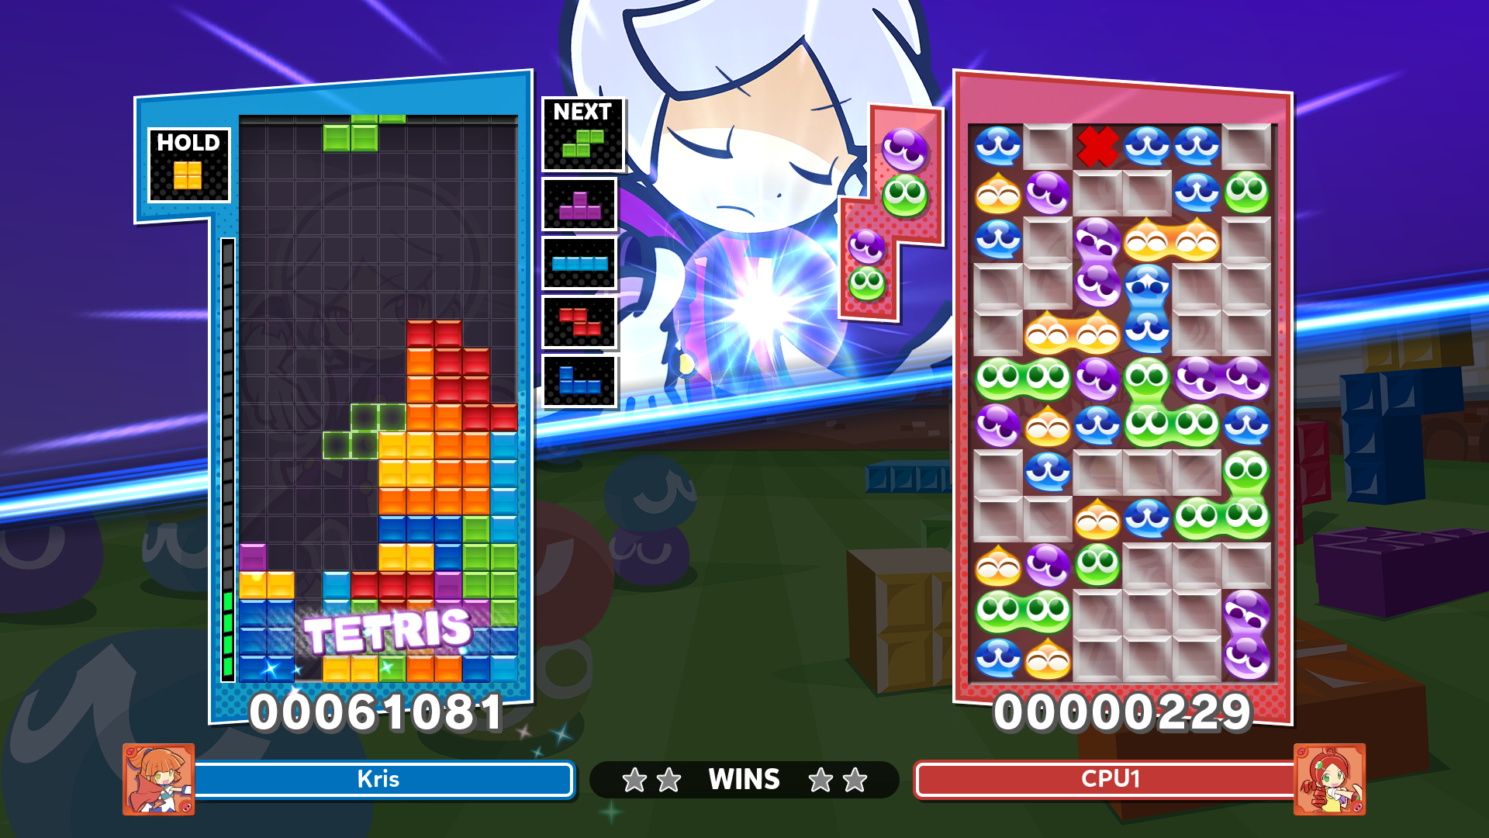

|  |  |
| --- | --- |
| Advantages | Disadvantages |
| * Cutesy art style is appealing to many, but can be swapped out with unlockable designs * Being an official release, it is very stable with a consistent online multiplayer * CPU opponents * Fully voice-acted story with unique and creative characters * Active modding community | * Ranked multiplayer is fundamentally flawed as leaving matches is not punished * CPU opponents fail to provide a challenge * The game is very expensive, whereas all other options listed above are free * Tsu ruleset, unable to be changed |

Overall Input -> Data Processing -> Output diagram for whole program

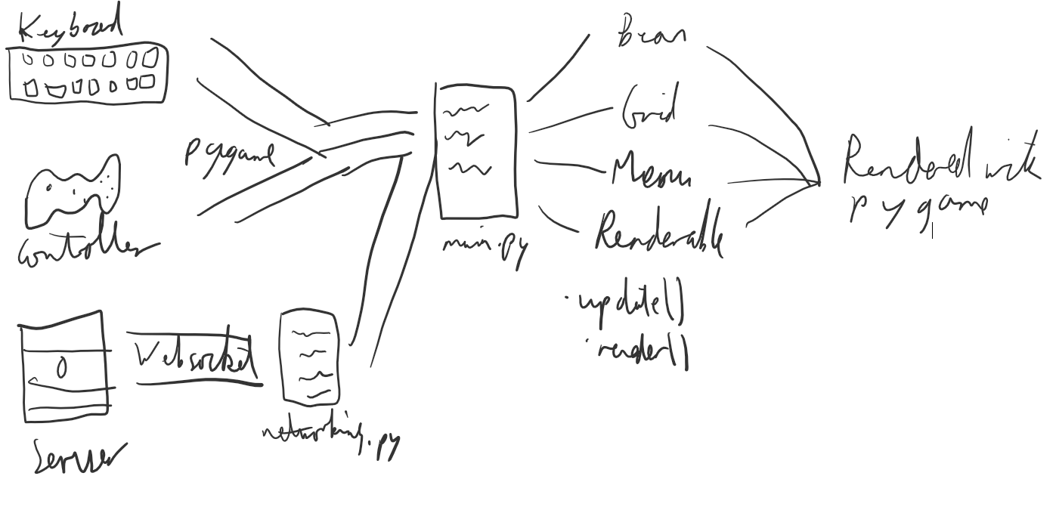 Research to be completed

* Research handling settings of original game
* Research more frame-perfect timings such as drop speeds for levels
* Establish the correct scoring table to use
* Obtain missing textures for nuisance queue
* Find efficient algorithm for checking for grouped colours
* Complete interviews/research with my target audience
* Obtain SFX and sound files