Bridge 4 nodes 512 processes profile result

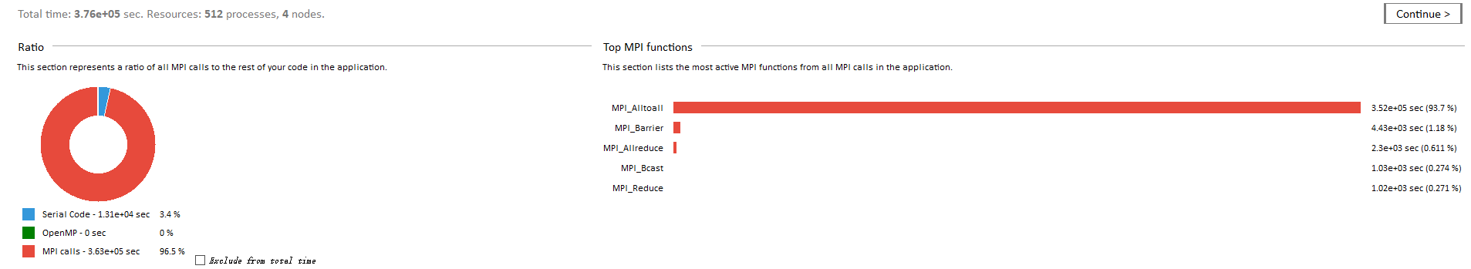

It’s obviously MPI time cost is so high. Among these calls, MPI_Alltoall, MPI_Barrier, MPI_Allreduce are the three highest cost calls with about 687.8s, 8.7s, 4.5s time been used.

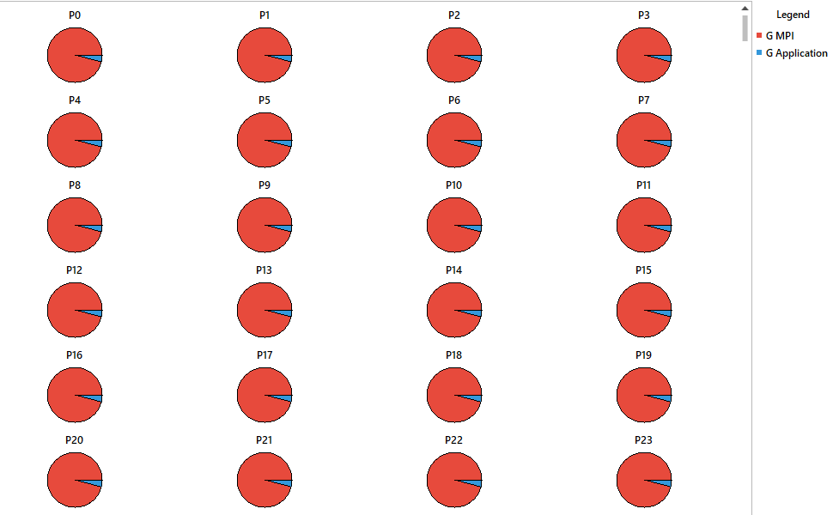

It’s an exceptional result because task cost too much time communicating rather than computing(serial code).

Due to MPI_Alltoall is a extreme bottleneck, we analyse some ways to reduce it: Using Caching, Adjusting cache block size, Choose the appropriate algorithm, Optimize communication mode, Adjusting process layout...

|  |  |  |  |  |
| --- | --- | --- | --- | --- |
|  |  |  |  |  |
|  |  |  |  |  |
|  |  |  |  |  |
|  |  |  |  |  |
|  |  |  |  |  |
|  |  |  |  |  |
|  |  |  |  |  |
|  |  |  |  |  |

