BONUS

1. GUI

To make the graphical interface, we need to use the "GUIDE" module and set up the required plug-ins in the".FIG "interface.

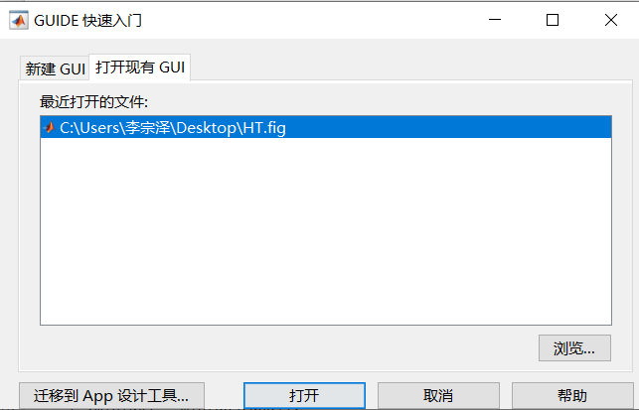

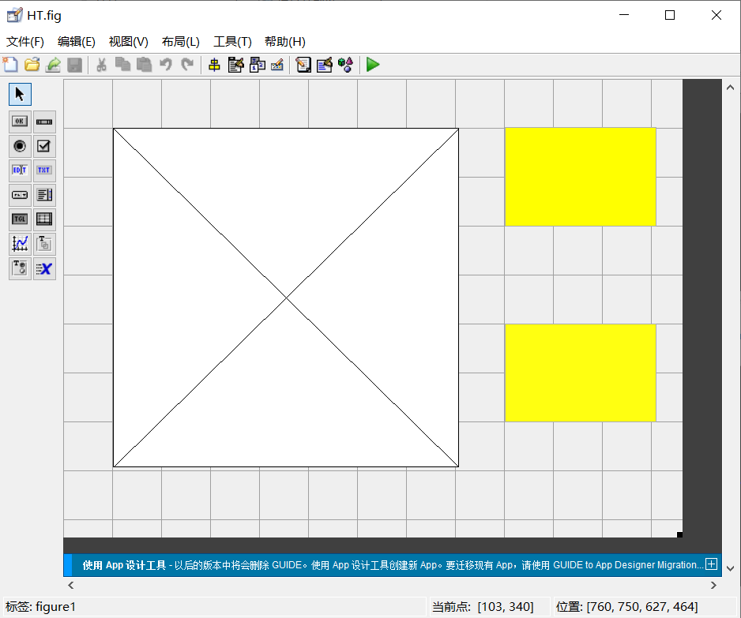

Then we can open the built-in function interface of the drawing plug-in, and then we are faced with two problems: first, how to import the data in the workspace into the graphical interface, and second, how to draw to reflect the specific DOA Angle.

For the first problem, we use the "evalin" function under the initialization function of the built-in function and successfully import the required data, annotated ,  
as follows

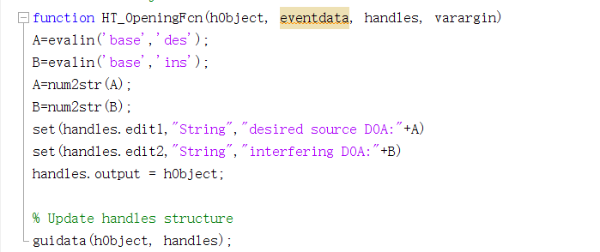

For the second problem, we use a circular statement to increase the DOA Angle value already obtained, make it different from other angles and bulge, and make it show graphically successfully, as shown below

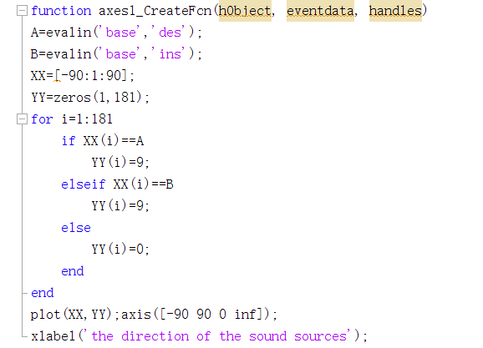

We take "Array output.wav" in T2 as an example and finally get the following result

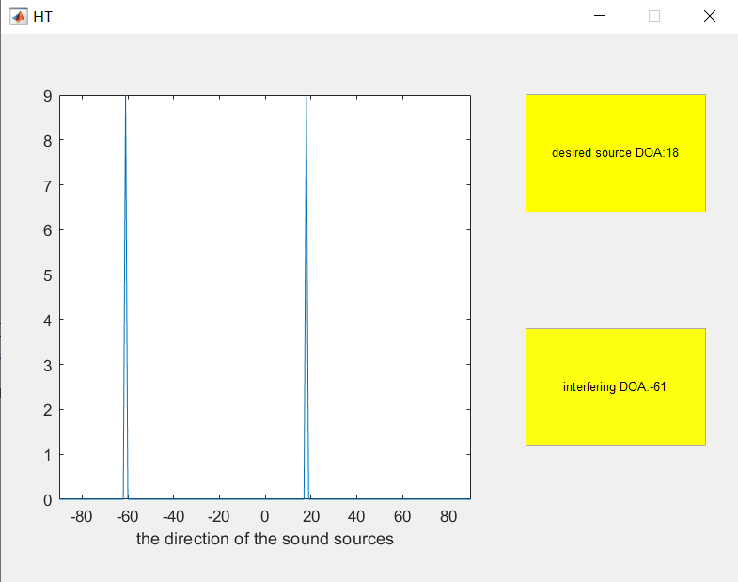

Other data can be similarly presented

1. Real-time

To realize the function of real-time display of sound source direction (with a necessary but small time delay),we choose to use the audioDeviceReader in matlab .

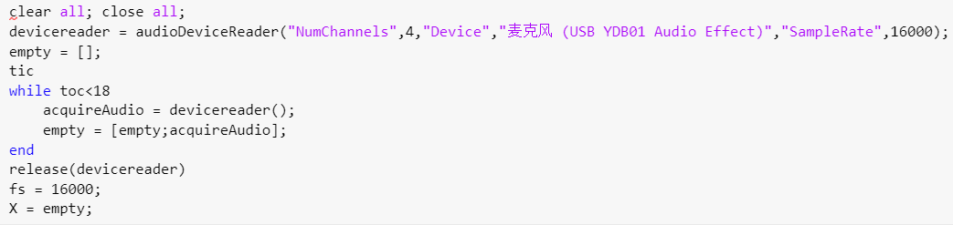

We set the parameters as above, then we also used broadband DOA analysis algorithm, which was completely consistent with T2 at the algorithm level, so there would be no more explanation at the algorithm level.

Through practice, when we first set the record time to be 5 seconds, we found that at least one of the two directions is extremely inaccurate. For example,no matter in what direction or distance we put the sound sources, the results always appeared 0 or 90. So we adjusted the record time according to the length of the input matrix X in order that the length of the sound is approximately the same as the one in the former task.

Finally we found that setting the record time as 18 seconds can produce the most accurate results, so we set: while toc < 18.

In the recorded condition, we can get the following results:JTZ)}EE`A`7~OU4)V~1EG39