T2

In task 2, the data we need to process is different from task 1. It has different center frequencies at different times, so we need to divide the data into multiple sections and process them separately.

(1)

In the first question, we used the same Fourier transform operation and "plot" function as T1 to make the corresponding image, while playing back the audio recorded by the first microphone with the "sound" function.

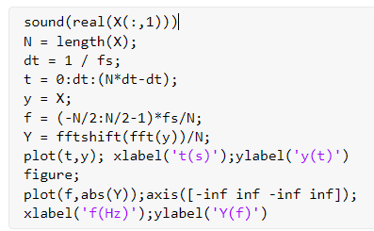

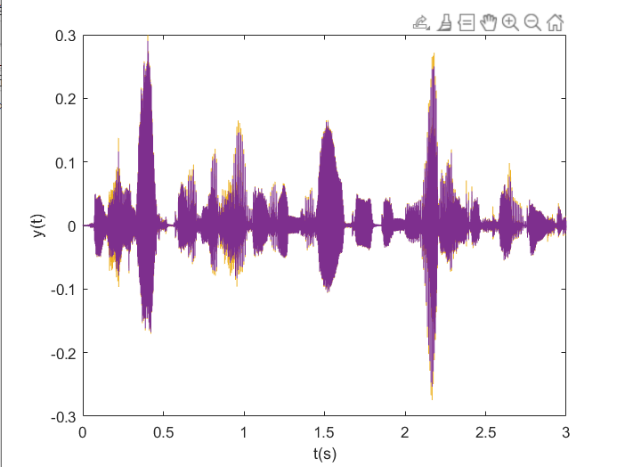

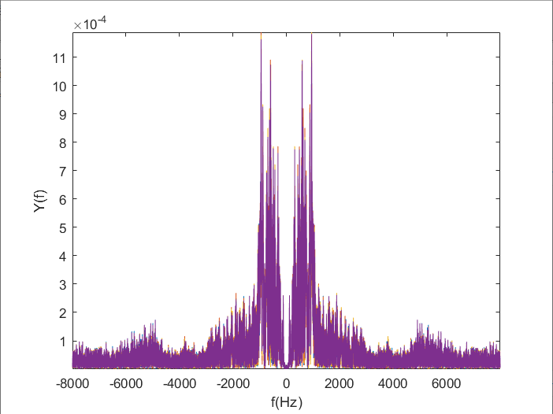

(2)

We use loop algorithm to broadband data into groups, each group as the same time, and different frequencies, at the same time give each a set of data hanning window, Fourier transform, respectively, at the same time, according to the data resulting from the Fourier transform symmetric distribution on the whole frequency, so we capture the data from each group of half, finally to deal with data.

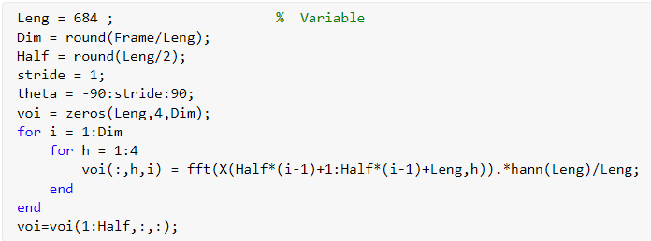

Next we simply use "permute" will change the dimension function data into data, similar to that of the narrowband types by using matrix for each frequency corresponding to the data set of expectations, and after that, we traverse the corresponding data set for each frequency, using "eig sells its" and "sort" functions to find every expectation under two minimum eigenvalue corresponds to the minimum characteristic vector, respectively for conjugate transpose and each group of data obtained from multiplication by the corresponding "denominator", and finally to all "denominator" to accumulate.

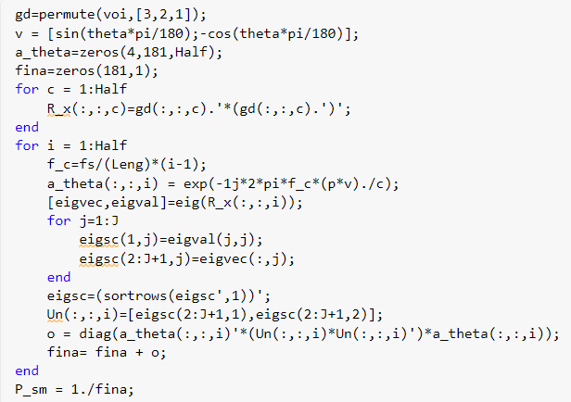

Finally, processed pseudo music power and data processing and expression.Get the final figure.

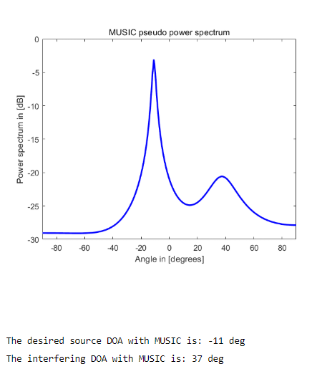

For the "Array output. Wav" file, the processing method is exactly the same as that of "Observation Wt.mat". You just need to read in the "Audioread" function at the beginning and set the corresponding microphone serial number.

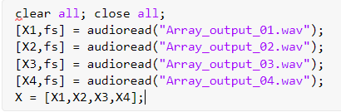

The corresponding images and DOA analysis results are as follows:

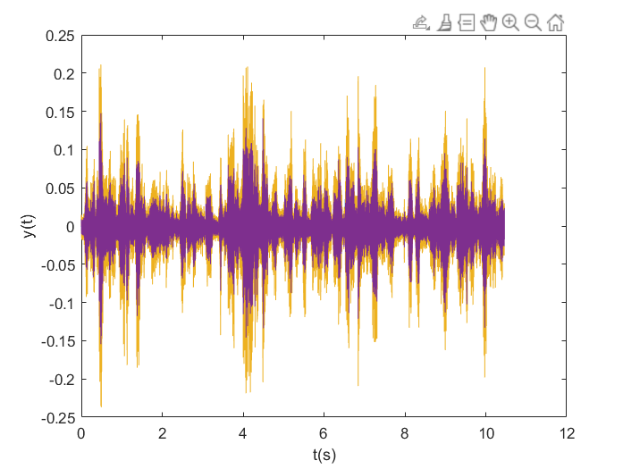

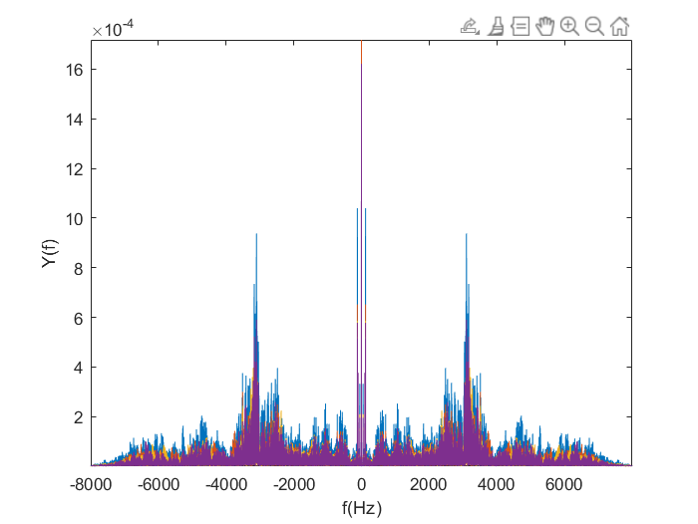

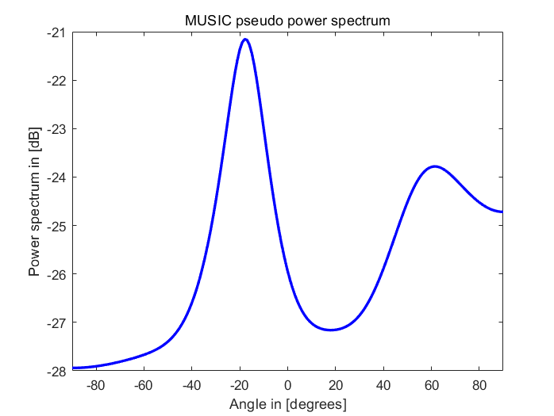

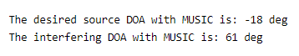

The error is within one degree.