T3

In task 3, we also used broadband DOA analysis algorithm, which was completely consistent with T2 at the algorithm level, so there would be no more explanation at the algorithm level. If you have any doubts, please refer to the analysis in T2 report.

Task 3 required us to use recording software to record audio and import data. After testing the corresponding number of microphone, we recorded an audio for about 17 seconds, exported it in four channels, and read it in MATLAB.

During recording, we placed the sound source at two angles of "30" and "-60" respectively.

In the first test, the two sound sources and the microphone were close together and got very wrong answers, as follows

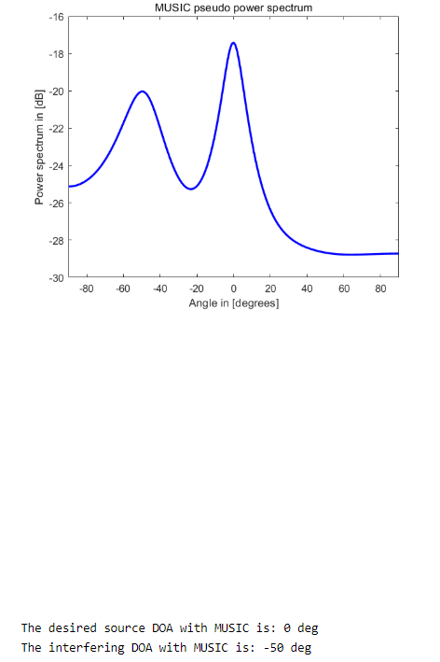

Therefore, we analyzed that because the sound source was too close to each other, the degree of mutual influence was too large, so there was mutual interference and the error was too large. Therefore, we pulled down the distance between the sound source and the microphone at the same Angle, carried out the second test and got the results as follows

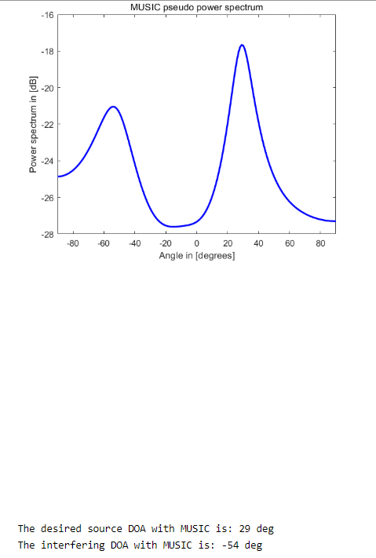

We can find that the obtained Angle is basically in line with the predicted result, and only the negative Angle has an error of about 5 degrees. We analyze that this may be caused by the small influence of the artificial sound we made during the recording process, but it generally meets the test expectation and gets the correct Angle

The error is within 5 degrees