BONUS

1. GUI

To make the graphical interface, we need to use the "GUIDE" module and set up the required plug-ins in the".FIG "interface.

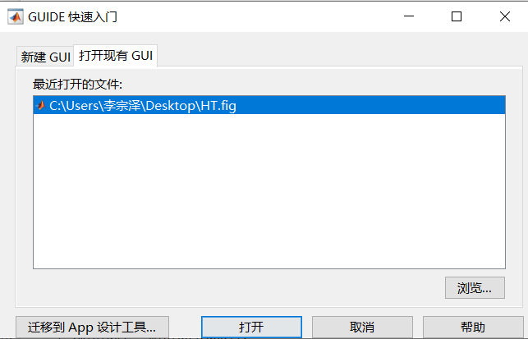

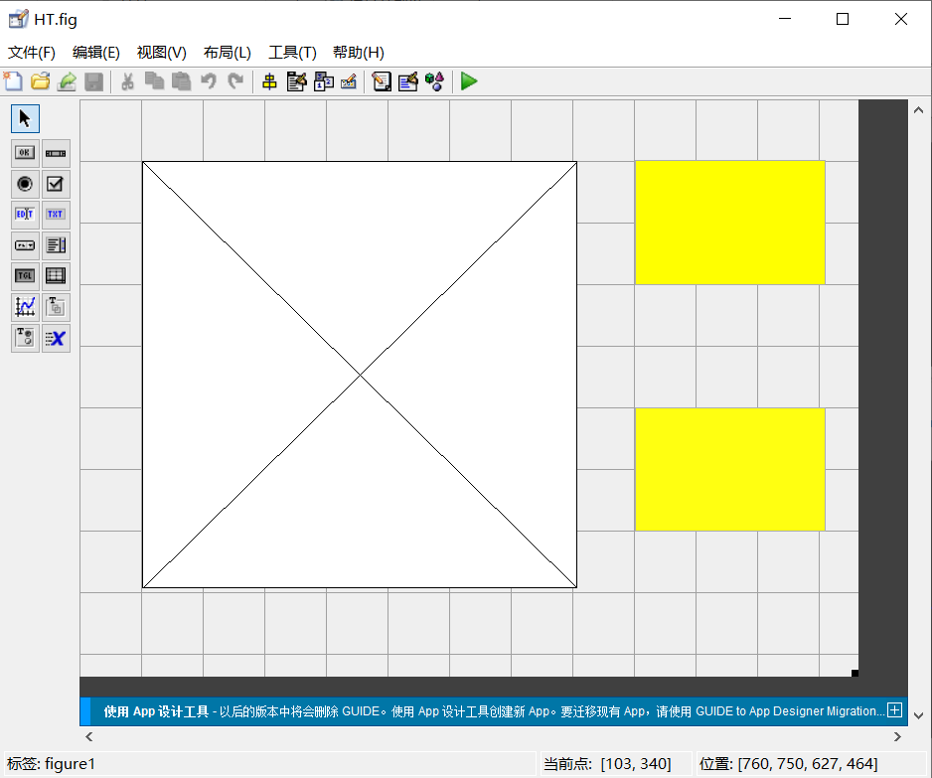

Then we can open the built-in function interface of the drawing plug-in, and then we are faced with two problems: first, how to import the data in the workspace into the graphical interface, and second, how to draw to reflect the specific DOA Angle.

For the first problem, we use the "evalin" function under the initialization function of the built-in function and successfully import the required data, annotated ,  
as follows

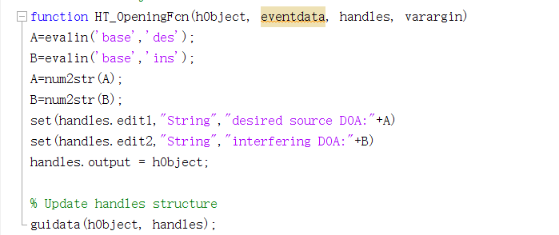

For the second problem, we use a circular statement to increase the DOA Angle value already obtained, make it different from other angles and bulge, and make it show graphically successfully, as shown below

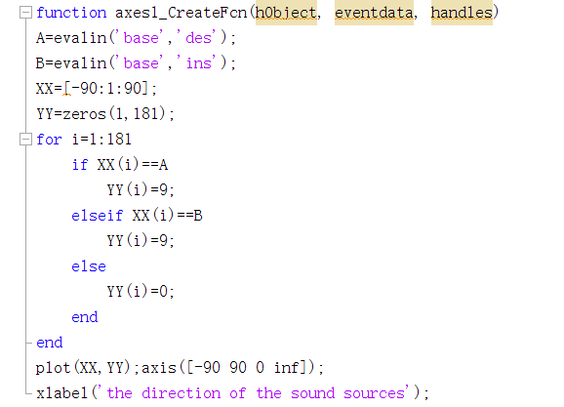

We take "Array output.wav" in T2 as an example and finally get the following result

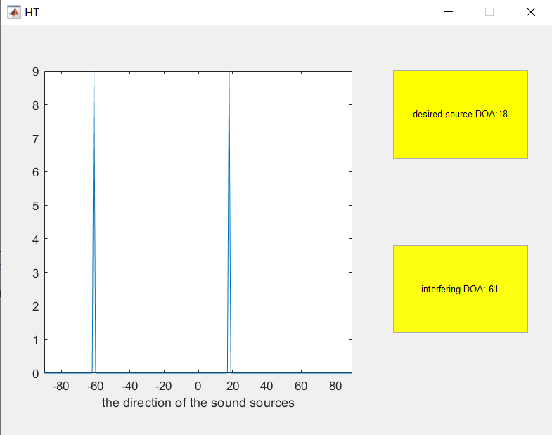

Other data can be similarly presented

(2)