Google Map: can find restaurants by cuisine – doesn’t have Vegetarian

Zomato: has vegetarian, but difficult to use map

Can’t save

Need one site that has just vegetarian

Search by cuisine

Ability to keep my own dining notes ….login to access

Restaurant listing:   
Zomato : address, type (fine dining/casual). Hours, delivery min& fee, link to menu, call option  
Users can add what Veg items are on menu or other notes(ie:rice made with chicken stock)

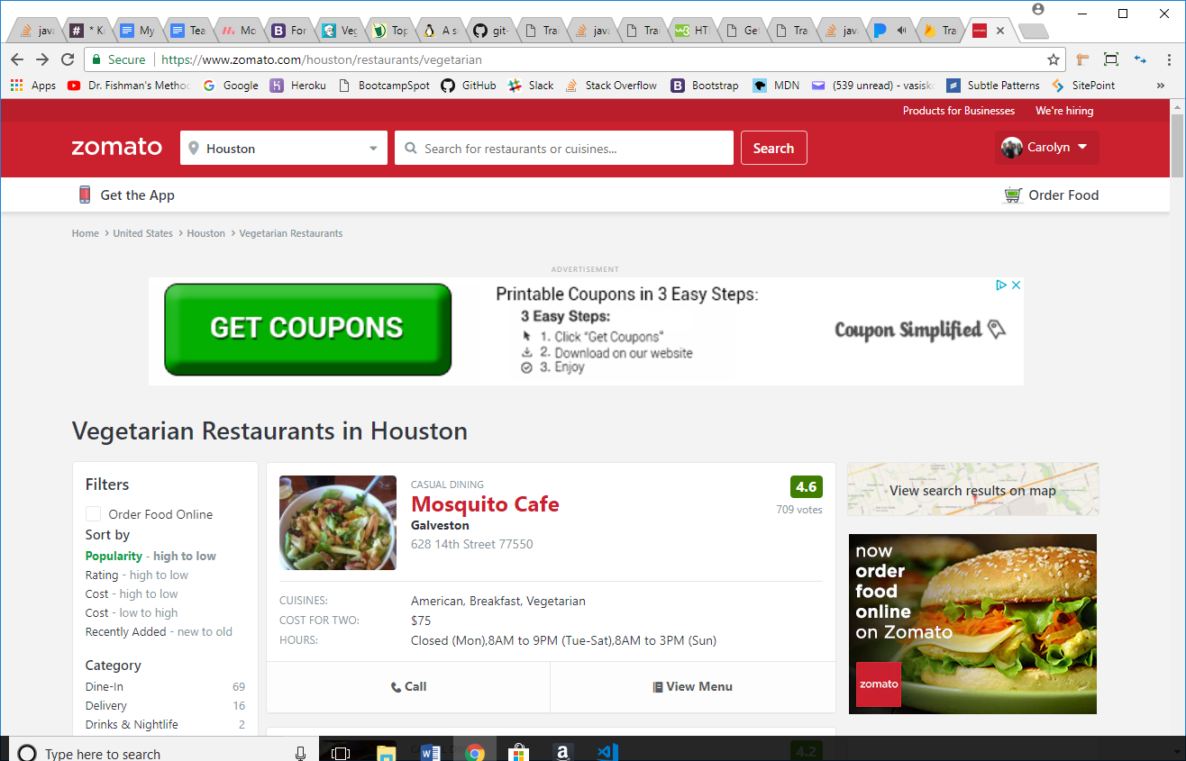

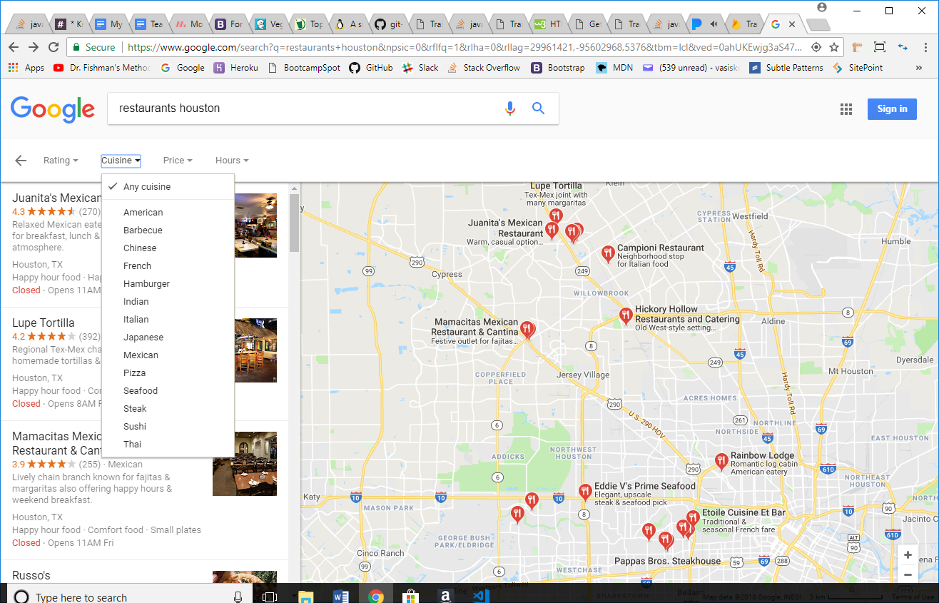

Design inspiration….

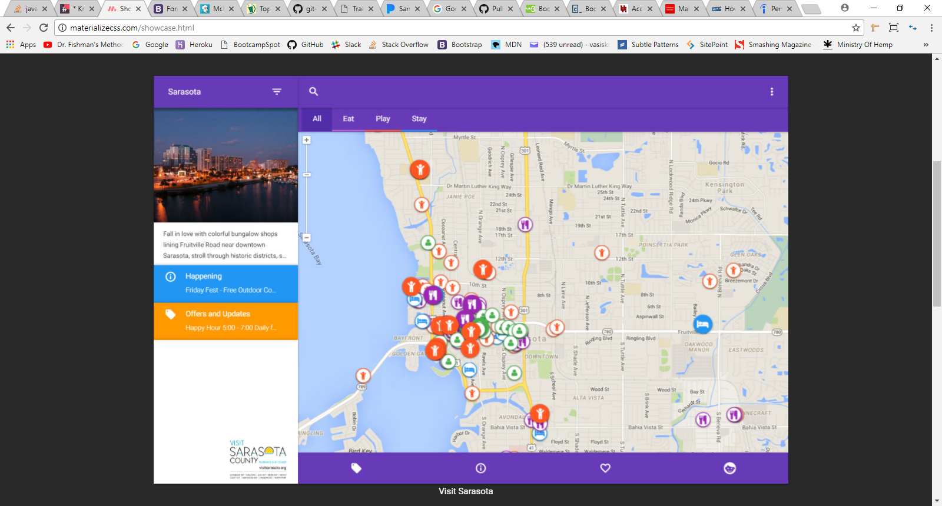

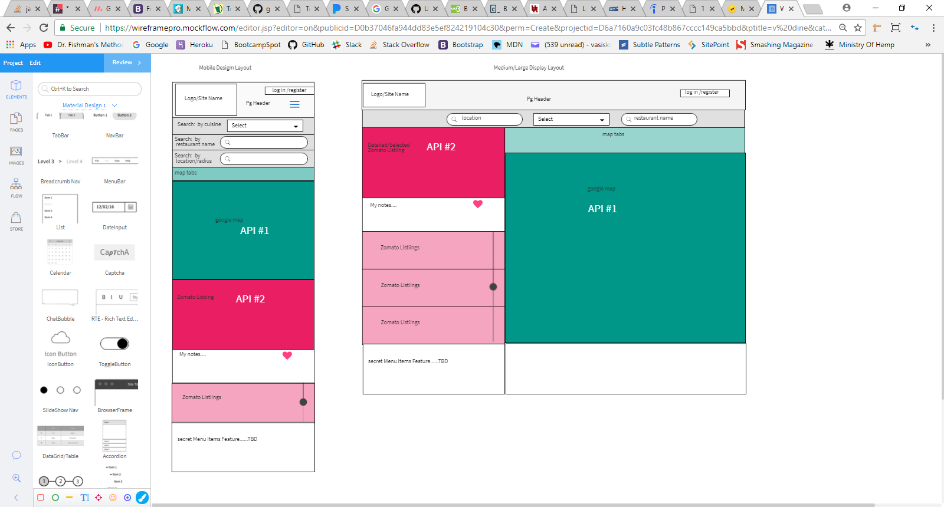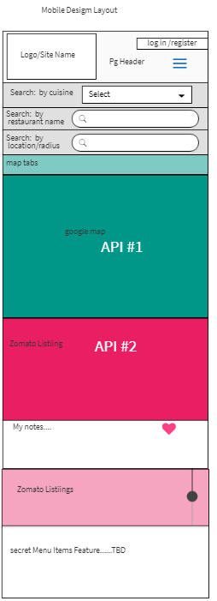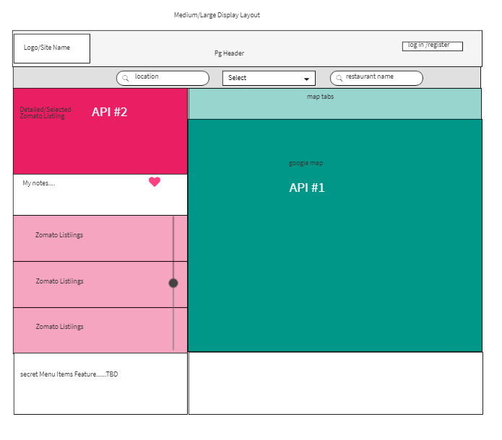

Secret Menu Info:

Starbucks: <https://starbuckssecretmenu.net/category/top-10-lists/>

Vegetarian Secret Menu Options | #HackTheMe:   
 http://hackthemenu.com/vegetarian-secret-menu-options/