EIE 2810 Digital System Design Laboratory

Laboratory Report #4

Name: LI, Yutao
Student ID: 121090294
Lab Date: March 17th

The Chinese University of Hong Kong, Shenzhen

Content

Introduction 3
1. Experiment A 3
1.1 Design 3
1.2 Results 3
2. Experiment B 4
2.1Design 4
2.2 Results 5
3. Experiment C 5
3.1 Design 5
3.2 Results 7
3.3 Questions 8
4. Experiment D 9
4.1 Design 9
4.2 Results 10
5. Conclusion 11

Introduction
This laboratory consists of 4 experiments, they are:
- Experiment A: The full adder simulation.
- Experiment B: Verify the 7-segment display with BCD codes.
- Experiment C: Verify the 2-bits * 2-bits multiplier with a 4-line-to-16-line decoder.
- Experiment D: Use the 7-segment display to show the outcomes of the 2-bits * 2-bits multiplier.

Experiment A

1.1 Design
To verify the full adder, with the truth table, we designed a circuit diagram for the full adder, and the designed circuit diagram is shown in Figure 1.

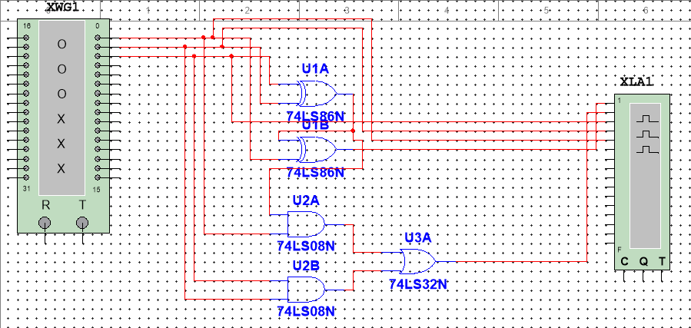
Figure 1 The Designed Circuit for the Full Adder
As shown in Figure 1, two XOR Gates, 2 AND Gates, and 1 OR Gate are used to construct this circuit.

1.2 Results
The truth table for full adder is shown in Table 1.

Table 1
Inputs |  |  | Outputs
A | B | C_{in} | C_{out} | Sum
0 | 0 | 0 | 0 | 0
0 | 0 | 1 | 0 | 1
0 | 1 | 0 | 0 | 1
0 | 1 | 1 | 1 | 0
1 | 0 | 0 | 0 | 1
1 | 0 | 1 | 1 | 0
1 | 1 | 0 | 1 | 0
1 | 1 | 1 | 1 | 1

The test results are shown in Figure 2.

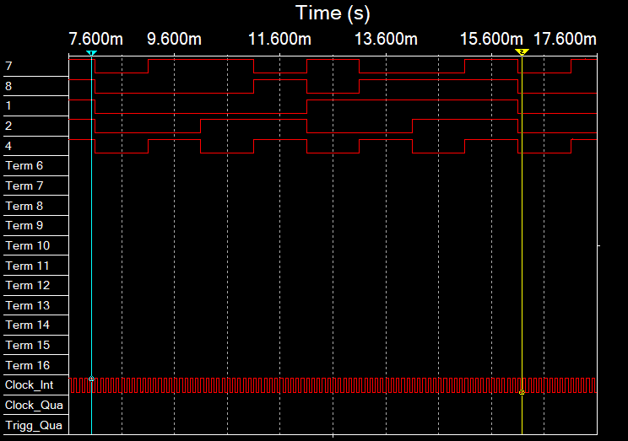
Figure 2 The Test Results for the Full Adder Circuit
As shown in Figure 2, the test results lie between the blue line and the yellow line, the top signal represents Sum, the second top signal represents C_{out}, the rest three signal represent A, B, and C_{in} from the third signal to the lowest signal, respectively. We can see that the Sum signal is in high level when there are one or three high-level input signals, and the C_{out} signal is in high level when there are two or three high-level inout signals, which are all go well with the truth table. This means our design successfully verified the two-bits full adder.

Experiment B

2.1Design
To verify the 7-segment display, a circuit was designed according to the 74LS47 truth table. The designed circuit diagram is shown in Figure 3.

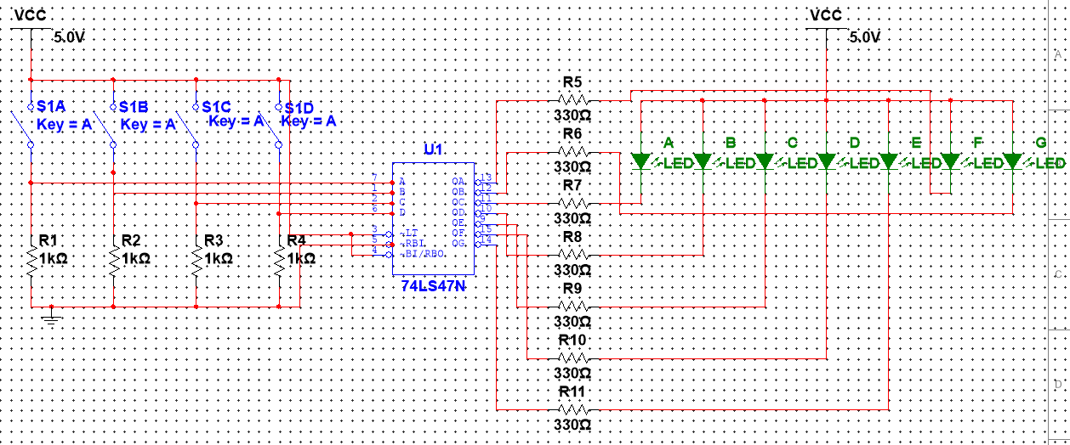
Figure 3 The Designed Circuit for the 7-Segment Display
As shown in Figure 3, four SIMs are used to produce the BCD codes adn they are connected to the inputs of the 74LS47 IC, 7 outputs of the 74LS47 IC are connected to 7 LEDs, which represent 7 LEDs on the 7-segment display.

2.2 Results
A circuit was assembled according to the circuit diagram shown in Figure 3. Different BCD signals are given to the input of the circuit, the results are shown in Figure 4.

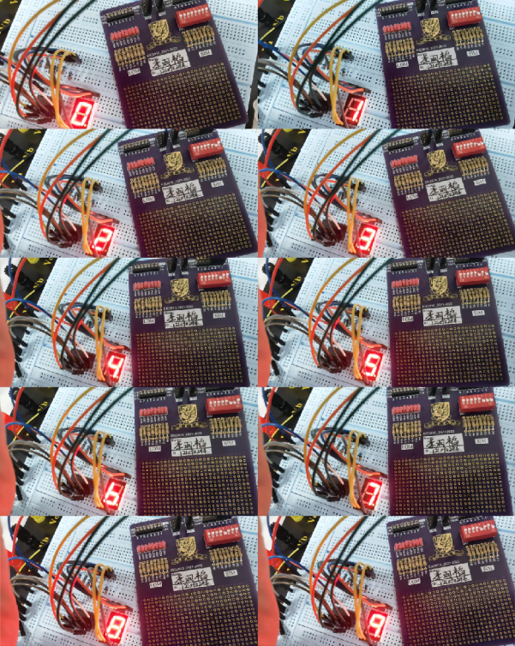
Figure 4 The 7-Segmengt Display With Different Input BCD Signals
As shown in Figure 4, when the input BCD signal is 0000, the 7-segment display is 0, when the input BCD signal is 0001, the 7-segment display is 1; when the input BCD signal is 0010, the 7-segment display is 2; when the input BCD signal is 0011, the 7-segment display is 3; when the input BCD signal is 0100, the 7-segment display is 4; when the input BCD signal is 0101, the 7-segment display is 5; when the input BCD signal is 0110, the 7-segment display is 6; when the input BCD signal is 0111, the 7-segment display is 7; when the input BCD signal is 1000, the 7-segment display is 8; when the input BCD signal is 1001, the 7-segment display is 9.,which are all correct. This means we successfully verified the 7-segment display circuit.

Experiment C

3.1 Design
To verify the 2-bits * 2-bits multiplier with IC 74HC154 (4-line-to-16-line decoder), a circuit was designed according to the multiplier truth table. The truth table of the multiplier is shown in Table 2, the output of the decoder corresponding to different inputs is shown in Table 3 (the decoder is always enabled to get the results).

Table 2
A0 | A1 | B0 | B1 |  | Y3 | Y2 | Y1 | Y0
0 | 0 | 0 | 0 |  | 0 | 0 | 0 | 0
0 | 0 | 0 | 1 |  | 0 | 0 | 0 | 0
0 | 0 | 1 | 0 |  | 0 | 0 | 0 | 0
0 | 0 | 1 | 1 |  | 0 | 0 | 0 | 0
0 | 1 | 0 | 0 |  | 0 | 0 | 0 | 0
0 | 1 | 0 | 1 |  | 0 | 0 | 0 | 1
0 | 1 | 1 | 0 |  | 0 | 0 | 1 | 0
0 | 1 | 1 | 1 |  | 0 | 0 | 1 | 1
1 | 0 | 0 | 0 |  | 0 | 0 | 0 | 0
1 | 0 | 0 | 1 |  | 0 | 0 | 1 | 0
1 | 0 | 1 | 0 |  | 0 | 1 | 0 | 0
1 | 0 | 1 | 1 |  | 0 | 1 | 1 | 0
1 | 1 | 0 | 0 |  | 0 | 0 | 0 | 0
1 | 1 | 0 | 1 |  | 0 | 0 | 1 | 1
1 | 1 | 1 | 0 |  | 0 | 1 | 1 | 0
1 | 1 | 1 | 1 |  | 1 | 0 | 0 | 1

Table 3
A0 | A1 | B0 | B1 | Outputs
 |  |  |  | O0 | O1 | O2 | O3 | O4 | O5 | O6 | O7 | O8 | O9 | O10 | O11 | O12 | O13 | O14 | O15
0 | 0 | 0 | 0 | 0 | 1 | 1 | 1 | 1 | 1 | 1 | 1 | 1 | 1 | 1 | 1 | 1 | 1 | 1 | 1
0 | 0 | 0 | 1 | 1 | 0 | 1 | 1 | 1 | 1 | 1 | 1 | 1 | 1 | 1 | 1 | 1 | 1 | 1 | 1
0 | 0 | 1 | 0 | 1 | 1 | 0 | 1 | 1 | 1 | 1 | 1 | 1 | 1 | 1 | 1 | 1 | 1 | 1 | 1
0 | 0 | 1 | 1 | 1 | 1 | 1 | 0 | 1 | 1 | 1 | 1 | 1 | 1 | 1 | 1 | 1 | 1 | 1 | 1
0 | 1 | 0 | 0 | 1 | 1 | 1 | 1 | 0 | 1 | 1 | 1 | 1 | 1 | 1 | 1 | 1 | 1 | 1 | 1
0 | 1 | 0 | 1 | 1 | 1 | 1 | 1 | 1 | 0 | 1 | 1 | 1 | 1 | 1 | 1 | 1 | 1 | 1 | 1
0 | 1 | 1 | 0 | 1 | 1 | 1 | 1 | 1 | 1 | 0 | 1 | 1 | 1 | 1 | 1 | 1 | 1 | 1 | 1
0 | 1 | 1 | 1 | 1 | 1 | 1 | 1 | 1 | 1 | 1 | 0 | 1 | 1 | 1 | 1 | 1 | 1 | 1 | 1
1 | 0 | 0 | 0 | 1 | 1 | 1 | 1 | 1 | 1 | 1 | 1 | 0 | 1 | 1 | 1 | 1 | 1 | 1 | 1
1 | 0 | 0 | 1 | 1 | 1 | 1 | 1 | 1 | 1 | 1 | 1 | 1 | 0 | 1 | 1 | 1 | 1 | 1 | 1
1 | 0 | 1 | 0 | 1 | 1 | 1 | 1 | 1 | 1 | 1 | 1 | 1 | 1 | 0 | 1 | 1 | 1 | 1 | 1
1 | 0 | 1 | 1 | 1 | 1 | 1 | 1 | 1 | 1 | 1 | 1 | 1 | 1 | 1 | 0 | 1 | 1 | 1 | 1
1 | 1 | 0 | 0 | 1 | 1 | 1 | 1 | 1 | 1 | 1 | 1 | 1 | 1 | 1 | 1 | 0 | 1 | 1 | 1
1 | 1 | 0 | 1 | 1 | 1 | 1 | 1 | 1 | 1 | 1 | 1 | 1 | 1 | 1 | 1 | 1 | 0 | 1 | 1
1 | 1 | 1 | 0 | 1 | 1 | 1 | 1 | 1 | 1 | 1 | 1 | 1 | 1 | 1 | 1 | 1 | 1 | 0 | 1
1 | 1 | 1 | 1 | 1 | 1 | 1 | 1 | 1 | 1 | 1 | 1 | 1 | 1 | 1 | 1 | 1 | 1 | 1 | 0

According to Table 2 and Table 3, we can get the relationship between the output signal (Y3, Y2, Y1, Y0) and the output of the decoder (O0, O1, ..., O15).
$$Y3=O15=\overset{̿}{O15}$$
$$Y2=O14+O11+O10=\overline{\overline{O14} \overline{O11}}+\overset{̿}{O10}$$
$$Y1=O6+O7+O9+O11+O13+O14=\overline{\overline{O6} \overline{O7}}+\overline{\overline{O9} \overline{O11}}+\overline{\overline{O13} \overline{O14}}$$
$$Y0=O5+O7+O13+O15=\overline{\overline{O5} \overline{O7}}+\overline{\overline{O13} \overline{O15}}$$
With all of these relationships, we can design a circuit as shown in Figure 5.

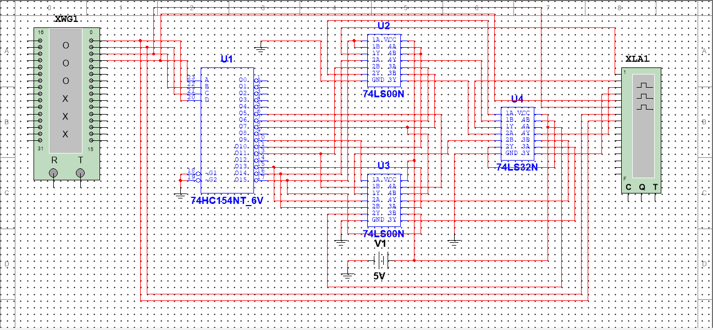
Figure 5 The IC Level Designed Circuit Diagram
As shown in Figure 5, one NAND Gate is used to produce $\overset{̿}{O15}$; 2 NAND Gates and 1 OR Gate are used to produce $\overline{\overline{O14} \overline{O11}}+\overset{̿}{O10}$; 3 NAND Gates and 2 OR Gates are used to produce $\overline{\overline{O6} \overline{O7}}+\overline{\overline{O9} \overline{O11}}+\overline{\overline{O13} \overline{O14}}$; and 2 NAND Gates and 1 OR Gates are used to produce $\overline{\overline{O5} \overline{O7}}+\overline{\overline{O13} \overline{O15}}$.

3.2 Results
The finished circuit for the circuit diagram in Figure 5 is shown in Figure 6.

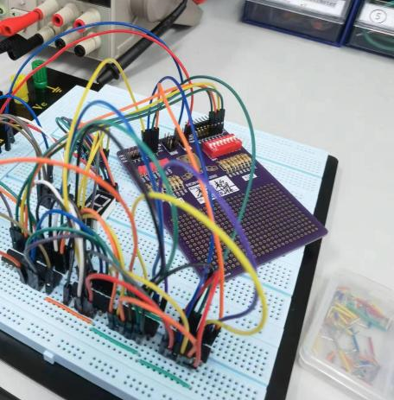
Figure 6 The Finished Circuit for the Multiplier With Decoder
Give the SIM different input and check the luminous condition of the LOM. The luminous conditions for different input logic are shown in Figure 7 and Figure 8.

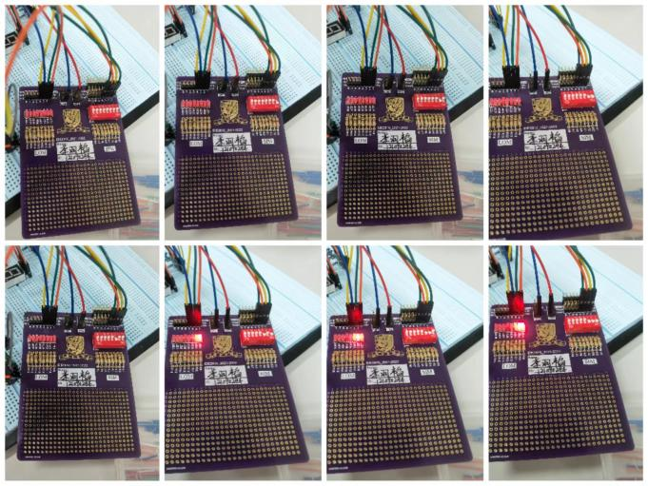
Figure 7 The Luminous Condition for First 8 Input Logic (0000 to 0111)
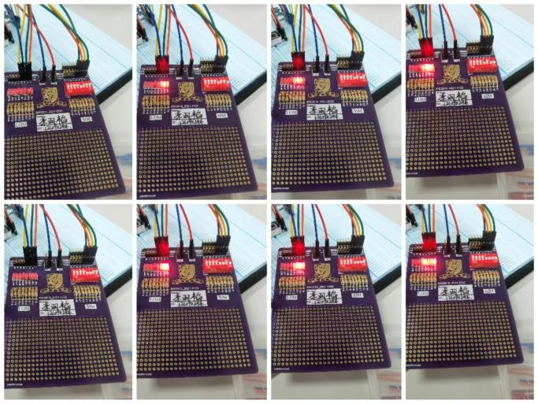
Figure 8 The Luminous Condition for Rest of the Input Logic (1000 to 1111)
As shown in Figure 7 and Figure 8, the output is 0001₂ (1₁₀) when the input is 01₂ and 01₂ (1₁₀), the output is 0010₂ (2₁₀) when one input is 01₂ (1₁₀) and another is 10₂ (2₁₀), the output is 0100₂ (4₁₀) when both inputs are 10₂ (2₁₀), the output is 0011₂ (3₁₀) when one inout is 11₂ and another is 01₂ (1₁₀), the output is 0110₂ (6₁₀) when one input is 11₂ (3₁₀) and another is 10₂ (2₁₀), the output is 1001₂ (9₁₀) when both two inputs are 11₂ (3₂). and the output is 0000₂ (0₁₀) otherwise. All of the results go well with the truth table, which means we successfully constructed the multiplier with decoder.

3.3 Questions
Step 1: Work out the truth table, a 2-bit binary number adding another 2-bit binary number will not give a result that exceeding 3 bits. So, 3 outcome bits are used. The truth table is shown in Table 4.

Table 4
A0 | A1 | B0 | B1 |  | Y2 (or carry bit) | Y1 | Y0
0 | 0 | 0 | 0 |  | 0 | 0 | 0
0 | 0 | 0 | 1 |  | 0 | 0 | 1
0 | 0 | 1 | 0 |  | 0 | 1 | 0
0 | 0 | 1 | 1 |  | 0 | 1 | 1
0 | 1 | 0 | 0 |  | 0 | 0 | 1
0 | 1 | 0 | 1 |  | 0 | 1 | 0
0 | 1 | 1 | 0 |  | 0 | 1 | 1
0 | 1 | 1 | 1 |  | 1 | 0 | 0
1 | 0 | 0 | 0 |  | 0 | 1 | 0
1 | 0 | 0 | 1 |  | 0 | 1 | 1
1 | 0 | 1 | 0 |  | 1 | 0 | 0
1 | 0 | 1 | 1 |  | 1 | 0 | 1
1 | 1 | 0 | 0 |  | 0 | 1 | 1
1 | 1 | 0 | 1 |  | 1 | 0 | 0
1 | 1 | 1 | 0 |  | 1 | 0 | 1
1 | 1 | 1 | 1 |  | 1 | 1 | 0

Step 2: Construct the relationship between the truth table (Y2, Y1, and Y0) and the outputs of the decoder (O0, O1,..., O15).
$$Y2=O7+O10+O11+O13+O14+O15=\overline{\overline{O7} \overline{O10} \overline{O11} \overline{O13} \overline{O14} \overline{O15}}$$
$$Y1=O2+O3+O5+O6+O8+O9+O12+O15=\overline{\overline{O2} \overline{O3} \overline{O5} \overline{O6} \overline{O8} \overline{O9} \overline{O12} \overline{O15}}$$
$$Y0=O1+O3+O4+O6+O9+O11+O12+O14=\overline{\overline{O1} \overline{O3} \overline{O4} \overline{O6} \overline{O9} \overline{O11} \overline{O12} \overline{O14}}$$
Step 3: Design the logic symbol level circuit diagram. The designed circuit diagram is shown in Figure 9.

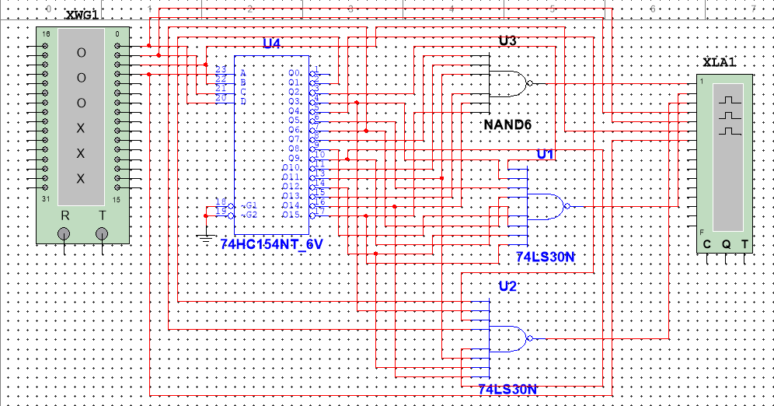
Figure 9 The Designed Circuit Diagram for the 2-bit+2-bit Adder

Experiment D

4.1 Design
To combine the 7-segment display and the 4-line-to-16-line decoder, a circuit was designed according to the 74LS47 truth table and 74HC154 truth table. The designed circuit diagram is shown in Figure 10.

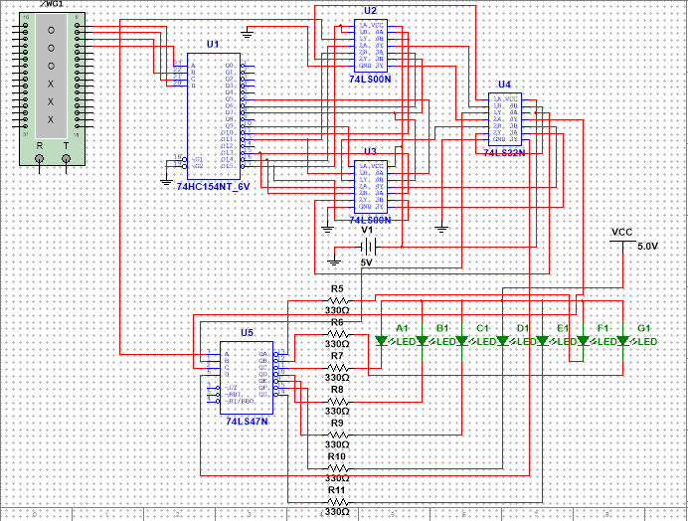
Figure 10 The Designed Circuit for the Combination of the 7-Segment Display and the 4-Line-to-16-Line Decoder

4.2 Results
The results of the 7-segment display corresponding to different input 2-bit*2-bit signal are shown in Figure 11 and Figure 12.

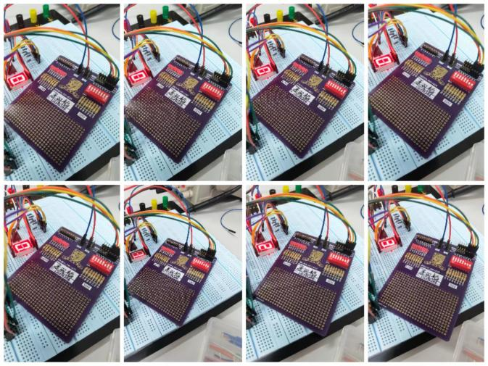
Figure 11 The 7-Segment Outputs for First 8 Input Logic (0000 to 0111)
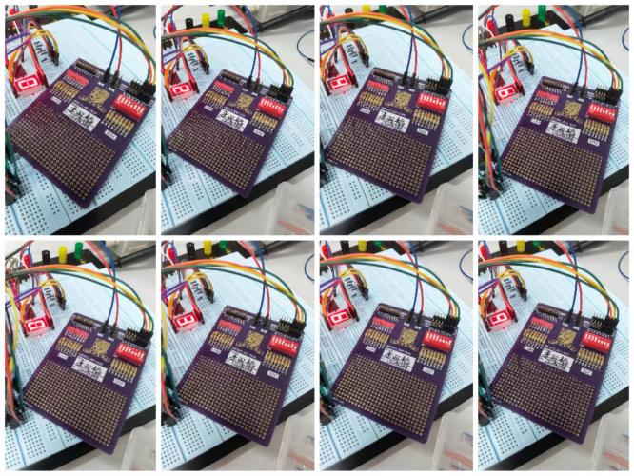
Figure 12 The 7-Segment Outputs for Rest of the Input Logic (1000 to 1111)
As shown in Figure 11 and Figure 12, the output is 1₁₀ when the input is 01₂ and 01₂ (1₁₀), the output is 2₁₀ when one input is 01₂ (1₁₀) and another is 10₂ (2₁₀), the output is 4₁₀ when both inputs are 10₂ (2₁₀), the output 3₁₀ when one inout is 11₂ and another is 01₂ (1₁₀), the output is 6₁₀ when one input is 11₂ (3₁₀) and another is 10₂ (2₁₀), the output is 9₁₀ when both two inputs are 11₂ (3₂). and the output is 0₁₀ otherwise. All of the results go well with the truth table, which means we successfully constructed the multiplier with decoder and combined it with 7-segment display.

Conclusion
In this lab, we did full-adder simulation, verified the 7-segment display and a multiplier with decoder, and we combined the 7-segment display and the multipier with decoder.From the lab, we know:
- The inner principle of the full-adder.
- The way to use the 7-segement display circuit element.
- The way to make use of and the logic the decoder.
- The way to use a decoder to construct a multiplier.
- The way to combine the constructed multiplier to the 7-segment display.

