Reading Guide for Eric R. Kandel, In Search of Memory: The Emergence of a New Science of Mind (New York: W. W. Norton & Company, 2006).

Core questions:
What is the human mind?

Introduction:
→ About Kandel, In Search of Memory and Chapter 4 “One cell at a time”
→ Main ideas in Chapter 28 “Consciousness”
# The unity and subjectivity of consciousness
# Unconscious emotional perception
# Free will
→ Implications

We think, we feel and we remember – how is it possible for our mind to have these amazing capabilities that make us human and who we are? How does our mind come into existence? Can our mind be understood by studying the complex organ in our head we call the brain?

These perplexing questions have been asked for more than two thousand years. Only until recent decades, scientists are ready to tackle these questions by uncovering the secret of the brain. More than one hundred years ago, Poincare could only speculate about the mental process of mathematical discovery as we went through Text 7 last week. This week, we will see how scientists today take up this big – even formidable – challenge at a modest distance through reading the excerpts from In Search of Memory: The Emergence of a New Science of Mind written by Eric R. Kandel, the Nobel laureate in Physiology or Medicine in 2000 for his contribution to the study of memory storage in the brain. In this autobiography, Kandel interweaved his scientific endeavour with the intellectual history of the emergence of a new science of studying mind – understanding the human mind in biological terms at the levels of cells and molecules.

Born in a Jewish family, Kandel lived happily in Vienna until Hitler marched into the city in 1938. He was eight. A year later, he managed to escape from the Nazis and fled to the United States. As Kandel recalled, the childhood experience of humiliation and fear in his last year in Vienna had a tremendous impact on his career. At Harvard University, Kandel majored in modern European history and literature to investigate Nazism and endeavoured to become a historian – it was the work of Sigmund Freud which turned him into another direction. He was deeply fascinated by psychoanalysis and hoped to understand the human mind, including the irrational aspect of human motivation and behaviour. After graduation, he entered medical school at New York University and decided to become a practicing psychoanalyst. Working on a course on brain anatomy with great enthusiasm, Kandel was gradually drawn towards a project: to locate Freud’s ego, id and superego in the brain. Then he took an elective at Columbia University to study brain science with the leading neurobiologist Harry Grundfest. When he told Grundfest about his ambition during their very first conservation, Grundfest’s response was surprisingly discouraging. This first encounter greatly changed the life of Kandel – he left psychoanalysis for the new science of mind, and is vividly depicted in Chapter 4 “One cell at a time”, our first selection from In Search of Memory.

In our second selection, Chapter 28 “Consciousness”, Kandel goes into “the most challenging task confronting science” – understanding consciousness, i.e. how consciousness derives from our physical brain. Why is it most challenging? Kandel explained it by the two characteristics of consciousness, namely unity and subjectivity. The unity of consciousness describes the phenomenon that despite numerous neural activities occurring in your brain, including those stimulated from your different senses, they are combined together seamlessly to create a single and coherent conscious experience owned by you. Taking a simple example, instead of two separated streams of images, you experience a unified vision from your eyes. How does unity happen in the brain? Kandel examined two theories, one from Francis Crick and his collaborators. We have met Crick in Text 5 for his discovery of the DNA structure with James Watson.

Nowadays scientists are still working hard to understand the unity of consciousness, but it is only considered to be an “easy problem” comparing to the “hard problem” – understanding of the subjectivity of consciousness, another characteristic of consciousness. The conscious experience is subjective – it is private, personal and unique. Your consciousness can only be experienced by you not by anyone else.
How does the subjective conscious experience arise from our physical brain? Some scientists and philosophers fear that this question cannot be answered via science – how can scientists objectively investigate subjective experience? Can the enormous gap between the subjective mental world and the objective physical world be bridged? Does the subjectivity of consciousness lie beyond the reach of science?

A problem once considered to be ineligible for scientific research might become eligible later on. After leaving psychoanalysis for a half century, Kandel could now explore the biological basis of Freud’s theory with brain imaging. He and his collaborators studied how and where unconscious emotional perceptions were processed in the brain. Another problem once considered scientifically inapproachable is the nature of free will - described at the end of the chapter. We seem to be able to choose the course of action for ourselves, yet the critical but debatable experiments carried out by Benjamin Libet show that we actually do not! So do we have free will? Is free will only an illusion?

There are still many questions to be answered. This is why Kandel wrote at the preface of In Search of Memory, “understanding the human mind in biological terms has emerged as the central challenge for science in the twenty-first century”. The road to understand the human mind is hard and challenging but it is greatly rewarding. Studying the human mind not only helps to develop more effective healing but also exhibits profound and even disturbing implications. Newton found the principles of the physical world, while Darwin, Watson and Crick found those of the world of life. Will the principles of our mind including the mysterious consciousness be found? If our mind can be fully explained by the cells and molecules in our brain, will our mind become “just a matter of physics and chemistry”? Will spirituality be ended? Are we only conscious but complex biological machines? And, at last, who are we?

Suggested outline of the text:
Chapter 4 — One cell at a time
1-9: How Kandel entered the field of brain science.
1: The first conversation between Kandel and Grundfest.
2-5: Freud’s structural theory of mind.
6-7: The conversation continued. Grundfest’s response: One cell at a time!
8-9: Kandel’s response.
10-53: Skipped.

Chapter 28 — Consciousness
1: Consciousness – the biggest question about the brain.
2: The working definition of consciousness.
3-4: Francis Crick and his scientific approach to life and consciousness.
5-7: Mind-body problem from the historical perspective.
8-9: Philosophers argues whether consciousness can be approached scientifically.
10-11: Two characteristics of the conscious state: Unity and subjectivity. The unity nature of consciousness.
12-15: Difficulty in explaining subjectivity.
16-19: Limitation of current methodology of science: no connection between objective phenomenon and subjective experience. The urge to find the “elements” of subjective experience.
20-28: Two theories to solve the easy problem of the consciousness, i.e. the unity of consciousness.
20: The hard and the easy problems.
21: The unity of consciousness as a variant of the binding problem.
22: Where is the neural machinery for the unity of consciousness? Gerald Edelman’s assertion and that of Crick and Koch.
23-25: Crick and Koch focused on claustrum.
26-27: The binocular rivalry experiment.
28: There are now two testable theories.
29-38: The author and his collaborators are working on unconscious emotional perception.
29-30: Background of the experiment.
31-33: The method of showing pictures of fearful faces and the result.
34-36: Analysis of the result.
37: Meaning of the result: the significance of unconsciousness.
38: The connection between the result and Freud.
39: Implications
40-44: The problem of free will
40: Introduction
41-42: Libet’s experiment and the result.
43-44: Discussions

Study Questions
(Answers can be found at the end of this session.)

(Chap. 4, Para. 1-5: Freud’s structural theory)
1. Circle the THREE psychic structures the author would like to locate in the brain:
Superego Supraego Sub-ego Id Pcpt-cs Ego

2. Freud uses an iceberg to represent the three levels of mental functions: Unconscious, Pre-conscious, and Conscious. Label the diagram below.
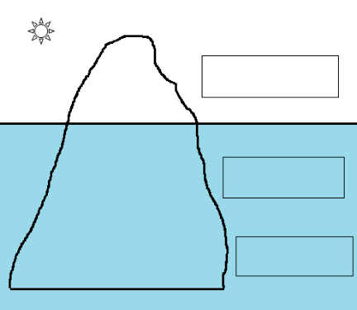

How can we improve our understanding of these components of personality?

(a)  (b)  (c) | By psychoanalysis.  By imagination.  By experience.
(d) | By dream analysis.

3. Complete the table according to Freud’s structural theory with the following terms:

i. Nature | ii. Conscious component | iii. Unconscious component
(a) executive agency | (d) does not exist | (h) concerned with psychological defences
(b) primitive mind | (e) in direct contact with the external world | (k) embodiment of aspirations
(c) moral agency | (f) concerned with perception and reasoning | (m) seeking pleasure and avoiding pain

Psychic agencies | i. Nature | ii. Conscious component | iii. Unconscious component
Ego
Id
Superego

(Chap. 4, Para. 7-9: To study the biological basis of Freud’s structural theory)
4. What advice did Grundfest give to the author?
(a) | Start studying a single animal.
(b) | Start studying a single brain.
(c) | Start studying a single nerve cell.
(d) | Start studying a single human.

5. What is the neuron doctrine?
(a) | There is only one cell in the human brain.
(b) | Nerve cells are the building blocks of the brain.
(c) | Only human being has an unconscious mental process.
(d) | Nerve cells control only the conscious motivation of behaviour.

(Chap. 28, Para. 1-4: The challenges about consciousness)

6. What were the TWO great biological questions that Francis Crick attempted to answer?
I. | What distinguishes the living from the non-living world?
II. | What is the nature of soul?
III. | What are the psychic agencies?
IV. | What are the building blocks of the brain?
V. | What is the biological nature of consciousness?

7. Circle the right answers:
McGinn: Consciousness (can / cannot) be studied.
Denett: There (is no / are many) problem(s) to study consciousness.
Searle and Nagel: Consciousness (can / cannot) be studied.
(Chap. 28, Para. 9-21: Characteristics of consciousness)
8. According to Searle and Nagel, consciousness is very complex because the processes of consciousness
(a) | represent more than the sum of their parts.
(b) | are not accessible for analysis.
(c) | are biological.
(d) | are different among individuals.

9. According to Searle and Nagel, what are the TWO characteristics of the conscious state?
(a) | Monism and dualism
(b) | Unity and subjectivity
(c) | Immaterial and immortal
(d) | Ego and Id

10. What is still unknown regarding the subjectivity of consciousness?
(a) | How neurons (brain cells) transmit signals.
(b) | How sensory modalities are melted into a single experience.
(c) | How electrical activity in neurons gives rise to our subjective conscious experience.
(d) | Whether soul exists or not.

(Chap. 28, Para. 22-28: Two theories of the unity of consciousness)
11. Circle the right answers to indicate the views of Edelman, Crick, and Koch on the biological basis of the unity of consciousness:
Edelman: The neural machinery for unity of consciousness is distributed throughout (thalamus / amygdala / claustrum / cortex) and (thalamus / amygdala / claustrum / cortex).
Crick & Koch: (thalamus / amygdala / claustrum / cortex) mediates unity of conscious experience.
12. In the experiment on binocular rivalry, what images were presented to the participants?
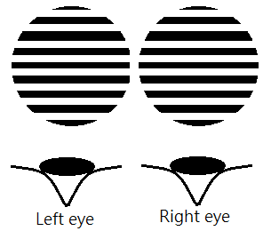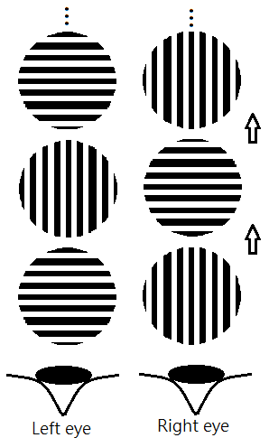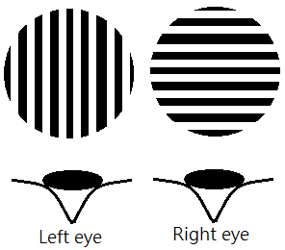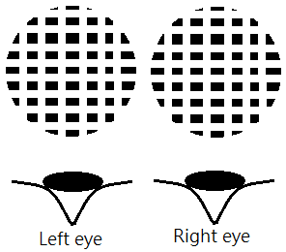
(a) (b) (c) (d)

(Chap. 28, Para. 29-39: The brain imaging study by Kandel and his collaborator)
13. Which of the following was NOT the purpose of the author’s experiment?
(a) | To understand how people respond unconsciously to emotional perceptions.
(b) | To find the part of the brain where the unconscious emotional perceptions are processed
(c) | To understand how people respond consciously to emotional perceptions.
(d) | To understand how emotional perceptions lead to mental disorder.

14. How did the researchers produce unconscious and conscious perception of fear respectively?
 | Unconscious | Conscious
(a) | presenting photos of fearful faces rapidly | presenting photos of fearful faces for a long period
(b) | playing scary music rapidly | presenting photos of fearful faces for a long period
(c) | presenting photos of fearful faces rapidly | reading horror stories for a long period
(d) | presenting photos of fearful faces for a long period | presenting photos of fearful faces rapidly

True or False:
The author’s brain imaging study found that:
15. | Amygdala is activated by both conscious and unconscious perception of fear.
16. | Both conscious and unconscious stimuli affect the same region of Amygdala.
17. | Unconsciously perceived threats proportionally affect people with high background anxiety.
18. | Consciously perceived threats activate the fight-or-flight response in all volunteers.
19. | The effects of anxiety are exerted more dramatically in the brain when the stimulus is left to the imagination.
20. | Kandel’s findings contradict Freud’s structural theory.

(Chap. 28, Para. 40-44: Libet’s experiment)
21. What was the aim of Libet’s experiment?
(a) | To prove the presence of readiness potential.
(b) | To investigate the nature of free will.
(c) | To compare the voluntary and involuntary finger movements.
(d) | To investigate the transfer of thoughts between people.

22. According to Libet, do we have any choice in our action? Why?
(a) | Yes. The conscious part of the brain initiates and executes the action.
(b) | Yes. The unconscious part of the brain initiates the action, but it requires the approval of consciousness for execution.
(c) | No. The action is initiated and executed without conscious awareness.
(d) | No. The unconscious part of the brain is not able to control our action.

— End —

