HW3:

Kun Han, 90607203

Ziyuan Cui, 47335412

Part1:

a):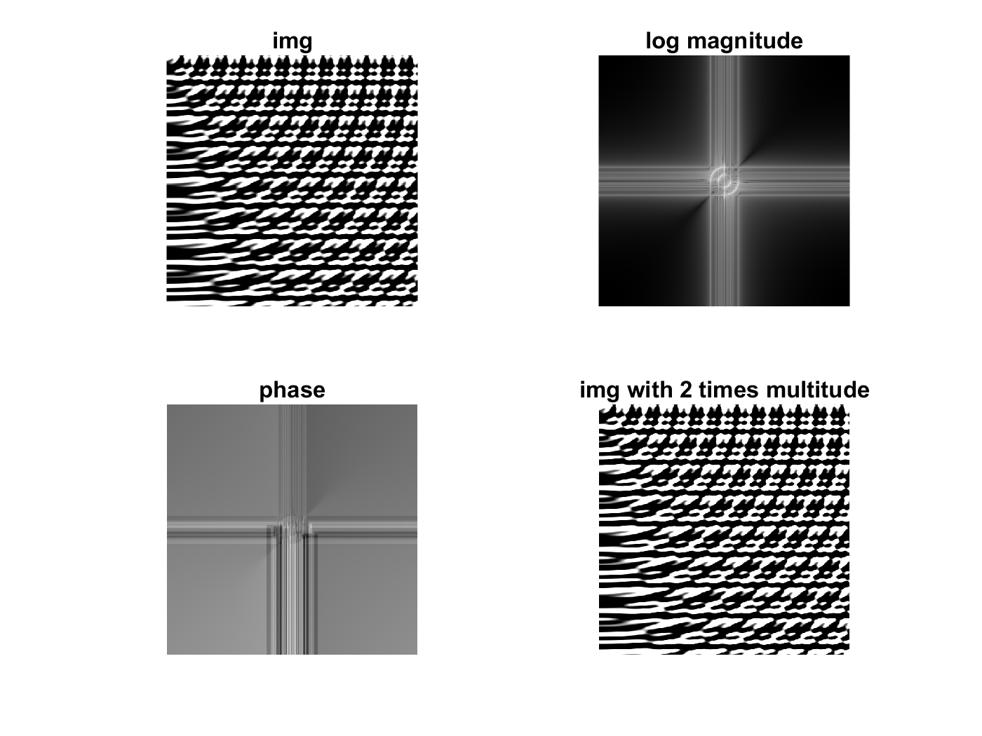

Almost no difference, between all frequencies are enlarged by the same scale.

b):

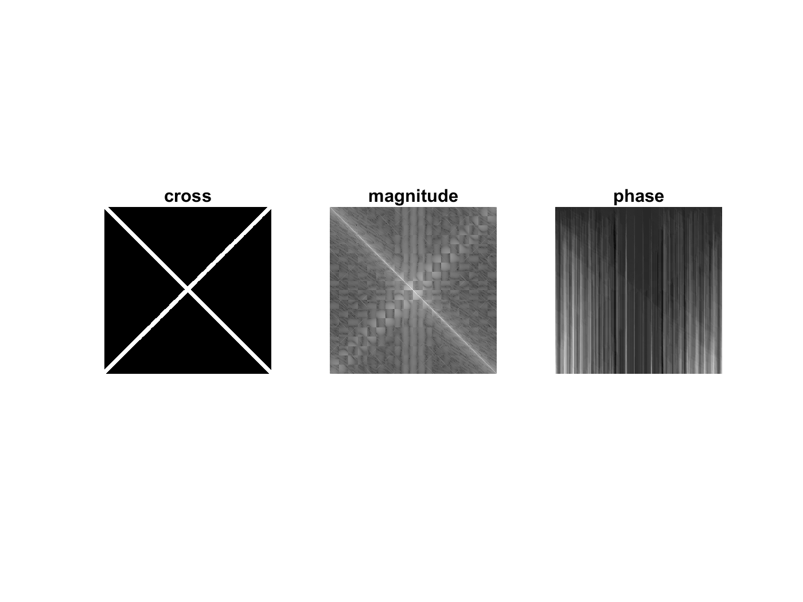

Because there two perpendicular lines (diagonal directions) in the cross image, frequency direction should be perpendicular to the edge in the original image, showing that there is a obvious change in the image plane. As a result, we can see there roughly 2 lines in the frequency image, each perpendicular to the direction of line in the original image.

Part2: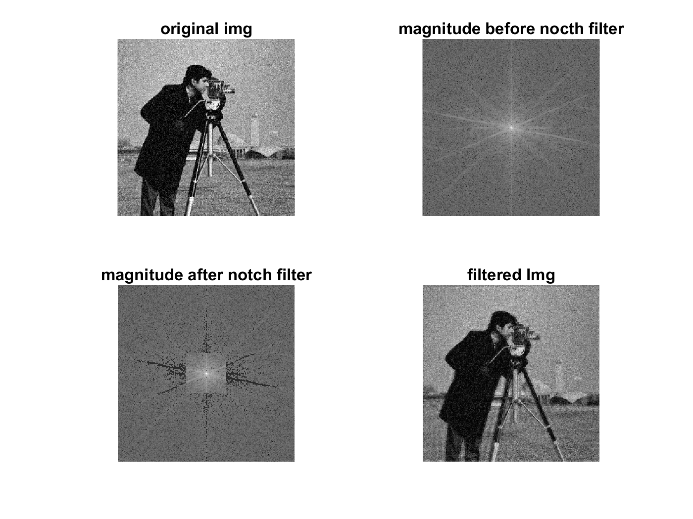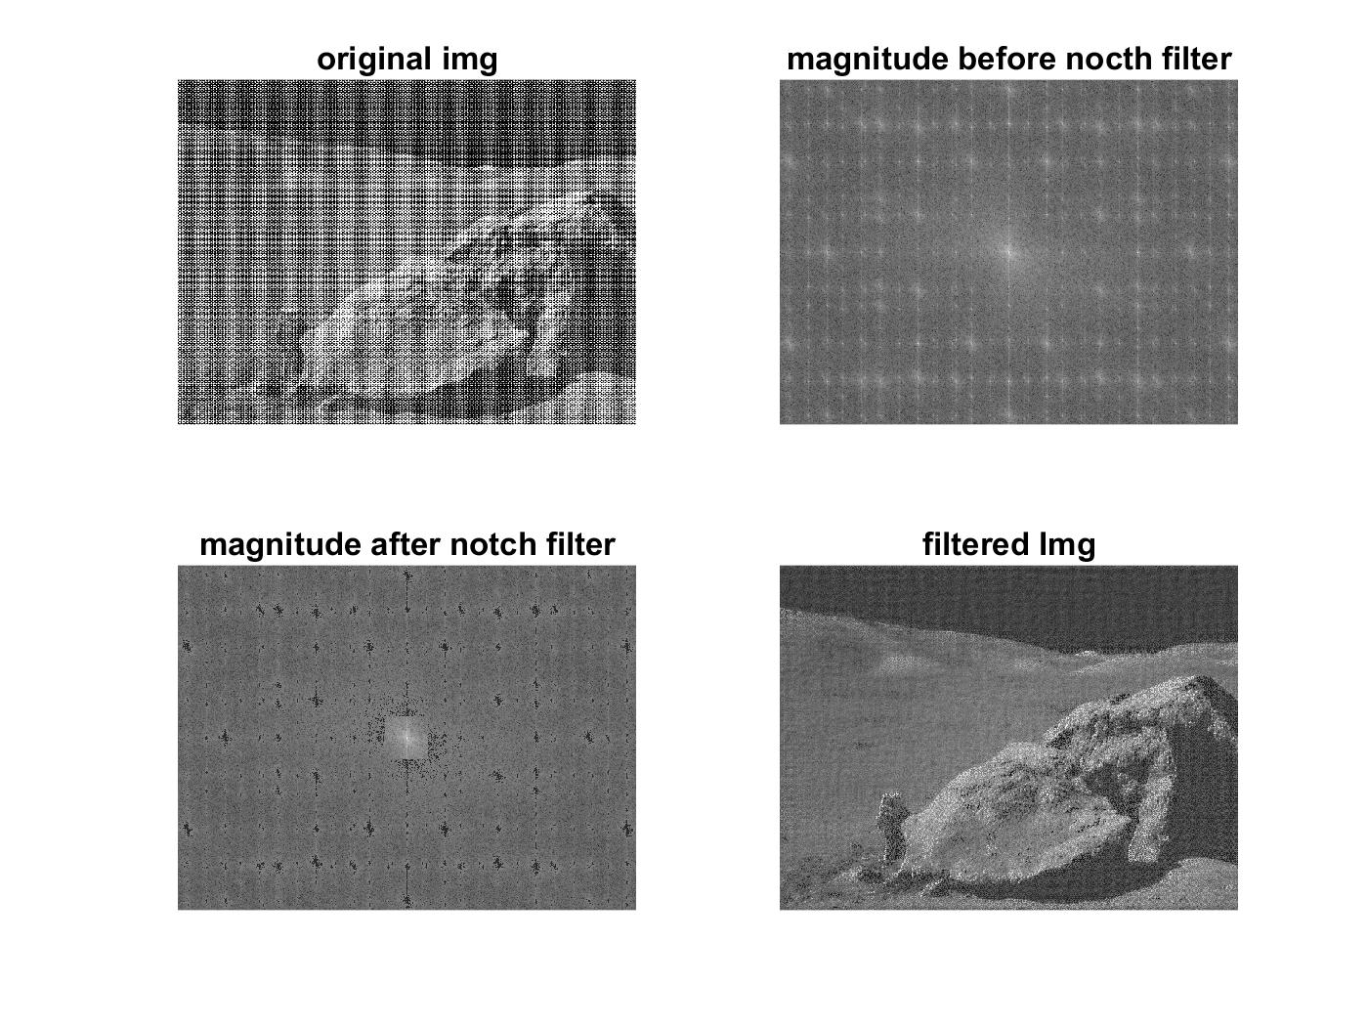

Part3: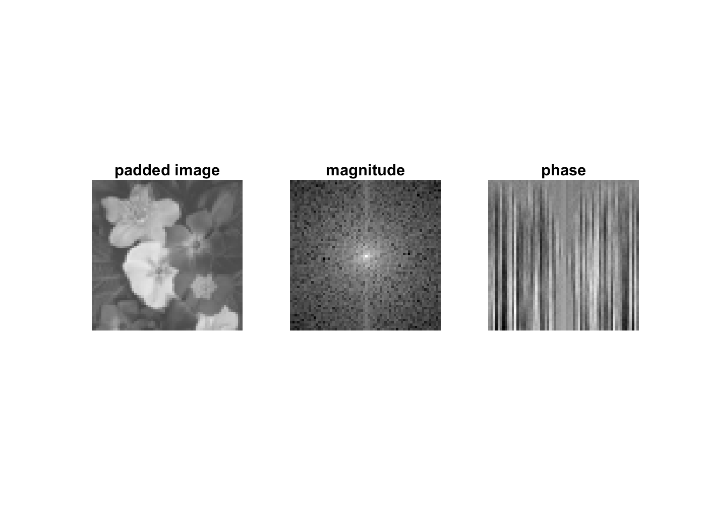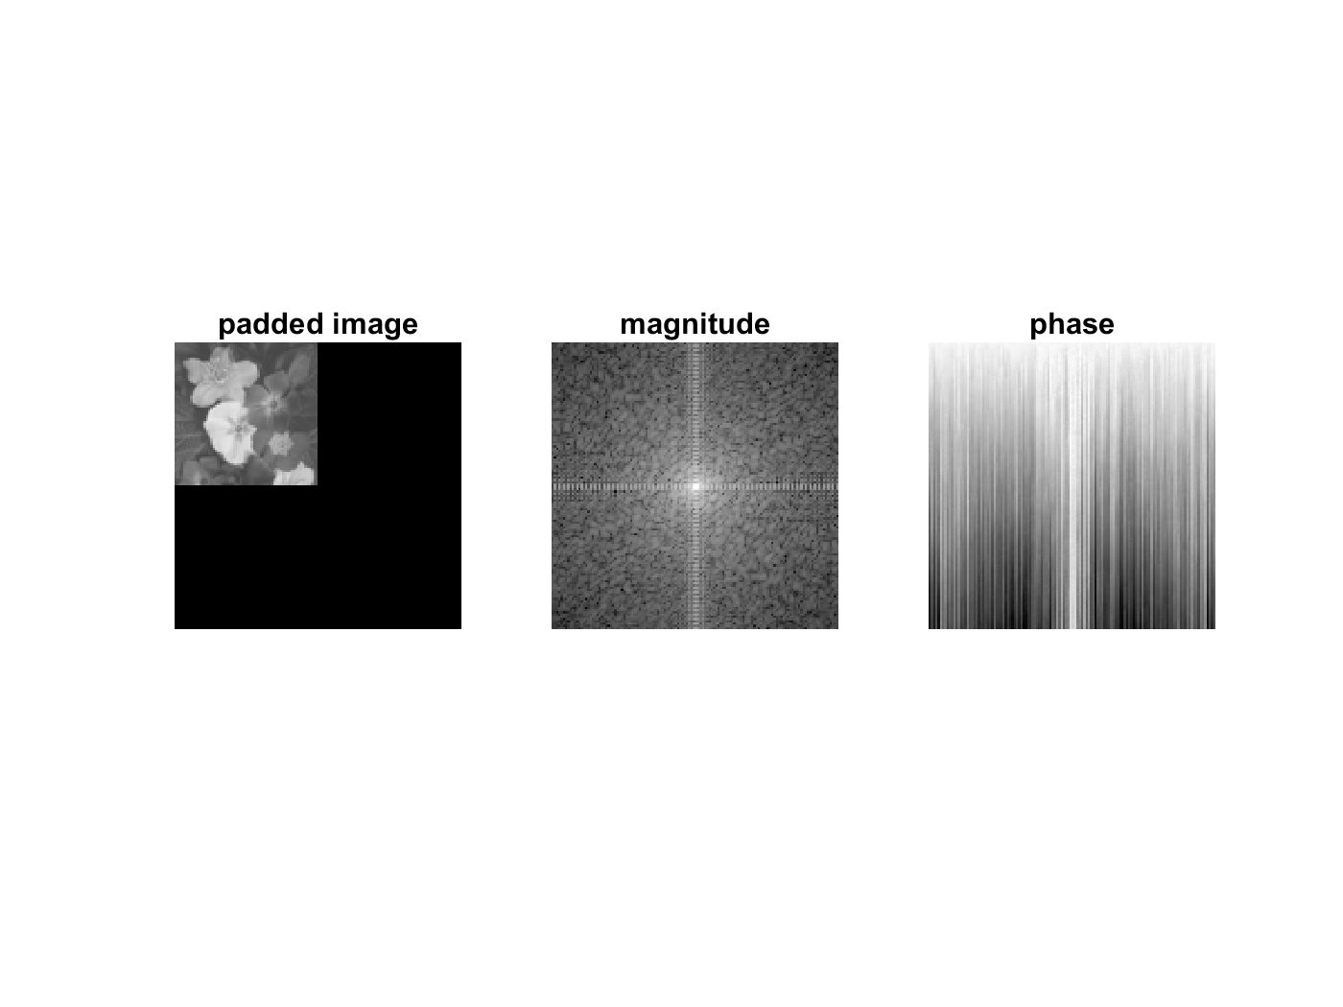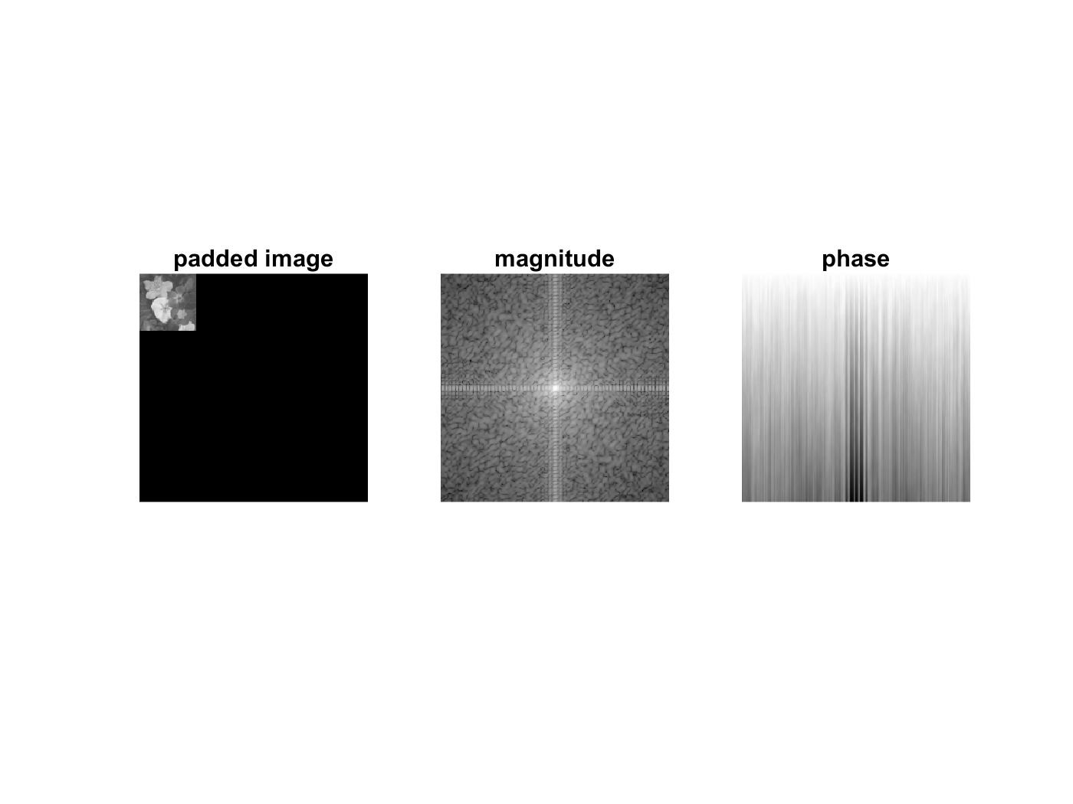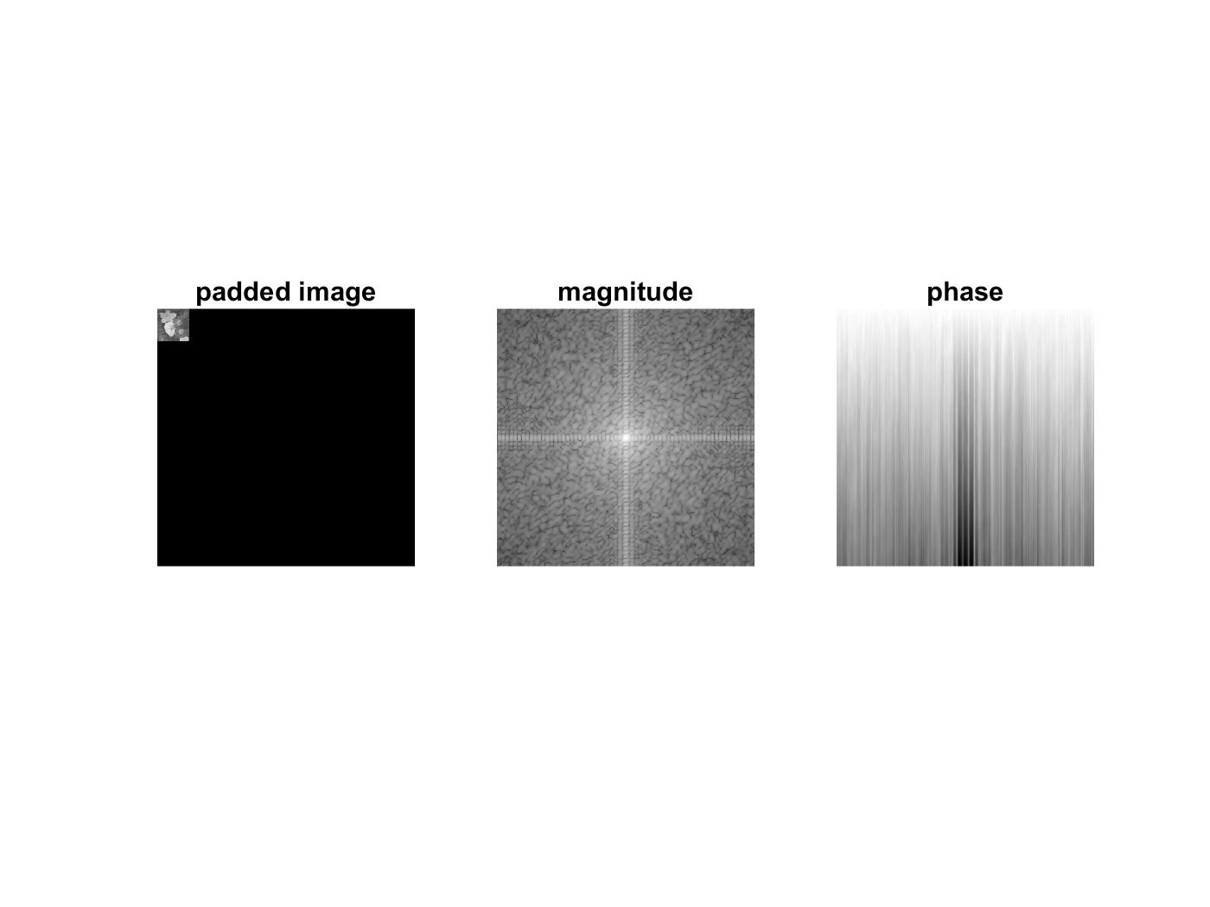

Compare to the original frequency, all the three padded image has 2 obvious lines in the magnitude map image for the sharp change due to the padding. The horizontal line in the magnitude map corresponds to the vertical padding to the original image, the vertical line is to the horizontal padding to the image.