Subset(1, 2, 3)

All the pictures used in the subset.

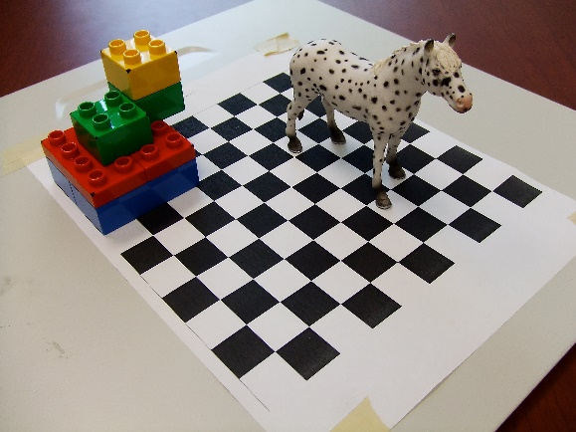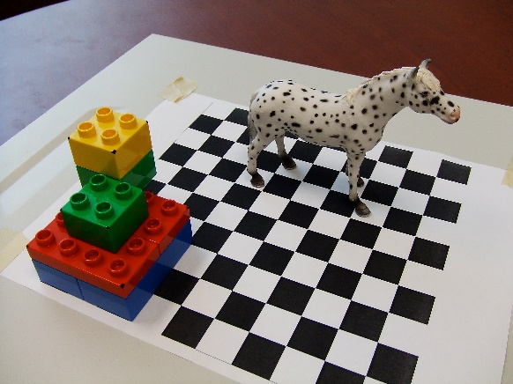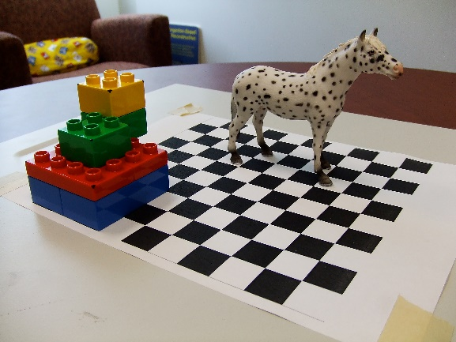

Show the top ten matching features for one pair of images.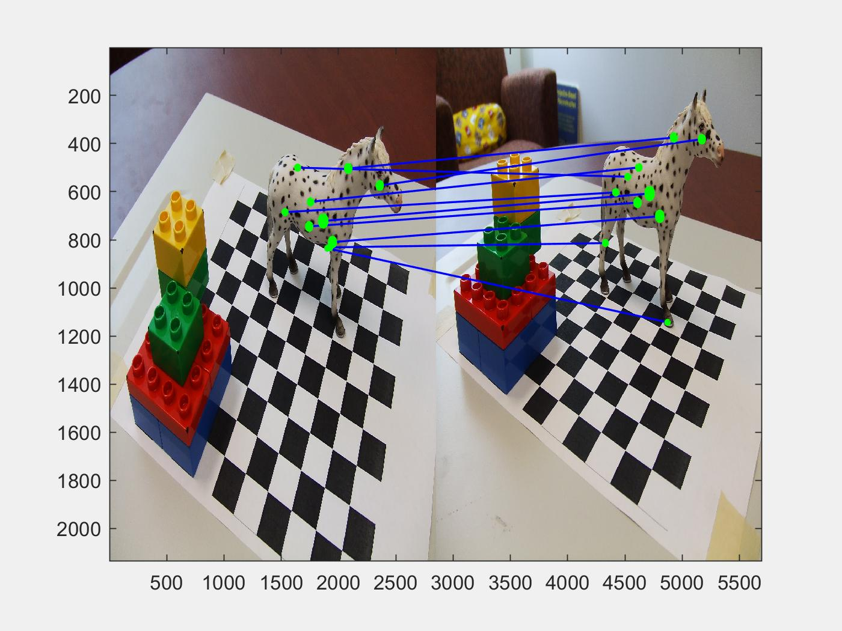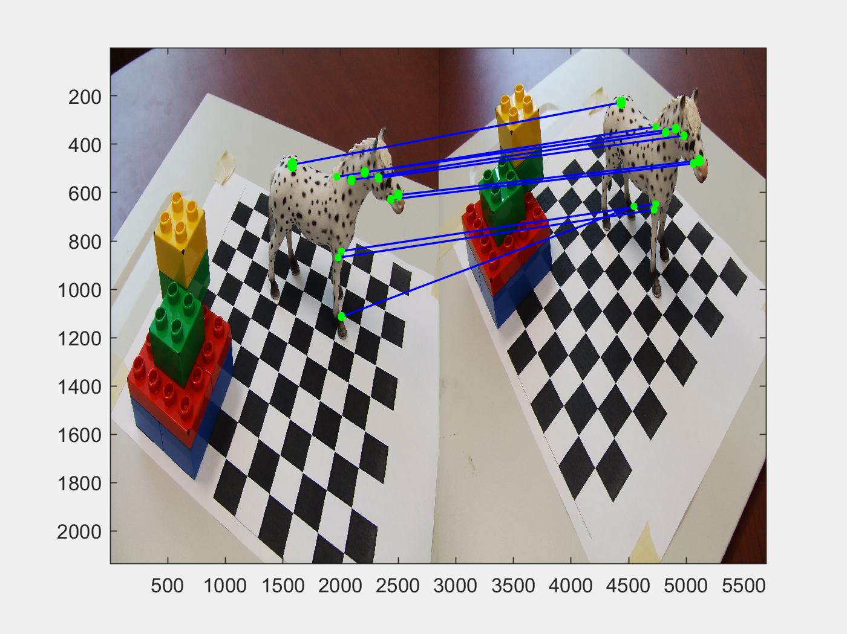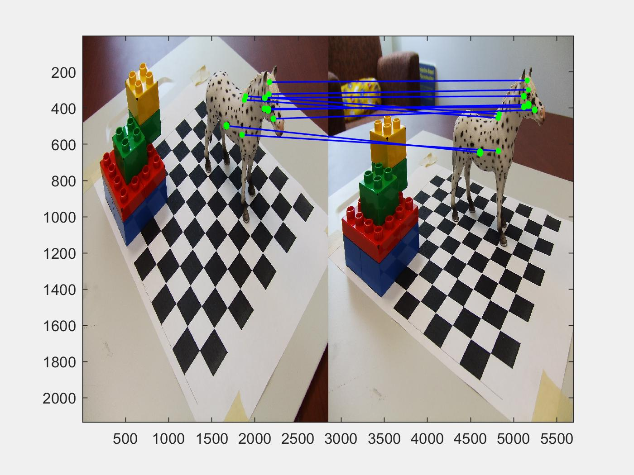

Show 3 examples of the epipolar line by showing the feature from one image and the corresponding line in the other images.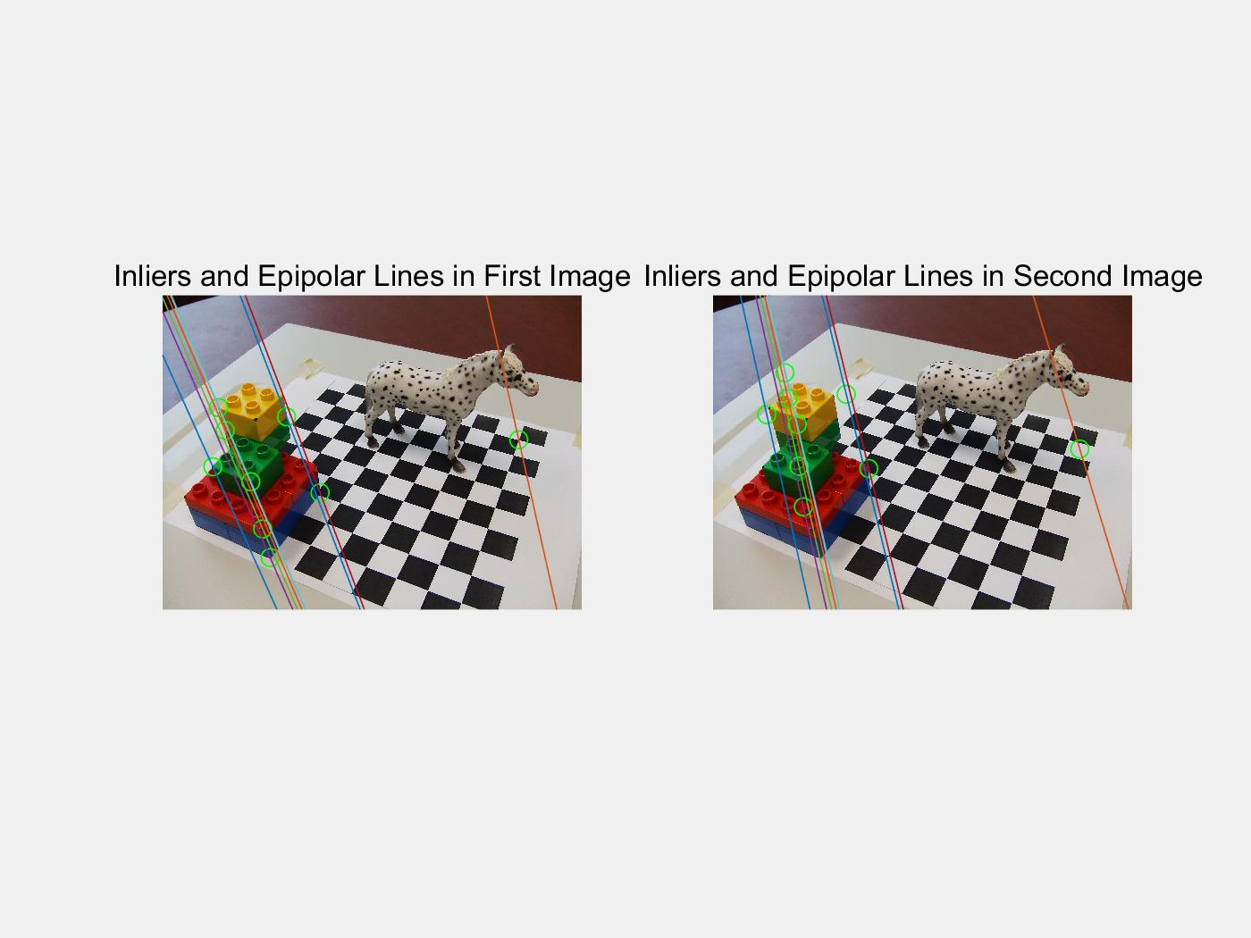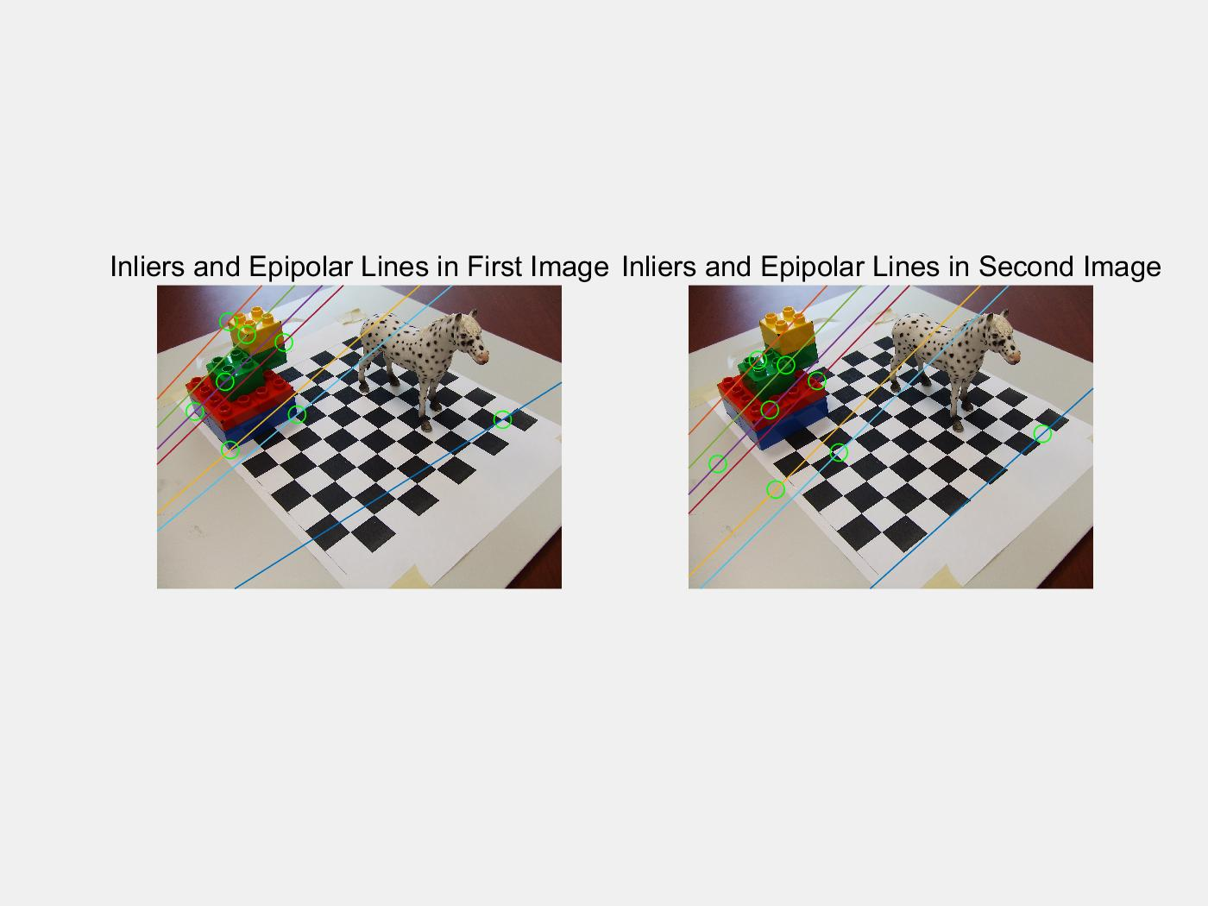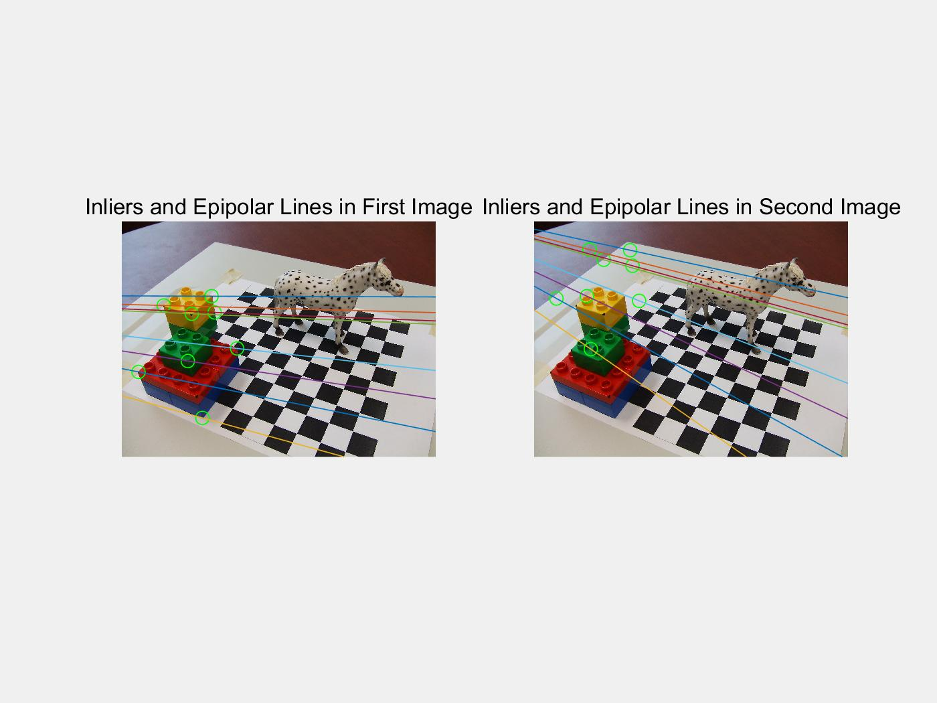

Plot the position and orientation extracted from each of the camera calibration matrix to show the camera positions from which the pictures were taken. For showing orientation plot the three axes of the camera’s local coordinate system.

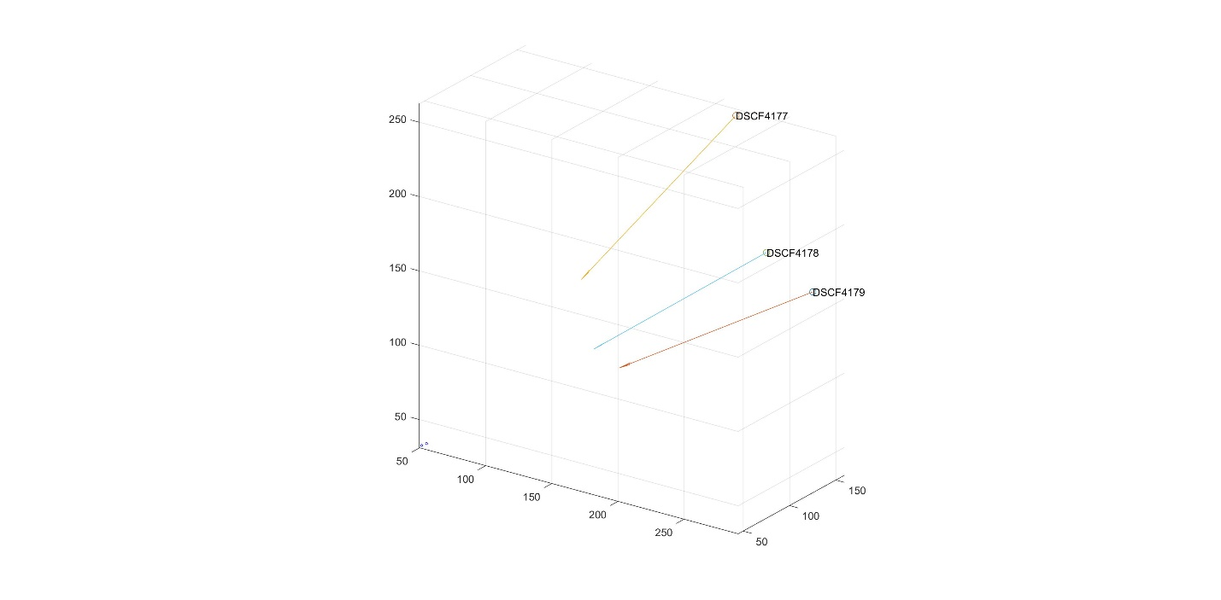

In the same plot, plot the 3D points recovered from this set of pictures by your depth estimation method. Extract around 150 point for the horse, this will give you a nice dense point cloud representation of the object.

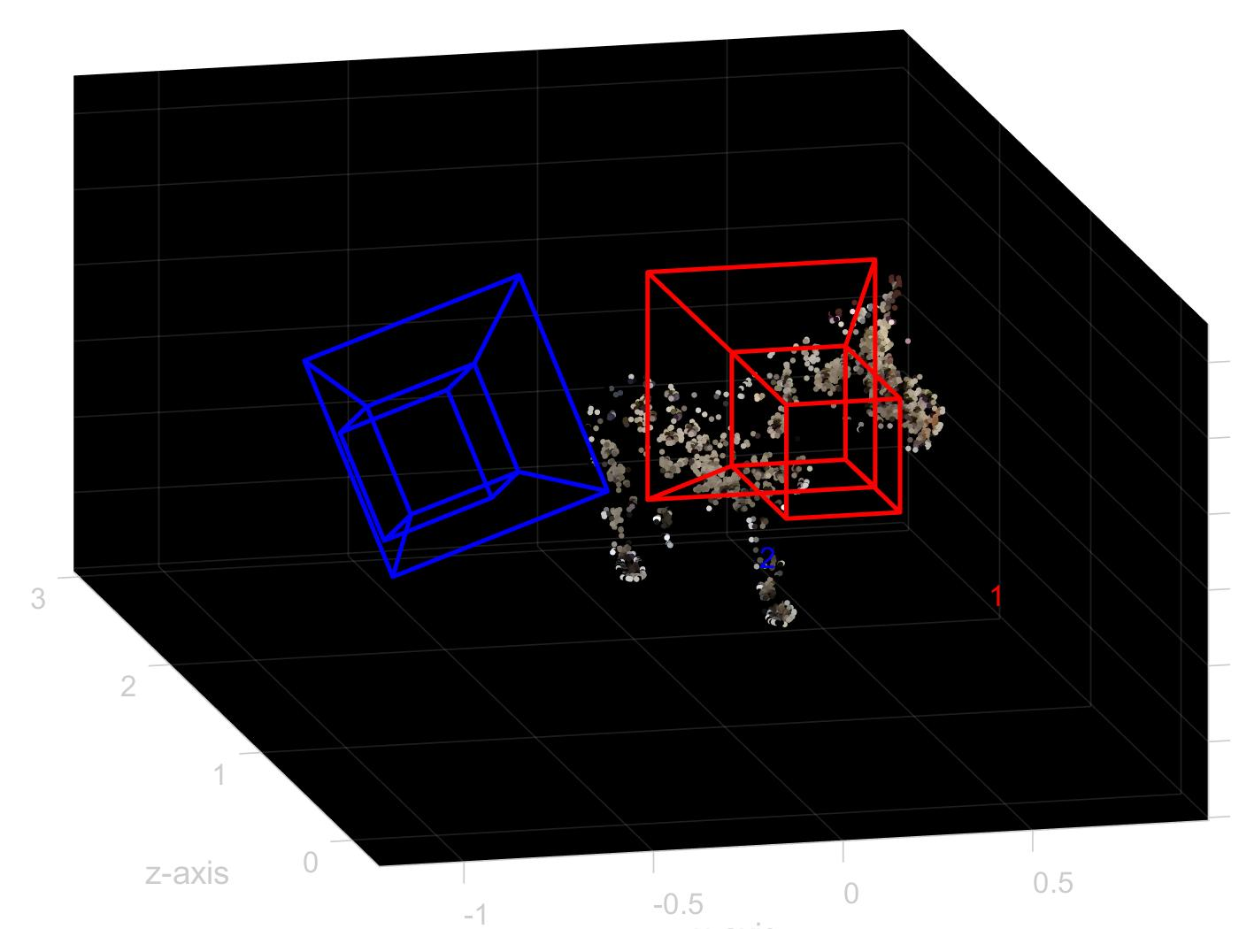

Subset(3, 4, 5)

Show the top ten matching features for one pair of images.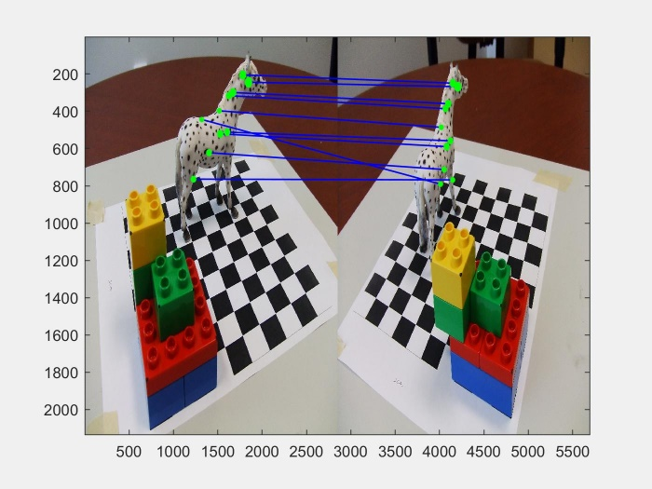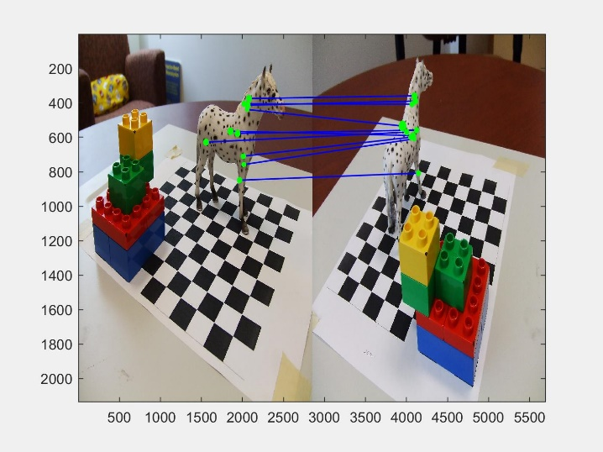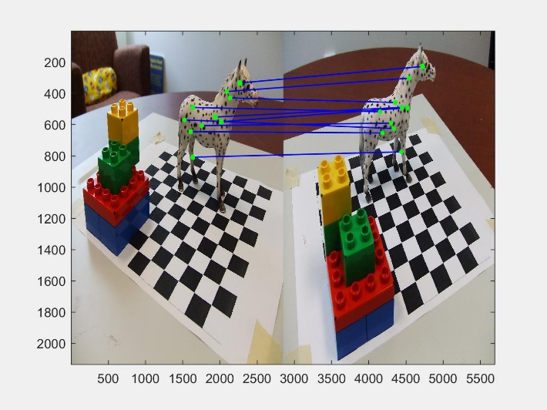

Plot the position and orientation extracted from each of the camera calibration matrix to show the camera positions from which the pictures were taken. For showing orientation plot the three axes of the camera’s local coordinate system.

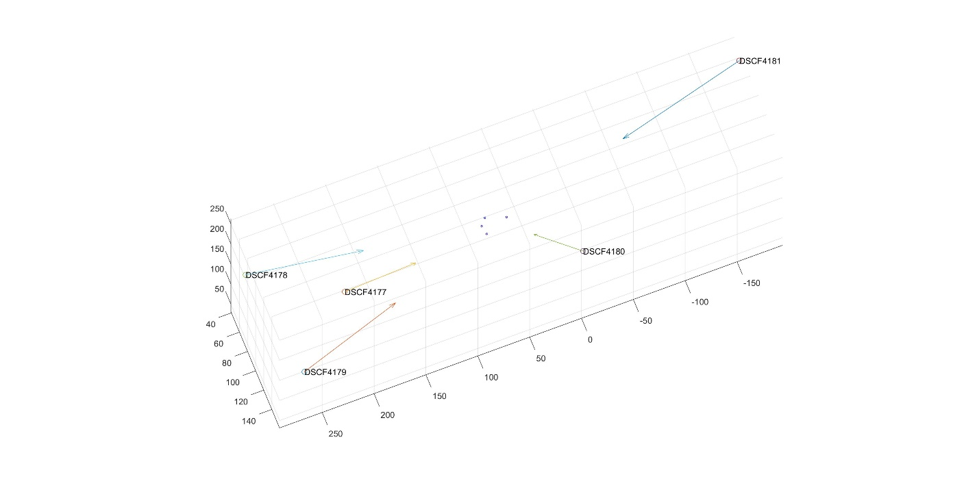

In the same plot, plot the 3D points recovered from this set of pictures by your depth estimation method. Extract around 150 point for the horse, this will give you a nice dense point cloud representation of the object.

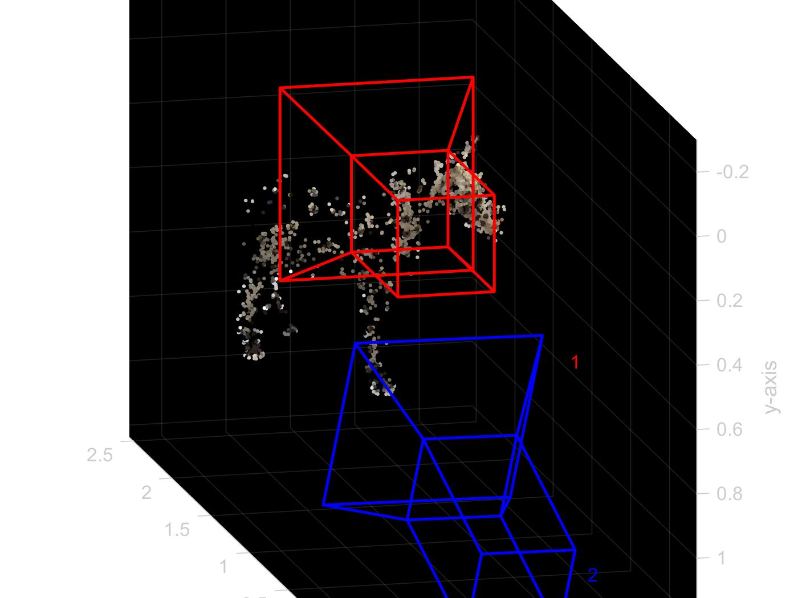

Final

