Kris Klindt

12/11/2024

PHYS 305

**Apparent Horizon of a Binary Black Hole System in 2+1 Dimensions**

**Abstract:**

In this study, I find the common apparent horizon of a binary black hole system and investigate how it changes with the distance between the two singularities. To do this, I used a second order Runga-Kutta method to solve the boundary value problem for the apparent horizon. I found that the black holes had formed a common apparent horizon at a distance of 1.52 (arbitrary units) between the singularities, and that distances larger than that caused the code to break down, indicating that the individual apparent horizons had not yet combined. When the common apparent horizon first forms, it has a peanut-like shape, but quickly loses this shape and becomes an oval as the singularities come closer, eventually becoming circular as the singularities get very close to one another. Simulations such as this one could aid other fields of active research, such as gravitational wave detection, which comes from the collision of two black holes.

**Introduction:**

Some of the most interesting and mysterious objects in the universe are black holes. They are objects that put the limits of our modern understanding of physics to the test. Many people have heard the term “event horizon” when referring to a black hole, especially considering the recent black hole images from the Event Horizon Telescope, but not very many have heard of the black hole’s apparent horizon. The distinction between the two is difficult to understand, and oftentimes the two coincide with one another anyways. Thornburg gives a definition for the apparent horizon, “Given a (spacelike) 3 + 1 [dimensional] slice, a “trapped surface” is defined as a smooth closed 2-surface in the slice whose future-pointing outgoing null geodesics have negative expansion Θ. The “trapped region” in the slice is then defined as the union of all trapped surfaces, and the “apparent horizon” is defined as the outer boundary of the trapped region” (Thornburg, 2007). This is a very difficult to understand definition, so instead I’ll give a simpler to understand definition: an apparent horizon is the boundary between light rays that are directed outward and moving outwards and those directed outward but moving inward (Booth, 2005). The apparent horizon of a black hole is easy enough to imagine for a single black hole, however, what would it look like for a binary black hole system? Binary black hole systems are at the forefront of scientific research, with LIGO’s very recent detections of gravitational waves from the collisions of black holes. So, how would you go about finding the apparent horizon of a binary black hole system, especially one that is about to combine?

**Procedure:**

As one might imagine, trying to calculate an equation for the apparent horizon of a binary black hole system is rather difficult. There are many factors that one would have to consider to truly simulate the apparent horizon of a binary black hole system, so I am going to be making several assumptions that allow me to try and numerically calculate an apparent horizon.

The first assumptions I am going to make are related to the spacetime around the black holes. I am going to assume that it is of the Brill-Lindquist type, meaning that the black holes themselves do not rotate, and therefore I do not need to account for the rotation of the black holes when determining their effect on spacetime (Dain, Valiente-Kroon, 2001). I will also assume that the spacetime is axisymmetric, conformally flat, and time symmetric. Also, I will put both black holes on the z-axis to simplify calculations.

With all of these assumptions, spacetime can be encoded into a single function $ψ$ that depends on the locations of the singularities. The equations that determine the spacetime would then be:

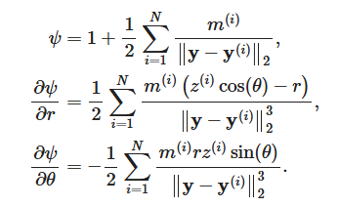

The coordinate system I use has (x, y) = (rcos($θ$), rsin($θ$)).

Now that we have equations for spacetime, we need a function for the apparent horizon. In order to do this, I once again need to make another assumption. The assumption I will make is the Strahlkorper assumption. This essentially says that a line going out radially from the origin will only touch a single point on the apparent horizon, which allows me to write the apparent horizon as a function of r and $θ$: h = h(r, $θ$) (Thornburg, 2007). This can be found from the boundary value problem:

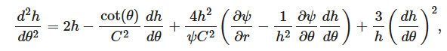

where

and with boundary conditions

This equation solves for the r values of h, which have a corresponding $θ$ value.

It can be seen that, as $θ$ goes to 0, $π$, and 2 $π$, the cot($θ$) term would blow up, however, it can be shown that

Which allows h to be defined for all $θ$.

In order to try and solve for h, I decided to split the second order differential equation into 2 first order differential equations:

$$\frac{dh}{dθ}=a$$

$$\frac{da}{dθ}=2h-\frac{\cot\left(θ\right)}{C^{2}}a+\frac{4h^{2}}{ψC^{2}}\left(\frac{∂ψ}{∂r}-\frac{1}{h^{2}}\frac{∂ψ}{∂θ}a\right)+\frac{3}{h}a^{2}$$

Now, there are two pieces of information needed to begin solving this problem: the initial $\frac{dh}{dθ}$ (which is 0, since it is one of the boundary conditions) and the initial r value for h at $θ=0$. This initial value of r was found using a shooting method found in the publicly available findhorizon code by Ian Hawke. This uses empirical data to try and find an initial r assuming that both black holes are the same mass and same distance away from the origin. So, this also limits my code to only being capable of using black holes that are symmetric about the x-axis with equal masses.

With this information, we can now begin solving the differential equations. The numerical integration technique I used was a second order Runge-Kutta method. I did run into some problems regarding the accuracy of this method that can somewhat be seen in Figure 2, so a fourth order Runge-Kutta method may have been a better choice to use.

**Results:**

There were several interesting results that could be found from running this code and analyzing the plots produced. I mainly focused on finding the apparent horizon of black holes with masses of 1 (arbitrary units). I varied their z-positions (and therefore, their distance from one another) in order to find the furthest distance that they could be from one another while still having a common apparent horizon. I found that, for two singularities with z-positions of 0.76 and -0.76 (arbitrary units), the black holes still had a common apparent horizon. At z-positions of 0.77 and -0.77, the apparent horizon started to deform, and at z-positions of 0.78 and -0.78, my code completely broke.

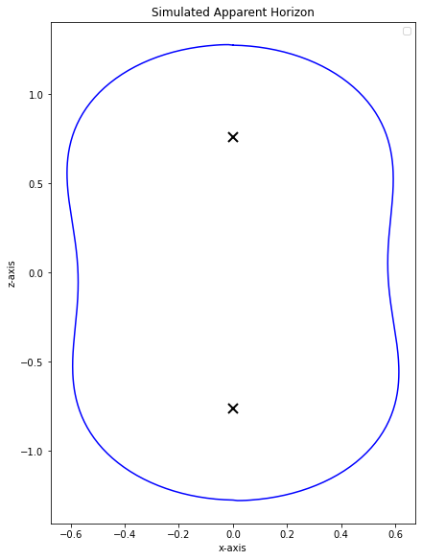

*Figure 1a, 1b, and 1c: The apparent horizon of the binary black hole system with a distance of 1.52, 1.54, and 1.56 (arbitrary units) between the singularities, respectively*

My code assumes that there will be a common apparent horizon for the two black holes, so it makes sense that the code would break down when the apparent horizons of the two black holes would be separate. Since the apparent horizon of the binary black hole system shown in Figure 1b is only starting to deform, it can be assumed that this is right around the distance at which the individual apparent horizons of the two black holes start to connect with one another.

Another interesting feature of the common apparent horizon that can be seen from Figures 1a and 1b is that it is peanut shaped. This is to be expected, since the apparent horizon of an individual black hole would be circular. So, when the two circular apparent horizons start connecting with each other, the part where they are connected would be thinner relative to the radius of each individual circle, resulting in a peanut shape.

So, how does the apparent horizon evolve as the distance between the two singularities shortens and the black holes begin to combine? In order to test this, I ran multiple simulations, shortening the distance between the two black holes each time.

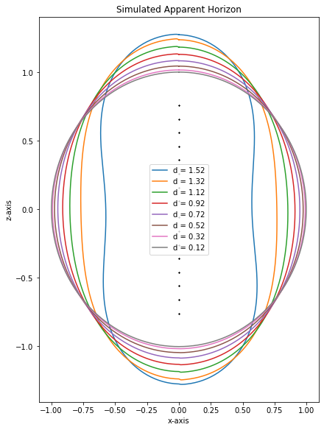

*Figure 2: The apparent horizons of binary black hole systems as the singularities get closer together. d represents the distance between the two singularities (arbitrary units)*

As can be seen in Figure 2, the common apparent horizon goes from a peanut shape to an oval shape, and finally becomes more and more circular as the two singularities get closer. The apparent horizon quickly loses its peanut shape, forming an oval shape. It then transitions to a circular shape, but more gradually than it loses its peanut shape.

One might think that this could represent an evolution through time of the apparent horizon as the two black holes merge, however, that is not necessarily the case. Each apparent horizon is found locally in time (t is constant), so finding the apparent horizons at different distances between singularities does not necessarily reflect a change in time. However, it can still prove to be a useful method to use, such as in apparent horizon pre-tracking (Schnetter, 2003).

**Discussion/Conclusion:**

There were several assumptions made in order to make this code actually possible to write and run, so a real apparent horizon of a binary black hole system might look different from my findings.

These findings show that, as two black holes get closer together, their apparent horizons connect with one another, at first forming a peanut-like shape. As the singularities of the black holes come closer to colliding and combining, the common apparent horizon of the two becomes more and more circular, which makes sense, since the two singularities start acting like a single singularity.

These simulations can have several implications on further research into binary black holes. One major field that can feel these implications is the detection of gravitational waves. By comparing these simulations with data that is derived from the gravitational waves, we may be able to derive a distance from each other for which the two black holes start producing gravitational waves.

**References:**

Booth, Ivan. (2005). "Black hole boundaries". *Canadian Journal of Physics*. **83** (11): 1073–1099. arXiv:gr-qc/0508107

Dain, S., Valiente-Kroon, J.A. (2001). “Conserved quantities in a black hole collision”.   
arXiv.gr-qc/0105109

Schnetter, Erik. (2003). “Finding apparent horizons and other two-surfaces of constant expansion”. arXiv:gr-qc/0306006

Thornburg, J. (2007) "Event and Apparent Horizon Finders for 3+1 Numerical Relativity", Living Reviews in Relativity 10 (3). http://dx.doi.org/10.12942/lrr-2007-3.