1.

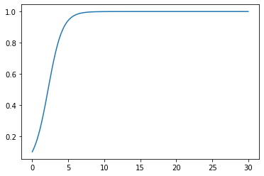

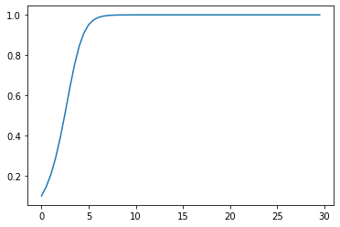

I think that the reason the behavior of the graph changes drastically around $∆t\sim 2+$ is because you multiply the timestep by the value of the function x-x2 and add that to the previous value. Since the timestep is so large, the result can be larger than 1, and when the result is larger than one, on the calculation for the next time step, x-x2 will be negative, causing the graph to increase and decrease in value.

2.Oscillations: x(t) : blue, y(t) : orange

a = 0.1, b = 0.5, x0 = 0.6, y0 = 1.3

Equilibrium: : x(t) : blue, y(t) : orange

a = 1, b = 2, x0 = 0, y0 = 0

3. m(t) : blue, c(t) : orange, w(t) : green

