3)

This figure displays the particles at the last time step with values N = 500, R = 0.01, L = 1, e = 0.06, sigma = 0.01, total time = 10, dt = 0.001, skip = 10

I tried to change several different parameters from e to sigma to the total time to dt, and even changing the amount at which the force was limited, but I could not come up with anything that gave me a result of very clear aggregation. The value I got from #1 also did not result in any clear aggregation.

4)

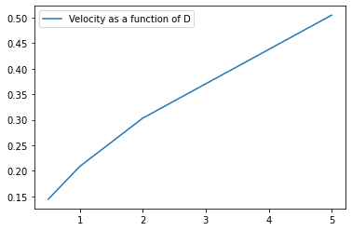

This figure is a plot with values for D on the x axis and the speed of the wave on the y axis.

The slope of this plot, assuming that it is nearly linear, is about 0.08. This means that speed of the wave is proportional to 0.08 times the value of D.