1)

This is the resulting electric potential that I got.

2)

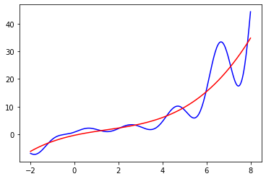

Above is the data along with a third order polynomial fit. The equation for that polynomial would be:

$$-0.346913+1.74142x-0.399362x^{2}+0.0913178x^{3}=0$$

3)

Below are the fits for the data using different values of lambda. I found that smaller values of lambda let to a fit that was more like the data than larger values. However, one trend I noticed is that the fit would not be accurate towards the end of the data, diverging away from the data. The amount by which it diverged increased as the lambda value got smaller. I think that the lambda value of 0.05 works best, since it’s fit is pretty close to the data set, and the offset at the end of the data is not as large as for the smaller lambda value of 0.01, despite 0.01 fitting the data more accurately until that point.

Lambda = 1:

Lambda = 0.1:

Lambda = 0.05:

Lambda = 0.01:

4)

Above is the plot after a Fourier transformation of the data was done. The three most dominant frequencies are 0.251327, 0.502655, and 1.00531.