**Software Architecture Document**

For Individual track project S3



Student name: Kristian Kolev

Student number: 4154738

Class: S3-CB04

Contents

C1 diagram 3

C2 diagram 4

C3 diagram 5

# C1 diagram

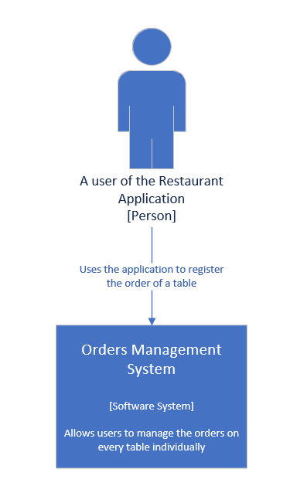

# C2 diagram

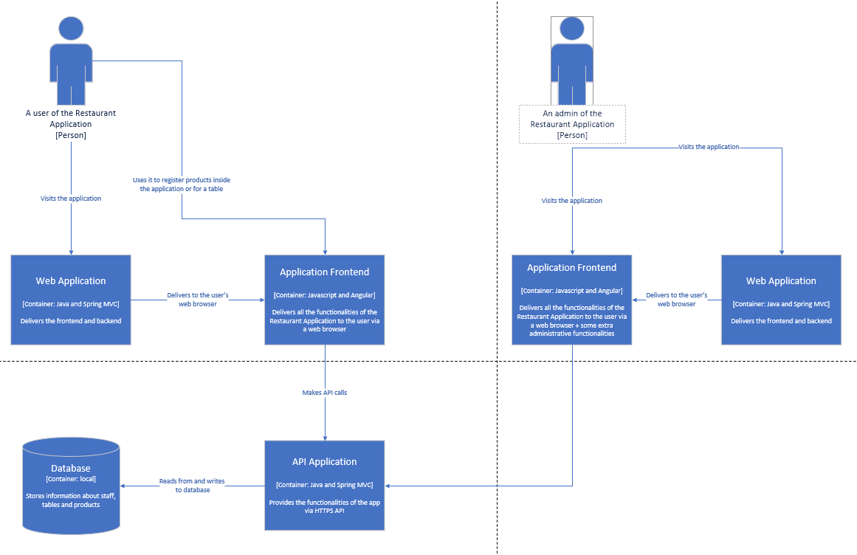

# C3 diagram

