**Untitled Project**

INSERT A JPG OF THE MENU SCREEN HERE

**Game Design/Technical Document**

Contents

One Sentence Pitch 2

Narrative 2

Main Concept 2

Proposed Development Approach 3

System Requirements 3

Software Requirements/3rd Party Tools 3

Storyboards/Concept Artwork/Media Catalogue 3

Visual References 5

Visual Style 6

Lighting 7

Audio Style and Requirements 7

Genre 8

Game Objectives 8

Menu Systems 8

Player Navigation/Controls 8

Gamepad 8

Keyboard 8

Motion Tracked VR Controllers 9

In-Game Information - GUI 9

Character Health 9

Difficulty 9

Missions/Objectives 9

Levelling Up/Power Ups/Perks 9

Power Downs/Debuffs 9

Bosses/Set Piece Events 10

Player to Environment 10

Player to Enemies 10

Multiplayer (Player to Player) 10

Win/Lose Conditions 10

High Scores and Ranking 10

Level Design 10

Level Structure 10

Maps and Level Design 11

Component Descriptions 11

Pseudocode 11

UML/Flowcharts 11

References 11

# One Sentence Pitch

3D, “low poly”, isometric game exploring hunger and death, in a simplified journey to escape the highland clearances.

# Narrative

You play as a highlander fleeing the violence of the highland clearances. Travelling ever westwards away from your burnt-out croft, you seek a rowing boat which will allow you to (eventually) escape to the new world.

# Main Concept

UNTITLED PROJECT is a short narrative experience designed to showcase the brutality of the highlanders’ plight during the clearances. The aim of UNTITLED PROJECT is to produce a prototype of the gameplay featuring a low poly, 3D clansman as the player character. User input will be handled by keyboard controls. On screen, a player-controlled highlander travels to the left of the screen, while encountering numerous sheep which flock in a random manner. The player has a hunger meter on a timer which will lead to player death when empty. Each sheep is edible, however interacting with the sheep in any way will immediately summon a squad of redcoats who will then kill you (no defence is possible). Running ever leftwards without interacting with the environment or sheep will lead you to the escape boat. The hunger meter is tweaked to allow for a no-deviations-escape to the west. Any dawdling will starve the player to death.

# Proposed Development Approach

Waffle here about Agile for a paragraph or two…

Waffle here about not using Waterfall for a paragraph…

# System Requirements

Operating System: Windows 7, 8, 8.1, 10

1 GHz or faster processor or SoC

1 GB RAM (32-bit systems) or 2 GB RAM (64-bit systems)

16 GB Hard disk space (32-bit systems) or 20 GB (64-bit systems)

DirectX 9.0c or later GPU with WDDM 1.0 driver

# Software Requirements/3rd Party Tools

Unity 2017.3.1f1 (64-bit)

Maya 2018

Audacity

XXX ADD MORE HERE

# Storyboards/Concept Artwork/Media Catalogue

**Storyboards**

XXX

**Concept Artwork**

XXX

**Media Catalogue/Production Assets**

Free Low Poly Pack <https://assetstore.unity.com/packages/3d/characters/free-low-poly-pack-65375>

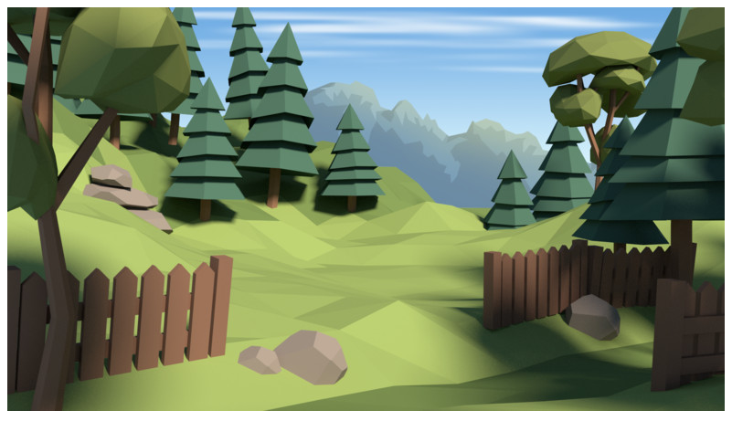

Figure 1 - Example scene from Free Low Poly Pack on the Unity Asset Store

Low Poly Game Kit <https://assetstore.unity.com/packages/templates/packs/low-poly-game-kit-110455>

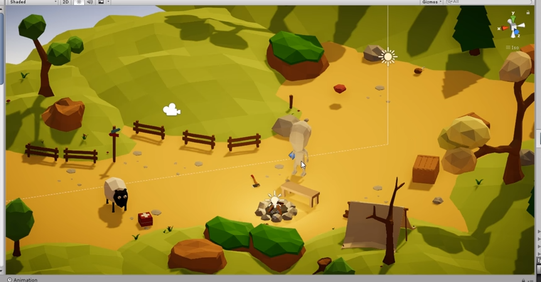

Figure 2 - Example scene from Low Poly Game Kit on the Unity Asset Store

# Visual References

The UNTITLED PROJECT is designed to visually reference the currently in vogue 3D low polygon count “cutesy” prototypes produced by independent game developer and Twitter user @PunchesBears (https://twitter.com/punchesbears), while the core game-play loop is intended to add a much-needed counterpoint to the cuteness.

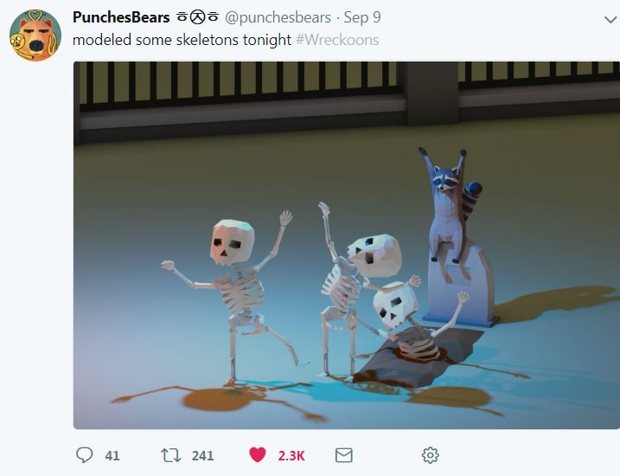

Figure 3 - Low poly, cute. Courtesy of the above Twitter account.

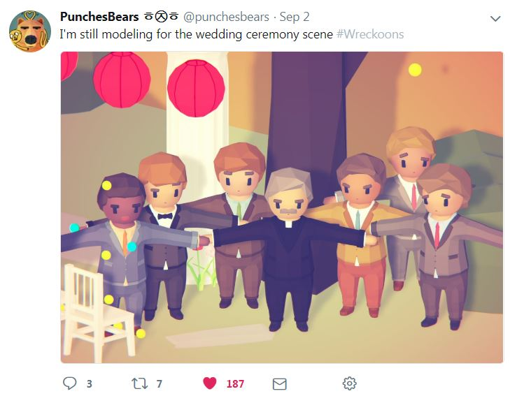

Figure 4 - Note the pastel colour palette and cute, low poly look.

# Visual Style

UNTITLED PROJECT is to be a single-player, 3D side scrolling, minimalistic “survival game”, with a cute, modern, low poly art style. A bright and breezy character will interact with a stylised, historical rural scene.

**Colour Palettes**

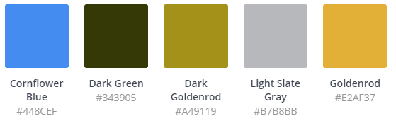

Figure 5 - Palette data courtesy of canva.com

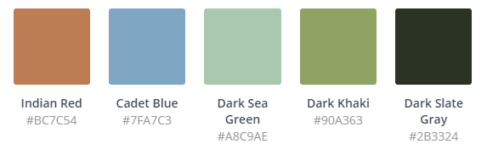

Figure 6 - Colour palette courtesy of canva.com

# Lighting

It is envisaged that UNTITLED PROJECT should be lit as if in the middle of a clear day. There will be no day/night cycle.

# Audio Style and Requirements

XXX

**Media Reference**

XXX

# Genre

“Experimental” Survival Game.

# Game Objectives

Reach the western shore, get in the boat, and escape to the new world.

# Menu Systems

XXX

Menu colours should be the same as the palette chosen for the main game scene, this will also provide a high contrast UI for colour-blind users.

All on screen UI elements in UNTITLED PROJECT will default to this colour palette.

# Player Navigation/Controls

Primary interaction with the game will be via device keyboard.

# Gamepad

Not applicable.

# Keyboard

Primary interaction with the game will be via the following keypresses:

A – Move left.

D – Move right.

W – Move up.

S – Move down.

E – Interact.

[ESC] – Back.

# Motion Tracked VR Controllers

Not applicable.

# In-Game Information - GUI

The in-game GUI will consist of a graphical icon of a stomach and a hunger bar towards the right/top? of the screen.

# Character Health

The player has one life which will end with the hunger meter reaching zero, or being shot by redcoats.

# Difficulty

Very Challenging. Designed to be frustrating to the player.

# Missions/Objectives

Head west, find a boat, escape famine.

# Levelling Up/Power Ups/Perks

Not applicable.

# Power Downs/Debuffs

Not applicable.

# Bosses/Set Piece Events

Initial cutscene showing burned out croft, drifting right to prop redcoats.

On alert frustum moves to instantiated redcoats and back to player.

On completion XXX

# Player to Environment

The player will move around the screen upon keyboard input. The environment will be a moving, low poly terrain.

# Player to Enemies

The player cannot evade the redcoats once they are summoned. Death is certain.

# Multiplayer (Player to Player)

Not applicable.

# Win/Lose Conditions

The player will win by reaching the escape boat.

The player will lose by starving to death or being shot by redcoats.

# High Scores and Ranking

No scoring/ranking system is required.

# Level Design

UNTITLED PROJECT will use a XXX

# Level Structure

XXX

# Maps and Level Design

XXX

# Component Descriptions

XXX

**Main Menu Components**

XXX

# Pseudocode

XXX

# UML/Flowcharts

XXX

# References