**A Study on**

**PERFORMANCE OF THE CELL PHONE OPERATORS FOR**

**PRE-PAID CONNECTION USERS**

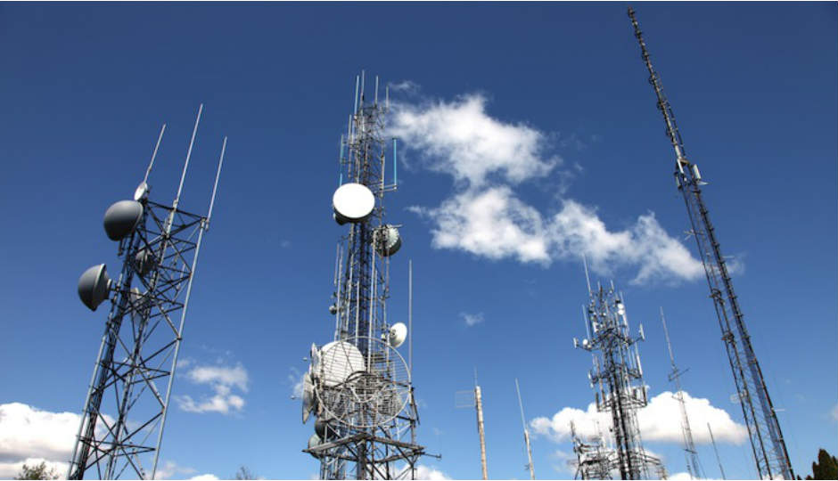

**[inqube-logo](http://www.inqube.biz/index.html)**

**SUBMITTED BY : KRISANU SEN**

**COURSE : MBA**

**BATCH : 2017-2019**

A Study on

**PERFORMANCE OF THE CELL PHONE OPERATORS FOR PRE-PAID CONNECTION USERS**

Submitted by **:** **KRISANU SEN**

**MBA : 2017-2019**

**3rd Semester (Major: Finance)**

**Registration No : 171480710018 OF 2017-2018**

**Roll No : 14800917034**

**Academic Mentor : DR. BISWAJIT ROY**

**Industry Mentor : KALPADIP BASU**

Name of the College:

**FUTURE INSTITUTE OF ENGINEERING AND**

**MANAGEMENT**

*A report submitted on the partial requirement of MBA programme*

**DECLARATION**

This is hereby declared that I, Krisanu Sen, student of 3rd semester of MBA, have carried out my Course containing project work entitled “**A study on performance of the cell phone operators of pre-paid connection users”** is done by myself in partial fulfilment for the award of the degree of Master of Business Administration from Future Institute of Engineering and Management.

It is further declared that the project work has not been submitter to any other University for

Award of any degree or examination.

12/10/2018 ………………………

KRISANU SEN

**ACKNOWLEDGEMENT**

I have received the assistance and co-operation of a few people during the project work. So I

Hereby, take the opportunity to extend my sincere gratitude to all those who provided their guidance, co-operation, assistance and valuable suggestion from time to time in spite of their busy schedule.

I would like to express my profound gratitude to my mentor **Dr. Biswajit Roy,** for the exemplary guidance, monitoring and constant encouragement throughout the course of this project.

I am also thankful to other faculty members and friends for their active co-operation support. The blessing, help and guidance given by my mentor, time to time shall carry a long way in the start journey of life on which I am about to embark.

I would also like to express my sincere gratitude to **Prof.(Dr.) Anirban Majumder, Prof. Prasanta Guha** for supported me to continue project and gain experience.

I would like to express my profound gratitude to our director **Prof. (Dr.) Mousumi Ghosh,** for giving me opportunity to do the project.

A special thanks to **Prof. Santanu Ray** for giving me the opportunity to do the internship in this company and also support behind the project.

**CONTENT**

|  |  |  |
| --- | --- | --- |
| **Sl. No** | **Topics** | **Page No.** |
| 1. | Declaration | i |
| 2. | Acknowledgement | ii |
| 3. | Introduction | 1-2 |
| 4. | Profile of The Company | 3-4 |
| 5. | Literature Review | 5-7 |
| 6. | Objective of the Study | 8 |
| 7. | Research Methodology | 9-13 |
| 8. | Research Analysis & Finding of The Study | 14-90 |
|  | 8.1-Linear Multiple Regression | 14-56 |
| 8.2- Thurston Case V | 57-59 |
| 8.3- Cluster Analysis | 60-64 |
| 8.4-One Way Anova | 65-90 |
| 9. | Conclusions | 91-96 |
| 10. | Recommendations & Suggestions | 97 |
| 11. | Limitations | 98 |
| 12 | References | 99-100 |

**3. INTRODUCTION**

The mobile network operators provide wireless communication and data service to the customers. Airtel was the largest mobile telecommunication network provider and currently the second largest mobile network company in India. Vodafone India and Idea cellular have been merging to become largest telecom company in India. Some cell phone operators in India are:

**Vodafone-Idea:** Vodafone and Idea are merging and have become largest telecom company in India. Both networks company will continue their own operation of 3G and 4G mobile services as independent brands till the merger, expected to be completed by March 2019.No of subscribers of Vodafone and Idea are 222.03 and 216.76 million respectively and market share of Vodafone and Idea are 19.74% and 19.27% respectively. Ownership of Vodafone and Idea are Vodafone Group (45.1%), Aditya Birla Group (26%) and Axiata Group Berhad Providence Equity (28.9%).

**Airtel:** Airtel India is the second largest mobile network operator and telecommunications service provider in India. Airtel operates in all telecom circles and known as India’s second most valuable mobile network brand**.** No of Airtel subscriber is 308.69 million and market share is27.44%.

**Jio:** Jio or Reliance Jio Infocomm Limited is owned by Reliance Industries and is the only Voice over LTE operator in India. The Jio provides wireless 4G LTE service across all 22 telecom circles in India.no of subscriber is 160 million and market share is 17.44%. Owner of the company is Reliance industries.

**BSNL Mobile:** BSNL Mobile was earlier known as CellOne is a state owned telecommunications service provider that provides both pre-paid and post-paid mobile services in India. BSNL has presence in the 21 telecom circles in India with roaming and International roaming. No of subscriber is 112.38 million and market share is 9.99%.

**Aircel:** Aircel is the fifth largest mobile service provider in India and offers 3G and 4G data services. Reliance Communications and Aircel are merging their mobile network operations.

**Reliance Communications:** Reliance Communications provides mobile services, DTH, GSM, broadband and leased lines services. RCom is merging its wireless business with Aircel and had acquired MTS India. Market share is 0.02%.

**Telenor India:** Telenor India was formerly known as Uninor and now acquired by Airtel. All the seven telecom circles of Telenor including assets and customers base. No of subscriber is 36.16 million and market share is 3.21%.

**Tata Docomo:** Tata Docomo is part of the Tata Group and offers telecommunications service including both GSM and CDMA. The company operates in 19 telecom circles of India and is the first private sector telecom company to launch 3G services in India. No of subscriber is 29.12 million and market share is 2.59%.

**MTS India:** MTS India is a subsidiary of the Russian mobile operator, headquartered in New Delhi. The messaging and data services provider currently operates in 9 circles in India.

**MTNL:** Mahanagar Telephone Nigam is state Government owned telecommunications service provider, currently operate in the metro cities of Mumbai and New Delhi. The company provides 3G mobile services, fixed line telephones, Wireless local loop, Broadband and leased lines. No of subscriber is3.54 million and market share is 0.32%.

**4. PROFILE OF THE COMPANY**

InQube Innoventures is an organization focussed on application of cutting-edge technologies and knowledge solutions to solve common man’s problems - and giving them access to the best. InQube has several organizations under its portfolio - each of which works on specific focus areas with dedicated management and operations team. InQube works on Technology, Analytics and Design solutions.

It has a vision that aims at integrating and harnessing the best of Technology, the predictive prowess of Analytics and the functionality of Design in crafting innovation-led applications and knowledge solutions that would touch the common man’s quest for a qualitative life by giving them equal opportunity access to health, education, agriculture, and livelihood.

**BOARD OF DIRECTORS:**

* **KALYAN KAR(** Co-Founder and Director)
* **TRIDIBESH BANDYOPADHYAY**
* **SAUVIK BANERJEE**
* **SANDIPAN CHATTOPADHYAY**
* **PARTHA S GHOSH**
* **DR. SAMIR K BRAHMACHARI**

**Services:-**

* Technology
* Analytics
* Design
* Relationship Management Services ( RMS 4.0)

**Focus Areas: -**

* **Healthcare: -** Using technology and connectivity to provide primary health and wellness support to the remote locations.
* **Education: -** Create digital interfaces for inclusive learning, from school children to employment  seekers.
* **Agriculture: -** Use technology, Analytics and Image Processing for farmer empowerment, access to information as well as decision support system for government.
* **Livelihood: -** Skill enhancement and linkages for livelihood creation across various sectors of growth.

**5. LITERATURE REVIEW**

Khan.S, et al. (2012) in their research paper “Determinants of Customer Satisfaction in Telecom Industry: a Study of Telecom industry Peshawar KPK Pakistan” discussed about some factors that can influence customer satisfaction in cellular industry in Peshawar region. The results of paper proves that there is positive and significant relationship between dependent variable (customer satisfaction) and independent variables (customer service, price fairness, sales promotion, coverage, signal strength and promotion).

Mukherjee.D, et al. (2013) in his research paper “Business process Reengineering and customer satisfaction with reference to Indian Telecommunication sector” discussed about the factors based on which telecom service providers can formulate strategy to satisfy customers to get an edge over the competitors and also seeing how Business Process Management and Re-engineering might play the role of a weapon to Indian Telecom service providers. Mainly three categories of research findings have been deduced from the study. The first category dealing with the customer’s perception on different areas of Indian Telecom processes. The second category analyses customer’s satisfaction with the existing service facilities. The third category describes customer’s perception on Indian telecom service providers for enhancement of the level of satisfaction revealing a strong need for strategic planning and implementation of IT-enabled reengineered business process.

Agarwalla.N (2014) in his research paper “Customer Satisfaction in the Telecom Sector in India: A study on Assam and North East Circle” discussed about weighted customer satisfaction (WCS) in different states of North Eastern region based on ten service parameters (Cost, Brand, Customer loyalty, Network, Billing, Call centre, store, Tariff plan, value added services, and Advertisement and communication). The paper analyses low, moderate and high WCS areas in North eastern region.

Pandey.D.K, et al. (2014) in his research paper “A Study of Customer Satisfaction on Telecom Service Providers” discussed about the customer satisfaction level in Telecom service provider players in the market. This study indicates that the customers have shown their satisfaction on GPRS service, festival offer service, free roaming service, validity service, bonus service and online recharge service. However the customers have reflected their dissatisfaction with the service quality of network, customer care, SMS packs, free talk time, connection charges, ease of availability of the retailer selling recharge coupon, Ease of availability of retailers transferring recharge voucher.

Madan.M (2016) in their research paper “Determinants of Customer Satisfaction in Telecom Industry - A Study of Indian Telecom industry” discussed about some determinants and factors which can affect and have an impact on the satisfaction level of customers in the telecom industry in the National Capital Region of Delhi, India especially cellular sector. The paper analyses that fairness in the prices and coverage area have great impact on the services of cellular companies which leads to customer satisfaction and ultimately to the maximization of profit of the organization.

Roy.B (2016) in his research paper “A Study on Consumer Perception of E-Tailing Services for Electronic Goods in Kolkata” discussed about consumer perception on e-service quality of e-tailing activities and different perceptual factors of e-tailing. The study is important for measuring the e-quality and satisfaction level of e-customers. A satisfaction index is developed for measurement of e-customers’ satisfaction level for electronic goods and confirmatory factor analysis is applied with multiple regression analysis for identifying perceptual dimensions.

Dahivale.R (2017) in his research paper “Impact of customer satisfaction on customer loyalty and switching intentions: A pilot study on telecom sector in Pune city” discussed about the impact of customer satisfaction on customer loyalty and their switching intentions. The Paper analyses that customer satisfaction has positive correlation with customer loyalty and negative correlation with customer’s switching intentions.

Hossain.Md. A, et al. (2018) in their research paper “Customer Retention and Telecommunications Services in Bangladesh” discussed about exploring antecedents of customer satisfaction and retention behaviour. The study has produced a greater understanding of the variables that appeared to be the most influential factors to structure the customer satisfaction toward telecommunication service which have ultimate impact on retention behaviour of customer.

Vijayakumar.V, et al. (2018) in their research paper “Understanding drivers of customer satisfaction in Indian telecom sector: A PLS-SEM based approach” discussed about understanding how service quality, value, image and customer satisfaction impacts customer loyalty. The paper analyses the core factors that drive customer satisfaction and loyalty and hence survive and prosper in this hyper-competitive market.

**6. OBJECTIVE OF THE STUDY**

1. To identify the factors that have impact on different parameters of customer satisfaction.
2. To measure customer satisfaction of different telecom service provider.
3. To make a comparative study on positioning on the mind of the customer of different telecom service provider brands.
4. To reveal the perceptual positioning of different telecom brands on the mind of the customer based on different attributes.
5. To identify the impact of different demographic attributes on overall satisfaction of different brands.

**7. RESEARCH METHODOLOGY**

**Research Methodology** is the systematic, theoretical analysis of the methods applied to a field of **s**tudy. It comprises the theoretical analysis of the body of methods and principles associated with a branch of knowledge. The process used to collect information and data for the purpose of making business decisions.

**Research Design:-**

**Research Design** is the framework that has been created to seek answers to research questions. The arrangement of conditions for collection and analysis of data in a manner that aims to combine relevance to the research purpose with economy in procedure.

* Research design is a conceptual structure within which research is conducted. It constitutes the blueprint for the collection, measurement and analysis of the data. As such the design includes an outline of what the researcher will do it from writing the hypothesis and its operational implications to the final analysis of data.

**Types of Research Design:-**

**EXPLORATORY**

**CONCLUSIVE**

**RESEARCH**

**DESIGN**

Fig: 7.1

**Exploratory: -** An exploratory design is conducted about a research problem where the focus is on gaining insights and familiarity for later investigation or undertaken when problems are in preliminary stage of investigation.

**Conclusive: -** Conclusive research is more likely to use statistical tests, advanced analytical techniques, and larger sample size, compared with exploratory studies. Conclusive research is more likely to use quantitative, rather than qualitative techniques.

**Conclusive has two types:-**

**DESCRIPTIVE**

**RESEARCH**

**CAUSAL**

**RESEARCH**

**CONCLUSIVE**

Fig: 7.2

**Descriptive Research: -** Descriptive research is conclusive in nature. This means that descriptive research gathers quantifiable information that can be used for statistical inference on your target audience through **data analysis**. As a consequence this type of research takes the form of **closed-ended questions,** which limits its ability to provide unique insights. However, used properly it can help an organization better define and measure the significance of something about a group of respondents and the population they represent.

**Causal Research: -** Casual research, as the name specifies, tries to determine the cause underlying a given behaviour. It finds the cause and effect relationship between variables. It seeks to determine how the dependent variable changes with variations in the independent variable.

**Here Causal Research designs have been considered.**

Here **Simple Random Sampling Research** designs have been considered.

**Sampling Technique: -** A process used in statistical analysis in which a predetermined number of observations will be taken from a large population. The methodology used to sample from a large population will depend on the type of analysis being performed, but will include simple random sampling, systematic sampling, and observational sampling. Here Simple random sampling is considered, which can be described as the subset of a statistical population in which each member of the subset has an equal probability of being chosen. A simple random sample is meant to be an unbiased representation of a group.

**Types of Data:-**

Any business research generally uses two types of data.

**TYPES OF DATA**

**SECONDARY DATA**

**PRIMARY DATA**

Fig: 7.3

**Primary Data: -** primary data can be explained as the information collected from sources such as personal interview, questionnaire or surveys with a specific intention and on a specific subject and observation and discussion by the researcher him or herself, which information is then assessed by that person. It is a direct approach and as it is tailored to a company’s particular needs, reveals apparently, much- needed information to that company which started the research for which they were originally intended. It can be a lengthy process but does provide first-hand information.

**Secondary Data: -** Secondary data is the data that have been already collected by and readily Available from other sources. Such data are cheaper and more quickly obtainable than the primary data and also may be available when primary data cannot be obtained at all. Accuracy of secondary data is not known. Data may be out-data.

Here **Secondary Data** has been provided by the company.

**Sample Size: -** The sample size of a survey most typically refers to the number of units that were chosen from which data were gathered. However, sample size can be defined in various ways. There is the designated sample size, which is the number of sample units selected for contact or data.

**Sample Size: - 3532**

**Statistical Tools used:-**

**1)Linear Multiple Regression Analysis: -** Multiple linear regression (MLR) is a statistical technique that uses several explanatory variables to predict the outcome of a response variable. The goal of multiple linear regression (MLR) is to model the relationship between the explanatory and response variables.

The model for MLR, given n observations, is:

Y=β0 + β1X1 + β2X2 + ….. + βnXn [n=1, 2, 3,….,n]

Here Y=dependent variable and β0=constant and β1, β2,….., βn are independent variables.

**2) Thurston Case V: -** Louis L. Thurston was a pioneer in psychometric theory and measurement of attitudes, interests, and abilities. Thurston Case V scaling allows for a scaling of objects compared to other objects. As one of the cases considered by Thurston, Case V makes the assumption of equal variances and uncorrelated distributions.

**3) Cluster Analysis: -** Cluster analysis is the task of grouping a set of objects in such a way that objects in the same group (called a cluster) are more similar (in some sense) to each other than to those in other groups (clusters). It is a main task of exploratory [data mining](https://en.wikipedia.org/wiki/Data_mining), and a common technique for [statistical](https://en.wikipedia.org/wiki/Statistics) [data analysis](https://en.wikipedia.org/wiki/Data_analysis), used in many fields, including [machine learning](https://en.wikipedia.org/wiki/Machine_learning), [pattern recognition](https://en.wikipedia.org/wiki/Pattern_recognition), [image analysis](https://en.wikipedia.org/wiki/Image_analysis), [information retrieval](https://en.wikipedia.org/wiki/Information_retrieval), [bioinformatics](https://en.wikipedia.org/wiki/Bioinformatics), [data compression](https://en.wikipedia.org/wiki/Data_compression), and [computer graphics](https://en.wikipedia.org/wiki/Computer_graphics).

**4) One Way Anova: -** In [statistics](https://en.wikipedia.org/wiki/Statistics), one-way [analysis of variance](https://en.wikipedia.org/wiki/Analysis_of_variance) (abbreviated one-way ANOVA) is a technique that can be used to compare means of two or more samples (using the [F distribution](https://en.wikipedia.org/wiki/F_distribution)). This technique can be used only for numerical response data, the "Y", usually one variable, and numerical or (usually) categorical input data, the "X", always one variable, hence it is called "one-way".

**Data Collection Location:-**

The data has been accumulated from following urban and rural places of Odisha.

These are:

1. BALASORE
2. BANKI
3. BARIPADA
4. BASUDEVPUR
5. BBSR
6. BEGUNIA
7. BERHAMPUR
8. BHADRAK
9. BIRAMITRAPUR
10. BOLANGIR
11. CHATRAPUR
12. CUTTACK
13. HIRAKUD
14. MANGALAPUR
15. MONGALPUR
16. NILGIRI
17. PURI
18. ROURKELA
19. SAMBALPUR
20. SONEPUR
21. UDALA

**8. RESEARCH ANALYSIS AND FINDINGS OF THE STUDY**

**The factors that have impact on different parameters of customer satisfaction and measurement of customer satisfaction of different telecom service providers**

**8.1. Linear Multiple Regression Analysis**

**Measurement of Satisfaction**

**Product/Tariff Attributes:-**

pr1=your operator charges a reasonable money for the services.

Pr2=Talk time available as per recharge voucher Terms.

Pr3=Easy availability of the recharge voucher of the own choice.

Pr4=wide range of the recharge voucher

Pr5=Low call rate within own network

Pr6=Low call rates to the other operator

Pr7=Low call rates for STD call

Pr8=Low roaming call rates

Pr9=Low MRP full talk time offers

Pr10=Not charged for VAS not requested

Pr11=No wrong balance deduction

Difference=performance-importance and Ratio= performance/importance.

**Customer Care Attributes:-**

Cc1= the ease of handling the menu options in the IVRS,

Cc2=Low response time taken to answer your call by a customer care executive,

Cc3=problem solving ability of the customer care executive,

Cc4=the time taken by the call center /customer care or helpline to resolve your complaint,

Cc5=operator has a physical service touch point (co-store) in your town,

Cc6=providing correct information of products over SMS/Call/Poster/Advertisements,

Cc7=the operator always comes up with new product/service

Cc8=Special offers applicable for your number only for your operator

**Network Performance, Reliability, Availability and Maintainability Attributes:-**

Net1=getting call connected in the first attempt

Net2=operator provides you network wherever you go

Net3=operator provides a clear voice quality during calls

Net4=operator provides zero call drops

Net5=do not experience “No signal” (network outage) situations

Net6=quick restoration of network (signal) problems

Net7=network coverage and signal quality on highways

Net8=network coverage and signal quality inside buildings

Net9=network coverage and signal quality inside lifts.

**Airtel Operator:-**

**Product/Tariff Attributes :-( Airtel)**

|  |  |  |  |  |  |  |  |  |  |
| --- | --- | --- | --- | --- | --- | --- | --- | --- | --- |
| **Table 8.1.1: Model Summary** | | | | | | | | | |
| Model | R | R Square | Adjusted R Square | Std. Error of the Estimate | Change Statistics | | | | |
| R Square Change | F Change | df1 | df2 | Sig. F Change |
| 1 | .201 | .040 | .025 | .568 | .040 | 2.668 | 11 | 697 | .002 |
| a. Predictors: (Constant), Ratio_pr11, Ratio_pr4, Ratio_pr8, Ratio_pr6, Ratio_pr9, Ratio_pr1, Ratio_pr2, Ratio_pr10, Ratio_pr5, Ratio_pr7, Ratio_pr3 | | | | | | | | | |

|  |  |  |  |  |  |  |  |  |  |  |  |  |  |  |  |  |  |  |  |  |  |  |  |  |  |  |  |  |  |  |  |  |  |  |  |  |  |  |  |  |  |  |  |  |  |  |  |
| --- | --- | --- | --- | --- | --- | --- | --- | --- | --- | --- | --- | --- | --- | --- | --- | --- | --- | --- | --- | --- | --- | --- | --- | --- | --- | --- | --- | --- | --- | --- | --- | --- | --- | --- | --- | --- | --- | --- | --- | --- | --- | --- | --- | --- | --- | --- | --- |
| |  |  |  |  |  |  |  | | --- | --- | --- | --- | --- | --- | --- | | **Table 8.1.2: ANOVA** | | | | | | | | Model | | Sum of Squares | Df | Mean Square | F | Sig. | | 1 | Regression | 9.466 | 11 | .861 | 2.668 | .002b | | Residual | 224.785 | 697 | .323 |  |  | | Total | 234.251 | 708 |  |  |  | | a. Dependent Variable: Satisfaction | | | | | | | | b. Predictors: (Constant), Ratio_pr11, Ratio_pr4, Ratio_pr8, Ratio_pr6, Ratio_pr9, Ratio_pr1, Ratio_pr2, Ratio_pr10, Ratio_pr5, Ratio_pr7, Ratio_pr3 | | | | | | | |

|  |  |  |  |  |  |  |
| --- | --- | --- | --- | --- | --- | --- |
| **Table 8.1.3: Coefficients** | | | | | | |
| Model | | Unstandardized Coefficients | | Standardized Coefficients | t | Sig. |
| B | Std. Error | Beta |
| 1 | (Constant) | 2.807 | .108 |  | 25.960 | .000 |
| Ratio_pr1 | .218 | .086 | .099 | 2.538 | .011 |
| Ratio_pr2 | .022 | .030 | .030 | .740 | .460 |
| Ratio_pr3 | -.021 | .049 | -.038 | -.436 | .663 |
| Ratio_pr4 | .024 | .046 | .044 | .513 | .608 |
| Ratio_pr5 | -.004 | .061 | -.003 | -.063 | .950 |
| Ratio_pr6 | .020 | .057 | .017 | .343 | .731 |
| Ratio_pr7 | .011 | .010 | .052 | 1.079 | .281 |
| Ratio_pr8 | -.017 | .008 | -.101 | -2.123 | .034 |
| Ratio_pr9 | .026 | .028 | .036 | .939 | .348 |
| Ratio_pr10 | -.009 | .011 | -.038 | -.820 | .412 |
| Ratio_pr11 | .088 | .031 | .109 | 2.797 | .005 |
| a. Dependent Variable: Satisfaction | | | | | | |

|  |
| --- |
|  |

|  |  |  |  |  |  |  |  |  |  |
| --- | --- | --- | --- | --- | --- | --- | --- | --- | --- |
| **Table 8.1.4: Model Summary** | | | | | | | | | |
| Model | R | R Square | Adjusted R Square | Std. Error of the Estimate | Change Statistics | | | | |
| R Square Change | F Change | df1 | df2 | Sig. F Change |
| 1 | .257a | .066 | .051 | .561 | .066 | 4.496 | 11 | 698 | .000 |
| a. Predictors: (Constant), Diff_pr11, Diff_pr3, Diff_pr8, Diff_pr6, Diff_pr9, Diff_pr1, Diff_pr2, Diff_pr5, Diff_pr10, Diff_pr7, Diff_pr4 | | | | | | | | | |

|  |  |  |  |  |  |  |
| --- | --- | --- | --- | --- | --- | --- |
| **Table 8.1.5: ANOVA** | | | | | | |
| Model | | Sum of Squares | Df | Mean Square | F | Sig. |
| 1 | Regression | 15.544 | 11 | 1.413 | 4.496 | .000b |
| Residual | 219.380 | 698 | .314 |  |  |
| Total | 234.924 | 709 |  |  |  |
| a. Dependent Variable: Satisfaction | | | | | | |
| b. Predictors: (Constant), Diff_pr11, Diff_pr3, Diff_pr8, Diff_pr6, Diff_pr9, Diff_pr1, Diff_pr2, Diff_pr5, Diff_pr10, Diff_pr7, Diff_pr4 | | | | | | |

|  |  |  |  |  |  |  |
| --- | --- | --- | --- | --- | --- | --- |
| **Table 8.1.6: Coefficients** | | | | | | |
| Model | | Unstandardized Coefficients | | Standardized Coefficients | t | Sig. |
| B | Std. Error | Beta |
| 1 | (Constant) | 3.144 | .028 |  | 110.950 | .000 |
| Diff_pr1 | .093 | .037 | .104 | 2.519 | .012 |
| Diff_pr2 | .024 | .024 | .043 | 1.009 | .313 |
| Diff_pr3 | -.004 | .029 | -.007 | -.121 | .904 |
| Diff_pr4 | .015 | .027 | .034 | .566 | .571 |
| Diff_pr5 | -.001 | .028 | -.001 | -.019 | .984 |
| Diff_pr6 | .004 | .026 | .007 | .171 | .864 |
| Diff_pr7 | .013 | .010 | .063 | 1.322 | .187 |
| Diff_pr8 | -.017 | .007 | -.107 | -2.262 | .024 |
| Diff_pr9 | .020 | .020 | .040 | 1.003 | .316 |
| Diff_pr10 | -.003 | .010 | -.013 | -.283 | .777 |
| Diff_pr11 | .077 | .020 | .151 | 3.778 | .000 |
| a. Dependent Variable: Satisfaction | | | | | | |

**Interpretation: -** From the above analysis, it can be found that the product variables like pr1, pr8 and pr11are affecting the overall satisfaction of the Airtel customers. So the regression equations of the overall satisfaction are given below: Y=a+bx1+cx2+…

Satisfaction=2.807(constant)+0.218×(Ratio_pr1)-0.017×(Ratio_pr8)+0.088×(Ratio_pr11)

Satisfaction=3.144(constant) +0.093×(Diff_pr1)-0.017×(Diff_pr8)+0.077×(Diff_pr11)

**Customer Care Attributes :-( Airtel)**

**Table 8.1.7: Model Summary**

|  |  |  |  |  |  |  |  |  |  |
| --- | --- | --- | --- | --- | --- | --- | --- | --- | --- |
|  | | | | | | | | | |
| Model | R | R Square | Adjusted R Square | Std. Error of the Estimate | Change Statistics | | | | |
| R Square Change | F Change | df1 | df2 | Sig. F Change |
| 1 | .219a | .048 | .037 | .564 | .048 | 4.424 | 8 | 700 | .000 |
| a. Predictors: (Constant), Ratio_cc8, Ratio_cc5, Ratio_cc1, Ratio_cc4, Ratio_cc7, Ratio_cc6, Ratio_cc3, Ratio_cc2 | | | | | | | | | |

|  |  |  |  |  |  |  |
| --- | --- | --- | --- | --- | --- | --- |
| **Table 8.1.8: ANOVA** | | | | | | |
| Model | | Sum of Squares | Df | Mean Square | F | Sig. |
| 1 | Regression | 11.273 | 8 | 1.409 | 4.424 | .000b |
| Residual | 222.978 | 700 | .319 |  |  |
| Total | 234.251 | 708 |  |  |  |
| a. Dependent Variable: Satisfaction | | | | | | |
| b. Predictors: (Constant), Ratio_cc8, Ratio_cc5, Ratio_cc1, Ratio_cc4, Ratio_cc7, Ratio_cc6, Ratio_cc3, Ratio_cc2 | | | | | | |

|  |  |  |  |  |  |  |
| --- | --- | --- | --- | --- | --- | --- |
| **Table 8.1.9: Coefficients** | | | | | | |
| Model | | Unstandardized Coefficients | | Standardized Coefficients | T | Sig. |
| B | Std. Error | Beta |
| 1 | (Constant) | 3.109 | .037 |  | 84.440 | .000 |
| Ratio_cc1 | -.126 | .042 | -.230 | -2.997 | .003 |
| Ratio_cc2 | .131 | .065 | .224 | 2.017 | .044 |
| Ratio_cc3 | .100 | .064 | .171 | 1.563 | .118 |
| Ratio_cc4 | -.056 | .048 | -.106 | -1.184 | .237 |
| Ratio_cc5 | -.011 | .017 | -.029 | -.638 | .524 |
| Ratio_cc6 | -.106 | .046 | -.194 | -2.282 | .023 |
| Ratio_cc7 | .109 | .044 | .177 | 2.484 | .013 |
| Ratio_cc8 | .023 | .045 | .039 | .525 | .600 |
| a. Dependent Variable: Satisfaction | | | | | | |

|  |  |  |  |  |  |  |  |  |  |
| --- | --- | --- | --- | --- | --- | --- | --- | --- | --- |
| **Table 8.1.10: Model Summary** | | | | | | | | | |
| Model | R | R Square | Adjusted R Square | Std. Error of the Estimate | Change Statistics | | | | |
| R Square Change | F Change | df1 | df2 | Sig. F Change |
| 1 | .258a | .067 | .056 | .559 | .067 | 6.272 | 8 | 701 | .000 |
| a. Predictors: (Constant), Diff_cc8, Diff_cc5, Diff_cc4, Diff_cc1, Diff_cc7, Diff_cc6, Diff_cc2, Diff_cc3 | | | | | | | | | |

|  |  |  |  |  |  |  |
| --- | --- | --- | --- | --- | --- | --- |
| **Table 8.1.11: ANOVA** | | | | | | |
| Model | | Sum of Squares | Df | Mean Square | F | Sig. |
| 1 | Regression | 15.692 | 8 | 1.962 | 6.272 | .000b |
| Residual | 219.232 | 701 | .313 |  |  |
| Total | 234.924 | 709 |  |  |  |
| 2a. Dependent Variable: Satisfaction | | | | | | |
| b. Predictors: (Constant), Diff_cc8, Diff_cc5, Diff_cc4, Diff_cc1, Diff_cc7, Diff_cc6, Diff_cc2, Diff_cc3 | | | | | | |

|  |  |  |  |  |  |  |
| --- | --- | --- | --- | --- | --- | --- |
| **Table 8.1.12: Coefficients** | | | | | | |
|  | | | | | | |
| Model | | Unstandardized Coefficients | | Standardized Coefficients | T | Sig. |
| B | Std. Error | Beta |
| 1 | (Constant) | 3.163 | .022 |  | 141.837 | .000 |
| Diff_cc1 | -.054 | .029 | -.128 | -1.870 | .062 |
| Diff_cc2 | .090 | .032 | .209 | 2.774 | .006 |
| Diff_cc3 | .066 | .033 | .154 | 1.992 | .047 |
| Diff_cc4 | -.028 | .026 | -.072 | -1.082 | .280 |
| Diff_cc5 | -.003 | .012 | -.010 | -.228 | .820 |
| Diff_cc6 | -.087 | .027 | -.207 | -3.250 | .001 |
| Diff_cc7 | .095 | .028 | .212 | 3.401 | .001 |
| Diff_cc8 | .003 | .024 | .007 | .115 | .908 |
| a. Dependent Variable: Satisfaction | | | | | | |

**Interpretation:-** From the above analysis, it can be found that the customer care variables like cc1, cc2, cc3, cc6, cc7 are affecting the overall satisfaction of the Airtel customers. The regression equation of overall satisfaction is given below:

Y=a+bx1+cx2+….

Satisfaction=3.109(constant)-0.126×(Ratio_cc1)+0.131×(Ratio_cc2)-

0.106× (Ratio_cc6)+0.109×(Ratio_cc7)

Satisfaction=3.163(constant)+0.090×(diff_cc2)+0.066×(diff_cc3)-0.087×(diff_cc6)+0.095×(diff_cc7)

**Vodafone Operator:-**

**Product attributes :-( Vodafone)**

**Table 8.1.13: Model Summary**

|  |  |  |  |  |  |  |  |  |  |
| --- | --- | --- | --- | --- | --- | --- | --- | --- | --- |
|  | | | | | | | | | |
| Model | R | R Square | Adjusted R Square | Std. Error of the Estimate | Change Statistics | | | | |
| R Square Change | F Change | df1 | df2 | Sig. F Change |
| 1 | .221a | .049 | .039 | .559 | .049 | 4.937 | 11 | 1059 | .000 |
| a. Predictors: (Constant), Ratio_pr11, Ratio_pr8, Ratio_pr2, Ratio_pr1, Ratio_pr6, Ratio_pr9, Ratio_pr10, Ratio_pr7, Ratio_pr4, Ratio_pr5, Ratio_pr3 | | | | | | | | | |

**Table 8.1.14: ANOVA**

|  |  |  |  |  |  |  |
| --- | --- | --- | --- | --- | --- | --- |
|  | | | | | | |
| Model | | Sum of Squares | Df | Mean Square | F | Sig. |
| 1 | Regression | 16.962 | 11 | 1.542 | 4.937 | .000b |
| Residual | 330.748 | 1059 | .312 |  |  |
| Total | 347.711 | 1070 |  |  |  |
| a. Dependent Variable: Satisfaction_Vodafone | | | | | | |
| b. Predictors: (Constant), Ratio_pr11, Ratio_pr8, Ratio_pr2, Ratio_pr1, Ratio_pr6, Ratio_pr9, Ratio_pr10, Ratio_pr7, Ratio_pr4, Ratio_pr5, Ratio_pr3 | | | | | | |

|  |  |  |  |  |  |  |
| --- | --- | --- | --- | --- | --- | --- |
| **Table 8.1.15: Coefficients** | | | | | | |
| Model | | Unstandardized Coefficients | | Standardized Coefficients | t | Sig. |
| B | Std. Error | Beta |
| 1 | (Constant) | 3.154 | .098 |  | 32.108 | .000 |
| Ratio_pr1 | .118 | .073 | .051 | 1.610 | .108 |
| Ratio_pr2 | -.026 | .023 | -.041 | -1.125 | .261 |
| Ratio_pr3 | .061 | .037 | .145 | 1.680 | .093 |
| Ratio_pr4 | -.035 | .035 | -.085 | -1.014 | .311 |
| Ratio_pr5 | .066 | .055 | .048 | 1.205 | .228 |
| Ratio_pr6 | .029 | .040 | .026 | .723 | .470 |
| Ratio_pr7 | .026 | .009 | .095 | 2.751 | .006 |
| Ratio_pr8 | -.025 | .006 | -.148 | -4.108 | .000 |
| Ratio_pr9 | -.015 | .023 | -.021 | -.660 | .509 |
| Ratio_pr10 | -.023 | .008 | -.097 | -2.835 | .005 |
| Ratio_pr11 | -.016 | .036 | -.015 | -.438 | .661 |
| a. Dependent Variable: Satisfaction_Vodafone | | | | | | |

|  |
| --- |
|  |
|  |

**Table 8.1.16: Model Summary**

|  |  |  |  |  |  |  |  |  |  |
| --- | --- | --- | --- | --- | --- | --- | --- | --- | --- |
|  | | | | | | | | | |
| Model | R | R Square | Adjusted R Square | Std. Error of the Estimate | Change Statistics | | | | |
| R Square Change | F Change | df1 | df2 | Sig. F Change |
| 1 | .225a | .050 | .041 | .558 | .050 | 5.132 | 11 | 1062 | .000 |
| a. Predictors: (Constant), Diff_pr11, Diff_pr8, Diff_pr3, Diff_pr1, Diff_pr9, Diff_pr6, Diff_pr10, Diff_pr7, Diff_pr2, Diff_pr5, Diff_pr4 | | | | | | | | | |

**Table 8.1.17: ANOVA**

|  |  |  |  |  |  |  |
| --- | --- | --- | --- | --- | --- | --- |
|  | | | | | | |
| Model | | Sum of Squares | df | Mean Square | F | Sig. |
| 1 | Regression | 17.607 | 11 | 1.601 | 5.132 | .000b |
| Residual | 331.209 | 1062 | .312 |  |  |
| Total | 348.816 | 1073 |  |  |  |
| a. Dependent Variable: Satisfaction_Vodafone | | | | | | |
| b. Predictors: (Constant), Diff_pr11, Diff_pr8, Diff_pr3, Diff_pr1, Diff_pr9, Diff_pr6, Diff_pr10, Diff_pr7, Diff_pr2, Diff_pr5, Diff_pr4 | | | | | | |

**Table 8.1.18: Coefficients**

|  |  |  |  |  |  |  |
| --- | --- | --- | --- | --- | --- | --- |
|  | | | | | | |
| Model | | Unstandardized Coefficients | | Standardized Coefficients | T | Sig. |
| B | Std. Error | Beta |
| 1 | (Constant) | 3.289 | .026 |  | 128.553 | .000 |
| Diff_pr1 | .054 | .032 | .056 | 1.683 | .093 |
| Diff_pr2 | -.012 | .019 | -.023 | -.655 | .513 |
| Diff_pr3 | .035 | .022 | .088 | 1.583 | .114 |
| Diff_pr4 | -.012 | .021 | -.030 | -.550 | .582 |
| Diff_pr5 | .015 | .025 | .023 | .596 | .551 |
| Diff_pr6 | .041 | .022 | .069 | 1.890 | .059 |
| Diff_pr7 | .023 | .008 | .095 | 2.744 | .006 |
| Diff_pr8 | -.021 | .006 | -.130 | -3.621 | .000 |
| Diff_pr9 | .010 | .016 | .019 | .584 | .560 |
| Diff_pr10 | -.019 | .008 | -.080 | -2.385 | .017 |
| Diff_pr11 | .001 | .020 | .001 | .025 | .980 |
| a. Dependent Variable: Satisfaction_Vodafone | | | | | | |

**Interpretation:-**From the above analysis, it can be found that the product variables like pr7, pr8, and pr10 are affecting the overall satisfaction of Vodafone customers. So the regression equations of the overall satisfaction can be expressed as: Y=a+bx1+cx2+….

Satisfaction=3.154(constant)+0.026×(Ratio_pr7)-0.025×(Ratio_pr8)-0.023×(Ratio_10)

Satisfaction=3.289(constant)+0.023×(Diff_pr7)-0.021×(Diff_pr8)-0.019×(Diff_pr10)

**Customer care attributes :-( Vodafone)**

|  |  |  |  |  |  |  |  |  |  |
| --- | --- | --- | --- | --- | --- | --- | --- | --- | --- |
| **Table 8.1.19: Model Summary** | | | | | | | | | |
|  | | | | | | | | | |
| Model | R | R Square | Adjusted R Square | Std. Error of the Estimate | Change Statistics | | | | |
| R Square Change | F Change | df1 | df2 | Sig. F Change |
| 1 | .151a | .023 | .016 | .566 | .023 | 3.125 | 8 | 1065 | .002 |
| a. Predictors: (Constant), Diff_cc8, Diff_cc5, Diff_cc3, Diff_cc1, Diff_cc7, Diff_cc4, Diff_cc6, Diff_cc2 | | | | | | | | | |

|  |  |  |  |  |  |  |
| --- | --- | --- | --- | --- | --- | --- |
| **Table 8.1.20: ANOVA** | | | | | | |
| Model | | Sum of Squares | Df | Mean Square | F | Sig. |
| 1 | Regression | 8.000 | 8 | 1.000 | 3.125 | .002b |
| Residual | 340.815 | 1065 | .320 |  |  |
| Total | 348.816 | 1073 |  |  |  |
| a. Dependent Variable: Satisfaction_Vodafone | | | | | | |
| b. Predictors: (Constant), Diff_cc8, Diff_cc5, Diff_cc3, Diff_cc1, Diff_cc7, Diff_cc4, Diff_cc6, Diff_cc2 | | | | | | |

|  |  |  |  |  |  |  |
| --- | --- | --- | --- | --- | --- | --- |
| **Table 8.1.21: Coefficients** | | | | | | |
| Model | | Unstandardized Coefficients | | Standardized Coefficients | T | Sig. |
| B | Std. Error | Beta |
| 1 | (Constant) | 3.255 | .019 |  | 167.815 | .000 |
| Diff_cc1 | .052 | .023 | .097 | 2.305 | .021 |
| Diff_cc2 | -.006 | .026 | -.011 | -.230 | .818 |
| Diff_cc3 | .053 | .025 | .094 | 2.114 | .035 |
| Diff_cc4 | -.018 | .022 | -.035 | -.794 | .428 |
| Diff_cc5 | -.009 | .013 | -.023 | -.684 | .494 |
| Diff_cc6 | .031 | .024 | .059 | 1.303 | .193 |
| Diff_cc7 | -.035 | .023 | -.066 | -1.513 | .131 |
| Diff_cc8 | .009 | .018 | .020 | .520 | .603 |
| a. Dependent Variable: Satisfaction_Vodafone | | | | | | |

**Interpretation:-**From the above analysis, it can be found that customer care variables like cc1, cc2 are affecting the overall satisfaction of Vodafone customers. So the regression equation of overall satisfaction can be expressed as: Y=a+bx1+cx2+…..

Satisfaction=3.255(constant)+0.052×(Diff_cc1)+0.053×(Diff_cc3)

**Network performance, reliability, availability and maintainability Attributes:-(Vodafone)**

|  |  |  |  |  |  |  |  |  |  |
| --- | --- | --- | --- | --- | --- | --- | --- | --- | --- |
| **Table 8.1.22: Model Summary** | | | | | | | | | |
| Model | R | R Square | Adjusted R Square | Std. Error of the Estimate | Change Statistics | | | | |
| R Square Change | F Change | df1 | df2 | Sig. F Change |
| 1 | .182a | .033 | .025 | .563 | .033 | 4.035 | 9 | 1062 | .000 |
| a. Predictors: (Constant), Ratio_net9, Ratio_net8, Ratio_net6, Ratio_net1, Ratio_net3, Ratio_net2, Ratio_net7, Ratio_net4, Ratio_net5 | | | | | | | | | |

|  |  |  |  |  |  |  |
| --- | --- | --- | --- | --- | --- | --- |
| **Table 8.1.23: ANOVA** | | | | | | |
| Model | | Sum of Squares | df | Mean Square | F | Sig. |
| 1 | Regression | 11.499 | 9 | 1.278 | 4.035 | .000b |
| Residual | 336.292 | 1062 | .317 |  |  |
| Total | 347.791 | 1071 |  |  |  |
| a. Dependent Variable: Satisfaction_Vodafone | | | | | | |
| b. Predictors: (Constant), Ratio_net9, Ratio_net8, Ratio_net6, Ratio_net1, Ratio_net3, Ratio_net2, Ratio_net7, Ratio_net4, Ratio_net5 | | | | | | |

|  |  |  |  |  |  |  |
| --- | --- | --- | --- | --- | --- | --- |
| **Table 8.1.24: Coefficients** | | | | | | |
| Model | | Unstandardized Coefficients | | Standardized Coefficients | T | Sig. |
| B | Std. Error | Beta |
| 1 | (Constant) | 2.898 | .094 |  | 30.827 | .000 |
| Ratio_net1 | .047 | .062 | .026 | .765 | .444 |
| Ratio_net2 | .171 | .061 | .097 | 2.791 | .005 |
| Ratio_net3 | .092 | .062 | .050 | 1.493 | .136 |
| Ratio_net4 | -.021 | .048 | -.016 | -.435 | .664 |
| Ratio_net5 | .140 | .053 | .120 | 2.635 | .009 |
| Ratio_net6 | -.083 | .054 | -.067 | -1.542 | .123 |
| Ratio_net7 | -.013 | .026 | -.017 | -.489 | .625 |
| Ratio_net8 | .018 | .043 | .014 | .430 | .667 |
| Ratio_net9 | -.006 | .007 | -.026 | -.850 | .395 |
| a. Dependent Variable: Satisfaction_Vodafone | | | | | | |

|  |  |  |  |  |  |  |  |  |  |
| --- | --- | --- | --- | --- | --- | --- | --- | --- | --- |
| **Table 8.1.25: Model Summary** | | | | | | | | | |
| Model | R | R Square | Adjusted R Square | Std. Error of the Estimate | Change Statistics | | | | |
| R Square Change | F Change | df1 | df2 | Sig. F Change |
| 1 | .207a | .043 | .035 | .560 | .043 | 5.273 | 9 | 1064 | .000 |
| a. Predictors: (Constant), Diff_net9, Diff_net1, Diff_net6, Diff_net3, Diff_net8, Diff_net4, Diff_net7, Diff_net2, Diff_net5 | | | | | | | | | |

**Table 8.1.26: ANOVA**

|  |  |  |  |  |  |  |
| --- | --- | --- | --- | --- | --- | --- |
|  | | | | | | |
| Model | | Sum of Squares | df | Mean Square | F | Sig. |
| 1 | Regression | 14.895 | 9 | 1.655 | 5.273 | .000b |
| Residual | 333.921 | 1064 | .314 |  |  |
| Total | 348.816 | 1073 |  |  |  |
| a. Dependent Variable: Satisfaction_Vodafone | | | | | | |
| b. Predictors: (Constant), Diff_net9, Diff_net1, Diff_net6, Diff_net3, Diff_net8, Diff_net4, Diff_net7, Diff_net2, Diff_net5 | | | | | | |

|  |  |  |  |  |  |  |
| --- | --- | --- | --- | --- | --- | --- |
| **Table 8.1.27: Coefficients** | | | | | | |
| Model | | Unstandardized Coefficients | | Standardized Coefficients | T | Sig. |
| B | Std. Error | Beta |
| 1 | (Constant) | 3.248 | .022 |  | 144.874 | .000 |
| Diff_net1 | -.025 | .028 | -.031 | -.904 | .366 |
| Diff_net2 | .071 | .025 | .099 | 2.797 | .005 |
| Diff_net3 | .048 | .026 | .063 | 1.873 | .061 |
| Diff_net4 | -.001 | .022 | -.001 | -.028 | .978 |
| Diff_net5 | .074 | .024 | .117 | 3.069 | .002 |
| Diff_net6 | -.016 | .025 | -.023 | -.641 | .522 |
| Diff_net7 | .000 | .019 | -.001 | -.016 | .987 |
| Diff_net8 | .021 | .022 | .033 | .957 | .339 |
| Diff_net9 | -.003 | .007 | -.013 | -.436 | .663 |
| a. Dependent Variable: Satisfaction_Vodafone | | | | | | |

**Interpretation:-** From the above analysis, it can be found that network performance, reliability and maintainability variables like net2, net5 are affecting the overall satisfaction of Vodafone customers. So the regression equations can be expressed as: Y=a+bx1+cx2+…

Satisfaction=2.898(constant)+0.171×(Ratio_net2)+0.140×(Ratio_net5)

Satisfaction=3.248(constant)+0.071×(Diff_net2)+0.074×(Diff_net5)

**BSNL OPERATOR**

**Product attributes :-( BSNL)**

**Table 8.1.28: Model Summary**

|  |  |  |  |  |  |  |  |  |  |
| --- | --- | --- | --- | --- | --- | --- | --- | --- | --- |
|  | | | | | | | | | |
| Model | R | R Square | Adjusted R Square | Std. Error of the Estimate | Change Statistics | | | | |
| R Square Change | F Change | df1 | df2 | Sig. F Change |
| 1 | .255a | .065 | .046 | .587 | .065 | 3.460 | 11 | 547 | .000 |
| a. Predictors: (Constant), Ratio_pr11, Ratio_pr3, Ratio_pr7, Ratio_pr5, Ratio_pr10, Ratio_pr9, Ratio_pr1, Ratio_pr2, Ratio_pr8, Ratio_pr6, Ratio_pr4 | | | | | | | | | |

|  |  |  |  |  |  |  |
| --- | --- | --- | --- | --- | --- | --- |
| **Table 8.1.29: ANOVA** | | | | | | |
| Model | | Sum of Squares | Df | Mean Square | F | Sig. |
| 1 | Regression | 13.135 | 11 | 1.194 | 3.460 | .000b |
| Residual | 188.765 | 547 | .345 |  |  |
| Total | 201.900 | 558 |  |  |  |
| a. Dependent Variable: Satisfaction_BSNL | | | | | | |
| b. Predictors: (Constant), Ratio_pr11, Ratio_pr3, Ratio_pr7, Ratio_pr5, Ratio_pr10, Ratio_pr9, Ratio_pr1, Ratio_pr2, Ratio_pr8, Ratio_pr6, Ratio_pr4 | | | | | | |

|  |  |  |  |  |  |  |
| --- | --- | --- | --- | --- | --- | --- |
| **Table 8.1.30: Coefficients** | | | | | | |
| Model | | Unstandardized Coefficients | | Standardized Coefficients | T | Sig. |
| B | Std. Error | Beta |
| 1 | (Constant) | 2.931 | .121 |  | 24.212 | .000 |
| Ratio_pr1 | .088 | .104 | .040 | .839 | .402 |
| Ratio_pr2 | .021 | .030 | .032 | .691 | .490 |
| Ratio_pr3 | -.003 | .036 | -.009 | -.086 | .931 |
| Ratio_pr4 | .001 | .035 | .002 | .021 | .983 |
| Ratio_pr5 | .047 | .055 | .040 | .854 | .393 |
| Ratio_pr6 | .034 | .073 | .024 | .464 | .643 |
| Ratio_pr7 | .047 | .014 | .153 | 3.278 | .001 |
| Ratio_pr8 | -.032 | .009 | -.173 | -3.721 | .000 |
| Ratio_pr9 | .022 | .034 | .030 | .639 | .523 |
| Ratio_pr10 | -.024 | .013 | -.082 | -1.759 | .079 |
| Ratio_pr11 | .068 | .053 | .060 | 1.270 | .205 |
| a. Dependent Variable: Satisfaction_BSNL | | | | | | |

|  |  |  |  |  |  |  |  |  |  |
| --- | --- | --- | --- | --- | --- | --- | --- | --- | --- |
| **Table 8.1.31: Model Summary** | | | | | | | | | |
| Model | R | R Square | Adjusted R Square | Std. Error of the Estimate | Change Statistics | | | | |
| R Square Change | F Change | df1 | df2 | Sig. F Change |
| 1 | .253a | .064 | .045 | .588 | .064 | 3.408 | 11 | 547 | .000 |
| a. Predictors: (Constant), Diff_pr11, Diff_pr8, Diff_pr3, Diff_pr1, Diff_pr10, Diff_pr2, Diff_pr7, Diff_pr5, Diff_pr9, Diff_pr6, Diff_pr4 | | | | | | | | | |

|  |  |  |  |  |  |  |
| --- | --- | --- | --- | --- | --- | --- |
| **Table 8.1.32: ANOVA** | | | | | | |
| Model | | Sum of Squares | df | Mean Square | F | Sig. |
| 1 | Regression | 12.949 | 11 | 1.177 | 3.408 | .000b |
| Residual | 188.951 | 547 | .345 |  |  |
| Total | 201.900 | 558 |  |  |  |
| a. Dependent Variable: Satisfaction_BSNL | | | | | | |
| b. Predictors: (Constant), Diff_pr11, Diff_pr8, Diff_pr3, Diff_pr1, Diff_pr10, Diff_pr2, Diff_pr7, Diff_pr5, Diff_pr9, Diff_pr6, Diff_pr4 | | | | | | |

|  |  |  |  |  |  |  |
| --- | --- | --- | --- | --- | --- | --- |
| **Table 8.1.33: Coefficients** | | | | | | |
| Model | | Unstandardized Coefficients | | Standardized Coefficients | T | Sig. |
| B | Std. Error | Beta |
| 1 | (Constant) | 3.182 | .033 |  | 95.356 | .000 |
| Diff_pr1 | .047 | .042 | .056 | 1.122 | .263 |
| Diff_pr2 | .020 | .024 | .038 | .803 | .422 |
| Diff_pr3 | .011 | .027 | .035 | .413 | .680 |
| Diff_pr4 | -.011 | .026 | -.037 | -.436 | .663 |
| Diff_pr5 | .019 | .031 | .032 | .609 | .543 |
| Diff_pr6 | .016 | .034 | .026 | .463 | .644 |
| Diff_pr7 | .038 | .013 | .140 | 2.901 | .004 |
| Diff_pr8 | -.026 | .008 | -.147 | -3.167 | .002 |
| Diff_pr9 | .011 | .025 | .024 | .462 | .644 |
| Diff_pr10 | -.014 | .012 | -.051 | -1.085 | .278 |
| Diff_pr11 | .039 | .030 | .066 | 1.321 | .187 |
| a. Dependent Variable: Satisfaction_BSNL | | | | | | |

**Interpretation:-**from the above analysis, it can be found that the product variables like pr7 and pr8 are affecting the overall satisfaction of BSNL customers. So the regression equations can be expressed as: Y=a+bx1+cx2+…

Satisfaction=2.931(constant)+0.047×(Ratio_pr7)-0.032×(Ratio_pr8)

Satisfaction=3.182(constant)+0.038×(Diff_pr7)-0.026×(Diff_pr8)

**Network performance, reliability, availability and maintainability Attributes :-( BSNL)**

|  |  |  |  |  |  |  |  |  |  |
| --- | --- | --- | --- | --- | --- | --- | --- | --- | --- |
| **Table 8.1.34: Model Summary** | | | | | | | | | |
| Model | R | R Square | Adjusted R Square | Std. Error of the Estimate | Change Statistics | | | | |
| R Square Change | F Change | df1 | df2 | Sig. F Change |
| 1 | .316a | .100 | .085 | .575 | .100 | 6.757 | 9 | 549 | .000 |
| a. Predictors: (Constant), Ratio_net9, Ratio_net1, Ratio_net6, Ratio_net8, Ratio_net2, Ratio_net4, Ratio_net3, Ratio_net7, Ratio_net5 | | | | | | | | | |

|  |  |  |  |  |  |  |
| --- | --- | --- | --- | --- | --- | --- |
| **Table 8.1.35: ANOVA** | | | | | | |
| Model | | Sum of Squares | df | Mean Square | F | Sig. |
| 1 | Regression | 20.134 | 9 | 2.237 | 6.757 | .000b |
| Residual | 181.766 | 549 | .331 |  |  |
| Total | 201.900 | 558 |  |  |  |
| a. Dependent Variable: Satisfaction_BSNL | | | | | | |
| b. Predictors: (Constant), Ratio_net9, Ratio_net1, Ratio_net6, Ratio_net8, Ratio_net2, Ratio_net4, Ratio_net3, Ratio_net7, Ratio_net5 | | | | | | |

|  |  |  |  |  |  |  |
| --- | --- | --- | --- | --- | --- | --- |
| **Table 8.1.36: Coefficients** | | | | | | |
| Model | | Unstandardized Coefficients | | Standardized Coefficients | T | Sig. |
| B | Std. Error | Beta |
| 1 | (Constant) | 2.492 | .118 |  | 21.206 | .000 |
| Ratio_net1 | .096 | .111 | .045 | .869 | .385 |
| Ratio_net2 | .271 | .089 | .151 | 3.053 | .002 |
| Ratio_net3 | .182 | .075 | .132 | 2.434 | .015 |
| Ratio_net4 | .038 | .035 | .057 | 1.083 | .279 |
| Ratio_net5 | -.041 | .050 | -.063 | -.830 | .407 |
| Ratio_net6 | -.073 | .052 | -.101 | -1.401 | .162 |
| Ratio_net7 | .002 | .039 | .004 | .059 | .953 |
| Ratio_net8 | .150 | .082 | .098 | 1.831 | .068 |
| Ratio_net9 | -.007 | .010 | -.031 | -.721 | .471 |
| a. Dependent Variable: Satisfaction_BSNL | | | | | | |

|  |
| --- |
|  |
|  |

|  |  |  |  |  |  |  |  |  |  |
| --- | --- | --- | --- | --- | --- | --- | --- | --- | --- |
| **Table 8.1.37: Model Summary** | | | | | | | | | |
| Model | R | R Square | Adjusted R Square | Std. Error of the Estimate | Change Statistics | | | | |
| R Square Change | F Change | df1 | df2 | Sig. F Change |
| 1 | .307a | .094 | .079 | .577 | .094 | 6.345 | 9 | 549 | .000 |
| a. Predictors: (Constant), Diff_net9, Diff_net2, Diff_net4, Diff_net6, Diff_net8, Diff_net1, Diff_net3, Diff_net7, Diff_net5 | | | | | | | | | |

|  |  |  |  |  |  |  |
| --- | --- | --- | --- | --- | --- | --- |
| **Table 8.1.39: ANOVA** | | | | | | |
| Model | | Sum of Squares | df | Mean Square | F | Sig. |
| 1 | Regression | 19.021 | 9 | 2.113 | 6.345 | .000b |
| Residual | 182.879 | 549 | .333 |  |  |
| Total | 201.900 | 558 |  |  |  |
| a. Dependent Variable: Satisfaction_BSNL | | | | | | |
| b. Predictors: (Constant), Diff_net9, Diff_net2, Diff_net4, Diff_net6, Diff_net8, Diff_net1, Diff_net3, Diff_net7, Diff_net5 | | | | | | |

|  |  |  |  |  |  |  |
| --- | --- | --- | --- | --- | --- | --- |
| **Table 8.1.38: Coefficients** | | | | | | |
|  | | | | | | |
| Model | | Unstandardized Coefficients | | Standardized Coefficients | T | Sig. |
| B | Std. Error | Beta |
| 1 | (Constant) | 3.114 | .030 |  | 103.699 | .000 |
| Diff_net1 | .019 | .045 | .023 | .414 | .679 |
| Diff_net2 | .107 | .037 | .148 | 2.855 | .004 |
| Diff_net3 | .086 | .037 | .133 | 2.334 | .020 |
| Diff_net4 | .046 | .027 | .092 | 1.670 | .096 |
| Diff_net5 | -.011 | .031 | -.023 | -.363 | .717 |
| Diff_net6 | -.043 | .030 | -.081 | -1.396 | .163 |
| Diff_net7 | -.005 | .029 | -.011 | -.180 | .858 |
| Diff_net8 | .049 | .035 | .077 | 1.408 | .160 |
| Diff_net9 | -.006 | .009 | -.027 | -.622 | .534 |
| a. Dependent Variable: Satisfaction_BSNL | | | | | | |

**Interpretation:-**from the above analysis, it can be found that the network performance, reliability, availability and maintainability variables like net2 and net3 are affecting the overall satisfaction of the BSNL customers. So the regression equations can be expressed as: y=a+bx1+cx2+….

Satisfaction=2.492(constant)+0.271×(Ratio_net2)+0.182×(Ratio_net3)

Satisfaction=3.114(constant)+0.107×(diff_net2)+0.086×(diff_net3)

**Aircel Operator**

**Product attributes:-(Aircel)**

|  |  |  |  |  |  |  |  |  |  |
| --- | --- | --- | --- | --- | --- | --- | --- | --- | --- |
| **Table 8.1.40: Model Summary** | | | | | | | | | |
| Model | R | R Square | Adjusted R Square | Std. Error of the Estimate | Change Statistics | | | | |
| R Square Change | F Change | df1 | df2 | Sig. F Change |
| 1 | .189a | .036 | .019 | .553 | .036 | 2.166 | 11 | 645 | .015 |
| a. Predictors: (Constant), Ratio_pr11, Ratio_pr4, Ratio_pr5, Ratio_pr1, Ratio_pr8, Ratio_pr2, Ratio_pr9, Ratio_pr10, Ratio_pr7, Ratio_pr6, Ratio_pr3 | | | | | | | | | |

|  |  |  |  |  |  |  |
| --- | --- | --- | --- | --- | --- | --- |
| **Table 8.1.41: ANOVA** | | | | | | |
| Model | | Sum of Squares | df | Mean Square | F | Sig. |
| 1 | Regression | 7.287 | 11 | .662 | 2.166 | .015b |
| Residual | 197.264 | 645 | .306 |  |  |
| Total | 204.551 | 656 |  |  |  |
| a. Dependent Variable: Satisfaction_Aircel | | | | | | |
| b. Predictors: (Constant), Ratio_pr11, Ratio_pr4, Ratio_pr5, Ratio_pr1, Ratio_pr8, Ratio_pr2, Ratio_pr9, Ratio_pr10, Ratio_pr7, Ratio_pr6, Ratio_pr3 | | | | | | |

|  |  |  |  |  |  |  |
| --- | --- | --- | --- | --- | --- | --- |
| **Table 8.1.42: Coefficients** | | | | | | |
| Model | | Unstandardized Coefficients | | Standardized Coefficients | T | Sig. |
| B | Std. Error | Beta |
| 1 | (Constant) | 3.017 | .130 |  | 23.154 | .000 |
| Ratio_pr1 | .153 | .099 | .061 | 1.539 | .124 |
| Ratio_pr2 | -.031 | .029 | -.043 | -1.044 | .297 |
| Ratio_pr3 | -9.897E-005 | .038 | .000 | -.003 | .998 |
| Ratio_pr4 | .028 | .035 | .057 | .803 | .422 |
| Ratio_pr5 | -.051 | .050 | -.056 | -1.011 | .313 |
| Ratio_pr6 | .057 | .045 | .075 | 1.271 | .204 |
| Ratio_pr7 | .029 | .011 | .121 | 2.550 | .011 |
| Ratio_pr8 | -.027 | .008 | -.162 | -3.436 | .001 |
| Ratio_pr9 | -.007 | .033 | -.010 | -.218 | .828 |
| Ratio_pr10 | -.008 | .012 | -.030 | -.662 | .508 |
| Ratio_pr11 | .001 | .048 | .001 | .016 | .987 |
| a. Dependent Variable: Satisfaction_Aircel | | | | | | |

|  |  |  |  |  |  |  |  |  |  |
| --- | --- | --- | --- | --- | --- | --- | --- | --- | --- |
| **Table 8.1.43: Model Summary** | | | | | | | | | |
| Model | R | R Square | Adjusted R Square | Std. Error of the Estimate | Change Statistics | | | | |
| R Square Change | F Change | df1 | df2 | Sig. F Change |
| 1 | .214a | .046 | .030 | .550 | .046 | 2.821 | 11 | 645 | .001 |
| a. Predictors: (Constant), Diff_pr11, Diff_pr3, Diff_pr8, Diff_pr5, Diff_pr2, Diff_pr9, Diff_pr1, Diff_pr10, Diff_pr7, Diff_pr6, Diff_pr4 | | | | | | | | | |

|  |  |  |  |  |  |  |
| --- | --- | --- | --- | --- | --- | --- |
| **Table 8.1.44: ANOVA** | | | | | | |
| Model | | Sum of Squares | df | Mean Square | F | Sig. |
| 1 | Regression | 9.389 | 11 | .854 | 2.821 | .001b |
| Residual | 195.162 | 645 | .303 |  |  |
| Total | 204.551 | 656 |  |  |  |
| a. Dependent Variable: Satisfaction_Aircel | | | | | | |
| b. Predictors: (Constant), Diff_pr11, Diff_pr3, Diff_pr8, Diff_pr5, Diff_pr2, Diff_pr9, Diff_pr1, Diff_pr10, Diff_pr7, Diff_pr6, Diff_pr4 | | | | | | |

|  |  |  |  |  |  |  |
| --- | --- | --- | --- | --- | --- | --- |
| **Table 8.1.45: Coefficients** | | | | | | |
| Model | | Unstandardized Coefficients | | Standardized Coefficients | T | Sig. |
| B | Std. Error | Beta |
| 1 | (Constant) | 3.141 | .032 |  | 98.383 | .000 |
| Diff_pr1 | .074 | .042 | .075 | 1.752 | .080 |
| Diff_pr2 | -.021 | .024 | -.037 | -.883 | .378 |
| Diff_pr3 | .002 | .027 | .005 | .082 | .935 |
| Diff_pr4 | .024 | .025 | .057 | .978 | .328 |
| Diff_pr5 | -.027 | .029 | -.044 | -.945 | .345 |
| Diff_pr6 | .049 | .026 | .095 | 1.907 | .057 |
| Diff_pr7 | .032 | .010 | .144 | 3.025 | .003 |
| Diff_pr8 | -.025 | .007 | -.156 | -3.355 | .001 |
| Diff_pr9 | -.014 | .021 | -.028 | -.644 | .520 |
| Diff_pr10 | -.002 | .011 | -.009 | -.202 | .840 |
| Diff_pr11 | .016 | .026 | .026 | .601 | .548 |
| a. Dependent Variable: Satisfaction_Aircel | | | | | | |

**Interpretation:-**from the above analysis, it can be found that the product variables like pr7 and pr8 are affecting the overall satisfaction of Aircel customers. So the regression equations can be expressed as: Y=a+bx1+cx2+….

Satisfaction=3.017(constant)+0.029×(Ratio_pr7)-0.027×(Ratio_pr8)

Satisfaction=3.141(constant)+0.032×(Diff_pr7)-0.025×(Diff_pr8)

**Network performance, reliability, availability and maintainability Attributes :-( Aircel)**

|  |  |  |  |  |  |  |  |  |  |
| --- | --- | --- | --- | --- | --- | --- | --- | --- | --- |
| **Table 8.1.46: Model Summary** | | | | | | | | | |
| Model | R | R Square | Adjusted R Square | Std. Error of the Estimate | Change Statistics | | | | |
| R Square Change | F Change | df1 | df2 | Sig. F Change |
| 1 | .229a | .053 | .039 | .547 | .053 | 3.981 | 9 | 646 | .000 |
| a. Predictors: (Constant), Ratio_net9, Ratio_net1, Ratio_net6, Ratio_net2, Ratio_net3, Ratio_net8, Ratio_net4, Ratio_net7, Ratio_net5 | | | | | | | | | |

|  |  |  |  |  |  |  |
| --- | --- | --- | --- | --- | --- | --- |
| **Table 8.1.47: ANOVA** | | | | | | |
| Model | | Sum of Squares | df | Mean Square | F | Sig. |
| 1 | Regression | 10.710 | 9 | 1.190 | 3.981 | .000b |
| Residual | 193.106 | 646 | .299 |  |  |
| Total | 203.816 | 655 |  |  |  |
| a. Dependent Variable: Satisfaction_Aircel | | | | | | |
| b. Predictors: (Constant), Ratio_net9, Ratio_net1, Ratio_net6, Ratio_net2, Ratio_net3, Ratio_net8, Ratio_net4, Ratio_net7, Ratio_net5 | | | | | | |

|  |  |  |  |  |  |  |
| --- | --- | --- | --- | --- | --- | --- |
| **Table 8.1.48: Coefficients** | | | | | | |
| Model | | Unstandardized Coefficients | | Standardized Coefficients | T | Sig. |
| B | Std. Error | Beta |
| 1 | (Constant) | 2.643 | .104 |  | 25.449 | .000 |
| Ratio_net1 | .189 | .079 | .102 | 2.386 | .017 |
| Ratio_net2 | .237 | .075 | .145 | 3.177 | .002 |
| Ratio_net3 | -.033 | .063 | -.028 | -.519 | .604 |
| Ratio_net4 | .041 | .040 | .065 | 1.025 | .306 |
| Ratio_net5 | -.054 | .054 | -.076 | -.992 | .321 |
| Ratio_net6 | .060 | .050 | .071 | 1.188 | .235 |
| Ratio_net7 | -.057 | .037 | -.104 | -1.523 | .128 |
| Ratio_net8 | .069 | .036 | .123 | 1.932 | .054 |
| Ratio_net9 | -.001 | .008 | -.003 | -.085 | .932 |
| a. Dependent Variable: Satisfaction_Aircel | | | | | | |

**Interpretation:-**from the above analysis, it can be found that the network performance, reliability, availability and maintainability variables like net1 and net2 are affecting the overall satisfaction of the Aircel customers. So the regression equation can be expressed as: Y=a+bx1+cx2+….

Satisfaction=2.643(constant)+0.189×(Ratio_net1)+0.237×(Ratio_net2)

**Reliance Operator**

**Product attributes :-( Reliance)**

|  |  |  |  |  |  |  |  |  |  |
| --- | --- | --- | --- | --- | --- | --- | --- | --- | --- |
| **Table 8.1.49: Model Summary** | | | | | | | | | |
| Model | R | R Square | Adjusted R Square | Std. Error of the Estimate | Change Statistics | | | | |
| R Square Change | F Change | df1 | df2 | Sig. F Change |
| 1 | .221a | .049 | .030 | .573 | .049 | 2.585 | 11 | 552 | .003 |
| a. Predictors: (Constant), Ratio_pr11, Ratio_pr2, Ratio_pr10, Ratio_pr5, Ratio_pr4, Ratio_pr9, Ratio_pr7, Ratio_pr6, Ratio_pr1, Ratio_pr8, Ratio_pr3 | | | | | | | | | |

|  |  |  |  |  |  |  |
| --- | --- | --- | --- | --- | --- | --- |
| **Table 8.1.50: ANOVA** | | | | | | |
| Model | | Sum of Squares | df | Mean Square | F | Sig. |
| 1 | Regression | 9.328 | 11 | .848 | 2.585 | .003b |
| Residual | 181.111 | 552 | .328 |  |  |
| Total | 190.440 | 563 |  |  |  |
| a. Dependent Variable: Satisfaction_Reliance | | | | | | |
| b. Predictors: (Constant), Ratio_pr11, Ratio_pr2, Ratio_pr10, Ratio_pr5, Ratio_pr4, Ratio_pr9, Ratio_pr7, Ratio_pr6, Ratio_pr1, Ratio_pr8, Ratio_pr3 | | | | | | |

|  |  |  |  |  |  |  |
| --- | --- | --- | --- | --- | --- | --- |
| **Table 8.1.51: Coefficients** | | | | | | |
| Model | | Unstandardized Coefficients | | Standardized Coefficients | t | Sig. |
| B | Std. Error | Beta |
| 1 | (Constant) | 2.825 | .137 |  | 20.686 | .000 |
| Ratio_pr1 | .030 | .102 | .014 | .296 | .767 |
| Ratio_pr2 | .041 | .047 | .044 | .869 | .385 |
| Ratio_pr3 | -.038 | .047 | -.084 | -.817 | .414 |
| Ratio_pr4 | .053 | .047 | .112 | 1.121 | .263 |
| Ratio_pr5 | .000 | .088 | .000 | -.003 | .997 |
| Ratio_pr6 | .126 | .084 | .069 | 1.488 | .137 |
| Ratio_pr7 | .018 | .014 | .066 | 1.356 | .176 |
| Ratio_pr8 | -.022 | .009 | -.120 | -2.375 | .018 |
| Ratio_pr9 | -.014 | .043 | -.014 | -.323 | .747 |
| Ratio_pr10 | -.027 | .013 | -.097 | -2.105 | .036 |
| Ratio_pr11 | .121 | .050 | .107 | 2.429 | .015 |
| a. Dependent Variable: Satisfaction_Reliance | | | | | | |

|  |  |  |  |  |  |  |  |  |  |
| --- | --- | --- | --- | --- | --- | --- | --- | --- | --- |
| **Table 8.1.52: Model Summary** | | | | | | | | | |
| Model | R | R Square | Adjusted R Square | Std. Error of the Estimate | Change Statistics | | | | |
| R Square Change | F Change | df1 | df2 | Sig. F Change |
| 1 | .233a | .054 | .036 | .571 | .054 | 2.888 | 11 | 553 | .001 |
| a. Predictors: (Constant), Diff_pr11, Diff_pr4, Diff_pr2, Diff_pr8, Diff_pr5, Diff_pr9, Diff_pr10, Diff_pr1, Diff_pr7, Diff_pr6, Diff_pr3 | | | | | | | | | |

|  |  |  |  |  |  |  |
| --- | --- | --- | --- | --- | --- | --- |
| **Table 8.1.53: ANOVA** | | | | | | |
| Model | | Sum of Squares | df | Mean Square | F | Sig. |
| 1 | Regression | 10.346 | 11 | .941 | 2.888 | .001b |
| Residual | 180.104 | 553 | .326 |  |  |
| Total | 190.450 | 564 |  |  |  |
| a. Dependent Variable: Satisfaction_Reliance | | | | | | |
| b. Predictors: (Constant), Diff_pr11, Diff_pr4, Diff_pr2, Diff_pr8, Diff_pr5, Diff_pr9, Diff_pr10, Diff_pr1, Diff_pr7, Diff_pr6, Diff_pr3 | | | | | | |

|  |  |  |  |  |  |  |
| --- | --- | --- | --- | --- | --- | --- |
| **Table 8.1.54: Coefficients** | | | | | | |
| Model | | Unstandardized Coefficients | | Standardized Coefficients | T | Sig. |
| B | Std. Error | Beta |
| 1 | (Constant) | 3.105 | .033 |  | 93.865 | .000 |
| Diff_pr1 | .007 | .044 | .008 | .159 | .874 |
| Diff_pr2 | .027 | .030 | .041 | .892 | .373 |
| Diff_pr3 | -.028 | .029 | -.068 | -.948 | .344 |
| Diff_pr4 | .043 | .029 | .103 | 1.457 | .146 |
| Diff_pr5 | -.004 | .037 | -.005 | -.105 | .916 |
| Diff_pr6 | .056 | .036 | .078 | 1.559 | .120 |
| Diff_pr7 | .018 | .012 | .071 | 1.451 | .147 |
| Diff_pr8 | -.020 | .009 | -.116 | -2.321 | .021 |
| Diff_pr9 | -.008 | .022 | -.017 | -.378 | .705 |
| Diff_pr10 | -.018 | .011 | -.073 | -1.604 | .109 |
| Diff_pr11 | .073 | .024 | .133 | 2.973 | .003 |
| a. Dependent Variable: Satisfaction_Reliance | | | | | | |

**Interpretation:-**from the above analysis, it can be found that the product variables like pr8, pr10 and pr11 are affecting the overall satisfaction of Reliance customers. So the regression equations can be expressed as: Y=a+bx1+cx2+…

Satisfaction=2.825(constant)-0.022×(Ratio_pr8)-0.027×(Ratio_pr10)+0.121×(Ratio_pr11)

Satisfaction=3.105(constant)-0.020×(Diff_pr8)+0.073×(Diff_pr11)

**Network performance, reliability, availability and maintainability attributes :-( Reliance)**

|  |  |  |  |  |  |  |  |  |  |
| --- | --- | --- | --- | --- | --- | --- | --- | --- | --- |
| **Table 8.1.55: Model Summary** | | | | | | | | | |
| Model | R | R Square | Adjusted R Square | Std. Error of the Estimate | Change Statistics | | | | |
| R Square Change | F Change | df1 | df2 | Sig. F Change |
| 1 | .307a | .094 | .079 | .558 | .094 | 6.389 | 9 | 554 | .000 |
| a. Predictors: (Constant), Ratio_net9, Ratio_net6, Ratio_net4, Ratio_net1, Ratio_net7, Ratio_net3, Ratio_net2, Ratio_net8, Ratio_net5 | | | | | | | | | |

|  |  |  |  |  |  |  |
| --- | --- | --- | --- | --- | --- | --- |
| **Table 8.1.56: ANOVA** | | | | | | |
| Model | | Sum of Squares | df | Mean Square | F | Sig. |
| 1 | Regression | 17.907 | 9 | 1.990 | 6.389 | .000b |
| Residual | 172.533 | 554 | .311 |  |  |
| Total | 190.440 | 563 |  |  |  |
| a. Dependent Variable: Satisfaction_Reliance | | | | | | |
| b. Predictors: (Constant), Ratio_net9, Ratio_net6, Ratio_net4, Ratio_net1, Ratio_net7, Ratio_net3, Ratio_net2, Ratio_net8, Ratio_net5 | | | | | | |

|  |  |  |  |  |  |  |
| --- | --- | --- | --- | --- | --- | --- |
| **Table 8.1.57: Coefficients** | | | | | | |
| Model | | Unstandardized Coefficients | | Standardized Coefficients | T | Sig. |
| B | Std. Error | Beta |
| 1 | (Constant) | 2.390 | .116 |  | 20.587 | .000 |
| Ratio_net1 | .121 | .093 | .061 | 1.311 | .190 |
| Ratio_net2 | .010 | .091 | .005 | .105 | .916 |
| Ratio_net3 | .348 | .090 | .189 | 3.880 | .000 |
| Ratio_net4 | .032 | .046 | .033 | .690 | .491 |
| Ratio_net5 | .062 | .042 | .081 | 1.479 | .140 |
| Ratio_net6 | -.012 | .056 | -.010 | -.212 | .832 |
| Ratio_net7 | -.037 | .038 | -.051 | -.970 | .333 |
| Ratio_net8 | .138 | .059 | .117 | 2.319 | .021 |
| Ratio_net9 | -.005 | .011 | -.018 | -.437 | .663 |
| a. Dependent Variable: Satisfaction_Reliance | | | | | | |

|  |  |  |  |  |  |  |  |  |  |
| --- | --- | --- | --- | --- | --- | --- | --- | --- | --- |
| **Table 8.1.58: Model Summary** | | | | | | | | | |
| Model | R | R Square | Adjusted R Square | Std. Error of the Estimate | Change Statistics | | | | |
| R Square Change | F Change | df1 | df2 | Sig. F Change |
| 1 | .339a | .115 | .100 | .551 | .115 | 7.999 | 9 | 555 | .000 |
| a. Predictors: (Constant), Diff_net9, Diff_net2, Diff_net5, Diff_net7, Diff_net4, Diff_net1, Diff_net6, Diff_net3, Diff_net8 | | | | | | | | | |

|  |  |  |  |  |  |  |
| --- | --- | --- | --- | --- | --- | --- |
| **Table 8.1.59: ANOVA** | | | | | | |
| Model | | Sum of Squares | df | Mean Square | F | Sig. |
| 1 | Regression | 21.867 | 9 | 2.430 | 7.999 | .000b |
| Residual | 168.583 | 555 | .304 |  |  |
| Total | 190.450 | 564 |  |  |  |
| a. Dependent Variable: Satisfaction_Reliance | | | | | | |
| b. Predictors: (Constant), Diff_net9, Diff_net2, Diff_net5, Diff_net7, Diff_net4, Diff_net1, Diff_net6, Diff_net3, Diff_net8 | | | | | | |

|  |  |  |  |  |  |  |
| --- | --- | --- | --- | --- | --- | --- |
| **Table 8.1.60: Coefficients** | | | | | | |
| Model | | Unstandardized Coefficients | | Standardized Coefficients | T | Sig. |
| B | Std. Error | Beta |
| 1 | (Constant) | 3.066 | .027 |  | 114.682 | .000 |
| Diff_net1 | -.001 | .037 | -.001 | -.018 | .986 |
| Diff_net2 | -.011 | .036 | -.016 | -.320 | .749 |
| Diff_net3 | .127 | .037 | .172 | 3.435 | .001 |
| Diff_net4 | .032 | .028 | .056 | 1.156 | .248 |
| Diff_net5 | .057 | .027 | .113 | 2.116 | .035 |
| Diff_net6 | .003 | .028 | .005 | .093 | .926 |
| Diff_net7 | -.027 | .026 | -.051 | -1.046 | .296 |
| Diff_net8 | .100 | .032 | .158 | 3.126 | .002 |
| Diff_net9 | -.001 | .009 | -.006 | -.141 | .888 |
| a. Dependent Variable: Satisfaction_Reliance | | | | | | |

**Interpretation:-**from the above analysis, it can be found that the network performance, reliability, availability and maintainability variables like net3,net5 and net8 are affecting the overall satisfaction of the Reliance customers. So the regression equations can be expressed as: Y=a+bx1+cx2+…..

Satisfaction=2.390(constant)+0.348×(Ratio_net3)+0.138×(Ratio_net8)

Satisfaction=3.066(constant)+ 0.127×(Diff_net3)+0.057×(Diff_net5)+0.100×(Diff_net8)

**Tata Operator**

**Product attributes :-( Tata)**

|  |  |  |  |  |  |  |  |  |  |
| --- | --- | --- | --- | --- | --- | --- | --- | --- | --- |
| **Table 8.1.60: Model Summary** | | | | | | | | | |
| Model | R | R Square | Adjusted R Square | Std. Error of the Estimate | Change Statistics | | | | |
| R Square Change | F Change | df1 | df2 | Sig. F Change |
| 1 | .345a | .119 | .101 | .550 | .119 | 6.665 | 11 | 543 | .000 |
| a. Predictors: (Constant), Ratio_pr11, Ratio_pr3, Ratio_pr10, Ratio_pr9, Ratio_pr5, Ratio_pr7, Ratio_pr1, Ratio_pr6, Ratio_pr2, Ratio_pr8, Ratio_pr4 | | | | | | | | | |

|  |  |  |  |  |  |  |
| --- | --- | --- | --- | --- | --- | --- |
| **Table 8.1.61: ANOVA** | | | | | | |
| Model | | Sum of Squares | df | Mean Square | F | Sig. |
| 1 | Regression | 22.208 | 11 | 2.019 | 6.665 | .000b |
| Residual | 164.488 | 543 | .303 |  |  |
| Total | 186.695 | 554 |  |  |  |
| a. Dependent Variable: Satisfaction_Tata | | | | | | |
| b. Predictors: (Constant), Ratio_pr11, Ratio_pr3, Ratio_pr10, Ratio_pr9, Ratio_pr5, Ratio_pr7, Ratio_pr1, Ratio_pr6, Ratio_pr2, Ratio_pr8, Ratio_pr4 | | | | | | |

|  |  |  |  |  |  |  |
| --- | --- | --- | --- | --- | --- | --- |
| **Table 8.1.62: coefficients** | | | | | | |
| Model | | Unstandardized Coefficients | | Standardized Coefficients | T | Sig. |
| B | Std. Error | Beta |
| 1 | (Constant) | 2.107 | .147 |  | 14.317 | .000 |
| Ratio_pr1 | .552 | .112 | .215 | 4.906 | .000 |
| Ratio_pr2 | -.029 | .026 | -.050 | -1.100 | .272 |
| Ratio_pr3 | .015 | .036 | .038 | .412 | .681 |
| Ratio_pr4 | .011 | .035 | .027 | .303 | .762 |
| Ratio_pr5 | .138 | .081 | .077 | 1.703 | .089 |
| Ratio_pr6 | .105 | .082 | .058 | 1.287 | .199 |
| Ratio_pr7 | .018 | .012 | .075 | 1.536 | .125 |
| Ratio_pr8 | -.005 | .009 | -.027 | -.534 | .594 |
| Ratio_pr9 | .044 | .049 | .038 | .908 | .364 |
| Ratio_pr10 | -.028 | .012 | -.102 | -2.333 | .020 |
| Ratio_pr11 | .136 | .071 | .081 | 1.896 | .058 |
| a. Dependent Variable: Satisfaction_Tata | | | | | | |

|  |  |  |  |  |  |  |  |  |  |
| --- | --- | --- | --- | --- | --- | --- | --- | --- | --- |
| **Table 8.1.63: Model Summary** | | | | | | | | | |
| Model | R | R Square | Adjusted R Square | Std. Error of the Estimate | Change Statistics | | | | |
| R Square Change | F Change | df1 | df2 | Sig. F Change |
| 1 | .379a | .143 | .126 | .542 | .143 | 8.274 | 11 | 544 | .000 |
| a. Predictors: (Constant), Diff_pr11, Diff_pr8, Diff_pr4, Diff_pr1, Diff_pr9, Diff_pr10, Diff_pr2, Diff_pr5, Diff_pr6, Diff_pr7, Diff_pr3 | | | | | | | | | |

|  |  |  |  |  |  |  |  |  |  |  |  |
| --- | --- | --- | --- | --- | --- | --- | --- | --- | --- | --- | --- |
| **Table 8.1.64: ANOVA** | | | | | | | | | | | |
| Model | | | Sum of Squares | | df | Mean Square | | F | | Sig. | |
| 1 | Regression | | 26.762 | | 11 | 2.433 | | 8.274 | | .000b | |
| Residual | | 159.965 | | 544 | .294 | |  | |  | |
| Total | | 186.727 | | 555 |  | |  | |  | |
| a. Dependent Variable: Satisfaction_Tata | | | | | | | | | | | |
| b. Predictors: (Constant), Diff_pr11, Diff_pr8, Diff_pr4, Diff_pr1, Diff_pr9, Diff_pr10, Diff_pr2, Diff_pr5, Diff_pr6, Diff_pr7, Diff_pr3 | | | | | | | | | | | |
| **Table 8.1.65: Coefficients** | | | | | | | | | | | |
| Model | | Unstandardized Coefficients | | | | | Standardized Coefficients | | T | | Sig. | |
| B | | Std. Error | | | Beta | |
| 1 | (Constant) | 3.056 | | .032 | | |  | | 96.391 | | .000 | |
| Diff_pr1 | .204 | | .042 | | | .209 | | 4.817 | | .000 | |
| Diff_pr2 | -.026 | | .020 | | | -.060 | | -1.301 | | .194 | |
| Diff_pr3 | .019 | | .024 | | | .056 | | .808 | | .419 | |
| Diff_pr4 | .013 | | .023 | | | .038 | | .578 | | .563 | |
| Diff_pr5 | .048 | | .035 | | | .064 | | 1.364 | | .173 | |
| Diff_pr6 | .031 | | .034 | | | .044 | | .923 | | .356 | |
| Diff_pr7 | .021 | | .011 | | | .095 | | 1.980 | | .048 | |
| Diff_pr8 | -.006 | | .008 | | | -.033 | | -.675 | | .500 | |
| Diff_pr9 | .040 | | .027 | | | .066 | | 1.488 | | .137 | |
| Diff_pr10 | -.023 | | .011 | | | -.088 | | -2.058 | | .040 | |
| Diff_pr11 | .089 | | .030 | | | .128 | | 3.002 | | .003 | |
| a. Dependent Variable: Satisfaction_Tata | | | | | | | | | | | | |

**Interpretation: -** From the above analysis, it can be found that product variables like pr1, pr7, pr10 and pr11are affecting the overall satisfaction of the Tata customers. So the regression equations of the overall satisfaction are given below: Y=a+bx1+cx2+….

Satisfaction=2.107(constant)+0.552×(Ratio_pr1)-0.028×(Ratio_pr10)

Satisfaction=3.056(constant)+0.204×(Diff_pr1)+0.021×(Diff_pr7)-0.023×(Diff_pr10)+ 0.089× (Diff_pr11)

**Network performance, reliability, availability and maintainability attributes :-( Tata)**

|  |  |  |  |  |  |  |  |  |  |
| --- | --- | --- | --- | --- | --- | --- | --- | --- | --- |
| **Table 8.1.66: Model Summary** | | | | | | | | | |
| Model | R | R Square | Adjusted R Square | Std. Error of the Estimate | Change Statistics | | | | |
| R Square Change | F Change | df1 | df2 | Sig. F Change |
| 1 | .343a | .117 | .103 | .550 | .117 | 8.056 | 9 | 545 | .000 |
| a. Predictors: (Constant), Ratio_net9, Ratio_net8, Ratio_net7, Ratio_net5, Ratio_net3, Ratio_net6, Ratio_net1, Ratio_net4, Ratio_net2 | | | | | | | | | |

|  |  |  |  |  |  |  |
| --- | --- | --- | --- | --- | --- | --- |
| **Table 8.1.67: ANOVA** | | | | | | |
| Model | | Sum of Squares | df | Mean Square | F | Sig. |
| 1 | Regression | 21.921 | 9 | 2.436 | 8.056 | .000b |
| Residual | 164.775 | 545 | .302 |  |  |
| Total | 186.695 | 554 |  |  |  |
| a. Dependent Variable: Satisfaction_Tata | | | | | | |
| b. Predictors: (Constant), Ratio_net9, Ratio_net8, Ratio_net7, Ratio_net5, Ratio_net3, Ratio_net6, Ratio_net1, Ratio_net4, Ratio_net2 | | | | | | |

|  |  |  |  |  |  |  |
| --- | --- | --- | --- | --- | --- | --- |
| **Table 8.1.68: Coefficients** | | | | | | |
| Model | | Unstandardized Coefficients | | Standardized Coefficients | T | Sig. |
| B | Std. Error | Beta |
| 1 | (Constant) | 2.268 | .126 |  | 17.979 | .000 |
| Ratio_net1 | .008 | .102 | .004 | .078 | .938 |
| Ratio_net2 | .138 | .084 | .085 | 1.630 | .104 |
| Ratio_net3 | .171 | .079 | .104 | 2.159 | .031 |
| Ratio_net4 | .143 | .079 | .086 | 1.821 | .069 |
| Ratio_net5 | .042 | .053 | .036 | .799 | .425 |
| Ratio_net6 | .105 | .069 | .069 | 1.508 | .132 |
| Ratio_net7 | .018 | .054 | .015 | .340 | .734 |
| Ratio_net8 | .215 | .081 | .124 | 2.654 | .008 |
| Ratio_net9 | .002 | .009 | .008 | .185 | .853 |
| a. Dependent Variable: Satisfaction_Tata | | | | | | |

|  |  |  |  |  |  |  |  |  |  |
| --- | --- | --- | --- | --- | --- | --- | --- | --- | --- |
| **Table 8.1.69: Model Summary** | | | | | | | | | |
| Model | R | R Square | Adjusted R Square | Std. Error of the Estimate | Change Statistics | | | | |
| R Square Change | F Change | df1 | df2 | Sig. F Change |
| 1 | .380a | .144 | .130 | .541 | .144 | 10.228 | 9 | 546 | .000 |
| a. Predictors: (Constant), Diff_net9, Diff_net3, Diff_net7, Diff_net6, Diff_net1, Diff_net8, Diff_net5, Diff_net4, Diff_net2 | | | | | | | | | |

|  |  |  |  |  |  |  |
| --- | --- | --- | --- | --- | --- | --- |
| **Table 8.1.70: ANOVA** | | | | | | |
| Model | | Sum of Squares | df | Mean Square | F | Sig. |
| 1 | Regression | 26.939 | 9 | 2.993 | 10.228 | .000b |
| Residual | 159.787 | 546 | .293 |  |  |
| Total | 186.727 | 555 |  |  |  |
| a. Dependent Variable: Satisfaction_Tata | | | | | | |
| b. Predictors: (Constant), Diff_net9, Diff_net3, Diff_net7, Diff_net6, Diff_net1, Diff_net8, Diff_net5, Diff_net4, Diff_net2 | | | | | | |

|  |  |  |  |  |  |  |
| --- | --- | --- | --- | --- | --- | --- |
| **Table8.1.71: Coefficients** | | | | | | |
| Model | | Unstandardized Coefficients | | Standardized Coefficients | T | Sig. |
| B | Std. Error | Beta |
| 1 | (Constant) | 3.127 | .028 |  | 110.046 | .000 |
| Diff_net1 | -.043 | .041 | -.050 | -1.045 | .296 |
| Diff_net2 | .063 | .034 | .098 | 1.846 | .065 |
| Diff_net3 | .077 | .032 | .116 | 2.431 | .015 |
| Diff_net4 | .029 | .033 | .043 | .880 | .379 |
| Diff_net5 | .044 | .030 | .071 | 1.463 | .144 |
| Diff_net6 | .042 | .028 | .069 | 1.493 | .136 |
| Diff_net7 | .031 | .028 | .049 | 1.105 | .270 |
| Diff_net8 | .107 | .032 | .156 | 3.347 | .001 |
| Diff_net9 | .002 | .008 | .008 | .194 | .846 |
| a. Dependent Variable: Satisfaction_Tata | | | | | | |

**Interpretation:-**from the above analysis, it can be found that the network performance, reliability, availability and maintainability variables like net3 and net8 are affecting the overall satisfaction of the Tata customers. So the regression equations can be expressed as: y=a+bx1+cx2+….

Satisfaction=2.268(constant)+0.171×(Ratio_net3)+0.215×(Ratio_net8)

Satisfaction=3.127(constant)+ 0.077×(Diff_net3)+0.107×(Diff_net8)

Here ratio and difference define the satisfaction gap between performance and importance of the particular attribute. These ratio and difference impacts on the overall satisfaction of the customer.

**Table 8.1.72: Measurement of satisfaction based on customer care attributes**

|  |  |  |  |
| --- | --- | --- | --- |
| **Satisfaction Factor** | **Service Provider** | **Difference Scale Determinant** | **Ratio Scale Determinant** |
| Customer Care Attributes | Airtel | 1. Low response time taken to answer your call by a customer care executive | 1. Low response time taken to answer your call by a customer care executive, |
| 2. problem solving ability of the customer care executive | 2. providing correct information of products over SMS/Call/Poster/Advertisements |
| 3. providing correct information of products over SMS/Call/Poster/Advertisements | 3. the operator always comes up with new product/service |
| 4. the operator always comes up with new product/service | 4. the ease of handling the menu options in the IVRS |
| Vodafone | 1. the ease of handling the menu options in the IVRS |  |
| 2. problem solving ability of the customer care executive |  |

**Table 8.1.73: Measurement of Satisfaction based on product attributes**

|  |  |  |  |
| --- | --- | --- | --- |
| **Satisfaction Factor** | **Service Provider** | **Difference Scale Determinant** | **Ratio Scale Determinant** |
| Product/Tariff Attributes  Product/tariff  Attributes | Airtel | 1. Your operator charges a reasonable money for the services. | 1. Your operator charges a reasonable money for the services. |
| 2. Low roaming call rates | 2. Low roaming call rates |
| 3. No wrong balance deduction | 3. No wrong balance deduction |
| Vodafone | 1. Low call rates for STD call | 1. Low call rates for STD call |
| 2. Low roaming call rates | 2. Low roaming call rates |
| 3. Not charged for VAS not requested | 3. Not charged for VAS not requested |
| BSNL | 1. Low call rates for STD call | 1. Low call rates for STD call |
| 2. Low roaming call rates | 2. Low roaming call rates |
| Aircel | 1. Low call rates for STD call | 1. Low call rates for STD call |
| 2. Low roaming call rates | 2.Low roaming call rates |
| Reliance | 1. Low roaming call rates | 1.Low roaming call rates |
| 2. No wrong balance deduction | 2. Not charged for VAS not requested |
|  | 3. No wrong balance deduction |
| Tata | 1. Your operator charges a reasonable money for the services. | 1. Your operator charges a reasonable money for the services. |
| 2. Low call rates for STD call | 2. Not charged for VAS not requested |
| 3.Not charged for VAS not requested |  |
| 4. No wrong balance deduction |  |

**Table 8.1.74: Measurement of satisfaction based on Network performance, Reliability, Availability & Maintainability Attributes**

|  |  |  |  |
| --- | --- | --- | --- |
| **Satisfaction Factor** | **Service Provider** | **Difference Scale Determinant** | **Ratio Scale Determinant** |
| Network performance, Reliability, Availability & Maintainability Attributes  Network performance, Reliability, Availability & Maintainability Attributes | BSNL | 1. operator provides you network wherever you go | 1. operator provides you network wherever you go |
| 2. operator provides a clear voice quality during calls | 2. operator provides a clear voice quality during calls |
| Aircel |  | 1. getting call connected in the first attempt |
|  | 2. operator provides you network wherever you go |
| Reliance | 1. operator provides a clear voice quality during calls | 1. operator provides a clear voice quality during calls |
| 2. do not experience “No signal” (network outage) situations | 2. network coverage and signal quality inside buildings |
| 3. network coverage and signal quality inside buildings |  |
| Tata | 1. operator provides a clear voice quality during calls | 1. operator provides a clear voice quality during calls |
| 2. network coverage and signal quality inside buildings | 2. network coverage and signal quality inside buildings |

**A comparative study on positioning on the mind of the customer of different telecom service provider brands**

**8.2. Thurston Case V:-**

**Table 8.2.1: Paired Comparison Frequency Table**

|  |  |  |  |  |  |  |
| --- | --- | --- | --- | --- | --- | --- |
| **Preference** | **Airtel** | **Vodafone** | **BSNL** | **Aircel** | **Reliance** | **Tata** |
| **Airtel** | 0 | 1826 | 1304 | 1064 | 930 | 755 |
| **Vodafone** | 1706 | 0 | 1320 | 984 | 885 | 728 |
| **BSNL** | 2228 | 2212 | 0 | 1401 | 1249 | 1073 |
| **Aircel** | 2468 | 2548 | 2131 | 0 | 1445 | 1152 |
| **Reliance** | 2602 | 2647 | 2283 | 2087 | 0 | 1142 |
| **Tata** | 2777 | 2804 | 2459 | 2380 | 2390 | 0 |

**Table 8.2.2: Probability Distribution Table**

|  |  |  |  |  |  |  |
| --- | --- | --- | --- | --- | --- | --- |
| **Preference** | **Airtel** | **Vodafone** | **BSNL** | **Aircel** | **Reliance** | **Tata** |
| **Airtel** | 0 | 0.516988 | 0.369196 | 0.301246 | 0.263307 | 0.21376 |
| **Vodafone** | 0.483012 | 0 | 0.373726 | 0.278596 | 0.250566 | 0.206116 |
| **BSNL** | 0.630804 | 0.626274 | 0 | 0.396659 | 0.353624 | 0.303794 |
| **Aircel** | 0.698754 | 0.721404 | 0.603341 | 0 | 0.409117 | 0.326161 |
| **Reliance** | 0.736693 | 0.749434 | 0.646376 | 0.590883 | 0 | 0.32333 |
| **Tata** | 0.78624 | 0.793884 | 0.696206 | 0.673839 | 0.67667 | 0 |

**Table 8.2.3: Z Value Table**

|  |  |  |  |  |  |  |
| --- | --- | --- | --- | --- | --- | --- |
| **Preference** | **Airtel** | **Vodafone** | **BSNL** | **Aircel** | **Reliance** | **Tata** |
| **Airtel** | 0 | 0.042594 | -0.33398 | -0.52082 | -0.63318 | -0.79344 |
| **Vodafone** | -0.04259 | 0 | -0.322 | -0.58702 | -0.67271 | -0.81997 |
| **BSNL** | 0.333984 | 0.322001 | 0 | -0.262 | -0.37555 | -0.51352 |
| **Aircel** | 0.520821 | 0.587018 | 0.262004 | 0 | -0.22982 | -0.45054 |
| **Reliance** | 0.633184 | 0.672709 | 0.375555 | 0.229818 | 0 | -0.45841 |
| **Tata** | 0.793443 | 0.819974 | 0.51352 | 0.450539 | 0.458408 | 0 |
| **Average** | 0.373139 | 0.407383 | 0.082516 | -0.11491 | -0.24214 | -0.50598 |
| **Adjusted Average** | 0.87912 | 0.913363 | 0.588496 | 0.391066 | 0.263838 | 0 |

Fig: 8.2(a)

**Interpretation: -** Thurston Case V scaling allows for a scaling of objects compared to other objects. As one of the cases considered by Thurston Case V makes the assumption of equal variances and uncorrelated distributions.

According to Thurston case V model, the preference order of the six service operators based on customer’s personal experience and whatever they have heard or read about these six operators is given as below:-

Vodafone>Airtel>BSNL>Aircel>Reliance>Tata

The preference of Vodafone operator is maximum and the preference of Tata operator is minimum.

**The perceptual positioning of different telecom brands on the mind of the customer based on different attributes**

**8.3**. **Cluster Analysis:-**

**a) Cluster Analysis based on Product/Tariff Attributes:-**

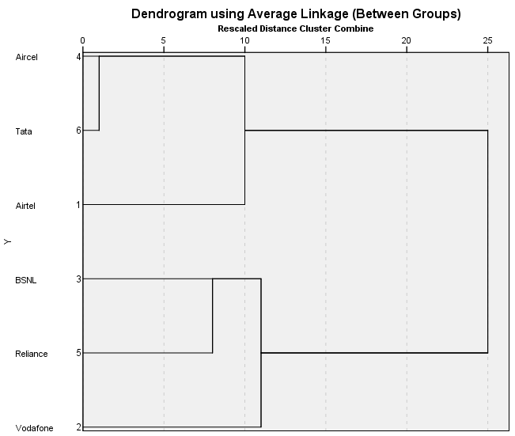

Fig: 8.3(a)

**Interpretation:-**From the above cluster analysis it is evident that the brands of telecom services can be classified under two categories .in one category there are three telecom service providers, viz, Airtel, Aircel, Tata which are similarly perceived by the consumers based on their service qualities. In the second cluster the members are BSNL , reliance, Vodafone.

**b) Cluster Analysis based on Customer Care Attributes:-**

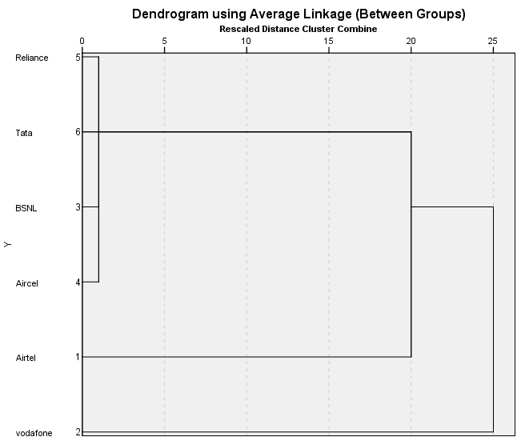

Fig: 8.3(b)

**Interpretation; -** From the above cluster analysis, it can be found that Reliance, Tata, BSNL and Aircel have similar types of customer care attributes. But both Airtel and Vodafone have unique customer care attributes.

**C) Cluster Analysis based on Network performance, Reliability and Maintainability Attributes:-**

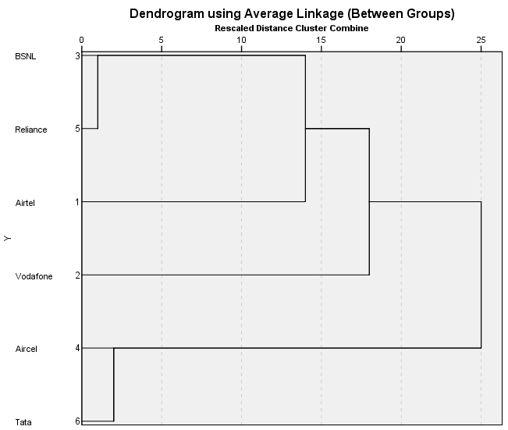Fig: 8.3(c)

**Interpretation:-** From the above cluster analysis, it can be found that BSNL and Reliance have similar types of customer care attributes and Aircel and Tata also have similar types of customer care attributes. But both Airtel and Vodafone have unique customer care attributes.

**d) Cluster Analysis based on Value Added Service (VAS) Attributes:-**

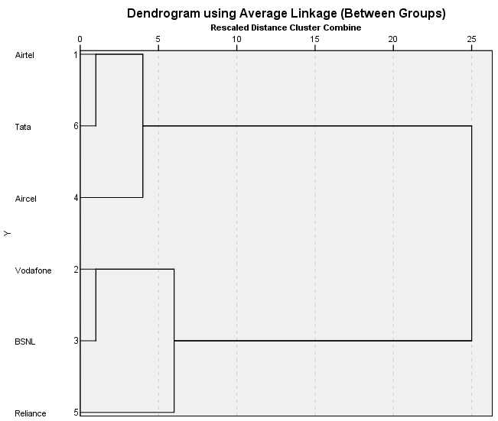

Fig: 8.3(d)

**Interpretation:-** From the above cluster analysis, it can be found that Airtel, Tata and Aircel have similar types of Value added service (VAS) attributes and Vodafone, BSNL have also similar types of value added service attributes. But Reliance has unique value added service attributes.

**e) Cluster Analysis based on Internet Attributes:-**

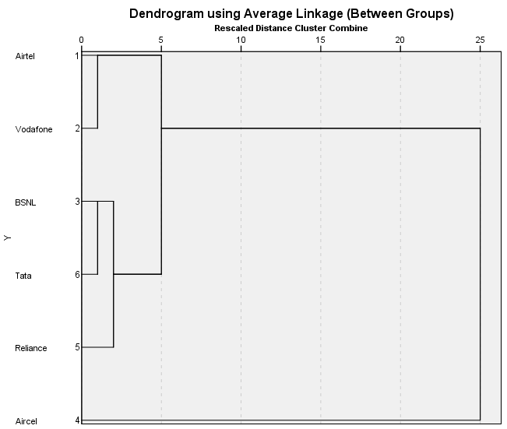

Fig: 8.3(e)

**Interpretation: -** From the above cluster analysis, it can be found that Airtel, Vodafone have Similar types of internet attributes and BSNL, Tata, Reliance have also similar types of internet attributes. But Aircel has unique internet attributes.

**The impact of different demographic attributes on overall satisfaction of different brands**

**8.4 One Way Anova Analysis:-**

**Airtel:-**

**i)** **Education Qualification:-**

H0 : There is no significance difference in overall satisfaction of Airtel operator across different educational qualification consumers.

H1 : There is a significance difference in overall satisfaction of Airtel operator across different educational qualification consumers.

|  |  |  |  |  |  |  |  |  |
| --- | --- | --- | --- | --- | --- | --- | --- | --- |
| **Table 8.4.1: Descriptives** | | | | | | | | |
| Overall Satisfaction level on Airtel | | | | | | | | |
|  | N | Mean | Std. Deviation | Std. Error | 95% Confidence Interval for Mean | | Minimum | Maximum |
| Lower Bound | Upper Bound |
| Below secondary | 179 | 3.29 | .604 | .045 | 3.20 | 3.38 | 1 | 4 |
| Secondary | 180 | 3.20 | .522 | .039 | 3.12 | 3.28 | 1 | 4 |
| Senior Secondary | 132 | 3.11 | .613 | .053 | 3.01 | 3.22 | 1 | 4 |
| Graduate | 167 | 3.08 | .553 | .043 | 3.00 | 3.17 | 1 | 4 |
| Post graduate - gen | 24 | 3.21 | .658 | .134 | 2.93 | 3.49 | 1 | 4 |
| Post graduate - prof | 20 | 3.30 | .470 | .105 | 3.08 | 3.52 | 3 | 4 |
| Illiterate | 8 | 3.00 | .535 | .189 | 2.55 | 3.45 | 2 | 4 |
| Total | 710 | 3.18 | .576 | .022 | 3.14 | 3.22 | 1 | 4 |

|  |  |  |  |
| --- | --- | --- | --- |
| **Table 8.4.2: Test of Homogeneity of Variances** | | | |
| Overall Satisfaction level on Airtel | | | |
| Levene Statistic | df1 | df2 | Sig. |
| 3.461 | 6 | 703 | .062 |

|  |  |  |  |  |  |
| --- | --- | --- | --- | --- | --- |
| **Table 8.4.3: ANOVA** | | | | | |
| Overall Satisfaction level on Airtel | | | | | |
|  | Sum of Squares | df | Mean Square | F | Sig. |
| Between Groups | 4.950 | 6 | .825 | 2.522 | .020 |
| Within Groups | 229.974 | 703 | .327 |  |  |
| Total | 234.924 | 709 |  |  |  |

**Means Plots**

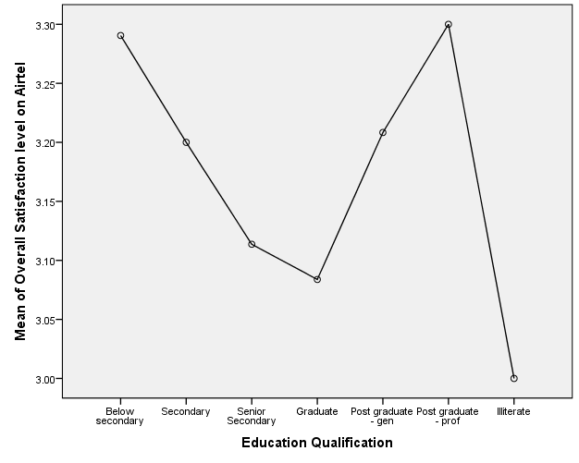

Fig: 8.4(a)

**Interpretation: -** from the above one way Anova analysis, it can be found that the significance level is less than 0.05(p<0.05) So Null hypothesis (H0) is rejected. Alternative hypothesis (H1) is accepted.

Hence it can conclude that there is a significance difference in overall satisfaction of Airtel operator across different education qualification consumers.

From means plots, it can find that the satisfaction level of Post graduate – Prof Consumers is maximum on Airtel operator and the satisfaction level of illiterate consumers is minimum on Airtel operator.

**Vodafone:-**

**i) Age:-**

H0 : There is no significance difference in overall satisfaction of Vodafone operator across different age category customers.

H1 : There is a significance difference in overall satisfaction of Vodafone operator across different age category customers.

|  |  |  |  |  |  |  |  |  |
| --- | --- | --- | --- | --- | --- | --- | --- | --- |
| **Table 8.4.4: Descriptives** | | | | | | | | |
| Overall Satisfaction level on Vodafone | | | | | | | | |
|  | N | Mean | Std. Deviation | Std. Error | 95% Confidence Interval for Mean | | Minimum | Maximum |
| Lower Bound | Upper Bound |
| Less than 21 | 209 | 3.21 | .566 | .039 | 3.13 | 3.29 | 1 | 4 |
| 21-25 | 315 | 3.24 | .582 | .033 | 3.18 | 3.31 | 1 | 4 |
| 26-40 | 424 | 3.33 | .537 | .026 | 3.28 | 3.38 | 2 | 4 |
| 41-60 | 117 | 3.36 | .636 | .059 | 3.24 | 3.48 | 1 | 4 |
| More than 60 | 9 | 3.22 | .667 | .222 | 2.71 | 3.73 | 2 | 4 |
| Total | 1074 | 3.28 | .570 | .017 | 3.25 | 3.32 | 1 | 4 |

|  |  |  |  |
| --- | --- | --- | --- |
| **Table 8.4.5: Test of Homogeneity of Variances** | | | |
| Overall Satisfaction level on Vodafone | | | |
| Levene Statistic | df1 | df2 | Sig. |
| 2.888 | 4 | 1069 | .081 |

|  |  |  |  |  |  |
| --- | --- | --- | --- | --- | --- |
| **Table 8.4.6: ANOVA** | | | | | |
| Overall Satisfaction level on Vodafone | | | | | |
|  | Sum of Squares | df | Mean Square | F | Sig. |
| Between Groups | 3.312 | 4 | .828 | 2.562 | .037 |
| Within Groups | 345.504 | 1069 | .323 |  |  |
| Total | 348.816 | 1073 |  |  |  |

**Means Plots**

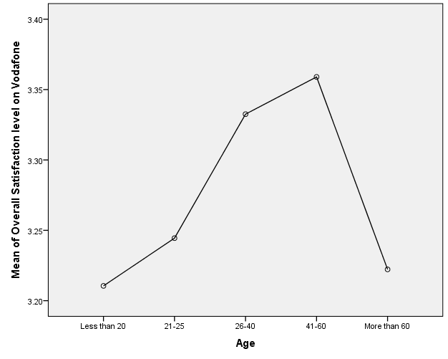Fig: 8.4(b)

**Interpretation: -** From the above one way Anova analysis, it can be find that the significance level is less than 0.05(p<0.05). So null hypothesis (H0) is rejected and alternative hypothesis (H1) is accepted.

Hence it can conclude that there is a significance difference in overall satisfaction of Vodafone operator across different age category customers.

From the means plots, it can find that the satisfaction level of 41-60 age category customers is maximum on Vodafone operator and the satisfaction level of less than 20 age category customers is minimum on Vodafone operator.

**ii)** **Occupation:-**

H0 : There is no significance difference in overall satisfaction of Vodafone operator across different occupation category customers.

H1 : There is a significance difference in overall satisfaction of Vodafone operator across different occupation category customers.

|  |  |  |  |  |  |  |  |  |
| --- | --- | --- | --- | --- | --- | --- | --- | --- |
| **Table 8.4.7: Descriptives** | | | | | | | | |
| Overall Satisfaction level on Vodafone | | | | | | | | |
|  | N | Mean | Std. Deviation | Std. Error | 95% Confidence Interval for Mean | | Minimum | Maximum |
| Lower Bound | Upper Bound |
| Student | 280 | 3.16 | .526 | .031 | 3.10 | 3.22 | 1 | 4 |
| Government employee | 55 | 3.38 | .733 | .099 | 3.18 | 3.58 | 1 | 4 |
| Private firm/co employee | 244 | 3.35 | .536 | .034 | 3.28 | 3.42 | 2 | 4 |
| Shopkeeper | 150 | 3.31 | .555 | .045 | 3.22 | 3.40 | 2 | 4 |
| Business/Self Employed | 127 | 3.43 | .572 | .051 | 3.33 | 3.53 | 2 | 4 |
| Farmer | 39 | 3.46 | .555 | .089 | 3.28 | 3.64 | 2 | 4 |
| House Wife | 122 | 3.23 | .572 | .052 | 3.13 | 3.33 | 1 | 4 |
| Retired | 5 | 3.20 | .447 | .200 | 2.64 | 3.76 | 3 | 4 |
| Unemployed | 44 | 3.05 | .645 | .097 | 2.85 | 3.24 | 1 | 4 |
| Others | 8 | 3.63 | .518 | .183 | 3.19 | 4.06 | 3 | 4 |
| Total | 1074 | 3.28 | .570 | .017 | 3.25 | 3.32 | 1 | 4 |

|  |  |  |  |
| --- | --- | --- | --- |
| **Table 8.4.8: Test of Homogeneity of Variances** | | | |
| Overall Satisfaction level on Vodafone | | | |
| Levene Statistic | df1 | df2 | Sig. |
| 6.135 | 9 | 1064 | .073 |

|  |  |  |  |  |  |
| --- | --- | --- | --- | --- | --- |
| **Table 8.4.9: ANOVA** | | | | | |
| Overall Satisfaction level on Vodafone | | | | | |
|  | Sum of Squares | df | Mean Square | F | Sig. |
| Between Groups | 14.135 | 9 | 1.571 | 4.993 | .000 |
| Within Groups | 334.681 | 1064 | .315 |  |  |
| Total | 348.816 | 1073 |  |  |  |

**Means Plots**

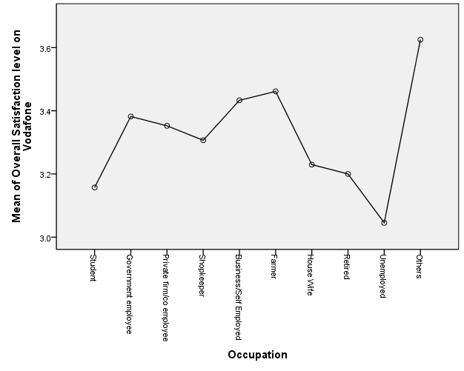

Fig: 8.4(c)

**Interpretation: -** From the above one way Anova analysis, it can be found that the significance level is less than 0.05(p<0.05). So null hypothesis (H0) is rejected and alternative hypothesis (H1) is accepted.

Hence it can conclude that there is a significance difference in overall satisfaction of Vodafone operator across different occupation category customers.

From the means plots, it can find that others occupation category customers have maximum level of satisfaction on Vodafone operator and unemployed customers have minimum level of satisfaction on Vodafone operator.

**iii) Area (Urban/Rural):-**

H0 : There is no significance difference in overall satisfaction of Vodafone operator across different areas(urban/rural).

H1 : There is a significance difference in overall satisfaction of Vodafone operator across different areas(urban/rural).

|  |  |  |  |  |  |  |  |  |
| --- | --- | --- | --- | --- | --- | --- | --- | --- |
| **Table 8.4.10: Descriptives** | | | | | | | | |
| Overall Satisfaction level on Vodafone | | | | | | | | |
|  | N | Mean | Std. Deviation | Std. Error | 95% Confidence Interval for Mean | | Minimum | Maximum |
| Lower Bound | Upper Bound |
| Rural | 288 | 3.22 | .568 | .033 | 3.15 | 3.28 | 2 | 4 |
| Urban | 786 | 3.31 | .569 | .020 | 3.27 | 3.35 | 1 | 4 |
| Total | 1074 | 3.28 | .570 | .017 | 3.25 | 3.32 | 1 | 4 |

|  |  |  |  |
| --- | --- | --- | --- |
| **Table 8.4.11: Test of Homogeneity of Variances** | | | |
| Overall Satisfaction level on Vodafone | | | |
| Levene Statistic | df1 | df2 | Sig. |
| 3.668 | 1 | 1072 | .056 |

|  |  |  |  |  |  |
| --- | --- | --- | --- | --- | --- |
| **Table 8.4.12: ANOVA** | | | | | |
| Overall Satisfaction level on Vodafone | | | | | |
|  | Sum of Squares | df | Mean Square | F | Sig. |
| Between Groups | 1.908 | 1 | 1.908 | 5.897 | .015 |
| Within Groups | 346.907 | 1072 | .324 |  |  |
| Total | 348.816 | 1073 |  |  |  |

**Means Plots**

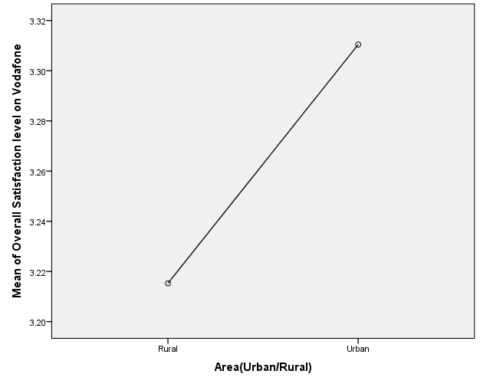

Fig: 8.4(d)

**Interpretation: -** From the above one way Anova analysis, it can be found that the significance level is less than 0.05(p<0.05). So null hypothesis (H0) is rejected and alternative hypothesis (H1) is accepted.

Hence it can conclude that there is a significance difference in overall satisfaction of Vodafone operator across different areas (urban/rural).

From the means plots, it can be found that the overall satisfaction on Vodafone operator is more in urban area rather than rural area.

.**BSNL: -**

1. **Occupation: -**

H0 : There is no significance difference in overall satisfaction of BSNL operator across different occupation category customers.

H1 : There is a significance difference in overall satisfaction of BSNL operator across different occupation category customers.

|  |  |  |  |  |  |  |  |  |
| --- | --- | --- | --- | --- | --- | --- | --- | --- |
| **Table 8.4.13: Descriptives** | | | | | | | | |
| Overall Satisfaction level on BSNL | | | | | | | | |
|  | N | Mean | Std. Deviation | Std. Error | 95% Confidence Interval for Mean | | Minimum | Maximum |
| Lower Bound | Upper Bound |
| Student | 64 | 3.25 | .563 | .070 | 3.11 | 3.39 | 2 | 4 |
| Government employee | 91 | 3.11 | .690 | .072 | 2.97 | 3.25 | 1 | 4 |
| Private firm/co employee | 117 | 3.33 | .525 | .049 | 3.24 | 3.43 | 2 | 4 |
| Shopkeeper | 80 | 3.09 | .532 | .060 | 2.97 | 3.21 | 2 | 4 |
| Business/Self Employed | 88 | 3.07 | .691 | .074 | 2.92 | 3.21 | 1 | 4 |
| Farmer | 10 | 3.20 | .632 | .200 | 2.75 | 3.65 | 2 | 4 |
| Daily Wage Earner | 11 | 3.55 | .522 | .157 | 3.19 | 3.90 | 3 | 4 |
| House Wife | 75 | 3.21 | .576 | .067 | 3.08 | 3.35 | 2 | 4 |
| Retired | 11 | 3.18 | .603 | .182 | 2.78 | 3.59 | 2 | 4 |
| Unemployed | 10 | 3.20 | .422 | .133 | 2.90 | 3.50 | 3 | 4 |
| Others | 2 | 3.00 | .000 | .000 | 3.00 | 3.00 | 3 | 3 |
| Total | 559 | 3.19 | .602 | .025 | 3.14 | 3.24 | 1 | 4 |

|  |  |  |  |
| --- | --- | --- | --- |
| **Table 8.4.14: Test of Homogeneity of Variances** | | | |
| Overall Satisfaction level on BSNL | | | |
| Levene Statistic | df1 | df2 | Sig. |
| 1.489 | 10 | 548 | .139 |

|  |  |  |  |  |  |
| --- | --- | --- | --- | --- | --- |
| **Table 8.4.15: ANOVA** | | | | | |
| Overall Satisfaction level on BSNL | | | | | |
|  | Sum of Squares | df | Mean Square | F | Sig. |
| Between Groups | 6.870 | 10 | .687 | 1.930 | .039 |
| Within Groups | 195.030 | 548 | .356 |  |  |
| Total | 201.900 | 558 |  |  |  |

**Means Plots**

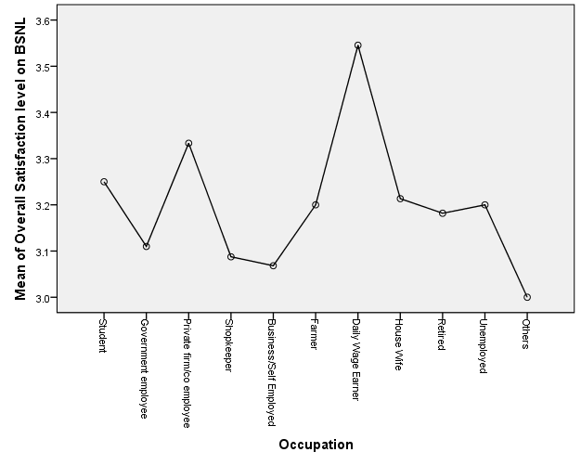Fig: 8.4(e)

**Interpretation:- -** From the above one way Anova analysis, it can be found that the significance level is less than 0.05(p<0.05). So null hypothesis (H0) is rejected and alternative hypothesis (H1) is accepted.

Hence it can conclude that there is a significance difference in overall satisfaction of BSNL operator across different occupation category customers.

From the means plots, it can be found that others daily wage earner category customers have maximum level of satisfaction on BSNL operator and other occupation category customers have minimum level of satisfaction on BSNL operator.

1. **Area: -**

H0 : There is no significance difference in overall satisfaction of BSNL operator across different areas(urban/rural).

H1 : There is a significance difference in overall satisfaction of BSNL operator across different areas(urban/rural).

|  |  |  |  |  |  |  |  |  |
| --- | --- | --- | --- | --- | --- | --- | --- | --- |
| **Table 8.4.16: Descriptives** | | | | | | | | |
| Overall Satisfaction level on BSNL | | | | | | | | |
|  | N | Mean | Std. Deviation | Std. Error | 95% Confidence Interval for Mean | | Minimum | Maximum |
| Lower Bound | Upper Bound |
| Rural | 191 | 3.07 | .557 | .040 | 2.99 | 3.15 | 2 | 4 |
| Urban | 368 | 3.25 | .615 | .032 | 3.19 | 3.31 | 1 | 4 |
| Total | 559 | 3.19 | .602 | .025 | 3.14 | 3.24 | 1 | 4 |

|  |  |  |  |
| --- | --- | --- | --- |
| **Table 8.4.17: Test of Homogeneity of Variances** | | | |
| Overall Satisfaction level on BSNL | | | |
| Levene Statistic | df1 | df2 | Sig. |
| 20.378 | 1 | 557 | .085 |

|  |  |  |  |  |  |
| --- | --- | --- | --- | --- | --- |
| **Table 8.4.18: ANOVA** | | | | | |
| Overall Satisfaction level on BSNL | | | | | |
|  | Sum of Squares | df | Mean Square | F | Sig. |
| Between Groups | 3.926 | 1 | 3.926 | 11.046 | .001 |
| Within Groups | 197.974 | 557 | .355 |  |  |
| Total | 201.900 | 558 |  |  |  |

**Means Plots**

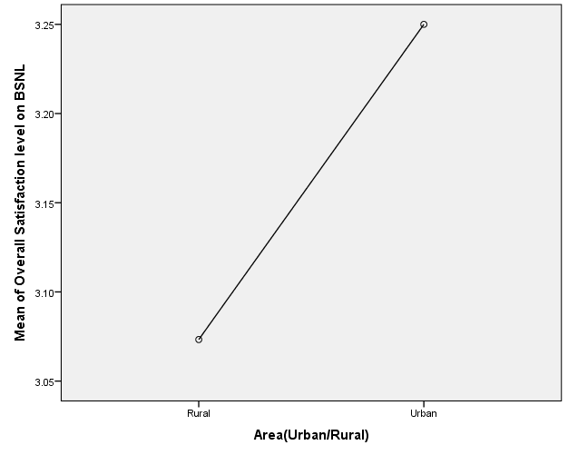

Fig: 8.4(f)

**Interpretation: -** From the above one way Anova analysis, it can be found that the significance level is less than 0.05(p<0.05). So null hypothesis (H0) is rejected and alternative hypothesis (H1) is accepted.

Hence it can conclude that there is a significance difference in overall satisfaction of BSNL operator across different areas (urban/rural).

From the means plots, it can be found that the overall satisfaction on BSNL operator is more in urban area rather than rural area.

**Aircel:-**

1. **Area: -**

H0 : There is no significance difference in overall satisfaction of Aircel operator across different areas(urban/rural).

H1 : There is a significance difference in overall satisfaction of Aircel operator across different areas(urban/rural).

|  |  |  |  |  |  |  |  |  |
| --- | --- | --- | --- | --- | --- | --- | --- | --- |
| **Table 8.4.19: Descriptives** | | | | | | | | |
| Overall Satisfaction level on Aircel | | | | | | | | |
|  | N | Mean | Std. Deviation | Std. Error | 95% Confidence Interval for Mean | | Minimum | Maximum |
| Lower Bound | Upper Bound |
| Rural | 217 | 3.05 | .563 | .038 | 2.98 | 3.13 | 2 | 4 |
| Urban | 440 | 3.19 | .551 | .026 | 3.14 | 3.24 | 1 | 4 |
| Total | 657 | 3.14 | .558 | .022 | 3.10 | 3.19 | 1 | 4 |

|  |  |  |  |
| --- | --- | --- | --- |
| **Table 8.4.19: Test of Homogeneity of Variances** | | | |
| Overall Satisfaction level on Aircel | | | |
| Levene Statistic | df1 | df2 | Sig. |
| 5.448 | 1 | 655 | .060 |

|  |  |  |  |  |  |
| --- | --- | --- | --- | --- | --- |
| **Table 8.4.20: ANOVA** | | | | | |
| Overall Satisfaction level on Aircel | | | | | |
|  | Sum of Squares | df | Mean Square | F | Sig. |
| Between Groups | 2.765 | 1 | 2.765 | 8.977 | .003 |
| Within Groups | 201.786 | 655 | .308 |  |  |
| Total | 204.551 | 656 |  |  |  |

**Means Plots**

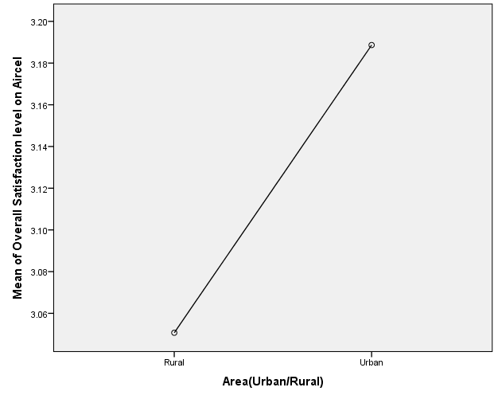

Fig: 8.4(g)

**Interpretation: -** From the above one way Anova analysis, it can be found that the significance level is less than 0.05(p<0.05). So null hypothesis (H0) is rejected and alternative hypothesis (H1) is accepted.

Hence it can conclude that there is a significance difference in overall satisfaction of Aircel operator across different areas (urban/rural).

From the means plots, it can be found that the overall satisfaction on Aircel operator is more in urban area rather than rural area.

**Reliance:-**

1. **Area: -**

H0 : There is no significance difference in overall satisfaction of Reliance operator across different areas(urban/rural).

H1 : There is a significance difference in overall satisfaction of Reliance operator across different areas(urban/rural).

|  |  |  |  |  |  |  |  |  |
| --- | --- | --- | --- | --- | --- | --- | --- | --- |
| **Table 8.4.21: Descriptives** | | | | | | | | |
| Overall Satisfaction level on Reliance | | | | | | | | |
|  | N | Mean | Std. Deviation | Std. Error | 95% Confidence Interval for Mean | | Minimum | Maximum |
| Lower Bound | Upper Bound |
| Rural | 192 | 2.95 | .572 | .041 | 2.87 | 3.03 | 1 | 4 |
| Urban | 373 | 3.17 | .572 | .030 | 3.12 | 3.23 | 1 | 4 |
| Total | 565 | 3.10 | .581 | .024 | 3.05 | 3.15 | 1 | 4 |

|  |  |  |  |
| --- | --- | --- | --- |
| **Table 8.4.22: Test of Homogeneity of Variances** | | | |
| Overall Satisfaction level on Reliance | | | |
| Levene Statistic | df1 | df2 | Sig. |
| 9.865 | 1 | 563 | .092 |

|  |  |  |  |  |  |
| --- | --- | --- | --- | --- | --- |
| **Table 8.4.23: ANOVA** | | | | | |
| Overall Satisfaction level on Reliance | | | | | |
|  | Sum of Squares | df | Mean Square | F | Sig. |
| Between Groups | 6.199 | 1 | 6.199 | 18.940 | .000 |
| Within Groups | 184.251 | 563 | .327 |  |  |
| Total | 190.450 | 564 |  |  |  |

**Means Plots**

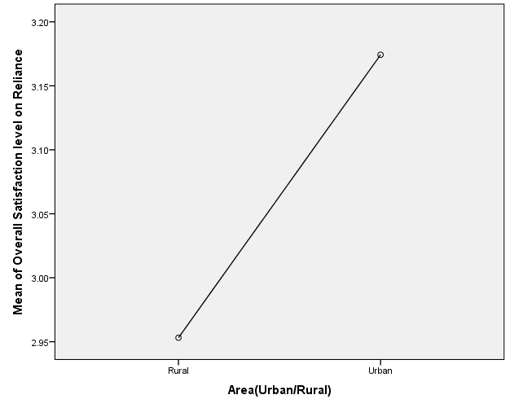

Fig: 8.4(h)

**Interpretation: -** From the above one way Anova analysis, it can be found that the significance level is less than 0.05(p<0.05). So null hypothesis (H0) is rejected and alternative hypothesis (H1) is accepted.

Hence it can conclude that there is a significance difference in overall satisfaction of Reliance operator across different areas (urban/rural).

From the means plots, it can be found that the overall satisfaction on Reliance operator is more in urban area rather than rural area.

**Tata:-**

1. **Gender: -**

H0 : There is no significance difference in overall satisfaction of Tata operator across male and female.

H1 : There is a significance difference in overall satisfaction of Reliance operator across male and female.

|  |  |  |  |  |  |  |  |  |
| --- | --- | --- | --- | --- | --- | --- | --- | --- |
| **Table 8.4.24: Descriptives** | | | | | | | | |
| Overall Satisfaction level on Tata | | | | | | | | |
|  | N | Mean | Std. Deviation | Std. Error | 95% Confidence Interval for Mean | | Minimum | Maximum |
| Lower Bound | Upper Bound |
| Male | 442 | 3.14 | .582 | .028 | 3.09 | 3.19 | 1 | 4 |
| Female | 114 | 3.32 | .554 | .052 | 3.21 | 3.42 | 2 | 4 |
| Total | 556 | 3.18 | .580 | .025 | 3.13 | 3.22 | 1 | 4 |

|  |  |  |  |
| --- | --- | --- | --- |
| **Table 8.4.25: Test of Homogeneity of Variances** | | | |
| Overall Satisfaction level on Tata | | | |
| Levene Statistic | df1 | df2 | Sig. |
| 3.325 | 1 | 554 | .069 |

|  |  |  |  |  |  |
| --- | --- | --- | --- | --- | --- |
| **Table 8.4.26: ANOVA** | | | | | |
| Overall Satisfaction level on Tata | | | | | |
|  | Sum of Squares | df | Mean Square | F | Sig. |
| Between Groups | 2.792 | 1 | 2.792 | 8.409 | .004 |
| Within Groups | 183.935 | 554 | .332 |  |  |
| Total | 186.727 | 555 |  |  |  |

**Means Plots**

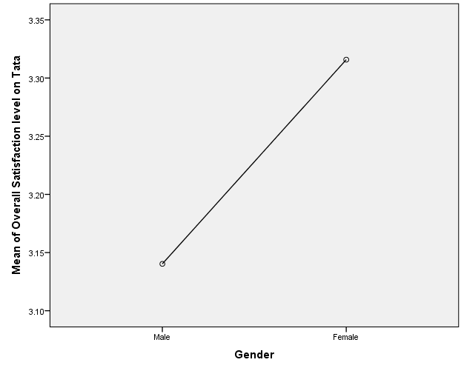

Fig: 8.4(i)

**Interpretation: -** From the above one way Anova analysis, it can be found that the significance level is less than 0.05(p<0.05). So null hypothesis (H0) is rejected and alternative hypothesis (H1) is accepted.

Hence it can conclude that there is a significance difference in overall satisfaction of Tata operator across male and female.

From the means plots, it can be found that the overall satisfaction on Tata operator is more in female than male.

1. **Occupation: -**

H0 : There is no significance difference in overall satisfaction of Tata operator across different occupation category customers.

H1 : There is a significance difference in overall satisfaction of Tata operator across different occupation category customers.

|  |  |  |  |  |  |  |  |  |
| --- | --- | --- | --- | --- | --- | --- | --- | --- |
| **Table 8.4.27: Descriptives** | | | | | | | | |
| Overall Satisfaction level on Tata | | | | | | | | |
|  | N | Mean | Std. Deviation | Std. Error | 95% Confidence Interval for Mean | | Minimum | Maximum |
| Lower Bound | Upper Bound |
| Student | 143 | 3.08 | .618 | .052 | 2.97 | 3.18 | 1 | 4 |
| Government employee | 24 | 3.13 | .448 | .092 | 2.94 | 3.31 | 2 | 4 |
| Private firm/co employee | 145 | 3.23 | .553 | .046 | 3.14 | 3.33 | 1 | 4 |
| Shopkeeper | 75 | 3.07 | .553 | .064 | 2.94 | 3.19 | 2 | 4 |
| Business/Self Employed | 73 | 3.14 | .631 | .074 | 2.99 | 3.28 | 2 | 4 |
| Farmer | 5 | 3.40 | .548 | .245 | 2.72 | 4.08 | 3 | 4 |
| Daily wage Earner | 12 | 3.42 | .515 | .149 | 3.09 | 3.74 | 3 | 4 |
| House Wife | 59 | 3.39 | .526 | .068 | 3.25 | 3.53 | 2 | 4 |
| Unemployed | 15 | 3.20 | .561 | .145 | 2.89 | 3.51 | 2 | 4 |
| Others | 5 | 3.40 | .548 | .245 | 2.72 | 4.08 | 3 | 4 |
| Total | 556 | 3.18 | .580 | .025 | 3.13 | 3.22 | 1 | 4 |

|  |  |  |  |
| --- | --- | --- | --- |
| **Table 8.4.28: Test of Homogeneity of Variances** | | | |
| Overall Satisfaction level on Tata | | | |
| Levene Statistic | df1 | df2 | Sig. |
| 1.163 | 9 | 546 | .316 |

|  |  |  |  |  |  |
| --- | --- | --- | --- | --- | --- |
| **Table 8.4.29: ANOVA** | | | | | |
| Overall Satisfaction level on Tata | | | | | |
|  | Sum of Squares | df | Mean Square | F | Sig. |
| Between Groups | 6.873 | 9 | .764 | 2.318 | .015 |
| Within Groups | 179.854 | 546 | .329 |  |  |
| Total | 186.727 | 555 |  |  |  |

**Means Plots**

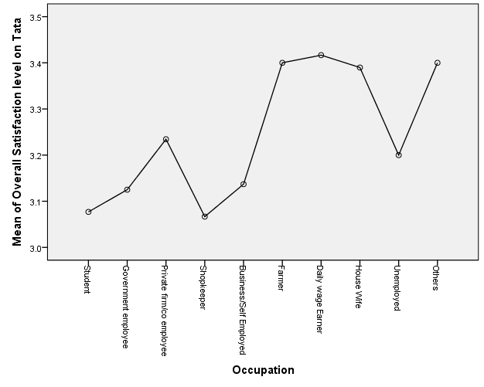

Fig: 8.4(j)

**Interpretation: -** From the above one way Anova analysis, it can be found that the significance level is less than 0.05(p<0.05). So null hypothesis (H0) is rejected and alternative hypothesis (H1) is accepted.

Hence it can conclude that there is a significance difference in overall satisfaction of Tata operator across different occupation category customers.

From the means plots, it can find that others occupation category customers have maximum level of satisfaction on Tata operator and student occupation category customers have minimum level of satisfaction on Tata operator.

1. **Education Qualification: -**

H0 : There is no significance difference in overall satisfaction of Tata operator across different educational qualification consumers.

H1 : There is a significance difference in overall satisfaction of Tata operator across different educational qualification consumers.

|  |  |  |  |  |  |  |  |  |
| --- | --- | --- | --- | --- | --- | --- | --- | --- |
| **Table 8.4.30: Descriptives** | | | | | | | | |
| Overall Satisfaction level on Tata | | | | | | | | |
|  | N | Mean | Std. Deviation | Std. Error | 95% Confidence Interval for Mean | | Minimum | Maximum |
| Lower Bound | Upper Bound |
| Below Secondary | 97 | 3.26 | .582 | .059 | 3.14 | 3.38 | 2 | 4 |
| Secondary | 130 | 3.23 | .578 | .051 | 3.13 | 3.33 | 2 | 4 |
| Senior Secondary | 123 | 3.15 | .553 | .050 | 3.05 | 3.25 | 1 | 4 |
| Graduate | 165 | 3.08 | .595 | .046 | 2.99 | 3.17 | 1 | 4 |
| Post graduate - gen | 20 | 3.50 | .607 | .136 | 3.22 | 3.78 | 2 | 4 |
| Post graduate - prof | 16 | 3.13 | .500 | .125 | 2.86 | 3.39 | 2 | 4 |
| Illiterate | 2 | 3.00 | .000 | .000 | 3.00 | 3.00 | 3 | 3 |
| 8 | 3 | 3.00 | .000 | .000 | 3.00 | 3.00 | 3 | 3 |
| Total | 556 | 3.18 | .580 | .025 | 3.13 | 3.22 | 1 | 4 |

|  |  |  |  |
| --- | --- | --- | --- |
| **Table 8.4.31: Test of Homogeneity of Variances** | | | |
| Overall Satisfaction level on Tata | | | |
| Levene Statistic | df1 | df2 | Sig. |
| 2.445 | 7 | 548 | .068 |

|  |  |  |  |  |  |
| --- | --- | --- | --- | --- | --- |
| **Table 8.4.32: ANOVA** | | | | | |
| Overall Satisfaction level on Tata | | | | | |
|  | Sum of Squares | df | Mean Square | F | Sig. |
| Between Groups | 5.001 | 7 | .714 | 2.155 | .037 |
| Within Groups | 181.725 | 548 | .332 |  |  |
| Total | 186.727 | 555 |  |  |  |

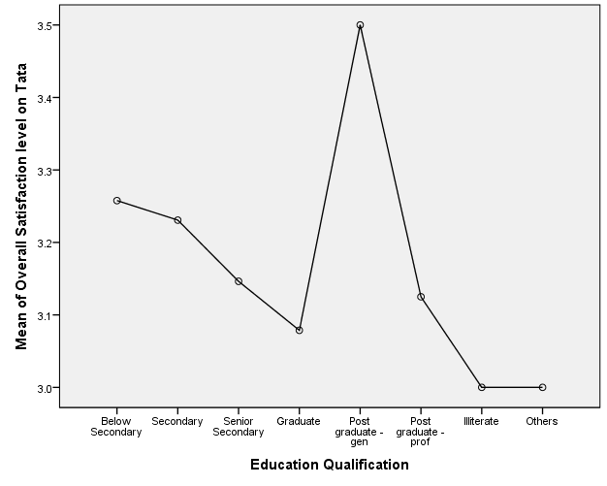**Means Plots**

Fig: 8.4(k)

**Interpretation: -** from the above one way Anova analysis, it can be found that the significance level is less than 0.05(p<0.05) So Null hypothesis (H0) is rejected. Alternative hypothesis (H1) is accepted.

Hence it can conclude that there is a significance difference in overall satisfaction of Tata operator across different education qualification consumers.

From means plots, it can find that the satisfaction level of Post graduate – Gen Consumers is maximum on Airtel operator and the satisfaction level of other education qualification category consumers is minimum on Airtel operator.

1. **Area(urban/rural): -**

H0 : There is no significance difference in overall satisfaction of Tata operator across different areas(urban/rural).

H1 : There is a significance difference in overall satisfaction of Tata operator across different areas(urban/rural).

|  |  |  |  |  |  |  |  |  |
| --- | --- | --- | --- | --- | --- | --- | --- | --- |
| **Table 8.4.33: Descriptives** | | | | | | | | |
| Overall Satisfaction level on Tata | | | | | | | | |
|  | N | Mean | Std. Deviation | Std. Error | 95% Confidence Interval for Mean | | Minimum | Maximum |
| Lower Bound | Upper Bound |
| Rural | 204 | 3.04 | .569 | .040 | 2.96 | 3.12 | 1 | 4 |
| Urban | 352 | 3.26 | .572 | .031 | 3.20 | 3.32 | 2 | 4 |
| Total | 556 | 3.18 | .580 | .025 | 3.13 | 3.22 | 1 | 4 |

|  |  |  |  |
| --- | --- | --- | --- |
| **Table 8.4.34: Test of Homogeneity of Variances** | | | |
| Overall Satisfaction level on Tata | | | |
| Levene Statistic | df1 | df2 | Sig. |
| 21.680 | 1 | 554 | .074 |

|  |  |  |  |  |  |
| --- | --- | --- | --- | --- | --- |
| **Table 8.4.35: ANOVA** | | | | | |
| Overall Satisfaction level on Tata | | | | | |
|  | Sum of Squares | df | Mean Square | F | Sig. |
| Between Groups | 6.052 | 1 | 6.052 | 18.556 | .000 |
| Within Groups | 180.675 | 554 | .326 |  |  |
| Total | 186.727 | 555 |  |  |  |

**Means Plots**

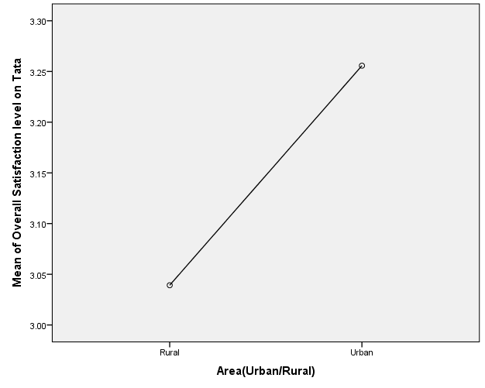

Fig: 8.4(l)

**Interpretation: -** From the above one way Anova analysis, it can be found that the significance level is less than 0.05(p<0.05). So null hypothesis (H0) is rejected and alternative hypothesis (H1) is accepted.

Hence it can conclude that there is a significance difference in overall satisfaction of Tata operator across different areas (urban/rural).

From the means plots, it can be found that the overall satisfaction on Tata operator is more in urban area rather than rural area.

**9. CONCLUSIONS**

In this research study on performance of the cell phone operators for prepaid connection users, it is carried out detailed survey of large number of respondents belonging to different cities of Odisha. The survey comprised of questionnaire containing questions relevant to the objectives of the research study. Different data was collated and analyzed. The result of the analysis are summarized below.

1) The factors which have impact on different parameters of customer satisfaction are given as below:-

**Customer care attributes:-**

**Airtel:-**

**Difference scale determinant:-**

1. Low response time taken to answer your call by a customer care executive
2. .problem solving ability of the customer care executive
3. providing correct information of products over SMS/Call/Poster/Advertisements
4. the operator always comes up with new product/service

**Ratio scale determinant:-**

1. Low response time taken to answer your call by a customer care executive
2. providing correct information of products over SMS/Call/Poster/Advertisements
3. . the operator always comes up with new product/service
4. . the ease of handling the menu options in the IVRS

**Vodafone:-**

**Difference scale determinant:-**

1. the ease of handling the menu options in the IVRS
2. problem solving ability of the customer care executive

**Product/ Tariff attributes:-**

**Airtel:-**

**Difference scale determinant:-**

1. Your operator charges a reasonable money for the services
2. Low roaming call rates
3. No wrong balance deduction

**Ratio scale determinant:-**

1. Your operator charges a reasonable money for the services
2. Low roaming call rates
3. No wrong balance deduction

**Vodafone:-**

**Difference scale determinant:-**

1. Low call rates for STD call
2. Low roaming call rates
3. Not charged for VAS not requested

**Ratio scale determinant:-**

1. Low call rates for STD call
2. Low roaming call rates
3. Not charged for VAS not requested

**BSNL:-**

**Difference scale determinant:-**

1. Low call rates for STD call
2. Low roaming call rates

**Ratio scale determinant:-**

1. Low call rates for STD call
2. Low roaming call rates

**Aircel:-**

**Difference scale determinant:-**

1. Low call rates for STD call
2. Low roaming call rates

**Ratio scale determinant:-**

1. Low call rates for STD call
2. Low roaming call rates

**Reliance:-**

**Difference scale determinant:-**

1. Low roaming call rates
2. No wrong balance deduction

**Ratio scale determinant:-**

1. Low roaming call rates
2. No wrong balance deduction
3. Not charged for VAS not requested

**Tata:-**

**Difference scale determinant:-**

1. Your operator charges a reasonable money for the services.
2. Low call rates for STD call
3. Not charged for VAS not requested
4. No wrong balance deduction

**Ratio scale determinant:-**

1. Your operator charges a reasonable money for the services.
2. .Not charged for VAS not requested

**Network performance, Reliability, Availability & Maintainability Attributes:-**

**BSNL:-**

**Difference scale determinant:-**

1. operator provides you network wherever you go
2. operator provides a clear voice quality during calls

**Ratio scale determinant:-**

1. operator provides you network wherever you go
2. operator provides a clear voice quality during calls

**Aircel:-**

**Ratio scale determinant:-**

1. getting call connected in the first attempt
2. operator provides you network wherever you go

**Reliance:-**

**Difference scale determinant:-**

1. operator provides a clear voice quality during calls
2. do not experience “No signal” (network outage) situations
3. network coverage and signal quality inside buildings

**Ratio scale determinant:-**

1. operator provides a clear voice quality during calls
2. network coverage and signal quality inside buildings

**Tata:-**

**Difference scale determinant:-**

1. operator provides a clear voice quality during calls
2. network coverage and signal quality inside buildings

**Ratio scale determinant:-**

1. operator provides a clear voice quality during calls
2. network coverage and signal quality inside buildings

2) The customer satisfaction with respect to different telecom company has been worked out under three different categories:

a) Product/ tariff attributes

b) Customer care attributes

c) Network performance, reliability and maintainability attributes.

The data with respect to above was collected and on it linear multiple regression analysis was carried out and the resultant equations derived for each operator.

3) For assessing the positioning of the telecom service provider brands in the mind of the customer, it was carried out Thurston case V analysis on the data belonging to each telecom operators. From the analysis, it could be concluded that the customer preference was in the following order.

Vodafone>Airtel>BSNL>Aircel>Reliance>Tata

4) To determine the perceptual positioning of different telecom brands on the mind of the customer, it is carried out the cluster analysis against different attributes. The results are

a) **Product Attributes:-**it is evident that the brands of telecom services can be classified under two categories .in one category there are three telecom service providers, viz, Airtel, Aircel, and Tata which are similarly perceived by the consumers based on their service qualities. In the second cluster the members are BSNL, reliance, Vodafone.

b) **Customer care attribute:-** it can be found that Reliance, Tata, BSNL and Aircel have similar types of customer care attributes. But both Airtel and Vodafone have unique customer care attributes

c) **Network performance, reliability and maintainability attributes:-**it can be found that BSNL and Reliance have similar types of customer care attributes and Aircel and Tata also have similar types of customer care attributes. But both Airtel and Vodafone have unique customer care attributes

d) **VAS attribute:-**it can be found that Airtel, Tata and Aircel have similar types of Value added service (VAS) attributes and Vodafone, BSNL have also similar types of value added service attributes. But Reliance has unique value added service attributes.

e) **Internet attributes:-**it can be found that Airtel, Vodafone have Similar types of internet attributes and BSNL, Tata, Reliance have also similar types of internet attributes. But Aircel has unique internet attributes.

5) To determine the impact of different demographic attributes on overall satisfaction of different brands, it was carried out one way ANOVA analysis. Based on this analysis the following were observed:

a) For Airtel, the demographic attribute is education qualification.

b) For Vodafone, the demographic attributes are age, occupation and area.

c) For BSNL, the demographic attributes are occupation and area.

d) For Aircel, the demographic attribute is area.

e) For reliance, the demographic attribute is area.

f) For Tata, the demographic attributes are gender, occupation, education qualification and area.

**10. RECOMMENDATIONS AND SUGGESTIONS**

1. During this research study, it is found that overall satisfaction of customer in rural areas is very low as compared to urban areas. So the telecom companies need to focus more on the rural areas to increase the visibility of their respective brands and work towards greater awareness of their services among the rural populace.

2. The penetration of internet is grossly lacking in deep hinterlands of Odisha. Hence the telecom companies need to create necessary infrastructure which will facilitate spread of internet connectivity.

3. The study did not reveal any significant findings as regards the impact of value added services on the customer satisfaction. This could be attributed to insufficient data or inadequate question in the survey questionnaire. Therefore it is recommended that a more elaborate questionnaire for relevant data collection may be formulated.

**11. LIMITATIONS**

1. The whole study was confined to the state of Odisha and the samples were taken from 21 cities of Odisha. Hence the study results are limited to the customer satisfaction of the state of Odisha only. The results do not represent the customer satisfaction of other states of India with respect to various Telecom Operators.
2. The study was also confined to only the pre-paid connection customers and therefore the research results represent findings only for this segment of the customers. Hence for a more realistic findings, the scope of the study need to be increased to PAN INDIA.

**12. REFERENCES**

Khan.S, Afsheen.S(2012), “Determinants of Customer Satisfaction in Telecom Industry: a Study of Telecom industry Peshawar KPK Pakistan”, Journal of Basic and Applied Science Research, 2(12)12833-12840, ISSN 2090-4304.

Mukherjee.D, Chatterjee.M(2013), “Business process Reengineering and customer satisfaction with reference to Indian Telecommunication sector”, Journal of Academia and Industrial Research (JAIR), Volume 2, ISSN: 2278-5213.

Agarwalla.N(2014), “Customer Satisfaction in the Telecom Sector in India: A study on Assam and North East Circle”, URL: <http://hdl.handle.net/10603/110822>.

Pandey. D.K, Kumar.Dr.B, Choudhury.H.M(2014), “A Study of Customer Satisfaction on Telecom Service Providers”, Indian Journal of Research, Volume: 3, ISSN - 2250-1991.

Madan.M (2016), “Determinants of Customer Satisfaction in Telecom Industry - A Study of Indian Telecom industry”, Indian Federation of United Nations Associations, ISBN: 978-93-86171-13-9.

Roy.B(2016), “A Study on Consumer Perception of E-Tailing Services for Electronic Goods in Kolkata”, TSM Business Review, Vol. 4, No. 2, ISSN: 2348-3784

Dahivale.R(2017), “Impact of customer satisfaction on customer loyalty and switching intentions: A pilot study on telecom sector in Pune city”, IMR (Indira Management Review) Volume XI.

Hossain.Md.A, Chowdhury.Md.R, Jahan.N(2018) “Customer Retention and Telecommunications Services in Bangladesh”, AESS Publications, URL: [www.aessweb.com](http://www.aessweb.com), International Journal of Asian Social Science, ISSN (e): 2224-4441, ISSN (p): 2226-5139, DOI: 10.18488/journal.1.2017.711.921.930 Vol. 7, No. 11, 921-930,

Vijayakumar.V, Shivdas.A(2018), “Understanding drivers of customer satisfaction in Indian telecom sector: A PLS-SEM based approach”, International Journal of Pure and Applied Mathematics, Volume 119 No. 7, 253-261, ISSN: 1311-8080 (printed version), ISSN: 1314-3395 (on-line version), URL: <http://www.ijpam.eu>.

URL: - <http://www.inqube.biz/>.

URL: - www.wikipedia.org