# NANOROBOTICS

**SEMINAR REPORT**

***Submitted in partial fulfillment of the requirements for the award of the degree of***

Bachelor of Computer Applications

Submitted By

# ATHUL KRISHNAN

# 210021089987

Under the guidance of

MS.**JEANNE JACOB**

(Assistant Professor, Department Of Computer Applications)



## Department of Computer Applications Mangalam M.C. Varghese College of Arts and Science

(Affiliated to Mahatma Gandhi University-Kottayam)

## Ettumanoor,Kottayam

## January 2024

**Department of Computer Applications Mangalam M.C. Varghese College of Arts and Science**

(Affiliated to Mahatma Gandhi University-Kottayam)

## Ettumanoor,Kottayam

## January 2024



***BONAFIDE CERTIFICATE***

*Certified that this is a Bonafide Report of the* **Seminar report** *done by Mr.* **ATHUL KRISHNAN** *with University Register Number* **210021089987** *under our supervision and guidance. The Seminar report has been submitted to the Department of Computer Applications ,Mangalam M.C. Varghese College Of Arts and Science, Ettumanoor, Kottayam in partial fulfillment of the award of the Degree of Bachelor Of Computer Applications.*

Internal Guide

**MS. JEANNE JACOB**

**Assistant Professor,**

**Dept. of Computer Applications**

##### MCVC

External Examiner

# DECLARATION

I hereby declare that this Seminar report entitled **“NANOROBOTICS”** is an original report prepared by us after detailed reference and consultation during our period of study in Mangalam M.C Varghese College of Arts and Science, Ettumanoor, affiliated to Mahatma Gandhi University,Kottayam under the guidance of Mr. Bijumoan Xavier, Assistant Professor, Department of Computer Applications.

The finding derived in the seminar report is based on the data collected by our self .We declare that this report has not been submitted elsewhere for award of any other degree.

**ATHUL KRISHNAN**

# ACKNOWLEDGEMENT

Firstly, I thank GOD Almighty whose blessings were always with me and helped me to complete this seminar work successfully.

I acknowledge our deep sense of gratitude to **Prof. Dr. K K JOHN**, the principal for permitting me to do this seminar.

I take the immense pleasure in expressing my thanks to the Head of the department **Mr. Bijumoan Xavier** , for his kind patronages in making this seminar a successful one.

I would like to extend my sincere thanks to **Ms.Jeanne Jacob**, Assistant Professor, Department of Computer Applications for the guidance and cooperation, without which this would not have been a success.

I would like to extend my graceful thanks to the staff and management of Mangalam

M.C. Varghese College of Arts & Science, for there valuable supports to carry out this seminar.

This leaf of acknowledgement would not be complete without a special word of thanks to my beloved parents and friends for their valuable support, encouragement and love, which enabled me to successfully bring out this seminar successfully.

**ATHUL KRISHNAN**

# ABSTRACT

Nanorobotics, a frontier field at the intersection of nanotechnology and robotics, focuses on the development of minute robotic devices with dimensions on the nanoscale, typically between 1 to 100 nanometers. These nanorobots exhibit unique properties stemming from their size, allowing for precision, agility, and versatility in various applications. In the realm of medicine, nanorobotics holds immense promise for targeted drug delivery, enabling the transport of therapeutic agents directly to diseased cells, minimizing side effects. Additionally, these tiny machines could revolutionize diagnostic procedures, operating at the molecular level for enhanced accuracy. Challenges such as propulsion, communication, and control are actively being addressed through innovations in materials and techniques.

Beyond healthcare, nanorobotics has implications for environmental remediation, manufacturing processes, and information technology. In environmental applications, nanorobots could be employed for the precise removal of pollutants or contaminants, mitigating the impact of human activities on ecosystems. In manufacturing, nanorobots may revolutionize production processes, enabling the fabrication of intricate structures with unprecedented precision. Furthermore, their integration into information technology could lead to advancements in data storage and processing at the molecular level.

As research progresses, ethical and safety considerations are paramount, necessitating a thorough understanding of the potential risks associated with the deployment of nanorobots in various domains. Overall, nanorobotics stands at the forefront of scientific exploration, poised to redefine the boundaries of what is possible at the nanoscale, with transformative implications across diverse sectors.

# CONTENTS

|  |  |
| --- | --- |
| Acknowledgement Investigation | (i) |
| Abstract | (ii) |
| 1. Introduction | 1 |
| 2. Existing System | 7 |
| 3. Proposed System | 8 |
| 4. System Design | 17 |
| 4.1 Introduction | 17 |
| 4.2 Input Design | 19 |
| 4.3 Output Design | 20 |
| 5.4 Database Design | 20 |
| 5.5 Tables | 23 |
| 5.6 Data Flow Diagram | 27 |
| 5.7 Entity Relationship Model | 36 |
| 6. System Testing | 38 |
| 7. Implementation | 42 |
| 8. Conclusion | 46 |
| 9. Future Scope | 47 |
| 10. References | 48 |
| 11.Screen layout | 49 |

* + - 1. **INTRODUCTION**

Nanorobotics, an interdisciplinary frontier at the confluence of nanotechnology and robotics, emerges as a transformative force in scientific exploration and technological innovation. Operating at scales ranging from 1 to 100 nanometers, nanorobotics harnesses the unique properties of nanomaterials to design and manipulate miniature robots with unprecedented precision. The convergence of these two realms opens vistas of possibilities across diverse domains.

In the medical arena, nanorobotics offers a revolutionary approach to healthcare. These minuscule agents hold the potential for targeted drug delivery, navigating the intricate landscape of the human body at the cellular and molecular levels with unparalleled accuracy. Moreover, the prospect of nanorobots executing minimally invasive surgeries or conducting intricate diagnostics signifies a new era in precision medicine.

Beyond healthcare, nanorobotics extends its influence into manufacturing, environmental remediation, and information technology. The ability to manipulate matter at the nanoscale allows for the fabrication of materials and structures with unprecedented precision, reshaping manufacturing processes. In environmental applications, nanorobots could revolutionize pollution cleanup by operating at the molecular level. Additionally, advancements in data storage and processing at the nanoscale promise transformative breakthroughs in information technology.

This introduction unveils the expansive and revolutionary landscape of nanorobotics, where the fusion of nanotechnology and robotics converges to redefine the boundaries of what is achievable in scientific discovery and technological progress.

# HOW DOES CHAT GPT WORKS TECHNICALLY

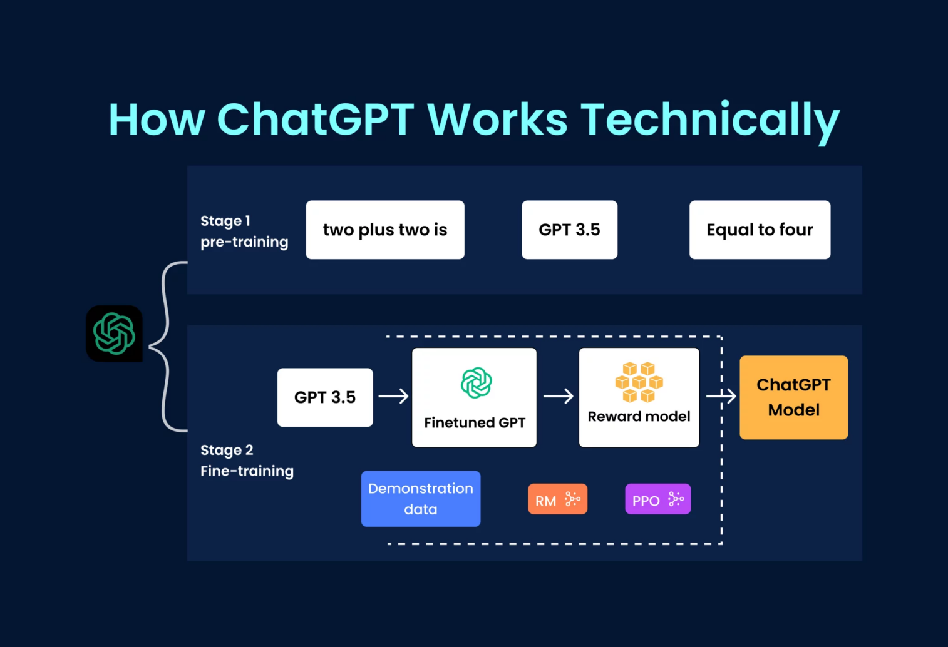

[fig - 1 how chat GPT works]

**STAGE 1**

Chat GPT operates on the GPT (Generative Pte-trained Transformer) architecture, specifically the GPT-3.5 version, developed by Open AI. The model's functionality can be broken down into several key components and steps:

* **Transformer Architecture:**

Attention Mechanism: The core of GPT is the Transformer architecture, which employs a mechanism known as attention. This allows the model to focus on different parts of the input sequence when generating an output. It captures relationships between words and understands context effectively.

* **Pre-training:**

Chat GPT is per-trained on a massive corpus of diverse internet text. During pre-training, the model learns to predict the next word in a sentence based on the context provided by the preceding words. This process helps the model grasp grammatical structures, language nuances, and contextual relationships.

**STAGE 2**

* **Fine-tuning:**

After pre-training, the model is fine-tuned on specific tasks or domains to improve its performance in targeted applications. Fine-tuning can involve exposing the model to a narrower data set related to the desired use case.

* **Input Encoding:**

When a user provides input in the form of a message or query, the text undergoes encoding. This process converts the input text into a numerical format that the model can comprehend.

#### FRAMEWORK APPORACH

#### Developing applications powered by Chat GPT and AI technology follows a structured framework that encompasses key components and steps. Beginning with a clear understanding of the specific use case, developers choose appropriate frameworks and libraries, such as the Open AI API, TensorFlow, or PyTorch. Data collection and pre processing play a crucial role in preparing relevant information for the model. Integration of the Chat GPT model involves utilizing the chosen framework, whether through API calls or deeper customization using TensorFlow or PyTorch. User input processing is implemented to convert queries into a format the model can comprehend. Efficient context management defines how much historical interaction the model considers when generating responses. The response generation phase utilizes the model to provide coherent and contextually relevant answers. Optional fine-tuning on domain-specific data enhances the model's performance. UI development creates a user interface for seamless interactions, and rigorous testing and evaluation ensure functionality and user satisfaction. Deployment considerations include scalability and security, while ongoing monitoring and maintenance keep the application optimized and responsive to evolving requirements. This comprehensive framework guides developers in creating intelligent conversational AI applications that leverage Chat GPT and AI technology effectively.

#### Additionally, the framework involves the design and implementation of user interfaces (UI) that facilitate intuitive interactions between users and the AI system. Whether through a chat-based interface or a custom application interface, the goal is to create a user-friendly experience. Extensive testing and evaluation phases are paramount to ensure the system's robustness, accuracy, and user satisfaction. Developers must consider both functional and non-functional requirements during this phase, addressing issues such as performance, scalability, and potential biases in the AI model's responses. Deployment strategies, including cloud-based solutions or on-premises servers, must align with the application's specific needs and anticipated user load. Monitoring and maintenance processes are crucial post-deployment, involving the implementation of tools to track the model's performance and user feedback. Regular updates based on new data and emerging user patterns contribute to the ongoing improvement of the AI system particularly regarding user privacy and bias mitigation, should be integrated throughout the development life cycle. Collaboration with stakeholders and the incorporation of user feedback loops ensure that the AI application remains adaptive to changing requirements and user expectations. This comprehensive frameworks and dynamic nature of developing AI-powered conversational systems, emphasizing a commitment to continual improvement and responsible deployment.

# 2. EXISTING SYSTEM

Existing System of Chat GPT (GPT-3):

1. **Open AI GPT-3 Model**:

* The existing system for Chat GPT is primarily based on the GPT-3 model developed by Open AI.

1. **Generative Re-trained Transformer (GPT) Architecture:**

* GPT-3 utilizes the Transformer architecture, specifically designed for natural language processing tasks.

1. **Pre-training on Diverse Internet Text:**

* The model has been per-trained on a vast corpus of diverse internet text, enabling it to understand language nuances and context.

1. **Open AI API Access:**

* Open AI provides access to GPT-3 through the Open AI API, allowing developers to integrate the model into their applications and systems.

1. **API-based Interaction:**

* Developers interact with GPT-3 through API calls, sending text prompts and receiving generated responses from the model.

1. **Versatile Applications:**

* GPT-3 finds applications in various domains, including chat bots, content generation, language translation, and more.

1. **Human-like Language Generation:**

* GPT-3 demonstrates impressive language understanding and generation abilities, producing human-like responses based on input prompts.

#### 2.1 Disadvantages of existing system

#### Here are some potential disadvantages associated with the existing system of GPT-3, the model powering Chat GPT:

#### Limited Understanding of Context:

#### While GPT-3 demonstrates impressive language generation capabilities, it may sometimes struggle with maintaining long-term context in a conversation. The model has a context window, and information from earlier parts of a conversation might not be fully retained.

#### Occasional Inaccuracies:

#### GPT-3 outputs are generated based on patterns learned during training, and there is a possibility of generating inaccurate or nonsensical responses. The model may provide answers that sound plausible but are factually incorrect.

#### Sensitivity to Input Phrasing:

#### The model's responses can be sensitive to slight changes in input phrasing. Small modifications in the way a question is posed might lead to different or inconsistent answers.

#### Tendency to Overuse Certain Phrases:

#### GPT-3 may exhibit a propensity to overuse certain phrases or respond in a verbose manner. This can result in outputs that seem repetitive or overly complex.

#### Lack of Real-world Understanding:

#### GPT-3 lacks real-world knowledge beyond what is present in its training data. It may struggle to provide accurate information about events or developments that occurred after its last training cut-off in 2021.

#### Potential for Biased Responses:

#### The model might inadvertently generate biased or politically charged responses, reflecting biases present in the training data. Open AI acknowledges the presence of biases and is actively working to address this issue.

#### No Inherent Fact-checking:

#### GPT-3 does not have built-in fact-checking mechanisms. It can generate information that may be inaccurate or outdated without independently verifying the correctness of the content.

#### Inability to Reason or Infer:

#### While GPT-3 excels in generating coherent text based on patterns it has learned, it may lack the ability to reason, infer, or genuinely understand the meaning of the information it generates.

# 3.PROPOSED SYSTEM

Chat GPT, developed by Open AI based on the GPT-3.5 architecture, is a powerful language model with 175 billion parameters, making it one of the largest in its class. This versatile model excels in natural language processing tasks, including text completion, question answering, summation, and translation. Its applications span diverse industries, such as customer support, content creation, and code generation, and it is commonly integrated into chat bots for improved conversational AI experiences. Open AI's API allows developers and businesses to leverage Chat GPT in building applications that benefit from its sophisticated language understanding capabilities. However, the model has limitations, such as occasional generation of incorrect or nonsensical responses, sensitivity to input phrasing, and the potential for biased behavior. Open AI actively seeks user feedback to enhance the model's safety and reliability, emphasizing a responsible AI approach and transparency in its development process. Ongoing research and collaboration with the wider community contribute to addressing challenges and advancing the field of language models.

#### 3.1 Advantages of proposed system

* Improved Language Understanding
* Expanded Task Capabilities
* Reduced Limitations and Biases
* Customization and User Control
* Continuous Learning and Adaptability
* Ethical Considerations and Safety Features:
* Integration with Emerging Technologies

1. **WEB MINING**

Web mining, a process dedicated to extracting valuable insights from the vast expanse of the World Wide Web, intersects with artificial intelligence (AI) in several impact ways. It serves as a crucial tool for gathering large datasets for training and refining AI models, particularly in the realm of natural language processing. Web mining techniques are instrumental in sentiment analysis and opinion mining, providing AI applications with the ability to discern public sentiment from user-generated content like reviews and social media posts. Additionally, it contributes to the improvement of content recommendation systems by analyzing user behavior on the web to offer personalized content suggestions. Through entity recognition and knowledge extraction, web mining aids in transforming unstructured web data into structured information, supporting AI applications that rely on knowledge graphs and databases. AI-powered web crawlers, guided by machine learning algorithms, enhance web content indexing and retrieval, ensuring AI systems have access to current and relevant data. Furthermore, web mining plays a pivotal role in cyber security and fraud detection, identifying anomalies and potential threats within web data. As an adaptive learning tool, web mining enables AI models to continuously evolve by monitoring and analyzing new data from the ever-changing landscape of the web, fostering ongoing improvement. It is essential, however, to prioritize ethical considerations and responsible data usage in the deployment of web mining techniques, especially concerning user-generated content.(AI) extends its influence into various domains, enriching the capabilities of AI systems. The analysis of user behavior through web mining contributes significantly to the development of user-eccentric AI applications, such as personalized marketing strategies and user experience optimization.. In the field of e-commerce, AI applications can benefit from web mining by extracting pricing information, product reviews, and market trends to optimize pricing strategies and offer personalized recommendations to users. Moreover, the integration of web mining with AI supports the creation of intelligent chat bots and virtual assistants, leveraging the mined data to understand user queries, preferences, and context for more effective and natural interactions. The fusion of web mining and AI also contributes to the advancement of knowledge discovery, aiding researchers and professionals in staying updated on the latest developments and insights within their respective fields. ensuring that AI systems remain dynamic, responsive, and attuned to the ever-changing landscape of the web.

1. **RELATED WORK**

Artificial intelligence (AI) research is a vibrant and rapidly evolving field, marked by a broad spectrum of investigations that span fundamental algorithms, cutting-edge models, and practical applications across diverse domains. One of the forefront areas of exploration lies in natural language processing (NLP), where researchers continually strive to enhance language understanding. Recent works delve into sentiment analysis, machine translation, and context-aware language models, with innovations exemplified by models such as Bidirectional Encoder Representations from Transformers (BERT) and Generative Re-trained Transformers (GPT). These models, particularly GPT, have demonstrated remarkable capabilities in generating coherent and contextually relevant text, sparking advancements in chat bots, content creation, and language generation applications.

Computer vision, another pivotal domain in AI, witnesses ongoing research to refine algorithms for image recognition, object detection, and image segmentation. Convolution Neural Networks (CNN) have emerged as a cornerstone in achieving state-of-the-art performance in various computer vision tasks. The synergy between computer vision and AI has given rise to applications ranging from facial recognition systems to autonomous vehicles, revolutionizing industries and enhancing the capabilities of systems relying on visual data.Reinforcement learning, a paradigm where agents learn to make decisions through interaction with an environment, represents a captivating frontier in AI research. Deep Reinforcement Learning (DRL) has gained prominence, demonstrating its prowess in mastering complex tasks in gaming, robotics, and control systems. The adaptability of reinforcement learning algorithms makes them well-suited for scenarios where agents must learn from trial and error, evolving strategies over time.Explainable AI (XAI) has emerged as a critical area of study, responding to the increasing complexity of AI models. Researchers seek to make AI systems more interpret able, transparent, and understandable, addressing the "black box" challenge. The ability to explain AI decisions becomes particularly crucial in sensitive applications such as healthcare, finance, and criminal justice, where transparency and accountability are paramount.Ethical considerations and bias mitigation have become focal points in AI research. As AI systems increasingly impact society, addressing biases in algorithms and datasets is imperative. Researchers are developing methods to identify, understand, and mitigate biases, ensuring that AI applications are fair, unbiased, and equitable. The intersection of AI and ethics involves ongoing discussions on responsible AI development, transparency, and the ethical on the static

significant strides. Applications range from medical imaging analysis for diagnosis to drug discovery and personalized medicine. AI models are trained on vast datasets, enabling them to detect patterns and anomalies in medical images with a level of precision that can augment diagnostic processes and improve patient outcomes.The financial sector is undergoing a transformation through the integration of AI technologies. Research in this domain includes the development of algorithms for risk assessment, fraud detection, algorithmic trading, and customer service. Machine learning models analyze vast datasets of financial transactions, market trends, and economic indicators, providing valuable insights for decision-making processes in the financial industry.

AI's role in addressing environmental challenges and climate change is an emerging area of interest. Researchers are exploring how AI can contribute to climate modeling, energy optimization, and sustainability initiatives. Machine learning algorithms analyze large datasets related to climate patterns, deforestation, and environmental changes, aiding scientists and policymakers in understanding and mitigating the impacts of climate change.Education is another domain where AI research is influencing practices. Intelligent tutoring systems, adaptive learning platforms, and AI-driven educational content creation are areas of exploration. AI applications in education aim to enhance personalized learning experiences, cater to individual student needs, and provide educators with valuable insights into student progress and performance.

As AI research continues to advance, human-AI collaboration becomes a focal point. Researchers are investigating ways to build AI systems that complement human abilities, fostering collaboration in areas such as co-creation, decision-making, and human-robot interaction. This research aims to create AI technologies that enhance human capabilities rather than replace them.

(NLP) and conversational AI. The model, based on the GPT (Generative Pte-trained Transformer) architecture, has been a focal point for researchers exploring the capabilities and limitations of large-scale language models.One major avenue of research focuses on improving the model's contextual understanding and response coherence. Researchers aim to refine Chat GPT ability to generate more contextually relevant and coherent responses, reducing instances of nonsensical or inaccurate answers. This work involves investigating training strategies, model architectures, and fine-tuning approaches to enhance the overall conversational quality.Efforts to address biases and ethical considerations in language models, including Chat GPT, have been another key area of research. Researchers work on developing methods to

identify and mitigate biases in the model's outputs, ensuring that it responds responsibly and without perpetuating harmful stereotypes. This research aligns with the broader industry-wide commitment to ethical AI development.Research has also delved into user customization and control over Chat GPT behavior. This involves exploring mechanisms that allow users to tailor the model's responses to specific preferences or guidelines, making it a more versatile tool for a variety of applications.

In conclusion, the vast landscape of AI research encompasses a myriad of topics, each contributing to the development and refinement of AI technologies. From the fundamental algorithms shaping the core of intelligent systems to the practical applications revolutionizing industries, AI research is a dynamic and interdisciplinary pursuit. As researchers navigate the complexities of AI, ethical considerations, transparency, and responsible deployment remain integral to ensuring the positive impact of AI on society. The continued exploration of these diverse avenues promises to unveil new possibilities and shape the trajectory of artificial intelligence in the years to come.Research on Chat GPT, the conversational language model developed by Open AI, has spurred significant advancements in natural language processing

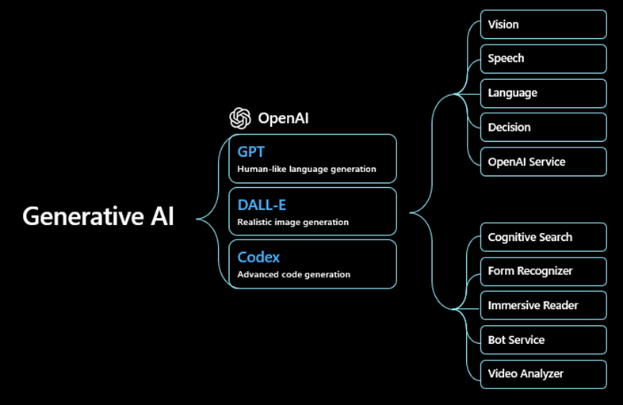

[fig 2 generative AI works behind the CHAT GPT]

# CONCLUSION

# FUTURE SCOPE

# REFERENCES