Cloud Infrastructure and Services
25CS2206E
2026-2027 Even Trimester (T5)
Name : Krish Sureja
Roll number : 2520030134

Experiment-1: a) Amazon Free Tier Account Creation

1.a) AWS Account Creation
Objective
To create an AWS account, complete the required verification procedures, and successfully access the AWS Management Console.
Prerequisites
- Valid email ID.
- Mobile phone number for OTP verification.
- Personal details (name and address).
- Internet connection.
- Payment method, requested by AWS:
  - Credit/Debit Card (Visa, Mastercard, RuPay or American Express).
  - UPI (where supported by the AWS India billing/payment process).
- AADHAR, PAN or another accepted identity document, if requested during AWS India customer verification.

Step-by-Step Procedure
- Open the AWS Website. Open a web browser (Chrome/Edge recommended).
Go to: https://aws.amazon.com/free
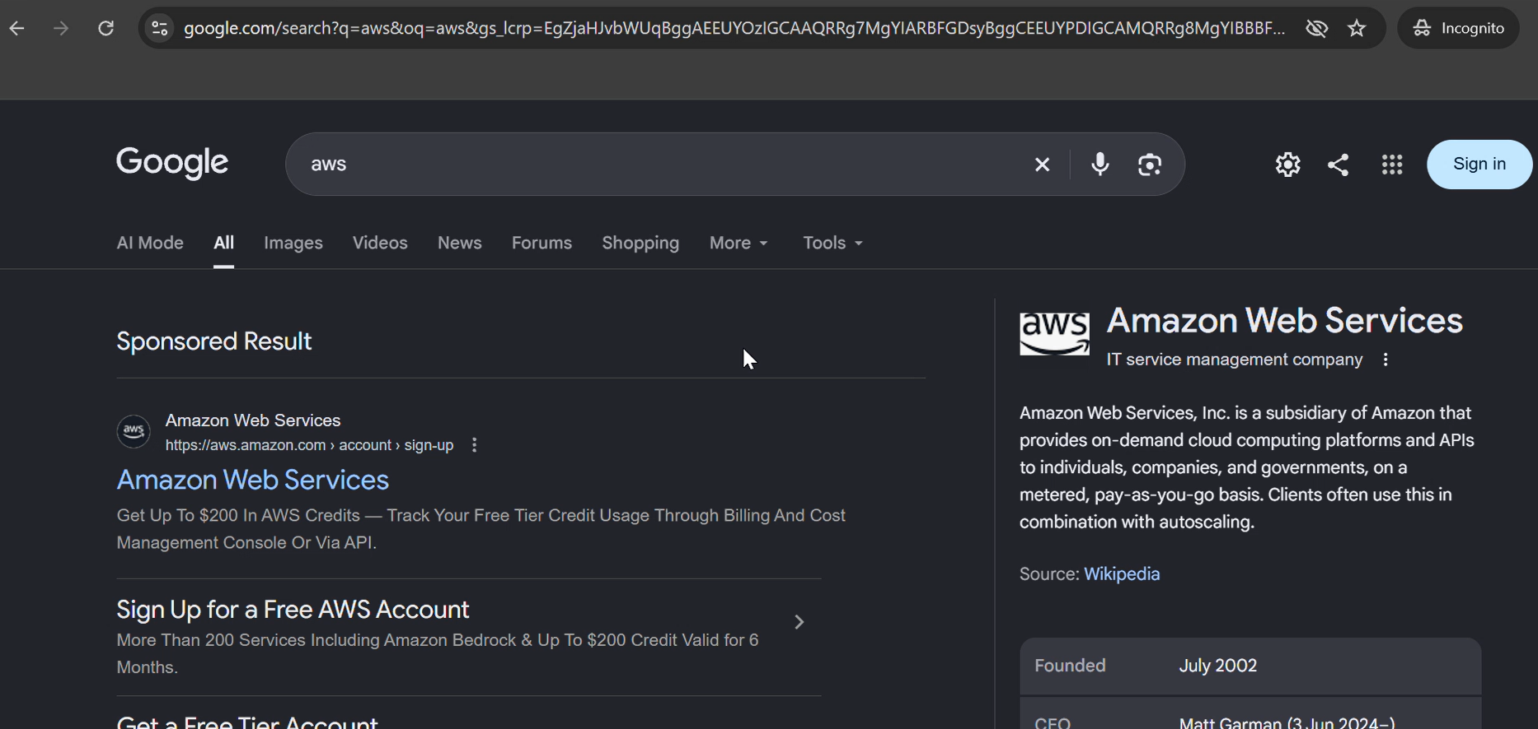
- Click Sign in to console
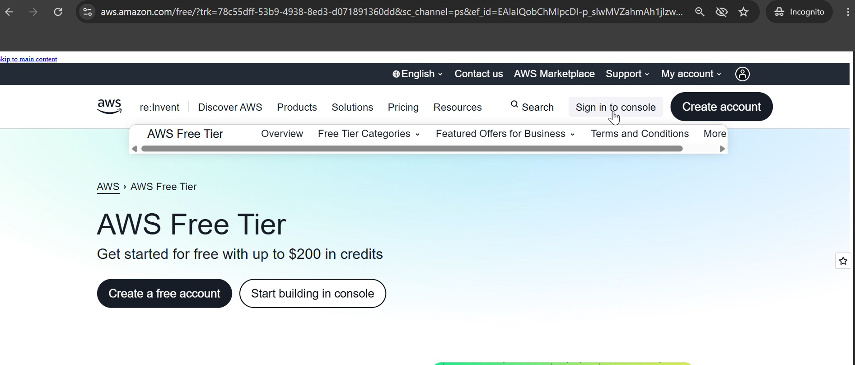

- Click Create a new AWS account.
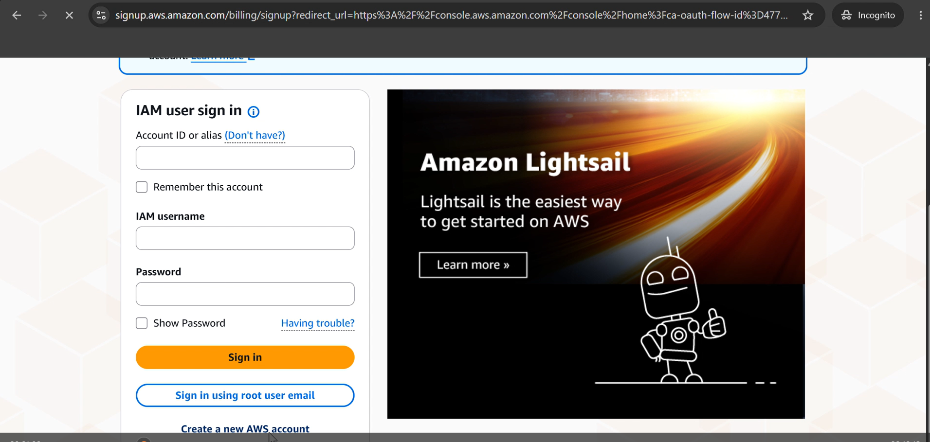
- Enter the following details:
  - Email address
  - Password
  - AWS Account Name (e.g., StudentAWSAccount)
- Click Verify email address and enter the OTP sent to your email.
- Choose your Account plan Free(6 months)-click Choose Free plan
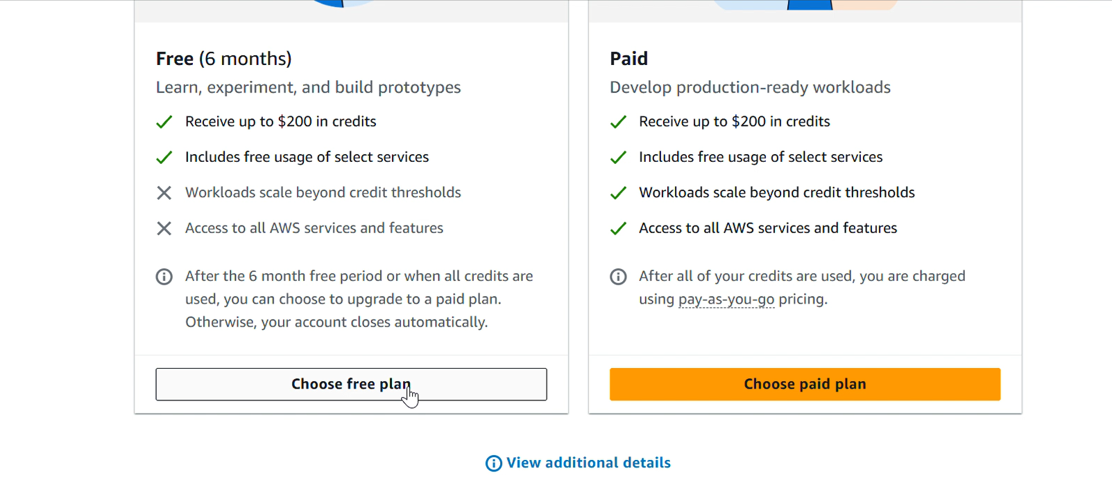
- Give all contact information. Enter personal details:
  - Full name
  - Phone number
  - Address…………..Click agree and continue
- In the next steps provide Billing information
You can choose UPI or Debit/Credit Card option and accordingly give the details. If UPI (Automatic Payment limit 15000 should be there) just for authorization later autopay can be deleted
Note: For AWS India accounts using the advanced registration process, card verification may involve a temporary ₹2 charge, which AWS refunds after verification. UPI is also supported for AWS India bill payments and UPI AutoPay.
- In the next step Confirm your Identity.
Choose primary purpose of Acount registration as Academic,
Ownership type as Individual
Document type as AADHAR…verification to be done through digilocker
Or voter id or driving license also can be provided….then click continue
- Provide Mobile number and click send SMS…..
Enter code for verification..continue
- Setting up of AWS account.( around 1 to 2 mins)
- AWS Management Console dashboard is visible.
or Login at: https://console.aws.amazon.com. and then sign in using root user email. (Sign in using your registered credentials)
Verification
- AWS Management Console dashboard is visible.
- The AWS account name is displayed in the account menu at the top-right corner.
- The account status and Free Plan information are accessible.
- You can access the AWS services available under your account plan.
Expected Outcome
A new AWS account is successfully created, verified and accessed through the AWS Management Console.



