3.EXAMPLES
2520030182
P.VENKATA SRI SAI MADHURIMA

1.CREATING PHYSICIAN TABLE AND INSERTING VALUES
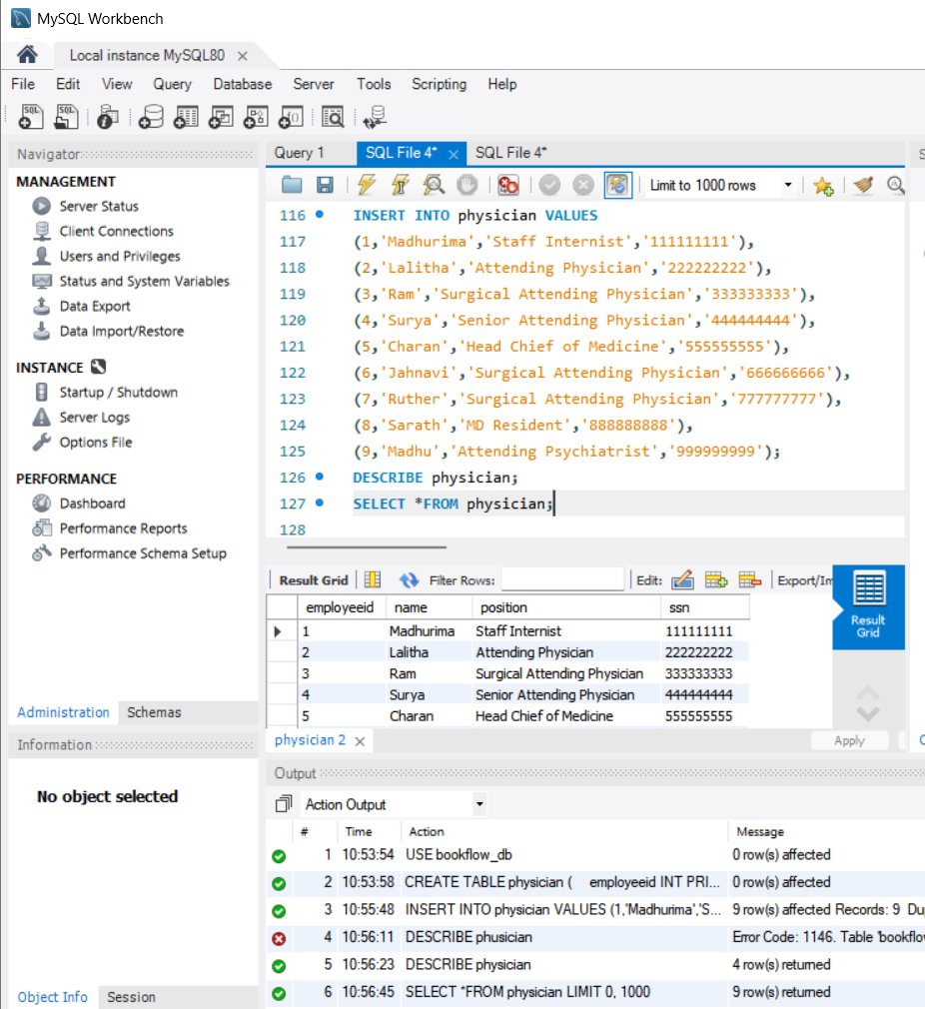

2.CREATED DEPARTMENT TABLE WITH VALUES INSERTED
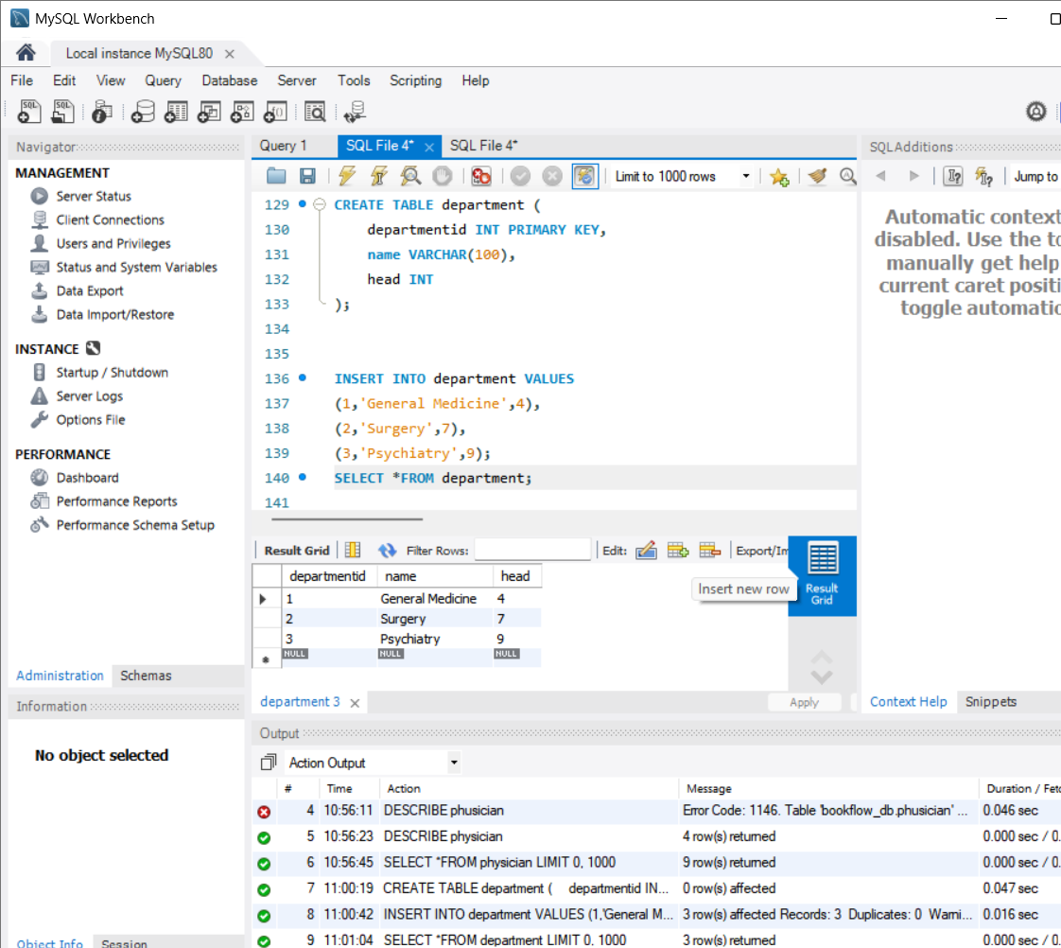

4.IMPLEMENTATION OF INNER JOIN
The extra values be deleted in inner join
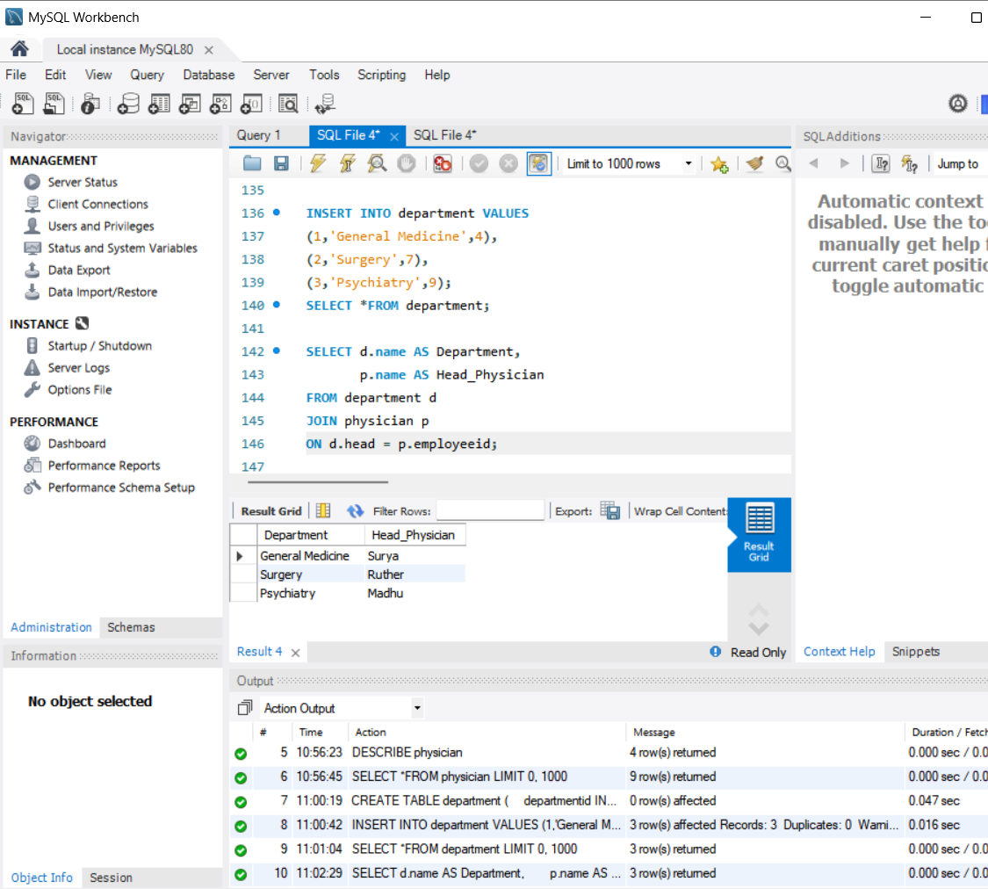

5.USING WHERE CLAUSE
Selecting where is the “Surgical attending physician “ is!!
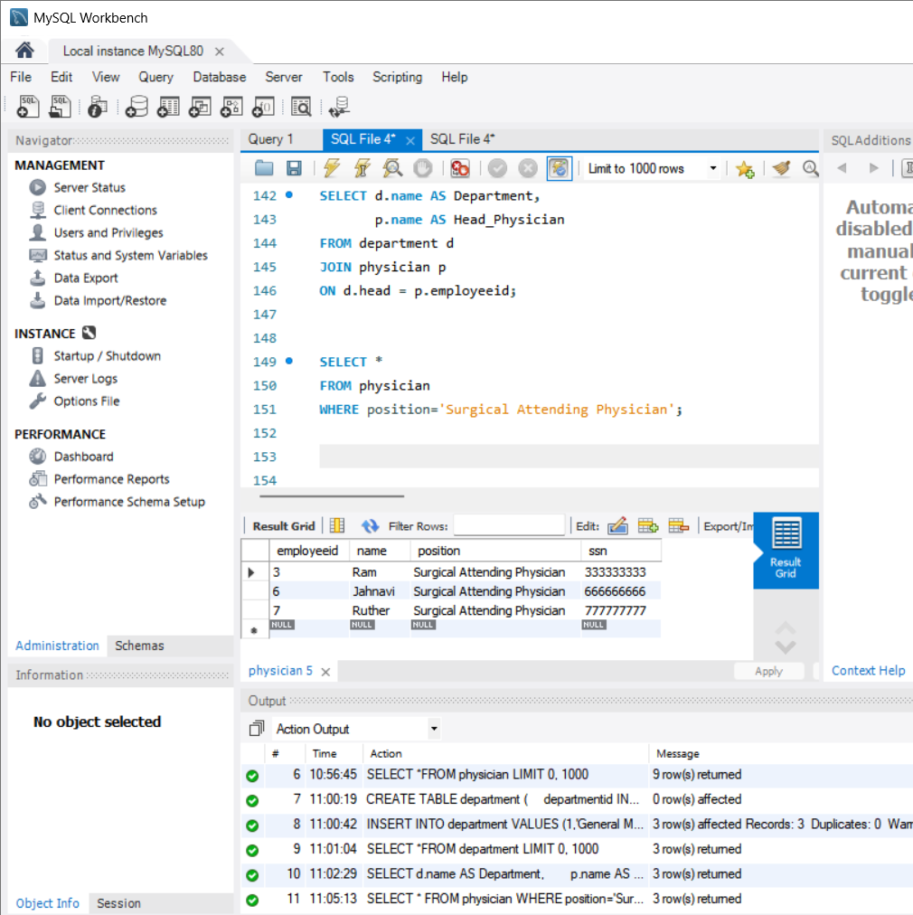

6.USING WHERE+LIKE
Selecting where Madhu similar names are there!!
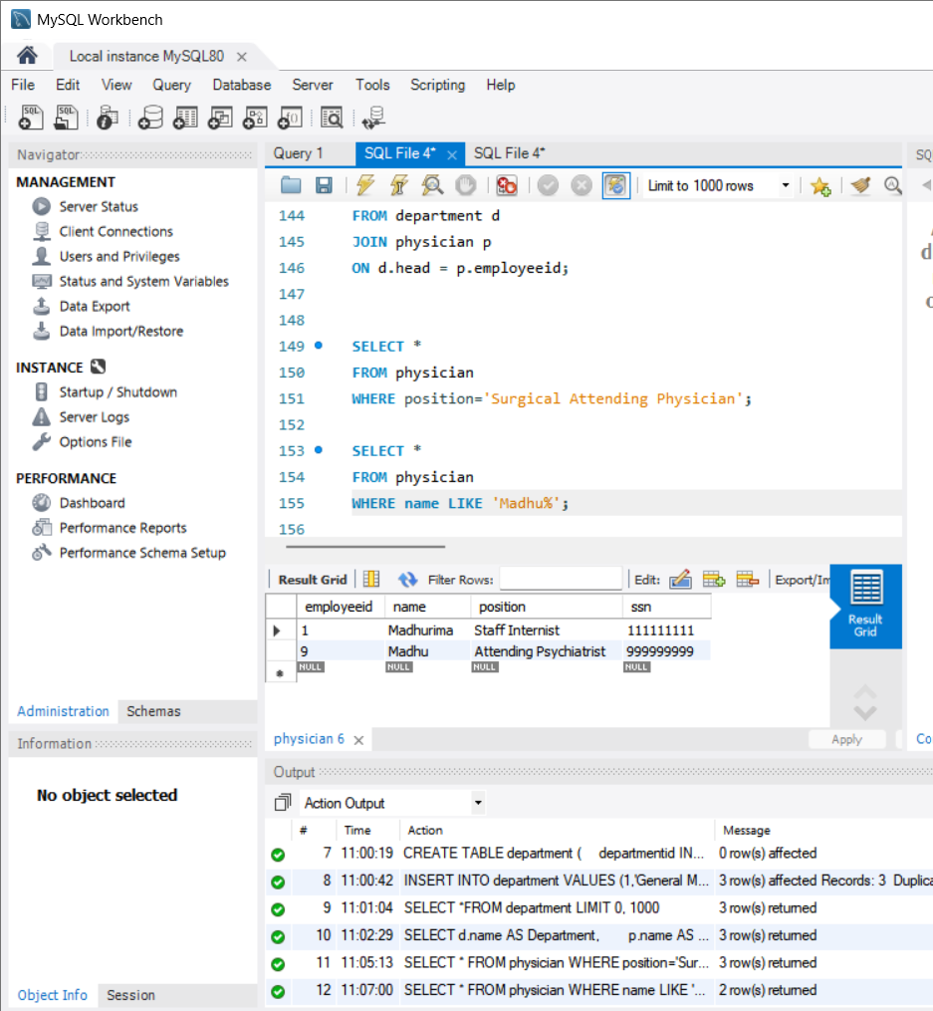

7.USING COUNT(*)
Counting how many physicians are there?
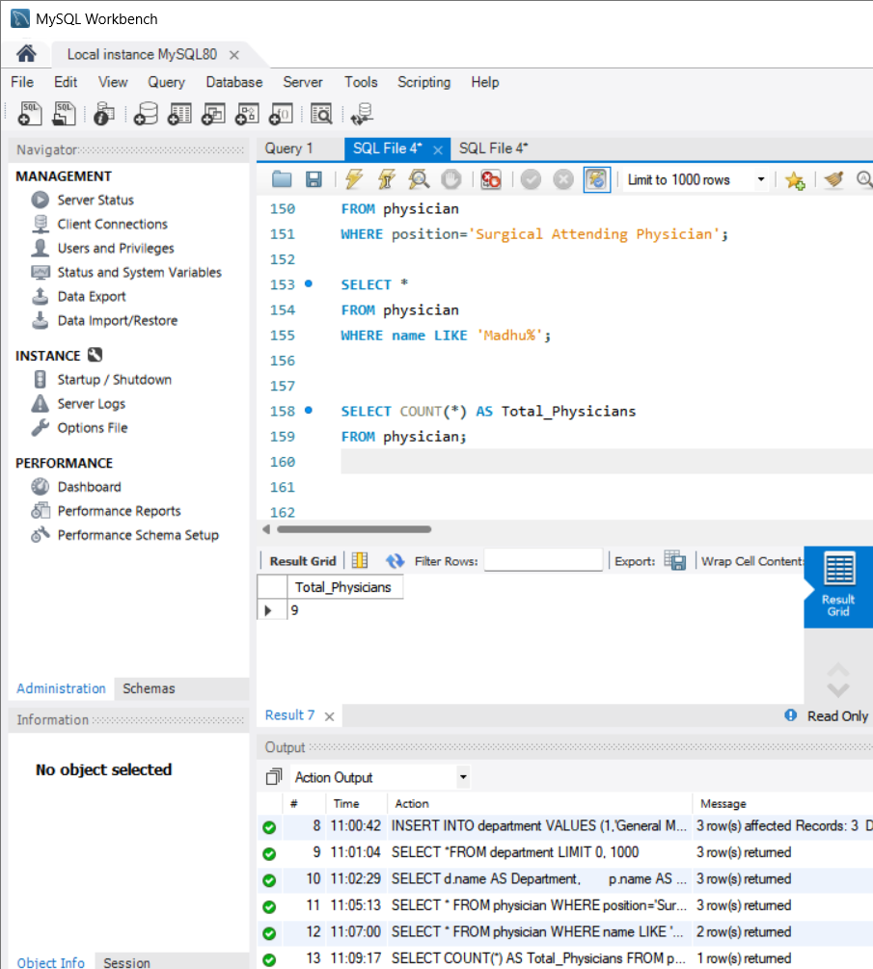

8.USING COUNT(DISTINCT position)
We find how many positions are there!!
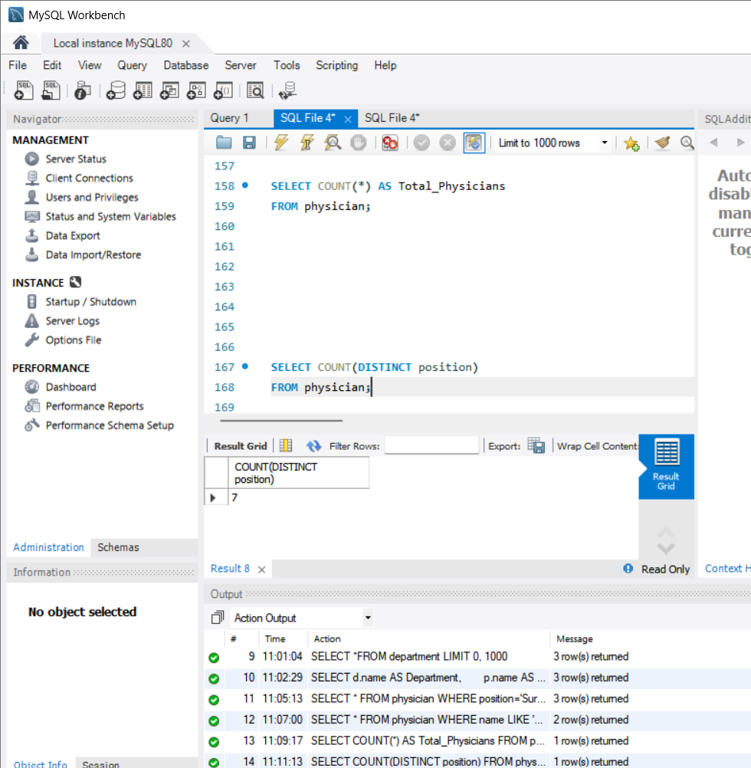

9.USING COUNT(*)
To find total employee using position
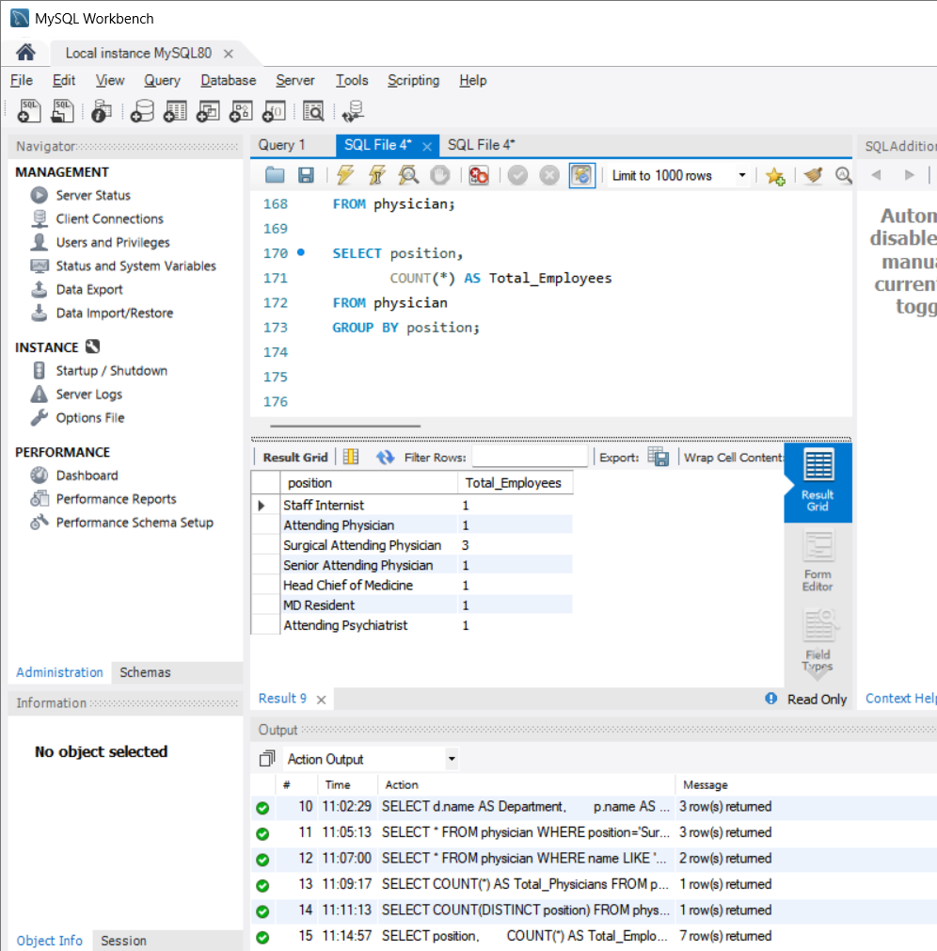

10.USING GROUP BY AND HAVING
When we are about to find how many members are in particular category
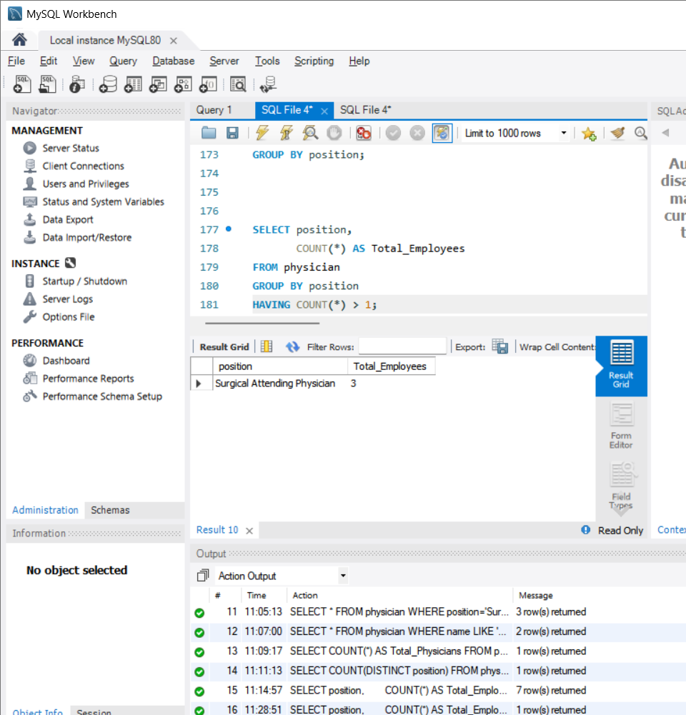

11.SORT BY ASC OF NAMES
Alplabetical order
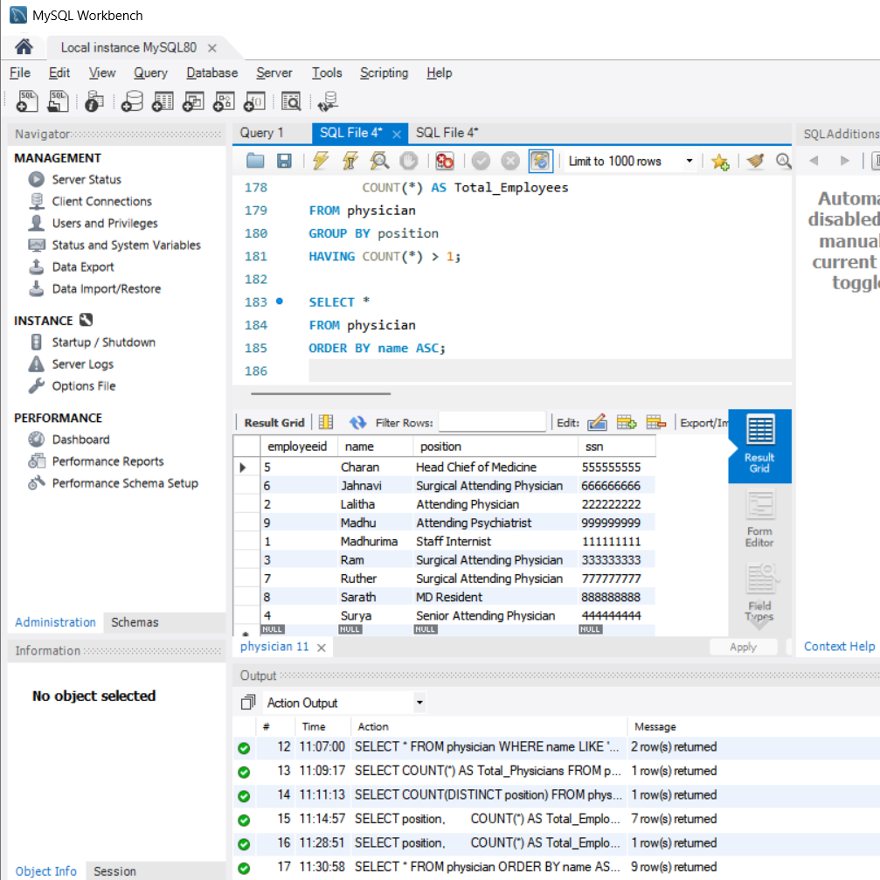

12.ORDER BY DSC
This is order by descending order of employee id all greater employee ids are at 1st
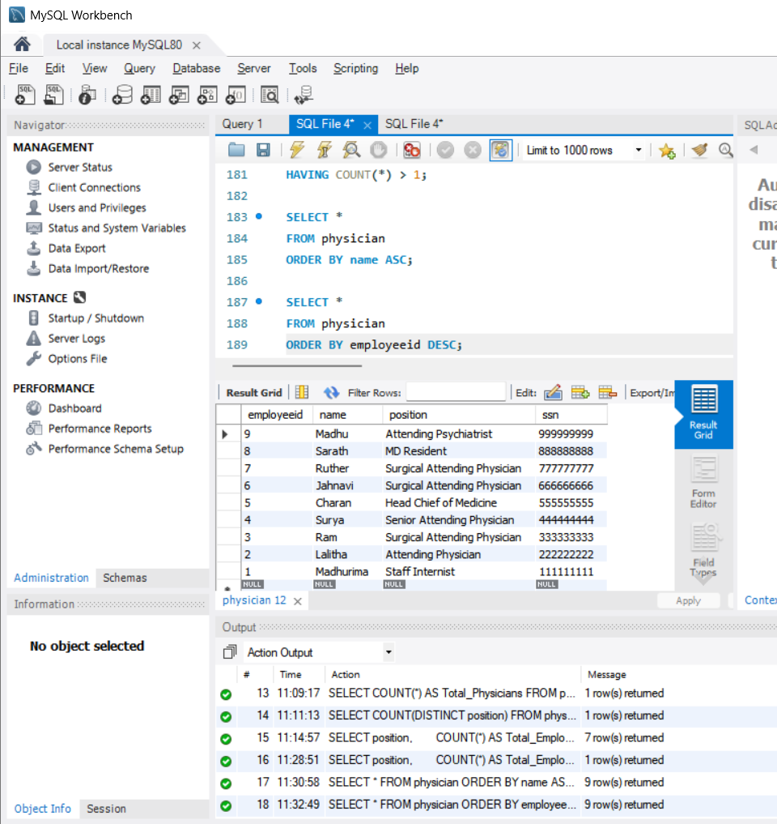

13.WHERE + IN
We use WHERE + IN to select the heads of the department
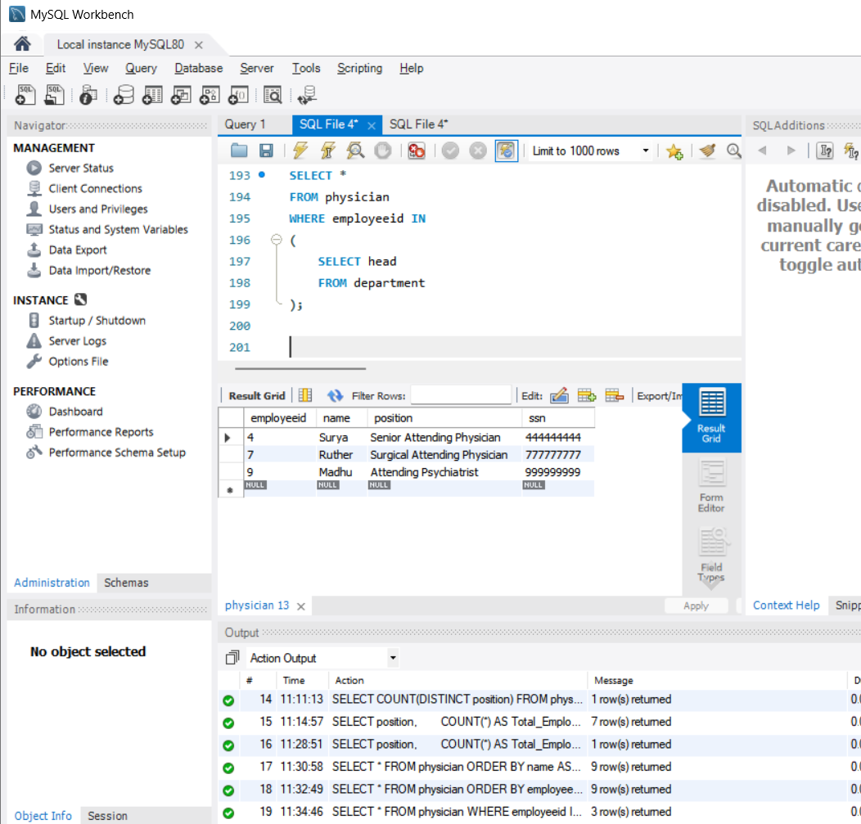

14.USING WHERE + IN WITH NOT
By this we find who are not the head of the department
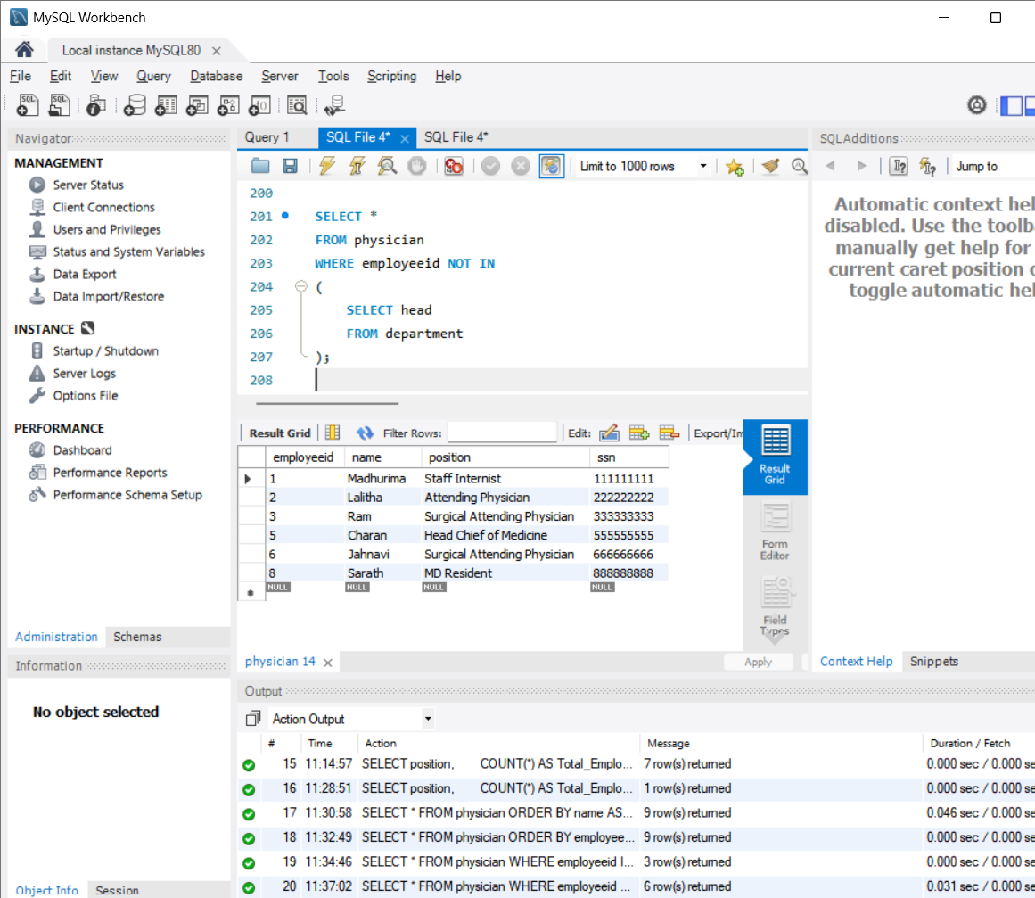

15.COMBINATION OF GROUP BY AND ORDER BY
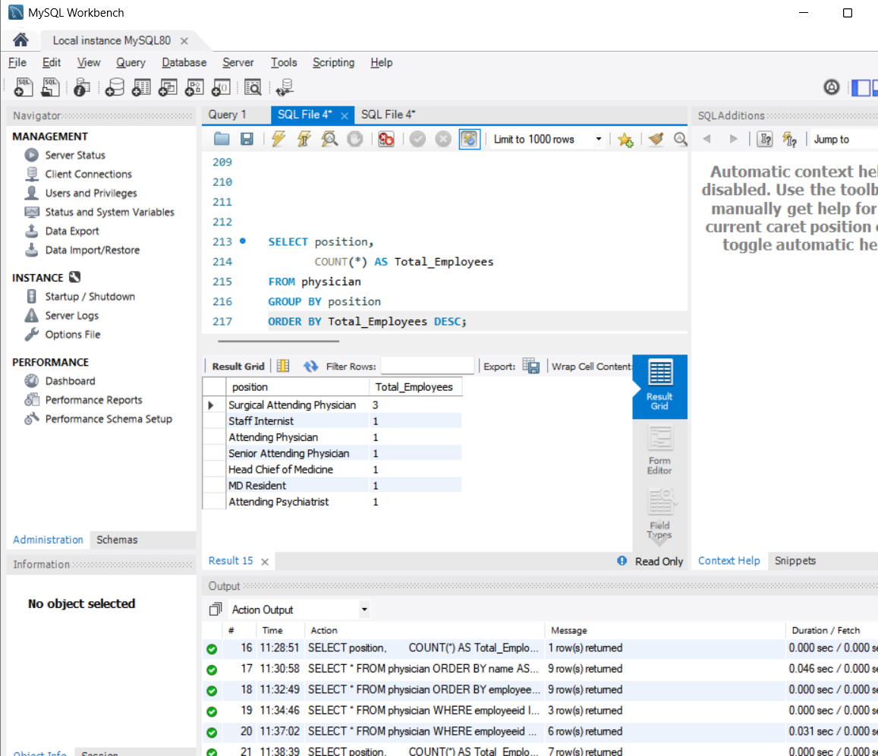

16.WHERE + LIKE
Finding who is an attending officer
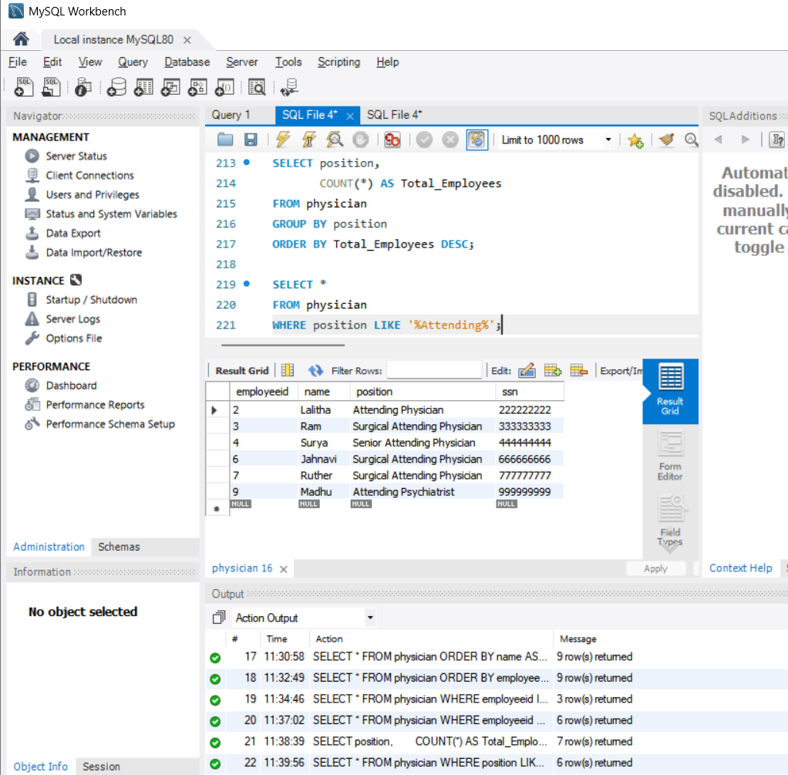

17.USING JOIN+WHERE
If we are about to find the head of particular department
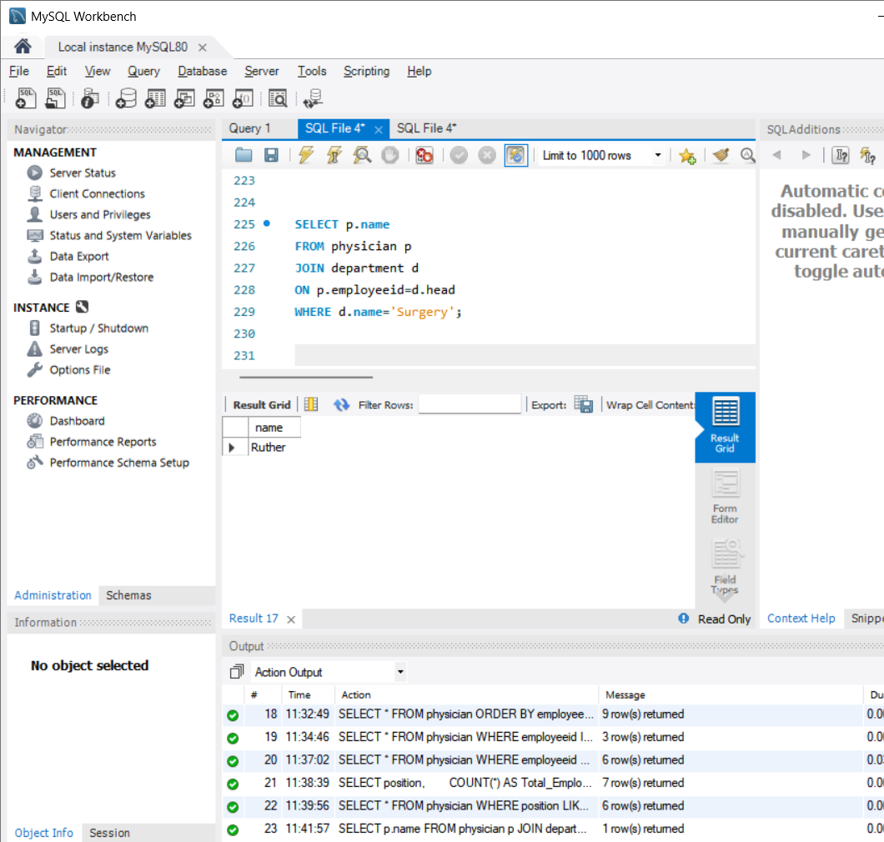

18.JOIN+ ORDER BY
Head of the department are sorted
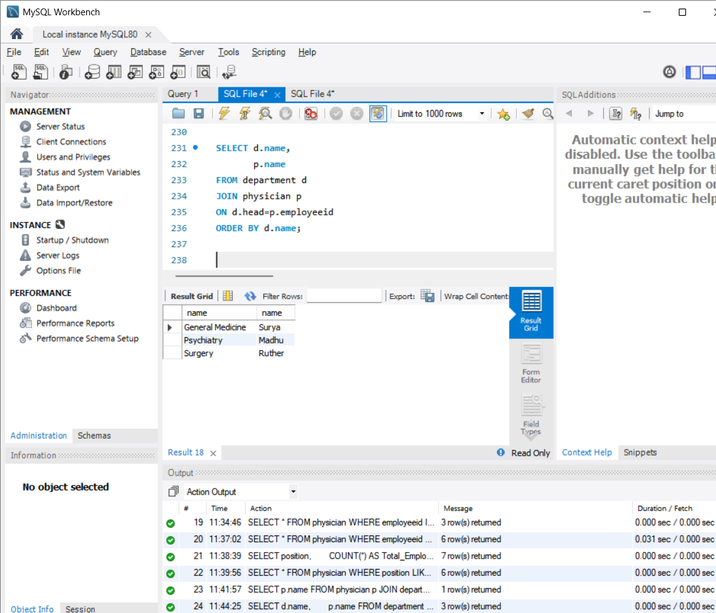

19.WHERE + NOT LIKE
The people who aren’t from surgical department
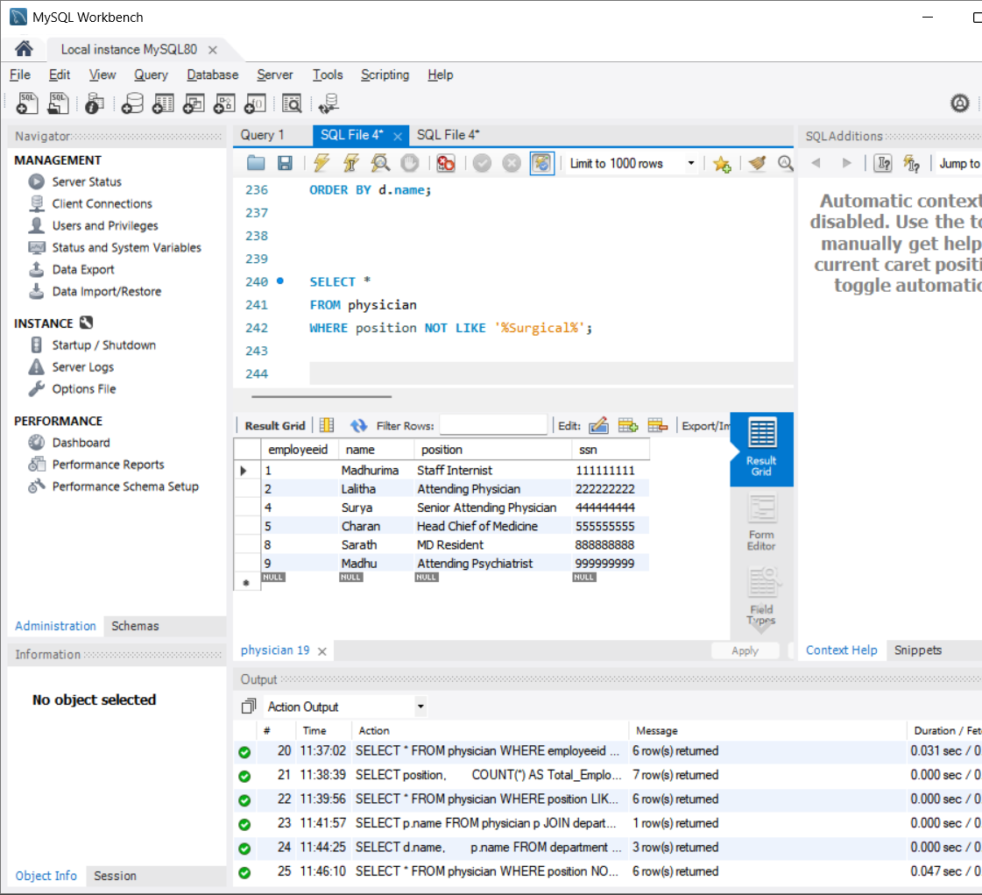

20.COUNT + HAVING
The positions which have at least 2 employees
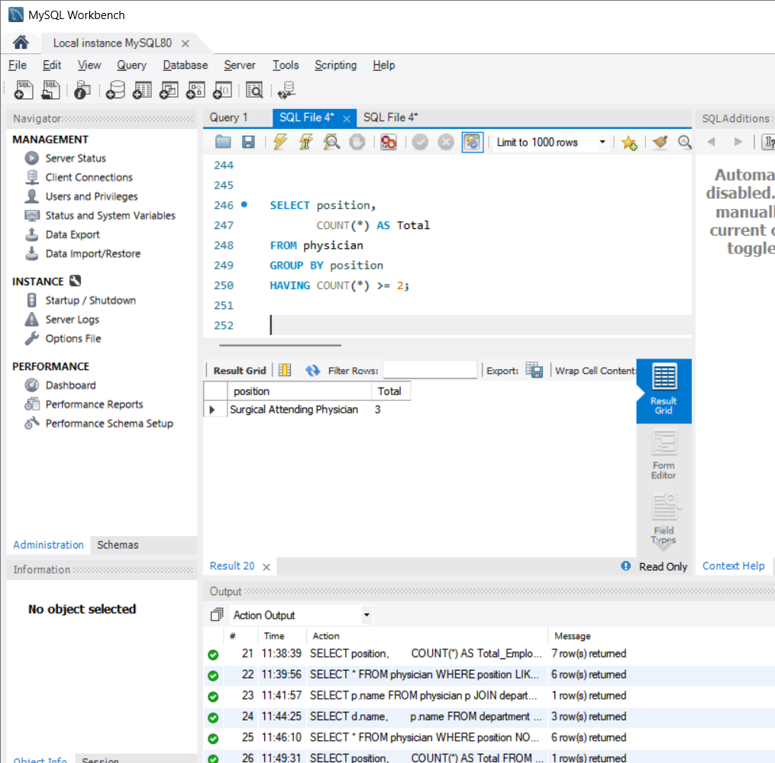

21.EXISTS
The departments which have valid head
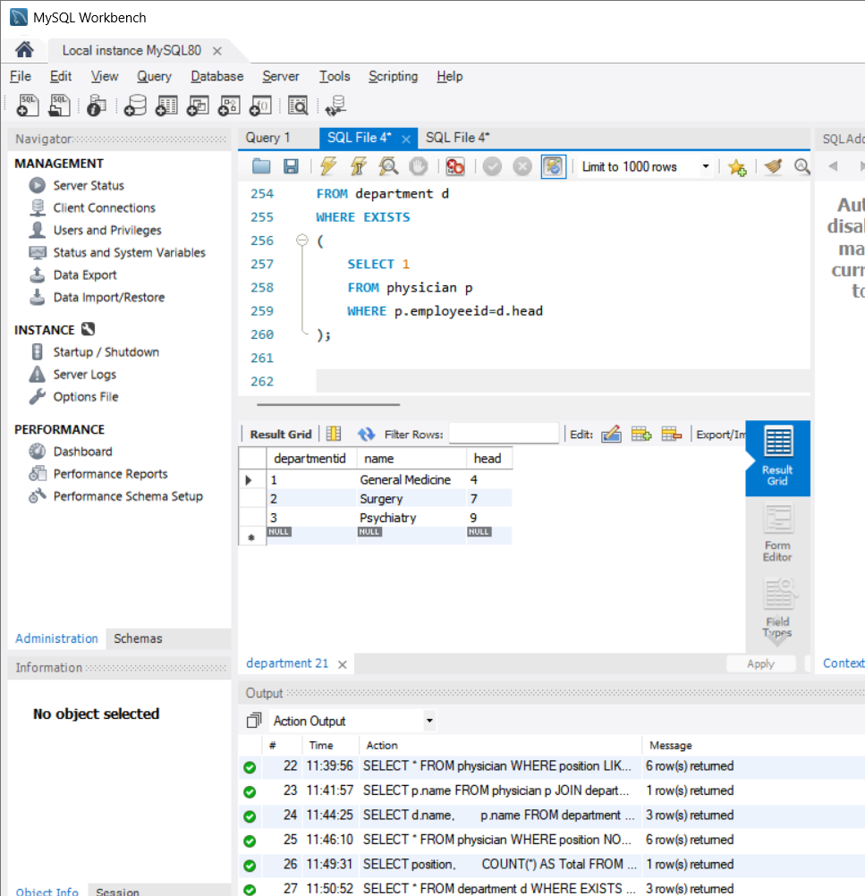

22.MIN()
Minimum employee id
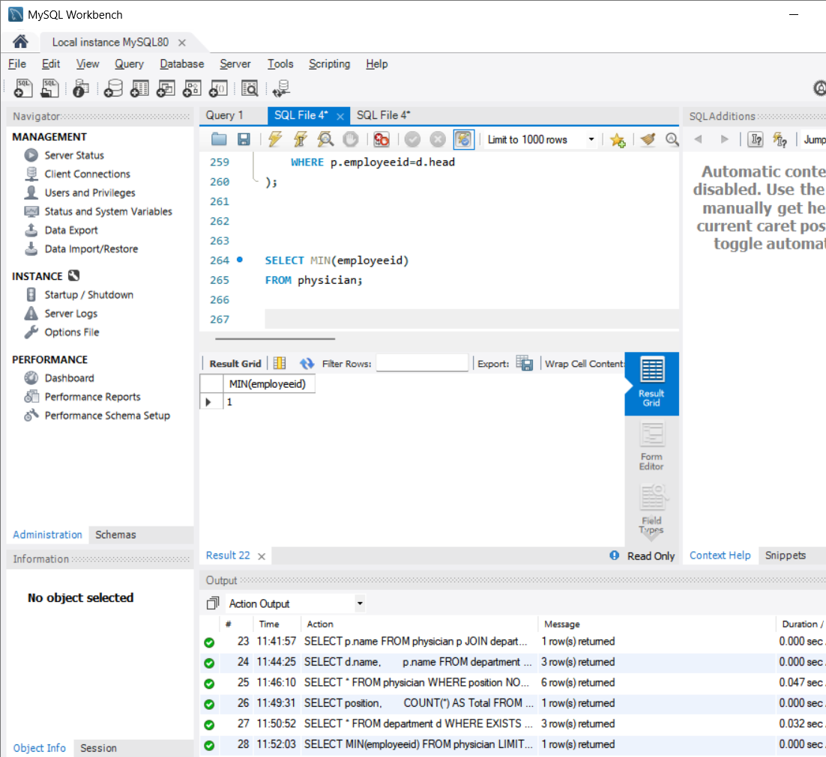

EXAMPLE DOCUMENT DONE BY,
2520030182
P.VENKATA SRI SAI MADHURIMA

