Design and Development of an
Interactive Turing Machine Simulator
CSET302 Automata Theory and Computability
M1 Problem Analysis and Project Design

Submission field | Value
University name | Bennett University
Student name | Krish Kumar
Enrollment number | S24CSEU1480
Faculty name | Dr Vicky Vikrant
Academic year | 2028
Submission date | 2 November 2026

TuringLab
Verified implementation and design report
2 November 2026

Table of Contents
Section | Page | Section | Page
Acknowledgement | 3 | Abstract | 3
1 Introduction | 3 | 2 Problem Statement | 3
3 Motivation and Problem Selection | 3 | 4 Project Objectives | 3
5 Scope | 4 | 6 Formal Automata Specification | 4
7 Existing Tools and Comparative Analysis | 4 | 8 Feasibility Study | 5
9 Technology Stack | 5 | 10 System Architecture | 5
11 Software Modules | 6 | 12 Simulator Flowchart | 6
13 UML Diagrams | 7 | 14 UI Design and Mock-ups | 8
15 Algorithm Selection | 9 | 16 Pseudocode | 9
17 Correctness Analysis | 10 | 18 Complexity Analysis | 10
19 Manual Validation Example | 10 | 20 Built-in Machines | 11
21 Testing and Verification | 11 | 22 Results and Discussion | 11
23 Limitations | 11 | 24 Future Enhancements | 12
25 Conclusion | 12 | 27 References | 12
28 Appendix A Installation | 12 | 29 Appendix B Directory and Sample JSON | 13

Acknowledgement
We thank the CSET302 course faculty for the project brief and assessment guidance. The following role allocation is a suggested contribution plan for the group; members should confirm that it reflects the work completed before submission.
Group member | Enrollment number | Suggested individual contribution
Krish Kumar | S24CSEU1480 | Suggested coordinator; integration of the simulator and repository preparation
Diwakar Puchhrat | S24CSEU1540 | Suggested formal model, transition semantics, and machine-definition review
Pranshita Sharma | S24CSEU1464 | Suggested interface design, tape visualization, and usability review
Sanjana Bhati | S24CSEU2542 | Suggested test cases, manual trace validation, and test evidence
Sreejit Roy | S24CSEU1842 | Suggested report preparation, diagrams, and documentation review

Project repository: https://github.com/Krish-46tech/Turing-machine-

Abstract
TuringLab is an implemented browser application that connects the formal definition of a deterministic Turing machine to an observable computation. A student can select or define a machine, enter a dynamic input, execute one transition at a time or under controlled playback, and inspect the tape, head, state graph, transition table, snapshot history, and final result. A pure TypeScript engine validates the formal seven-tuple, stores an unbounded two-way tape sparsely, and distinguishes acceptance, rejection, a missing-rule STUCK condition, and resource-bound exhaustion. Six complete machines and independent automated oracles support correctness validation. The verified prototype demonstrates the required Input → Algorithm → Step-by-Step Visualization → Result → Validation workflow.

1 Introduction
A Turing machine models computation with a finite controller, an unbounded tape, and a read/write head. Despite its compact definition, a run quickly becomes difficult to trace because every transition changes a symbol, head position, and state. Static textbook tables describe the rule system but do not continuously expose the active configuration. TuringLab turns that changing configuration into a synchronized, inspectable interface without changing the formal semantics.

2 Problem Statement
Students need a way to move from a transition function to the exact sequence of configurations it induces. Manual traces are valuable but error-prone for long inputs, marker-based algorithms, and machines that travel left of the initial cell. The project implements a dynamic educational simulator that validates a deterministic single-tape definition, executes its partial transition function exactly, visualizes each configuration, and compares outcomes with declared test cases.

3 Motivation and Problem Selection
Turing machines are central to effective computation, recognizability, decidability, and computability. Manual tracing becomes complex as the head revisits positions and temporary symbols accumulate. Animated movement helps a reader associate a transition rule with its operational effect, while complete history preserves evidence needed to audit that effect. Because an incorrect rule silently changes the recognized language, the engine and example definitions require stronger validation than a visual mock-up.

4 Project Objectives
1. Implement M = (Q, Σ, Γ, δ, q0, B, F) with explicit accepting and rejecting states.
2. Execute valid inputs reproducibly on a two-way sparse tape, including negative indexes and stationary moves.
3. Synchronize tape, graph, table, history, and result views for every transition.
4. Block invalid definitions and label a missing transition as STUCK.
5. Supply six complete classroom machines and validate them with independent oracles.
6. Support local JSON import/export, trace export, and static browser deployment.
7. Verify the exact 1101 ending-in-01 trace and retain repeatable test evidence.

5 Scope
The system supports one deterministic tape, one head, a tape unbounded in both integer directions, a partial transition function, individual-character symbols, movements L, R, and S, explicit accept/reject states, controlled playback, snapshots, machine editing, and bounded automated runs. It does not simulate nondeterministic branches, multiple tapes, oracle machines, or a universal machine encoding. It does not and cannot decide whether every arbitrary machine halts. A practical step limit only ends that simulation attempt with STEP_LIMIT_REACHED.

6 Formal Automata Specification
The implemented variant is M = (Q, Σ, Γ, δ, q0, B, F), where Q is a finite nonempty state set; Σ is the input alphabet; Γ is the tape alphabet with Σ ⊆ Γ; q0 ∈ Q; B ∈ Γ \ Σ is the blank; and F ⊆ Q contains accepting states. The implementation additionally names a disjoint rejecting set R ⊆ Q.
δ : (Q \ (F ∪ R)) × Γ ⇀ Q × Γ × {L, R, S}
If δ(q,a) = (p,b,D), one step writes b, moves left, right, or stays, and enters p. Entering F accepts; entering R rejects. If a nonhalting pair has no rule, the result is STUCK, intentionally distinct from rejection. Input begins at cell 0 and all other cells are implicit blanks.
The primary sample uses Q={q0,q1,q2,qAccept,qReject}, Σ={0,1}, Γ={0,1,□}, initial q0, F={qAccept}, and R={qReject}. State q1 means the current final symbol is 0; q2 means the current suffix is 01. On the right blank, only q2 accepts.

7 Existing Tools and Comparative Analysis
Tool | Verified published capabilities | TuringLab focus
JFLAP | Desktop package covering one-tape, multitape, and building-block TMs plus other automata | Browser workflow, explicit runtime semantics, trace export, built-in validation
Morphett simulator | Browser program-text simulator associated with a published universal-machine example | Formal JSON model, graph, rewind, explicit outcomes, validation dashboard
Open Logic Project visualization | Browser step/pause/reset, highlighted tape/state, editable program, many examples, one-character symbols | Seven-tuple validation, rejecting states, history restore, machine/trace JSON, oracle tests
Vassar simulator | Browser tape with table/graph modes, rules, speed, and reset | Integrated configuration, execution evidence, and multi-case validation

TuringLab does not claim competitors lack features that their official material does not document. Its contribution is a coherent path from a validated seven-tuple through auditable execution to repeatable expected-result validation.

8 Feasibility Study
Technical feasibility. React and TypeScript express the interface while a framework-independent engine remains directly testable. JavaScript Map supports sparse integer tape positions. React Flow supplies graph interaction, and static deployment needs no server.
Operational feasibility. A machine library and example inputs reduce setup. Direct controls and explanations preserve the connection to formal rules. JSON enables exchange without accounts.
Economic feasibility. All dependencies are open source, storage is local, and the application can use free static hosting. No paid API, database, or authentication is required.
Schedule feasibility. Engine, examples, interface, verification, and documentation are modular enough to complete before the 2–6 November 2026 evaluation.
Risks and mitigation. Independent oracles and exhaustive short inputs catch faulty example rules. Resource budgets and one cleanup-safe playback loop constrain runaway execution. Every view derives from the same definition and configuration. A bounded viewport and sparse tape limit rendering cost.

9 Technology Stack
Technology | Installed version | Responsibility
React / React DOM | 19.3.1 | Component rendering and interaction
TypeScript | 5.9.3 | Strict formal types and compiler checks
Vite | 8.3.5 | Development and optimized static build
Tailwind CSS | 4.3.3 | Utility compiler and compatible Vite styling pipeline
React Flow | 12.12.0 | Pan, zoom, drag, nodes, labeled edges
Zustand | 5.0.16 | Synchronized simulator state
Motion | 12.43.0 | Restrained tape movement animation
Lucide React | 0.548.0 | Consistent interface icons
Vitest | 4.1.12 | Unit, algorithm, and integration tests
Testing Library | 16.3.3 | User-oriented React checks
Playwright | 1.64.1 | Chromium workflows and screenshots
ESLint | 9.39.5 | Static code-quality gate

The interface applies shadcn-style reusable button, panel, form, and dialog conventions inside a project-specific CSS-variable design system with dark and light themes.

10 System Architecture
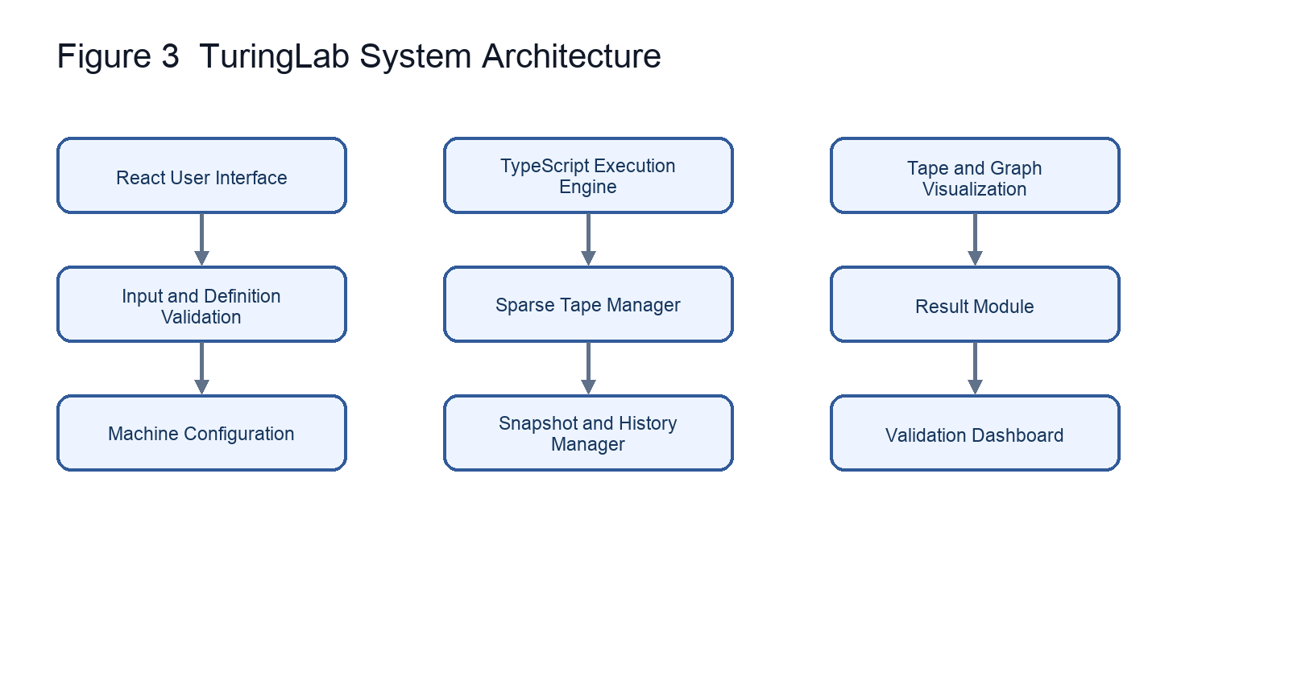

11 Software Modules
- Machine configuration: states, alphabets, halting sets, transitions, descriptions, examples.
- Input validator: rejects characters outside Σ.
- Tape manager: returns implicit blanks and stores only nonblank cells.
- Transition engine: deterministic lookup and exact one-step semantics.
- Execution controller: single playback schedule, pause/reset, resource limits.
- Graph renderer: nodes and edges derived from the active definition.
- History manager: initial and post-step snapshots with restoration.
- Validation module: pass, fail, and inconclusive bounded results.
- Import/export: validated machine JSON and execution trace downloads.

12 Simulator Flowchart
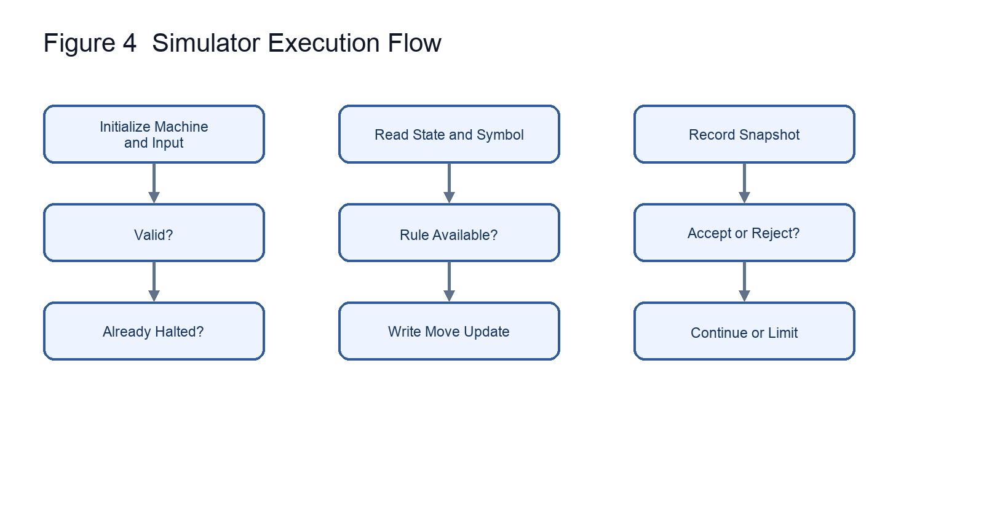

13 UML Diagrams
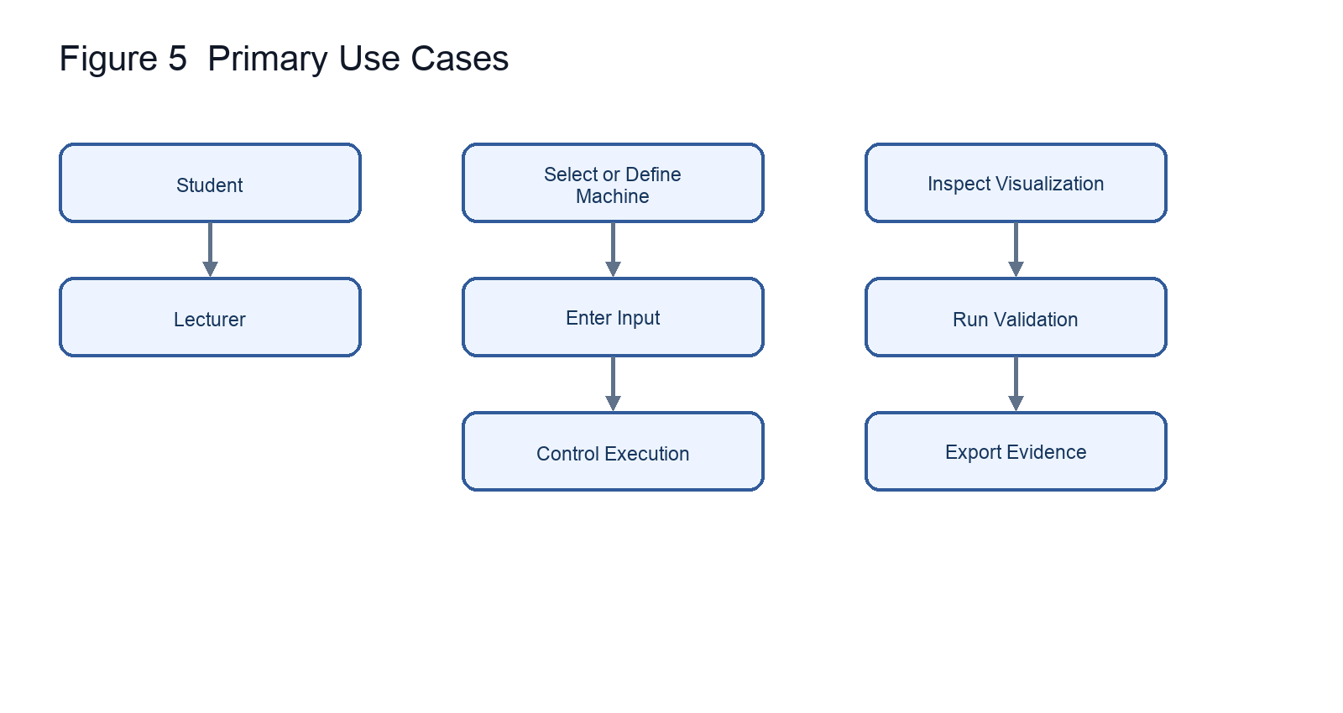
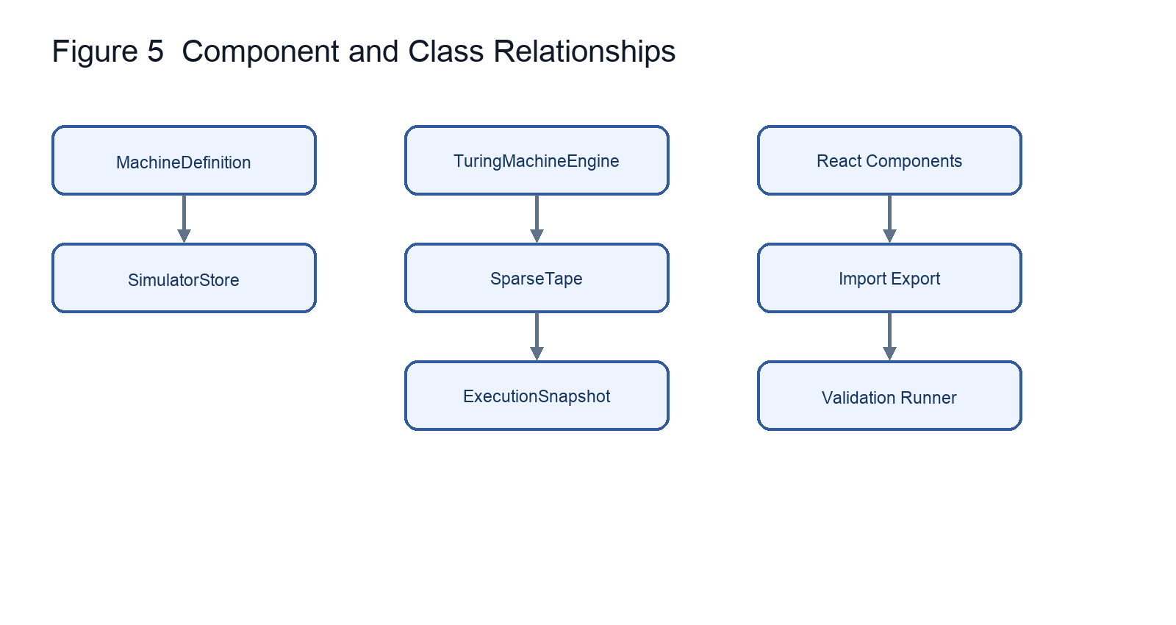
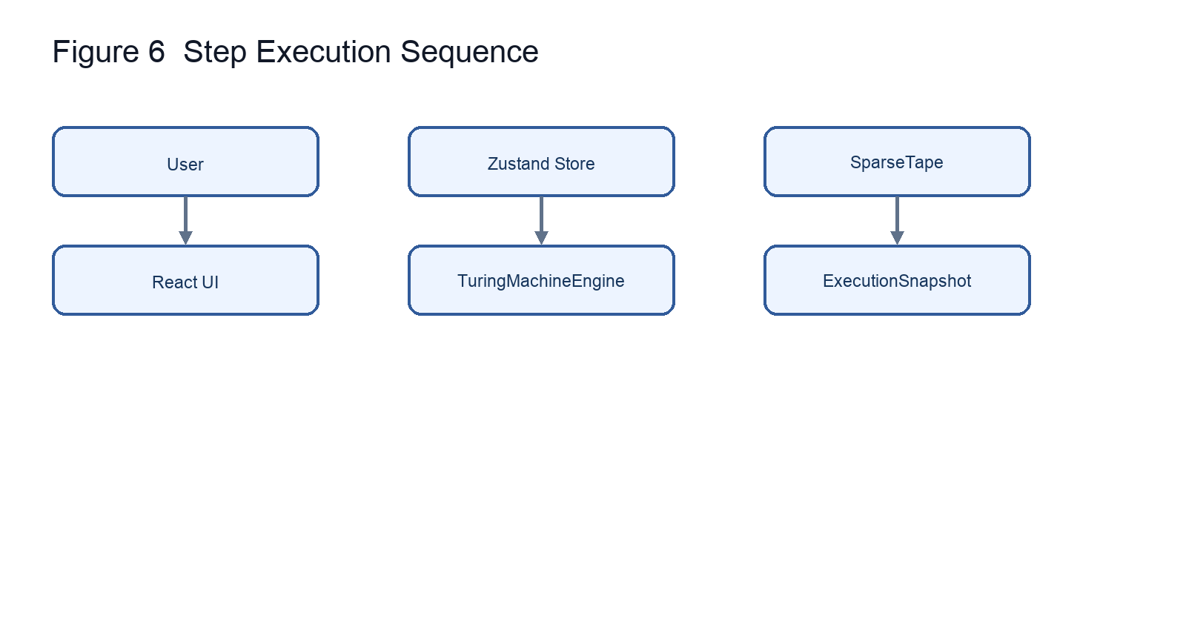
The sequence shows initialization of 1101, repeated UI → store → engine → sparse-tape calls, snapshot delivery, and the fifth-transition acceptance.

14 UI Design and Mock-ups
The desktop layout uses a formal-configuration rail and a computation workspace. The top block presents state, head, symbol, transition count, status, a 15-cell moving viewport, and playback. A result banner precedes graph/table/history tabs and a validation dashboard. On narrow screens the rail stacks above the workspace. Cyan indicates active computation, green acceptance, red rejection/error, and amber resource limits.
Figure 1. Actual application after accepting `1101`.
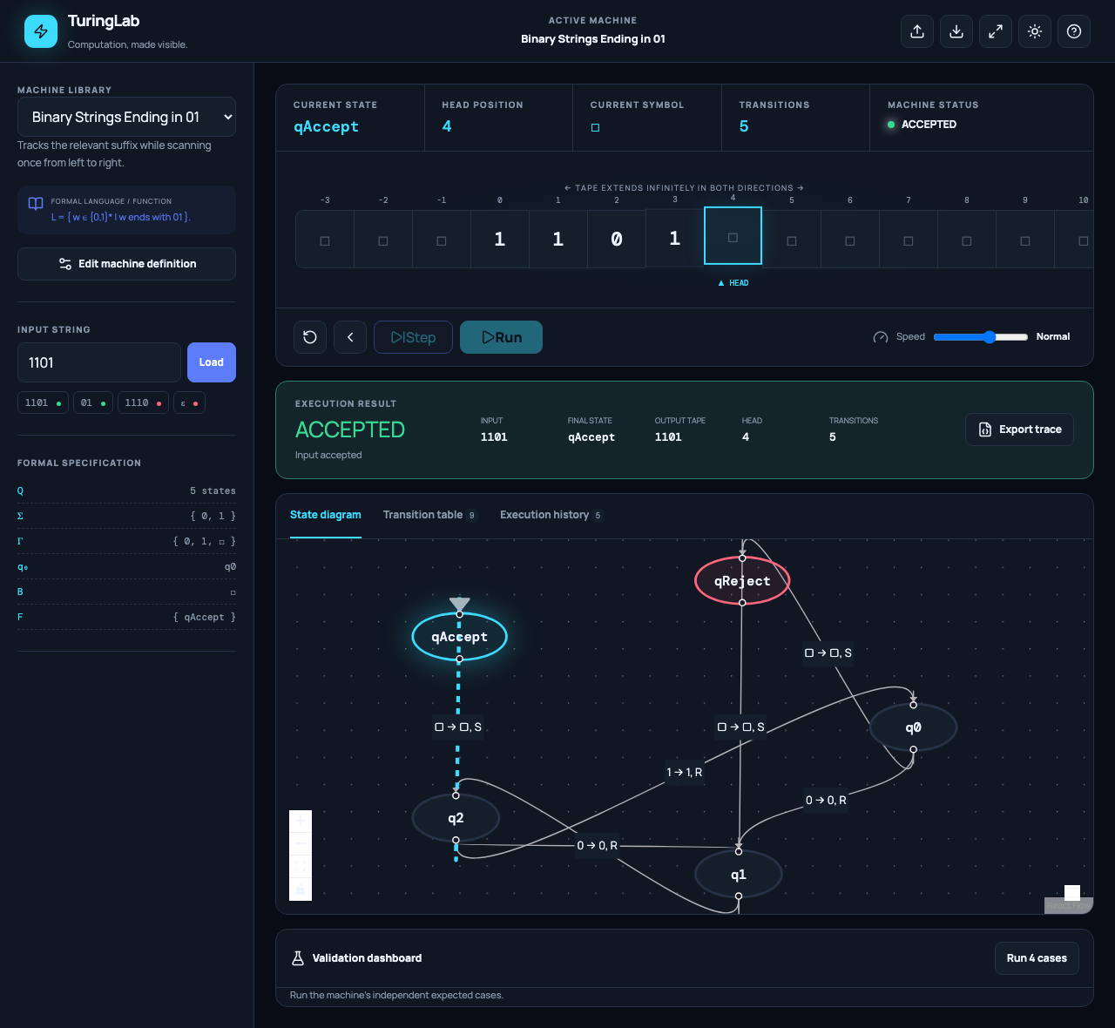
Figure 2. Actual application after rejecting `1110`.
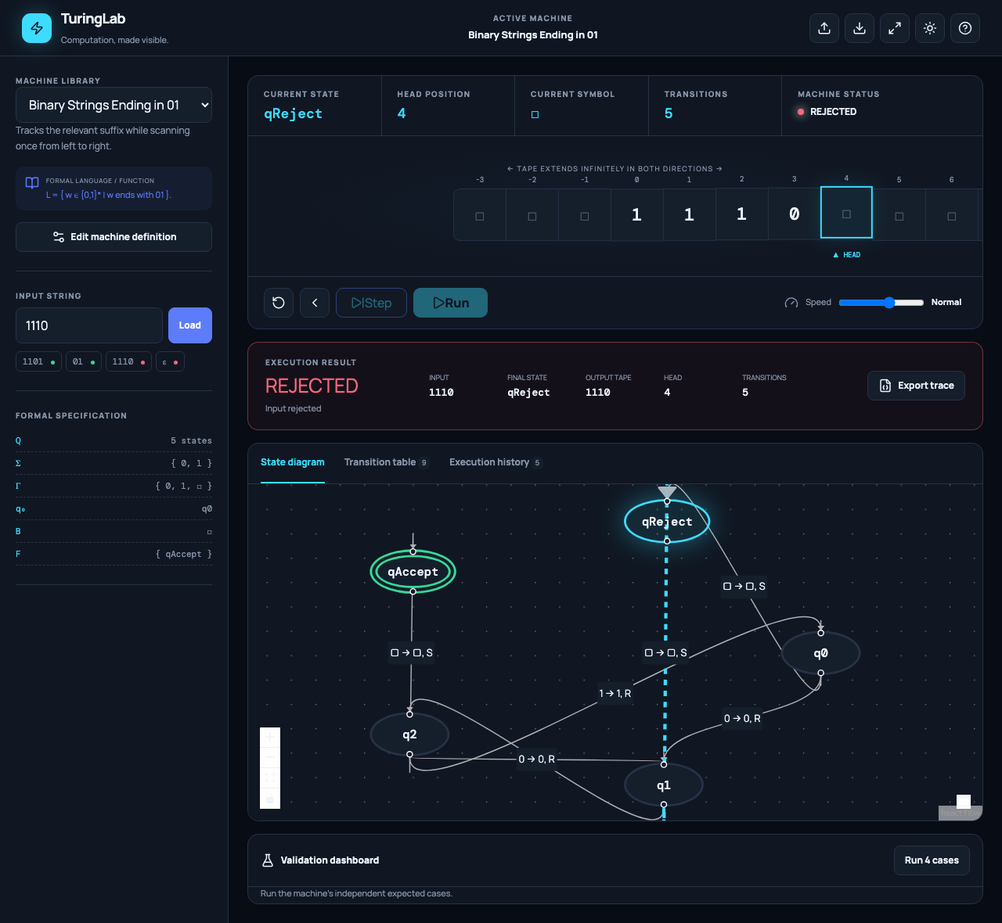
These are Playwright captures of the working application, not conceptual mock-ups.

15 Algorithm Selection
A deterministic hash lookup matches the mathematical condition that each (state,symbol) pair has at most one result. The sparse tape avoids a falsely finite or enormous array and permits negative positions. Each successful step follows: inspect state and symbol; check halting; find rule; write; move; change state; increment; snapshot; check the new state. Rewind uses stored snapshots because an arbitrary transition need not be invertible.

16 Pseudocode
VALIDATE machine
require Q nonempty and q0 in Q
require Sigma subset Gamma and blank in Gamma minus Sigma
require accept and reject sets valid and disjoint
require valid references, no outgoing rule from a halt state
require at most one rule per state-symbol pair
INITIALIZE(machine, input)
reject any character outside Sigma
tape := sparse nonblank input cells at indexes 0..n-1
configuration := (q0, tape, head 0, step 0, READY)
history := [initial snapshot]
STEP(configuration)
if state accepts return ACCEPTED
if state rejects return REJECTED
a := tape.read(head)
rule := delta(state, a)
if rule absent snapshot and return STUCK
tape.write(head, rule.write)
head := head + movement(rule)
state := rule.nextState
step := step + 1
record complete snapshot
if state accepts return ACCEPTED
if state rejects return REJECTED
return RUNNING
RUN(limit, timeBudget)
while status is nonterminal
if a budget is exhausted return STEP_LIMIT_REACHED
STEP(configuration)

17 Correctness Analysis
The engine maintains these invariants: current state belongs to Q; head is an integer; every stored tape value belongs to Γ and differs from B; blank reads do not mutate storage; and a successful step increments exactly once. Validation ensures an applicable rule has a valid next state, write symbol, and movement. Applying it therefore produces the successor defined by δ. Snapshotting preserves that successor for replay. Explicit halting checks implement the declared convention; an absent partial-function value remains STUCK.
Exhaustive short-input tests compare four recognizers with independent predicates: suffix 01, parity of counted 1s, structure/count for 0ⁿ1ⁿ, and equality with reversal. Transducers compare unary length and BigInt addition, not the machine itself. These checks support the implementation but do not prove every user-authored machine correct or solve the halting problem.

18 Complexity Analysis
Let k be nonblank cells and t executed transitions. Under expected JavaScript Map behavior, lookup and tape read/write are expected O(1), so state-changing work per step is expected O(1). A serialized snapshot copies k cells, giving O(k) per recorded step and an O(tk) uniform history-space bound. Sparse tape alone is O(k). The visible window is O(1) at 15 cells. These are implementation assumptions, distinct from theoretical TM complexity.

19 Manual Validation Example
Input 1101 starts in q0 with head 0.
Step | Before | Read | Write | Move | After | Head | Status
0 | q0 | 1 | — | — | q0 | 0 | READY
1 | q0 | 1 | 1 | R | q0 | 1 | RUNNING
2 | q0 | 1 | 1 | R | q0 | 2 | RUNNING
3 | q0 | 0 | 0 | R | q1 | 3 | RUNNING
4 | q1 | 1 | 1 | R | q2 | 4 | RUNNING
5 | q2 | □ | □ | S | qAccept | 4 | ACCEPTED

Expected and actual agree: ACCEPTED, 5 transitions, final head 4, displayed tape 1101. Counterexample 1110 reaches qReject at the right blank after 5 transitions. Section 14 records both browser outcomes.

20 Built-in Machines
Machine | Behavior | Edge convention
Unary Increment | `1ⁿ → 1ⁿ⁺¹` | Empty represents zero and becomes `1`
Binary Increment | Adds one by right-to-left carry | Empty is zero; leading width preserved unless overflow
Ending in 01 | Exactly binary words ending `01` | Empty rejects
Even Number of 1s | Exactly even parity | Empty accepts
`0ⁿ1ⁿ` | Pairs every leading 0 with one following 1 | `n ≥ 0`, so empty accepts
Binary Palindrome | Marks matching outer symbols | Empty and one-symbol inputs accept

Every definition contains complete states, alphabets, transitions, halting sets, explanation, and expected cases in src/machines/index.ts.

21 Testing and Verification
On 30 October 2026, 19 Vitest tests in two files and 3 Playwright Chromium workflows passed. The production build transformed 2,234 modules without TypeScript errors; ESLint reported zero errors. Vitest covers units, exhaustive algorithm oracles, and React integration. Browser workflows cover acceptance/rejection with exact count, unary output, rewind, run/pause, editor display, screenshots, and console issue detection.
The self-correcting loop fixed concrete failures: npm’s resolver fault was bypassed with pnpm; jsdom received a test-only ResizeObserver; Vitest and Playwright globs were isolated; DOM cleanup was registered; and an unsupported graph edge type was replaced and rechecked. No product assertion was weakened. Full evidence is in TEST_REPORT.md.

22 Results and Discussion
The simulator demonstrates writes, every movement, negative positions, active highlighting, explicit accept/reject, missing-rule handling, rewind, and trace export. The primary validation returned the specified five-step acceptance. Independent exhaustive checks agreed for all generated words within documented lengths. Graph and tables derive from the same machine used by the engine.

23 Limitations
The simulator is deterministic and single-tape. Symbols are individual characters. Snapshot copying can consume memory in long runs with many nonblank cells. The 10,000-step default and optional time budget are safeguards, not conclusions about nontermination. Browser responsiveness and available memory bound practical execution although the abstract tape is unbounded.

24 Future Enhancements
Possible extensions include nondeterministic branch exploration, multiple tapes, universal-machine demonstrations, classroom exercise packs, delimited token alphabets, state/symbol breakpoints, bounded-history policies, qualified cycle warnings, and generation of limited simple machines.

25 Conclusion
TuringLab meets the milestone’s problem-analysis, specification, feasibility, architecture, algorithm, and validation requirements and goes beyond M1 with a verified end-to-end simulator. An independently tested engine with sparse tape and complete snapshots keeps visualization accountable to formal computation without overstating what bounded execution proves.

26 Acknowledgement
We thank the CSET302 course faculty for the project brief and assessment guidance. The following role allocation is a suggested contribution plan for the group; members should confirm that it reflects the work completed before submission.
Group member | Enrollment number | Suggested individual contribution
Krish Kumar | S24CSEU1480 | Suggested coordinator; integration of the simulator and repository preparation
Diwakar Puchhrat | S24CSEU1540 | Suggested formal model, transition semantics, and machine-definition review
Pranshita Sharma | S24CSEU1464 | Suggested interface design, tape visualization, and usability review
Sanjana Bhati | S24CSEU2542 | Suggested test cases, manual trace validation, and test evidence
Sreejit Roy | S24CSEU1842 | Suggested report preparation, diagrams, and documentation review

Project repository: https://github.com/Krish-46tech/Turing-machine-

27 References
1. JFLAP. “What Is JFLAP?” https://jflap.org/whatis.html (accessed 30 October 2026).
2. JFLAP. “Turing Machine.” https://jflap.org/tutorial/turing/one/index.html (accessed 30 October 2026).
3. Morphett, Anthony. “Turing Machine Simulator.” http://morphett.info/turing/turing.html (accessed 30 October 2026).
4. Open Logic Project. “Turing Machine Visualization.” https://turing.openlogicproject.org/ (accessed 30 October 2026).
5. Vassar College. “Turing Machine Simulator.” https://turingmachine.vassar.edu/ (accessed 30 October 2026).
6. React documentation. https://react.dev/ (accessed 30 October 2026).
7. TypeScript documentation. https://www.typescriptlang.org/docs/ (accessed 30 October 2026).
8. Vite documentation, “Releases.” https://vite.dev/releases (accessed 30 October 2026).
9. React Flow documentation. https://reactflow.dev/ (accessed 30 October 2026).
10. Playwright documentation. https://playwright.dev/docs/intro (accessed 30 October 2026).

28 Appendix A Installation
pnpm install
pnpm dev
pnpm run lint
pnpm run test
pnpm run build
pnpm exec playwright install chromium
pnpm run test:e2e
The production output is dist/. No backend or environment variables are required.

29 Appendix B Directory and Sample JSON
src/engine formal types, validator, sparse tape, executor
src/machines six complete definitions
src/components tape, graph, editor, validation dashboard
src/store execution synchronization and playback actions
src/tests unit, algorithm, and integration tests
e2e Chromium workflows
docs/diagrams architecture, flowchart, UML Mermaid sources
docs/screenshots actual application evidence
{
"id": "custom",
"name": "Custom machine",
"description": "A deterministic example",
"language": "Documented language or function",
"states": ["q0", "qAccept", "qReject"],
"inputAlphabet": ["1"],
"tapeAlphabet": ["1", "□"],
"blankSymbol": "□",
"initialState": "q0",
"acceptingStates": ["qAccept"],
"rejectingStates": ["qReject"],
"transitions": [
{"currentState":"q0","readSymbol":"□","nextState":"qAccept","writeSymbol":"□","movement":"S"}
],
"exampleInputs": [{"input":"","expectedStatus":"ACCEPTED"}]
}

