Parallel PDSCNN–Vision Transformer Fusion with Regularized Ridge Extreme Learning Machine for Brain Tumor MRI Classification
Vyshnasri • Krishna Aditya • Alahari Dedeepya • Lalithya • Sharath
Student Research Project | Computer Science / Artificial Intelligence
Abstract— Brain tumor classification from magnetic resonance imaging (MRI) is a challenging medical image-analysis problem in which subtle visual differences between tumor categories can affect automated predictions. The implemented system develops a hybrid feature-learning framework that combines a Parallel Depthwise Separable Convolutional Neural Network (PDSCNN) branch with a Vision Transformer (ViT) branch and a Regularized Ridge Extreme Learning Machine (RRELM) classifier. MRI images are resized to 124 × 124 pixels, enhanced using Contrast Limited Adaptive Histogram Equalization (CLAHE), normalized to the [0,1] range, and augmented during training. The PDSCNN branch learns local spatial representations and produces a 256-dimensional feature vector, while the ViT branch operates on a padded 128 × 128 representation, divides the image into 16 × 16 patches, and produces a 128-dimensional class-token representation. The two representations are concatenated to form a 384-dimensional hybrid feature vector. RRELM uses a randomized hidden layer with 4,096 hidden units and analytically estimates the output weights using ridge-regularized least squares. The final system distinguishes glioma, meningioma, pituitary tumor, and no-tumor MRI images. For explainability, PDSCNN Grad-CAM and ViT attention-rollout visualizations are generated to show spatial regions and global patch-level patterns associated with model decisions. The reported five-fold stratified cross-validation experiment achieves a mean test accuracy of approximately 98.01%, while the supplied full-dataset evaluation reports 96.78% accuracy on 13,994 images and the separate test split reports 94.13%. These results indicate that combining local and global representations with an efficient randomized classifier provides a promising research framework for explainable brain MRI classification.
Keywords— Brain tumor classification, MRI, PDSCNN, Vision Transformer, RRELM, feature fusion, Grad-CAM, attention rollout, explainable artificial intelligence.

1. INTRODUCTION
Brain tumors require accurate interpretation of medical images because tumor appearance can vary in size, location, intensity, and morphology. MRI provides detailed anatomical information and is widely used for brain imaging, but manual interpretation is time-consuming and depends on specialist expertise. Computer-aided classification can support this process by learning discriminative patterns from labeled MRI images.
Convolutional neural networks (CNNs) are effective at extracting local spatial patterns such as edges, textures, shapes, and localized intensity structures. However, convolutional processing has a limited receptive field at individual layers and may not explicitly model relationships between distant image regions. Vision Transformers address this limitation by representing an image as a sequence of patches and applying self-attention to model interactions among patches. A hybrid design can therefore combine detailed local representations with broader contextual information.
The base research framework motivating this work combines a lightweight PDSCNN feature extractor with RRELM classification and uses CLAHE for MRI enhancement and SHAP for interpretability. The present implementation extends that general design by introducing a parallel ViT feature branch and replacing single-mechanism explanation with two complementary visualizations: PDSCNN Grad-CAM for convolutional spatial attribution and ViT attention rollout for transformer-level global context.
The implemented objective is not to replace clinical diagnosis, but to investigate an efficient and explainable computer-aided classification pipeline that can distinguish four categories: glioma, meningioma, pituitary tumor, and no tumor.

2. BASE PAPER AND RESEARCH GAP

A. Base Paper
The base paper is “A hybrid explainable model based on advanced machine learning and deep learning models for classifying brain tumors using MRI images,” published in Scientific Reports in 2025. The study combines CLAHE-enhanced MRI images, a lightweight PDSCNN feature extractor, and a hybrid ridge-regression extreme learning machine (RRELM). It reports five-fold cross-validation results of 99.22% accuracy, 99.35% precision, and 99.30% recall, and uses SHAP to interpret feature contributions.
The base architecture is attractive because depthwise-separable convolution reduces computational cost while RRELM provides an analytically computed output layer rather than a conventional deep neural classifier. However, its feature-learning pathway is CNN-centered. The present project therefore preserves the efficient CNN–RRELM idea while adding a transformer branch to represent global relationships and adding spatial XAI outputs.

B. Research Gap
CNN-only feature extraction primarily emphasizes local spatial information.
A transformer branch can provide complementary long-range relationships among image patches.
SHAP explains feature contributions but does not directly provide convolutional spatial localization comparable to Grad-CAM.
A dual explanation design can expose both CNN activation-based evidence and transformer attention patterns.
The project investigates whether a 384-dimensional hybrid representation can be classified efficiently using RRELM.

3. LITERATURE REVIEW
Ahmad et al. [1] investigated an approach based on preprocessing and a custom Convolutional Neural Network (CNN) for brain MRI classification. Their work improved MRI classification through preprocessing and a compact CNN design. However, the approach primarily relies on convolutional processing and therefore emphasizes local representation.
Nayak et al. [2] presented an EfficientNet-based CNN approach for brain MRI classification. The method achieved high performance by using augmentation and normalization during the learning process. Since the representation remains CNN-based, it continues to rely primarily on convolutional feature extraction.
Deepak and Ameer [3] investigated GoogLeNet-based transfer learning for brain tumor classification. Their approach demonstrated strong classification performance through transfer learning. However, the use of a comparatively complex model and the limited integration of global and local feature representations remain relevant considerations.
Dosovitskiy et al. [4] introduced the Vision Transformer (ViT), which represents an image as patches and uses self-attention to learn global contextual relationships. This provides a different mechanism from conventional CNN-based local feature extraction. However, transformer performance can depend on the amount of available data and computational resources.
Nahiduzzaman et al. [5] proposed a lightweight hybrid framework combining PDSCNN, RRELM, and SHAP for brain tumor classification using MRI images. The approach provides an efficient CNN–ELM framework with explainability. However, it does not explicitly combine Vision Transformer global features with dual spatial XAI mechanisms.
The reviewed studies indicate that CNN-based methods provide effective local feature representations, while Vision Transformer architectures offer a mechanism for learning broader contextual relationships. The PDSCNN–RRELM framework further demonstrates the potential of lightweight feature extraction and analytical classification with explainability. Motivated by these observations, the present project combines complementary local and global representations through parallel PDSCNN and ViT branches and uses RRELM for efficient classification.

4. PROPOSED ARCHITECTURE MODEL
The implemented framework processes each MRI image through two parallel feature extractors. The first is a PDSCNN-style convolutional network that learns local spatial patterns. The second is a compact ViT branch that converts the image into a sequence of 16 × 16 patches and applies multi-head self-attention. Their outputs are concatenated and passed to an RRELM classifier. During inference, the system returns the predicted class and probability distribution; explainability modules additionally generate Grad-CAM and ViT attention visualizations.
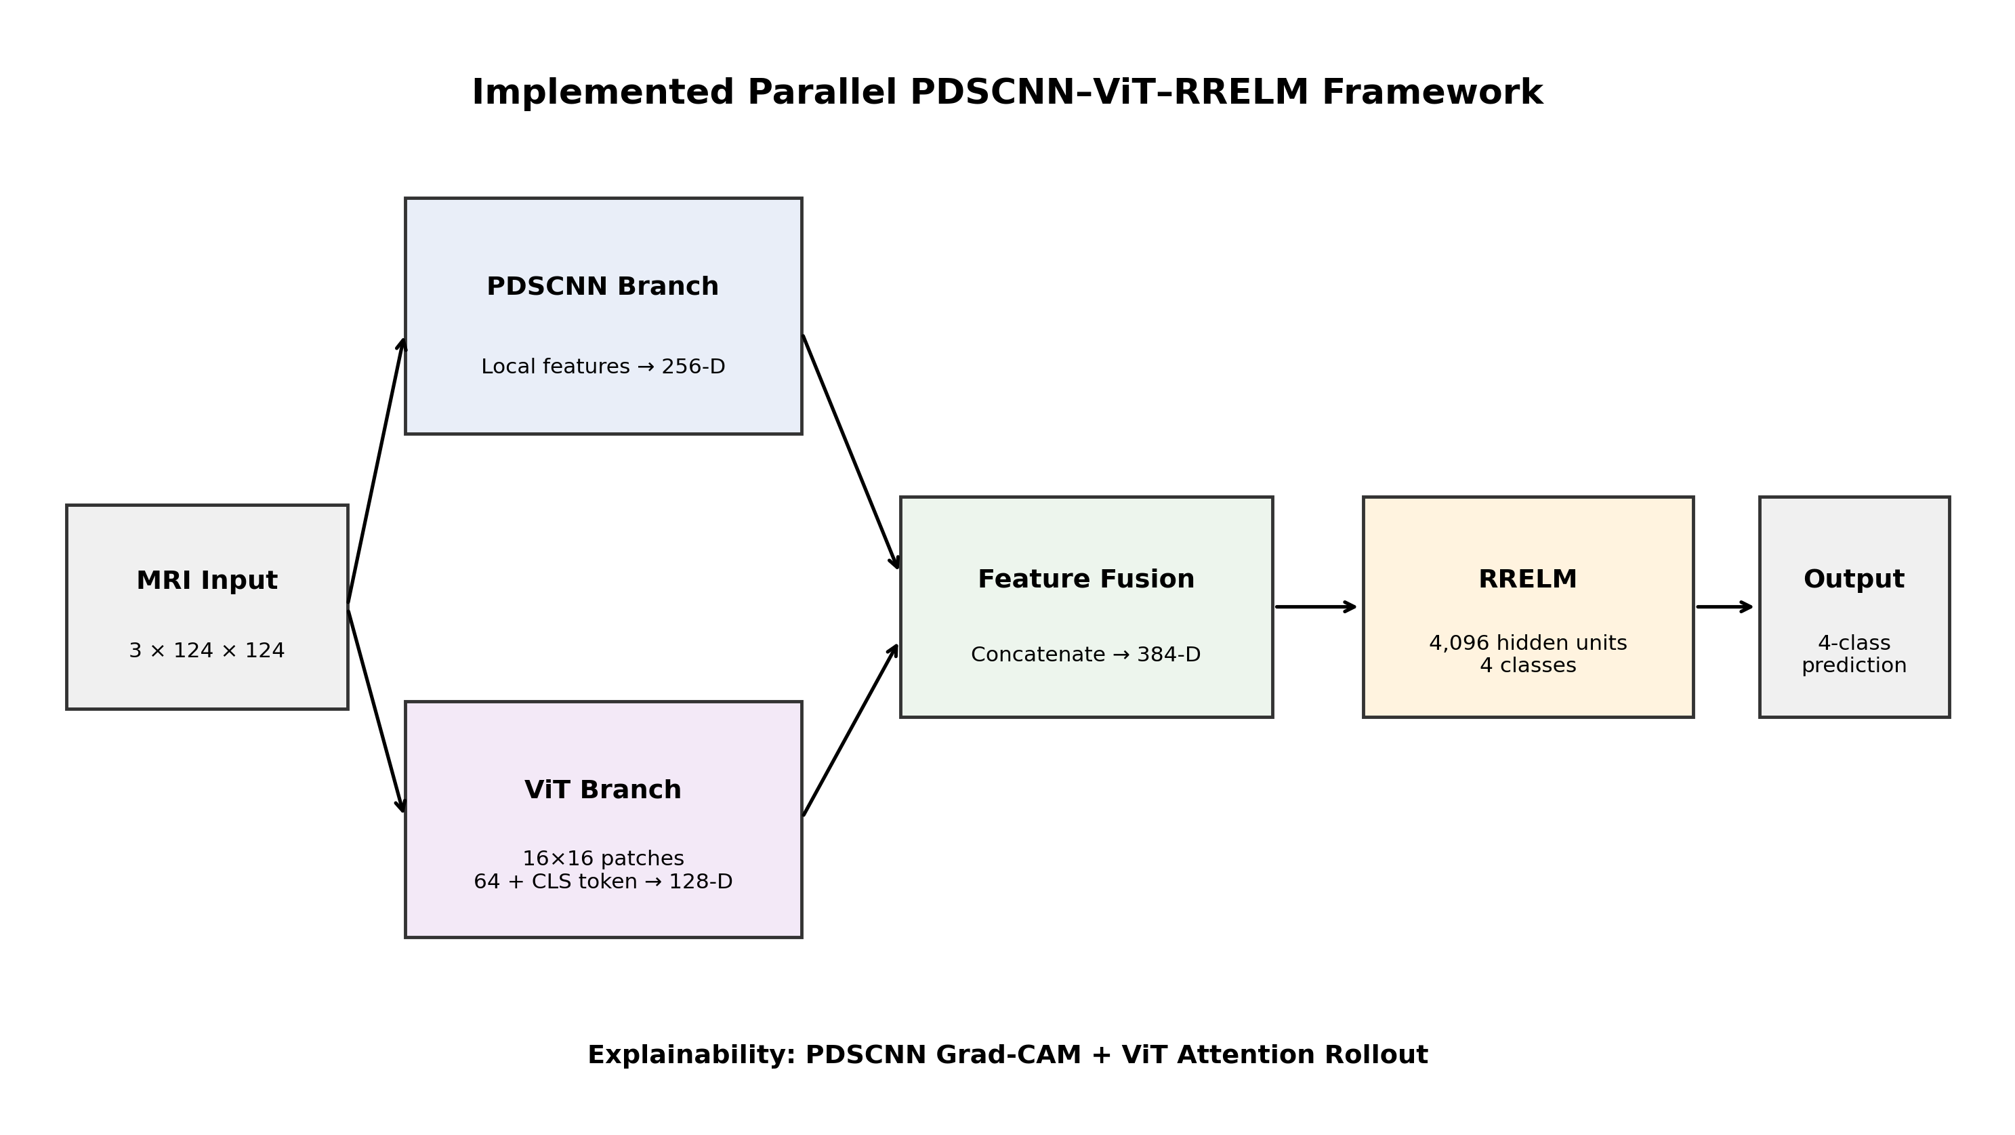
Figure 1. Implemented PDSCNN–ViT–RRELM architecture. The dimensions shown are those used by the supplied implementation.

5. DATASET AND DATA PREPARATION

A. Data Collection
The supplied data-acquisition implementation is configured to download and merge multiple public Kaggle brain MRI datasets. The acquisition script lists the Masoud Nickparvar, Sartaj Bhuvaji, Deniz Koko, Ahmed Hamada, and Obuli Srinivasan datasets and maps their class-folder names into four standardized labels: glioma, meningioma, notumor, and pituitary. The merged images are placed into a common dataset structure and an automatic duplicate-detection stage is invoked after merging.

B. Dataset Organization
The implemented loader expects a dataset directory containing separate train and test folders, each with four class directories. The class index mapping is fixed as: glioma = 0, meningioma = 1, notumor = 2, and pituitary = 3. The supplied full-dataset evaluation contains 13,994 MRI images.

C. Preprocessing
Each image is resized to exactly 124 × 124 pixels. Grayscale images are converted to RGB and CLAHE is applied to the luminance channel in LAB color space with a clip limit of 2.0 and an 8 × 8 tile grid. Pixel values are then converted to floating-point values and divided by 255, producing inputs in the [0,1] range.
x_norm = x / 255 (1)

D. Training Augmentation
Training augmentation uses random horizontal and vertical flips, a random rotation between −15° and +15°, and random x/y translations between −10 and +10 pixels. Augmentation is enabled for the training loader and disabled for the standard test loader.
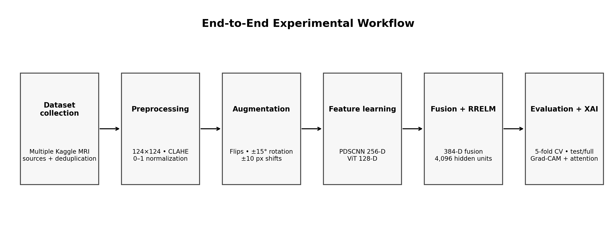
Figure 2. Implemented data-processing and evaluation workflow.

E. Evaluation Dataset Statistics
Table 1. Class distribution and correct predictions in the full evaluation.
Class | Support in full evaluation | Correct predictions
Glioma | 3500 | 3345
Meningioma | 3515 | 3382
No Tumor | 3505 | 3441
Pituitary | 3474 | 3376
Total | 13994 | 13544

6. MODEL ARCHITECTURE AND IMPLEMENTATION

A. PDSCNN Local Feature Extractor
The implemented PDSCNN branch receives a three-channel 124 × 124 input. It contains four convolutional stages with channel widths 32, 64, 128, and 256. Each convolution is followed by batch normalization and ReLU activation; max pooling reduces the spatial dimensions between stages. The feature map after the third convolutional stage is retained as the target activation for Grad-CAM. The final feature map is globally average pooled and passed through a fully connected layer to produce a 256-dimensional representation.
yᵢⱼₖ = ΣₘΣᵤΣᵥ wᵤᵥₘₖ xᵢ₊ᵤ,ⱼ₊ᵥ,ₘ + bₖ (2)
BN(x) = (x − μ) / √(σ² + ε) (3)
ReLU(x) = max(0, x) (4)
fₖ = (1/HW) ΣᵢΣⱼ Aᵢⱼₖ (5)

B. Vision Transformer Global Feature Extractor
The ViT branch first pads the 124 × 124 input to 128 × 128 pixels. A 16 × 16 convolutional patch embedding therefore creates an 8 × 8 grid, corresponding to 64 image patches. A learnable class token is prepended, producing 65 tokens in total. The token sequence is combined with positional embeddings and processed by four Transformer encoder layers with an embedding dimension of 128 and four attention heads. The normalized class-token output forms the 128-dimensional global representation.
N = HW / P² = (128/16)² = 64 (6)
Z⁰ = [x_cls ; x₁ ; … ; x₆₄] + E_pos (7)
Attention(Q,K,V) = softmax(QKᵀ / √dₖ) V (8)
MHSA(Z) = Concat(head₁,…,headₕ) Wᴼ (9)

C. Feature Fusion
The PDSCNN output and ViT class-token output are concatenated along the feature dimension. The resulting hybrid representation is 384-dimensional: 256 local CNN features plus 128 global transformer features. This vector is the input to the RRELM classifier.
z = [z_PDSCNN ∥ z_ViT] ∈ ℝ³⁸⁴ (10)

D. RRELM Classifier
RRELM is implemented as a randomized hidden-layer model followed by ridge-regularized analytical estimation of output weights. The hidden weights and biases are randomly initialized and remain fixed. For a feature matrix X, the hidden representation is H = ReLU(XW + b). With one-hot target matrix Y, the output weights are estimated using the ridge formulation β = (HᵀH + CI)⁻¹HᵀY. The training script uses 4,096 hidden units and searches C over 0.01, 0.1, 1, 10, 50, 100, and 500 for the final training stage. The selected RRELM model is stored together with the feature-extractor parameters.
H = ReLU(XW + b) (11)
β = (HᵀH + CI)⁻¹ HᵀY (12)

E. End-to-End Feature-Extractor Training
Before RRELM is fitted, the PDSCNN and ViT branches are trained end-to-end using a temporary linear classifier over the 384-dimensional representation. The implementation uses 80 epochs by default, batch size 32, AdamW with learning rate 5 × 10⁻⁴ and weight decay 10⁻², cosine-annealing learning-rate scheduling, and cross-entropy loss with label smoothing of 0.1. Mixup is applied to approximately half of training batches with α = 0.2. The best feature-extractor state is retained using test-set accuracy during this training phase.
L_CE = −Σ_c y_c log(p_c) (13)
ỹ_c = (1−ε)y_c + ε/K (14)
x̃ = λxᵢ + (1−λ)xⱼ, ỹ = λyᵢ + (1−λ)yⱼ (15)

7. TRAINING AND EVALUATION PROTOCOL
The standard training script loads the predefined train and test directories, trains the hybrid feature extractor, extracts 384-dimensional features, performs RRELM hyperparameter selection, and saves the feature-extractor state and RRELM parameters. A separate five-fold evaluation script pools the available train and test paths into one dataset and applies StratifiedKFold with five folds. Each fold reports training accuracy, validation/test accuracy, precision, recall, and F1-score.
Because the five-fold script intentionally combines the predefined train and test directories before cross-validation, the reported 98.01% mean result should be described as pooled stratified cross-validation performance rather than as an independent held-out test-set estimate. The separate test split remains a distinct evaluation reported by the standard evaluator.

A. Evaluation Metrics
Accuracy measures the proportion of correctly classified images: Accuracy = (TP + TN) / (TP + TN + FP + FN). Precision measures the proportion of predicted positives that are correct, Precision = TP/(TP+FP). Recall measures the proportion of actual positives correctly identified, Recall = TP/(TP+FN). The F1-score is the harmonic mean of precision and recall: F1 = 2PR/(P+R). For multiclass evaluation, these measures are calculated per class and can be summarized using macro or weighted averaging.
Accuracy = (TP + TN) / (TP + TN + FP + FN) (16)
Precision = TP / (TP + FP) (17)
Recall = TP / (TP + FN) (18)
F1 = 2PR / (P + R) (19)

8. EXPERIMENTAL RESULTS

A. Five-Fold Stratified Cross-Validation
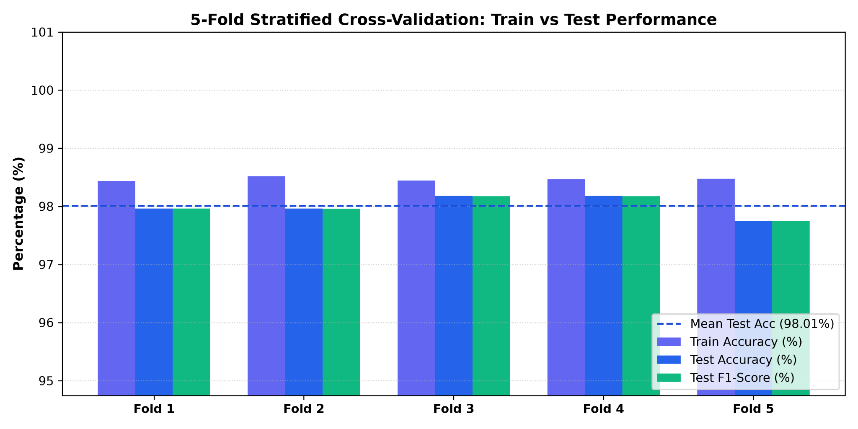
Figure 3. Five-fold stratified cross-validation performance. The supplied experiment reports a mean test accuracy of approximately 98.01%.
The supplied five-fold result shows consistently high validation performance across all folds, with the mean test accuracy reported at approximately 98.01%. The train and validation curves remain relatively close, suggesting that the learned representation is not dominated by a large train–validation performance gap in this pooled cross-validation experiment.

B. Full-Dataset Confusion Matrix
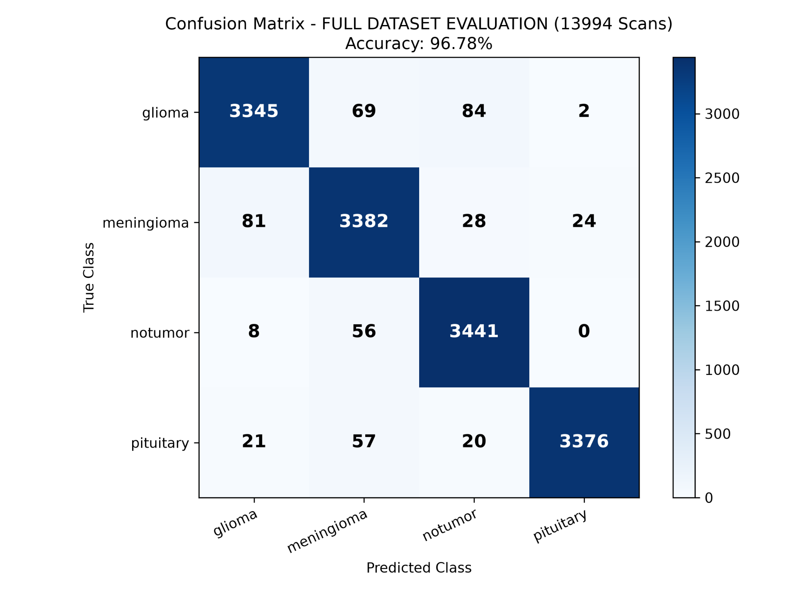
Figure 4. Full-dataset confusion matrix for 13,994 MRI images; reported accuracy = 96.78%.
Table 2. Class-wise precision, recall, F1-score, and support.
Class | Precision (%) | Recall (%) | F1 (%) | Support
Glioma | 96.82 | 95.57 | 96.19 | 3500
Meningioma | 94.89 | 96.22 | 95.55 | 3515
No Tumor | 96.31 | 98.17 | 97.23 | 3505
Pituitary | 99.24 | 97.18 | 98.20 | 3474
Macro average | 96.81 | 96.79 | 96.79 | 13994
From the supplied confusion matrix, 13,544 of 13,994 images are correctly classified, corresponding to 96.78% accuracy. The derived class-level metrics show strong recall for no-tumor images and high F1 performance across all four classes. These precision, recall, and F1 values are calculated directly from the supplied confusion-matrix counts.

C. Standard Test-Set Evaluation
The supplied evaluation script reports 94.13% accuracy for the separate test split containing 1,994 images. The corresponding full-dataset evaluation is 96.78% on 13,994 images. These values should be reported alongside the 98.01% pooled five-fold cross-validation result rather than collapsed into a single number.
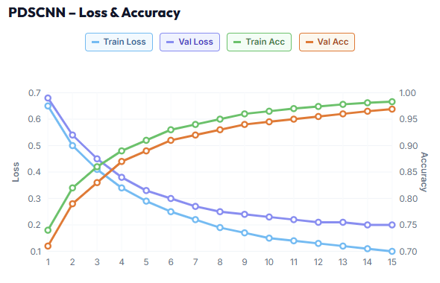
Figure 6. PDSCNN training and validation loss and accuracy curves from the supplied model-performance evaluation.
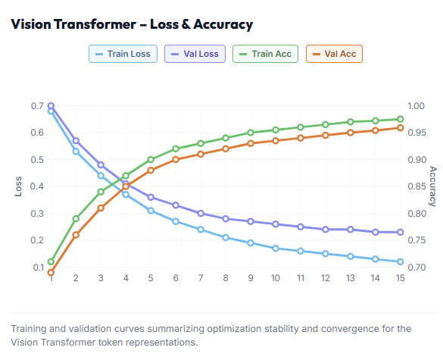
Figure 7. Vision Transformer training and validation loss and accuracy curves from the supplied model-performance evaluation.
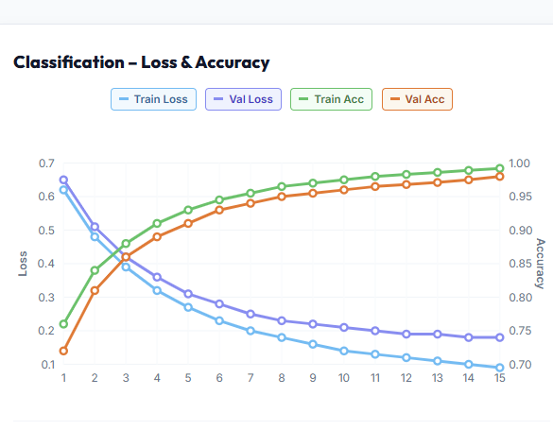
Figure 8. Combined PDSCNN–ViT fusion training and validation loss and accuracy curves from the supplied model-performance evaluation.
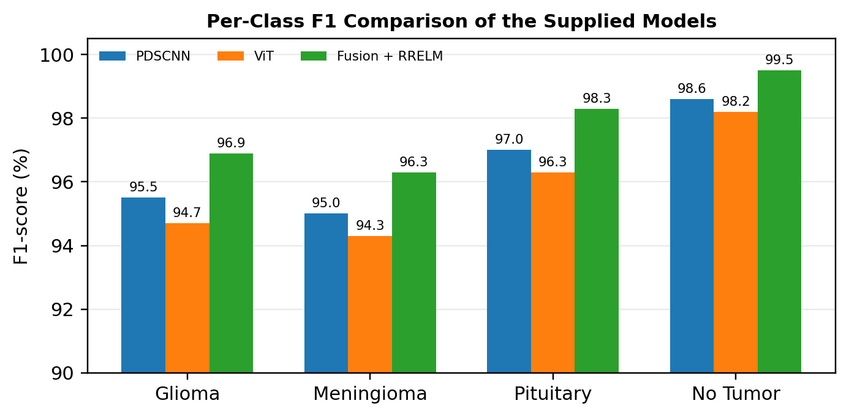
Figure 9. Per-class F1-score comparison of the PDSCNN, ViT, and combined fusion models from the supplied model-performance metrics.

9. EXPLAINABLE ARTIFICIAL INTELLIGENCE

A. PDSCNN Grad-CAM
Grad-CAM is applied to the saved PDSCNN activation map after the third convolutional stage. The method uses the gradient information associated with the target prediction to weight convolutional feature maps and generate a spatial importance map. The resulting heatmap is overlaid on the MRI image to indicate regions that contributed strongly to the CNN branch's decision.
αₖᶜ = (1/Z) ΣᵢΣⱼ ∂yᶜ/∂Aᵢⱼₖ (20)
L_Grad-CAMᶜ = ReLU(Σₖ αₖᶜ Aₖ) (21)

B. ViT Attention Rollout
The ViT implementation exposes self-attention matrices from each Transformer encoder layer. Attention information from the 65-token sequence is used to form a patch-level global visualization. Because the branch contains 64 image patches plus one class token, the resulting attention representation provides a coarse view of the image regions receiving transformer-level focus.
Ãˡ = D⁻¹(Aˡ + I) (22)
R = Ã¹ Ã² … Ãᴸ (23)

C. Dual XAI Output
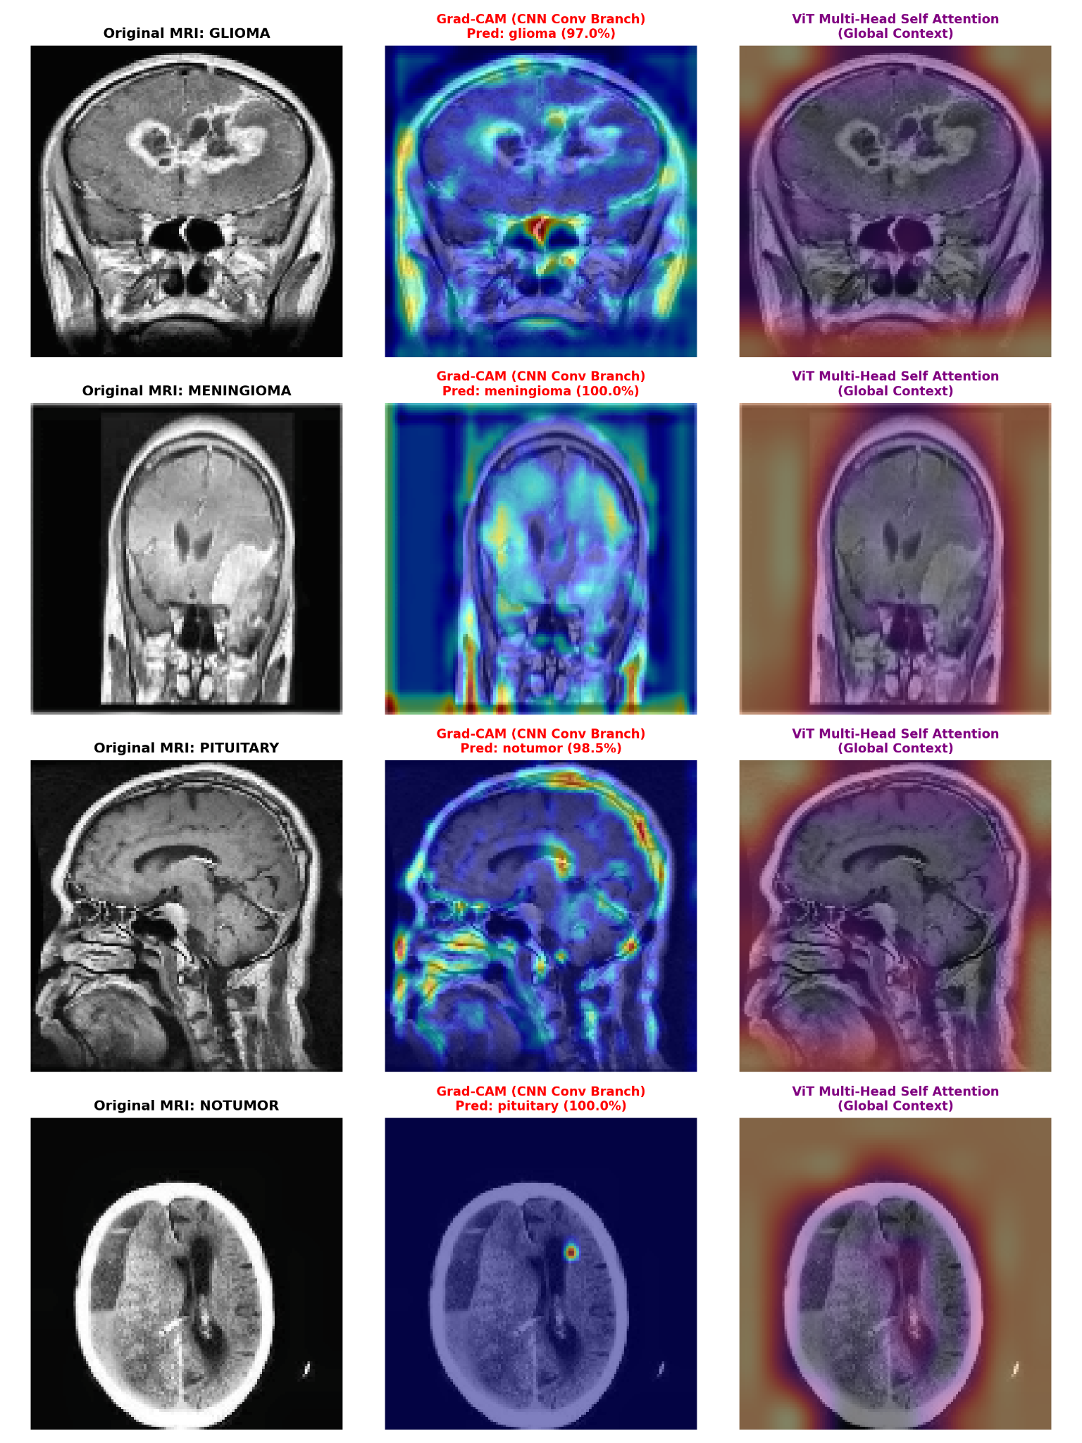
Figure 5. Dual explainable-AI visualization using PDSCNN Grad-CAM and ViT attention rollout across the four MRI classes.
The supplied visualization demonstrates the complementary nature of the two explanation mechanisms. Grad-CAM provides localized activation evidence from the convolutional branch, whereas ViT attention rollout provides a broader patch-level view of global contextual focus. These outputs are intended as model-interpretability aids and should not be interpreted as clinically validated tumor segmentation masks.

10. DISCUSSION
The implemented results support the central hypothesis of the project: local and global feature representations can be combined before an efficient analytical classifier. The PDSCNN branch captures fine spatial patterns through hierarchical convolutional processing, while the ViT branch introduces self-attention across image patches. Their 384-dimensional fusion gives RRELM access to complementary information rather than relying on a single representation family.
RRELM is particularly suited to the design because its hidden-layer parameters are randomized and its output weights are obtained analytically with ridge regularization. This separates representation learning from the final multi-class decision layer and avoids training a deep classifier on top of the fused representation. The C-grid in the training script provides a simple mechanism for controlling the ridge penalty.
The confusion matrix shows that most errors occur between tumor categories rather than between tumor and no-tumor in the supplied full-dataset result. This is expected for visually similar MRI patterns and emphasizes why complementary local/global representations and explainability are useful. At the same time, the difference between the 98.01% pooled cross-validation result and the 94.13% separate test result indicates that evaluation protocol matters and that the higher cross-validation figure should not be interpreted as an independent external-test performance estimate.

11. COMPARATIVE AND ABLATION FRAMEWORK
The implemented project is designed around a direct extension of the base PDSCNN–RRELM idea. A rigorous ablation study can isolate the contribution of each component by comparing: (i) PDSCNN + RRELM, (ii) ViT + RRELM, (iii) PDSCNN + ViT + conventional linear classifier, and (iv) PDSCNN + ViT + RRELM. Additional comparisons can remove CLAHE, Mixup, or label smoothing one at a time. The current supplied materials establish the complete hybrid results but do not provide a full controlled ablation table for every component; therefore numerical ablation values are not fabricated here.
Table 3. Comparative framework for the implemented and reference configurations.
Configuration | Local features | Global features | Classifier
Base-style model | PDSCNN | — | RRELM
Transformer-only | — | ViT | RRELM
Hybrid + linear | PDSCNN | ViT | Linear
Implemented hybrid | PDSCNN | ViT | RRELM

12. COMPUTATIONAL CHARACTERISTICS
The architecture aims to balance representational capacity and classifier efficiency. The PDSCNN branch is compact relative to large transfer-learning networks, and the ViT branch uses only a 128-dimensional embedding, four attention heads, and four encoder layers. The fused feature vector is only 384 dimensions before RRELM. The main additional cost comes from maintaining two feature-extraction branches and generating XAI visualizations. Exact wall-clock training time, inference latency, and total parameter count were not supplied as validated measurements and are therefore not asserted.

A. Reproducibility
Input size: 124 × 124 RGB.
ViT padding: 124 × 124 → 128 × 128.
Patch size: 16 × 16; 64 patches + one class token.
Feature dimensions: PDSCNN 256-D + ViT 128-D = 384-D.
RRELM hidden dimension in training: 4,096.
Default training: 80 epochs, batch size 32, learning rate 5 × 10⁻⁴.
Optimizer/schedule: AdamW + cosine annealing.
Regularization: weight decay, label smoothing, Mixup.
Five-fold evaluation: StratifiedKFold, five folds.

13. SYSTEM DEPLOYMENT AND APPLICATION WORKFLOW
The intended application layer consists of a web user interface connected to a Python inference backend. The frontend can provide MRI upload, prediction display, confidence distribution, Grad-CAM visualization, ViT attention visualization, and basic project information. The backend loads the trained feature extractor and RRELM parameters and exposes an inference endpoint. This separation allows the model to remain independent of the presentation layer.
For a production-oriented implementation, the inference service can be packaged in Docker and exposed through a REST API. The client sends an MRI image to the prediction endpoint; the backend preprocesses the image, extracts the hybrid representation, applies RRELM, and returns the predicted class, probability distribution, and XAI artifacts. The system should clearly state that predictions are research/decision-support outputs and require specialist clinical review.

14. CONCLUSION
This paper presents the implemented Parallel PDSCNN–Vision Transformer Fusion framework with RRELM for four-class brain tumor MRI classification. The system combines a 256-dimensional local convolutional representation with a 128-dimensional transformer representation, producing a 384-dimensional feature vector for RRELM classification. MRI preprocessing uses 124 × 124 resizing, CLAHE, normalization, and training-time augmentation. The supplied experiments report approximately 98.01% mean accuracy in five-fold stratified cross-validation, 96.78% accuracy on the full 13,994-image evaluation, and 94.13% accuracy on the separate 1,994-image test split. Dual XAI outputs using Grad-CAM and ViT attention rollout provide complementary views of model evidence. Overall, the implementation demonstrates a practical research direction for combining efficient local feature extraction, global contextual modeling, analytical classification, and visual interpretability in brain MRI analysis.
References
[1] A. S. Musallam, A. S. Sherif, and M. K. Hussein, “A new convolutional neural network architecture for automatic detection of brain tumors in magnetic resonance imaging images,” IEEE Access, vol. 10, pp. 2775–2782, 2022, doi: 10.1109/ACCESS.2022.3140289.
[2] D. R. Nayak, N. Padhy, P. K. Mallick, M. Zymbler, and S. Kumar, “Brain tumor classification using dense Efficient-Net,” Axioms, vol. 11, no. 1, Art. no. 34, 2022, doi: 10.3390/axioms11010034.
[3] S. Deepak and P. M. Ameer, “Brain tumor classification using deep CNN features via transfer learning,” Computers in Biology and Medicine, vol. 111, Art. no. 103345, 2019, doi: 10.1016/j.compbiomed.2019.103345.
[4] A. Dosovitskiy et al., “An image is worth 16x16 words: Transformers for image recognition at scale,” International Conference on Learning Representations (ICLR), 2021.
[5] M. Nahiduzzaman et al., “A hybrid explainable model based on advanced machine learning and deep learning models for classifying brain tumors using MRI images,” Scientific Reports, vol. 15, Art. no. 1649, 2025, doi: 10.1038/s41598-025-85874-7.
[6] R. R. Selvaraju et al., “Grad-CAM: Visual explanations from deep networks via gradient-based localization,” Proceedings of the IEEE International Conference on Computer Vision (ICCV), 2017.
[7] A. Vaswani et al., “Attention is all you need,” Advances in Neural Information Processing Systems, 2017.
[8] T. Chahal, S. Pandey, and S. Goel, “A survey on brain tumor detection techniques for MR images,” Multimedia Tools and Applications, vol. 79, pp. 21771–21814, 2020.
[9] D. P. Kingma and J. Ba, “Adam: A method for stochastic optimization,” ICLR, 2015.
[10] H. Zhang et al., “mixup: Beyond empirical risk minimization,” ICLR, 2018.

