My forked github repo: https://github.com/Krish-Arun/01_frogger

I asked chatGPT for a prompt I could give to claude cowork (the claude coding agent that I ran on desktop): https://chatgpt.com/share/6abe03de-381c-83ee-8e8c-2109bd4659cb

I ended up having to use only a single prompt, the details of which are in “/CHAT_SUMMARY.md”, it was created like this:

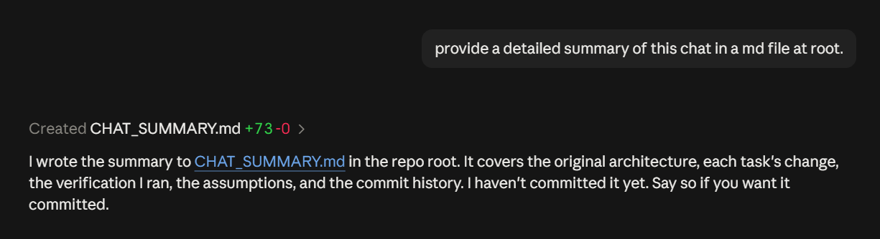

Before and after videos are in “/videos”

