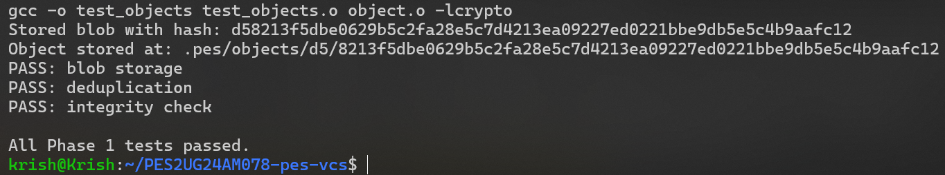

2a.
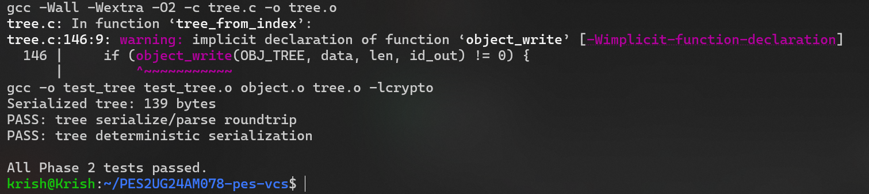

I gave up after phase 3 due segfault (did without LLM), and theres not enough time given for a problem of this complexity (sorry for being unprofessional)

