ADS NITRO
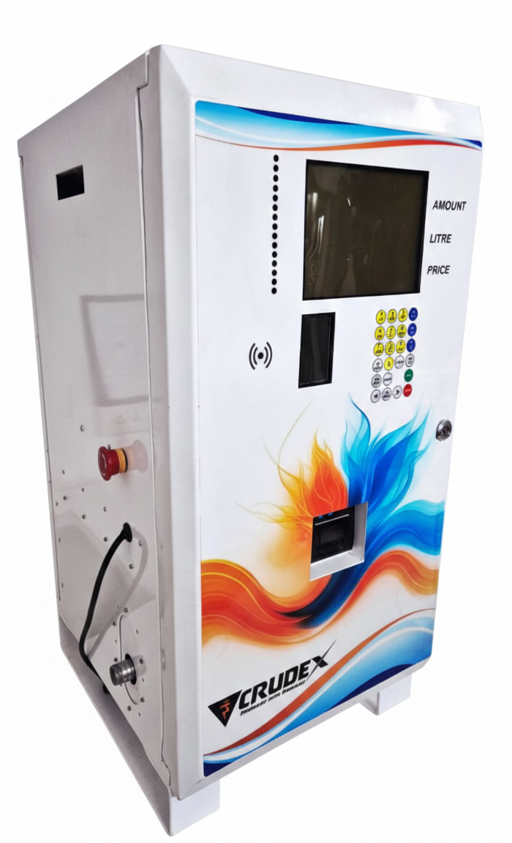

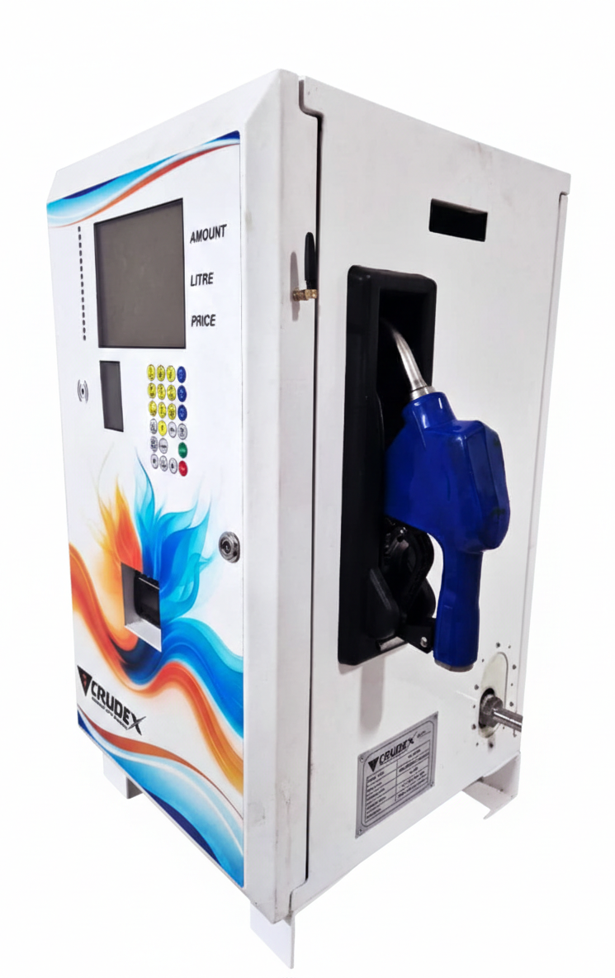

Product Technical Specification: ADS NITRO

:

Specification
Available Nozzles | 1
Nozzle Reach | 10 m Hook (Perpetual) (Hose Reel Optional)
Display Options | - 3 line 1.25-inch display for transaction data  - Graphic Display for Configurations, Errors, messages and other explicit data.  - Multi-functional 23 key keypad  - Smart indication system  - Segment LCD with Backlight display  - Hardware lock for calibration  - Secure passwords for calibration & Multiple Dispensing Mode
Working temperature | (0 to + 55°C)
Relative Humidity | 5 to 95%
Voltages | 180 V to 300V AC Single Phase; 50/60 Hz AC
Rated Flow Rate  Practical Flow Rate | 30 LPM  20 LPM
Pre-set | Pre-Set (from ERP or local) & Manual (Volumetric and Amount based)
Flow Meter Accuracy | 0.2%
Hose Length | 4 Meters Nozzle Hose pipe
Enclosure | MS Powder Coated heavy ENCLOSURE with thermal insulation of 30mm (For better Rust Protection)
Boot-up | Boot-Up Log (For identifying power loss and frequent restart conditions)
Transaction | Shift settlement and Records for easy monitoring of financial transactions.
No-Cheating | Reset to Zero announcements over speaker for drivers (FOR no-Cheating while dispensing)
Storage | 3 months or 15000 transactions local Storage Available
Relay | Power Control Relay for Electronics Input Power control.
Single Nozzle | Auto cut-off/ Pressure Sensitive with latch, colours cuff guard
Breakaway | Nozzle mounted
Connectivity | IOT enabled Communication options include Wi-Fi / Ethernet / RS485 / RS232
Totalizer | Electronic Non-Resettable Totalizer
Printer | - Receipt Printer, Inbuilt 2-inch Thermal Printer for Receipt Printing, Paper/Printing width-58/48mm  - Paper roll dia./Length-40mm/18meter  - Communication protocol-RS232  - Power Supply: 5V, 2.5 A  - High Resolution Printing Low Power Consumption
Security | Enhanced Security Features
 | AES 256 Bit Encryption
 | One-Time password for calibration & replacement of critical components
Rate control can be change from LOCAL to Central and vice Versa
Remote locking of Dispenser for unauthorized Usage.
 | Non-resettable electronics totalizer
ERP & Management | Integration With Client ERP using CSV data over TCPIP for easy Integration.  SET ACCESS RIGHTS and limitations for Different Employee categories  (Attendant / Accountant / Manager)
Structure | Comparatively Integrated, small and Robust design
GSM | - Enables real-time data transmission and  - monitoring via 2G/4G networks  - Supports OTA (Over-the-Air) firmware  - updates for remote maintenance  - Compatible with mobile app for dispenser  - configuration and diagnostics  - Built-in data buffer ensures offline data is  - auto-synced when network is restored
Features | - Dispenser Registration  - Dispenser configuration  - Transactions Logs  - Shift Log (3 Shift/Day)  - Error logs  - Calibration Logs  - Configuration Logs  - Accessible Multiple pump managers  - Real time data monitoring  - Firmware updates through OTA  - Data Recovery

Commercial Offer for ADS NITRO (DEF)

Sr. No. | Description | Total Order Quantity | Minimum Order Quantity in a Lot | Ex Work Price Per Pcs (Excluding taxes & transit cost)
1 | Advanced DEF Dispenser Set. | 20 | 5 | 72,000.00 INR

