Lab 1.4: C implementation of Priority CPU Scheduling

THEORY:
Priority scheduling is one of the most common scheduling algorithms used by the operating system to schedule processes based on their priority. Each process is assigned a priority value based on criteria such as memory requirements, time requirements, other resource needs, or the ratio of average I/O to average CPU burst time.
The process with the highest priority is selected for execution first. If there are multiple processs sharing the same priority, they are scheduled in the order they arrived. The chosen process is then executed, either until completion or until it is preempted, depeneding on whether the scheduilng is preemptive or non-preemptive.

Code Implementation:

#include<stdio.h>
#include<stdlib.h>
#include<unistd.h>
#define MAX 4

// Function to sort processes by priority (lower number = higher priority)
void sortByPriority(int BT[], int priority[], int process_id[]) {
for (int i = 0; i < MAX - 1; i++) {
for (int j = 0; j < MAX - i - 1; j++) {
// If current priority is higher than next (lower number = higher priority)
if (priority[j] > priority[j + 1]) {
// Swap priorities
int temp = priority[j];
priority[j] = priority[j + 1];
priority[j + 1] = temp;

// Swap burst times
temp = BT[j];
BT[j] = BT[j + 1];
BT[j + 1] = temp;

// Swap process IDs
temp = process_id[j];
process_id[j] = process_id[j + 1];
process_id[j + 1] = temp;
}
}
}
}

int main(){
// Process Burst Times
int BT[MAX] = {5, 1, 6, 7};
// Process Priorities (1 = highest priority, 4 = lowest priority)
int priority[MAX] = {3, 1, 4, 2};
// Process IDs to keep track of original process numbers
int process_id[MAX] = {0, 1, 2, 3};

// Arrays for scheduling calculations
int WT[MAX] = {0}; // Waiting time
int TAT[MAX] = {0}; // Turnaround time
int CT[MAX] = {0}; // Completion time

int totalWT = 0, totalTAT = 0;

printf("Original Process Information:\n");
printf("Process\tBurst Time\tPriority\n");
for (int i = 0; i < MAX; i++) {
printf("P%d\t%d\t\t%d\n", process_id[i], BT[i], priority[i]);
}

// Sort processes by priority (highest priority first)
sortByPriority(BT, priority, process_id);

printf("\nAfter sorting by priority (1=highest, 4=lowest):\n");
printf("Process\tBurst Time\tPriority\n");
for (int i = 0; i < MAX; i++) {
printf("P%d\t%d\t\t%d\n", process_id[i], BT[i], priority[i]);
}

printf("\nExecution Order:\n");

// Calculate completion, waiting, and turnaround times
CT[0] = BT[0]; // First process completes at its burst time
printf("P%d executes from 0 to %d\n", process_id[0], CT[0]);
sleep(1);

for (int i = 1; i < MAX; i++) {
CT[i] = CT[i-1] + BT[i]; // Each process completes after the previous one
printf("P%d executes from %d to %d\n", process_id[i], CT[i-1], CT[i]);
sleep(1);
}

// Calculate Turnaround Time and Waiting Time
for (int i = 0; i < MAX; i++) {
TAT[i] = CT[i]; // Since arrival time is 0 for all
WT[i] = TAT[i] - BT[i]; // Waiting time = Turnaround time - Burst time
totalWT += WT[i];
totalTAT += TAT[i];
}

printf("\nFinal Results:\n");
printf("Process\tPriority\tBT\tCT\tTAT\tWT\n");
for (int i = 0; i < MAX; i++) {
printf("P%d\t%d\t\t%d\t%d\t%d\t%d\n",
process_id[i], priority[i], BT[i], CT[i], TAT[i], WT[i]);
}

printf("\nTotal Waiting Time: %d\tAvg Waiting Time: %.2f\n",
totalWT, (float)totalWT / MAX);
printf("Total Turnaround Time: %d\tAvg Turnaround Time: %.2f\n",
totalTAT, (float)totalTAT / MAX);

return 0;
}

Output:
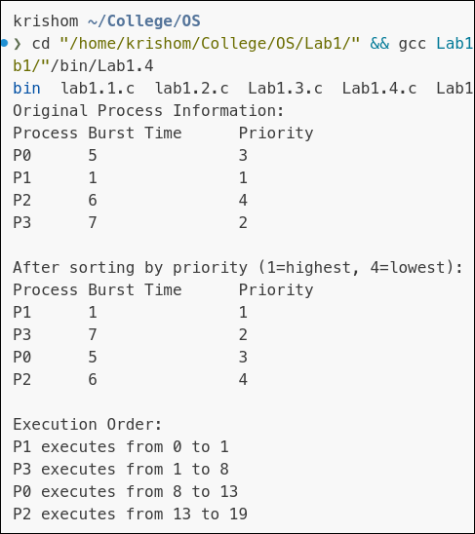
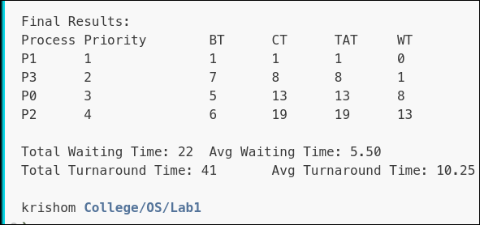

Discussion:

