# FLEX Paid Claims Data Interchange between Lilly USA IRIS & IQVIA ERMDM

Table of Contents

# Overview

This document provides an overview of the process involving the exchange of Paid Claims data between the Lilly USA IRIS System and the IQVIA ERMDM System. It delves into the technical architecture underpinning this data interchange, outlines the key activities that the operations team should undertake to ensure a smooth file transfer, and offers additional relevant details.

# File Interface Agreement

## Output file to IQVIA

|  |  |
| --- | --- |
| **File Name** | LILLY_PAID_CLAIMS_YYYYMMDD.txt |
| **File Format** | | Pipe delimited text file |
| **Control File** | LILLY_PAID_CLAIMS_YYYYMMDD.ctl |

Control file will contain only the record count of the data file (excluding the header).

|  |  |  |  |
| --- | --- | --- | --- |
| **Field Name** | **Data Type** | **Description** | **Example** |
| FILE_ID | NUMBER(18,0) | The unique system-assigned ID of the transaction file associated with this transaction record that client defines. |  |
| DATE_TIME | DATETIME | Date data was loaded into client system | 01-02-2022 00:00 |
| TRANSACTION_RECORD_ID | NUMBER(18,0) | A unique system-assigned sequential number to uniquely identify a row in the client defined data (e.g. - Validata unique tracking ID) | 846159472 |
| RX | VARCHAR | The prescription reference number for the transaction record | 8303812 |
| PRODUCT_ID | VARCHAR | The product NDC 11 code (no dashes or spaces) | 00005089426 |
| PRODUCT | VARCHAR | The name of product and description | Brand A |
| FILL_DATE | VARCHAR | The date of service for the transaction record. (YYYYMMDD) | 20211229 |
| REFILL_TYPE | VARCHAR | The fill number for the transaction record | 2 |
| QUANTITY | NUMBER(22,6) | The total quantity of product in the prescription | 60 |
| PHARMACY_NCPDP | VARCHAR | The pharmacy NCPDP number on the claim | 1902124 |
| PHARMACY_NPI | VARCHAR | The pharmacy NPI on claim if provided | 1738213931 |
| PHARMACY_STATE | VARCHAR | The two character abbreviation for the state that the pharmacy resides in | NC |
| PHARMACY_ZIP | VARCHAR | The zip code for the state that the pharmacy resides in | 28752 |
| PRESCRIBER_ID | VARCHAR | The prescriber NPI for the prescriber/physician on the claim (when available…) | 1410403860 |
| REBATE_DAYS_SUPPLY | NUMBER(22,6) | The rebate days supply | 30 |
| SOURCE_NAME | VARCHAR | PBM/MCO name that submitted data | PBM123 |
| CONTRACT_MARKET_TYPE | VARCHAR | A description of the Market Type.  (COMMERCIAL, MEDICARE D, Mgd Medicaid, ETC…) | MMA |
| PLAN_NAME | VARCHAR | The name of the plan associated with this record | Plan_456_PartD |
| SUBMITTED_PLAN_ID | VARCHAR | The plan id code for the transaction record. Unaltered from PBM | 31060M |
| RBT_AMT | NUMBER(11,2) | Amount requested by payer; used to quantify ERMDM opportunity by payer/product | $50 |
| SUBMISSION_PERIOD | VARCHAR | Submission Period for the claim data in a YYYYQxx (quarterly submissions) or YYYYMxx (monthly submissions) | 2022Q01 (for Q1 2022) 2022M03 (for March 2022) |
| EXCLUSION_STATUS | VARCHAR | Binary flag of <"Yes" | "No"> indicating whether an exclusion was taken on that rebate claim | Yes |
| FORMULARY_ID | VARCHAR | The formulary id code for the transaction record. Unaltered from PBM | 1702 |

## Incoming file from IQVIA

|  |  |
| --- | --- |
| **File Name** | LILLY_PAID_CLAIMS_YYYYMMDD_Output.txt |
| **File Format** | | Pipe delimited text file |
| **Control File** | LILLY_PAID_CLAIMS_YYYYMMDD_Output.ctl |

Control file will contain only the record count of the data file (excluding the header).

|  |  |  |  |
| --- | --- | --- | --- |
| **Field Name** | **Data Type** | **Description** | **Example** |
| FILE_ID | NUMBER(18,0) | File ID submitted on the rebate claim file | 123 |
| TRANSACTION_RECORD_ID | DECIMAL(18,0) | Unique claim identifier provided in the incoming rebate file | 123123123123 |
| RX | STRING | Rx number | 9999999 |
| PRODUCT | STRING | Product name | ELIQUIS |
| PRODUCT_ID | STRING | NDC11 | 99999999999 |
| FILL_DATE | DATE | Fill date of the claim; MM/DD/YYYY | 12/31/2020 |
| REFILL_TYPE | STRING | The fill number of the transaction record | 1 |
| QUANTITY | DECIMAL(22,6) | Quantity of drug dispensed | 30 |
| PHARMACY_NCPDP | STRING | Pharmacy NCPDP on the claim.  This field is blank when the claim does not have NCPDP information. | 9999999 |
| PHARMACY_NPI | STRING | Pharmacy NPI on the claim.  This field is blank when the claim does not have NPI information populated. | x |
| PHARMACY_STATE | STRING | State code of Pharmacy found in NCPDP dataQ database. | UT |
| PHARMACY_ZIP | STRING | Zip code of Pharmacy found in NCPDP dataQ database. | 846014276 |
| PRESCRIBER_ID | STRING | The Prescriber NPI provided for the incoming rebate claim | 1528329299 |
| REBATE_DAYS_SUPPLY | DECIMAL(22,6) | The rebate days supply provided for the incoming rebate claim. | 30 |
| SOURCE_NAME | STRING | PBM/MCO name that submitted data | SELECTHEALTH INC. |
| CONTRACT_MARKET_TYPE | STRING | A description of the Market Type. | Medicare Program Exclusion |
| PLAN_NAME | STRING | The name of the plan associated with this record. | MEDICARE ADVANTAGE UT |
| CLIENT_ID | STRING | Client ID (aka SUBMITTED_PLAN_ID) | 9999 |
| DATE_TIME | STRING | The date the data was loaded into the client system. | 01-02-2022 00:00 |
| RBT_AMT | DECIMAL(19,6) | Amount requested by payer; used to quantify ERMDM opportunity by payer/product. | 34.05 |
| SUBMISSION_PERIOD | STRING | Submission Period for the claim data in a YYYYQxx (quarterly submissions) or YYYYMxx (monthly submissions) format. | 2022Q02 (quarterly) or 2022M03 (monthly) |
| EXCLUSION_STATUS | STRING | Binary flag of <Yes | No> indicating whether an exclusion was taken on that rebate claim.  If nothing provided in the incoming data file, field will be blank/NULL. | Yes |
| FORMULARY_ID | STRING | The formulary id code for the transaction record. Unaltered from PBM | 1702 |
| **REPLACEMENT_PRESCRIBER_NPI** | **STRING** | **Prescriber NPIs that were harvested during the NPI Harvesting process of ERMDM** | **1234567893** |
| **PROB_340B** | **DECIMAL(19,6)** | **Likelihood a claim is 340B eligible. This is an output of the ERMDM process. Rounded to 3 decimal places** | **0.854** |
| **SCC** | **STRING** | **Submission Clarification Code for matched LAAD claim.** | **20** |
| **NONFILL_CLAIM** | **STRING** | **Indicates whether or not the claim was Non-Filled.** | **Y** |

# Architecture

Lucid Chart diagram for the architecture diagrams are also available at - <https://lucid.app/lucidchart/ab617e6c-f84f-4edf-a42b-679aec0a5225/edit?viewport_loc=-2810%2C-108%2C2907%2C1441%2Cj8Ww3.9TMaJg&invitationId=inv_7ebba07e-158e-4b75-b7a5-8d122e39b722>

## Outbound Process

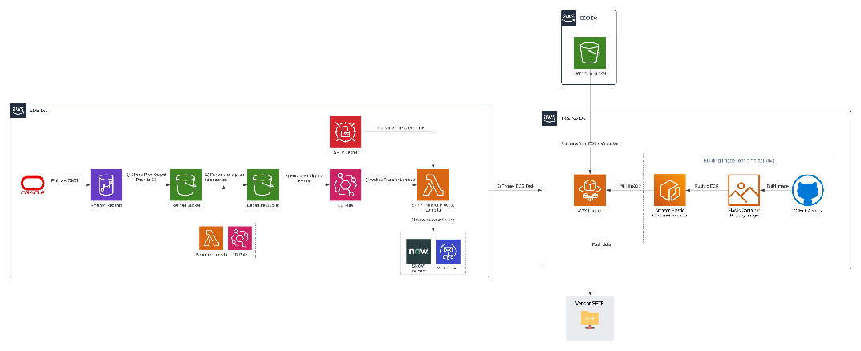

### Technical Details

1. IRIS DMS Tasks pull data from FLEX Oracle System and push them into IRIS Redshift flex_refined_ex schema (Source is [prd494@pawnee.am.lilly.com](mailto:prd494@pawnee.am.lilly.com) for IRIS Prod DMS and [stgg494@pawnee-qa.am.lilly.com](mailto:stgg494@pawnee-qa.am.lilly.com) for IRIS QA DMS).
2. The CAWA Job triggers the stored procedure which loads the data into the table flex_ex.flex_paid_claims_transactions_extract_iqvia that needs to be sent to IQVIA.
3. The CAWA job also triggers the unload stored procedure which then dumps the data into a Refined S3 location at s3://lly-edp-refined-us-east-2-prod/flex_lusa_paid_claims_restricted/output/paid_claims_extract_part000
4. An EventBridge rule edb-iris-iqvia-340b-scrub-extract-rename-rule monitoring the location triggers a lambda function edb_iris_iqvia_scrub_extract_rename, renames the output part file to LILLY_PAID_CLAIMS_YYYYMMDD.txt, pushes the renamed file to s3://lly-edp-departure-us-east-2-prod/flex_lusa_paid_claims_restricted/output/ and also deletes the paid_claims_extract_part000 file from the refined location.
5. As soon as the file is copied into departure bucket, another event bridge rule edb-iris-iqvia-340b-scrub-sftp-put-event-rule triggers a generic lambda function edb_iris_sftp_transfer_process. This lambda expects input from the EB rule in a certain format as defined in [Design Doc](https://github.com/EliLillyCo/lusa-iris-edb/blob/dev/docs/sftp_transfer_process/edb_iris_dsg_sftp_transfer_process.md).
6. The SFTP Transfer Lambda Process starts a Fargate Task inside the ECS cluster iris-sftp-transfer-process-cluster in IRIS NoDx account which will do the below steps -
   1. Download the file from departure bucket using aws cli
   2. Use lftp to transfer file to IQVIA SFTP into the /in folder.
   3. Creates a control file which has the record count of the data file and push it to IQVIA SFTP.
7. A mail will be sent to operations team once the file transfer has been initiated.
8. A SNOW incident will be raised in case the file transfer has not started successfully.

## Inbound Process

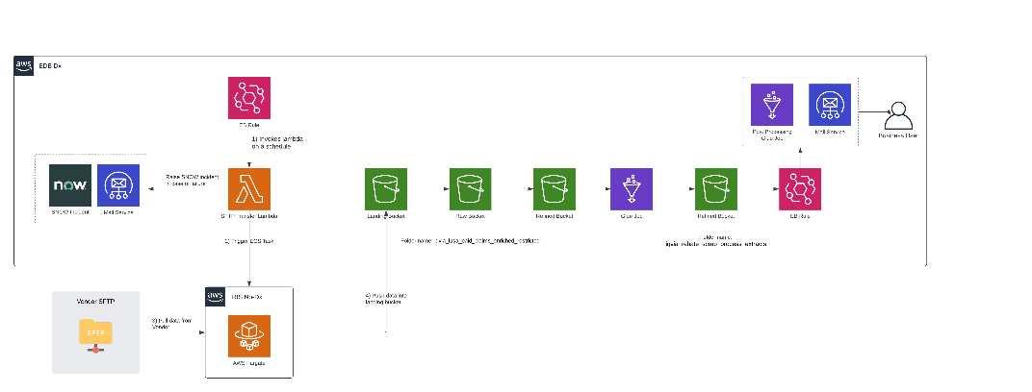

### Technical Details

1. Whenever a business confirms that the file has been placed on the SFTP server, the SFTP Transfer Process Lambda function **edb_iris_sftp_transfer_process** must be manually invoked.
2. To trigger the function, it requires a specific payload to be passed as defined in the [Design Doc](https://github.com/EliLillyCo/lusa-iris-edb/blob/dev/docs/sftp_transfer_process/edb_iris_dsg_sftp_transfer_process.md). For this project, the event passed to the lambda makes it check for any new text files that have been pushed into the SFTP in the past day.
3. If the lambda detects that there is any new text file that has been pushed into SFTP’s /out folder, it starts a Fargate Task inside the ECS cluster iris-sftp-transfer-process-cluster in IRIS NoDx account which will do the below steps -
   1. Downloads the file from SFTP into the container’s local storage.
   2. Pushes it into the EDB’s AWS Landing Bucket into the folder s3://lly-edp-landing-us-east-2-prod/iqvia_lusa_paid_claims_enriched_restricted/data/inbox/
   3. Deletes the file from IQVIA’s SFTP folder.
4. As soon as the file lands in EDB’s Landing Bucket, an EB rule edb-iris-iqvia-scrub-landing-to-raw-event-rule triggers the lambda edb_landing_to_raw_lambda, which moves the file from landing location to a location in Raw Bucket s3://lly-edp-raw-us-east-2-prod/iqvia_lusa_paid_claims_enriched_restricted/data/inbox/.
5. Once the file is moved into Raw bucket, an EB rule iqvia-lusa-paid-claims-enriched-raw-to-refined-event-rule triggers the lambda edb_iris_raw_s3_processRawFile which triggers a glue job edb_iris_raw_to_refined_iqvia_lusa_paid_claims_enriched_restricted. The glue job moves the file from Raw bucket into Refined Bucket at s3://lly-edp-refined-us-east-2-prod/iqvia_lusa_paid_claims_enriched_restricted/data/inbox/
6. Along with putting the data in above Refined location, the glue job also creates a trigger file at s3://lly-edp-refined-us-east-2-prod/iqvia_lusa_paid_claims_enriched_restricted/data/trigger_file.json which will invoke another event bridge rule edb-iris-iqvia-scrub-glue-trigger-lambda-event-rule.
7. This event bridge rule invokes a lambda function edb_iris_iqvia_scrub_glue_trigger which will trigger another glue job edb_iris_iqvia_scrub_extracts_load.
8. The extracts glue job does the below things -
   1. Reads the configuration for 340B extract and Non Fill extract from the glue configuration file.
   2. Based on the configuration, generate extracts and put them in the final location as defined below -
      1. **340B Extract** 
         1. Latest File Location - s3://lly-edp-refined-us-east-2-prod/iqvia_rebate_scrub_lusa_dataextracts_restricted/340b/postprocess/data/inbox/
         2. Archive Location - s3://lly-edp-refined-us-east-2-prod/iqvia_rebate_scrub_lusa_dataextracts_restricted/340b/postprocess/data/archive/
      2. **Non Fill Extract**
         1. Latest File Location - s3://lly-edp-refined-us-east-2-prod/iqvia_rebate_scrub_lusa_dataextracts_restricted/nonfill/postprocess/data/inbox/
         2. Archive Location - s3://lly-edp-refined-us-east-2-prod/iqvia_rebate_scrub_lusa_dataextracts_restricted/nonfill/postprocess/data/archive/
   3. The glue job also sends a mail to the downstream users. Mail ids is configured in the [glue job configuration](https://github.com/EliLillyCo/lusa-iris-edb/blob/stage-qa/glue/config/sources/edb_iris_iqvia_scrub_extracts_load.json).

Extracts copied into archive location will have _YYYYMMDD appended to them.

#### Business Extract Generation Glue Job Configuration Details

|  |  |
| --- | --- |
| **Key** | **Description** |
| email_config → email_to_address | Email Id to which extract generation mail with download link will be sent. |
| email_config → email_template | Email text that will be used in generating the mail body. |
| source_location | The source location in refined bucket from where the data used for generating extracts has to be read. |
| extract_config → EXTRACT_IDENTIFIER → send_extract | A True or False string denoting if extract needs to be generated or not for that use case. |
| extract_config → EXTRACT_IDENTIFIER → columns_to_select | The columns to select and keep in the output extract generated. |
| extract_config → EXTRACT_IDENTIFIER → columns_to_rename | The columns to rename. A dictionary with {old_columnname: new_columnname} mapping. |
| extract_config → EXTRACT_IDENTIFIER → filters | The filters to be applied when generating this extract. SQL style filters denoted within a string. |
| extract_config → EXTRACT_IDENTIFIER → file_name | The file name of the extract being generated. |
| extract_config → EXTRACT_IDENTIFIER → seperator | The separator of the output file. This will be used in spark writer directly. |
| extract_config → EXTRACT_IDENTIFIER → format | The format of the output file. This will be used in spark writer directly. |
| extract_config → EXTRACT_IDENTIFIER → header | A True or False string denoting if extract generated needs to have header or not. |
| extract_config → EXTRACT_IDENTIFIER → target_location | The final location to which the extract is written to. |
| extract_config → EXTRACT_IDENTIFIER → archive_location | The location to which files gets copied to for archival. |
| extract_config → EXTRACT_IDENTIFIER → temp_location | The location that the glue jobs uses to put files temporarily. |
| dq_check_error_email_template | Email text that will be used when generation an error mail when count mismatch happens. |
| perform_dq_check | A True or False string denoting if Count DQ check needs to be performed or not |

**\*\*EXTRACT_IDENTIFIER in current configuration file is either** 340b **or** nonfill

## Building ECR image that supports the Outbound and Inbound process

As mentioned in the above architecture diagram, when the Fargate task starts, it searches for an image in the Elastic Container Registry (ECR) as per the container definition. Below are the steps to build the IRIS SFTP Transfer Process Image in the IRIS NoDx Account.

1. Navigate to the [lusa-iris-nodx](https://github.com/EliLillyCo/lusa-iris-nodx) repo.
2. Under Actions, open DeployContainerGeneric action.
3. Select main from the Branch dropdown.
4. Enter sftp-transfer-process as the folder name. This is the name of the folder inside /docker where the Dockerfile of this image will reside.
5. Enter iris-sftp-transfer-process-repo as the ECR Repository Name. This is the repo into which the image will be built and pushed.
6. Click on Run workflow. Once the workflow has completed successfully, navigate to IRIS NoDx account via operations role and confirm that the image has been updated.

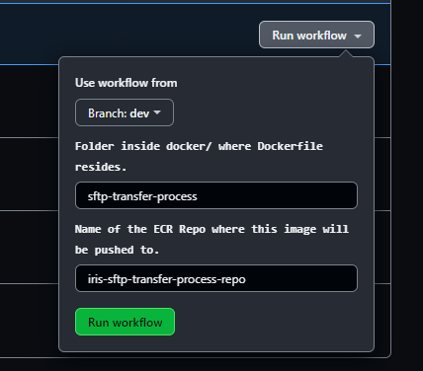

# Triggering Outbound Process

|  |  |
| --- | --- |
| **Table Name** | flex_ex.flex_paid_claims_transactions_extract_iqvia |
| **Stored Procedure Name** | flex_ex.flex_paid_claims_transactions_extract_iqvia_sp() |
| **Unload Stored Procedure** | iris_public.cnf_dynamic_unload_redshift_to_s3_sp('IQVIA_REBATE_SCRUB_EXTRACT', 'DEV/QA/PRD') |
| **CAWA Job Name** | IRIS_EDB_IQVIA_FLEX_CLAIMS_TRANSACTION_LD |

Exchange of Paid Claims data with IQVIA ERMDM is a quarterly process. Business users will raise an RITM with IRIS Cloud Ops team to trigger the CAWA Job mentioned in above table. IRIS Ops team will trigger the CAWA Job and monitor the outbound process to ensure that file has been generated and transferred to IQVIA successfully.

## Request format for triggering outbound process to send file to IQVIA ERMDM

1. Navigate to [Lilly ServiceNow](https://lilly.service-now.com/ess/home.do) and click on "Order Things" from the home page
2. Search for Lilly USA Application Management in the search box.
3. Select the first result by the same name
4. In the template, fill out the fields based on below details -
   1. Type of Request: Configuration
   2. Select application name: IRIS EDB: IQVIA ERMDM
   3. Select the application environment: Production
   4. Select the priority of request: Medium
   5. Earliest start date: First date ops can run the job (usually next day be default). Leave this value as it is.
   6. Select data needed: Date the job should be completed by (a week out by default). Change this to next day.
   7. Business impact: None
   8. Description:
   9. Please complete the below mentioned activities to start the outbound process for sending Paid Claims data to IQVIA ERMDM.
   10. a) Verify if rpvsrefinedreplicationtask1, rivdtransactionrecordsreplicationtasks and rmdmrefinedflexreplicationtasks DMS tasks are completed in Production.
   11. b) Trigger the DMS Task rivdtransactionrecorddetailsreplicationtasks and wait for it to complete. Post completion, veriy the record count of table flex_refined_ex.ivd_transaction_record_details in Production.

c) Trigger the CAWA Job IRIS_EDB_IQVIA_FLEX_CLAIMS_TRANSACTION_LD to send Paid Claims data extract to IQVIA ERMDM.

1. Click Order Now and Submit
2. An email will be generated and sent from ServiceNow with RITM number, which can be used to view the request in ServiceNow and track as needed.

## Prerequisites for triggering the CAWA Job

Before the CAWA Job is triggered, operations team should ensure that the below tables are loaded via their corresponding DMS tasks.

* **rpvsrefinedreplicationtask1-* (CDC Enabled)**
  + flex_refined_ex.ivd_pharmacy
  + flex_refined_ex.ivd_transaction_file
  + flex_refined_ex.ivd_rec_check_item_sum_status
* **rivdtransactionrecordsreplicationtasks-* (full load daily)**
  + flex_refined_ex.ivd_transaction_records
* **rmdmrefinedflexreplicationtasks-* (CDC Enabled)**
  + flex_refined_ex.submitem
  + flex_refined_ex.adjitem
  + flex_refined_ex.buid
  + flex_refined_ex.bunit
  + flex_refined_ex.ttbc
  + flex_refined_ex.display_msg
* **rivdtransactionrecorddetailsreplicationtasks-\***
  + flex_refined_ex.ivd_transaction_record_details

**No schedule is enabled for** rivdtransactionrecorddetailsreplicationtasks**; This needs to be manually triggered.**

# Accesses to manage in Group Manager

## Email Distribution Groups

Two email groups are created to notify users about File Transfer Initiation and and Output files Generation. Operations team can manage user access to these groups in [Group Manager Portal](https://idmportal.rf.lilly.com/IdentityManagement/aspx/groups/MyDLs.aspx).

|  |  |
| --- | --- |
| **Environment** | **Group Name** |
| Non Prod (Dev/QA) | [lusa_iqvia_scrub_notifications_nonprd@lists.lilly.com](mailto:lusa_iqvia_scrub_notifications_nonprd@lists.lilly.com) |
| Prod | [lusa_iqvia_scrub_notifications@lists.lilly.com](mailto:lusa_iqvia_scrub_notifications@lists.lilly.com) |

## Business User Extract Download Groups

An IAM Role has been created in all environments of EDB to allow business users to login via this role into AWS Console and downloaded the extract directly from S3. Access to this role is managed via the Group Manager Portal.

|  |  |
| --- | --- |
| **Environment** | **Group Name** |
| Dev | aws_edb_buids_iris_dev_iqvascrb_users_ex |
| QA | aws_edb_buids_iris_qa_iqvascrb_users_ex |
| Prod | aws_edb_buids_iris_prd_iqvascrb_users_ex |

Note that when adding business users to this group, normal user ids should be added and not the CA user ids.

## NoDx Account Access Groups

An IAM Role has been created in all environments of NoDx Account. This will allow operations team to login via this role into AWS NoDx Console and monitor the SFTP Transfer ECS Task. Access to this role is managed via the Group Manager Portal.

|  |  |
| --- | --- |
| **Environment** | **Group Name** |
| Dev (**AWS Account Name** - dev-igw-nodx-bu-iris) | aws_iris_nodx_dev_iqvascrb_ops |
| QA (**AWS Account Name** - qa-igw-nodx-bu-iris) | aws_iris_nodx_qa_iqvascrb_ops |
| Prod (**AWS Account Name** - prod-igw-nodx-bu-iris) | aws_iris_nodx_prd_iqvascrb_ops |

# NoDX Account Navigation

* When logging into NoDx accounts, use [Identity Center](https://lilly-aws-login.awsapps.com/start#/) and not the Legacy AWS Login Page. Login should be done via -CA account (Username is [LillyId-CA@llynet.com](mailto:LillyId-CA@llynet.com) and password is your -CA password).
* Navigate to <https://us-east-2.console.aws.amazon.com/ecs/v2/clusters/iris-sftp-transfer-process-cluster/tasks?region=us-east-2> into AWS Console for accesing the SFTP Transfer Process Cluster.
* Navigate to <https://us-east-2.console.aws.amazon.com/ecr/repositories/private/572922920319/iris-sftp-transfer-process-repo?region=us-east-2> for accessing the SFTP Transfer Process ECR Repository.
* Navigate to <https://us-east-2.console.aws.amazon.com/ecs/v2/task-definitions/iris-sftp-transfer-process?region=us-east-2> for accessing the Task Definition.

# Business Rules

## Exclusion of Contract IDs

* Business has asked to exclude certain contract IDs when generating the extract that we send to IQVIA ERMDM. This logic has been implemented in the stored procedure and the IDs to exclude are dynamically taken from the param table.
* Currently, there are 3 IDs excluded which is evident by below query.
* SELECT PARAM_VALUE AS CONTRACT_ID FROM IRIS_PUBLIC.ALL_PARAM WHERE PARAM_PURPOSE = 'IQVIA_ERMDM_CONTRACT_IDS_TO_EXCLUDE' AND ACTIVE_FLAG;
* -- A00990
* -- A00990
* -- A01218
* In the future, if business requests for additional contract ids to be excluded, operations team should add an entry into this param table.

Please reach out to [Kyle McColley](https://lilly-confluence.atlassian.net/wiki/people/5a8cf27d79bfa8335fcaea0c?ref=confluence) [Suraj Potnuru](https://lilly-confluence.atlassian.net/wiki/people/620fc1bbbba9ca0070cc88b2?ref=confluence) in case of any queries.