dnf update -y

dnf install -y https://dl.grafana.com/enterprise/release/grafana-enterprise-11.1.4-1.x86_64.rpm

wget https://github.com/prometheus/prometheus/releases/download/v2.53.2/prometheus-2.53.2.linux-amd64.tar.gz

wget https://github.com/prometheus/node_exporter/releases/download/v1.8.2/node_exporter-1.8.2.linux-amd64.tar.gz

tar -xvf prometheus-2.53.2.linux-amd64.tar.gz

tar -xvf node_exporter-1.8.2.linux-amd64.tar.gz

cp -rvf node_exporter-1.8.2.linux-amd64/node_exporter /usr/local/bin

cp -rvf prometheus-2.53.2.linux-amd64/prom* /usr/local/bin

mkdir -p /etc/prometheus

cp -rvf prometheus-2.53.2.linux-amd64/prometheus.yml /etc/prometheus/

Config file mod

nano /etc/prometheus/prometheus.yml

#append at end

- job_name: "node_exporter"

# metrics_path defaults to '/metrics'

# scheme defaults to 'http'.

static_configs:

- targets: ["localhost:9100"]

Firewall mod

firewall-cmd --add-port=3000/tcp --permanent

firewall-cmd --add-port=9100/tcp --permanent

firewall-cmd --add-port=9090/tcp --permanent

firewall-cmd --reload

Systemd unit conf for automatic execution

nano /etc/systemd/system/prometheus.service

##add content

[Unit]

Description=prometheus@9090

[Service]

User=root

ExecStart=/usr/local/bin/prometheus --config.file=/etc/prometheus/prometheus.yml

#--web.enable-admin-api --web.listen-address=”0.0.0.0:9090”

Restart=on-failure

[Install]

WantedBy=multi-user.target

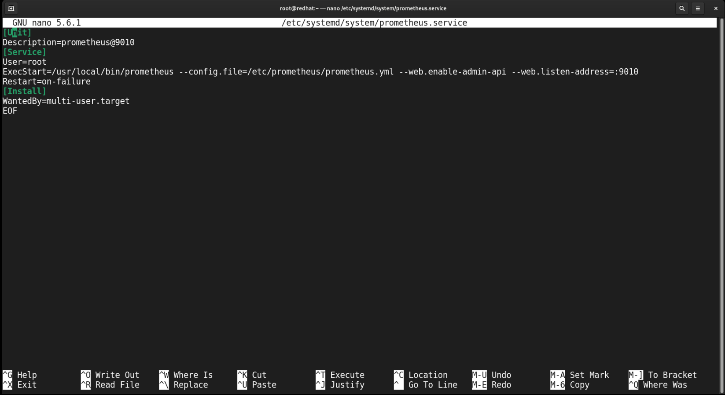

nano /etc/systemd/system/node_exporter.service

[Unit]

Description=node_exporter@9100

[Service]

User=root

ExecStart=/usr/local/bin/node_exporter

Restart=on-failure

[Install]

WantedBy=multi-user.target

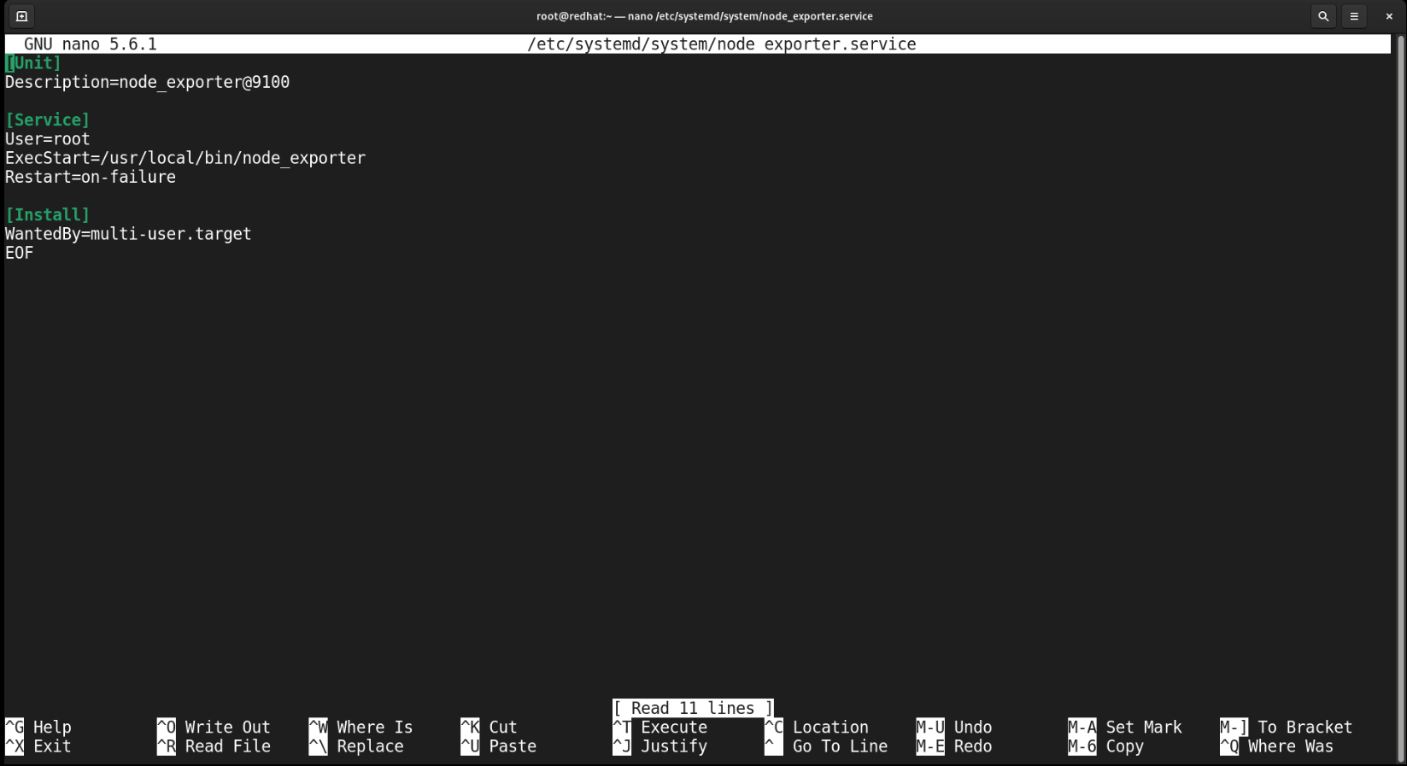

systemctl daemon-reload

systemctl start node_exporter.service

systemctl start prometheus.service

systemctl enable node_exporter.service

systemctl enable prometheus.service

systemctl start grafana-server

##check if the configured services are active

semanage port -a -t http_port_t -p tcp 9090

semanage port -a -t http_port_t -p tcp 9080

semanage port -a -t http_port_t -p tcp 9100

semanage port -a -t http_port_t -p tcp 3100

semanage port -a -t http_port_t -p tcp 3000

WEB Dashboard Configuration

<http://localhost:3000>

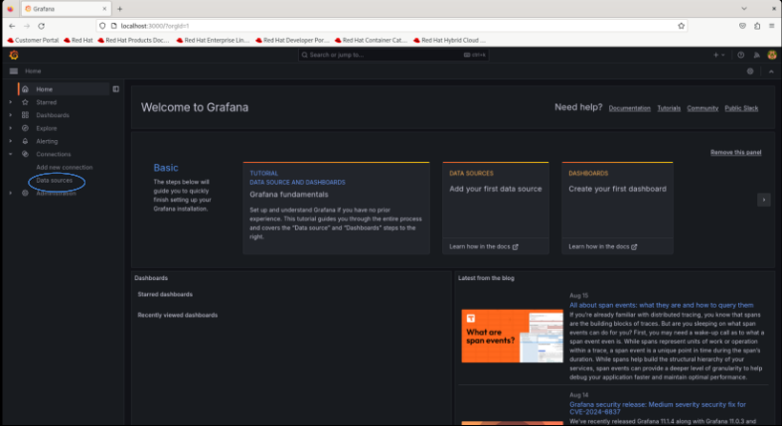

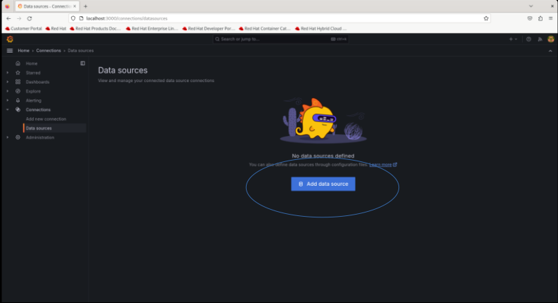

Add prometheus as data source

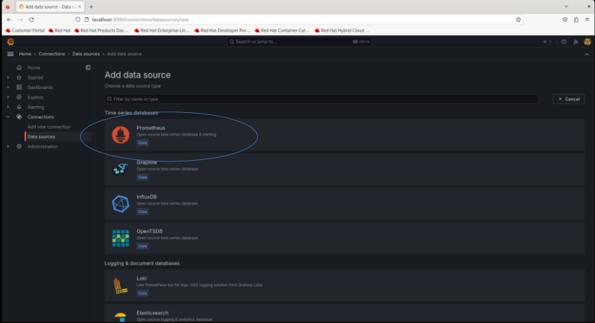

Edit Connection by add the url http://localhost:9090

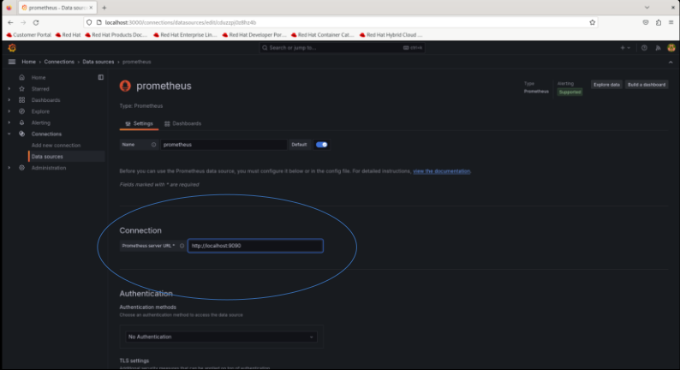

Save and test

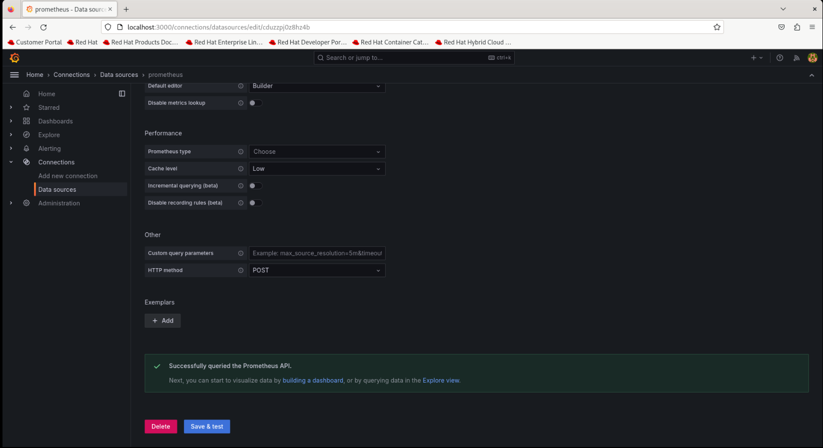

Select dashboard from the menu, then click new

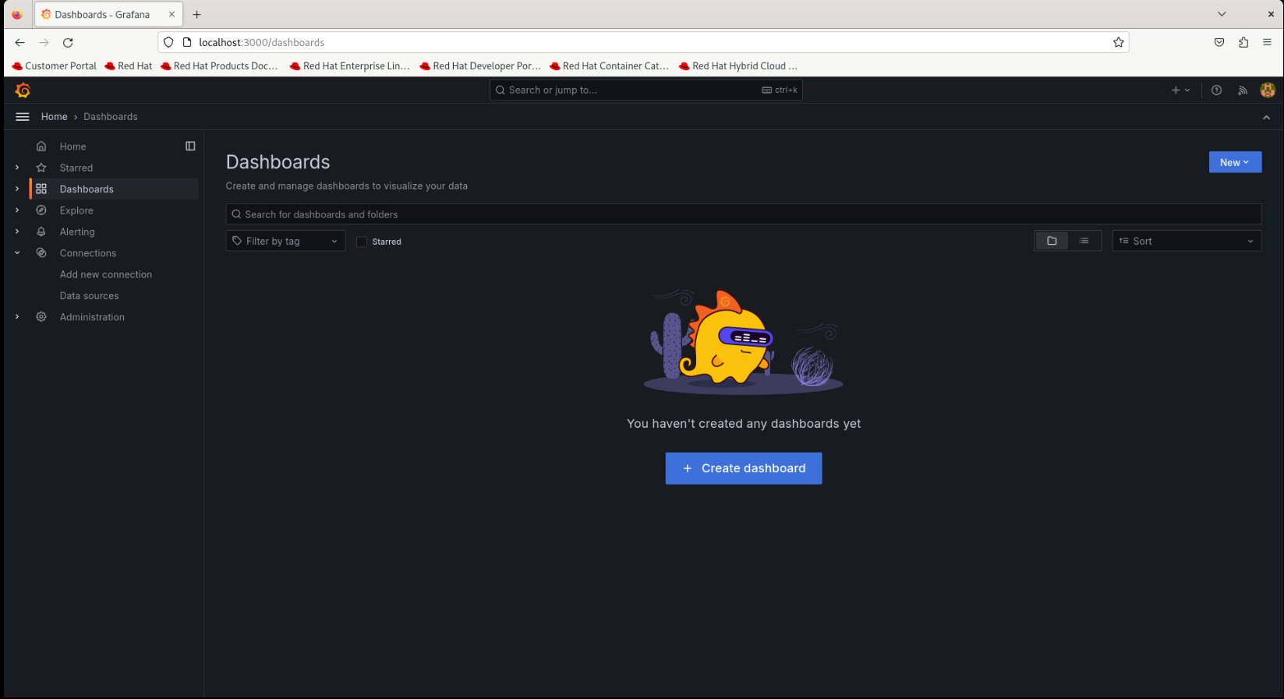

Select import

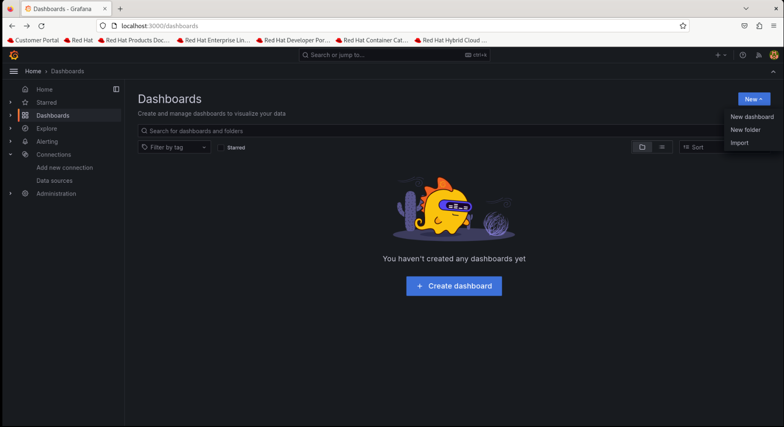

Click import and, value 1860 and then click load near the id field.

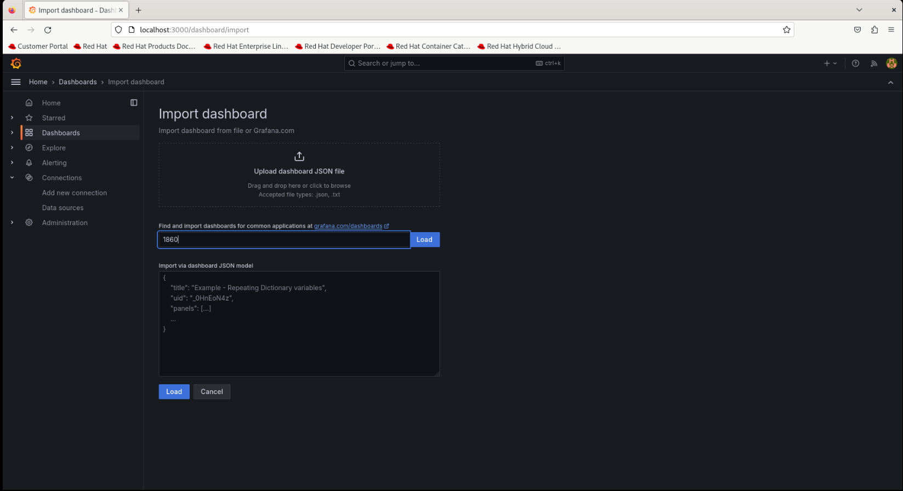

Select the created datasource, click import

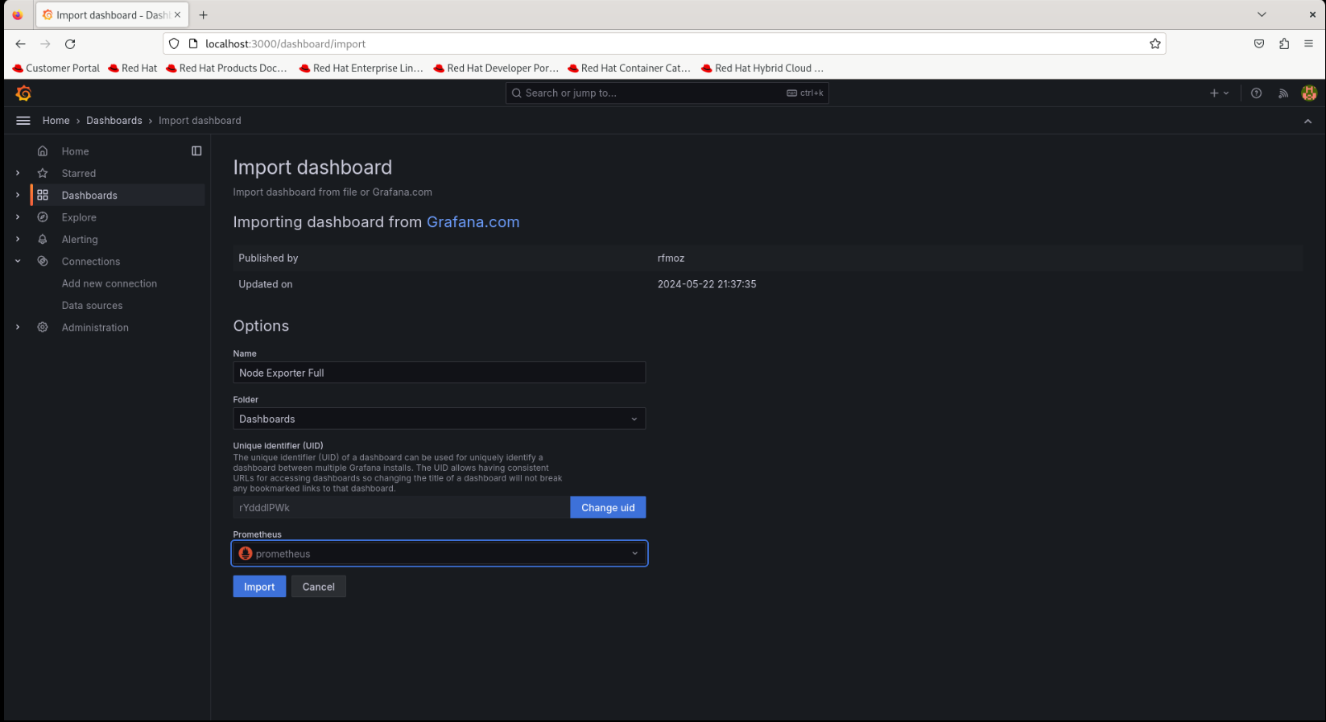

Out:

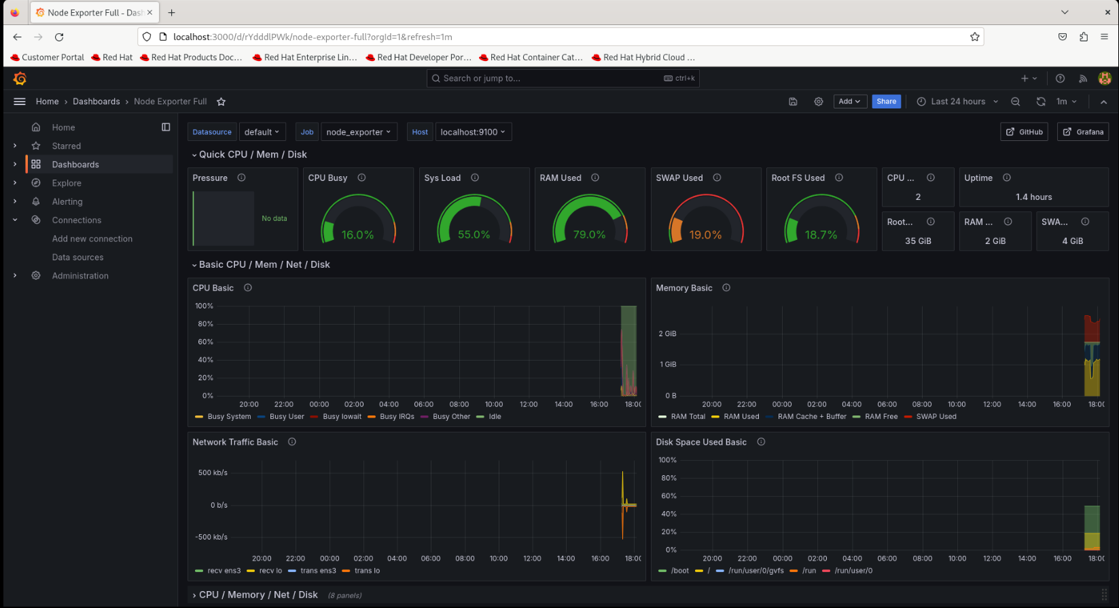

Logs monitor setup

wget -q -O gpg.key https://rpm.grafana.com/gpg.key

rpm --import gpg.key

##Create repo file with following content

nano /etc/yum.repos.d/grafana.repo

[grafana]

name=grafana

baseurl=https://rpm.grafana.com

repo_gpgcheck=1

enabled=1

gpgcheck=1

gpgkey=https://rpm.grafana.com/gpg.key

sslverify=1

sslcacert=/etc/pki/tls/certs/ca-bundle.crt

dnf update

dnf install loki promtail

systemctl start loki

systemctl enable loki

systemctl start promtail

systemctl enable promtail

nano /etc/promtail/config.yml

/var/log/messages → /var/log/*

firewall-cmd --add-port=3100/tcp --permanent

firewall-cmd --add-port=9080/tcp --permanent

firewall-cmd --reload

WEB Dashboard Configuration

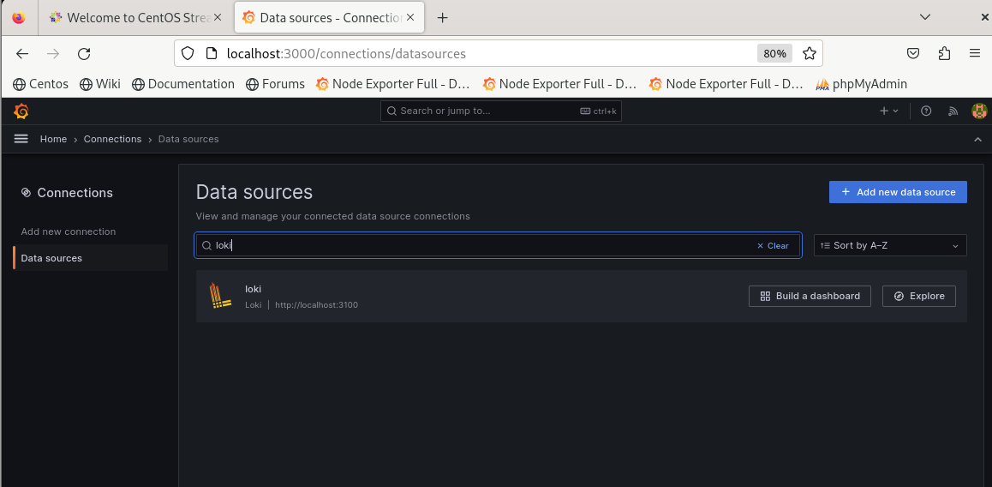

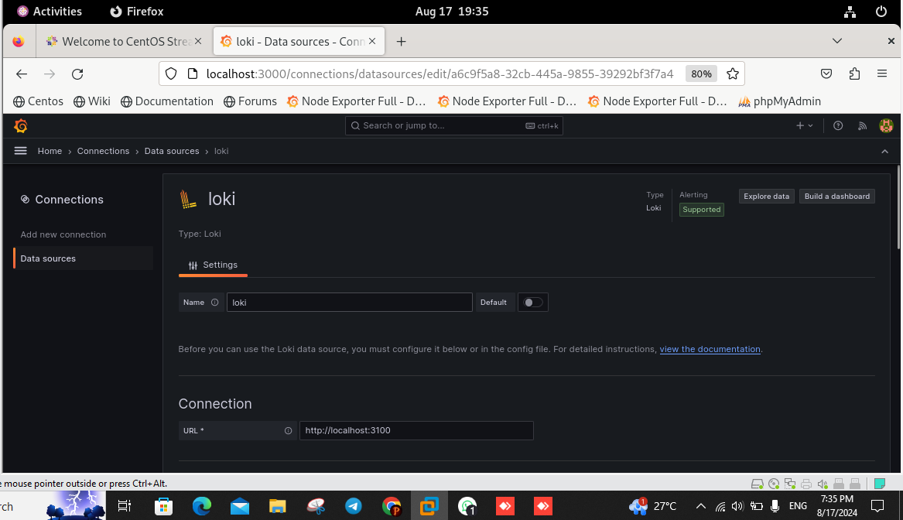

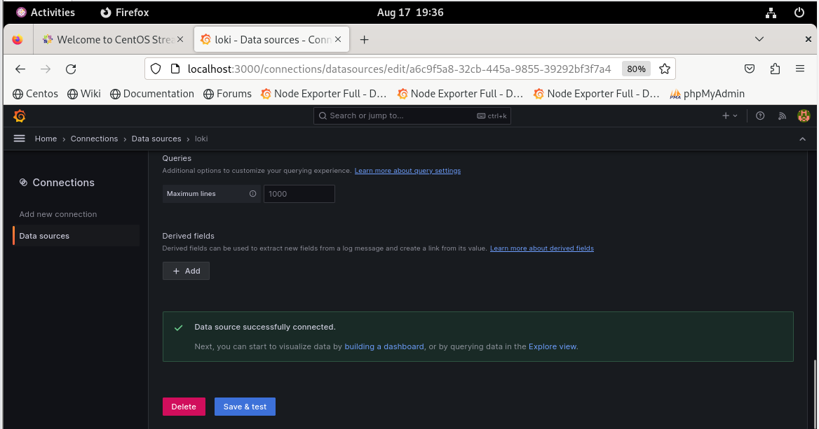

##select the visualisation option

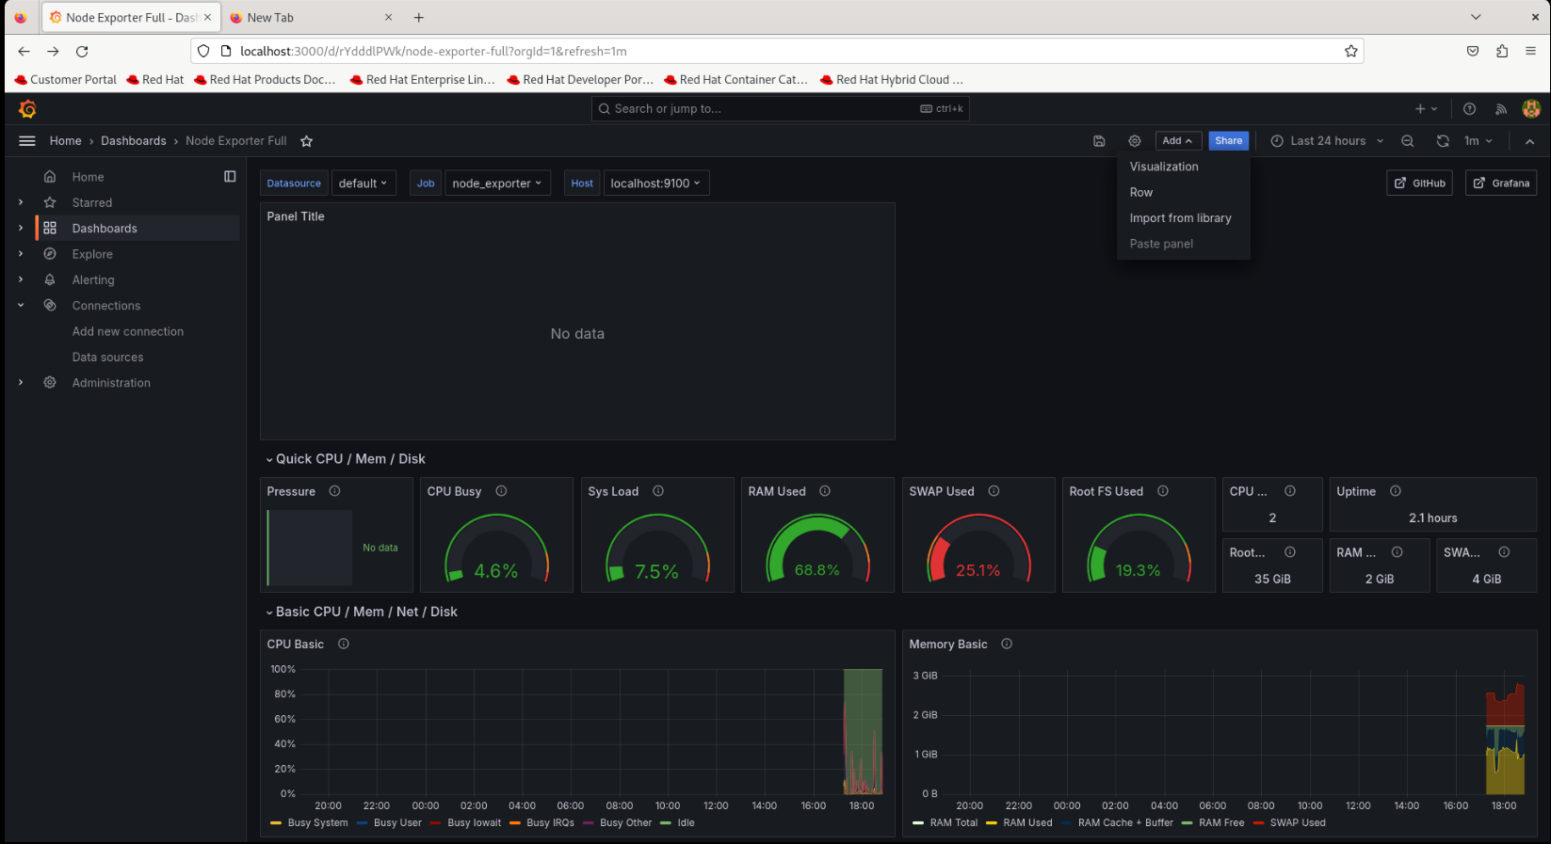

##select loki as data source

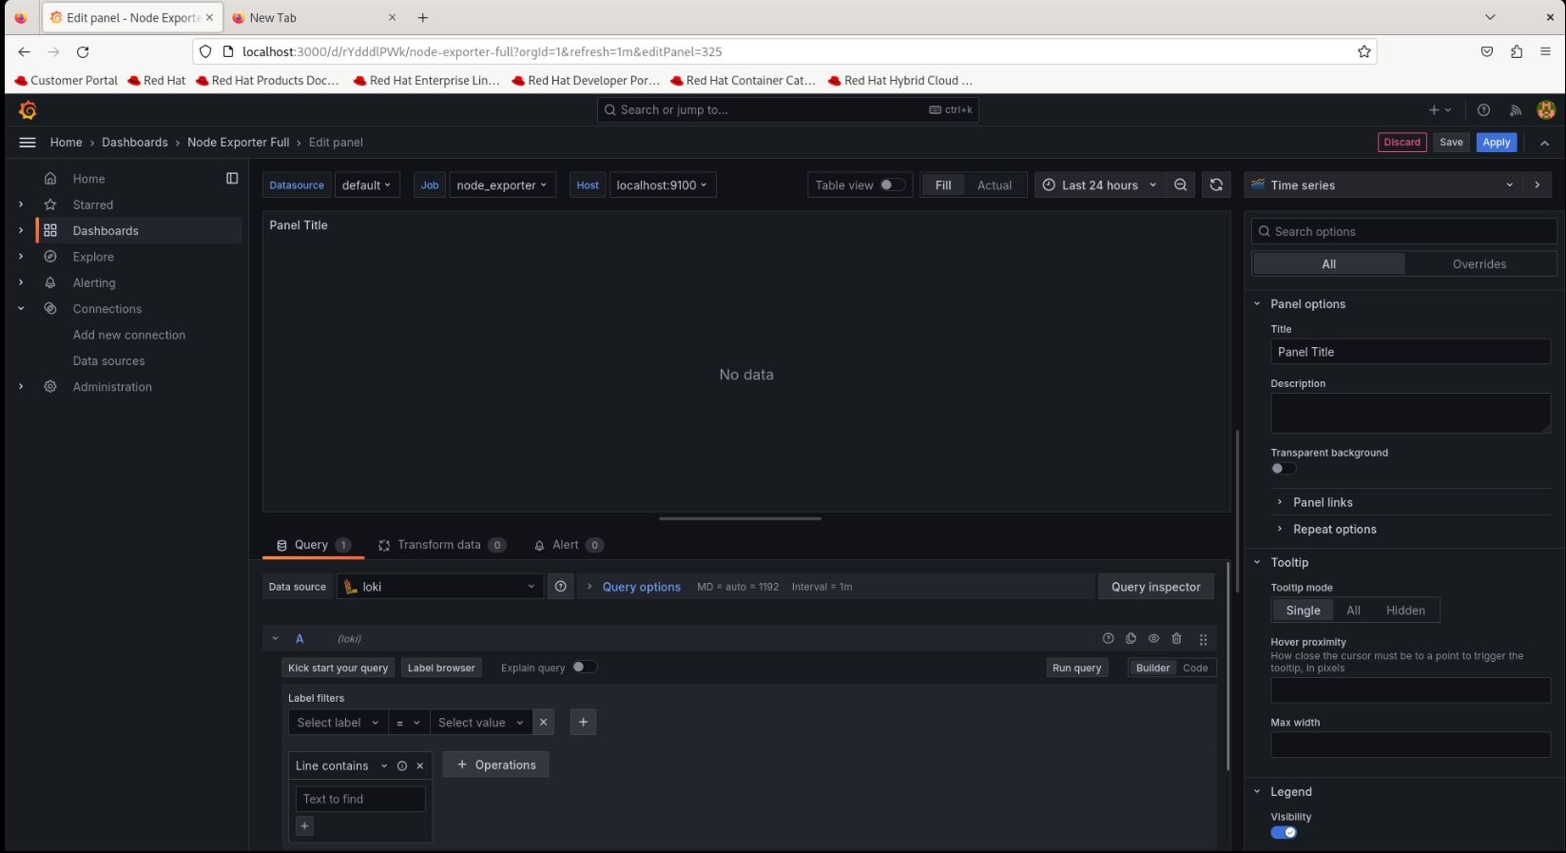

#select job and varlogs in the label and value

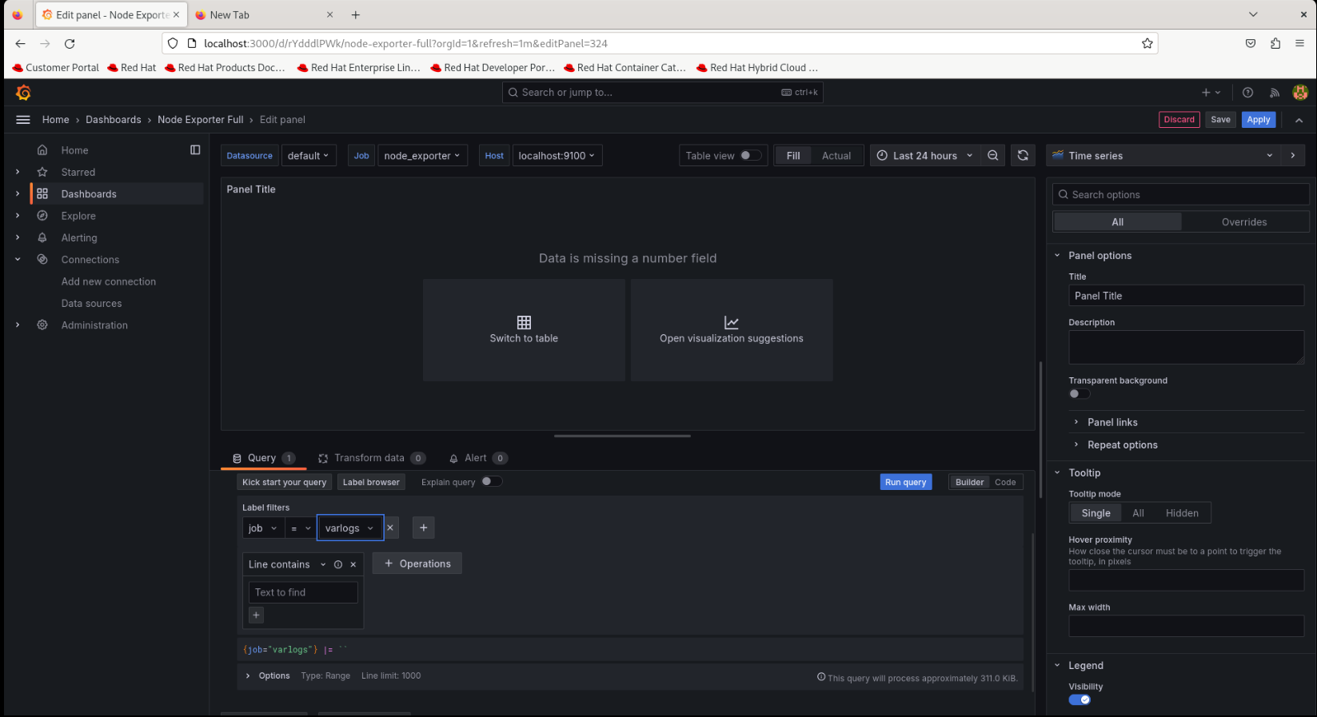

#run query



#select open visualization suggestions and select the suggestion by clicking the change in right side

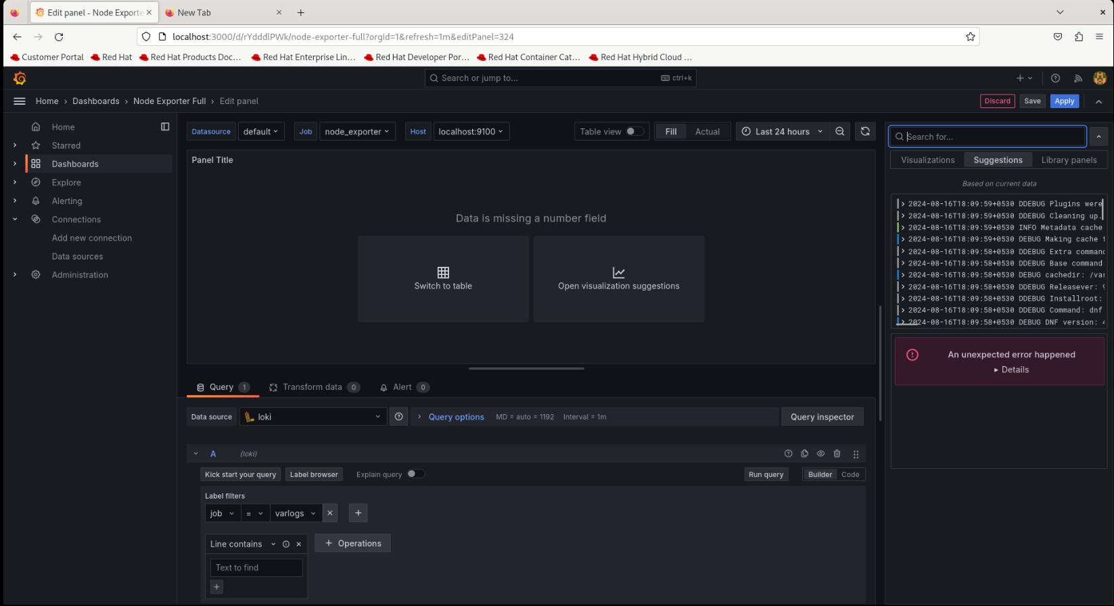

#click apply

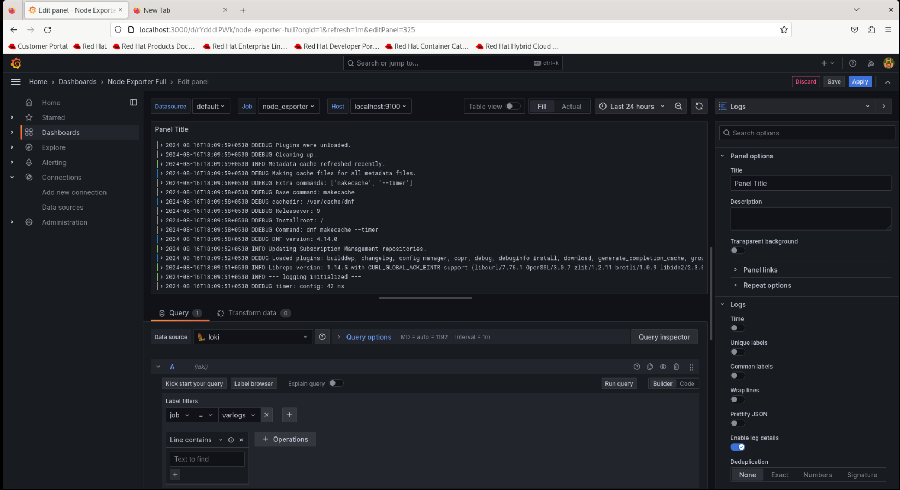

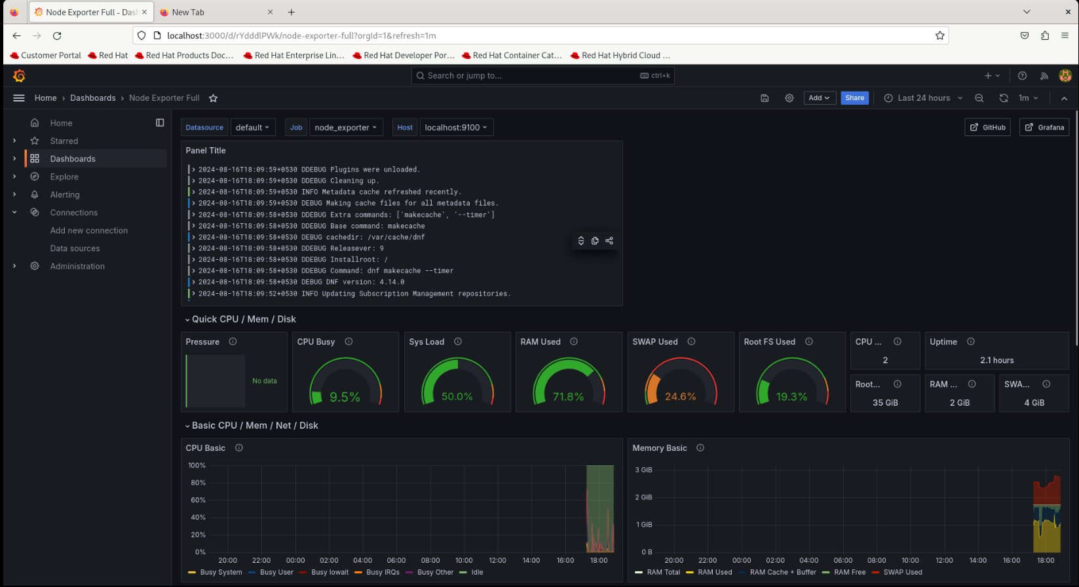

# PHPMYADMIN

dnf install https://dl.fedoraproject.org/pub/epel/epel-release-latest-9.noarch.rpm

dnf update

dnf install httpd phpmyadmin mysql-server -y

nano /etc/httpd/conf.d/phpMyAdmin.conf

#Find and replace

<Directory /usr/share/phpMyAdmin/>

AddDefaultCharset UTF-8

Require all granted

</Directory>

Systemctl restart httpd

Systemctl enable –now mysqld

mysql_secure_installation

mysql -u root -p