PROJECT DOCUMENT
CyberTwin-NX
An AI-Assisted Network Digital Twin for Safe Autonomous Response
Observe the network, mirror it in a twin, test every response in simulation, and only then act, with a safety gate and a verified feedback loop.
Student: [Name, Roll No.]
Guide: [Name, Designation]
Department / Institution: [Department, Institution]
Programme: [Degree, Final-year project]
Date: October 2026
Version: 1.0 (proposal + starter implementation)

Contents
1 Abstract
2 Introduction
3 Objectives and Scope
4 Background and Related Work
5 System Architecture
6 Methodology
7 Implementation and Current Status
8 Evaluation Plan
9 Project Timeline
10 Risk Register
11 Ethical and Safety Considerations
12 Expected Outcomes and Contributions
Appendix A Scenario Catalogue
Appendix B Repository Layout
Appendix C Reference Topics to Cite

1 Abstract
Operating a network means making changes that can themselves cause outages. Autonomous defence systems make this worse: an AI that reconfigures a live network can take it down faster than an attacker could. CyberTwin-NX addresses this by placing a digital twin between the AI and the network. Telemetry from the live (emulated) network keeps a graph-based twin synchronised; when something goes wrong (a failed link, a traffic surge, a compromised host, an attacker moving laterally), the AI generates candidate responses, simulates every one inside the twin, scores the predicted outcomes on service impact, threat containment and cost, and passes the best candidate through an explicit safety gate before it is applied. After the action, the system compares what the twin predicted with what actually happened and feeds the error back into calibration.
The project contributes a small, fully reproducible reference platform (Containerlab testbed, flow-level simulator, learned latency calibrator, host-compromise detector, attack-graph risk model, safety gate and rollback-capable actuator) together with a quantitative evaluation of twin fidelity, decision quality and safety against simple baselines.

2 Introduction

2.1 Problem statement
Network operations teams increasingly rely on automation, but automated changes are tested poorly: staging networks rarely match production, and "try it and roll back" is unacceptable during an active incident. Security response has the same problem. Isolating the wrong host, blocking the wrong path or overloading the backup link can cause more damage than the incident being handled. What is missing is a safe place to ask "what happens if we do this?" before doing it.

2.2 Motivation
- Safety: experiment in a model, not on production traffic.
- Speed: evaluate several responses in seconds instead of debating them during an incident.
- Accountability: every decision has a recorded prediction, an approval verdict and a measured outcome.
- Honesty about uncertainty: the twin's own prediction error is measured and used to decide when a human must approve.

2.3 Research questions
- RQ1 (fidelity). How accurately can a lightweight flow-level twin, synchronised from telemetry, predict latency, loss, utilisation and reachability on an emulated network, and how much does a learned correction improve it?
- RQ2 (decision quality). Does choosing responses by simulating them in the twin reduce time-to-remediate, collateral damage and residual risk compared with doing nothing or applying a fixed playbook?
- RQ3 (safety). When the twin is wrong, does a rule-based safety gate keyed on protected assets, collateral limits and measured fidelity prevent harmful actions from reaching the network?

3 Objectives and Scope

3.1 Objectives
- Build an emulated enterprise-style network (Containerlab + FRRouting) that produces realistic telemetry and can be attacked and repaired programmatically.
- Build a twin that ingests telemetry, stays synchronised, and reports its own drift.
- Implement a flow-level simulator supporting link/router failure, traffic surge, host compromise and lateral movement what-ifs.
- Implement a detector for compromised hosts and a generator/scorer for candidate responses.
- Implement a safety gate and an actuator with dry-run default, rollback and audit logging.
- Evaluate fidelity, decision quality and safety with documented experiments and an honest failure analysis.

3.2 In scope
One topology of 13 nodes (3 routers, 2 switches, 6 hosts, 2 servers); four scenario families; a single incident at a time; OSPF-routed IPv4; actions limited to host isolation, rate limiting and routing-cost changes.

3.3 Out of scope (explicit non-goals)
- Production deployment or control of real enterprise networks.
- Packet-level or ns-3-grade simulation; TCP congestion dynamics.
- Novel attack techniques: attacks are emulated only as traffic and behaviour patterns inside the isolated lab.
- Concurrent multi-incident handling, multi-vendor configuration management, and encrypted-traffic analysis.

4 Background and Related Work
The project sits at the intersection of five established areas. Each should be developed into a short literature subsection in the final report (suggested search terms are listed in Appendix C).
Area | Idea used here | Gap this project addresses
Network digital twins | A synchronised virtual copy of a network used for analysis and planning. | Few open, reproducible twins that close the loop to a safety-gated actuator.
Intent-based / SDN control | Declare a goal and let a controller compute configuration. | Controllers rarely test candidate changes in a model before applying them.
SOAR and automated response | Playbooks execute response steps when alerts fire. | Playbooks are fixed; they do not predict side-effects for the current network state.
Attack graphs | Model how an attacker can move between assets. | Used here as a scoring input so responses are judged by residual exposure.
Anomaly detection | Isolation Forest flags points that are easy to isolate in feature space. | Applied per-host on behaviour features with debouncing, trained only on clean baseline.

5 System Architecture
The system is a closed loop. Telemetry updates the twin; the AI proposes responses; the simulator predicts their effects; the gate decides what may touch the network; the actuator applies it; verification compares prediction with reality.
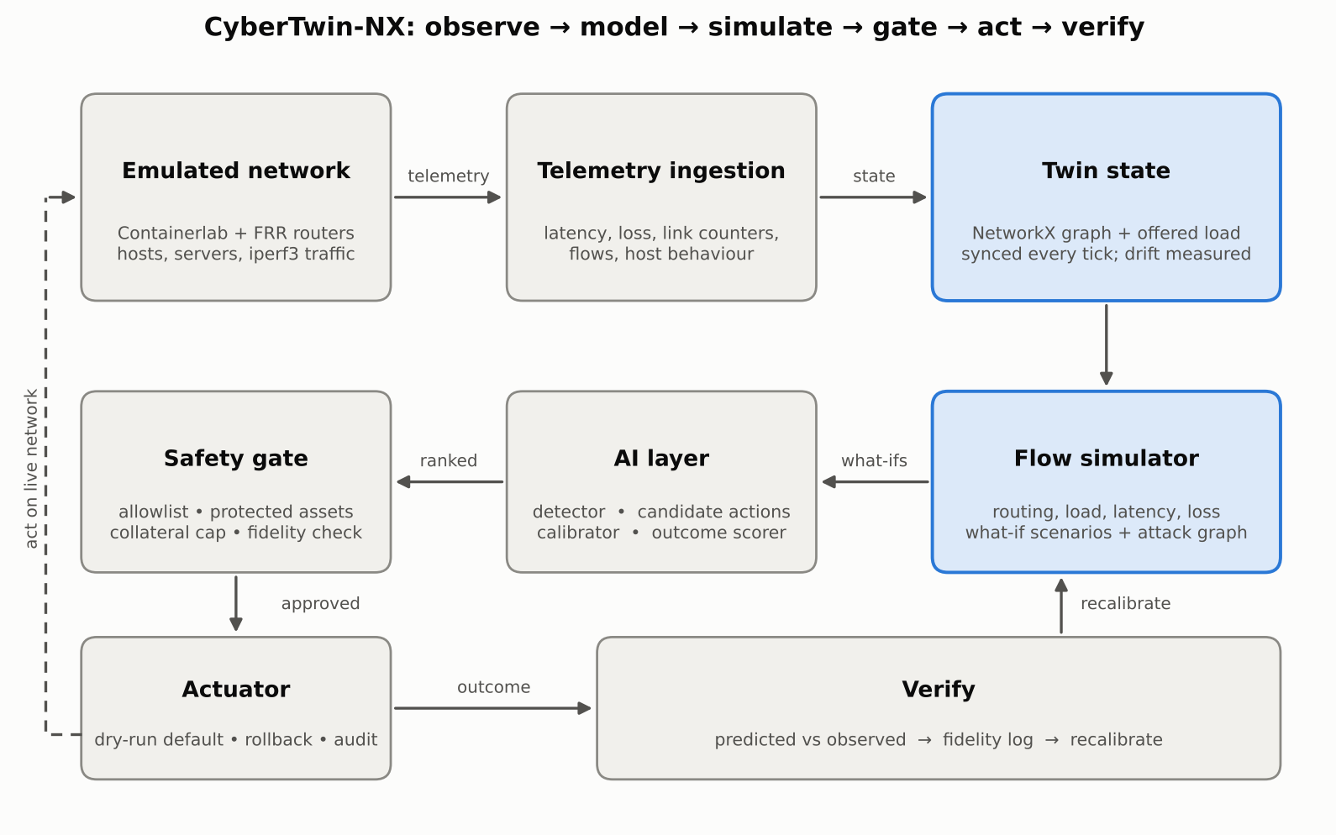
Figure 1. CyberTwin-NX closed-loop architecture. Blue boxes are the twin core.
Component | Responsibility | Key design decision
Emulated network | Containerlab: FRR routers (OSPF), Linux hosts/servers, iperf3 traffic, scripted compromise. | Generated from one topology file so lab, twin and actuator never disagree.
Telemetry ingestion | Per-flow latency and loss, link counters, link/node state, host behaviour features. | One telemetry schema for every source (synthetic or Containerlab).
Twin state | NetworkX graph with offered load; sync, predict, incident view. | Offered load is measured at senders so isolation does not erase the evidence.
Flow simulator | Shortest-path routing, link load, latency (propagation + queueing), loss. | Analytic and deterministic: defensible and fast; not a learned black box.
AI layer | Host-compromise detector, candidate generator, outcome scorer, latency calibrator. | Learning is limited to detection and residual correction; ranking is explicit and inspectable.
Safety gate | Allowlist, improvement-over-no-action, protected assets, collateral cap, fidelity check. | Three verdicts: APPROVED, ESCALATE (human), BLOCKED.
Actuator | Maps actions to argv commands; dry-run default; rollback; audit log. | No shell strings; every token validated; partial failures are rolled back.
Verify | Predicted-vs-observed metrics and a fidelity log. | The same metric definitions are used by the scorer and the verifier.

6 Methodology

6.1 Twin state and synchronisation
At each telemetry tick the twin updates link and node state (up/down, isolated, rate-limited) and rebuilds its demand list from measured offered load. Flows seen during a clean warm-up are marked as baseline; flows that appear later from a flagged host are tagged suspicious in an incident view of the twin. Drift is quantified every tick by comparing the twin's prediction for the current state with the observation.

6.2 Flow-level simulator
- Routing: shortest path on propagation delay multiplied by an administrative penalty, over links and nodes that are up.
- Load: each reachable flow adds its (rate-limited) rate to every link on its path.
- Latency: per link, propagation delay plus a queueing term proportional to u/(1-u), with utilisation u capped at 0.98.
- Loss: a link loses 1 - 1/u of traffic when utilisation exceeds 1; flow loss compounds along the path.
Known simplifications (links are undirected, no TCP dynamics, no ECMP) are documented and are themselves a subject of the evaluation: the twin is used to rank options, and its absolute error is measured, not assumed.

6.3 Lateral-movement model
Lateral movement is modelled as a probabilistic attack graph. Edges carry the probability that an attacker owning one asset compromises another; the most likely path is found with Dijkstra on negative log-probabilities. An edge only counts if both endpoints are alive and the network can currently carry traffic between them, so isolating a host or failing a router changes the attack surface. Residual risk is the sum over exposed assets of asset value multiplied by compromise probability. Edge probabilities are assumptions and are subjected to a sensitivity analysis rather than presented as measurements.

6.4 AI components
Component | Technique | Input / output | Purpose
Compromise detector | Isolation Forest, threshold below lowest training score, 2-window debounce | Per-host [out rate, fan-out, failed auth] → suspect host | Detect without labelled attacks
Latency calibrator | Linear regression on (predicted, observed) pairs | Warm-up telemetry → correction a·x + b | Reduce systematic simulator error
Candidate generator | Rule-based enumeration, deliberately including harmful options | Incident view → list of actions | Give the scorer and gate something to reject
Outcome scorer | Weighted multi-objective sum (lower is better) | Simulated outcome → collateral, leaked exfiltration, residual risk, action cost | Rank responses

Collateral damage is defined as priority-weighted loss of legitimate traffic from hosts other than the suspect: the suspect's own traffic is untrusted, so losing it is not counted as harm. This definition is used identically by the scorer and the verifier so that predicted and observed values are comparable.

6.5 Safety gate
# | Rule | Outcome if violated
1 | Action kind must be on the allowlist. | BLOCKED
2 | Action must improve the total score over "do nothing" by a margin (default 20 %). | BLOCKED
3 | Never act automatically on protected assets (routers, switches, servers). | ESCALATE to a human
4 | Predicted collateral damage must stay below a cap (default 15 %). | ESCALATE to a human
5 | Twin fidelity (latency MAPE) must be below a threshold (default 35 %). | ESCALATE to a human

6.6 Actuator
Approved actions are translated to concrete commands: iptables rules at the first-hop router for host isolation, tc token-bucket filters for rate limiting, interface shutdown for segment isolation and OSPF cost changes for rerouting. Commands are argv lists (never shell strings), node names and addresses are validated, and each action has a paired rollback. The actuator is in dry-run mode by default; in live mode, a failure part-way triggers rollback of everything already applied, and every action is written to an audit log.

7 Implementation and Current Status

7.1 Technology stack
Layer | Choice
Emulated network | Containerlab, FRRouting (OSPF), Linux bridge switches, iperf3, nmap (in-lab ping sweep)
Twin and simulator | Python 3, NetworkX, NumPy
AI | scikit-learn (Isolation Forest), NumPy regression
Configuration | Single YAML topology (nodes, links, demands, attack edges) → lab, twin and actuator
Quality | 39 unit and end-to-end tests; dry-run, rollback and audit log for every action
Planned | FastAPI + web dashboard; Prometheus/InfluxDB for telemetry storage

7.2 Status of the starter implementation
A working starter repository accompanies this document. Its status is stated plainly so the plan below is not mistaken for completed work:
Part | Status | Evidence / caveat
Flow simulator, what-if scenarios, attack-graph risk | Implemented, tested | Failure, partition, surge, isolation and rate-limit behaviour covered by unit tests
Detector, calibrator, candidate generator, scorer, safety gate | Implemented, tested | Evaluated only on synthetic telemetry so far
Actuator (plan, dry-run, rollback, audit) | Implemented, tested | Never executed against a live lab
Containerlab and FRR generator, traffic and attack emulation | Implemented; output consistency-tested | Not yet deployed on a Containerlab host
Containerlab telemetry collector | Experimental draft | Untested; failed-authentication and firewall/tc state are TODO
Synthetic emulator | Implemented | Shares the twin's flow model, so it validates plumbing, not real-world fidelity
Dashboard | Not started | Planned for month 6

Result of the end-to-end demo on the synthetic emulator (5 seeds, a compromised host exfiltrating at 120 Mbps): the detector raised no false alarms in 15 clean ticks and flagged the compromised host after 2 ticks; the twin ranked host isolation first and the gate approved it; the commands were planned in dry-run; measured exfiltration after the action was near zero and collateral damage stayed within noise of the prediction. Calibration reduced latency error from about 36 % to about 17 % against the emulator's hidden parameters. These numbers demonstrate that the pipeline works end to end; they are not evidence of accuracy on a real network, which is what the evaluation plan in Section 8 is for.

8 Evaluation Plan
All experiments run on the Containerlab testbed with fixed seeds, at least 20 repetitions per condition, reporting mean and standard deviation.

8.1 Metrics
Group | Metric | Definition
Fidelity | Latency MAPE | Mean of |predicted − observed| / observed over reachable flows
Fidelity | Loss MAE, utilisation MAE | Absolute error of per-flow loss and per-link utilisation
Fidelity | Reachability accuracy | Share of flows where twin and network agree on reachable/unreachable
Fidelity | Decision agreement | Rank correlation (Kendall τ) between the twin's ranking of candidate actions and the ranking measured on the network
Detection | Time to detect; false alarms per hour | Ticks from injection to debounced alert; alerts during clean traffic
Response | Time to remediate; collateral damage; residual risk | Time until leaked exfiltration < 5 %; collateral as defined in 6.4; risk after ÷ risk before
Safety | Harmful-if-applied rate; gate catch rate | Share of top-ranked actions causing > 15 % service loss if applied blindly; share of those stopped by the gate

8.2 Baselines and ablations
- No action: lower bound.
- Fixed playbook: always isolate the flagged host, no simulation, no gate.
- Twin without calibration: ablates the learned corrector.
- Twin without gate: ablates the safety layer.

8.3 Experiments
# | Experiment | Evidence produced
E1 | Steady-state fidelity: 30 minutes of baseline traffic, fidelity logged every tick | MAPE and MAE with and without calibration
E2 | Failure what-ifs: predict, then fail r2–r3 and r2; compare | Reachability accuracy; post-reroute latency error
E3 | Surge what-ifs at ×2, ×3, ×4 load | Predicted versus measured congested links
E4 | Compromise response from each host, ≥ 20 runs, all baselines | Detection delay, remediation time, collateral, residual risk
E5 | Lateral-movement exposure versus a scripted multi-hop scenario | Rank agreement of exposed hosts
E6 | Twin-is-wrong stress: unmodelled background load and hidden path | Gate escalation rate; harmful-if-applied with and without gate
E7 | Telemetry outage and recovery | Time for fidelity to recover after resumption

8.4 Failure analysis and threats to validity
The report will include at least three cases in which the twin was wrong, each with the prediction, the observed outcome, the root cause (model simplification, stale telemetry, wrong parameter or unmodelled behaviour) and whether the gate caught it. Threats to validity are stated explicitly: an emulated network is not production; attack-edge probabilities are assumptions and will be swept ±50 %; and results from the synthetic emulator are never reported as fidelity.

9 Project Timeline
Six months, six four-week phases, five milestones. Because a working starter implementation already exists, month 1 and 2 focus on replacing the synthetic emulator with the real testbed, and the schedule has slack for the integration problems that this typically uncovers.
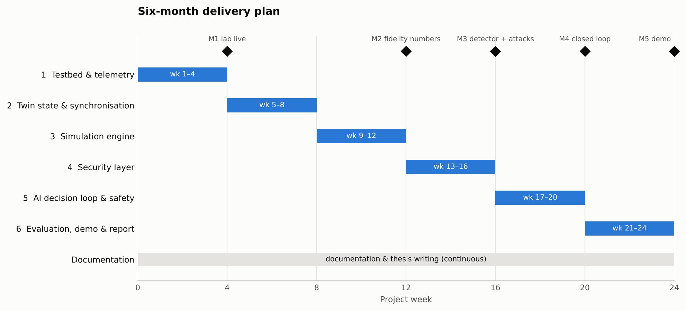
Figure 2. Delivery plan with milestones M1–M5.
Phase | Weeks | Main tasks | Deliverable | Exit criterion
1 Testbed and telemetry | 1–4 | Deploy generated Containerlab lab; baseline traffic; finish and test the Containerlab collector; metrics store | Running lab with live telemetry | M1: 30 minutes of baseline telemetry captured for all flows and links
2 Twin state and sync | 5–8 | Build twin from live telemetry; drift metrics; handle missing and late samples | Self-updating twin | Twin reachability accuracy ≥ 95 % on baseline
3 Simulation engine | 9–12 | Failure and surge what-ifs; directional links; queue model; calibration | What-if engine with fidelity report | M2: first fidelity numbers (E1–E3)
4 Security layer | 13–16 | Compromise and lateral-movement scenarios; real behaviour features; detector tuning | Detector and attack-graph module on live lab | M3: detection delay and false-alarm rate measured
5 AI decision loop and safety | 17–20 | Candidate generation and scoring on live lab; safety gate; live actuator with rollback | Closed loop in dry-run, then supervised live | M4: full loop demonstrated with predicted-vs-actual check
6 Evaluation, demo and report | 21–24 | Experiments E4–E7; failure analysis; dashboard; demo script; final report | Evaluation results, demo, thesis | M5: final demo and report submitted

10 Risk Register
Risk | Likelihood | Impact | Mitigation
Simulator is too inaccurate to rank actions | Medium | High | Keep the topology small; measure fidelity from month 3; use calibration; gate escalates on poor fidelity
Scope creep (more scenarios, more actions) | High | Medium | Freeze four scenarios and four action types at the end of month 1
Telemetry gaps or delay desynchronise the twin | Medium | Medium | Fixed polling interval; report drift instead of hiding it; experiment E7
Containerlab or FRR behaviour differs from assumptions | Medium | Medium | Early deployment in month 1; generated configs from a single source of truth
Unsafe actuation damages the testbed | Low | Medium | Dry-run default; rollback; supervised live mode only after dry-run results
Detector over-fits to synthetic behaviour | Medium | Medium | Re-train on real baseline in month 4; report false-alarm rate per hour
Attack-graph probabilities are arbitrary | High | Low | Document as assumptions; sensitivity sweep ±50 %
Hardware limits (RAM/CPU) for the lab | Low | Medium | 13 lightweight containers; fall back to Mininet if needed

11 Ethical and Safety Considerations
- All attack emulation (bulk transfers, ping sweeps, anomalous connection patterns) runs only against containers the project owns, inside an isolated lab network.
- The project does not develop exploits or intrusion tools; attacks are represented as traffic and behaviour patterns and as probabilities in a model.
- The actuator is dry-run by default, restricted to an allowlist, never acts automatically on protected assets, and records every action in an audit log.
- Automated isolation of hosts affects users: the collateral-damage limit and human escalation exist to keep a person accountable for high-impact actions.
- Limitations are reported honestly, including every case where the twin predicted incorrectly.

12 Expected Outcomes and Contributions
- An open, reproducible reference platform for safe, simulation-tested network response.
- A quantified answer to how accurate a lightweight flow-level twin can be, and how much a small learned correction helps.
- A measured comparison of twin-guided response with no action and a fixed playbook.
- A concrete, evaluated safety-gate design, including how often the twin's top choice would have been harmful.
- Documented failure cases that show where lightweight twins break, which is useful knowledge in its own right.

Possible extensions
- Plug in a per-connection trust score as an additional host-risk input (Zero Trust).
- Add routing policies that weigh security signals as a new candidate-action type.
- Train a reinforcement-learning action selector inside the twin and compare it with the explicit scorer.

Appendix A Scenario Catalogue
Scenario | Parameters | What the twin predicts | Typical candidate responses
Link failure | link (a, b) | Reroute path, added latency, congestion on the backup path, reachability | Routing-cost change; traffic shaping
Router failure | router | Partitioned servers/segments, surviving paths, load shift | Reroute; escalate to human
Traffic surge | factor, optional destination | Congested links, loss, priority-weighted service loss | Reroute; rate limiting
Host compromise | host, exfiltration rate, target | Leaked exfiltration, collateral damage, residual lateral risk | Isolate host; rate-limit host; (rejected) isolate victim server or whole segment
Lateral movement | start host | Exposure probability per asset and value-weighted risk | Isolate pivot host; segment access

Appendix B Repository Layout
data/topology.yaml single source of truth (nodes, links, demands, attack edges)
cybertwin/model.py Network and Demand dataclasses, loader, validation
cybertwin/sim/flow.py flow-level simulator
cybertwin/scenarios/ what-if scenarios and attack graph
cybertwin/twin/state.py twin: sync, predict, incident view
cybertwin/telemetry/ schema, synthetic emulator, Containerlab collector
cybertwin/ai/ detector, calibrator, candidate actions, scorer
cybertwin/safety/gate.py safety gate
cybertwin/actuator/ commands, dry-run, rollback, audit
cybertwin/verify/ fidelity metrics and log
cybertwin/lab/ addressing plan, Containerlab generator, traffic emulation
cybertwin/main.py end-to-end loop
tests/ 39 tests
docs/EVALUATION.md experiment protocol

Appendix C Reference Topics to Cite
The author should complete the literature review with primary sources on the following. No citations are listed here deliberately, so that none are included that have not been read and verified.
- Network digital twins: definitions, architectures, fidelity and synchronisation challenges.
- Intent-based networking and SDN controllers with pre-deployment verification.
- Security orchestration, automation and response (SOAR) and automated incident response.
- Attack graphs and probabilistic lateral-movement modelling.
- Isolation Forest (Liu, Ting and Zhou, ICDM 2008) and unsupervised host-behaviour anomaly detection.
- Flow-level and fluid network models; queueing approximations for delay.
- Containerlab and FRRouting documentation for the testbed.

