WealthWise – System Design Document

1. Introduction

1.1 Purpose
The purpose of this document is to describe the system architecture, components, database structure, and interactions of the WealthWise platform. WealthWise is a web-based financial application that allows users to manage mutual fund investments through SIPs, track portfolio performance, and analyze investment growth.
This document serves as a technical reference for developers, maintainers, and stakeholders involved in the development and maintenance of the system.

1.2 Scope
The WealthWise platform provides the following functionalities:
- User authentication and account management
- Mutual fund browsing and filtering
- SIP (Systematic Investment Plan) management
- Portfolio tracking and investment analytics
The system allows investors to:
- Register and securely log in
- Explore mutual funds categorized by Large Cap, Mid Cap, and Small Cap
- Create and manage SIP investments
- Track portfolio performance and growth metrics

1.3 Technology Stack
Layer | Technology
Frontend | React.js
Backend | Spring Boot (Java)
Database | MySQL
Authentication | JWT + BCrypt
API Communication | REST APIs
Build Tool | Maven
ORM | Spring Data JPA / Hibernate

2. System Architecture

2.1 High-Level Architecture
The WealthWise system follows a three-tier architecture:
- Presentation Layer (Frontend)
- Application Layer (Backend Services)
- Data Layer (Database)
Architecture Flow
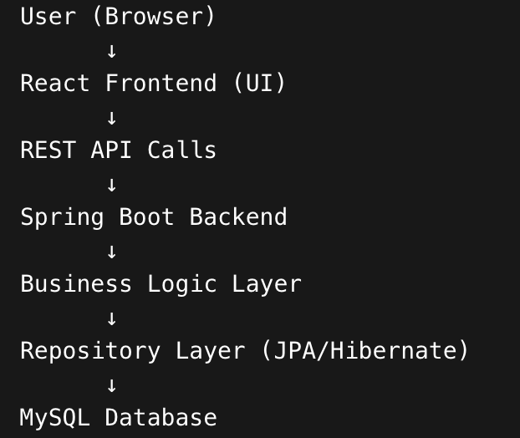

2.2 Architecture Components

1. Frontend (React.js)
Responsibilities:
- User Interface
- API communication
- Form validation
- Data visualization
Main UI Components:
- Login / Register
- Dashboard
- Mutual Funds List
- SIP Management
- Portfolio Analytics

2. Backend (Spring Boot)
The backend handles:
- Authentication
- Business logic
- API endpoints
- Database interaction
Layers:
Controller Layer
Service Layer
Repository Layer
Entity Layer
Security Layer

3. Database (MySQL)
The database stores:
- User information
- Mutual fund details
- SIP investments
- Transaction history
- Portfolio data

3. Module Design
The system consists of four major modules.

Module 1: User Authentication & Management

Overview
This module handles user registration, login, and authentication. It ensures secure access to the platform using JWT tokens and BCrypt password hashing.

Working
- User registers with:
  - Name
  - Email
  - Mobile Number
  - Password
- Password is encrypted using BCrypt.
- During login:
  - Credentials are verified.
  - JWT token is generated.
  - Token is used for all API requests.

Database Schema

Users Table
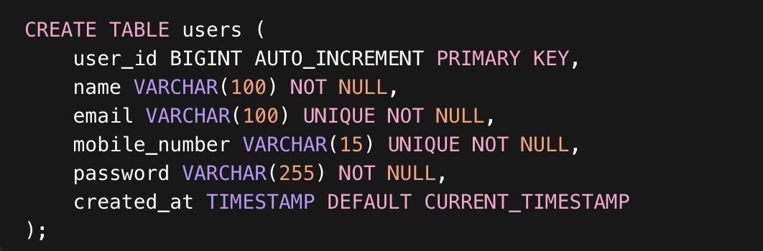

Module 2: Mutual Fund Management

Overview
This module manages mutual fund data. It allows users to explore available funds and filter them based on categories.
Categories supported:
- Large Cap
- Mid Cap
- Small Cap

Working
- System stores mutual fund information.
- Backend exposes APIs to fetch funds.
- Frontend displays funds in list/grid format.
- Users can select funds to start SIP.

Database Schema

Mutual Funds Table
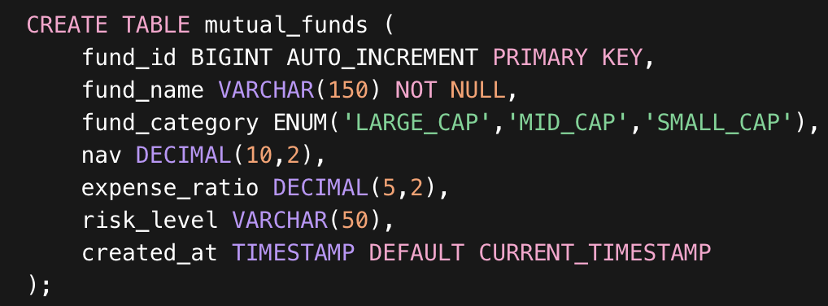

Module 3: SIP Investment Management

Overview
This is the core module of the WealthWise system. It allows users to create and manage Systematic Investment Plans (SIPs) for mutual funds.

Working
- User selects a mutual fund.
- User creates a SIP with:
- Monthly amount
- Start date
- Frequency
- The system records SIP details.
- Each installment generates a transaction record.

Database Schema

SIP Investments
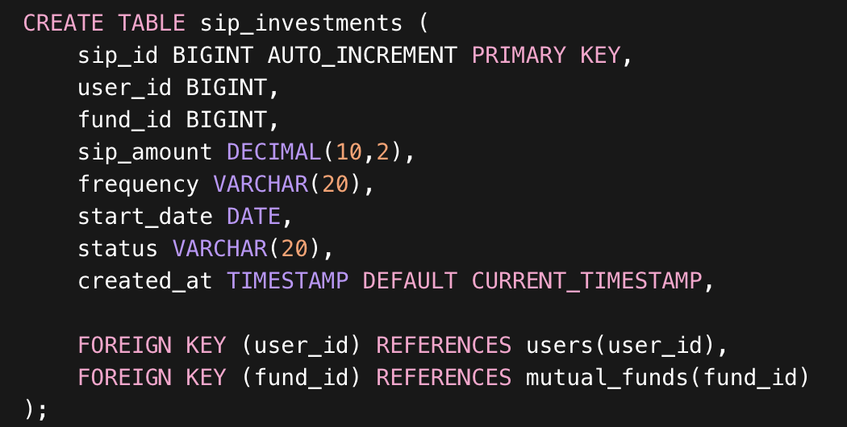
SIP Transactions
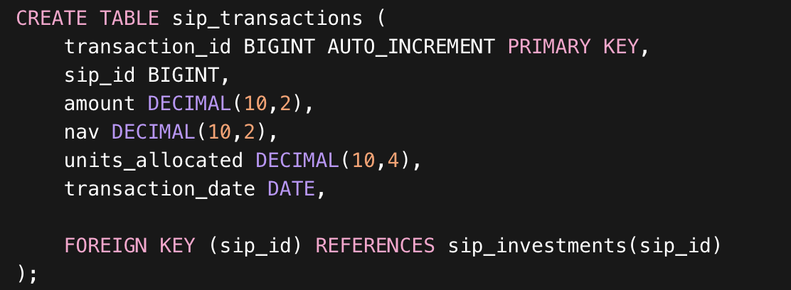

Module 4: Portfolio Tracking & Analytics

Overview
This module provides investment insights and portfolio performance metrics.
It aggregates data from SIP investments and transactions to calculate:
- Total invested amount
- Current portfolio value
- Profit/Loss
- Growth percentage

Working
- System collects all SIP investments of a user.
- It calculates total units owned.
- Fetches latest NAV of funds.
- Computes current portfolio value.

Portfolio Metrics
Metric | Formula
Total Investment | Sum of all SIP transactions
Portfolio Value | Units × Current NAV
Profit/Loss | Portfolio Value − Total Investment
Growth % | (Profit ÷ Investment) × 100

Portfolio Table
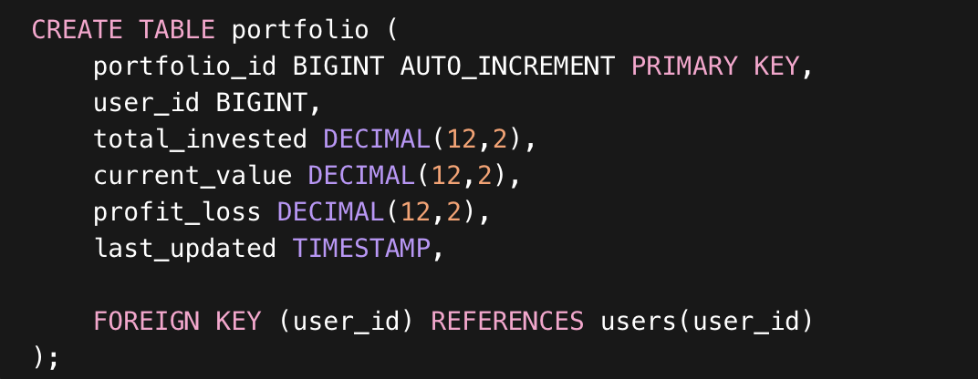

4. Backend Package Structure (Spring Boot)
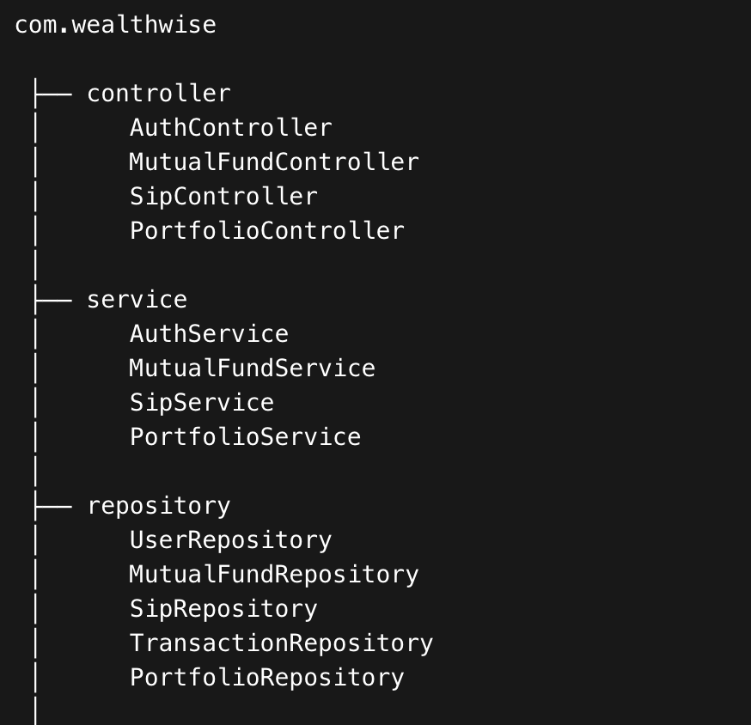
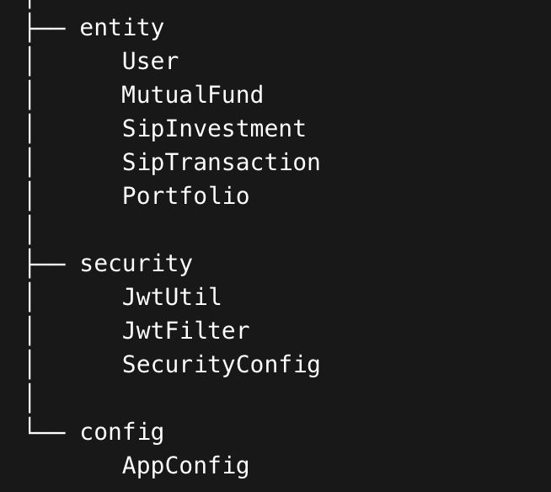

- Frontend Structure (React)
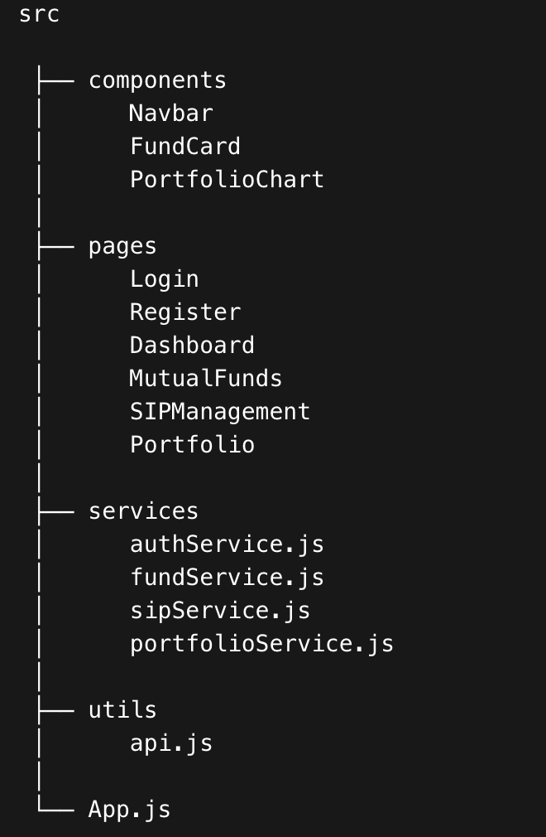

6. API Design

Authentication APIs
Method | Endpoint | Description
POST | /api/auth/register | Register user
POST | /api/auth/login | User login

Mutual Fund APIs
Method | Endpoint
GET | /api/funds
GET | /api/funds/category/{type}
GET | /api/funds/{id}

SIP APIs
Method | Endpoint
POST | /api/sip/create
GET | /api/sip/user/{userId}
PUT | /api/sip/update
DELETE | /api/sip/cancel

Portfolio APIs
Method | Endpoint
GET | /api/portfolio/{userId}
GET | /api/portfolio/analytics/{userId}

7. Security Design
Security mechanisms used:
- BCrypt Password Hashing
- JWT Authentication
- Spring Security Filters
Workflow:
- User logs in.
- Backend generates JWT token.
- Frontend stores token.
- All requests include token in headers.
Example Header:
Authorization: Bearer <JWT_TOKEN>

8. Future Enhancements
Potential future improvements:
- Real-time NAV updates
- Payment gateway integration
- AI-based investment recommendations
- Risk analysis dashboard
- Mobile application

9. Conclusion
The WealthWise platform provides a scalable and modular investment management system that enables users to track mutual fund SIP investments efficiently. The system leverages modern technologies such as Spring Boot, React.js, and MySQL to deliver a secure, scalable, and maintainable architecture.
The modular structure ensures easy expansion and allows the addition of advanced financial analytics features in future iterations.

