
Strategic Branding & Digital Marketing Proposal for
"A comprehensive marketing strategy to enhance digital presence, brand engagement



Submitted To:
|

Prepared By:
| Arowa Webtech

Date of Submission:
17 April 2026
Proposal Version: V 1.0
Note: This document is confidential and intended solely for . Unauthorized sharing, copying, or distribution is strictly prohibited.

Arowa Webtech
Arowa Webtech is a leading Digital Marketing & Branding Agency in Ahmedabad, where we believe that “innovative idea begins from the mind of creative people”. Our mission is to deliver impactful and result-driven digital solutions for businesses. With a blend of Creative thinkers, skilled designers, and experienced professionals, we constantly strive to craft something unique and valuable for our clients. At Arowa Webtech, we provide the perfect platform for brands to establish and grow their presence in the ever-evolving digital world.

Our Experience & Expertise:
- 9+ years of experience in digital marketing
- 350+ successful projects across 60+ industries
- A strong team of brand strategists, social media managers, designers, content writers & video animators
- Expertise in branding, digital growth, and lead generation
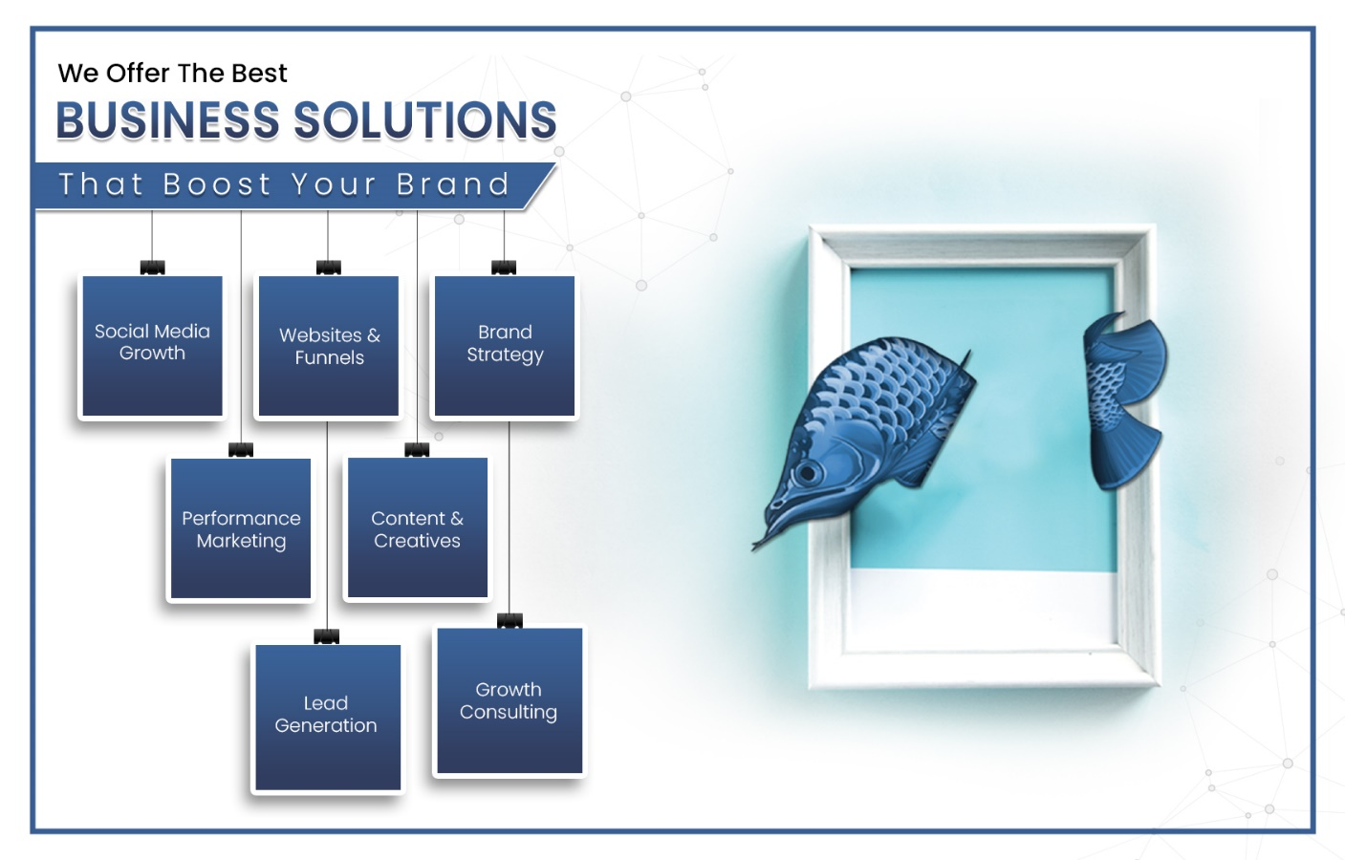

Overview

Business Model

Core Offerings

Target Audience

Current Positioning
is positioned as:

Future Positioning (The Vision)
can evolve into:

Understanding Market Position & Potential Growth

Strengths:
:
:
:
:

Opportunities for Growth:
Content Gaps:

Branding & Marketing– Strategic Growth Plan
Business Goals

Content Pillars
- :
- :
- :
- :
- :

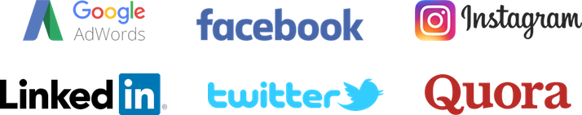




Platforms

Our Working Methodology
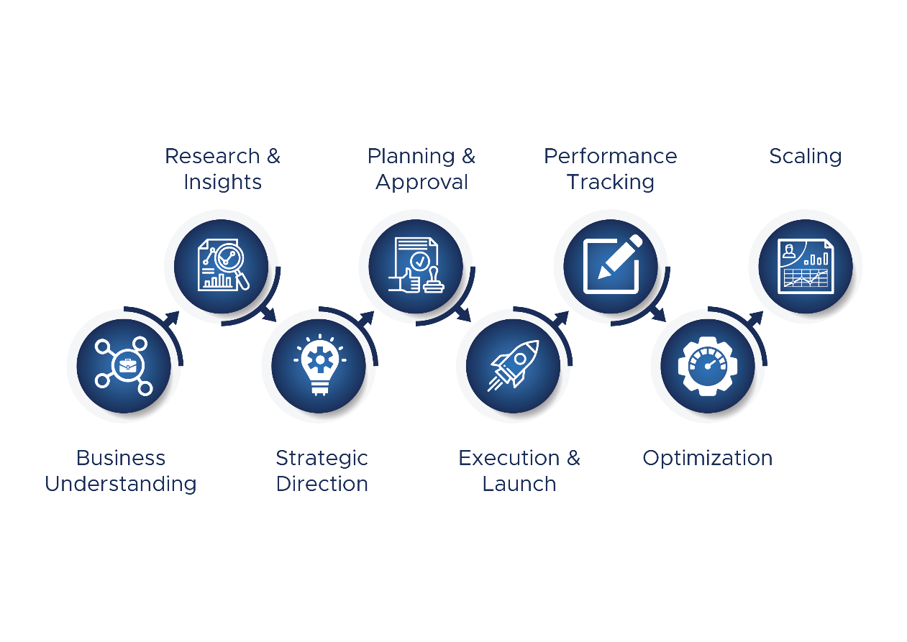

Month By Month Strategy & Ideas
Month | Focus Theme | Campaign / Offer | Content Ideas | Special Roles
Month 1
Month 2
Month 3
Month 4
Month 5
Month 6
Month 7
Month 8
Month 9
Month 10
Month 11
Month 12

Team Allocation, Deliverables, Pricing & Suggested Ad Budget
Team Allocation
Allocated Team
01 | Designer
01 | Social Media Manager
01 | Team Leader
01 | Content Writer
01 | Strategy Planner

Project Deliverables

Service | Platforms | Deliverables
✔️ Social Media Management | Facebook, Instagram,  Google My Business | Per Month  - Posts  - Reel  - Story
✔️ Strategy & Creative Direction
✔️ Campaign Planning
✔️ Reels Creation Ideas and Editing
✔️ Paid Promotions Setup
✔️ Content Calendar & Copy
✔️ Monthly Reporting & Consultation

Pricing

Service | Monthly Charges
Handling Social Media Marketing on  Facebook + Instagram + Google My Business | Rs. /- + 18% GST
Total Service Pricing | Rs. /- +18% GST

Suggested Ad Budget

Service | Platforms | Monthly Charges
Paid Promotion | Facebook – Instagram | Rs. 5,000 + 18% GST
Note: Suggested ad budget has been determined based on the current digital presence and the planned strategic roadmap for upcoming campaigns.

Terms & Conditions

Company Policy
- We operate from Monday to Friday, between 10:00 AM and 7:00 PM.
- The office remains closed on all public holidays declared by the Government of India.
- A dedicated Social Media Manager will be assigned via WhatsApp for all coordination. Please route all communications and requirements through the group only; avoid personal messages.
- All communication will be carried out via email, WhatsApp, or phone calls.

Social Media Marketing terms
- The client must provide any additional content, ideas, or references at least 24 hours in advance of posting.
- Weekend requirements (Saturday/Sunday) must be communicated on or before Thursday, in line with company policy.
- Any requests beyond working hours will be addressed based on availability, as per company policy.
- Selected festival creatives are included in the Service Quotation.
- Any changes to images will be made either in the morning (10:00 AM to 12:00 PM) or in the evening (5:00 PM to 7:00 PM). A maximum of two revisions per image is allowed.
- In case of emergencies, support may be provided subject to staff availability.
- If you conduct any event and require urgent posting, we will upload the content as received, along with event images and a generic caption, at our discretion.
- After receiving the required inputs, we need at least 24 hours to create images as per your requirements.
- Additional images beyond the agreed SMM scope can be created upon request. Extra charges will apply based on the number of images.
- Only one point of contact from your side should coordinate for this SMM service, including involvement, approvals, and feedback. Multiple decision-makers may affect the efficiency of the process.
- Please note that SMM services are designed to generate leads organically through brand awareness, audience engagement, and strategic content.
- If services are paused mid-month, the full monthly charges will remain applicable as agreed, without adjustments based on completed deliverables.

Payment terms
- This proposal is valid for .
- All payments shall be made on an advance payment basis.
- Paid promotion / advertisement budget will be charged separately and shall be borne by the client account.
- Any additional services outside the agreed scope of Social Media Management will be charged separately upon prior approvals
- Due to any delay from the client in providing required data, content, or information, the payment cycle shall not be adjusted, paused, or extended.

Cancellation Terms
- Once a payment or deposit is made, it is non-refundable.
- If a project is cancelled or postponed, all payments are retained by Arowa Webtech and if applicable, a fee for all work completed beyond what was already paid for shall be paid by the client.

Let’s Have a Cup of Coffee

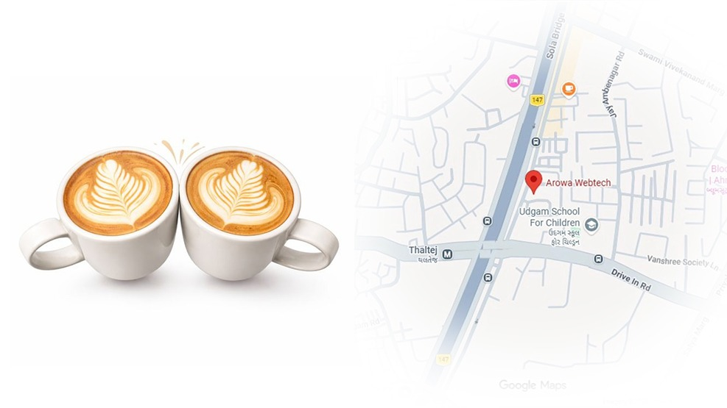

Arowa Webtech
C-901, Titanium Square, Near Oreva House,
S.G Highway, Thaltej,
Ahmedabad, Gujarat (India) – 380054

Info.arowawebtehc@gmail.com www.arowawebtech.com +91 70167 114970

