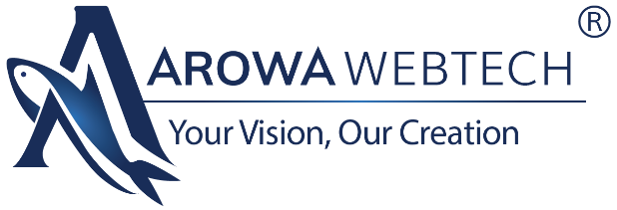
Strategic Branding & Digital Marketing Proposal for Natural Active Clay LLP
"A comprehensive marketing strategy to enhance digital presence, brand engagement

None

Submitted To:
Mayank Bhai | Natural Active Clay LLP

Prepared By:
Krish Zinzuvadiya | Arowa Webtech

Date of Submission:
17 April 2026
Proposal Version: V 1.0
Note: This document is confidential and intended solely for Natural Active Clay LLP. Unauthorized sharing, copying, or distribution is strictly prohibited.

Arowa Webtech
Arowa Webtech is a leading Digital Marketing & Branding Agency in Ahmedabad, where we believe that “innovative idea begins from the mind of creative people”. Our mission is to deliver impactful and result-driven digital solutions for businesses. With a blend of Creative thinkers, skilled designers, and experienced professionals, we constantly strive to craft something unique and valuable for our clients. At Arowa Webtech, we provide the perfect platform for brands to establish and grow their presence in the ever-evolving digital world.

Our Experience & Expertise:
- 9+ years of experience in digital marketing
- 350+ successful projects across 60+ industries
- A strong team of brand strategists, social media managers, designers, content writers & video animators
- Expertise in branding, digital growth, and lead generation
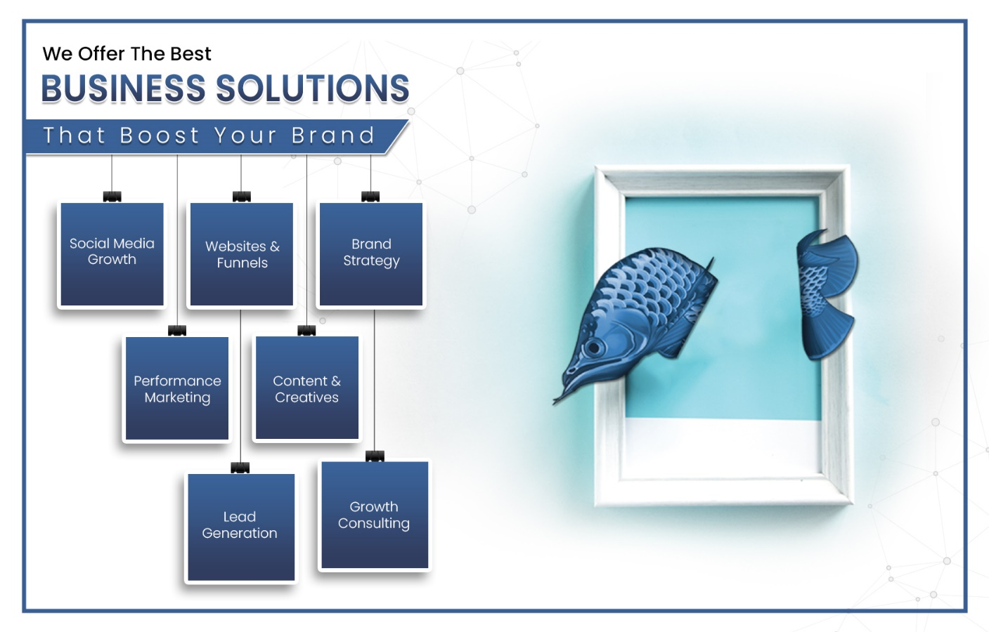

Natural Active Clay LLP Overview

Business Model
Natural Active Clay LLP is a manufacturing-driven, export-oriented company specializing in natural clay products. It operates on a B2B and B2C model, supplying bulk materials to industries, distributors, and international markets. The business is supported by a structured system of sourcing, processing, quality control, and distribution, ensuring consistent product quality and reliable supply across both domestic and global clients.
The company’s infrastructure reflects a quality driven manufacturing ecosystem, supported by advanced processing capabilities, quality control systems, and structured operational processes that ensure consistent purity, reliability, and supply of natural clay products across domestic and international markets.

Core Offerings
- Natural clay products
- Natural clay products
- Natural clay products
- Natural clay products
- Natural clay products
- Natural clay products
- Natural clay products

Target Audience
- il refineries requiring industrial-grade clay for filtration and processing
- il refineries requiring industrial-grade clay for filtration and processing
- il refineries requiring industrial-grade clay for filtration and processing
- il refineries requiring industrial-grade clay for filtration and processing
- il refineries requiring industrial-grade clay for filtration and processing
- il refineries requiring industrial-grade clay for filtration and processing

Current Positioning
Natural Active Clay LLP is positioned as:
- sitioning is supply-driven rather than solution-driven
- sitioning is supply-driven rather than solution-driven
- sitioning is supply-driven rather than solution-driven
- sitioning is supply-driven rather than solution-driven
Future Positioning (The Vision)
Natural Active Clay LLP can evolve into:
A Global Industrial Mineral Solutions Partner Delivering High-Performance Natural Clay Materials with Consistent Quality, Customization, and Scalable Supply.

Understanding Market Position & Potential Growth

Strengths:
Integrated Manufacturing Processing Capability: End-to-end control ensures consistent quality and reliability.
Integrated Manufacturing Processing Capability: End-to-end control ensures consistent quality and reliability.
Integrated Manufacturing Processing Capability: End-to-end control ensures consistent quality and reliability.
Integrated Manufacturing Processing Capability: End-to-end control ensures consistent quality and reliability.

Opportunities for Growth:
Content Gaps:
- Strong Brand Positioning Gap
- Strong Brand Positioning Gap
- Strong Brand Positioning Gap
- Strong Brand Positioning Gap
- Strong Brand Positioning Gap

Branding Marketing– Strategic Growth Plan
Business Goals
Establish Natural Active Clay LLP as a trusted, quality-driven global mineral solutions partner by generating consistent B2B and export inquiries, building credibility through process transparency and quality assurance, increasing visibility across industrial sectors, and improving conversions through application-focused and value-driven communication

Content Pillars
- Application Showcase: Material types Industry applications
- Application Showcase: Material types Industry applications
- Application Showcase: Material types Industry applications
- Application Showcase: Material types Industry applications
- Application Showcase: Material types Industry applications

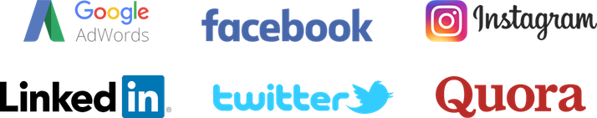




Platforms

Our Working Methodology
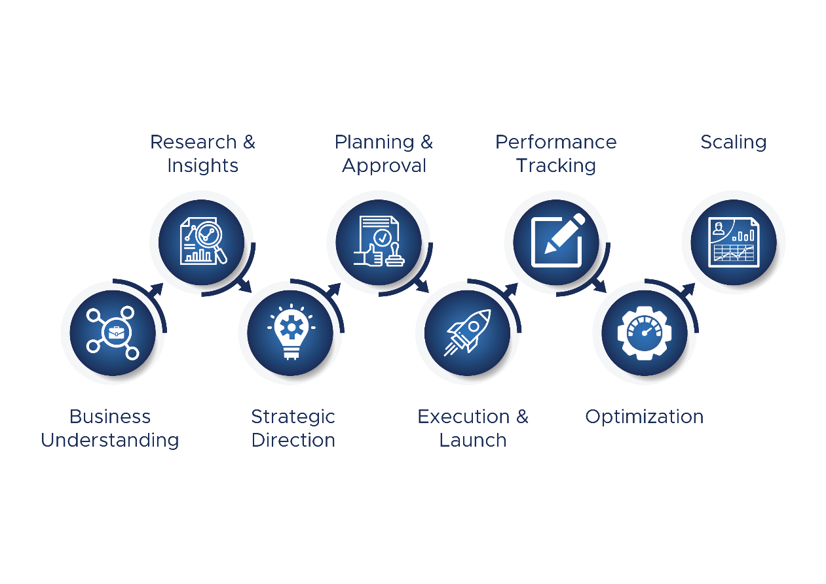

Month By Month Strategy Ideas
Month | Focus Theme | Campaign / Offer | Content Ideas | Special Roles
Month 1 | Brand Foundation | Brand Foundation | Brand Foundation | Brand Foundation
Month 2 | Brand Foundation | Brand Foundation | Brand Foundation | Brand Foundation
Month 3 | Brand Foundation | Brand Foundation | Brand Foundation | Brand Foundation
Month 4
Month 5
Month 6
Month 7
Month 8
Month 9
Month 10
Month 11
Month 12

Team Allocation, Deliverables, Pricing Suggested Ad Budget
Team Allocation
Allocated Team
01 | Designer
01 | Social Media Manager
01 | Team Leader
01 | Content Writer
01 | Strategy Planner

Project Deliverables

Service | Platforms | Deliverables
✔️ Social Media Management | Facebook, Instagram,  Google My Business | Per Month  - 6 Posts  - 4 Reel  - 4 Story
✔️ Strategy Creative Direction
✔️ Campaign Planning
✔️ Reels Creation Ideas and Editing
✔️ Paid Promotions Setup
✔️ Content Calendar Copy
✔️ Monthly Reporting Consultation

Pricing

Service | Monthly Charges
Handling Social Media Marketing on  Facebook + Instagram + Google My Business | Rs. 25000 /- + 18% GST
Total Service Pricing | Rs. 25000/- +18% GST

Suggested Ad Budget

Service | Platforms | Monthly Charges
Paid Promotion | Facebook – Instagram | Rs. 5,000 + 18% GST
Note: Suggested ad budget has been determined based on the current digital presence and the planned strategic roadmap for upcoming campaigns.

Terms Conditions

Company Policy
- We operate from Monday to Friday, between 10:00 AM and 7:00 PM.
- The office remains closed on all public holidays declared by the Government of India.
- A dedicated Social Media Manager will be assigned via WhatsApp for all coordination. Please route all communications and requirements through the group only; avoid personal messages.
- All communication will be carried out via email, WhatsApp, or phone calls.

Social Media Marketing terms
- The client must provide any additional content, ideas, or references at least 24 hours in advance of posting.
- Weekend requirements (Saturday/Sunday) must be communicated on or before Thursday, in line with company policy.
- Any requests beyond working hours will be addressed based on availability, as per company policy.
- Selected festival creatives are included in the Service Quotation.
- Any changes to images will be made either in the morning (10:00 AM to 12:00 PM) or in the evening (5:00 PM to 7:00 PM). A maximum of two revisions per image is allowed.
- In case of emergencies, support may be provided subject to staff availability.
- If you conduct any event and require urgent posting, we will upload the content as received, along with event images and a generic caption, at our discretion.
- After receiving the required inputs, we need at least 24 hours to create images as per your requirements.
- Additional images beyond the agreed SMM scope can be created upon request. Extra charges will apply based on the number of images.
- Only one point of contact from your side should coordinate for this SMM service, including involvement, approvals, and feedback. Multiple decision-makers may affect the efficiency of the process.
- Please note that SMM services are designed to generate leads organically through brand awareness, audience engagement, and strategic content.
- If services are paused mid-month, the full monthly charges will remain applicable as agreed, without adjustments based on completed deliverables.

Payment terms
- This proposal is valid for 6 months.
- All payments shall be made on an advance payment basis.
- Paid promotion / advertisement budget will be charged separately and shall be borne by the client account.
- Any additional services outside the agreed scope of Social Media Management will be charged separately upon prior approvals
- Due to any delay from the client in providing required data, content, or information, the payment cycle shall not be adjusted, paused, or extended.

Cancellation Terms
- Once a payment or deposit is made, it is non-refundable.
- If a project is cancelled or postponed, all payments are retained by Arowa Webtech and if applicable, a fee for all work completed beyond what was already paid for shall be paid by the client.

Let’s Have a Cup of Coffee

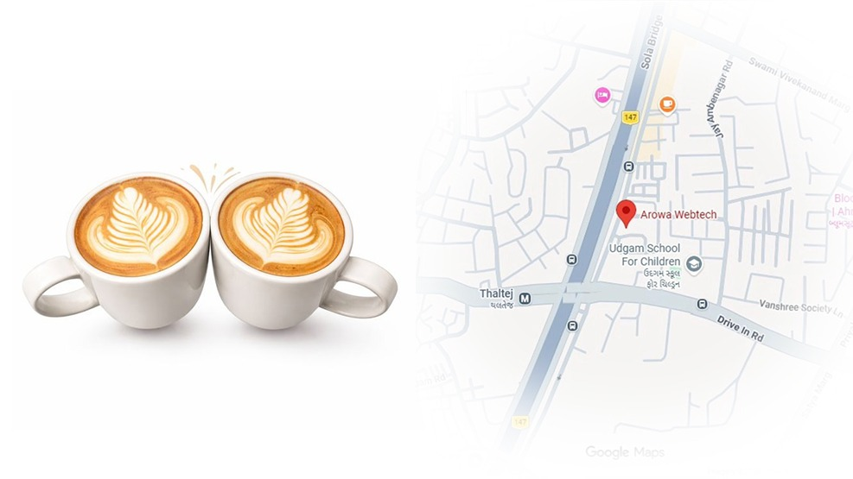

Arowa Webtech
C-901, Titanium Square, Near Oreva House,
S.G Highway, Thaltej,
Ahmedabad, Gujarat (India) – 380054

Info.arowawebtehc@gmail.com www.arowawebtech.com +91 70167 114970

