Mse - 1
Name : Krish Kumar Chaurasia
Roll No: 202401100200175

Git hub repo url : https://github.com/Krish08-sudo/github-skills-challenge

Pr url: https://github.com/Krish08-sudo/github-skills-challenge/pull/4

Git hub actions work flow and successful work flow:
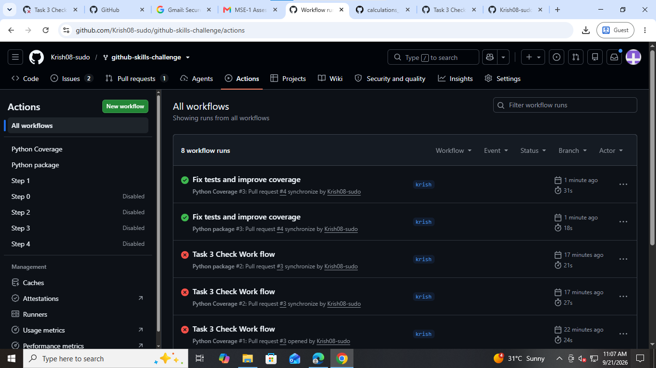

Coverage Result:
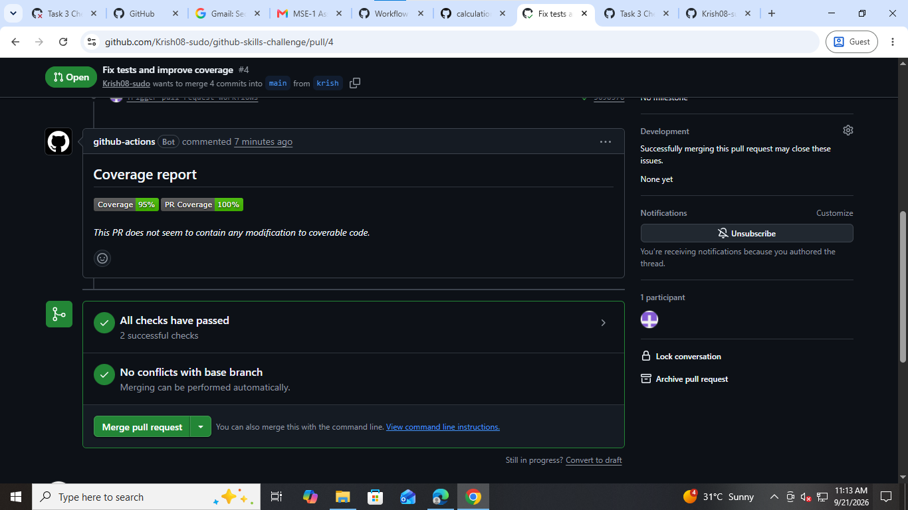

Final repo:
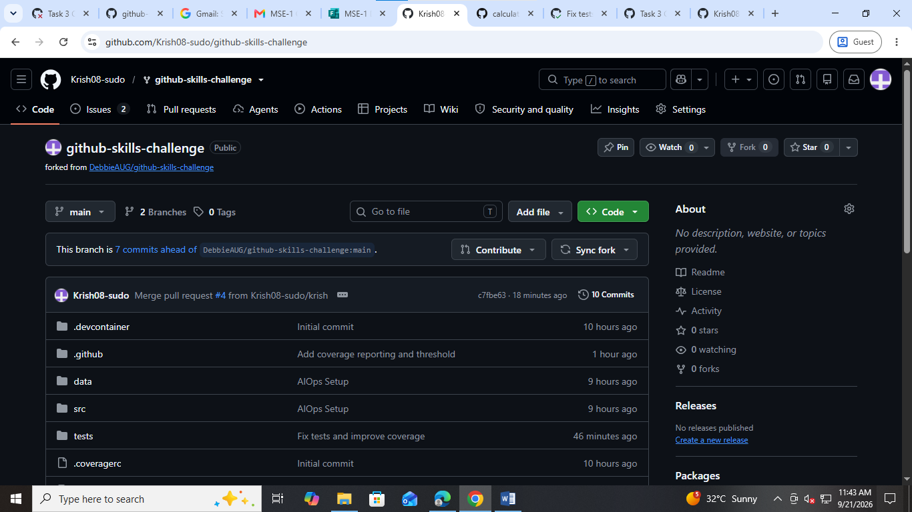
Final workflow codes:
