SEATING ARRANGEMENT SYSTEM

- Project Overview: "Seating Arrangement System" is designed to manage seating allocations for teams in organizations.
- System Features: Key features include organization registration, generating seat allocation based on layout and team details, and storing/comparing previous seat allocations.
- Role in Development: You were responsible for creating APIs, the main control logic, and handling authentication and session validation.
- Target Audience: The system is intended for companies or organizations.
System Technologies: The project uses Java, SpringBoot, PostgreSQL, MongoDB, and tools

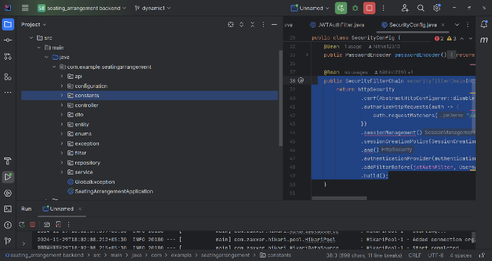

Database Creation

creating in database n postgreSQL : seating
mongoDB : Seating-Management

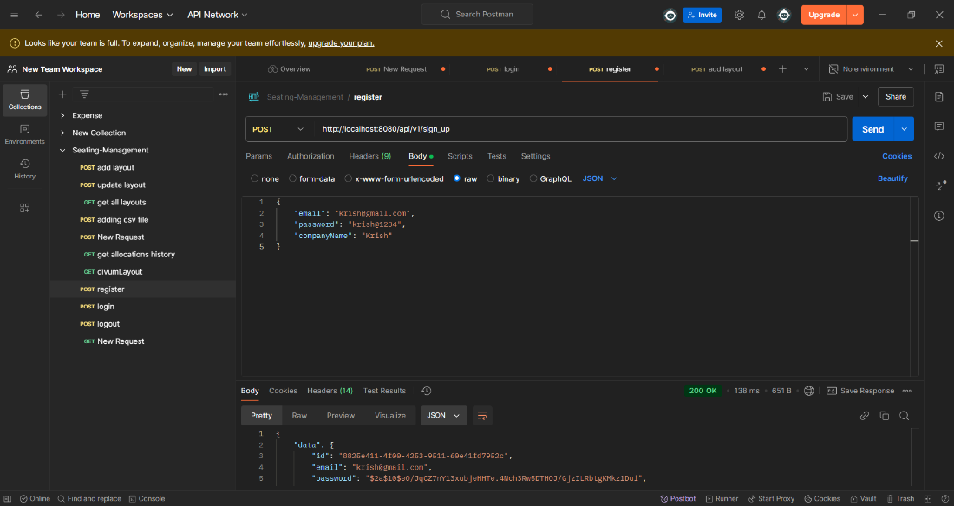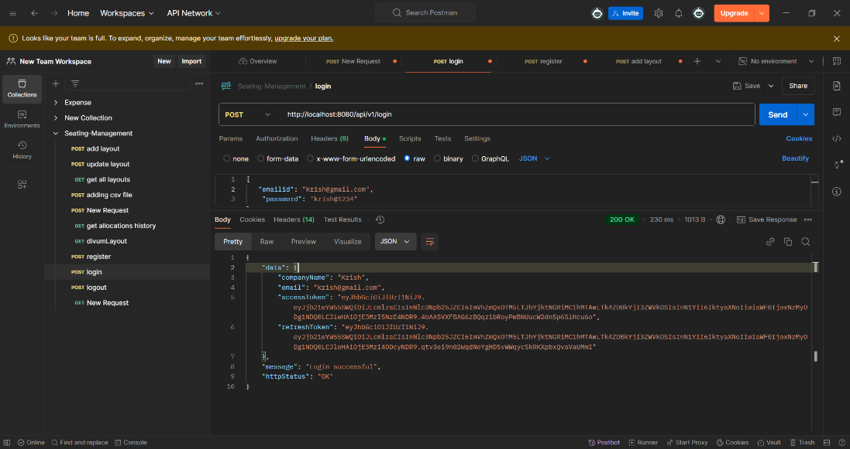

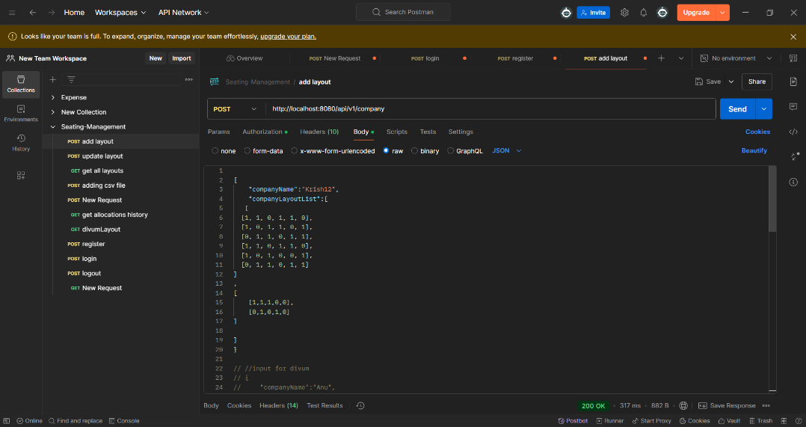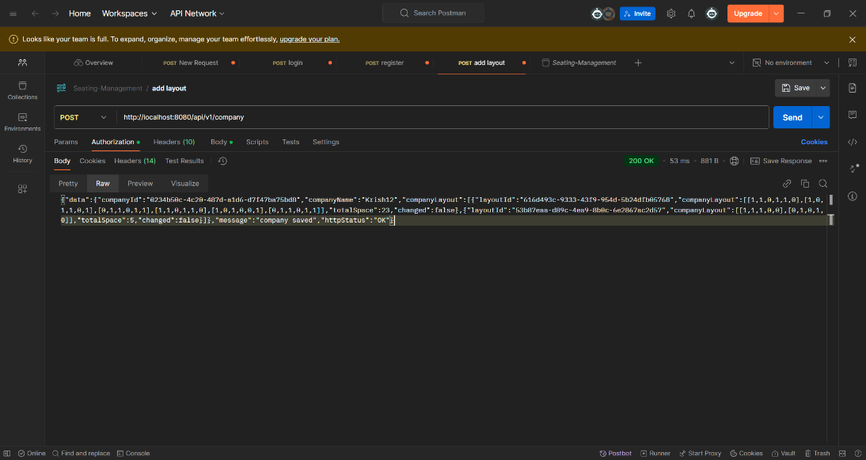

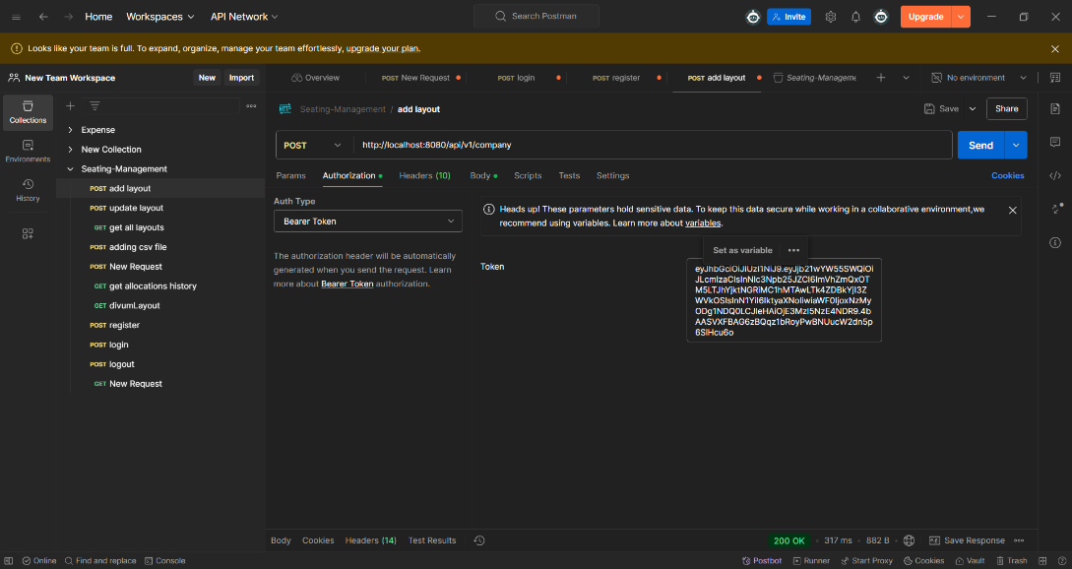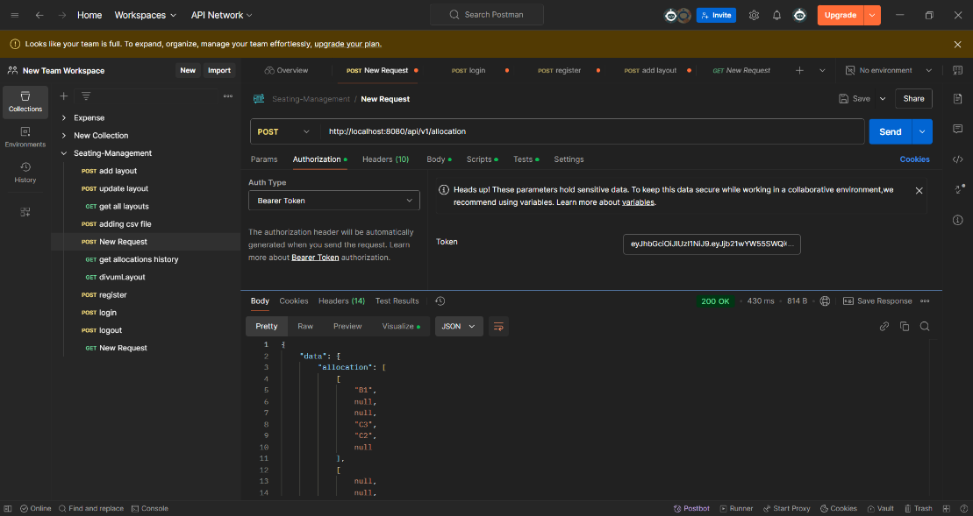

Login Method:
- Find User: The method retrieves company details using the provided email. If not found, it throws a UserNotFoundException.
- Validate Password: It checks if the provided password matches the stored password using passwordEncoder.matches(). If incorrect, it throws an IncorrectPasswordException.
- Session Creation: A new session is created with a generated sessionId and saved.
- JWT Tokens: Generates an access token and refresh token using the session details.
- Return Response: Returns a LoginResponseDTO containing the email, company name, access token, and refresh token.

Logout Method:
- Extract Token Claims: Extracts the session ID from the provided access token.
- Check Session: Finds the session using the session ID. If already logged out, throws an AlreadyLogOutException.
- Logout Time: Sets the logoutTime to mark the session as logged out and saves the session.
- Success Response: Returns a success message ("Logged Out") with a 200 OK status.

How Authentication Works

- Checking whether the session has been logged out.
- Authenticating Extracting and validating the JWT token from the Authorization header.
- the user if the token is valid, using UsernamePasswordAuthenticationToken.
- Ensuring the user’s authentication context is set correctly for the request.

Control Logic
GreedyImpl Class:
- Implements the AllocationAbstract class and handles seating allocation logic using a greedy approach.
- Uses Dynamic Programming (DP) to compute optimal seating arrangements based on team preferences and layout constraints.
Key Variables:
- arr: Represents the seating layout.
- dp: Stores DP results for dynamic seat allocation.
- teamNames: A 2D array storing assigned team names in the seating arrangement.
- tempTeamList: Stores temporary team assignments.
Methods:
- createAllocation(): Main entry point to create seat allocations. It calculates if available spaces can accommodate team sizes and performs seating calculations based on user preferences (ascending, descending, or random).
- Dynamic Programming: Used to determine the most optimal seating based on the layout and team sizes.
- changingTrueToFalse(): Updates seating positions when a seat is filled.
- seatingCalculation(): Computes seating based on team allocations, layout, and preferences.
Preference Handling:
- Preferences (ASC, DESC, or Random) affect how teams are allocated in the layout. Response:
- After processing, the system returns the allocated seating arrangement for teams.

