Identified the dokcer role from ansible galaxy

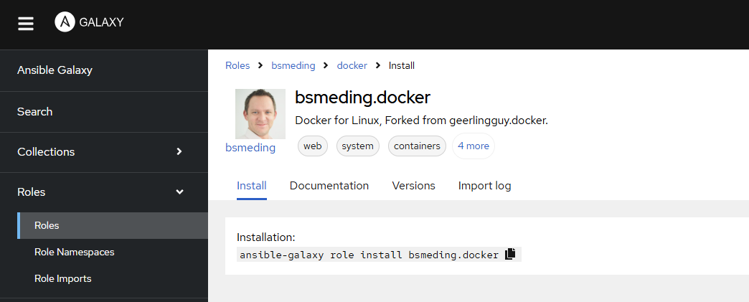

Executed the command in the ansible master

[kk@ansible-master ~]$ ansible-galaxy role install bsmeding.docker
Starting galaxy role install process
- downloading role 'docker', owned by bsmeding
- downloading role from https://github.com/bsmeding/ansible_role_docker/archive/1.0.23.tar.gz
- extracting bsmeding.docker to /home/kk/.ansible/roles/bsmeding.docker
- bsmeding.docker (1.0.23) was installed successfully
[kk@ansible-master ~]$

The role exists in .ansible/roles directory as follows:
[kk@ansible-master roles]$ pwd
/home/kk/.ansible/roles
[kk@ansible-master roles]$ ls -l
total 0
drwxrwxr-x. 10 kk kk 235 Nov 23 00:49 bsmeding.docker
[kk@ansible-master roles]$

Created the file like this.
[kk@ansible-master ~]$ cat first-docker.yml
---
- hosts: all
become: true
roles:
- bsmeding.docker

[kk@ansible-master ~]$

Executed the playbook as follows:

[kk@ansible-master ~]$ ansible-playbook -i inventory first-docker.yml

PLAY [all] *********************************************************************

TASK [Gathering Facts] *********************************************************
ok: [192.168.1.18]
ok: [192.168.1.19]

TASK [bsmeding.docker : Load OS-specific vars.] ********************************
ok: [192.168.1.18]
ok: [192.168.1.19]

TASK [bsmeding.docker : Ensure group "docker" exists] **************************
changed: [192.168.1.19]
changed: [192.168.1.18]

TASK [bsmeding.docker : set docker user] ***************************************
changed: [192.168.1.19]
changed: [192.168.1.18]

TASK [bsmeding.docker : get the username] **************************************
ok: [192.168.1.18]
ok: [192.168.1.19]

TASK [bsmeding.docker : Add current user to docker users group variable] *******
ok: [192.168.1.18]
ok: [192.168.1.19]

TASK [bsmeding.docker : Creates directory for proxy file (older version before 23)] ***
skipping: [192.168.1.18]
skipping: [192.168.1.19]

TASK [bsmeding.docker : Set docker http-proxy.conf (older version before 23)] ***
skipping: [192.168.1.18]
skipping: [192.168.1.19]

TASK [bsmeding.docker : Include tasks for RedHat] ******************************
skipping: [192.168.1.18]
skipping: [192.168.1.19]

TASK [bsmeding.docker : Include tasks for Debian] ******************************
included: /home/kk/.ansible/roles/bsmeding.docker/tasks/setup-Debian.yml for 192.168.1.18, 192.168.1.19

TASK [bsmeding.docker : Ensure apt key is not present in trusted.gpg.d] ********
ok: [192.168.1.19]
ok: [192.168.1.18]

TASK [bsmeding.docker : Ensure old apt source list is not present in /etc/apt/sources.list.d] ***
ok: [192.168.1.18]
ok: [192.168.1.19]

TASK [bsmeding.docker : Ensure the repo referencing the previous trusted.gpg.d key is not present] ***
ok: [192.168.1.18]
ok: [192.168.1.19]

TASK [bsmeding.docker : Ensure old versions of Docker are not installed.] ******
ok: [192.168.1.18]
ok: [192.168.1.19]

TASK [bsmeding.docker : Ensure dependencies are installed.] ********************
changed: [192.168.1.18]
changed: [192.168.1.19]

TASK [bsmeding.docker : Ensure directory exists for /etc/apt/keyrings] *********
ok: [192.168.1.19]
ok: [192.168.1.18]

TASK [bsmeding.docker : Add Docker apt key.] ***********************************
changed: [192.168.1.19]
changed: [192.168.1.18]

TASK [bsmeding.docker : Ensure curl is present (on older systems without SNI).] ***
skipping: [192.168.1.18]
skipping: [192.168.1.19]

TASK [bsmeding.docker : Add Docker apt key (alternative for older systems without SNI).] ***
skipping: [192.168.1.18]
skipping: [192.168.1.19]

TASK [bsmeding.docker : Add Docker repository.] ********************************
changed: [192.168.1.19]
changed: [192.168.1.18]

TASK [bsmeding.docker : Ensure group "docker" exists] **************************
ok: [192.168.1.18]
ok: [192.168.1.19]

TASK [bsmeding.docker : Install Docker packages.] ******************************
skipping: [192.168.1.18]
skipping: [192.168.1.19]

TASK [bsmeding.docker : Install Docker packages (with downgrade option).] ******
changed: [192.168.1.18]
changed: [192.168.1.19]

TASK [bsmeding.docker : Install docker-compose plugin.] ************************
skipping: [192.168.1.18]
skipping: [192.168.1.19]

TASK [bsmeding.docker : Install docker-compose-plugin (with downgrade option).] ***
ok: [192.168.1.18]
ok: [192.168.1.19]

TASK [bsmeding.docker : Ensure /etc/docker/ directory exists.] *****************
skipping: [192.168.1.18]
skipping: [192.168.1.19]

TASK [bsmeding.docker : Configure Docker daemon options.] **********************
skipping: [192.168.1.18]
skipping: [192.168.1.19]

TASK [bsmeding.docker : Ensure Docker is started and enabled at boot.] *********
ok: [192.168.1.19]
ok: [192.168.1.18]

TASK [bsmeding.docker : Ensure handlers are notified now to avoid firewall conflicts.] ***

RUNNING HANDLER [bsmeding.docker : restart docker] *****************************
changed: [192.168.1.18]
changed: [192.168.1.19]

TASK [bsmeding.docker : Include tasks for docker-compose] **********************
skipping: [192.168.1.18]
skipping: [192.168.1.19]

TASK [bsmeding.docker : Get docker group info using getent.] *******************
ok: [192.168.1.19]
ok: [192.168.1.18]

TASK [bsmeding.docker : Check if there are any users to add to the docker group.] ***
ok: [192.168.1.18] => (item=kk)
ok: [192.168.1.19] => (item=kk)

TASK [bsmeding.docker : Include tasks for Docker users] ************************
included: /home/kk/.ansible/roles/bsmeding.docker/tasks/docker-users.yml for 192.168.1.18, 192.168.1.19

TASK [bsmeding.docker : Ensure docker users are added to the docker group.] ****
changed: [192.168.1.18] => (item=kk)
changed: [192.168.1.19] => (item=kk)

TASK [bsmeding.docker : Reset ssh connection to apply user changes.] ***********

TASK [bsmeding.docker : Reset ssh connection to apply user changes.] ***********

TASK [bsmeding.docker : get docker uid] ****************************************
ok: [192.168.1.19]
ok: [192.168.1.18]

TASK [bsmeding.docker : Save UID] **********************************************
ok: [192.168.1.18]
ok: [192.168.1.19]

PLAY RECAP *********************************************************************
192.168.1.18 : ok=26 changed=8 unreachable=0 failed=0 skipped=10 rescued=0 ignored=0
192.168.1.19 : ok=26 changed=8 unreachable=0 failed=0 skipped=10 rescued=0 ignored=0

[kk@ansible-master ~]$

Now I can see the docker is installed In client1 and client2

kk@client1:~$ docker
Usage: docker [OPTIONS] COMMAND

A self-sufficient runtime for containers

Common Commands:
run Create and run a new container from an image
exec Execute a command in a running container
ps List containers
build Build an image from a Dockerfile
bake Build from a file
pull Download an image from a registry
push Upload an image to a registry
images List images
login Authenticate to a registry
logout Log out from a registry
search Search Docker Hub for images
version Show the Docker version information
info Display system-wide information

Management Commands:
builder Manage builds
buildx* Docker Buildx
checkpoint Manage checkpoints
compose* Docker Compose
container Manage containers
context Manage contexts
image Manage images
manifest Manage Docker image manifests and manifest lists
network Manage networks
plugin Manage plugins
system Manage Docker
volume Manage volumes

kk@client2:~$ docker
Usage: docker [OPTIONS] COMMAND

A self-sufficient runtime for containers

Common Commands:
run Create and run a new container from an image
exec Execute a command in a running container
ps List containers
build Build an image from a Dockerfile
bake Build from a file
pull Download an image from a registry
push Upload an image to a registry
images List images
login Authenticate to a registry
logout Log out from a registry
search Search Docker Hub for images
version Show the Docker version information
info Display system-wide information

