1. Login To portal.Azure.com
2. Go to Market place and search for App Service Plan
3. 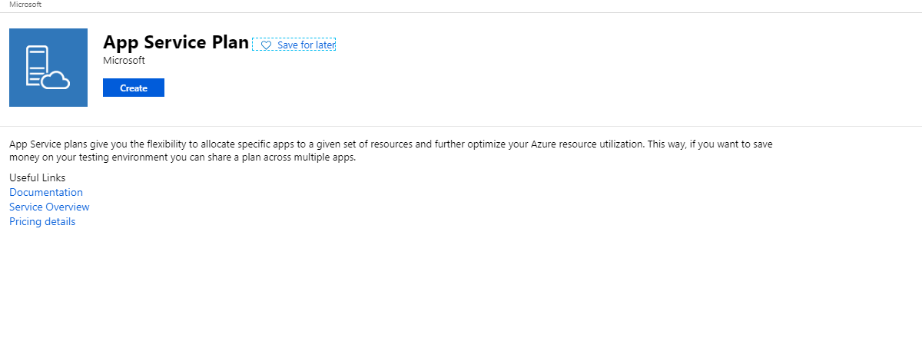
4. Create a resource group along with app service plan

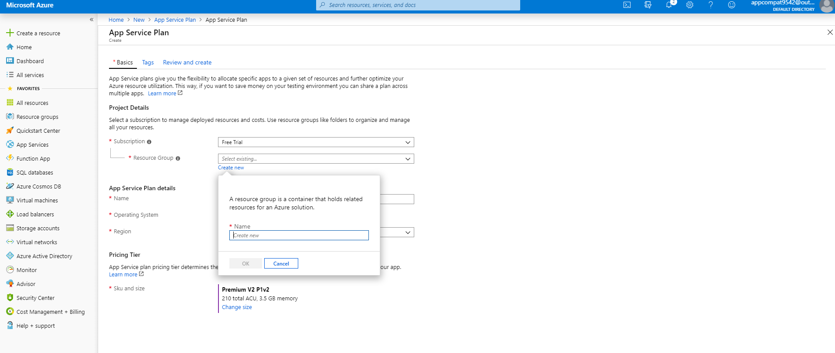

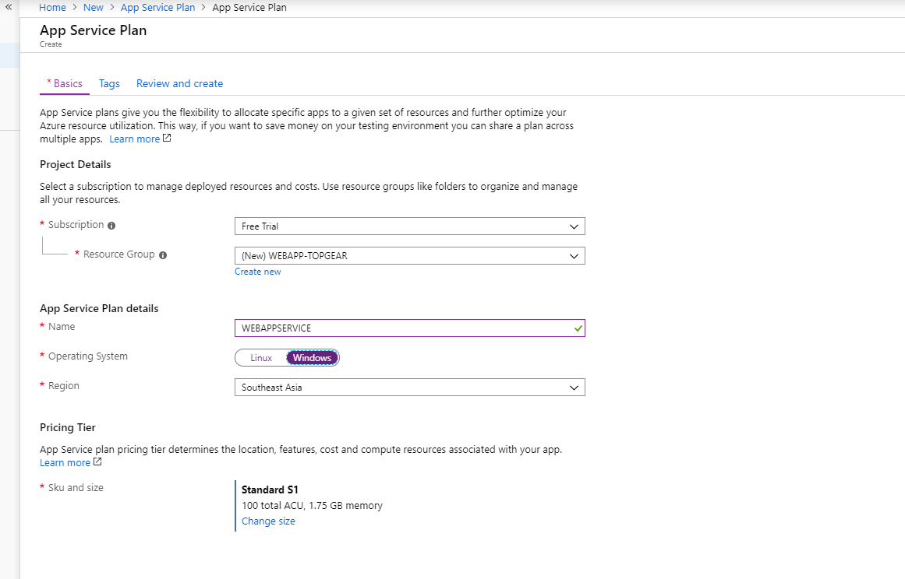

1. Click on Review and create which will deploy the service plan.

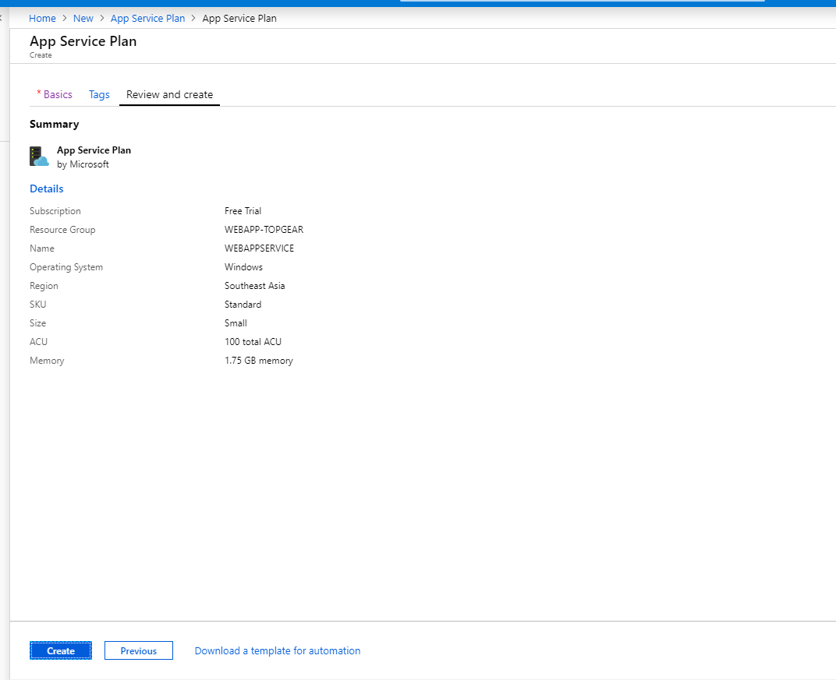

1. 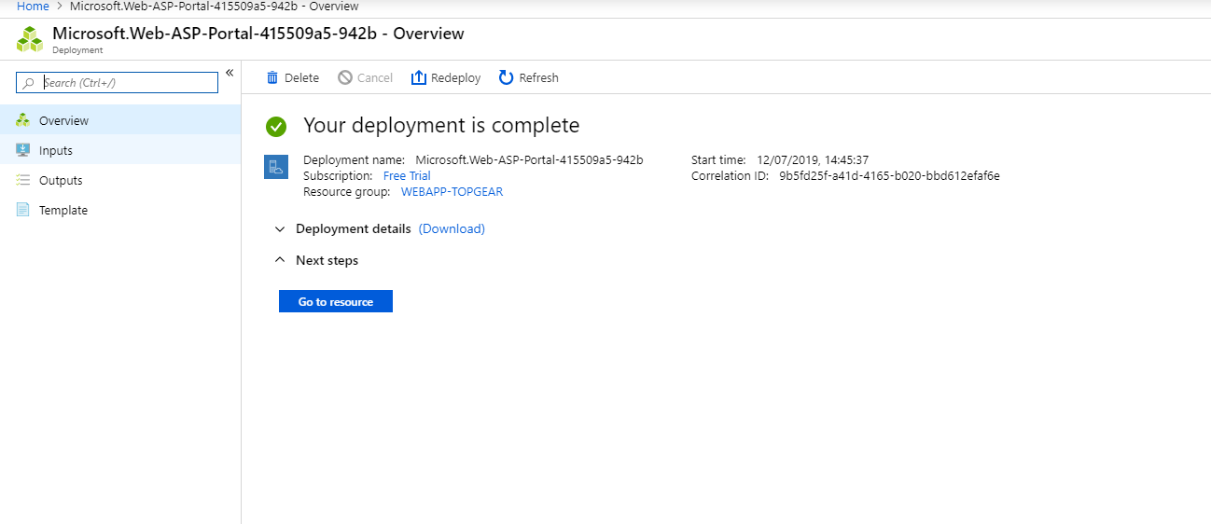
2. In the market place search for web app and create in the existing resource group with existing service plan.

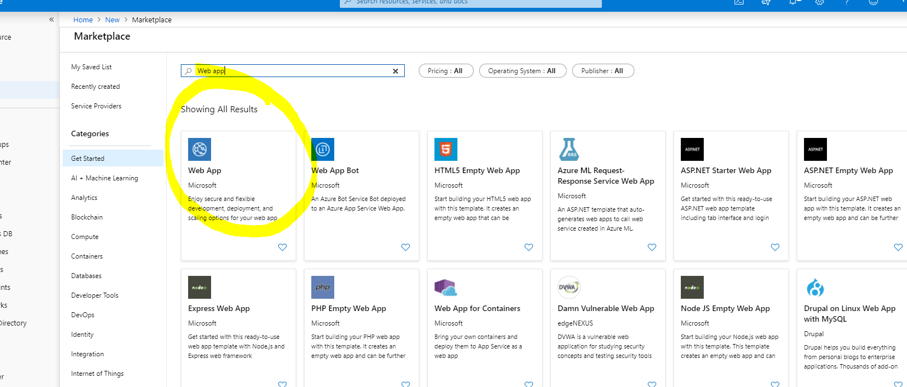

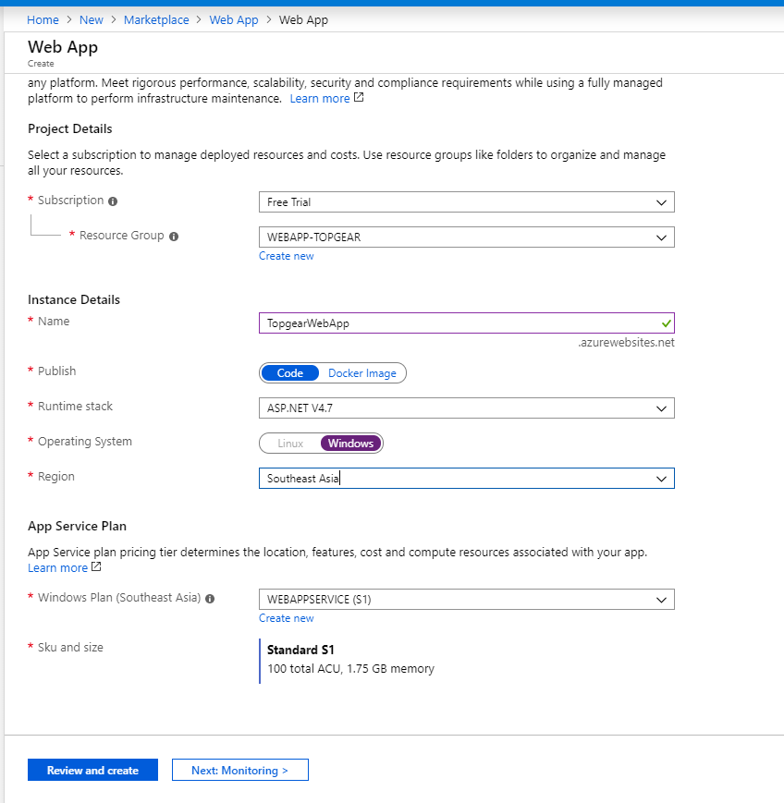

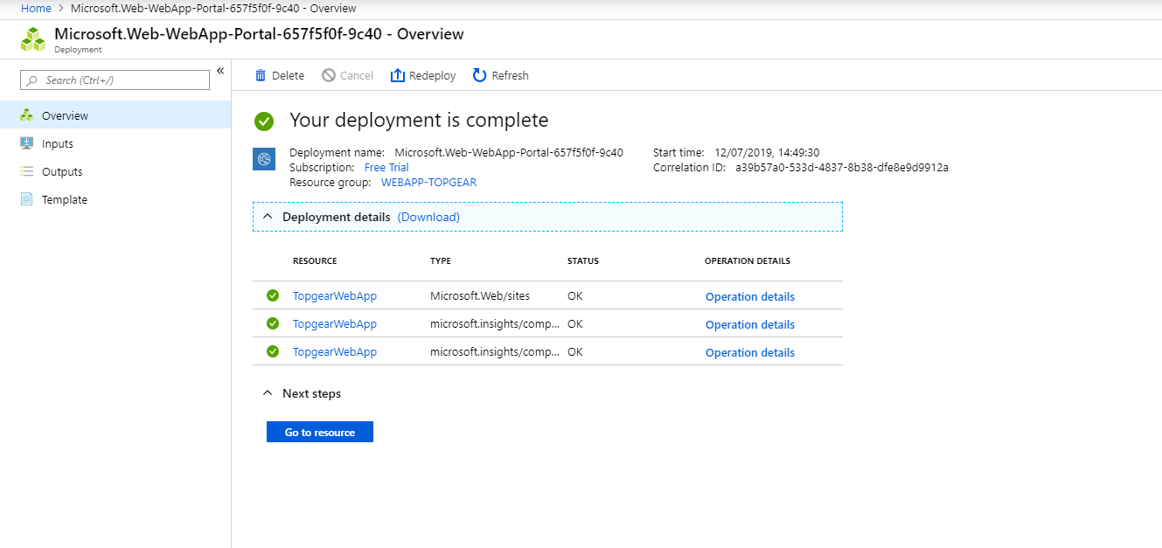

Click on the URl to acess webapp globally.

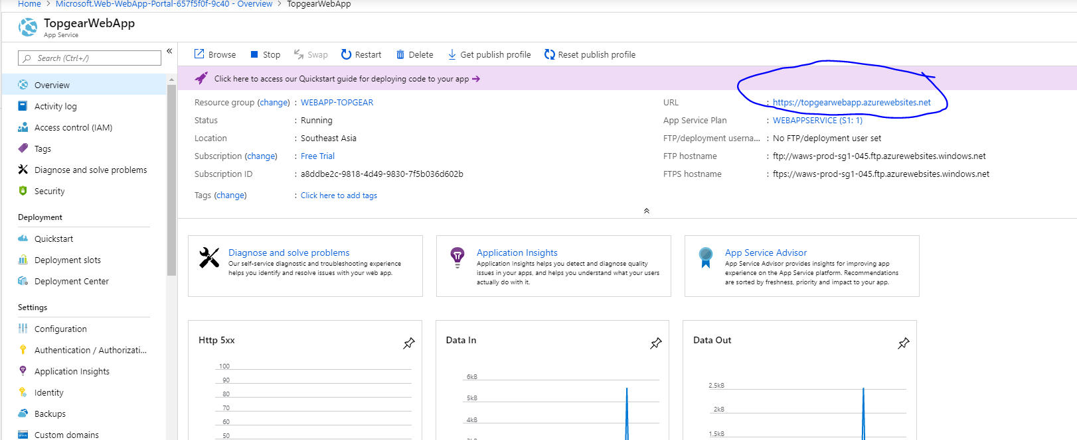

It will redirect to default page of azure web app.

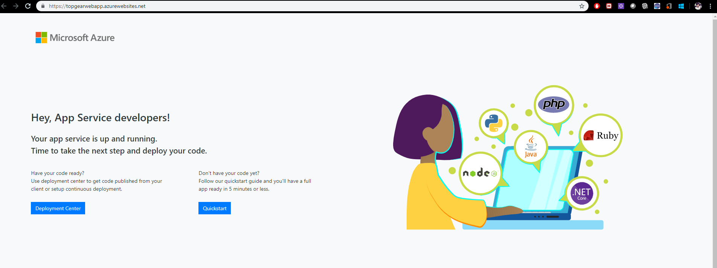

Now in local machine install visual studio and create a ASP.net web app

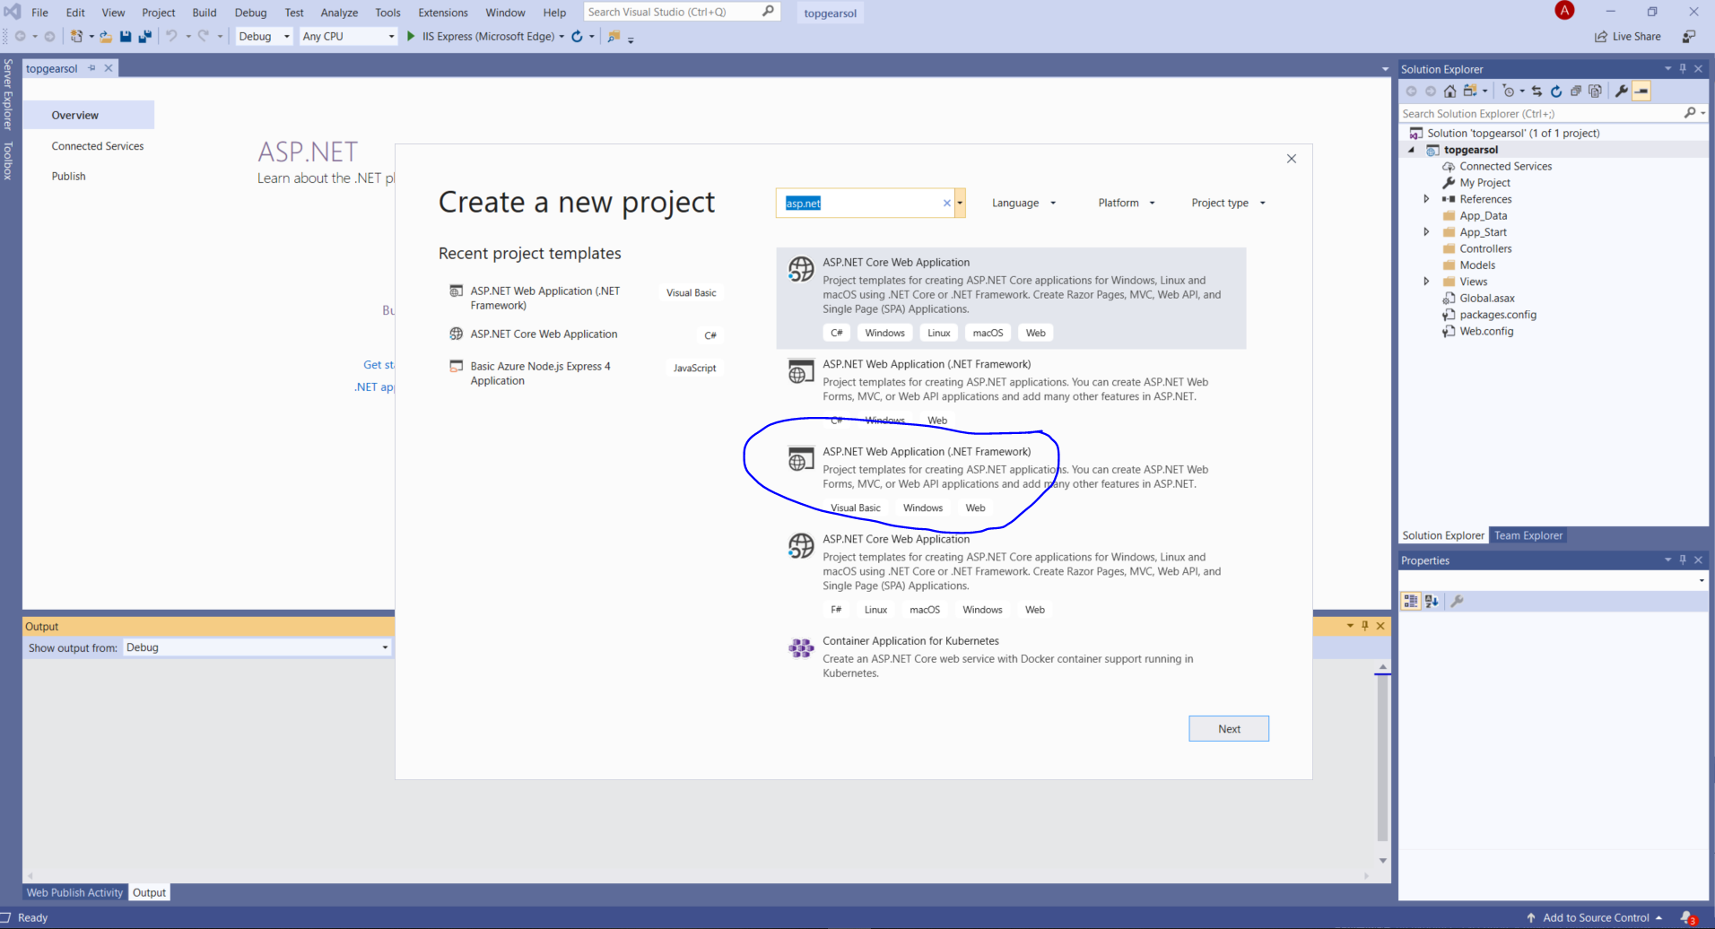

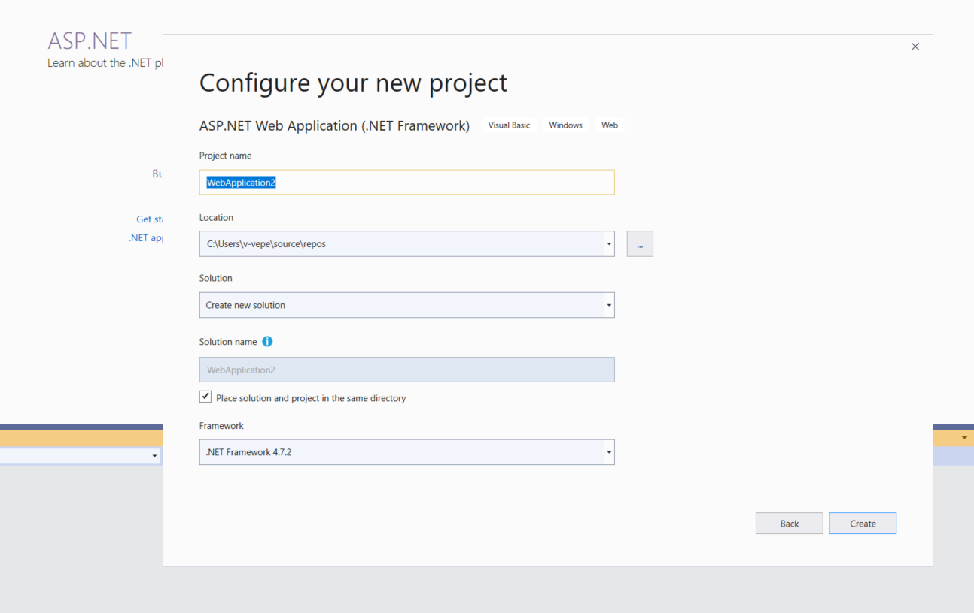

After coding successfully deploy the web app to local host.

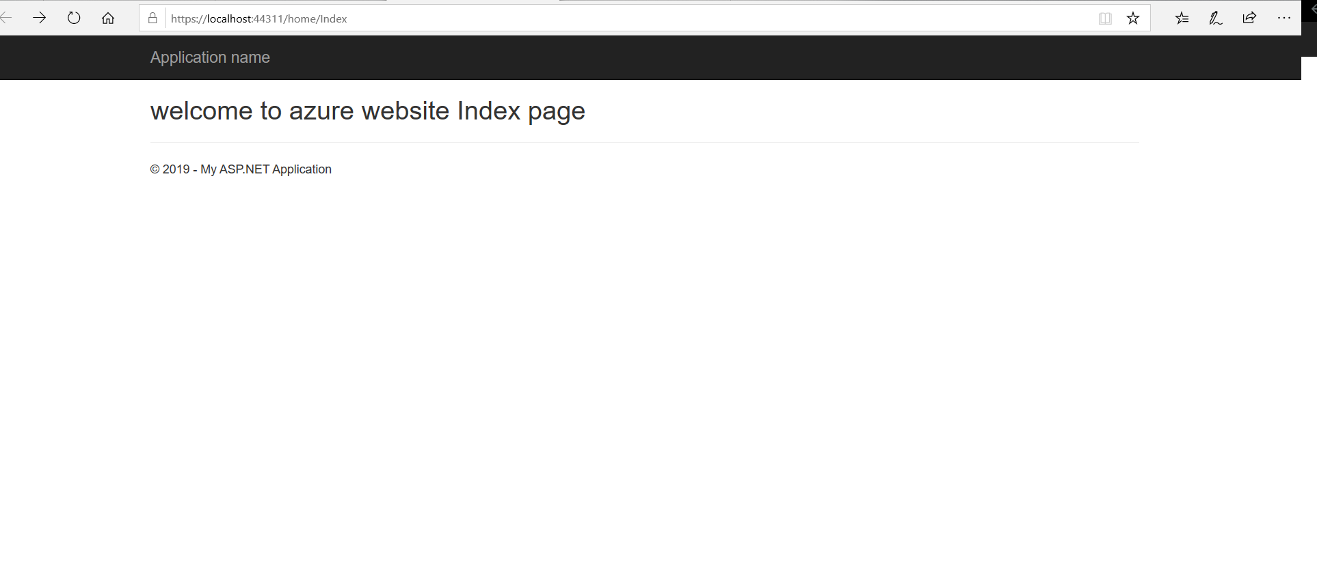

To publish it to azure, right click on the project and click on publish and with the azure credentials and subscription choose the resource group and plan where the azure web app is located. Deploy the locally created app to the azure and check with azure created portal for the webapp.

