**Ansible**

* Now we need to create 5 linux VMS
  + 1 for controller
  + 2 for dev
  + 2 for qa
* Now we need to login to Controller and do below

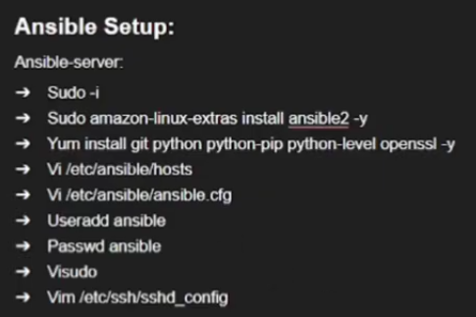

* Run sudo -i to got to root
* Install ansible using 2nd command
* Install git and python using second command
* Now run below command to add dev and qa nodes IP’s to write in hosts file.
  + CMD: vi /etc/ansible/hosts
* Now we need to add dev and qa ip address in vi editor by going insert mode

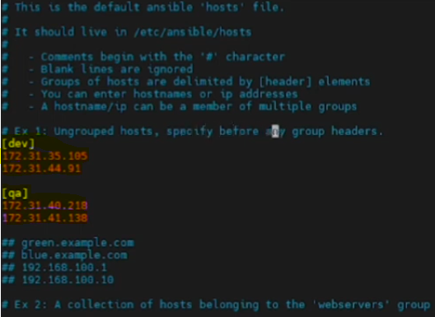

* Save the file
* Now we need to un comment the ansible inventory and rootuser in ansible.cfg
  + vi /etc/ansible/ansible.cfg

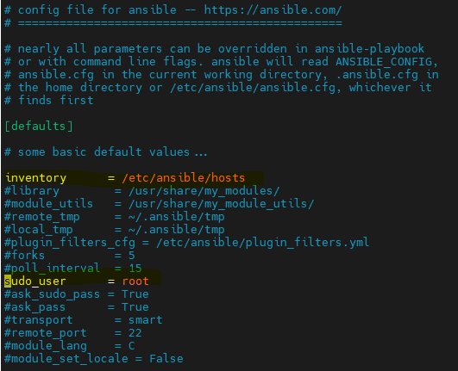

* we have removed the # from highlighted lines and saved
* now we have to create ansible user and set password
* Now we need to give root permission to ansible user
  + CMD: visudo

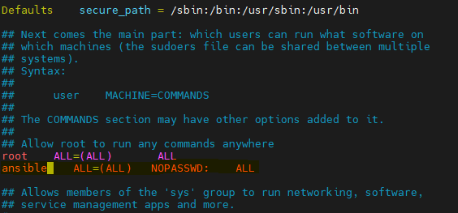

* Above we have given root permissions to ansible and saved the file.
* Now we need to set Password authenitication yes by below command
  + CMD: vim /etc/ssh/sshd_config
* Now we need to set Passwordauthentication as yes as below

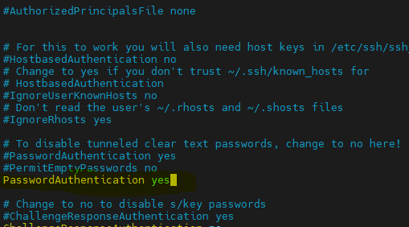

* Save the file
* So for what we did commands below on controller

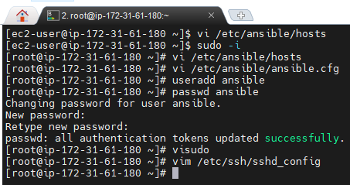

* Now we need to perform same as for few commands on node those commands are below

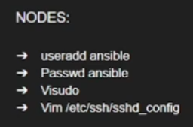

* We need to add ansible user and set pass
* Give sudo permission to ansible user
* Enable password authentication
* Now restart the sshd service as below

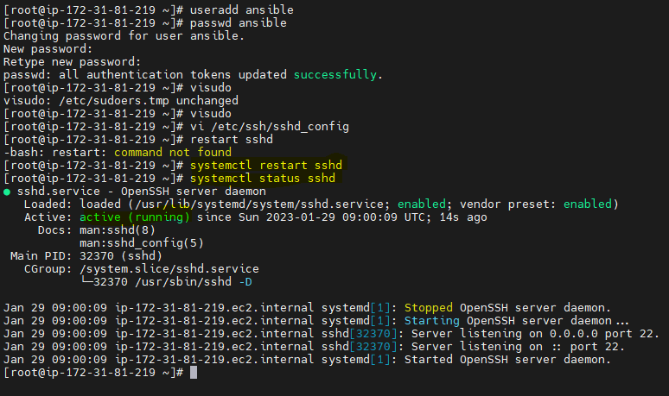

* Do above in all nodes
* Now login as ansible user in all servers using below command
  + CMD: su – ansible
* Now go to Ansible controller and generate ssh and copy in controller and nodes
* Go to controller run below
* Generate the ssh
  + CMD: ssh-keygen
* It will generate key like below

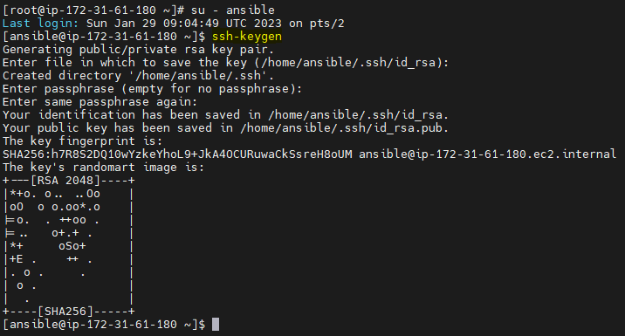

* Now copy the key in controller
  + CMD: ssh-copy-id ansible@controller ip (or) localhost
  + Or
  + CMD: ssh-copy-id <controller ip>
  + It will ask yes or no give as yes
  + And then give the password what you have given to ansible user
* Now copy key to key to node
  + CMD: ssh-copyy-id ansible@ip of node
  + Same give asnsible password
* Now do the same to copy the ssh id in all nodes by
  + CMD: ssh-copyy-id ansible@ip of node

Setup has been completed

* Now to check the ansible inventory use below command it will show the nodes we have listed in hosts file above in controller
  + CMD: ansible all --list-hosts

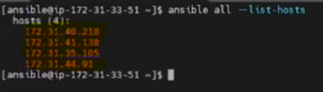

* So now we can do the configuration on all 4 servers registered from controller
* To check node in particular environment
  + CMD: ansible dev –list-hosts

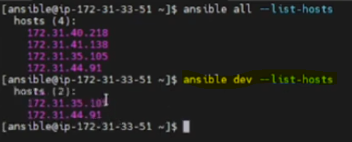

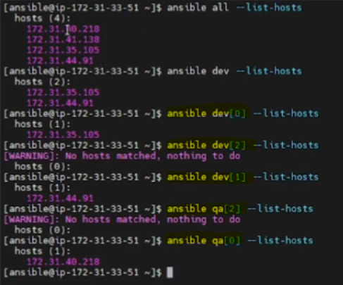

* Now we want to create file1 on all dev nodes using bleow command (below is Ad-hoc command)
* Ad-hoc commands are one time use and they can’t be reuse and this will not use in automation, this will only use an immediate and temporarily use.
* CMD: ansible dev -a “touch file1”
* It will create file1 in all dev nodes
* To check file list in all nodes
  + CMD: ansible dev -a “ls”
* Now we want to install git in all dev use below command
  + CMD: ansible dev -a “sudo yum install git -y”
* Now we want to delete the file1 from dev nodes use below commad
  + CMD: ansible dev -a “rm -rf file1”
* Now we need to install maven use below any one command
  + CMD: ansible dev -a “sudo yum install maven -y”
  + CMD: ansible dev -ba “ yum install maven -y”

Note: above we have used -ba and didn’t use sudo. -ba will work like sudo

**Ansible Modules**

* Ansible modules can be reused
* Ansible modules can be use like below

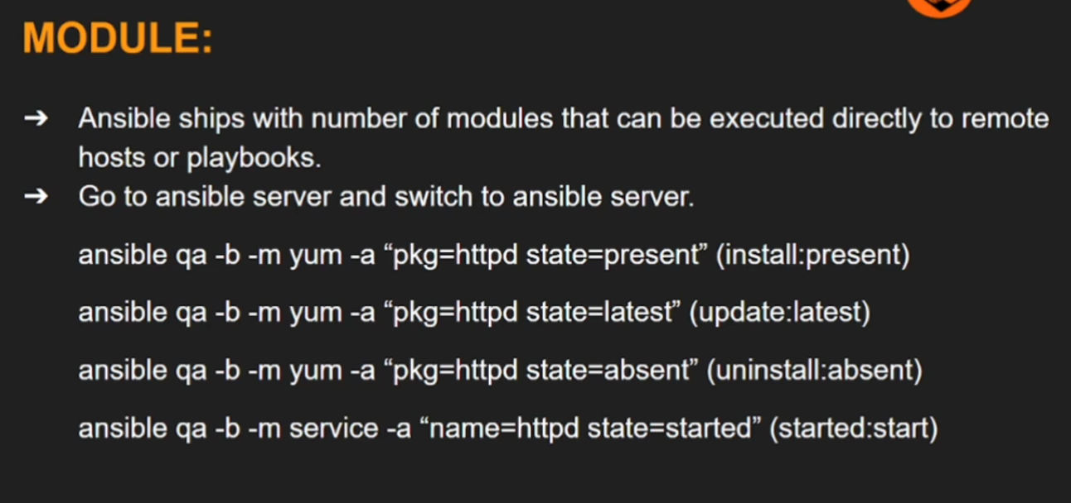

**Ansible-Playbooks**

* Ansible-playbooks are heart of the ansible
* Playbooks can use to automate configuration
* Playbooks can write in YAML language
* This will be used in DevOps

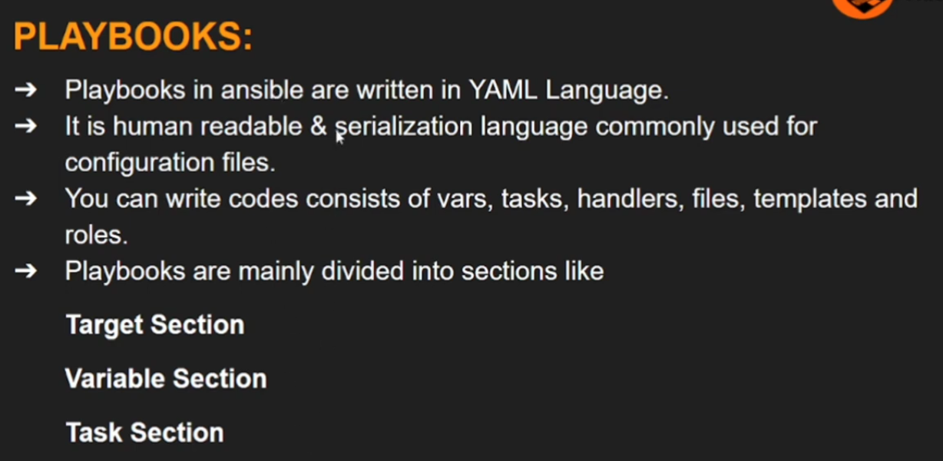

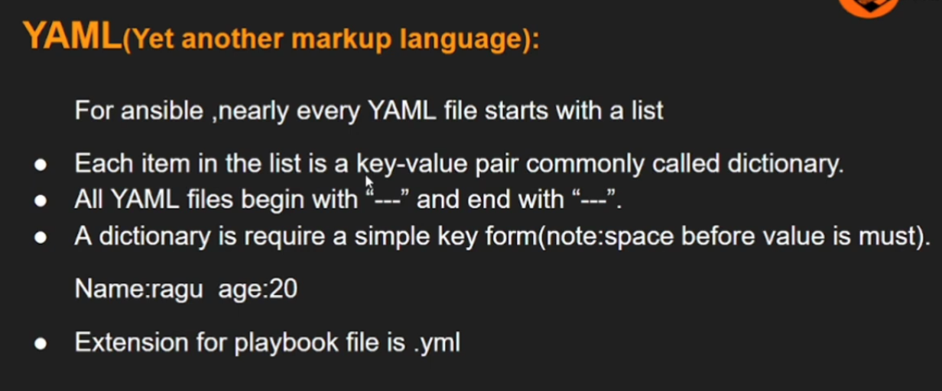

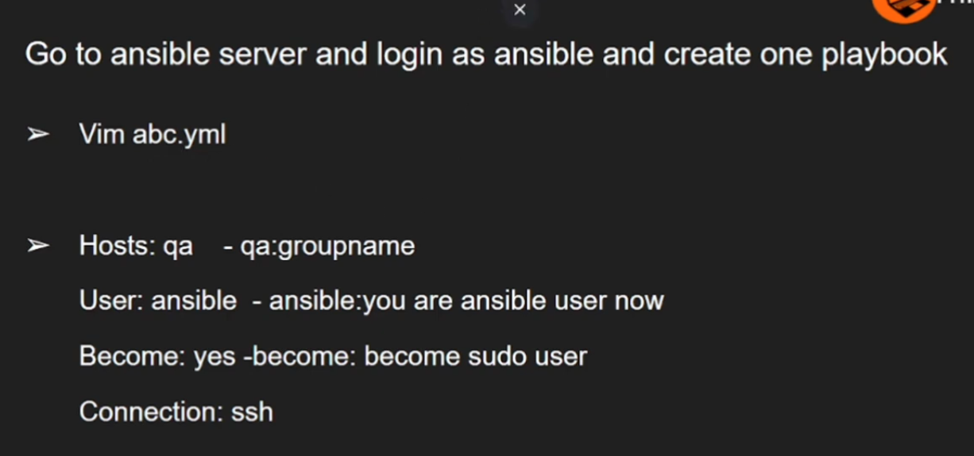

* Now we want to install httpd on all qa servers so we need to create the abc.yaml that is playbook file
  + CMD: vim abc.yaml

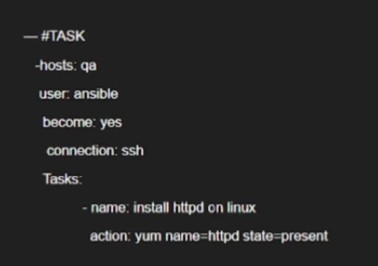

* Now save the file and run below command to execute the playbook
  + CMD: ansibe-playbook abc.yaml
* The above command will install the httpd

**Vars in Ansible:**

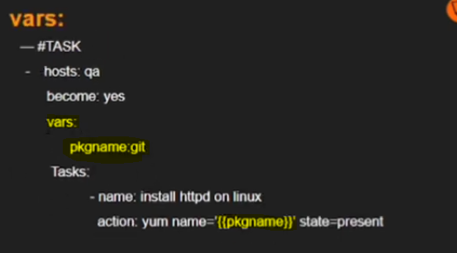

Note: above we haven’t include the connection:ssh, by default ansible connect on ssh

* Installing maven

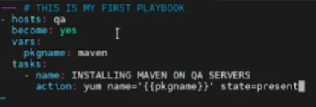

* Uninstalling maven

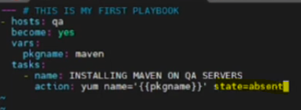

**Ansible Handlers:**

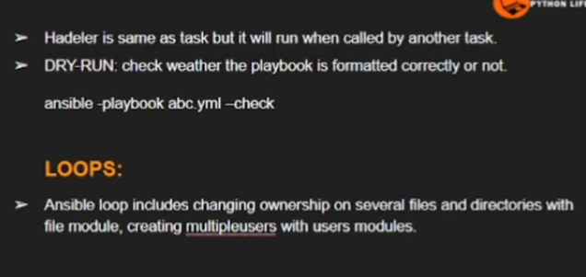

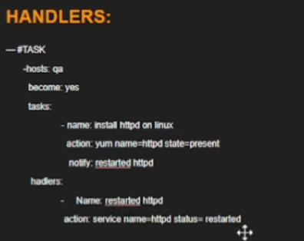

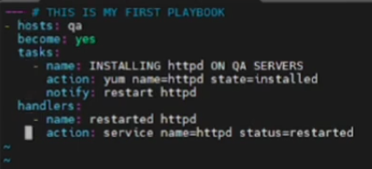

**Ansible Handlers:**

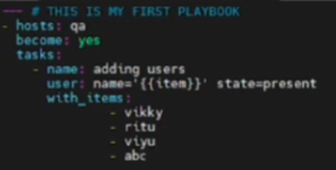

* The above will create the multiple users once