**Docker-3**

* Now we are building node js application
* Go to vs code and run below command in terminal
  + CMD: npm init -y
* The above command will create the “package.json” file
* Now we need to edit the package.json file as below.

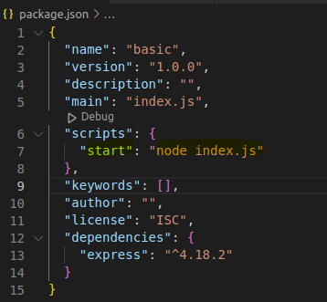

* Create index.js file
* Now run below command
  + CMD: npm install express
* The above command will create all dependent files
* Now go to express documentation and copy the hello world program and paste in “index.js”
* Do the changes as below

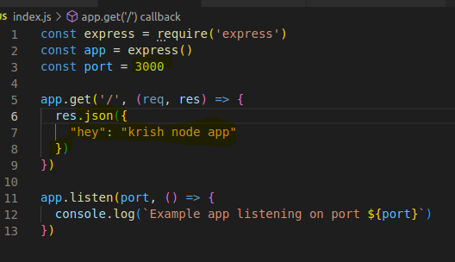

* Now create Dockerfile as below

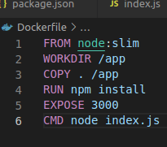

* Now build docker and run

**Creating Python application & Attaching MongoDB**

* First we need to pull the mongo db and mongo-express using below commands
  + CMD: docker pull mongo
  + CMD: docker pull mongo-express
  + Now we need to run both and attach them
  + Wen need to create docker compose to attach both and run together.
* Note: docker-compose will create the network automatically and place both containers in the network. By using docker-compose we can run both at a time.
* Lets create docker-compose.yaml as below

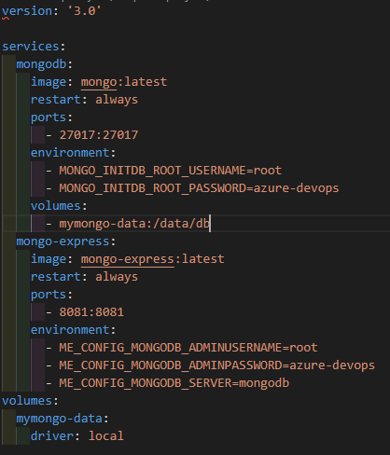

* Now run below command to run the both containers
  + CMD: docker-compose up -d
* Now we can check both containers on localhost:8081

**Creating and Running Python Flask image**

* Now we need to go to Vs code and create new file as “index.py”
* Go to internet and search as python flask code copy that and paste in index.py
* Index.py should be as below

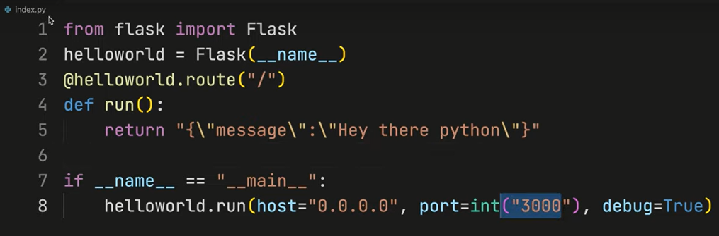

* Now create requirements.txt and in that file write as “flask” and save the file
* Now we need to write Dockerfile as below

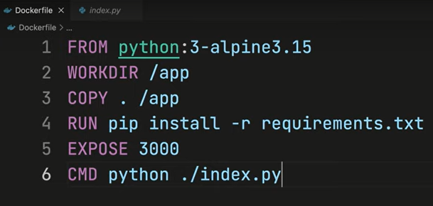

* Now we can build and run the image