**Post Graduate Diploma in Project Management**

**(PGDPM)**

**424: PROJECT REPORT**

### **Coordinator**

Prof. V. Mary Jessica



**Centre for Distance and Virtual Learning**

**University of Hyderabad**

**Hyderabad-500 046**

**A Study on Evaluation of Project Management Practices for a Start-Up Business - Restaurant on Wheels**

##### 

##### **Project Report**

(A Report Submitted in Partial Fulfilment of the Requirements for the Post Graduate

Diploma in Project Management in University of Hyderabad)

Submitted by Mr. Sriram Sai Krishna

Enrolment No. 11PM02464-21



**CENTER FOR DISTANCE AND VIRTUAL LEARNING**

**UNIVERSITY OF HYDERABAD**

##### **DECLARATION**

I, Mr. Sriram Sai Krishna , hereby declare that the Project Work titled “**A Study on Evaluation of Project Management Practices for Start-Up Business - Restaurant on Wheels**” is the original work done by me and submitted to the University of Hyderabad in partial fulfillment of requirements for the award of Post Graduate Diploma in Project Management (PGDPM) is a record of original work done by me under the supervision of Prof. Dr. V. Mary Jessica.

Center for Virtual and Distance Learning, University of Hyderabad

(Organization of the guide)

Enrolment No: 11PM02464-21

Date: 15 May 2022

Signature of the Student

# 

# 

# **PREFACE**

This report is prepared as part of my final project, for Post Graduate Diploma in Project Management (PGDPM). The report is prepared with the view to include all the details regarding the project that I carried out.

This project report is based on the business plan of start-up – Restaurant on Wheels, located in SanDiego, California.

This project report outlines how they created a Start-up from the ground up while following Project Management Practices, which quickly became popular and profitable.

I have provided a microscopic picture of the industry by researching the various business models used by various types of restaurants in and around SanDiego, California. The Annexure section of the report contains all of the specifics of the organizational units that I reviewed.

This paper provides an overview of the industry, highlighting major elements that have formed patterns, demand, and how the food truck sector has come full circle from its inception.

The report also includes the following:

■ Data points are used to comprehend the past, assess the present, and forecast the future.

■ Trends that may have an immediate and long-term influence on the restaurant-on-wheels industry.

■ A better grasp of the target audience's motives, objectives, and service provider expectations.

**This report is not just data, but the insights that I have incorporated in our strategic decision-making for the business.**

# **ACKNOWLEDGEMENT**

I would like to convey my heartfelt gratitude to everyone who helped me complete a project report titled “**A Study on Evaluation of Project Management Practices for Start-Up Business - Restaurant on Wheels**”.

I'd like to thank Professor for this chance. V. Mary, M.D. Jessica Madam, Coordinator of the Center for Virtual and Distance Learning, University of Hyderabad,

I'd like to take this opportunity to thank my seniors for assisting me in reverse engineering my real-time experience and preparing the report on our new venture.

Last but not least, I am grateful to my parents for their support in pursuing the course and at every stage of my life.

**TABLE OF CONTENTS**

| **S No** | **Contents** | **Page No** |
| --- | --- | --- |
|  | Preface | 4 |
|  | Acknowledgement | 5 |
| 1 | Abstract | 9 |
| 2 | Introduction | 11 |
| 3 | History of Mobile Restaurants | 12 |
| 4 | Restaurants of Several Types | 17 |
| 5 | 7 P’s of Restaurant on Wheels | 23 |
| 6 | Data Analysis |  |
|  | Food Truck Business SWOT Analysis | 29 |
|  | Financial Projection of the Start-Up Restaurant on Wheels | 34 |
| 7 | Generally Asked Questions | 37 |
| 8 | Conclusion |  |
|  | Introduction | 45 |
|  | Findings | 45 |
| 9 | Annexures |  |
|  | Future Scope | 47 |
|  | Research Methodology | 48 |
|  | List of References | 49 |

**LIST OF FIGURES**

| **S No** | **Contents** | **Page No** |
| --- | --- | --- |
| 1 | Figure 1: Chuckwagon | 12 |
| 2 | Figure 2: Dog wagon | 13 |
| 3 | Figure 3: Oscar Mayers Food Truck | 13 |
| 4 | Figure 4: Oscar Mayers Food Truck | 14 |
| 5 | Figure 5: Grease truck | 14 |
| 6 | Figure 6: Food Vendor project | 14 |
| 7 | Figure 7: Kogi | 15 |
| 8 | Figure 8: Food truck race | 15 |
| 9 | Figure 9: Mobile Cuisine | 16 |
| 10 | Figure 10: National Food Truck Association | 16 |
| 11 | Figure 11: Ethnic Restaurant | 17 |
| 12 | Figure 12: Quick Service Restaurant | 17 |
| 13 | Figure 13: Quick and casual Dining Restaurant | 18 |
| 14 | Figure 14: Relaxed Dining | 19 |
| 15 | Figure 15: Casual Dining | 19 |
| 16 | Figure 16: Barbeque | 20 |
| 17 | Figure 17: Cafe | 20 |
| **S No** | **Contents** | **Page No** |
| 18 | Figure 18: Cafeteria | 21 |
| 19 | Figure 19: Food truck | 21 |
| 20 | Figure 20: Pop up Restaurants | 21 |
| 21 | Figure 21: 7 Ps | 23 |
| 22 | Figure 22: Product decisions | 24 |
| 23 | Figure 23: Pricing strategies | 24 |
| 24 | Figure 24: Swot Analysis | 29 |

**ABSTRACT**

This study utilizes both quantitative and qualitative data collecting and analysis methodologies. Data was acquired through an online poll targeting daytime inhabitants of SanDiego and an interview with the owner of start-up "Restaurant on Wheels" to capture best practices for mobile food vehicle techniques followed in those other cities identical to SanDiego, California. The opinion survey was conducted using convenience sampling, with the survey link emailed to randomly chosen persons and attendees at the SanDiego food truck festival. The SWOT analysis methodologies used in creating this business, finances procured, funds acquired from individuals, expenses and budgets involved in setting up this start-up, on-going expenses incurred over a year, collected and analyzed and ascertained the Profit or Loss statement, future revenues prediction are all thoroughly examined. Regardless of any apparent gender bias, the respondents represented the target demographic for the city's Food Truck Park.

**INTRODUCTION**

**&  
HISTORY OF MOBILE RESTAURANTS**

**INTRODUCTION**

A food truck is a huge vehicle that is capable of cooking and selling meals.

Some, such as ice cream trucks, offer frozen or pre-made food; others, such as food trucks, have mobile kitchens and create meals from scratch. Burgers, cheeseburger, French fries, and other local fast food items are widely available. Food trucks serving delicious food and a range of expertise and ethnic menus have grown popular in recent years, as part of the pop-up restaurant boom.

Food trucks, portable food booths, and food carts are at the forefront of the street food sector, which feeds an incredible 3 billion people daily.

The methods and technologies used to change raw components into food for humans are referred to as food processing. Food may be made in a number of different ways.

**Batch production:** This strategy is utilized when the size of a product's market is unknown however there is a range within a product line. A batch or run will consist of a set number of the same items; for instance, a bakery may prepare a restricted number of cupcakes.

**HISTORY OF MOBILE RESTAURANTS**

The Food Trucks Industry is made up of businesses that specialize in cooking and serving meals from a mobile truck. On the truck, food is usually prepped, stored, and cooked. The vehicle may or may not park in the same spot every day.

A food truck is a truck that transports and sells food. It is also known as a mobile kitchen, mobile canteen, roach coach, gut truck, and food service truck in various locations. If it transports a specific type of meal, it may alternatively be referred to as a breakfast truck, a lunch truck or waggon, a snack truck, a kebab trailer, a break truck, or a taco truck. They are frequently positioned in areas where there are customers, such as larger enterprises or schools. Some food trucks offer ice cream and frozen or pre-made foods, while others have onboard kitchens and prepare fresh meals. Sandwiches, hamburgers, French fries, and other regional fast food items are widely available.

Food trucks may be traced back to the "chuckwagon," a waggon used to transport food and cooking utensils during cattle drives in the nineteenth century. Charles Goodnight, a Texas farmer known as the "Father of the Texas Panhandle," established it in 1866. He utilized a US Army vehicle that was outfitted with floating shelves. He next loaded the waggon with long-lasting crockery and food, such as dried beans, coffee, cornmeal, and other items. These carts quickly became popular, and by the 1890s, they were a regular sight in major towns, where they fed night-time employees.

**Figure 1: Chuckwagon**

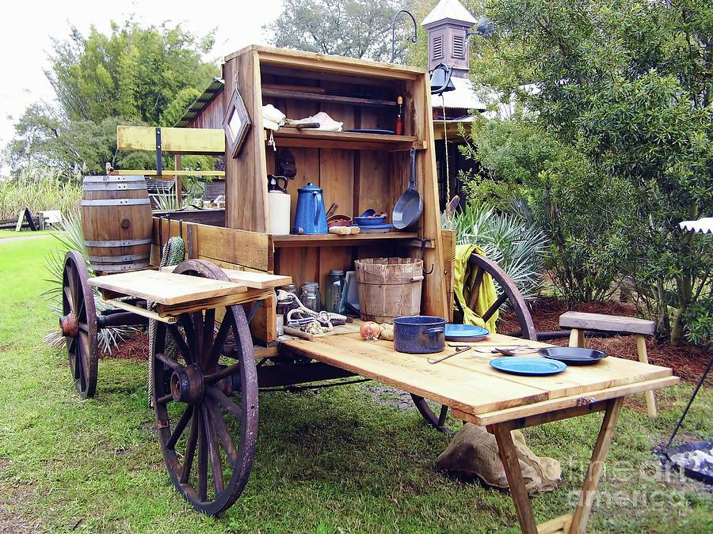

In 1894, "dog waggon" vendors began selling hot dogs from outside student dorms of major eastern colleges.

**Figure 2: Dog wagon**

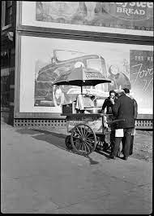

In 1917, the United States Army invented and sanctioned the first food truck, a mobile canteen.

In the United States, the mobile food sector has a brief history:

In 1936, Oscar Mayer introduced the Weiner Mobile, the first transportable hot dog vendor. In 1950, the first ice cream trucks arrived on the streets.

**Figure 3: Oscar Mayers Food Truck**

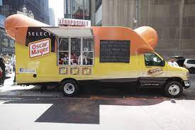

Raul Martinez created very first taco truck in the United States in 1974.

**Figure 4: Oscar Mayers Food Truck**

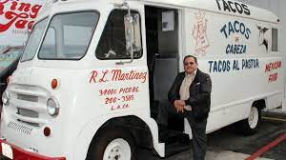

Grease trucks started parked on Rutgers University's campus in New Brunswick, NJ, selling "Fat Sandwiches" to college students in the 1980s.

**Figure 5: Grease truck**

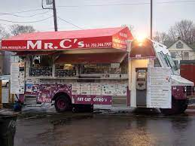

The Food Vendor Project establishes the Vendy Awards in 2004. A competition that finds and honors the greatest street food sellers in New York City.

**Figure 6: Food Vendor project**



Kogi BBQ debuted on the city of Los Angeles in November 2008, selling Asian-inspired tacos.

**Figure 7: Kogi**

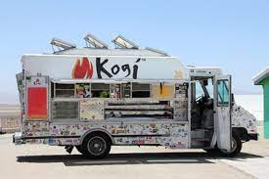

The Southern California Food Ordering Vendors Organization (SoCalMFVA) is founded in January 2010, becoming the first group to safeguard the rights of fancy food truck entrepreneurs.

May 2010 — At its annual conference in Chicago, the National Restaurant Association wanted to dedicate 1,500 square feet to food delivery exhibitions.

The Great Food Truck Race is the first television programme focusing on the mobile food business, premiering in August 2010.

**Figure 8: Food truck race**

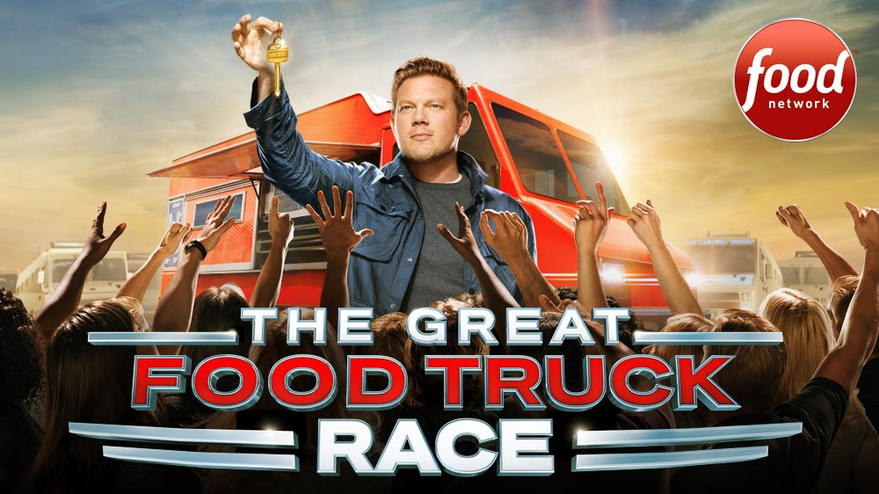

September 2010 – Mobile Cuisine (mobile-cuisine.com) is the first website to give nationwide coverage of the mobile food business.

**Figure 9: Mobile Cuisine**

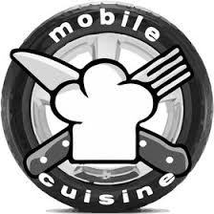

September 2010 – The US administration updates its business website business.gov with "Tips for Starting Your Own Street Food Business."

August 2011 – The Gap starts a statewide advertising campaign including a food truck to promote a retro-style denim.

The National Food Truck Union was founded in June 2014, becoming the first national union of food truck associations.

**Figure 10: National Food Truck Association**

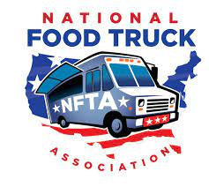

**RESTAURANTS OF SEVERAL TYPES**

**i) Ethnic Restaurants**

Ethnic restaurants are restaurants that specialize in ethnic or national cuisines.

**Figure 11: Ethnic Restaurant**

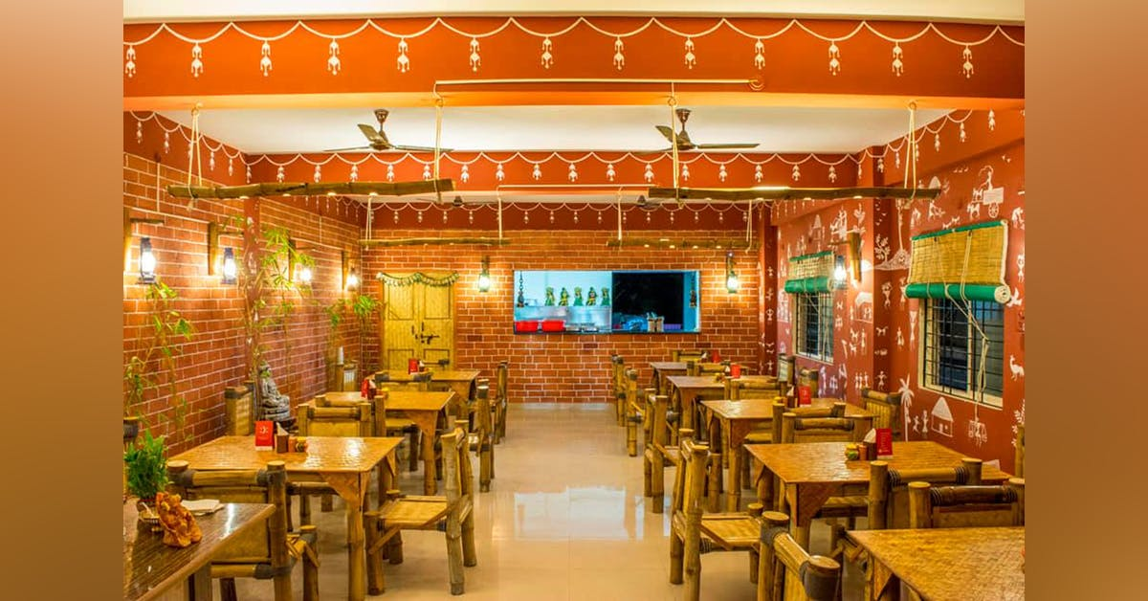

**ii) Quick service restaurants**

Fast food restaurants place a premium on quick service. Small-scale street vendors with food carts to multibillion-dollar businesses like McDonald's and Burger King are all involved.

**Figure 12: Quick Service Restaurant**

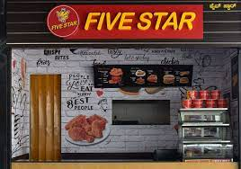

Food is ordered at a front counter rather than at the table (or in some cases, using an electronic terminal).

In the restaurant sector, fast food restaurants are referred to as QSRs (quick-service restaurants).

**iii) Quick and casual Restaurant**

Fast casual restaurants are mostly chain restaurants where the majority of the food is made on site rather than at fast food companies.

Although fast casual restaurants do not typically provide full table service, many do provide non-disposable plates and cutlery. The food quality and prices are often greater than those of a traditional fast food restaurant, but they may be lower than those of casual dining.

**Figure 13: Quick and casual Dining Restaurant**

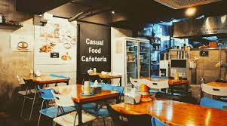

**iv) Relaxed Dining**

A casual dining restaurant is one that delivers reasonably priced food in a relaxed setting.Table service is common at casual dining establishments.

Casual eating is a market sector that exists between fast food and fine dining restaurants. A full bar with separate bar staff, a wider beer menu, and a limited wine menu are common features of casual dining restaurants.

**Figure 14: Relaxed Dining**

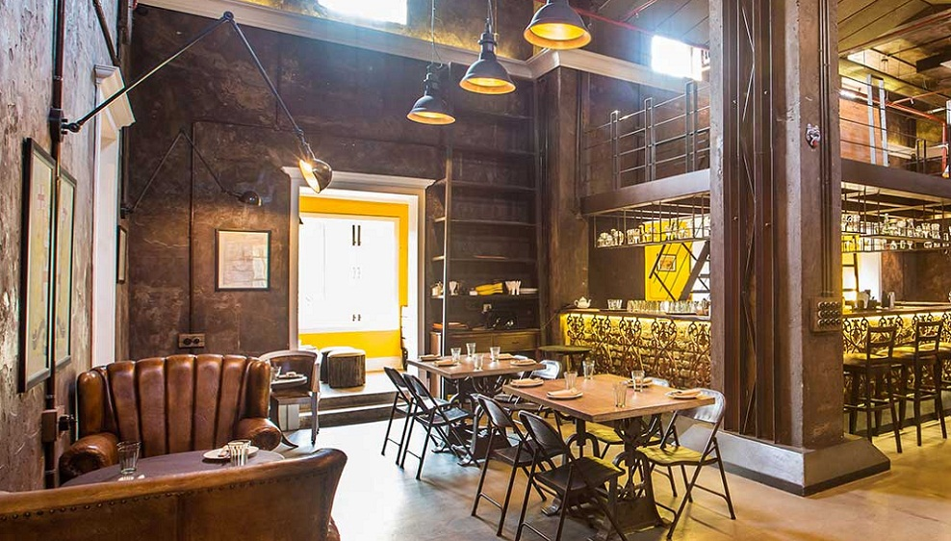

**v) Family-friendly**

Family style restaurants are informal dining establishments that offer food on platters and allow diners to serve themselves.

**vi) Casual dining**

Fine dining establishments offer full service and specialize in certain meal courses. The décor of such restaurants is made of higher-quality materials, and the venues have certain eating standards that patrons are expected to obey.

**Figure 15: Casual Dining**

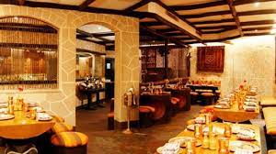

**vii) Barbecue**

Barbecue is a type of restaurant that specializes on barbecue-style cuisine and dishes.

**Figure 16:Barbeque**

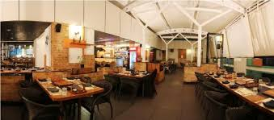

**viii) Cafe**

Cafés are casual eateries that serve a variety of hot meals and made-to-order sandwiches. Coffee shops, while comparable to cafés, are not restaurants because they offer and rely on hot drinks for the majority of their earnings. Many cafés serve full hot meals and are open for breakfast.

**Figure 17: Cafe**

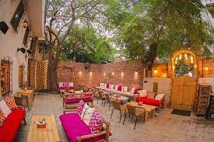

**ix) Fine Cafeteria**

A cafeteria is a restaurant that serves ready-to-eat cuisine from behind a counter. Table service is minimal to non-existent. In most cafeterias, self-service is the practice. It is most commonly seen in institutes,hostels, and cafeterias in offices.

**Figure 18: Cafeteria**

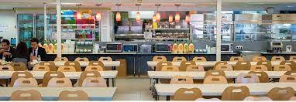

**x) Restaurants with food trucks**

Mobile food truck restaurants are a popular food trend around the country. Little cost and low overhead are two advantages of food trucks.

**Figure 19: Food truck**

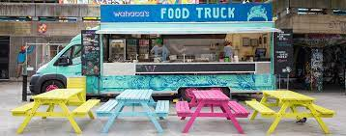

**xi)Pop up restaurants**

Pop-up restaurants, like food trucks, are a growing trend in the hospitality business.

**Figure 20: Pop up Restaurants**

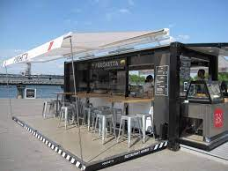

**7 P’S OF RESTAURANT ON WHEELS**

**7 P’S OF RESTAURANT ON WHEELS**

The 7 Ps are a series of well-known marketing strategies that you can employ in any order to please clients in your target market. The seven Ps are within your control, but they are influenced by your internal and external marketing environments. Using a 'tactical marketing mix' means combining these distinct marketing strategies to fulfill your clients' demands and wishes.

**Figure 21: 7 Ps**

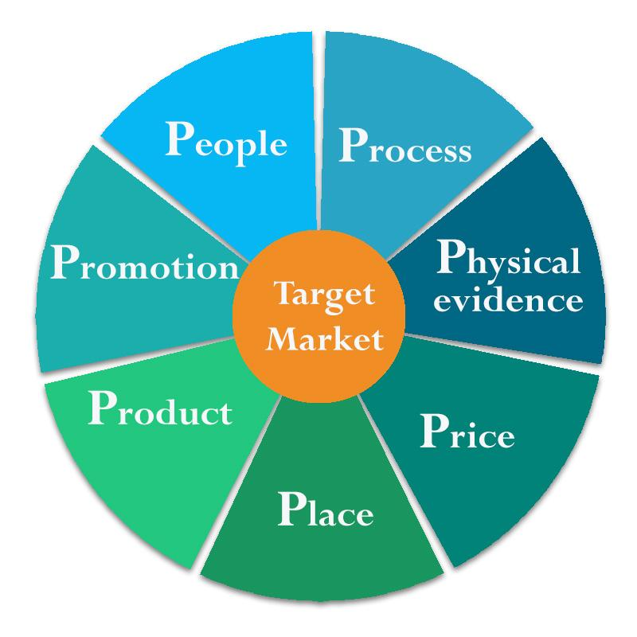

**i) PRODUCT**

Menu goods and services provided by the food truck are examples of products. Quality, design, features, packaging, customer service, and any following after-sales service should all be considered while producing a product. The menu offerings vary depending on the location and type of mobile restaurant.

The term "product" refers to what you're selling, as well as all of the characteristics, advantages, and benefits that your clients will receive as a result of purchasing your goods or services. When promoting your product, consider the important qualities and benefits that your customers desire or need, such as styling, quality, repairs, and accessories.

**Figure 22: Product decisions**

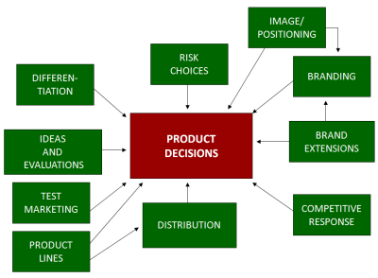

**ii) PRICE**

The amount of money that customers must spend in order to purchase food truck products is referred to as price. The price will be determined by local demand, resource availability, and consumer preferences.

This pertains to your product and service price strategy and how it will affect your customers. You should figure out how much your customers are willing to pay, how much overhead you need to cover, your profit margins and payment options, and other expenses. You may also want to consider discounts and seasonal pricing to entice clients and maintain your competitive advantage.

**Figure 23: Pricing strategies**

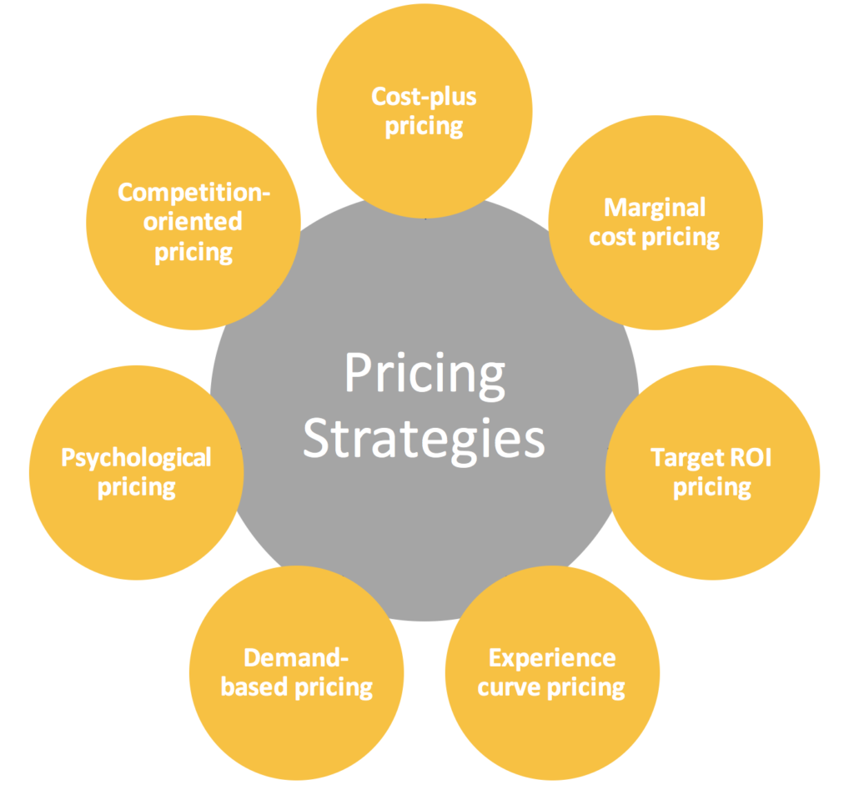

**Pricing Strategies:**

Let's take a deeper look at a few most prevalent pricing techniques as mentioned above.

**Dynamic pricing**

In some businesses, you may get away with adjusting your rates all the time to reflect the market demand for the goods. Customers anticipate constant monthly or yearly expenditures, hence this does not work well for premium service and Subscription businesses.

**Price comparison**

You'll be adopting the price skimming approach if you set your prices as high as the market will bear and then gradually lower them. The idea is to skim the top of the market and reach everyone else at lower pricing. It can work with the correct substance, but you should use it with caution.

**Value-based pricing**

You establish your prices depending on what your customers believe your product is worth.

**Cost-effective pricing**

You establish your prices depending on what the competition charges when you utilize a competitive pricing approach. This can be an excellent strategy in the right conditions, such as for a new corporation, but it leaves little possibility for expansion.

**Cost - plus pricing**

This is one of the most straightforward pricing schemes. Simply take the product's manufacturing cost and multiply it by a percentage. While it is basic, it is not suitable for anything other than physical things.

**Penetration Pricing**

It can be difficult for new businesses to establish themselves in highly competitive marketplaces. Some corporations try to sell new items by giving prices that are significantly lower than the competitors. This is known as penetration pricing. While it may bring you consumers and reasonable product sales, you'll need a number of them and they'll have to be incredibly devoted to remain around if the price rises in the future.

**Pricing for the masses**

This method is widely used in the commodity products industry. The idea is to price a service lower than the competitors and recoup the difference through increasing sales. While it's a terrific way to persuade to buy your generic drink, it's not ideal for subscription businesses.

iii) **PLACE**

Place is in regards to distribution, location, and methods of getting food truck products to the customers. Restaurant on wheels is located in SanDiego, California. It works efficiently in busy areas.

Your items and services are seen, created, sold, and distributed in a specific location. Customers need easy access to your items, and you need to make sure they can discover you.

You may differentiate yourself from the competition by implementing efficient visual merchandising tactics and designing your retail location. Even if you don't run a physical store, location is a vital aspect of any marketing strategy. Customers may require a short turnaround or prefer to purchase things made locally.

Finding the right business location is an important marketing strategy for new businesses.

Businesses develop a location strategy by establishing where their target audience shops. A cookbook publisher, for example, can display its items in a bookshop to reach clients seeking for books, as well as in a housewares store to connect with customers engaged in cooking.

Market positioning is another name for distribution strategy. Place strategy may be divided into three categories:

**Intensive:** When a corporation uses an intense location strategy, it places its goods in as many outlets as feasible. Candy firms frequently employ this method when distributing their products at supermarkets, movie theatres, convenience shops, and airports.

A selective location strategy is one in which a corporation places their goods in only some few distributors.

When a corporation uses an exclusive location strategy, it places its goods in only one store. This is typically used for luxury items that require salesperson to impart a lot of product knowledge during in the sale, such as automobiles.

**iv) PROMOTION**

The act of presenting the benefits and worth of a food truck's product to clients is known as promotion.

Advertising, sales strategies, promotions, and direct marketing are examples of promotional activities used to make clients aware of your products and services. These are sometimes referred to as marketing strategies.

**v) PHYSICAL EVIDENCE**

Everything your customers see while dealing with your company is referred to as physical evidence. This covers the physical setting in which you provide the product or service, the layout or interior design of your product or service, as well as your packaging and branding.

Physical evidence can also apply to your employees' appearance and behaviour.

Consider how the layout, fixtures, and signage in your store may help you create your brand and enhance sales.

**vi) PROCESS**

The processes involved in delivering your products and services to customers are referred to as processes. Being 'better able to deal with' is also important.

Having solid processes in place ensures that you: give the same level of service to your clients on a consistent basis save time and money by increasing efficiency

**vii) PEOPLE**

People refer to your company's employees and salesmen, including yourself.

When you deliver exceptional customer service, you provide your customers a positive experience and promote your brand to them. Existing clients may then spread the word about your exceptional service, resulting in referrals.

Recruiting the proper people, training your employees to improve their abilities, and retaining good employees will provide your company a competitive advantage.

**DATA ANALYSIS**

**&**

**GENERALLY ASKED QUESTIONS**

**FOOD TRUCK BUSINESS SWOT ANALYSIS**

**Introduction**

A food truck company consists of just a food truck with such a valid license to park, prepare meals on the truck, and serve the people while traveling about. You've probably seen food carts parking from outside retail malls or office complexes. It differs from ordinary hotels and restaurants in that it must visit particular sites at various moments of the day on its tour. Then, instead of waiting for consumers to come to you, you go to them. Whenever it comes to meal service and preparation, it is the same now as in other hotels.

As per an IBIS World survey, there are roughly 23873 food stalls in the United States, with over 28916 individuals working by 2020. As per projections, the food truck industry is increasing at a rate of 5.4 percent vs 4.3 percent. In comparison to its results in 2019, it really has increased by almost 20% for one year. As per Forbes, the total income earned by the food truck company in 2019 was $985 million US dollars. It's time to talk about the food truck business's SWOT analysis and take a careful look at its different activities in terms of strengths, weaknesses, opportunities, and threats. It is as follows:

**Figure 24: Swot Analysis**

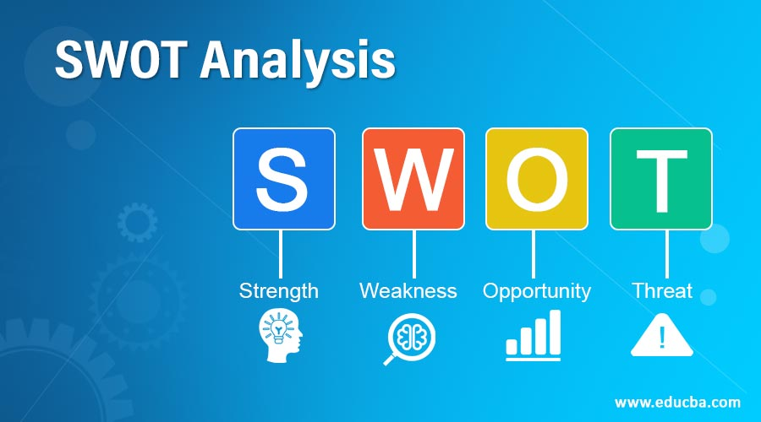

**i) Strengths**

The following are some of the food truck industry's advantages:

**Brand Awareness**

If you have a hotel and a restaurant and your marketing budget is limited, you may reach a larger audience and create trust. An eatery is an excellent way to create your brand's image and gain people's confidence. Some consumers find it difficult to trust any business identity, but they will once they meet you and taste your cuisine. They may reconsider their feelings toward you.

**Rent is reduced**

To start a hotel or restaurant it is quite expensive, and rents are indeed very high in congested areas. A food truck spares you the headache of paying costly rent. Once you have a permit, you can begin your journey from wherever you want.

**Experienced Staff**

Staff with a lot of experience implies professional drivers and a flexible cook. Because this is a mobile food company, the cook must be adaptable in order to produce meals in a tiny, mobile kitchen without sacrificing food quality or taste. The truck driver must be familiar with the route and be aware of numerous public business locations where additional revenues may be generated.

**Food that is new and exciting**

The food truck has little storage space. As a result, they prepare and cook meals at the same moment, leaving little area for storage. People can sample freshly prepared cuisine. People will not be able to queue for hours for food to be prepared, therefore you must come up with a novel way of cooking and display meals in a short amount of time.

**Rapid Service**

Sometimes, especially at upscale hotels, you must make a reservation days in advance. Food trucks, on either hand, allow you to walk about, buy food, and enjoy it wherever you want.

**Low Costs**

The meal menu costs at premium hotels and restaurants are quite costly. In comparison, food trucks provide meals at very affordable prices to ordinary people earning minimum wage. When you provide a high-quality service at the lowest price, you may quickly get a large market share.

**Location Versatility**

We know this is a food truck, a mobile vehicle with the ability to park wherever if permitted. Some restaurants and hotels nearby office buildings or in tourist areas rely on either employees or tourists for revenue. They are frequently closed on weekends and special days since no one is present. Food trucks, on the other hand, have the mobility to travel around and take business in congested areas. Take the business wherever the clients are.

**ii) Weaknesses**

The following are among some of the food truck industry's flaws:

**Limited Funding**

Establishing a food truck company is less expensive than opening a hotel or restaurant. However, this does not imply it would be bankrupt. Of course, a suitable amount of money is required to purchase a vehicle as well as other legal expenses to complete basic permission requirements. These prices differ from one country to the next and from one state to the next.

**Food Ingredients That Are Expensive**

Because fundamental food components are growing more expensive, food trucks must provide meals at a reduced price to separate themselves from competition and lure the price-conscious consumer. If they accomplish that, it will barely cover their costs.

**Least Experiential**

Whether you're new to the food truck industry, you'll have less experience dealing with day-to-day challenges. Since it's a traveling food company, you'd meet all types of individuals, from affluent to poor, modest to impolite. It will take some time to understand how to deal with them while still making a profit.

**Inadequate Information**

In the mobile food truck, there are items about the market, preparation style and procedure, and data about just the route and schedule at various locations. Nobody will provide you with such knowledge; you must learn it for yourself by keeping engaged in the market. So rivals have this knowledge advantage over business, and they will continue to use it on you as long as you do not discover it.

**iii) Opportunities**

The following are among the opportunities open to the food truck industry:

**Collaboration with Regional Bars and Clubs**

The clubs and regional bars solely provide beverages. If you agree to give the dinner in the night or at midnight by staying on standby outside their club. It's a fantastic chance for pubs and clubs to diversify their menus and attract new clientele.

**A Larger Market**

The food industry is vast, and we all need to eat in order to survive. Except for the rich, individuals in the era of business and technology who are busy with their work don't really have much opportunity to join luxury restaurants. However, the bulk of regular employees are the target audience for food trucks. They will buy meals for you every day if you provide them with good service at a cheap price.

**Customers' feedback on a new product**

In conclusion, it all boils down to food quality and flavor. When you have the skill and talent to try out new ideas by incorporating new flavors and tastes into your meals. If clients enjoy it, you will attract more customers as long as you're willing to provide great service.

**Modern Enterprise**

The food truck industry is an example of a newly developing company. Although the market is very competitive, it has not grown overloaded. There is enough market share for newcomers to enjoy. They can get a significant market share if they deliver high-quality service and perform successfully.

**Website and smartphone apps**

Given that we live in a technological age, having a website for your business and providing a smartphone app to your clients would be advantageous. It will, however, help you when you run your eatery or begin delivery services on weekends. If your cuisine tastes nice, people will post positive evaluations, and you will gain more new customers.

**COVID-19**

The food trucks have a fresh chance due to the Coronavirus (COVID-19) shutdown. People are stranded at home, and restaurants and hotels are closed. Food trucks are similar to delivery services in that they may deliver food to people's homes.

**iv) Threats**

The following are among the risks which the food truck industry faces:

**Legal Obligation**

Some nations and states make it difficult for food trucks to obtain permits. In truth, their legal criteria are quite tough to meet and vary by state. Going all around the city in a food truck and serving everyone without a permission may result in a significant lawsuit from the authorities. As a result, a permit is issued before traveling around.

**Simple to replicate**

Because there are no licensing issues. A rival may control the industry, copy your recipe, and sell the identical product and taste under a new product line. This competition would grab your market share and you would be unable to stop it.

People Who Care About Hygiene

Many customers are highly particular about hygiene, so you must exercise extreme caution when it comes to the cleanliness of your food and your vehicle. If they notice something unsanitary, they will ruin the thoughts of someone else and you will lose your company as a result. The cleaner your food, clothing, and vehicle are, the more consumers you will attract.

**FINANCIAL PROJECTION OF THE START-UP**

**RESTAURANT ON WHEELS**

**i) Obtaining Investment / Seed Funding for Our Portable Food Company**

They did not plan to bring in outside business partners to participate in the company, at certainly not for the first five years, which is why they have limited our initial funding to

* Obtain soft financing from friends and family
* Use my savings to fund a portion of the start-up cash
* Acquiring a bank loan

They have already been able to earn well over 60% of the funds required to launch the firm, and the majority of the equipment they have acquired are on a time-based installment basis.

**ii) Startup Expenses and Budget**

* The registration fee for a business is $725.
* The insurance, permits, and licensing budget is $10,000.
* Renting an office space with a storefront and space for four months in SanDiego, California, costing $50,000.
* A brand new converted eatery with all the necessary equipment (stove, roaster, coffee makers, barbeque, hot – dog maker, and refrigerator) costs $120,000.
* The cost of cooking equipment, pots, and pans, etc. is $15,000
* A month's supply of raw meals, ingredients, drinks, and beverages costing $5,000.
* Food packing costs $2,000 dollars.
* A food cart costs $3,000 to purchase.
* The price of launching a website is $600.
* The cost of parking and vehicle upkeep for one month is $300

Total Outgoings: $211,625

The entire cost they anticipated to incur from the start of the firm until it is fully functioning is estimated to be around $250,000

**iii) Profit and Loss Statement – Financial Plan**

Businesses that do well are those that produce money from several sources. Running a firm in which you can only earn money from one source is dangerous. The fact is that if the source of money fails, the firm will most certainly fail.

That's why they tried so hard to create an example food truck marketing strategy document to assist you in the process. The overall goal for On the Go Mobile Food Company is to earn revenue from the following sources:

* Income Sources
* Beverage sales
* Our franchise sales
* Sales of the meals
* Snacks are being sold.
* Providing training services
* Providing consulting services in accordance with our business objectives

**iv) Income over the First Year:**

* Lunch Sales: Each person will pay $20 for a dish of food

The cost of 30,000 people is $600,000

* Snack sales: Each individual will pay $5 for a snack box

It will cost $250,000 to employ 50,000 people.

* Drink sales: A bottles of drink will cost $1.5 per person

A total of 80,000 people will pay $120,000

Total Revenue: $970,000

**v) Fixed Implementation Costs over the first year:**

* The amount required to rent an office space in Inglewood, Los Angeles, with a shop and parking for the next six months is $50,000.
* Yearly expense (staff wages, bill payments, and so on) – $160,000
* $80,000 for food and beverage restocking (pizza doughs, sugars, lard, wrappings, grains, beverages, food products, and so forth).
* $20,000 for office goods (stationery, paper products, plates/napkins, and so on).
* Fees for credit card processing – $1,000
* Other undetermined costs – $24,000

Total: $335,000

**vi) Sales Prediction**

It is critical to note that our sales prediction is based on facts collected during our feasibility analysis as well as assumptions. Depending on what they saw, these are for sales forecasts.

Meal:

* 1000 meals each day (on average), 365 days a year
* On average, $20 per person

Snack foods :

* 1500 snacks every day, 365 days per year
* On average, $5 per person

Spent on drinks and water :

* On average, more than 80% of people who pay for meals and snacking also buy beverages
* A glass of Coke costs $1.5 USD
* This translates to 2000 drinks per day; multiplying 2000 by 1.5 yields a daily estimate of $3000 from the sale of beverages alone

The potential of the figure increasing or decreasing could be thrown out. Because the majority of the statistics cited above are based in part just on reports of the market research and pre - feasibility and in part on assumptions.

**GENERALLY ASKED QUESTIONS**

The general and frequently asked questions of Restaurant on Wheels Start-Up are :

* What Really is the Average Food Truck Income?

The total revenue of a food truck fluctuates around $250,000 and $500,000.

* What Are the Best five Causes Food Trucks Mess up?

Below are the top five reasons why food trucks screw up:

* Without knowing who they are
* Never knowing who they're talking to
* Saving money on equipment
* They are not advertising their company.
* Presumptions about selecting quality over quantity
* What Are all the Advantages of Having a Food Cart?
* You will be your own boss.
* You will be working in a limited space and will be able to construct your own menu.
* There are always plenty of opportunities.
* It is less hazardous than starting a physical restaurant.
* So How Do Business Financial Statements Be Prepared?

To start preparing a financial statement, user must first produce a balance sheet report, then quantify one's revenue, ascertain one's sales price, evaluate one's net profit, involve operational costs, quantify ones earnings, involve taxable income, measure gross revenue, and finally finalize one's net income with business.

* How Often Money Does Food Vendors Make in a Day?

At a reasonable price, a food truck seller might expect to generate between $100 and $2,000 in net profit each day.

* How Then Do One Obtain Financing To Begin A Food Cart?
* Microloans from the SBA
* Finance for equipment
* Credit cards for businesses
* Crowdfunding initiatives
* Credit lines for businesses
* What Equipment Is Required for a Food Truck?

Some of the equipment required in a food cart operation is given below;

* Ovens \sMicrowaves
* Surfaces for food preparation
* Refrigerators and freezers; Sinks for ice makers, compartment sinks, and disposal sinks
* Equipment for safety; Gloves, aprons, and a first-aid kit are required.
* utensils for food preparation; Knives, chopping boards, as well as pots and pans
* Range; Grills and ventilation, gas, flat, and induction ranges
* How Many Food Truck Menu Options Will There Be?

At any given moment, many food vendors can handle between five and twelve different menu items. The simpler the better to maintain high quality.

* How Much Does Food Truck Owners Usually Make?

Setting up and maintaining a food truck operational expenses approximately $28,000 and $114,000, with the typical food truck making roughly $300,000 per year.

* And What's the Average Food Truck Startup Cost?

Food truck owners in modest, more mid-sized cities earn between $5,000 and $16,000 a month. As per the webpage Successful Enterprise, every famous food truck in a big metropolitan area may generate between $20,000 and $50,000 in sales.

* How Does A Food Truck Network Get Started?
* Register your company.
* Make a business strategy.
* Carry out your feasibility studies.
* Create a business contract document.
* Obtain the necessary licenses and permissions.
* The food truck parks will be leased and built.
* Promote and market your food truck park.
* How many people visit food trucks each day?

If a meal takes minutes to prepare for a client during a rush, you may serve up to 15 consumers every hour, 45 customers each 3 shifts, or 90 consumers per day if you're operating for 2 - 3 shifts.

* Is a Profit/Loss statement the same as an income statement?

Yes! An income statement is another name for a profit and loss statement. It is a fiscal statement that outlines the income, expenditures, and expenses incurred for a certain time period, generally a financial year or quarter.

* How Far Should I Start charging Food Carts to Serve at Our Food Park?

Food trucks will often spend $500 - $1000 to spot at an event.

* How Much is a Higher Profitability Return for such a Food Truck?

Whereas a greater catering business might generate earnings of 15% more than, the general standard operating income for only a food truck is around 7 to 8%.

* How Then do You Make A Statement Of Financial Position For A Restaurant?

Here are some principles for creating a business profit and loss statement:

* Select a time window
* Sales figures for the chosen time period
* Fill in the cost of products sold
* Labor
* Operating costs
* Costs of occupancy
* Depreciation
* How Then Do You Interpret A Restaurant Profit and Loss Statement?

To calculate gross profit, deduct complete (Components) from overall for that week. To generate this amount, add all of the Operating Costs data from each week. Then, for that week, add labor costs and total operating costs; subtract that figure from gross profit to determine net profit/loss.

* Which is superior, a food truck or a restaurant?

It is preferable to start a food truck business. Perhaps a small-scale restaurant takes far more capital than food trucks. Food trucks are an option if you have minimal capital and a restricted budget. Food trucks not only demand a lower initial investment, but they also have lower running costs.

* And What were the Drawbacks of Owning a Food Truck?

The three key problems in running a food truck company are as follows:

* Local zoning regulations
* Become aware of the expenditures associated with your automobile.
* Inside the food truck sector, competition is fierce.
* Does It Really Cost to Run a Food Cart in New York?

Launching a food cart in New York City costs between $100,000 and $150,000, with the vehicle itself being the most variable. In NYC, trucks may range from $50,000 to $200,000.

* Which is more profitable: a food truck or a franchise?

A food truck company has had little success over the years when compared to the tried and true franchise model. So, in practice, having a franchise is both lucrative and preferred.

* Is it more profitable to run a food cart or a shop?

The food truck business is more profitable. Food trucks often have cheaper starting and overhead expenses than traditional businesses.

* How Much Money Do You Need to Launch a Food Cart Business in the State?

To establish a food truck company in the United States, you may expect to spend between $75,000 and $150,000 for a new, made-to-order vehicle.

* Is Purchasing A Food Cart A Good Investment?

Without a doubt!

* How much would it make sense to pay accounting and tax assistance to register your business?

Accountants in the United States typically charge around $30 to $300 per hour. Accountancy expenses are affected by the characteristics of your company and its accounting requirements.

* What Causes Food Truck Failure?

The most common reasons for food truck failure are poor inventory management and underestimating food expenses. Without proper preparation, a company's future may be bleak. Some food truck entrepreneurs find ways to expand and increase profits by offering a service such as catering.

* How Frequently Must You Refresh Your Restaurant Profit and Loss Statement?

It is normally ideal to check your profit and loss statement at least every four weeks. However, if you use bar management software such as BinWise Pro, it is instantly available for your evaluation whenever you choose. It is the most significant document produced by any accountants or eatery accounting software.

* How Often Money Can You Make With A Food Cart In Victoria Or Ontario Per Month?

In Ontario, the monthly food truck pay is around $35,100 per year, or $18 per hour. Admission salaries begin at $31,200 annually, with the most experienced professionals earning up to $45,630 annually.

* Is the Food Truck Business Dangerous?

Yes, for a variety of reasons. Food-related ailments including such foodborne illness, traffic collisions, and falls backwards are just a few of the hazards involved in operating a food truck company.

* How So much Profit Margin Can A Professional Food Truck Make In The United States Per Year?

As per IBISWorld, after deducting overhead and salaries, the profitability for a food cart in the United States may be approximately 7.7 percent of total revenue. That implies a food truck with $400,000 in yearly sales may generate more than $30,000 in profit.

* Which Food Truck Is the Most Profitable?

The most lucrative food truck items are as follows:

* Falafels
* Burgers
* The grilled cheese
* Street food of India
* Macaroni and cheese
* stuffed fries
* Pizza cooked on a stone
* How much would it take to have your truck wrapped such that it accurately represents your brand?

The cost of covering a truck is determined by a variety of factors, but most vehicles price from $1,500 to $5,000 to wrap. The size of the wrap, the intricacy of the pattern, and the type of vehicle are all influencing variables.

* What Are by Far the most Favorite Food Truck Menu Items?

The following are most popular food truck menu items

* Barbeque
* Tacos
* Sliders
* Pizza
* Rolls of Lobster
* Cupcakes
* Grilled Cheese Ethiopian Food
* How Do You Establish A Food Truck When You Don't Have Any Money?
* Rent a van
* Purchase used equipment
* Participate in mobile catering. Facebook pages
* Begin with a minimal viable product (MVP)
* Get a credit card with no interest.
* Rather than a food truck, commence with a food stall.
* Collect food scraps from local restaurants and shops.

**CONCLUSION**

**INTRODUCTION**

The major objective of this study was to look at the management of a startup called Restaurant on Wheels, it's financial projections, and the importance given on consumer choice and satisfaction. The study aimed to provide further insights for food truck enthusiasts in terms of customer perception, consumer preferences, and developing a food truck company.

**FINDINGS**

The research was carried out to discover how a start-up is launched, beginning with capital and progressing to management, financial projections of the firm, profits produced, and consumer opinions and preferences. Different views were discovered for various characteristics of food truck parks. According to the research, the majority of respondents attend food truck parks for the live cuisine and live atmospheres that they give. We asked respondents to rate their experience of visiting a food truck park, and we discovered that the majority of them were really happy with the quality of the food as well as the live ambiences given at food truck.

When it comes to assessing how much it will cost a person to establish a business, there seem to be no hard and fast rules. Your budget will be determined by the size and capability of the firm you wish to launch.

The major purpose of this research is to investigate how effectively this start-up became profitable with only one vehicle, with the eventual goal of expanding to truck fleets, their Financing / Initial Funding for Mobile Food Company, Starting Costs and Expenditures, Financial Plan – Profit & Loss Statement, Ongoing operational expenses for the first year, Forecasted Sales It can be seen that the first year profit is about 40%, and predictions for subsequent years show much higher profits.

**ANNEXURES**

**FUTURE SCOPE**

It is a comprehensive research that focuses just on Restaurant on Wheels food truck. The study might be expanded to include other successful food truck start-ups in other states or countries which are successful . With the expansion of the food business, numerous new restaurant ideas are emerging. As a result, there is plenty of room for further research. This study may also be useful for emerging new entrepreneurs who want to establish a business in the food industry segment; the statistics and areas to focus on could provide adequate drive and confidence.

**RESEARCH METHODOLOGY**

Quantitative Research is the type of research used in the study of this project. Primary data and secondary data is used from research and while surveying the target of people from SanDiego for study Restaurant on Wheels. Data like target consumers' opinions, likes, dislikes, tastes and convenience are collected via questionnaire.

Google Forms was used to create an online survey to gather knowledge about consumer values, consumer responses and expectations about service qualities, consumer inclinations, and demographics about the market size and feasibility of food carts in SanDiego, California. Adjustments were made based on the data and input from the pilot research in order to produce an accurate survey instrument to estimate the potential value for Mobile Food Cart in SanDiego, California.

The survey participants were chosen by convenience sampling. SanDiego is primarily made up of housing estates, with clusters of retail interspersed throughout. SanDiego, in particular, is dominated by individual enterprises and professional offices. Because the regulatory changes are intended for specific locations, the consumer groups chosen for the survey are appropriate. The study was conducted between January4 and April 3, 2021. The survey may be viewed using any computer browser by following a web link.

The understanding of project is analyzed about the SWOT analytical techniques used in attempting to establish this business, funds procured, finances obtained from individuals, expenses and budgets associated with starting this start-up, continual added expenses over a year, collected and analyzed and ascertained the Profit or Loss statement, and future revenues forecasting is also done.

**LIST OF REFERENCES**

The information provided in this project is collected from various sources like:

* <https://repository.rmutp.ac.th/handle/123456789/3673>
* https://link.springer.com/chapter/10.1007/978-981-33-4134-0_10
* www.google.com
* [www.restaurantonwheels.com](http://www.restaurantonwheels.com)
* [www.slideshare.com](http://www.slideshare.com)
* [www.wikipedia.org](http://www.wikipedia.org)